Eco-friendly fly ash composite brick: A novel approach towards Sustainable Development.

Amarnath P C ¹, Srinidhi R Kulkarni ² and Dr. Praveen Kumar D. G ³.
- Assistant Professor Department of Chemical Engineering, BIET,Davangere-04.
- Assistant Professor Department of Chemical Engineering, BIET,Davangere-04
- Associate Professor Department of Chemical Engineering, BIET,Davangere-04
.
ABSTRACT
Fly ash is generated in vast quantity as a sub product from fossil fuels as source for energy in the thermal plant production of electricity. Currently, 12-15% of the fly ash generation in other country is utilized in cement production and civil construction industry, with the out from this major issue and costly for disposal phenomenon. Due to development ecological concerns, it needs for cleaner technology; the management of fly-ash has become a significant problem facing the power production industry. For that context, many appraisals are actively functioning to find novel and improved techniques of combating the fly-ash waste disposal issue, specifically by establish its useful and economic application. One such type is gaining significant role in many zones of the world is the application of fly ash in brick manufacturing. This chapter explains the potential for utilization of fly-ash is a cheap constituent in the production of common constructional building blocks. Scaled down pressed blocks were prepared by varying percentage of fly-ash, sand, lime-stone, gypsum, LDPE (low density polyethylene) and water. Fired, temperature controlled and air-cured blocks were estimated for their characteristics along with mechanical properties including water absorption and durability. Chapter contains the analytical values and effects of different variables are discussed.
Keywords—Fly-ash, Brick, mechanical properties, Waste disposal.

Outline
Preamble of the chapter
Aim of the Chapter
Methodology adopted in the chapter
Chapter Analytical results
Production of Bricks
Conclusion of the Chapter

INTRODUCTION
Fly ash is produced by combustion of coal, which occurs in thermal-power plants. It consists of small, solid particles that are carried away in the flue gas and collected by electrostatic precipitators or baghouses before being released into the atmosphere. Fly-ash is generally composed of silicon dioxide (SiO₂), Oxides of aluminum, calcium and magnesium.
Composite fly-ash is produced in a large quantity especially in thermal industries. Plastics are produced in large quantity with the population. The suitable disposal of plastic bags has highlighted into a chief issue. The waste from plastics in household is more and increases with era. These waste cause severe ecological changes and creates many issues. The key aim of this chapter is to replace those plastics with varied fly-ash content in the production of blocks industry. This chapter describes the fly-ash blocks are casted using powdered plastics varied with the 20% with an interval of 5%. Fly-ashes blocks are manufactured using plastics and subjected for various experimental variables like compressive strength, water absorption and efflorescence. The durable characteristics of composite blocks containing with composite materials, it describes the elements and considerations of design for the concrete block by incorporating plastic bag. It is economically viable, when compared with the normal fly-ash blocks.
This chapter contains, main objectives are to manufacture fly ash based brick as a measure of reusing fly ash waste. To develop the composite fly ash brick, study different mechanical variables strength, dimensional stability and water absorption. Finally, the cost-effectiveness was compared with the traditional bricks.
Materials used in the study are Fly ash, sand, LDPE (low density polyethylene), gypsum, water, limestone. Weighing machine or Oven, mold etc.

Methodology adopted in the study is

Collection of Raw Material (fly ash)
Fly ash is a by-product of burning coal in thermal power plants, and it can be collected and reused in various applications. The collection of fly ash typically involves the use of electrostatic precipitators (ESPs) or baghouses, which are devices that capture the fly ash particles from the flue gases before they are released into the atmosphere. In an ESP, the fly ash particulate get charged and afterwards drawn to electrodes, where they are collected and removed. In a baghouse, the flue gases are passed through fabric filters, which trap the fly ash particles. The collected fly ash can then be transported to storage facilities for further processing and use.

Mixing of Raw Materials
Composite ash bricks are made by mixing a combination of raw materials that include fly ash, sand or stone dust, lime, gypsum, And Low-Density Polyethylene.

Fly Ash
Majorly fly ashes are obtained from industries like thermal power plants where coal is burned to produce. The ash is collected from the exhaust gases and stored in silos for further use. The fly ashes are then sieved to remove any large particles and formed a slurry when combined with water.

m- sand
m- Sand is added to the fly ash slurry in a specific proportion. The purpose of adding sand or stone dust is developed with the strength and durability of the bricks.

Lime
Lime is added to the mixture in a specific proportion to provide the necessary binding properties to the bricks. The lime is reacted with the silica present in the fly ash and forms a complex compound that acts as a binder.

Gypsum
Gypsum is added to regulate the setting time of the fly ash blocks. Gypsum also helps to prevent the cracking of bricks during the drying process.

Low density polyethylene
Low density polyethylene acts as a binding agent in the composite, helping to improve the strength and durability of the resulting brick.

Moulding
The mixture is then poured into moulds of desired shapes and sizes. The moulds are generally made of metal or plastic.

Curing
The curing process of fly ash bricks is a crucial step that helps to enhance their strength and durability.

Water curing
After the bricks are moulded, they need to be kept moist for at least seven days. This process is known as water curing. During this period, the bricks are covered with wet gunny bags or straw to prevent evaporation of moisture.

Drying
After the water curing process, the bricks are taken out of the moulds and kept in a shady area for drying. This process takes around 7-10 days depending on the weather conditions. During this period, the bricks should be kept away from direct sunlight to prevent cracking.

Natural cooling
After the steam curing process, the bricks are taken out of the chamber and allowed to cool naturally. This process takes around 24 hours. The bricks should not be cooled suddenly as it may lead to cracking.

Demoulding
Demoulding of fly ash bricks is an important step in the brick-making process, as it involves removing the newly formed bricks from their moulds without damaging them.
TESTING PROCEDURE

SHAPE AND SIZE TEST
Bricks' dimensions and shapes are to be carefully calculated. The size of each block applied in construction in uniform condition. Bricks have only a rectangular outline and separate edges. The dimensions of a standard size are 19 cm long by 9 cm wide by 6 cm high. Conducted this experiment by randomly selecting 20 fly-ash bricks from bunches. Stack the bricks with length, breadth, and height, and then make a comparison. Since, all the bricks are in same proportion are allowed.

TEST FOR COMPRESSIVE STRENGTH
Bricks's capacity for crushing was estimated using compression testing machine. After placing the brick, applied force on the composite materials until it breaks. The load is which breaked the brick was noted and crushing strength value of the brick can be calculated. The Crushing strength value of the brick is 3.50 N/mm². If the value is less than 3.50 N/mm², then this brick is not used in construction. Generally the brick crushing strength value is expressed in N/mm², and it is the proportion of the brick's area to its maximum load.
Table 3.1 Material ratio for the composite brick test
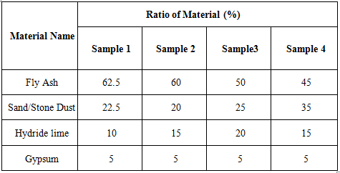
Table 3.2 Stresses in Fly-ash Composite Brick applying Different percentage of materials
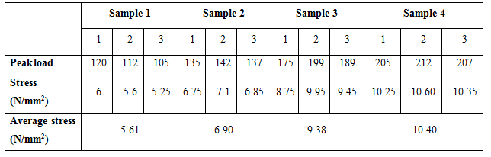
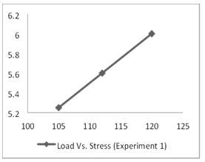  Fig 3.1:Sample 1: Load Vs Stress graph | 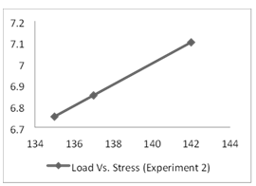  Fig 3.2: Sample 2:Load Vs Stress graph
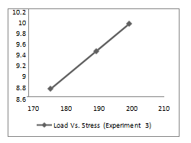  Fig 3.4 : Sample 3: Load Vs Stress graph | 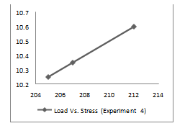  Fig 3.5: Sample 4: Load Vs Stress graph for

TEST FOR WATER ABSORPTION
Brick is tested for water absorption to understand the percentage of moisture is present and adsorbed in varied conditions. Dry brick samples are taken, initial weight was noted. The quantity of water absorption in good quality blocks showing greater than 20% of the dry brick's weight. % Water Absorbed = [(Wt - Wo) / Wo] * 100
Where: Wt = weight of the material after being immersed in water
Wo = initial weight of the material before immersion in water
For,
Sample 1 - [2100.19 – 2395.5/ 2395.5] * 100 =16.502%
Sample 2 - [1850 – 2006.1/ 2006.1] * 100 =7.78%
Sample 3 - [1500 – 1690.8/ 1690.8] * 100 =11.28%
Sample 4 - [1500 – 1681.7/ 1681.7] * 100 =10.80%
COST ESTIMATION
Table 4.1: Cost estimation
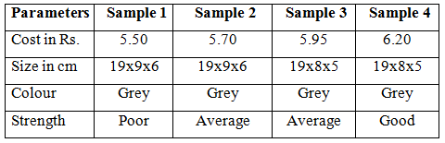

REFERENCES
- Ujjwal Bhattacharjee, Tara Chandra Kandpal “Potential of fly ash utilization in India” Energy 27, 2002, pp. 151-166
- Samir Mistry (2002); “Thesis report on study on compressive strength of fly ash bricks”, Sardar Patel university, V.V. Nagar
- Jayesh Pitroda (2010); paper on “A study of utilization aspect of fly ash in Indian contex” New Building Materials and Construction World October 2000, B.N. Agrawal, S.M. Kohl
- Er. Rinku Kumar, Er. Naveen Hooda, “An Experimental Study on Properties of Fly Ash Bricks”, International Journal of Research in Aeronautical And Mechanical Engineering, Vol.2 Issue.9, September 2014, Issn (Online): 2321-3051, (2014).
- Prabir Kumar Chaulia and Reeta Das, Process Parameter Optimization for Fly Ash Brick by Taguchi Method: Material Research; 2008.11. 159-164.
- Tahmina Banu, Md. Muktadir Billah, “Experimental studies on Fly Ash-Sand Lime Bricks with Gypsum Addition: American Journal of Materials Engineering and Technology, 2013, Vol. 1, no. 3, pp.35-40.
- Gupta P.C, Ray S. C.,” Commercialization of Fly ash”, The Indian Concrete Journal, 167, 1993, 554-560.
- Sengupta J., “Availability of Fly ash and its Application in Construction Industry,” NBO Journal, XXXIX, 1984, 17-22.
- Gupta, R.L., Bhagwan, Gautam, D.K., Garg, S.P., “A Press for Sand Lime Bricks Research and Industry”, 22(40), 1977, 246-249.

