Fish Scales
Kamei Lanthaimeilu
Ph.D. scholar, FRM
ICAR – Central Institute of Fisheries Education
Mumbai – 400061, India
e-mail- lanthaimeilukamei@gmail.com
Abstract
Fish scales are the small, flat, overlapping structures covering most fish species' skin. It is a vital part for the fish, but as for humans, it is the unwanted part, and it is termed fish waste. Fish scales are of many types and have different modifications for their survival instinct in which ecological environment they thrive; it protects against physical damage, parasites, and infections.

Keywords: Types of fish scales, fish scales modification, importance of fish scales.

Introduction
Fish scales are usually the first thing we as humans remove or discard and throw away when preparing fish as a waste product, but they play a vital role in fish life. The principal purpose of scales in fish is to protect against predators and parasites, so they are relatively complex and present in the outermost layer of the fish that comes in contact with the environment. The way the scales overlap each other aids in streamlining the fish’s body so that there is less resistance to water and the fish during its migration. The study of scales is termed “Squamatology”.
The outer body of many jawed fish is adorned with scales, which are part of the fish's integumentary system. The scales originate from the
mesoderm and may be similar in structure to teeth. Some species are covered with scutes (bony external Plate or scale overlaid with horn), e.g., Sturgeon. Some fishes are devoid of scales, e.g., freshwater catfish. Certain species display an intermediate, generally naked condition but possess scales in restricted areas. As such, in the case of paddlefish (Polydon), scales are present in the region of the throat, pectoral, and base of the tail.
In some fishes, scales are adapted into teeth, bony armour plates (Sea horse) and spiny stings (stingray). In freshwater eel (Anguilla), scales are minute and deeply embedded, and the arrangement is mosaic; the scales wed their neighbouring ones at their margins so that the fish appear naked. Almost all fish are covered in a slime (mucus) protective layer. Mostly, scales are arranged in an imbricate manner and overlap with a free margin directed towards the tail that minimises friction with the water.
Upon hatching from the egg, the fish's body becomes enveloped in diminutive scales. Nevertheless, these scales persist in number throughout their lifespan, yet any lost scales have the potential to regenerate over time. Within these scales, a minuscule circular growth ring materialises, referred to as a "circulus" or "circuli" in the singular form. Circuli originating during the summer exhibit a notable breadth, whereas those arising in the winter intertwine intricately. A black circle were formed in that densely enclosed region, known as the annulus. The age of the fish is known by counting the number of annuluses on the scales.

Formation of scale
Scales are plate-shaped dermal or epidermal structures in the outermost layered fish bodies. Numerous vertebrates possess a dual classification of scales: epidermal and dermal scales. Epidermal scales trace their origins to the Malpighian layer within the epidermis, while dermal scales surface from the fish's mesenchyme. These scales consist of petite, slender, spiky, and compacted plates, which interlock securely. The external framework of a fish is recognised as its scales. Thin scales cover the body of an ideal fish. The scales form as outward projections of the epidermis, also known as the skin. Within the epidermal layer are abundant mucus cells that produce and release mucus or slime, serving as a protective barrier against the easy intrusion of parasites, fungi, pathogens, and more.

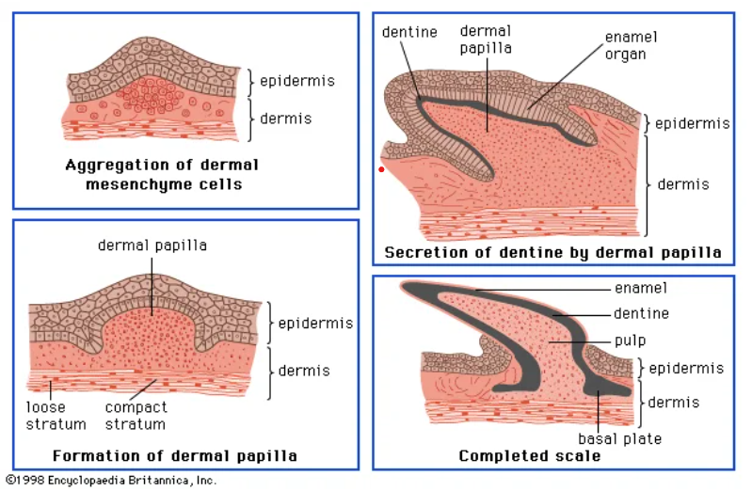
Figure1: Formation of scales

Type of Scales in Fishes:
Scales are derivatives of mesenchymal cells of the dermis
There are four main types of scales and numerous variations of each kind.
- Cosmoid (lungfish and some fossil fishes)
- Placoids are Plate (sharks and rays)
- Ganoids are rhombic or diamond-shaped (bichirs, bowfin, paddlefishes, gars, sturgeons)
- Leptoid scales are of two types: - Cycloid and Ctenoid (most bony fishes)

Four primary categories of fish scales exist.
- Placoid scales, known as dermal denticles, resemble teeth in structure, comprising dentin enveloped in enamel. These are characteristic of cartilaginous fish (though chimaeras only possess them on claspers).
- Ganoid scales are level and exhibit a basal appearance, enveloping a fish's body with gentle overlapping. These scales are common to gar and bichirs.
- Ctenoid scales exhibit similarities to cycloid scales due to their possession of growth rings. What sets them apart is the presence of spines covering one of their edges. This scale variety characterises Halibut.

- Cycloid scales, on the other hand, are small and oval-shaped, displaying growth rings reminiscent of tree rings. Fish like bowfin and remora possess cycloid scales.

A less common scale type is the scute, an outer bony plate resembling a shield, a modified and thickened scale often featuring keels or spines, or a projecting scale with rough and prominent ridges. Scutes are commonly located along the lateral line but can also be found on the caudal peduncle (where they create caudal keels) or the ventral profile. Certain fish, like pinecone fish, may sport scutes that cover them partially or entirely.

The arrangement and characteristics of scales not only facilitate the identification of the species they originate from but also influence the behaviour of the fish.

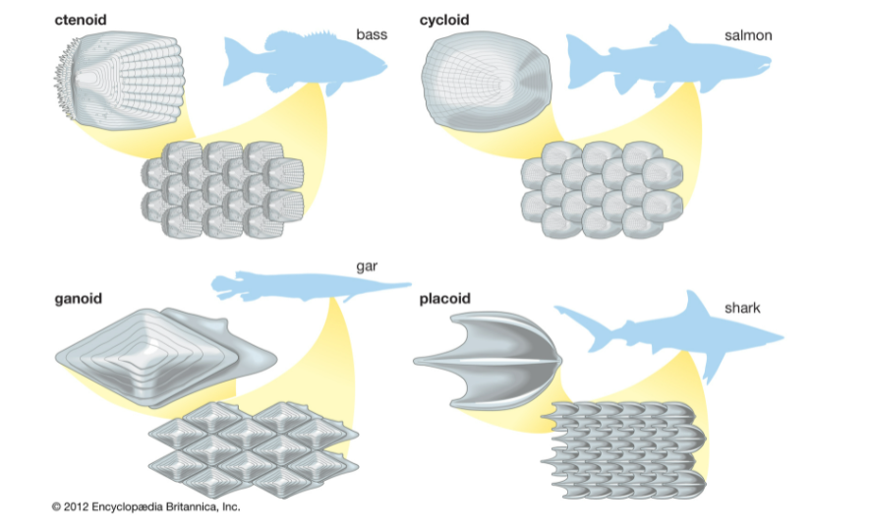
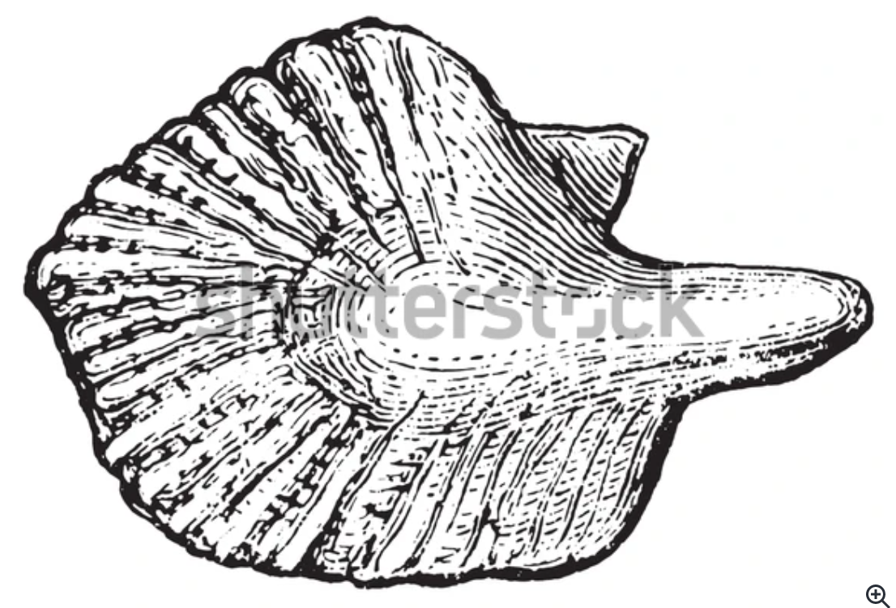Cosmoid Scales
Figure 2: Different types of fish scales

Cosmoid Scales:
These scales were not found in any extant fish species but in certain ostracoderms, placoderms, and extinct sarcopterygians. These scales exhibit a layered structure comprising four distinct levels. Outermost are thin, enamel-like spines and a hard vitrodentin layer; a complex and acellular cosmin layer is beneath this. Internally, the isopedine layer consists of the duct and ossicular layer. Scale growth occurs along the periphery due to the absence of viable cells at the base. In the case of lungfish, the original cosmoid structure has transformed into cycloid scales.
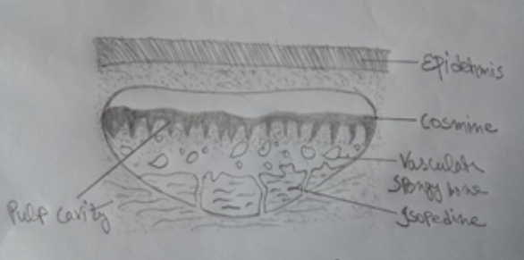
Figure3: Cosmoid scales

Placoid scales:
Placoid scales are characteristically found among the sharks and other Elasmobranches. They are small denticles that remain embedded in the skin. Each scale has two parts: an upper part known as the ectodermal cap or spine. The scales enrobe the skin akin to grains of sand. Placoid scales are organised into separate rows, combining to create the external framework. Underneath each scale is a foundational plate and a backward-curved, pointed spine that originates from this base. This curvature functions to shield the skin against abrasive harm. Each foundational Plate comprises tissue abundant in calcium. The spiky structures are anchored within the dermis through the assistance of sharp fibres and other connecting fibres. The design consists of dentin covered by an enamel coating.
The basal Plate has a small aperture through which blood vessels and nerves enter the pulp cavity. The placoid scales are modified in jaw teeth in sharks, spines in dorsal fins, Squalus (spiny dogfish), stingrays, and saw teeth in the Pristis.
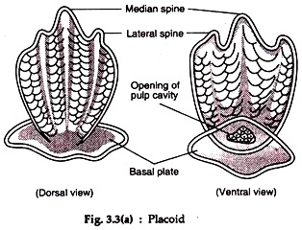
Figure 4: Placoid scales

Ganoid scale:
The ganoid scales are thick and rhomboid, usually diamond-shaped plates. They consist of an outer layer of a hard inorganic substance called ganoine, different from the vitreodentine of placoid scales. A cosmine-like layer with many branching tubules follows the ganoid layer.
A bony layer of isopedine occupies the innermost layer. These scales grow at the edges and unwind at the surface. The growth takes place by the addition of new layers of isoprene.
The ganoid scale is best found in the Polypterus and Lepidosteius. These fishes’ ganoid scales are rhombic plate-like, from the right edge to edge, and invest the entire body. In Acipencer, the ganoid scales are modified into large bony scutes arranged into five rows.
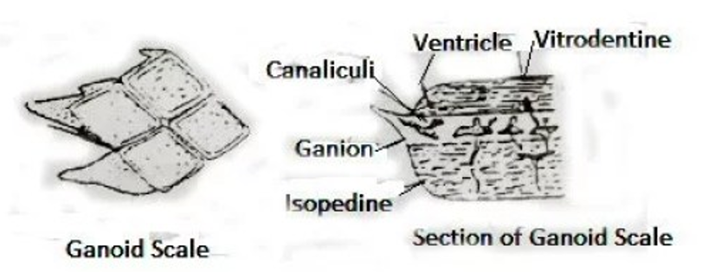
Figure 5: Ganoid scales

Leptoid scale
Such scales are thin and piercing. It does not have an enameloid and dentinal layer. This type of scale is found in most living bony fish (Osteichthyes). It is of two types, namely: Ctenoid and Cycloid Scale.

Ctenoid scale:
They have characteristic teeth in their posterior part. Ctenoid scales are found in spiny-rayed teleost. They are arranged obliquely so that the rear end of one scale overlaps the anterior edge of the scale present behind. The chromatophores are present in the posterior part of these scales.
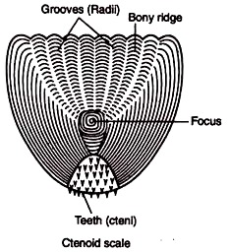
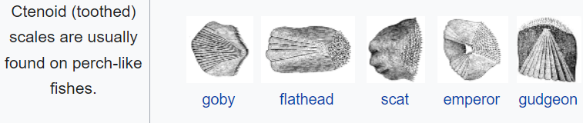
Figure 6: Ctenoid scale

Cycloid scale:
The cycloid scales are devoid of teeth or spines and hence seem cyclic. They are found in soft-rayed teleost and modern lobe-finned fishes. But some spiny-rayed fishes, i.e., Lepidosteius, show the presence of cycloid scales. In Micropterus, both cycloid and ctenoid scales are found.
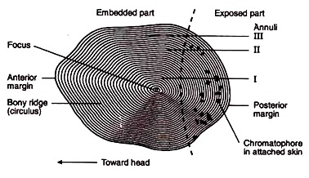
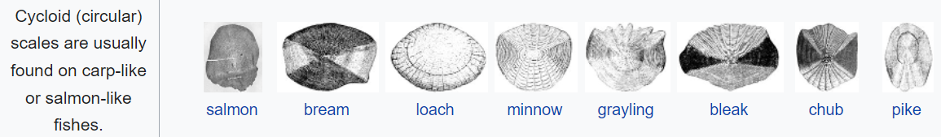
Figure 7: Cycloid scale
Some fish, such as Jewfish (Johnius), flatfish (Cynoglossus), and flounder fish, have cycloid and ctenoid types. These fish have ctenoid scales on the surface and cycloid scales on the numerical side.

Modification of Scales
Various forms of adaptations are observed within fish scales, showcasing their versatility. Certain fish, including electric fish, catfish (Siluriformes), and eels (Anguilliformes), feature diminutive scales embedded in the dermal layer. In specific cases (chimaeras), these scales become localised. Some fish scales transform distinct structures. The teeth in the jaws of sharks, dorsal spines of dogfish (Squalus) and chimerids (Chimera), tail spines of stingrays (Dasyatidae), saw teeth of saw sharks (Pristis), and the gill rakers of basking sharks (Cetorhinus), among others, are derived from modified placoid scales.

The surgeonfish (Acanthurus) possesses a lancet formed by converting tinoid scales, which are modified into sharp cutting blades. The abdominal scutes of herring (Clupeidae) transform into cycloid scales. Lepidotricia found in fins and dermal bones represent adaptations of the bony ridge. Numerous bony fish scales have been altered to create a sturdy groove for the lateral line organ. Bone plates or scutes of sturgeon fish (Acipenser) also modify scales. In coffer fish, Ostracion, the scales form polygonal bony plates articulating with one another to form a rigid protective box. In the globefish, Tetrodon and the porcupine fish, Diodon, the scales are elongated to form spines for protection. The jointed fin rays, leptotrichia of the bony fishes, are also modified scales. The scales change in the basking shark, Cetorhinus, to form gill-rakers. The scales along the fish's lateral line become perforated to provide an exit for the canal in the sea-horse. The hippocampus and the pipe-fish Syngnathus scales are fused to form protective bony rings around the body. Multiple transformations of scales have occurred due to the urge to live, mainly due to self-defence, food intake, etc.

Table1: Difference Between Placoid scale and Cycloid scale

Placoid scale | Cycloid scale
These scales are plate-shaped. | These scales are round and circular.
These scales are found in the skin of cartilaginous fish. | Cycloid scales are found in soft-feathered, hardy fish such as Labeo, Catla, Punteus, etc.
Such scales are called dermal denticles. | This is called a bony ridge.
Such scales have disc or disc-shaped base plates. | Such scales have no base plate.
These scales originate from the epidermis and dermis. | These scales form from the dermis.
Such scales have a thorn that is exposed in the epidermis. | Such scales do not have any thorns.
Such scales do not have circular chromatophores. | Such scales contain numerous circles, radii and chromatophores.
The scales contain an enamel-like hard and transparent material called vitrodentine | The scales do not contain hard and transparent ingredients like enamel, called vitrodentin.
It does not have a growth line. | There are growth lines.
It is transformed into a bone-like structure, especially the dorsal fins of the Squalus, the tail thorns in the stingrays (Dasyatidae), and the saw-like teeth in the saw sharks. | It is transformed into an abdominal squat (Clupeidae)

Uses and Functions of Scales
Scales serve as defensive external structures and offer a range of functions and applications. The subsequent points outline their roles and uses:
  - Fish classification: The significance of scales in fish classification cannot be overstated. The quantity of scales varies across different species. Rows of scales situated above and below the fish's lateral line play a crucial role in discerning its position within the family, genus, and species hierarchy.
  - Life history of fish: As fish grow throughout their lives, their scales also undergo enlargement. This developmental process leads to the emergence of concentric circular lines on the scales known as growth rings. These rings serve to document physical changes in the fish across different seasons. In winter, fish development is slowed, resulting in the annual formation of a pronounced line called the annulus. Insights into fish breeding, seasonal growth, and yearly development are gleaned from these lines. Additionally, Atlantic salmon scales bear a spawning mark that offers information about how many times a fish has spawned. A noticeable alteration occurs in the existing circuli on the scales during reproduction.
  - In self-defence and food hunting: Adapting scales into thorns is crucial in both the self-defence and food acquisition of fish. Furthermore, these modified scales function as a protective shield against parasites, forming a defensive coating. They provide a safeguarding mechanism by creating a barrier between the fish's delicate skin and the external surroundings.
  - Gender selection: Some mature male fish species have different colours during the breeding season (Punteus).
  - Adaptation: Different fish scales and their colour help the fish adapt to different environments. Some fish scales have reflective or iridescent properties that can support fish blend into their surroundings, offering a form of camouflage from predators or prey.
  - Locomotion: Scales help reduce friction as fish move through the water. The streamlined shape and arrangement of scales aid in minimising water resistance and optimising the fish's swimming efficiency. Some fish scales (Anabas) help the fish move.
  - Osmosis: Due to its impermeability, water from the reservoir assists in regulating the intake or expulsion of water from the fish's body, maintaining balance.
  - Thermoregulation: Fish scales can play a role in regulating the fish's body temperature by insulating against heat loss and helping to maintain a stable internal environment.
  - Sensory Function: Some fish scales have nerve endings associated with them, which can help the fish detect changes in water pressure, temperature, and other environmental factors.

Significance of Scales:
Scales play a significant role in the classification, hence very useful for the ichthyologists. They are not found in the lampreys and hagfishes; placoid scales characterise sharks; primitive bony fishes possess ganoid scales; the higher bony fishes have ctenoid or cycloid scales.
The scales’ count is critical in taxonomy. The number of scales in lateral lines and around the body is specific in every species. The age of fish could be determined by measuring space in annual rings of the scales.
In some species, like Atlantic Salmon, the scales exhibit spawning marks on them. These marks indicate how many times the fish has spawned and the time of first spawning.
Most fish bear scales: Agnatha and catfish lack scales on their bodies. Certain fish, like paddlefish (Polyodon) and mirror carp (Cyprinus carpio), possess partial scales. Conversely, species like trout and freshwater eel exhibit small scales. These scales predominantly cover the body, providing a safeguard against injuries.

Notably, more substantial scales offer heightened protection but can limit the fish's mobility. In contrast, more minor, lighter scales, albeit with less protection
, grant more excellent manoeuvrability.
A diverse range of pigments exists within the scales, contributing to the fish's various colours. These scales collectively create a lateral line along the fish’s body, running along its side, and assume a critical function in sensing water vibrations, acting as sensory receptor
s.
References
Briggs, J.C. in Paxton, J.R. & W.N. Eschmeyer (Eds). 1994. Encyclopedia of Fishes. Sydney: New South Wales University Press; San Diego: Academic Press [1995]. Pp. 240.
Helfman, G.S., Collette, B.B. & D.E. Facey. 1997. The Diversity of Fishes. Blackwell Science. Pp. 528.
https://biologyeducare.com/fish-scales/
https://www.britannica.com/science/scale-zoology
Michael, S.W. 1998. Reef Fishes. Volume 1. A Guide to Their Identification, Behaviour, and Captive Care. Microcosm. Pp. 624.
Roberts, C.D. 1993. Comparative morphology of spined scales and their phylogenetic significance in the Teleostei. Bull. Mar. Sci. 52(1):60-113

