Review on Pharmacongoceutical & Pharmacological Properties of Pyrostegia Venusta; An Ornamental Plant

Authors: Mrs. Shital Revan Kalelkar^{1*}, Ms. Harshita Rajeev Agarwal¹, Mr. Ganesh Shamrao More², Mr. Manas Mahesh Joshi³

Designation:
1*: Assistant Professor, Department of Pharmacognosy, D.Y. PATIL UNIVERSITY School Of Pharmacy, Sr. No. 124 & 126, A/p Ambi MIDC Road, Tal Maval, Talegaon Dabhade, Maharashtra 410506
1: Undergraduate Student
2: Assistant Professor, Department of Pharmacology, D.Y. PATIL UNIVERSITY, School Of Pharmacy, Sr. No. 124 & 126, A/p Ambi MIDC Road, Tal Maval, Talegaon Dabhade, Maharashtra 410506
3: Undergraduate Student

Corresponding author:
Mrs. Shital Revan Kalelkar
Assistant Professor, Department of Pharmacognosy, D.Y. PATIL UNIVERSITY, School Of Pharmacy, Sr. No. 124 & 126, A/p Ambi MIDC Road, Tal Maval, Talegaon Dabhade, Maharashtra 410506.

ABSTRACT:
Herbal and natural folk medicine products have been used for centuries in every culture around the world. Plants, without a doubt, are a reservoir of potentially useful chemical compounds that serve as drugs, providing newer leads and clues for modern design by synthesis. Pyrostegia venusta, also known as flame vine or orange trumpet vine, is a plant species of the genus Pyrostegia in the Bignoniaceae family that was originally native to southern Brazil, Bolivia, north-eastern Argentina, and Paraguay; it is now a popular garden species. The plant prefers sunny, sheltered locations and is sensitive to cold winds. Venusta translates as "beautiful," "charming," or "graceful." Pyrostegia" comes from the Greek pyros, which means "fire" and refers to the colour of the flowers and the shape of the upper lip, and stegia, which means "covering." When flowers cover a structure, it may appear to be on fire.
John Miers described the species for the first time in 1863.
KEYWORDS:
Pyrostegia venusta, Flamevine, orange trumpet vine.
INTRODUCTION:
John Miers described the species for the first time in 1863.
Pyrostegia venusta, also known as flame vine (Flame vine, which was formerly known as
Pyrostegia ignea) or orange trumpet vine, is a plant species of the genus Pyrostegia in the Bignoniaceae family that was originally native to southern Brazil, Bolivia, north-eastern Argentina, and Paraguay; it is now a popular garden species.
It is an evergreen, vigorously growing climber, if left unattended, this vine grows quickly and can spread like wildfire. that can reach a height of 5 m. The foliage consists of opposite, pinnate leaves with two or three, 4 to 8 cm leaflets and a three-branched tendril that emerges from the end of the leaf petiole. The orange flowers are 5 to 9 cm long and densely clustered, appearing from winter to spring. Hummingbirds pollinate the plants. The fruits are brown capsules that are smooth and 3 cm long. The plant is sensitive to cold winds and prefers sun and shelter. It is frost hardy in USDA zones 9 to 11. It is tolerant of soil salinity. Forked tendrils on the plant hold on to any tough surface, including brick walls. Semi-hardwood cuttings taken in the summer, autumn, or winter can be used to grow it. It has spread to eastern Australia, eastern Africa, and the south-eastern United States.
Despite the fact that this plant produces bean-like seed pods, the pods rarely contain viable seeds. As a result, layering suckers is the best way to propagate flame vine.
Venusta translates as "beautiful," "charming," or "graceful." Pyrostegia" comes from the Greek pyros, which means "fire" and refers to the colour of the flowers and the shape of the upper lip, and stegia, which means "covering." When flowers cover a structure, it may appear to be on fire.
PLANT DESCRIPTION:
Biological Source: Pyrostegia venusta, also known as flame vine or orange trumpet vine, is a plant species in the Bignoniaceae family Pyrostegia.
Pyrostegia venusta

“Fig. 1 – Whole Plant” “Fig 2 – Flower of the plant”
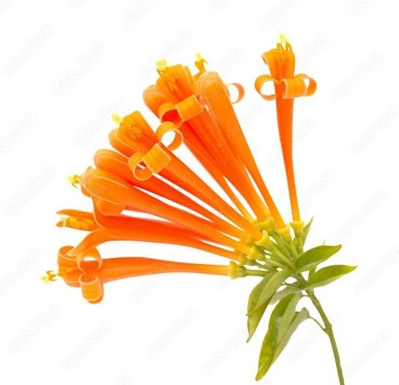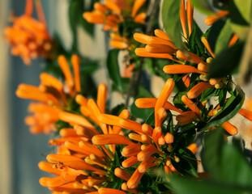

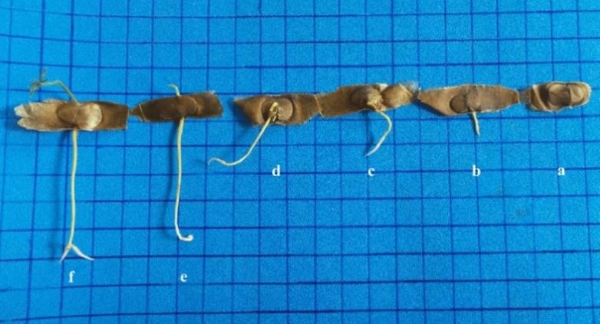
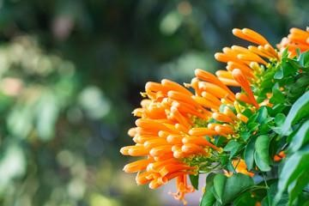
“Fig 3 – Different seeding phases” “Fig 4 – Aerial roots”

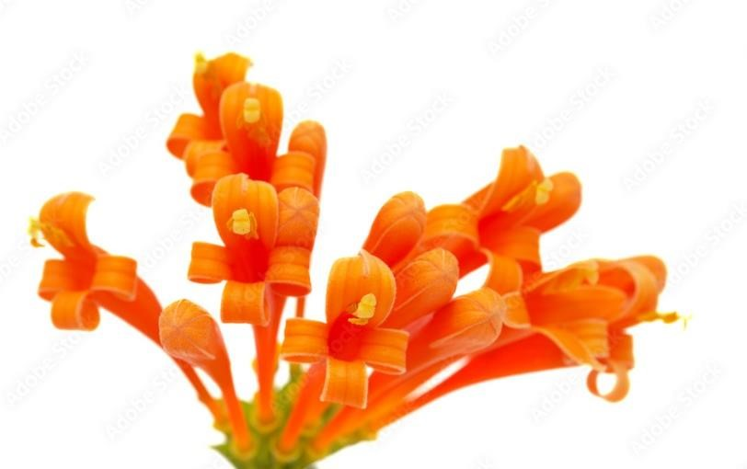
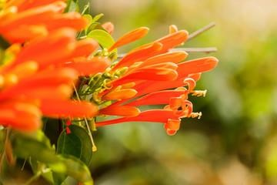

“Fig 5- Pyrostegia venusta” “Fig 6- Pyrostegia venusta”

Kingdom | Plantae
Clade | Tracheophytes
Clade | Angiosperms
Clade | Eudicots
Clade | Asterids
Order | Lamiales
Family | Bignoniaceae
Genus | Pyrostegia
Species | P. venusta
Table 1.1

Taxonomy of Pyrostegia venusta:
Synonyms:
Flame flower, flame vine, flaming trumpet vine, orange creeper, orange trumpet vine, Flaming trumpet, Golden shower trumpet, Orange Bignonia, flame creeper, flame flower vine, golden shower, golden shower vine, golden showers, orange creeper vine, orange trumpet creeper, Chinese cracker flower, belas, Flame vine and Orange trumpet, Bignonia ignea Vell., Bignonia tecomiflora Rusby., Bignonia tubulosa Klotzsch., Bignonia venusta Ker Gawl. Jacaranda echinata Spreng., Pyrostegia amabilis Miers nom. inval., Pyrostegia dichotoma Miers ex K.Schum., Pyrostegia ignea (Vell.) C.Presl., Pyrostegia ornata Miers nom. inval., Pyrostegia pallida Miers nom. inval., Pyrostegia parvifolia Miers nom. inval., Pyrostegia puberula Miers nom. inval., Pyrostegia reticulata Miers nom. inval., Pyrostegia tecomiflora (Rusby) K.Schum. ex Urb., Pyrostegia tubulosa (Klotzsch) Bureau & K.Schum., Tecoma venusta (Ker Gawl.) Lem., Tynanthus igneus (Vell.) Barb.Rodr.

Distribution:
Argentina Northeast, Bolivia, Brazil North, Brazil Northeast, Brazil South, Brazil Southeast,
Brazil West-Central, Colombia, Costa Rica, Ecuador, El Salvador, Guatemala, Guyana, Honduras, Mexico Central, Mexico Gulf, Mexico Northwest, Mexico Southeast, Mexico Southwest, Panamá, Paraguay, Peru, Suriname, Venezuela.

Macroscopic Description:
Pyrostegia venusta Foliage:
P venusta palmately compound leaves on the stem are opposite. The margins of the leaves are entire, ovate with pinnate venation, and evergreen. Leaf blade length ranges from 2 to 4 inches.
Pyrostegia venusta Flower:
P venusta orange tubular flowers had dichasial cymes inflorescence, winter flowering, and autumn flowering. The style and long orange stamens extend beyond the tube.
Pyrostegia venusta Fruit:
Found in an elongated shape with a dry or hard cover, inconspicuous and not showy.
Phytochemical and Pharmacological activities:
The Pyrostegia genus of the Bignoniaceae family. This genus contains four species that are native to South America. This genus' plants are used for traditional purposes in Brazil. According to a literature review, the Pyrostegia genus has been used traditionally to treat diarrhoea, coughing, vitiligo, jaundice, and respiratory system-related diseases such as colds, coughs, and bronchitis. Flavonoids, phenolic compounds, phenylpropanoids, phenylethanoid glycosides, triterpenes, and sterols have been found in phytochemical compounds from the Pyrostegia genus. Pyrostegia genus extract has a wide range of pharmacology actions, including antioxidant, antimicrobial, antifungal, anti-inflammatory, wound healing activities, antinociceptive, analgesic, vasorelaxant activities, antitumor, cytotoxic, hepatoprotective, antitussive, anthelmintic, hyperpigmented, treatment of sickness behaviour, estrogenic, antihypertensive, and immunomodulatory. The Pyrostegia genus is widely used in traditional medicine and has a wide range of pharmacological activities. However, most Pyrostegia species require additional research into their chemical constituents and pharmacological activities.
Pyrostegia venusta is a plant that contains phytochemicals. Terpenoids, alkaloids, tannins, steroids, and saponins have been discovered in flower and root extracts.
According to the Avnish Kumar literature review, flowers of P. venusta, from which the compounds β-sitosterol, n-hentriacontane, acacetin-7-O- β-glucopyranoside and mesoinositol have been isolated. Other studies have indicated the presence of carotenoids in the flowers and rutin in the leaves. GCMS analysis of flower extract has showed the presence of Acetophenone; alpha.-l-Mannopyranoside, methyl 6-deoxy-2,3,4- tris-O-(trimethylsilyl)-;3H-
3a,7-Methanoazulene, 2,4,5,6,7,8- hexahydro-1,4,9,9-tetramethyl-, (3aR (3a.alpha.,4.beta.,7.alpha.))- (Synonym Cyperene); trans-3-Hexenedioic acid, bis(trimethylsilyl) ester; beta.-DL-Arabino pyranose, 1,2,3,4-tetrakis- O- (trimethylsilyl)- (Synonym- B Arabipyranos); Ethyl malonate, ethyl trimethylsilyl ester; Propionic acid, pentamethyldidilanyl ester; Glycoside, .alpha.-methyl-trtrakis-O-(trimethylsilyl);Hexadecenoic acid, methyl ester (Synonym-Palmitic Acid; D-Xylose, tetrakis(trimethylsilyl)-;Glycoside,. Alpha.-methyl-trtrakis-O- (trimethylsilyl)-;Gluconic acid, 2-methoxime, tetra(trimethylsilyl)-, trimethylsilyl ester; 12-Octadecadienoic acid, methyl ester (Synonym Linoleic acid); 9-Octadecenoic acid (Z)-, methyl ester (Synonym Oleic Acid) ;Myo-Inositol, 1, 2, 3, 4, 5, 6-hexakis-O- (trimethylsilyl)-; Docosanoic acid, methyl ester
(Synonym Hysterene); 1,2-Benzenedicarboxylic acid, mono(2-ethylhexyl) ester (Synonym Phthalic Acid); Methyl 10-methyl-undecanoate; (1,2,4)Triazolo(1,5-a)pyrimidine-6carboxylic acid, 4, 7-dihydro-7- imino-, ethyl ester; Dotriacontane; Silicic acid, diethyl bis(trimethylsilyl) ester; Tetracosanoic acid, methyl ester; Di-ndecylsulfone;
Dodecahydropyrido(1,2-b)isoquinolin-6-one; Heptacosane; Tetra siloxane, decamethyl-;
Tetra decanoic acid, 12- methyl-, methyl ester; Stigmasteryltosylate; 2-p-
Nitrophenyloxadiazol-1, 3, 4-one-5; 2-Methyl-6-(5-methyl-2-thiazolin-2- ylamino)pyridine; Diazo progesterone; 1, 6-Dibromo-2- cyclohexyl pentane; Cyclotrisiloxane, hexamethyl-; cis2-Hexen-1- ol, trimethylsilyl ether.
It has been demonstrated that the compounds acacetin-7-O-β glucopyranoside and βsitosterol showed anti-inflammatory activity. The Dr. Dukes phytochemical and ethnobotanical database has mentioned some of these compounds to be useful in various medicinal complications. Database has mentioned that Acetophenone are useful Antibacterial, fungicide, pesticide, hypnotic, perfumery, soporific; 3H-3a,7-Methanoazulene, 2, 4, 5, 6, 7, 8hexahydro-1, 4, 9, 9-tetramethyl-, (3aR-(3a.alpha.,4.beta., 7.alpha.))-(Cyperene) is an Antimalarial and Anti-plasmodial; Hexadecenoic acid, methyl ester (Synonym-Palmitic Acid) is an Antioxidant, hypo-cholesterolemic-nematicide, pesticide, antiandrogenic flavour, haemolytic, 5- Alpha reductase inhibitor; 9, 12- Octadecadienoic acid, methyl ester (Synonym - Linoleic acid) is an Anti-inflammatory, hypo-cholesterolemic cancer preventive, hepatoprotective, nematicide, insectifuge, anti-histaminic antieczemic, anti-acne, 5-Alpha reductase inhibitor, anti-androgenic, anti-arthritic, anti-coronary, insectifuge; 1,2-
Benzenedicarboxylic acid, mono (2-ethylhexyl) ester (Synonym - Phthalic acid) is useful in preparation of perfumes and cosmetics, and as plasticized vinyl seats on furniture and in cars, and clothing including jackets, raincoats and boots, as well as in textiles, as dye stuffs, cosmetics and glass making; Myo-Inositol, 1, 2, 3, 4, 5, 6-hexakis-O- (trimethylsilyl)- is useful in anti-depression, liver problems, panic disorders and diabetes; 9-Octadecenoic acid (Z)-, methyl ester is a 5-alpha-reductase-inhibitor, allergenic, alpha-reductase-inhibitor, anemiagenic, anti-alopecic, anti-androgenic, anti-inflammatory, anti-leukotriene-D4 (antiplatelet activating factor), dermatitigenic, insectifuge, perfumery, propecic cancer-preventive, choleretic, flavour, hypocholesterolaemia, irritant, percutaneostimulant; Stigmasteryltosylate is used as anti-hepatotoxic, anti-inflammatory, anti-ophidic, anti-oxidant, artemecide, estrogenic, sedative.

Chemical constituents & structures
Acetophenone; alpha.-lMannopyranoside | 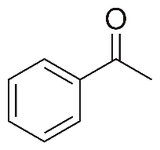
Diethyl malonate | 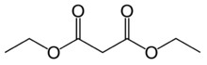
Docosanoic acid | 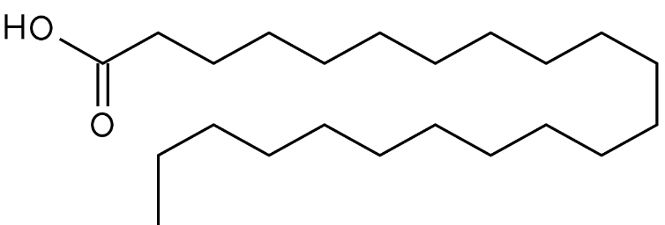
octadecadienoic acid | 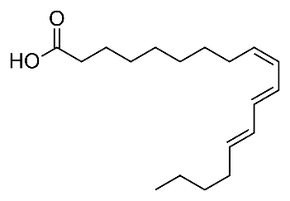
Benzenedicarboxylic acid | 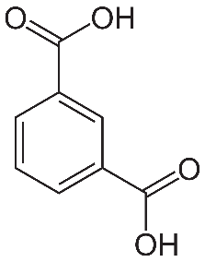
Tetracosanoic acid | 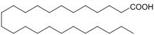
Tetra decanoic acid | 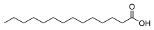
Stigmasteryl Tosylate | 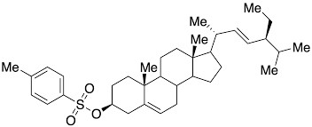
Di-n decylsulfone | 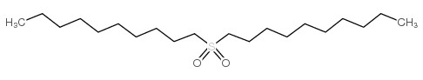
myo-inositol | 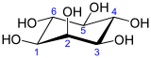
Nitrophenyloxadiazol | 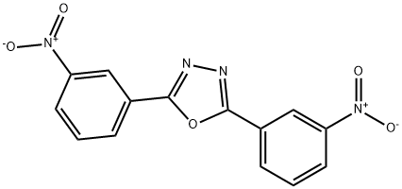
Cyclotrisiloxane | 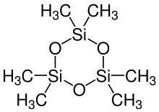
Linoleic acid | 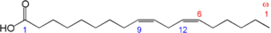
Ethyl malonate
DL-Arabinose pyranose | 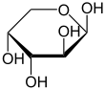
Table 1.2

TRADITIONAL USE:
Pyrostegia venusta aerial parts are used as an infusion or decoction in traditional Brazilian medicine as a general tonic, and also as a therapy for diarrhoea, vitiligo, cough, and common respiratory system infections such as bronchitis, flu, and cold.
The isolation of oleanolic acid from Pyrostegia venusta aerial parts and flowers is documented in the literature. Oleanolic acid has proven to be extremely important in biology. It has antimicrobial, hepatoprotective, anti-inflammatory, antipruritic, spasmolytic, antiangiogenic, antiallergic, antiviral, and immunomodulatory properties. Acacetin7-Oglucopyranoside and -sitosterol, which were isolated from the flowers, roots, and aerial parts of Pyrostegia venusta, also demonstrated anti-inflammatory activity. These findings highlight Pyrostegia potentially fruitful activities.
BIOLOGICAL STUDIES:
Antioxidant activity:
The antioxidant capacity of Pyrostegia venusta flowers and roots was assessed using 1,1diphenyl-2-picrylhydrazyl (DPPH), 2,2'-azinobis-3-ethylbenzothiazoline-6-sulfonic acid (ABTS), and ferric reducing antioxidant power (FRAP) assays.

Treatment of sickness behaviour:
A study was carried out to assess the effects of a hydroethanolic extract of Pyrostegia venusta flowers on sickness behaviours induced by lipopolysaccharide in mice. Lipopolysaccharideinduced depressive-like and exploratory behaviours were reduced by Pyrostegia venusta extract. These findings back up previous claims about the usefulness of these plants in traditional therapies and suggest that they may be useful in the treatment of disorders that cause sickness behaviour, such as the flu and cold.
Estrogenic activity:
In recent years, tea made from the plant Pyrostegia venusta has been used to alleviate menopausal symptoms. The active ingredients in this extract, however, are in relatively low concentrations. Plant tissue culture is an option for producing plant extracts with higher metabolite concentrations.
Genotoxic activity:
Pyrostegia venusta extracts were tested for genotoxicity in mice using the micronucleus (MN) and chromosome aberration (CA) tests. Different concentrations (50, 100, and 200 mg/kg body weight) were administered orally to the experimental groups. When compared to the negative control group receiving water, the frequency of micro nucleated polychromatic erythrocytes (MNPCE) in the experimental controls was significantly lower, and it was statistically lower than that of the positive control group receiving Cyclophosphamide.
Pyrostegia venusta exhibited no genotoxicity activity.
Antimicrobial activity:
The flower extract was tested for antimicrobial activity against twelve microorganisms. The extract of Pyrostegia venusta exhibited moderate antimicrobial activity against the following organisms: Bacillus subtilis is a type of bacteria. Staphylococcus epidermidis,
Staphylococcus pyogenes, Staphylococcus aureus, Escherichia coli, Micrococcus luteus,
Enterobacter aerogenes, Salmonella typhi, Pseudomonas aeruginosa, Candida albicans, Aspergillus niger, and Candida tropicana are among the bacteria that have been identified.
Melanogenic activity:
The melanogenic activity of hydroalcoholic extracts of Pyrostegia venusta leaves and flowers on murine B16F10 melanoma cells was recently investigated; both extracts, leaves (0.1; 0.3; 1 and 3 g/mL) and flowers (0.03 and 0.1 g/mL), increased melanin content in a concentration dependent manner after 4 days incubation on melanoma cells. Cell viability was also tested in murine B16F10 cells using the MTT (3-(4,5-dimethythiazol-2-yl)-2,5-diphenyl tetrazolium bromide) assay, which revealed that no cell death was detected at the same tested concentrations of both extracts. Both extracts were also tested in vitro for mushroom tyrosinase activity. Actually, neither extract was able to change the tyrosinase activity.

CONCLUSION:
Plants have tremendous therapeutic and economic value throughout the world. Pyrostegia venusta has numerous pharmacological effects, which are discussed in this review. Studies on this plant have revealed that it has a wide range of pharmacological properties with high medicinal value. It has been observed that almost all parts of the plants have been widely used as traditional or folk medicine for centuries. The study about Pyrostegia Venusta is still going on & will be published soon.

REFERENCES:
- Montandon A, Zuza E, Toledo BE. Prevalence and reasons for tooth loss in a sample from a dental clinic in Brazil. Int J Dent. 2012;2012:719750. [PMC free article] [PubMed] [Google Scholar]
- Shivakumar KM, Vidya SK, Chandu GN. Dental caries vaccine. Indian J Dent

Res. 2009;20:99–106. [PubMed] [Google Scholar]
- Sasaki EY, Ito LA, Canteli VC, Ushirobira TM, Ueda-Nakamura T, Dias Filho BP, et al. Antioxidant capacity and in vitro prevention of dental plaque formation by extracts and condensed tannins of Paullinia cupana. Molecules. 2007;12:1950–63. [PMC free article] [PubMed] [Google Scholar]
- Argimón S, Alekseyenko AV, De Salle R, Caufield PW. Phylogenetic analysis of glucosyltransferases and implications for the coevolution of mutans streptococci with their mammalian hosts. PLoS One. 2013;8:e56305. [PMC free article] [PubMed] [Google Scholar]
- Kolenbrander PE, London J. Adhere today, here tomorrow: Oral bacterial adherence. J

Bacteriol. 1993;175:3247–52. [PMC free article] [PubMed] [Google Scholar]
- Palomer LR. Dental caries in children: a contagious disease. Rev Chil Pediatr. 2006;77:50– 6. [Google Scholar]
- Coronado-Castellote L, Jiménez-Soriano Y. Clinical and microbiological diagnosis of oral candidiasis. J Clin Exp Dent. 2013;5:279–86. [PMC free article] [PubMed] [Google Scholar]
- Campisi G, Pizzo G, Milici ME, Mancuso S, Margiotta V. Candidal carriage in the oral cavity of human immunodeficiency virus-infected subjects. Oral Surg Oral Med Oral Pathol Oral Radiol Endod. 2002;93:281–6. [PubMed] [Google Scholar]
- Kumamoto CA. A contact-activated kinase signals Candida albicans invasive growth and biofilm development. Proc Natl Acad Sci U S A. 2005;102:5576–81. [PMC free article] [PubMed] [Google Scholar]
- Socransky SS, Haffajee AD. Dental biofilms: Difficult therapeutic targets. Periodontology. 2012;28:12–55. [PubMed] [Google Scholar]
- Paquette DW, Williams RC. Modulation of host inflammatory mediators as a treatment strategy for periodontal diseases. Periodontol. 2000;2000(24):239–52. [PubMed] [Google Scholar]
- Shetty S, Bose A, Sridharan S, Satyanarayana A, Rahul A. A clinico-biochemical evaluation of the role of a herbal (Ayurvedic) immunomodulator in chronic periodontal disease: A pilot study. Oral Health Dent Manag. 2013;12:95–104. [PubMed] [Google Scholar]
- Ferreira DT, Alvarez PS, Houghton PJ, Braz-Fillho R. Chemical isolated compounds from roots of Pyrostegia venusta and considerations about its medicinal importance. Quim Nova. 2000;23:42–6. [Google Scholar]
- Scalon SP, Vieira MC, Lima AA, Souza CM, Mussury RM. Pregerminative treatments and incubation temperatures on the germination of “cipó-de-São-João” [Pyrostegia venusta (Ker Gawl.) Miers]-Bignoniaceae. Rev Bras Plant Med. 2008;10:37–42. [Google Scholar]
- Veloso CC, Bitencourt AD, Cabral LD, Franqui LS, Dias DF, dos Santos MH, et al.
Pyrostegia venusta attenuate the sickness behavior induced by lipopolysaccharide in mice. J Ethnopharmacol. 2010;132:355–8. [PubMed] [Google Scholar]
- Roy P, Amdekar S, Kumar A, Singh V. Preliminary study of the antioxidant properties of flowers and roots of Pyrostegia venusta (Ker Gawl) Miers. BMC Complement Altern Med. 2011;11:69. [PMC free article] [PubMed] [Google Scholar]
- Moreira CG, Horinouchi CD, Souza-Filho CS, Campos FR, Barison A, Cabrini DA, et al.
Hyperpigmentant activity of leaves and flowers extracts of Pyrostegia venusta on murine B16F10 melanoma. J Ethnopharmacol. 2012;141:1005–11. [PubMed] [Google Scholar]
- Silva RM, Rodrigues DT, Augustos FS, Valadares F, Neto PO, Santos L, et al. Antitumor and cytotoxic activity of Kielmeyeracoriacea mart. Zucc. And Pyrostegia venusta (Ker Gawl.) Miers extracts. J Med Plants Res. 2012;6:4142–8. [Google Scholar]
- Nisha PV, Shruti N, Swamy KS, Kumari M, Vedamurthy AB, Krishna V, et al.
Anthelmintic activity of Pyrostegia venusta using Pheretimaposthuma. Int J Pharm Sci Drug
Res. 2012;4:205–8. [Google Scholar]
- Veloso CC, Bitencourt AD, Cabral LD, Franqui LS, Santa-Cecília FV, Dias DF, et al. Anti-inflammatory and antinociceptive effects of the hydroethanolic extract of the flowers of Pyrostegia venusta in mice. Rev Bras Farmacognosia. 2012;22:162–8. [Google Scholar]
- Roy P, Amdekar S, Kumar A, Singh R, Sharma P, Singh V. In vivo antioxidative property, antimicrobial and wound healing activity of flower extracts of Pyrostegia venusta (Ker Gawl) Miers. J Ethnopharmacol. 2012;140:186–92. [PubMed] [Google Scholar]
- CLSI. Clinical and Laboratory Standards Institute, Reference Method for Broth Dilution
Antifungal Susceptibility Testing of Yeasts: Approved Standard M27-A2. NCCLS. Villanova,
PA, USA: CLSI; 2002. [Google Scholar]
- Bauer AW, Kirby WM, Sherris JC, Turck M. Antibiotic susceptibility testing by a standardized single disk method. Am J Clin Pathol. 1966;45:493–6. [PubMed] [Google Scholar]
- Holetz FB, Pessini GL, Sanches NR, Cortez DA, Nakamura CV, Filho BP. Screening of some plants used in the Brazilian folk medicine for the treatment of infectious diseases. Mem Inst Oswaldo Cruz. 2002;97:1027–31. [PubMed] [Google Scholar]
- Hamada S, Torii M, Kotani S, Tsuchitani Y. Adherence of Streptococcus sanguis clinical isolates to smooth surfaces and interaction of the isolates with Streptococcus mutans glucosyltransferase. Infect Immun. 1981;32:364–72. [PMC free article] [PubMed] [Google Scholar]
- Ooshima T, Osaka Y, Sasaki H, Osawa K, Yasuda H, Matsumura M, et al. Caries inhibitory activity of cacao bean husk extract in in-vitro and animal experiments. Arch Oral Biol. 2000;45:639–45. [PubMed] [Google Scholar]
- Ishida K, de Mello JC, Cortez DA, Filho BP, Ueda-Nakamura T, Nakamura CV. Influence of tannins from Stryphnodendron adstringens on growth and virulence factors of Candida albicans. J Antimicrob Chemother. 2006;58:942–9. [PubMed] [Google Scholar]
- Tada H, Shiho O, Kuroshima K, Koyama M, Tsukamoto K. An improved colorimetric assay for interleukin 2. J Immunol Methods. 1986;93:157–65. [PubMed] [Google Scholar]
- Aligiannis N, Kalpoutzakis E, Mitaku S, Chinou IB. Composition and antimicrobial activity of the essential oils of two Origanum species. J Agric Food Chem. 2001;49:4168–

[PubMed] [Google Scholar]
- Duarte MC, Figueira GM, Sartoratto A, Rehder VL, Delarmelina C. Anti-Candida activity of Brazilian medicinal plants. J Ethnopharmacol. 2005;97:305–11. [PubMed] [Google Scholar]
- Ower PC, Ciantar M, Newman HN, Wilson M, Bulman JS. The effects on chronic periodontitis of a subgingivally-placed redox agent in a slow release device. J Clin Periodontol. 1995;22:494–500. [PubMed] [Google Scholar]
- Marsh PD. Are dental diseases examples of ecological
catastrophes? Microbiology. 2003;149:279–94. [PubMed] [Google Scholar]
- Calderone RA, Fonzi WA. Virulence factors of Candida albicans. Trends

Microbiol. 2001;9:327–35. [PubMed] [Google Scholar]
- Lohinai Z, Benedek P, Fehér E, Györfi A, Rosivall L, Fazekas A, et al. Protective effects of mercaptoethylguanidine, a selective inhibitor of inducible nitric oxide synthase, in ligature-induced periodontitis in the rat. Br J Pharmacol. 1998;123:353–60. [PMC free article] [PubMed] [Google Scholar]
- Ugar-Cankal D, Ozmeric N. A multifaceted molecule, nitric oxide in oral and periodontal diseases. Clin Chim Acta. 2006;366:90–100. [PubMed] [Google Scholar]
- de Almeida MV, Teixeira FM, de Souza MV, Amarante GW, Alves CC, Cardoso SH, et al. Thalidomide analogs from diamines: Synthesis and evaluation as inhibitors of TNF-alpha production. Chem Pharm Bull (Tokyo) 2007;55:223–6. [PubMed] [Google Scholar]
- Ferreira DT, Alvares PS, Houghton PJ, Braz-Filho R.Chemical constituents from roots of Pyrostegia venusta and considerations about its medicinal importance. Quím Nova. 2000;23:42-46.
- Scalon SP, Vieira MC, Lima AA, Souza CM, Mussury RM. Pregerminative treatments and incubation temperatures on the germination of „cipóde- São-João‰ (Pyrostegia venusta (Ker Gawl) Miers)-Bignoniaceae. Rev Bras Plantas Med. 2008;10:37-42.
- Veloso CC, Bitencourta AD, Cabral LD, Franqui LS, Dias DF, dos Santos MH, Soncini R, Giusti-Paiva A. Pyrostegia venusta attenuate the sickness behavior induced by lipopolysaccharide in mice. J Ethnopharmacol. 2010;132:355-358.
- Singh S, Rana A and Chauhan SVS. Impact of environmental changes on the reproductive biology in Pyrostegia venusta Presl. J Environ Biol. 2009;30(2): 271-273.
- Ndayisenga I. Pyrostegia venusta ker Gwal Miers. In Thesis: Butare city ornamental plant taxonomy and phytogeography; Submitted for the award of BachelorÊs degree in Biology in University of Rwanda
- URL:http://www.biology.nur.ac.rw/IMG/pdf/Ndayisenga_I_2011.pdf Dubey R, Misra KJ. Chemical components of Pyrostegia venusta flowers. J Indn Chem Soc. 1976;53: 378381.
- Harbone JB. Comparative biochemistry of the flavonoids VI Flavonoid patterns in the
Bignoniaceae and Gesneriaceae. Phytochem. 1967;6: 1646-1651
- Blatt CTT, Santos MD, Salatino A. Flavonoids of Bignoniaceae from "cerrado" and their possible taxonomic significance. Plant Syst Evol. 1998;210: 289-292.
- Roy P, Amdekar S, Kumar A, and Singh V. Preliminary study of the antioxidant properties of flowers and roots of Pyrostegia venusta (Ker Gawl) Miers. BMC Complement Altern Med. 2011;11: article 69.
- Gupta MB, Nath R, Srivastava N, Shanker K, Kishor K, Bhargava KP. Anti-inflammatory and antipyretic activities of beta-sitosterol. Planta Med. 1980;39: 157-163.
- Shen KH, Hung SH, Yin LT, Huang CS, Chao CH, Liu CL, Shih YW. Acacetin, a flavonoid, inhibits the invasion and migration of human prostate cancer DU145 cells via inactivation of the p38 MAPK signaling pathway. Mol Cell Biol. 2010;333: 279-291
- URL for Dukes phytochemical and ethnobotanical databases- http://www.arsgrin.gov/cgi-bin/duke/listChemicals.pl
- Pan MH, Lai CS, Wang YJ, Ho CT. Acacetin suppressed LPS-induced up expression of iNOS and COX-2 in murine macrophages and TPA-induced tumor promotion in mice. Biochem Pharmacol. 2006;72:1293-1303.
- Pan MH, Hsieh MC, Hsu PC, Ho SY, Lai CS, Wu H, Sang S, Ho CT. 6-Shogaol suppressed lipopolysaccharide-induced up-expression of iNOS and COX-2 in murine macrophages. Mol Nutr Food Res. 2008;52(12):1467-77.
- Dantzer R. Cytokine, Sickness Behavior and Depression. Immunol Allergy Clin. 2009;29:247-264.
- De Paiva VN, Lima SNP, Fernandes MM, Soncini R, Andrade CA, Giusti-Paiva, A. Prostaglandins mediate depressive-like behaviour induced by endotoxin in mice. Behav Brain Res. 2010;215: 46-151.
- Lima LA, Siani AC, Brito FA, Sampaio ALF, Henriques MGMO, Riehl CAS. Correlation of anti-inflammatory activity with phenolic content in the leaves of Syzygium cumini (L) Skeel (Myrtaceae). Quim Nova. 2007;30:860-864
- Mertz PM, Ovington LG. Wound healing microbiology. Dermatol Clin. 1993;11(4):739747.
- Roy P, Amdekar S, Kumar A, Singh R, Sharma P, Singh V. In vivo antioxidative property, antimicrobial and wound healing activity of flower extracts of Pyrostegia venusta (Ker Gawl) Miers. J Ethnopharmacol. 2012;140(1):186-92
- Nisha PV, Shruti N, SwetaSwamy K, Kumari M, Vedamurthy A B, Krishna V, Hoskeri JH. Anthelmintic activity of Pyrostegia venusta using Pheretima posthuma. Int J Pharma Sci Drug Res. 2012;4(3): 205-208.
- Silva RMG , Rodrigues DTM, Augustos FS, Valadares F, Neto PO, dos Santos L, Silva LP. Antitumor and cytotoxic activity of Kielmeyer acoriacea mart Zucc and Pyrostegia venusta (ker-gawl) Miers extracts. J Med Plants Res. 2012;6(24):4142-4148.
- Moreira CG, Horinouchi CD, Souza-Filho CS, Campos FR, Barison A, Cabrini DA, Otuki MF. Hyperpigmentant activity of leaves and flowers extracts of Pyrostegia venusta on murine B16F10 melanoma. J Ethnopharmacol. 2012;141(3):1005-1011.
- Magalhães EA, Silva Jr GJ, de Campos TA, Silva LP, Silva RMG. The Evaluation of the genotoxic potency of the Pyrostegia venusta (Ker Gawl) Miers, Bignoneaceae, crude extract on bone marrow of mice. Rev bras farmacogn. 2010;20(1): 65-69
- The Plant List Flowers of India Top Tropicals Dave's Garden Wikipedia
- World Health Organization. Summary of WHO guidelines for the assessment of herbal medicines. Herbal Gram 1993; 28:1314.
- Hill AF. Economic Botany. A text Book of useful plants and plant products. 2nd edn. Mc Garw-Hill book company lnc, New York. 1952.
- Buenz IFF, Schenepple DJ, Motley TJ. Technique, Biopreospecting historical herbal; texts by hunting for new leads in old tomes. Trends in pharmacological sciences. 2004; 25: 494498.
- Park EJ, Pezzutto JM. Botanicals in cancer chemo preventives. Cancer and Reviews. 2002; 21:231-255.
- Tyagi V, Farooq U, Awasthi G. Phytochemical Analysis and Evaluation of Antiinflammatory Activity of Bignonia venusta (Ker Gawl.) Miers Flower Extracts. Univerties Journal of Phytochemistry and Ayurvedic Heights.2020; 1(28):32-40.
- Jin Dai and Russell J. Mumper. Plant Phenolics: Extraction, Analysis and Their Antioxidant and Anticancer Properties. Molecules. 2010; 15: 7313-7352.
- Veena Sharma and Ritu Paliwal. Isolation and Characterization of Saponins from Moringa Oleifera (Moringaeceae) Pods. International Journal of Pharmacy and Pharmaceutical Sciences. 2013; 5(1):179-183.
- Reyes-Martinez A, Valle-Aguilera JR, Antunes-Ricardo M, Gutierrez-Uribe J, Gonzalez C, del Socorro Santos-Diaz M. Callus from Pyrostegia venusta (Ker Gawl.) Miers: a source of phenylethanoid glycosides with vasorelaxant activities. Plant Cell, Tissue and Organ Culture (PCTOC). 2019; 139(1):119-29.
- Coimbra MC, Chagas RC, Vilela MS, Castro AH. Growth, morphology and bioactive phenolic compounds production in Pyrostegia venusta calli. Biocatalysis and Agricultural Biotechnology. 2019; 18:101036.
- Usman MR, Choubey N. Pharmacognostic and antioxidant studies of Pyrostegia venusta pres. stem. Indo American journal of pharmaceutical sciences. 2017; 4(8):2295-303.
- Zari ST, Zari TA. Wound healing, hyperpigmentant and antitumor activity of Pyrostegia venusta. Int. J. Res. Biosciences. 2015; 4(4): 29-37.
- Mostafa NM, El-Dahshan O, Singab AN. Pyrostegia venusta (Ker Gawl.) Miers: a botanical, pharmacological and phytochemical review. Medicinal and Aromatic Plants. 2013; 2(3):1-6.
- Kumar A, Asthana M, Roy P, Amdekar S, Singh V. Phytochemistry and pharmacology of Pyrostegia venusta: a plant of family Bignoniaceae. International Journal of Phytomedicine. 2013; 5(3): 257-261
- Moreira CG, Horinouchi CD, Souza-Filho CS, Campos FR, Barison A, Cabrini DA, Otuki MF. Hyperpigmentant activity of leaves and flowers extracts of Pyrostegia venusta on murine B16F10 melanoma. Journal of ethnopharmacology. 2012; 141(3):1005-11.
- Silva RM, Rodrigues DT, Augustos S, Valadares F, Neto PO, dos Santos L, Silva LP. Antitumor and cytotoxic activity of Kielmeyera coriacea mart. Zucc. and Pyrostegia venusta (ker-gawl.) Miers extracts. Journal of Medicinal Plants Research. 2012; 6(24):4142-8.
- Nisha PV, Shruti N, Swamy KS, Kumari M, Vedamurthy AB, Krishna V, Hoskeri JH. Anthelmintic activity of Pyrostegia venusta using Pheretima posthuma. International Journal of pharmaceutical sciences and drug research. 2012; 4(3):205-208.
- Roy P, Amdekar S, Kumar A, Singh V. Preliminary study of the antioxidant properties of flowers and roots of Pyrostegia venusta (Ker Gawl) Miers. BMC Complementary and Alternative Medicine. 2011; 11(1):1-8.
- Bouzada Maria LM, Fabri R.L, Nogueira M, Konno Tatiana U P, Duarte Gizele G and Scio Elita. Antibacterial, cytotoxic and phytochemical screening of some traditional medicinal plants in Brazil 2009;47(1):44-52.
- Veloso Clarice C, Cabral Layla DM, Bitencourt Andressa D., Franqui Lidiane S., Cecilia FVS, Dias DF, Soncini R, Vilela FC, Paiva AG. Antiinflammatory and antinociceptive effects of the hydroalcholic extract of the flowers of Pyrostegia venusta in mice. 2012; 22(1): 162168.
- Altoe TDP, Amorim GM, Gomes JVD, Borges AS, Valadao C, Silva IV, Rangel LDA, Vieira PC, Jamal CM, Kitagawa RR, Borges WS, In vitro antioxidant and cell viability of Pyrostegia venusta(Ker Gawl.) Miers). 2014; 6(4):215-222.
- Baker HG 1978 Chemical aspects of the pollination biology of woody plants in the tropics. In: PB Tomlinson, MH Zimmerman. eds. Tropical trees as living systems. Cambridge : Cambridge University Press, 57– 82.
- Baker HG, Baker I. 1975 Studies of nectar-constitution and pollinator-plant convolution. In: LE Gilbert, PH Raven, eds. Coevolution of animals arid plants. Austin : University of Texas Press, 100– 40.
- Baker HG, Baker I. 1983a Floral nectar sugar constituents in relation in pollinator type. In: CE Jones, RJ Little, eds. Handbook of experimental pollination biology. New York : Van Nostrand Reinhold Co., 117– 141.
- Baker HG, Baker I. 1983a A brief historical review of the chemistry of floral nectar. In: B Bentley, T Elias, eds. The biology of nectaries. New York : Columbia University Press, 127– 152.
- Bertin RI 1982 Floral biology, hummingbird pollination, and fruit production of trumpet creeper (Campsis radicans, Bignoniaceae). American Journal of Botany 69: 122– 134.
- Bolten AB, Feinsinger P. 1978 Why do hummingbird flowers secrete dilute nectar. Biotropica 10: 307– 309.
- Bolten AB, Feinsinger P, Baker HG, Baker I. 1979 On the calculation of sugar concentration in flower nectar. Oecologia (Berlin) 41: 301– 304.
- Brice AT 1992 The essentiality of nectar and arthropods in the diet of the anna's hummingbird (Calipte anna). Comparative Biochemistry and Physiology 101A: 151– 155.
- Búrquez A, Corbel SA 1991 Do flowers reabsorb nectar. Functional Ecology 5: 369– 379.
- Cocucci AA, Galetto L, Sérsic A. 1992 El sindrome floral de Caesalpinia gilliesii (Fabaceae-Caesalpinioideae). Darwiniana 31: 111– 135.
- Cruden RW 1976 Intraspecific variation in pollen-ovule ratios and nectar secretion – preliminary evidence of ecotypic adaptation. Annals of the Missouri Botanical Garden 63: 277– 289.
- Cruden RW, Hermann SM, Peterson S. 1983 Patterns of nectar production and plantpollinator coevolution In: B Bentley, T Elias, eds. The biology of nectaries. New York : Columbia University Press, 80– 125.
- Elias TS, Gelband H. 1978 Nectar: its production and functions in trumpet creeper. Science 189: 289– 291.
- Feinsinger P. 1978 Ecological interactions between plants and hummingbirds in a successional tropical community. Ecological Monographs 6: 105– 128.
95.Feinsinger P. 1987 Approaches to nectarivore–plant interactions in the New World. Revista Chilena de Historia Natural 60: 285– 319.
- Freeman CE, Reid WH, Becvar JE, Scogin R. 1984 Similarity and apparent convergence in the nectar-sugar composition of some hummingbird-pollinated flowers. Botanical Gazette 145: 132– 135.
- Galetto L, Bernardello LM 1992 Nectar secretion pattern and removal effects in six Argentinean Pitcairnioideae (Bromeliaceae). Botanica Acta 105: 292– 299.
- Galetto L, Bernardello L. 1993 Nectar secretion pattern and removal effects in three species of Solanaceae. Canadian Journal of Botany 71: 1394– 1398.
- Gentry AH 1974a Flowering phenology and diversity in tropical Bignoniaceae. Biotropica 6: 64– 68.
- Gentry AH 1974a (Revolutionary patterns in Central American Bignoniaceae. Annals of the Missouri Botanical Garden 61: 728– 759.
- Gill FB 1988 Effects of nectar removal on nectar accumulation in flowers of Heliconia imbricata (Heliconiaceae). Biotropica 20: 169– 171.
- Gobatto-Rodrigues AA, Stort MNS. 1992 Biologia floral e reproducao de Pyrostegia venusta (Ker-Cjawl.) Miers (Bignoniaceae). Revista Brasileira de Botanica 15: 37– 41.
- Gottsberger G, Schrauwen, J, Linskens, HF 1984 Ammo acids and sugars in nectar, and their putative evolutionary significance. Plant Systematics and Evolution 145: 55– 77.
- Gryj E, Martinez del Rio C, Baker I. 1990 Avian pollination and nectar use in Combretum fruticosum (Loefl). Biotropica 22: 169– 171.
- McDade LA, Kinsman S. 1980 The impact of floral parasitism in two neotropical hummingbird-pollinated plant species. Evolution 34: 944– 958.
- Martínez del Rio C, Búrquez A. 1986 Nectar production and temperature-dependent pollination in Mirabilis jalapa L. Biotropica 18: 28– 31.
- Montgomerie RD 1984 Nectar extraction by hummingbirds: response to different floral characters. Oecologia (Berlin) 63: 229– 236.
- Pleasants JM 1983 Nectar production patterns in Ipomopsis aggregata (Polemoniaceae). American Journal of Botany 70: 1468– 1475.
- Plowright RC 1981 Nectar production in the boreal forest lily Clintonia borealis. Canadian Journal of Botany 59: 156– 160.
- Pyke GH 1991 What does it cast a plant to produce floral nectar. Nature 350: 58– 59.
- Rathcke BJ 1992 Nectar distributions, pollinator behavior, and plant reproductive success. In: MD Hunter, T Ohguishi, PW Price, eds. Effects of resource distribution on animal-plant interactions. New York : Academic Press. 113– 138.
- Raw GR 1953 The effect on nectar secretion of removing nectar from flowers. Bee World 34: 23– 25.
- Sandwith NY, Hunt DR 1974 Bignoniáceas. In: P Reitz, ed. Flora Ilustrada Catarinense I (BIGN), Itajai , Brazil : Herb, Barbosa-Rodrigues, 1– 72.
- Schemske DW 1980 Floral ecology and hummingbird pollination of Combretum Farinosum in Costa Rica. Biotropica 12: 169– 181.
- Southwick AK, Southwick EE 1983 Aging effect on nectar production in two clones of Asclepias syriaca. Oecologia (Berlin) 56: 121– 125.
- Steiner KE 1985 The role of nectar and oil in the pollination of Drymonia serrulata (Gesneriaceae} by Epicharis bees (Anthophoridae) in Panama. Biotropica 17: 217– 229.
- Sweeley SC, Bentley R, Makita M, Wells WW 1963 Gas liquid chromatography of trimethylsilyl derivatives of sugars and related substances. Journal of the American Chemical Society 85: 2497– 2507.
- Tamm S, Gass CL 1986 Energy intake rates and nectar concentration preferences by hummingbirds. Oecologia (Berlin) 70: 20– 23.
- Zimmerman M. 1988 Nectar production, flowering phenology. and strategies for pollination. In: J Lovett Doust. L. Lovett Doust eds. Plant reproductive ecology. New York , Oxford : Oxford University Press, 157– 178.
- Zimmerman M, Pyke GH 1986 Reproduction in Polemonium. patterns and implications of Moral nectar production and standing crops. American Journal of Botany 7: 1405– 1415.

