AN APPROACH OR TORQUE RIPPLE MINIMIZATION IN BLDC MOTOR USING CASCADED H-BRIDGE MULTILEVEL INVERTER
Murugan .M¹

¹Assistant Professor, Department of Electrical and Electronics Engineering, Government College of Engineering, Bodinayakkanur, Tamil Nadu, India, marimurugan81@gmail.com

Abstract
This work proposes a cascaded H-bridge multilevel inverter design for reducing torque ripple in brushless direct current (BLDC) motor drives. Efficiency and affordability are the main challenges for low power motor drives in residential applications. These applications often employ BLDC motor drives because to its high efficiency, minimal maintenance, and simple structure. Due to design and manufacturing constraints, the produced EMF is not perfectly trapezoidal and the current is not inactive. This causes ripples in the load torque, affecting the motor's performance. Using a multilayer inverter reduces the ripple in load torque. The CHB multilevel inverter is used for this purpose and its simulation results are examined in MATLAB/Simulink. The suggested architecture is confirmed using a hardware experimental setup that performs well over a broad range of speeds.

Keywords
BLDC Motor, Back EMF, Torque Ripple, Multilevel Inverter Topology

1. Introduction
Over the next decade, home appliances like fans and water pumps are predicted to expand at the quickest rate [1-4]. These appliances usually use DC motors. However, lack of maintenance and sparking in the brushes are disadvantages. Consumers now need variable speed motors with great efficiency, cheap cost, and little acoustic noise. These aren't met by conventional motors Consumers are opting for single phase AC induction motors. These motors are inefficient and run on AC mains at a steady speed. Because of their simplicity, high efficiency, minimal maintenance, high dependability, high flux density per unit volume, and low electromagnetic interference, permanent magnet synchronous motors (PMSM) and brushless DC motors (BLDC) are preferred in these appliances [5-6]. BLDC motors provide better speed control and power density than PMSM motors. Also utilised in robots, medical equipment, precision motion control systems and industrial tools, as well as heating and ventilation systems.

The performance of BLDC motors is vital due to its inherent uses in industries and domestic appliances. The inverter's power electronic switches are commutated using rotor position sensors such hall sensors, optical encoders, or optical resolvers [7-8]. Three square wave current pulses separated by 1200 activate the stator windings. The stator windings are activated by the inverter's electronic commutation of power electronic switches. Due to commutation, the resulting load torque has ripples. At any one time, only two phases are active, while the third is inert. The diode freewheeling current causes torque ripple [9]. The ripple in load torque causes acoustic noise in the motor, affecting its performance and speed control characteristics. As a consequence of the non-linearity in the back EMF waveform, conventional control approaches create greater ripple content in the generated load torque [10]. The PWM ON pattern is the optimum option for commutation torque ripple reduction in BLDC motor drives, according to Chuang et al. [11]. Zhang et al. minimised torque ripple in BLDC motor driving by adding a buck converter in front of VSI. Because this approach does not account the buck converter's bandwidth, the drive can only be used at low speeds [12]. For DC link voltage control, Chen et al. used a super lift Luo converter. But the suggested drive performs better at high speeds and the circuit layout is complicated [13].

The efficacy of PWM ON modulation on diode freewheeling torque ripple was studied [14-15]. Fang et al. suggested a unique automated current control approach for BLDC motor drives with non-linear back EMF waveforms. The PWM ON switching pattern decreases diode freewheeling during the inactive period [16]. The decrease of torque ripple has been suggested using artificial intelligence. The flux and torque are calculated using the Clarke and Park transformation. Due to inaccuracy, this transformation takes longer [17-18]. Shakouhi et al. advocated reducing commutation torque ripple by energising all phases just before each conduction period. [19]. However, these topologies increase switching losses and thermal stresses. Multi-Level Inverter supplied BLDC motors provide less distortion in the output load torque. The suggested technique uses a bridgeless topology, specifically a Bridgeless Buck-Boost converter, which has fewer components than existing bridgeless topologies.
2. Cascaded H-Bridge Multilevel Inverter
BLDC motors are usually driven by a two-level voltage source inverter. Figure 1 depicts a cascaded H-bridge multilevel inverter supplied BLDC motor. As a consequence of the sharp voltage wavefronts (dv/dt) over the terminals of the motors, performance is reduced and motor damage ensues. Multilevel inverters have recently acquired popularity owing to their low dv/dt ratio, minimal harmonic distortions, low voltage stress on the switches, and low switching frequency. Multilevel inverters are appropriate for high and medium power applications.
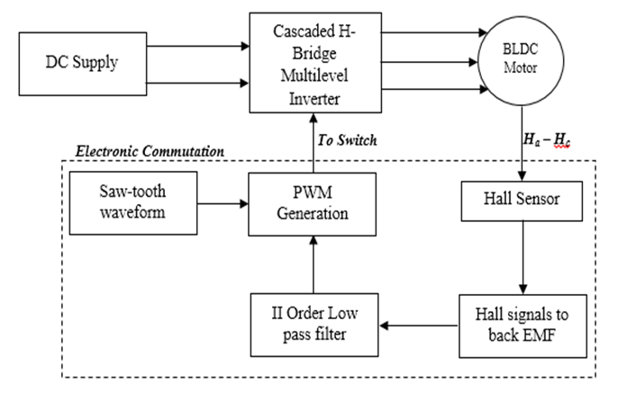
Figure 1. Block Diagram Representation of Cascaded H-Bridge Multilevel Inverter fed BLDC Motor
The most popular multilevel inverter topologies are diode clamped/neutral clamped, flying capacitor, and cascaded H-bridge. The cascaded H-bridge multilevel inverter requires no clamping diodes or flying capacitors. So it is ideal for BLDC motor drives to reduce torque ripple. Cascaded H-bridge multilevel inverters combine H-bridge inverters with independent DC sources. Three-phase inverters are coupled in a star or delta arrangement. This architecture has fewer components than conventional multilevel inverter topologies, reducing switching loss. Having a separate DC source for each cell restricts its use. 2(n-1) switches per leg for the n-level inverter Single-phase five-level cascaded inverter topology 2
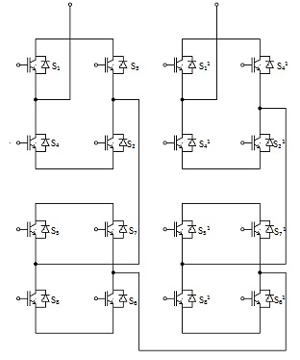
Figure 2. Cascaded H-Bridge Multilevel Inverter
In cascaded H-bridge multilevel inverter each level generates five different output voltages +2V_{dc}, +V_{dc}, 0, -V_{dc}, -2V_{dc} by connecting the DC source to the AC output terminal of the inverter with a different combination of four switches. The output voltage of the multilevel inverter is some of the individual H-bridge inverter.
Table 1. Switching States of Five Level Cascaded H-Bridge Multilevel Inverter

Switches Turn_ON | Voltage Level
S₁, S₂ | +V_{dc}
S₁,S₂,S₅, S₆ | +2V_{dc}
S₄,D₂,S₈,D₆ | 0
S₃,S₄ | -V_{dc}
S₃,S₄,S₇,S₈ | -2V_{dc}

Table 1 shows a five level inverter's switching table. Four switches are actuated simultaneously, from upper to lower arm. Initially, all upper arm switches are activated, and then all lower arm switches are triggered. As seen in Table 1, five-level cascaded H-bridge multilevel inverters. The output voltage is double the input voltage. So it's ideal for high power applications with low input voltage. Initially, two upper arm switches from the upper cell are conducted, then two upper arm switches and two lower arm switches. At the highest output voltage, four switches are run. A whole cycle has five switching states.

3. Design of Simulation Diagram
BLDC motors are available in single, two, and three phase. The stator has the same number of windings as the rotor and the permanent magnet. It lacks commutation brushes, as the name implies. Power electronic switches are used for commutation. The electronic commutated motor is thus termed. The switches are commutated by the rotor position. BLDC motors are often driven by two-level inverters, resulting in electromagnetic torque ripple. People nowadays seek low electromagnetic torque ripple; which multilayer inverters may provide.
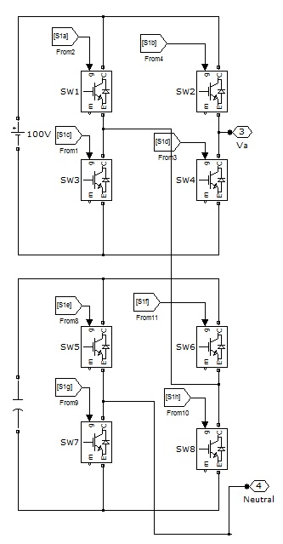
Figure 3 Simulink Model for Single Leg of Cascaded H-Bridge Multilevel Inverter
The simulation model of cascaded H-bridge multilevel inverter is created in MATLAB/Simulink. Three legs with 24 switches form a 3-phase arrangement. Each leg has two cells, each with a DC source. There are 6 isolated DC sources. Figure 3 shows a MATLAB model of a single leg. Figure 4 depicts a three-phase five-level cascaded H-bridge multilevel inverter. Instead of several DC sources, the suggested model features a single DC source with multiple DC links.
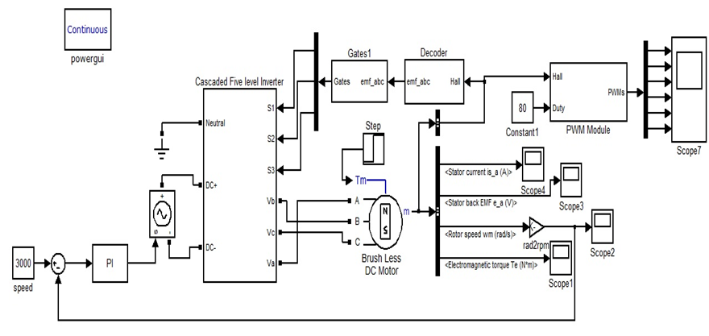
Figure 4. Simulink Model of Five Level Cascaded H-Bridge Multilevel Inverter
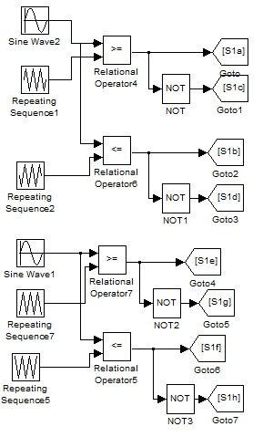
Figure 5 PWM Generation
The initial cell was powered only by DC. The rest of the cells are cascaded or powered by capacitors. The switch firing pulses are created using sinusoidal pulse width modulation. Each leg's sine wave is 1200 phase shifted. To create a pulse, the carrier signal is compared to the reference. Figure 5 shows the PWM generating block. The reverse EMF waveform generates the multilayer inverter firing pulse. The trapezoidal back EMF is sinusoidalized and compared to a reference signal for firing pulse production.
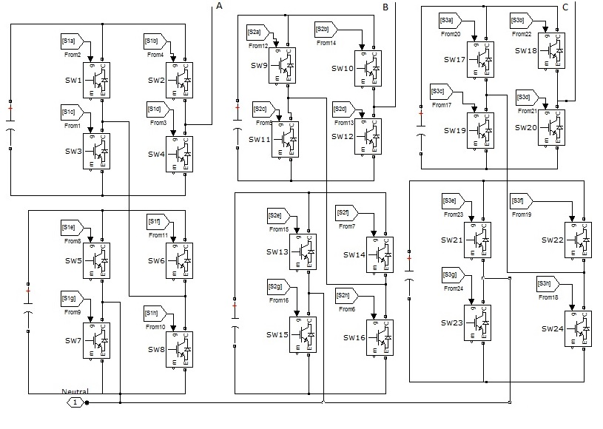
Figure 6 Subsystem Block of Five Level Cascaded H-Bridge Multilevel Inverter
Figure 6 shows the subsystem block of five level Cascaded H-Bridge multilevel inverter. The speed control can be achieved with the help of PI controller. The actual speed of the motor is compared with reference speed value and the resulted error signal is given to PI controller. The PI controller controls the DC link voltage of the inverter depending upon the error value. So speed control can be achieved with different load conditions.

4. Simulated Performance of Proposed BLDC Motor Drive
The suggested motor drive's performance is evaluated in terms of stator current, back EMF, electromagnetic torque, and speed. Figure 7 shows the stator current and back EMF waveforms of two and five level H-Bridge Multilevel Inverter supplied BLDC motors. The stator current is sinusoidal owing to the low harmonic content of MLI output. The stator current is distorted in two-level inverter BLDC motors. The back EMF waveform should have little distortion and non-linearity.
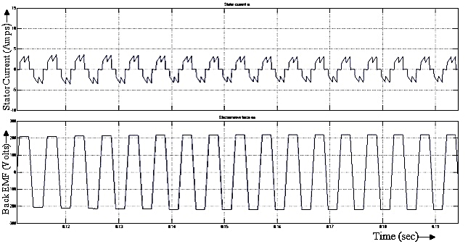
(a) Two Level Inverter fed BLDC Motor
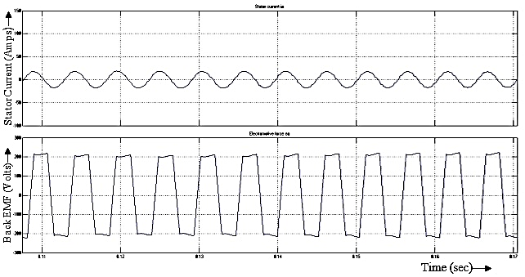
(b) Five Level Cascaded H-Bridge Multilevel Inverter fed BLDC Motor
Figure 7 Stator Current and Back EMF Waveform
Due to commutation electromagnetic torque ripple, the generated back EMF is not perfectly trapezoidal in two-level inverter supplied BLDC motors. However, multilevel inverter driven BLDC motors emit a trapezoidal back EMF. This reduces electromagnetic torque ripples and improves overall system performance. A two and five level Cascaded H-Bridge MultiLevel Inverter supplied BLDC motor's electromagnetic torque waveform is depicted in Figure 8.
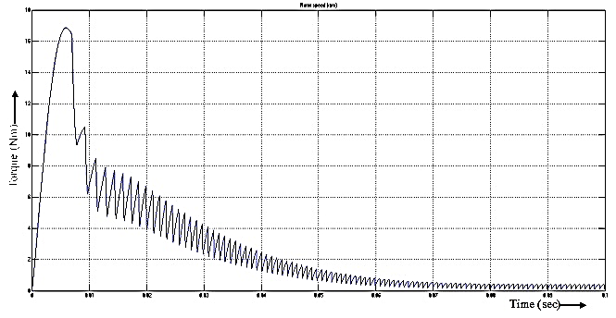
- Two Level Inverter fed BLDC Motor
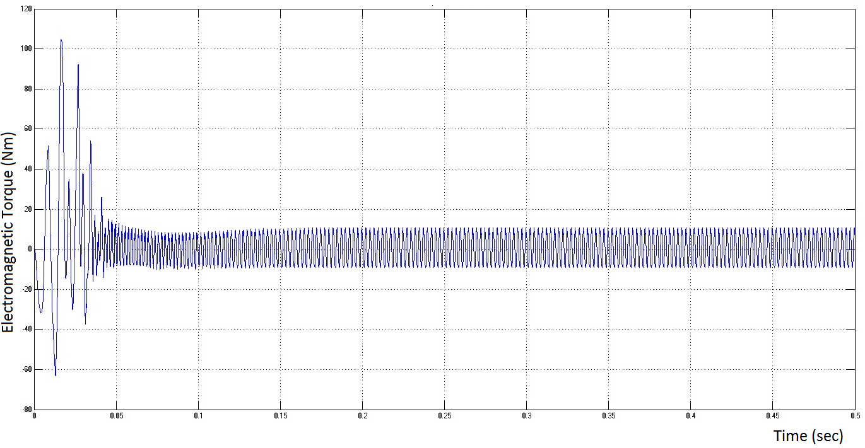
(b) Five Level Cascaded H-Bridge Multilevel Inverter fed BLDC Motor
Figure 8. Electromagnetic Torque Waveform
When beginning, the torque should be maximal, and then settle to its nominal amount as the speed increases. An inverter's five-level output voltage waveform is displayed in Figure 9. Figure 10 shows the motor's speed response. Due to the regulated source, speed should be linearly modulated.
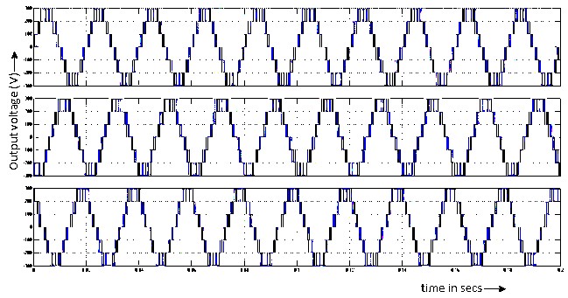
Figure 9. Five Level Output Voltage Waveform of CHBML Inverter
Figure 10. Speed Response of the Proposed Drive
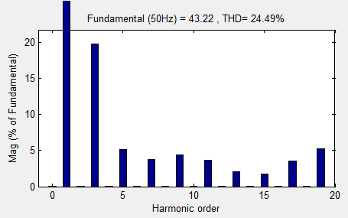
Figure 11. FFT Spectrum of Stator Back EMF
Figure 11 displays the stator EMF FFT spectrum. Five-level multilevel inverter fed BLDC motor has lower THD than two-level inverter fed BLDC motor, increasing motor efficiency.
5. Experimental Results
Figure 12 shows the implementation of a hardware prototype model for proposed cascaded H-bridge multilevel inverter fed BLDC motor drive with various components such as the power supply, driver circuit, relay circuit and PWM generator.
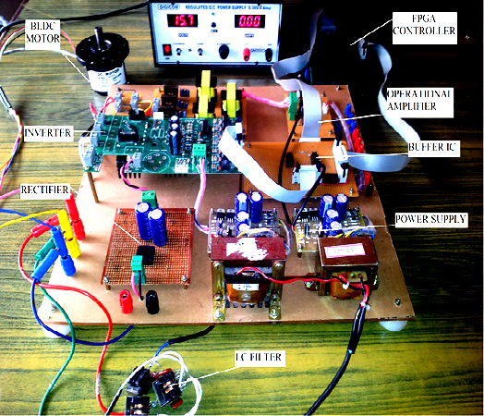
Figure 12 Experimental Setup

The driver circuit software is written in embedded C and executed by the FPGA controller. The pulse may be changed by changing the BLDC motor's speed. Upper and lower switches have variable pulse width. Figure 13 depicts the lower inverter switch input pulse. A multilayer inverter has three bridges, each with four switches. a driver circuit with 6 switches Two driver circuit switches and two bridge circuit switches are used for one commutation sequence.
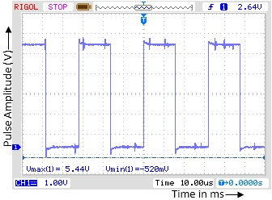
Figure 13 Driver Circuit Voltage Waveform for Phase A
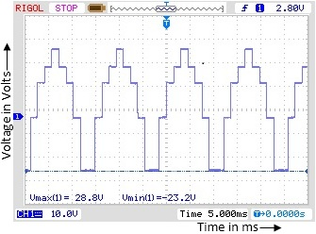
Figure 14. Five Level Output Voltage Waveform
A multilayer inverter powers the BLDC motor. Two switches in the driving circuit are commutated. The driving circuit's output is square. A staircase waveform requires commutating one H-bridge. So six switches are activated at once, generating a three-level stairwell voltage waveform. There are 6 commutation sequences and 3 H-bridges. Three independent DC sources, capacitor banks, SMPS, and a 12V power supply, power the three bridges. Figure 14 shows the three-level staircase output voltage waveform in steady state. Table 2 summarises the proposed system's overall performance. The table showed that the BLDC motor receives distortionless sinusoidal current. So the motor's efficiency improves. The electromagnetic torque produced is smooth, improving the motor's performance. The response time is excellent.

Table 2 Result Analysis of CHBMLI Fed BLDC Motor with Two-Level Inverter Fed BLDC Motor
Characteristics | Two Level Inverter fed BLDC Motor | Multilevel Inverter fed BLDC Motor
Stator Current | Trapezoidal shape and distortion is high (2.6A) | Sinusoidal shape distortion less waveform (4A)
Back EMF | Trapezoidal shape back EMF waveform with minimum distortion (210V) | The shape of the back EMF waveform should be ideal (220V)
Electromagnetic Torque | The ripple in the generated electromagnetic torque is high | Compare to two-level inverter, the ripple content in the torque is minimum
Speed | Linearly varied and settled down slowly to the reference speed (0.15ms) | The starting speed is high with minimum oscillation occurs (0.08ms)
THD | 54.61% | 24.49%
Power Factor | 0.9 | 0.98

6. Conclusion
The cascaded H-bridge multilevel inverter fed BLDC motor drive is suggested in this study. It provides sinusoidal stator current with little distortion and trapezoidal back EMF waveform compared to two-level inverter. So, the THD value of these parameters is minimal. As seen above, THD decreases by nearly 60%, resulting in increased efficiency. The PMBLDCM system has better power quality at AC mains with little torque ripple in a broad speed range. An experimental prototype of the suggested BLDC motor drive with better power quality has been created. The suggested technique performs well and is recommended for low power BLDC motor drives. For household applications, BLDC motors with cascaded H-bridge Multilevel Inverters are the most cost-effective alternative.
References

- Dai, M., Keyhani, A., and Sebastian, T. (2004) Torque ripple analysis of a PM brushless DC motor using finite element method, IEEE Transaction on Energy Conversion, vol. 19(1), pp. 40–45. http://dx.doi.org/10.1109/IEMDC.2001.939306
- Wang, H.B., and Liu (2009) A novel sensorless control method for brushless DC motor, IET Electrical Power Applications, vol. 3(3), pp. 240–246. http://dx.doi.org/10.1109/ASEMD.2009.5306645
- Gan, W.C., and Qiu, L. (2004) Torque and velocity ripple elimination of AC permanent magnet motor control systems using the internal model principle, IEEE/ASME Transaction on Mechatronics. vol. 9(2), pp. 436–447. http://dx.doi.org/10.1109/TMECH.2004.828626
- Tabarraee, K., Atighechi, H., and Jatskevich, J. (2012) Dynamic average-value modeling of 120° VSI-commutated brushless DC motors with trapezoidal back EMF IEEE Transaction on Energy Conversion, vol. 27(2), pp. 296–307. http://dx.doi.org/10.1109/TEC.2012.2188032
- Kim, T.H., and Ehsani, M. (2004) Sensorless control of the BLDC motors from near-zero to high speeds, IEEE Transaction on Power Electronics, vol. 19(6), pp. 1635–1645. http://dx.doi.org/10.1109/TPEL.2004.836625
- Ozturk, S.B., Alexander, W.C., and Toliyat, H.A(2010) Direct torque control of four-switch brushless DC motor with non-sinusoidal back EMF IEEE Transaction on Power Electronics, vol. 25(2), pp. 263–271. http://dx.doi.org/10.1109/PESC.2008.4592717
- Bhim Singh and Sanjeev Singh, (2009) State of the Art on Permanent Magnet Brushless DC Motor Drives, Journal of Power Electronics, vol. 9(1), pp. 1-17.
- Haifeng Lu, Lei Zhang, and Wenlong Qu, (2008) A New Torque Control Method for Torque Ripple Minimization of BLDC Motors With Un-Ideal Back EMF, IEEE Transaction on Power Electronics, vol. 23(2). http://dx.doi.org/ 10.1109/TPEL.2007.915667
- Yandamuri Haribabu and Narasimha Murthy, (2013) A New Torque Control Method for Torque Ripple Suppression in BLDC Motor With Nonideal Back EMF, Indian Streams Research Journal, vol. 3(11).
- Calson, R., Milchel, L.M., and Fagundes, J.C.(1992) Analysis of torque ripple due to phase commutation in brushless dc machines, IEEE Transaction on Industrial Applications, vol. 28(3), pp. 632–638.
- Chuang, H.S., and Ke Y.L, (2009) Analysis of commutation torque ripple using different PWM modes in BLDC motors, Proceedings of IEEE Industrial Commercial Power Systems and Technology Conference, pp. 1–6. http://dx.doi.org/ 10.1109/ICPS.2009.5463966
- Zhang, X.F., and Lu, Z.Y (2006) A new BLDC motor drives method based on BUCK converter for torque ripple reduction, Proceedings of IEEE Power Electronics Motion Control, Conf., pp. 1–4. http://dx.doi.org/ 10.1109/IPEMC.2006.4778275
- Chen, W., Xia, C.L., and Xue, M (2006) A torque ripple suppression circuit for brushless DC motors based on power DC/DC converters, Proceedings of Industrial of Electronics Applications Conf., pp. 1–4.
- Wei, K., Hu, C.S., and Zhang, Z.C. (2005) A novel commutation torque ripple suppression scheme in BLDCM by sensing the DC current, in 36th IEEE Power Electron. Spec. Conf., pp. 1259–1263. http://dx.doi.org/
- Meng, G.W., Hao, X., and Li, H.S (2009) Commutation torque ripple reduction in BLDC motor using PWM_ON_PWM mode, Proceedings of International Conference on Electrical Machines Systems, pp. 1–6, 2009.
- Lu, H., Zhang, L., and Qu, W. (2008) A new torque control method for torque ripple minimization of BLDC motors with un-ideal back EMF, IEEE Transaction on Power Electronics, vol. 23(2), pp. 950–958. http://dx.doi.org/ 10.1109/TPEL.2007.915667
- Ozturk, S.B., and Toliyat, H.A (2011) Direct torque and indirect flux control of brushless DC motor', IEEE/ASME Transaction on Mechatronics, vol. 16(2), pp. 351–360
- Ozturk, S.B., Alexander, W.C., and Toliyat, H.A. (2010) Direct torque control of four-switch brushless DC motor with non-sinusoidal back EMF, IEEE Transaction on Power Electronics, vol. 25(2), pp. 263–271.
- Seyed Mohammad Shakouhi, Mustafa Mohamadian and Ebrahim Afjei. (2013) Torque ripple minimization control method for a four-phase brushless DC motor with non-ideal back electromotive force, IET Electric Power Applications, vol. 7(5), pp. 360-368. http://dx.doi.org/10.1049/iet-epa.2012.0269

