Mangrove Ecosystems and Their Conservation
Rayan Bhattacharya¹, Sayani Chanda², Anwesha Mondal², Animesh Ankuria².
Department of Fisheries Resource Management, Faculty of Fisheries Sciences, WBUAFS.
Department of Fisheries Engineering and Technology, Faculty of Fisheries Sciences, WBUAFS.

ABSTRACT
Coastal ecosystems are one of the most productive and diverse ecosystems present on the planet earth. Coastal ecosystems vary from the dense mangrove forests near the river mouth to the coastal dunes of the beach and the seagrass beds to the beautiful coral reefs just to name a few. Mangrove ecosystems are one of the most productive ecosystems in the planets, ecosystems like mangrove forests and seagrass beds are the best carbon sinks in the planets. Moreover, the high nutritive content in the mangrove areas makes the ecosystems coming under this banner the ideal site for breeding and nursery for many a marine finfish, shellfishes, reptiles and mammals. Also, the high biological productivity of the mangroves ecosystems also made these areas the center of human activities for millennia. Mangrove ecosystems provide an extensive spectrum of goods and services: they are primarily responsible for the production of fish, shellfish, and seaweed for both human and animal consumption; and they are a significant source of fertilizer, pharmaceuticals, cosmetics, household products, and construction supplies. Apart from diversity and productivity and services to human society, mangrove ecosystems are one the fastest depleting ecosystems of the globe at present. This chapter mainly focuses on the mangrove ecosystems, the threats they face and their conservation aspects.
Keywords – Coastal, Ecosystem, Mangroves, Productive, Seagrass, Corals, Dunes, Conservation, Threats
- INTRODUCTION
Coastal ecosystems, which are situated around continental perimeters, have outstanding biological productivity and are easily accessible. This has made them centers of human activity for millennia. Coastal ecosystems provide a diverse range of goods and services: they are the primary producers of fish, shellfish, and seaweed for both human and animal utilization; and they are a key supplier of fertilizer, drugs, cosmetics, household products, and building supplies. Coastal ecosystems, which include a diverse variety of habitat types and a wealth of species and genetic diversity, store and cycle nutrients, filter pollutants from inland freshwater systems, and serve to protect shorelines from erosion and storms. Oceans, on the other hand, play an important role in regulating planetary hydrology and climate, and they are a major carbon sink and oxygen supply due to the high productivity of phytoplankton. Coastal ecosystem services are more difficult to quantify in absolute terms, but they are nevertheless invaluable to human culture and life on Earth. These include coastal protection (buffering the coastline, shielding it from storms and wind and wave erosion), storing and cycling nutrients, sustaining biodiversity, maintaining water quality (by filtering and degrading pollutants), and functioning as recreation and tourism sites.
The coastal zone includes the intertidal and subtidal areas on and above the continental shelf (to a depth of 200 meters), as well as the lands immediately adjacent to it. As a result, this term encompasses places that are regularly inundated by saltwater. Because coastal ecosystems are defined based on physical characteristics (proximity to the coast) rather than a distinct set of biological features, they include a much broader range of habitats than other ecosystems in the Pilot Analysis of Global Ecosystems (PAGE), such as grasslands or forests. Coral reefs, mangroves, tidal wetlands, seagrass beds, barrier islands, estuaries, peat swamps, and other habitats each supply their own specific set of goods and services and face relatively distinct challenges.
In 1995, almost 2.2 billion people, or 39% of the world's population, lived within 100 kilometers of a shore, up from 2 billion in 1990. In comparison coastal areas make up only 20% of the total land area of the planet. With the exception of Antarctica, 19% of all lands within 100 km of the coast are categorized as altered, which means they are used for agriculture or urban purposes; 10% are semi altered and contain a mix of natural and altered vegetation; and 71% are classified as least modified. This least modified category contains a sizable portion of uninhabited areas in northern latitudes. According to Cohen et al. (1997) and Gommes et al. (1998), 20% of the world's population reside within 30 km of the sea, and over twice that amount do so within 100 km of the coast. By 2100, 600 million people are projected to live in coastal floodplains below the 1,000-year flood level, according to Nicholls and Mimura's estimates from 1998.Many crucial coastal habitats, including mangroves, wetlands, seagrass beds, and coral reefs, are rapidly vanishing. It is estimated that in different nations where such data are available, anything between 5 and 80 percent of the natural mangrove area has been lost. Significant losses have occurred, especially over the past 50 years. Natural coastal environments in India are extremely diverse. The entire Indian coast can be broadly classified into West Coast, East Coast and the islands. Backwaters and mudflats dot the western coastline, which has a larger continental shelf. The east coast on the other hand has a narrower continental shelf and is lined with lagoons, marshes, beaches and mangrove rich river deltas. Coral reefs are dominant in the small islands in the Gulf of Kutch in Gujarat, Gulf of Mannar in Tamil Nadu and in Lakshadweep and Andaman and Nicobar groups of islands
The world's coastal ecosystems depend heavily on mangroves. Mangroves are great friends in our fight to achieve net-zero carbon emissions by 2050 because they absorb carbon at up to four times the rate of terrestrial forests. They serve as significant nidifiers and habitats for fish, crustaceans, shellfish, and wildlife as well as stabilizing coasts, defending coastal populations against storm surges, and reducing erosion. This unit will deal with one of the most ecologically important coastal ecosystems, viz. mangroves; their diversity and distributions, the threats they face and the conservation efforts and a few case studies related to them.
- MANGROVES: THE SENTINELS OF THE SHORE
The term “mangrove” refers to tidally influenced wetland ecosystems within the intertidal zones of tropical and subtropical latitudes. Mangroves are coastal forests that grow in sheltered estuaries, river banks, and lagoons across the tropics and subtropics. The term ‘mangrove’ describes both the ecosystem and the plant families that have developed specialized adaptations (e.g., aerial roots, salt excretion glands and vivipary of seeds) to live in this tidal environment (Tomlinson, 1986). To avoid confusion, Macnae (1968) proposed that “mangal” should refer to the forest community while “mangroves” should refer to the individual plant species. The predominant ecosystem found along the subtropical and tropical coastlines of the planet is the mangrove. Mangroves are resilient. Mangrove trees live in hot, muddy, salty circumstances that would kill other plants rapidly because their roots are submerged in water. These plants have a number of adaptations that allow them to not only survive but also thrive in these environments. Two of these adaptations are a complex root system that maintains mangrove trees upright in shifting sediments at the point where land and water converge and a filtration system that keeps out much of the salt. Additionally, the mangrove environment is home to a staggering variety of organisms, some of which are specific to mangrove forests. Mangrove swamps are also crucial to both the health of the earth and our own well-being, as scientists are learning. Natural barriers between the land and the sea are provided by mangroves. Strong waves that have accumulated on open oceans are absorbed by mangroves. This is particularly crucial when there are tropical storms. Mangroves also prevent erosion that waves over time bring about. Mangroves are frequently referred to as carbon sinks because of the way they filter sediment runoff from both natural and human activity.
Snapper and grouper, among other juvenile fish from the surrounding coral reefs, congregate in the mangroves' tangled roots to seek safety. The baby fish may grow here with a lot less competition and predatory pressure. Mangrove lagoons can serve as nurseries for both estuary and reef fishes (Odum et al., 1982; Boulon, 1992) and are an essential habitat for young members of many fish species (Thayer et al., 1987; Cintron-Molero, 1992; Boulon, 1992). Shrimp, crabs, and lobster are just a few examples of the crustaceans that thrive in these settings. Some smaller fish species never leave the mangroves' complex root systems. Fish like tarpon, rays, and lemon sharks prefer to hunt in the area near the edges of mangroves (Wolf, 2012).
Mangrove forests are essential ecosystems for both humanity and biodiversity. Despite the loss of vast areas, things are evolving. As we come to understand their full potential as carbon sinks, fish factories, coastal defenses, and more, ever-increasing efforts are being undertaken to save what is left and launch restoration initiatives. Mangrove forests provide an important purpose and serve as a powerful metaphor. These ecosystems are border ecosystems, spanning land and water. They have seen significant losses, possibly greater than a number of other ecosystems, which have already had an impact on the local population as well as the world. Mangroves are also the best ecosystems in the world at capturing and storing carbon per unit of land. Therefore, the loss of mangroves and their soils has resulted in much higher greenhouse gas emissions on the largest possible scales (SOWM, 2021).
- Status of Mangrove Cover Worldwide

- As in 2016 the mangroves cover 136000 km² area world-wide.
- South-east Asia houses a third of all the mangroves, with Indonesia alone accounting for 20% of the world total.
- South Asia accounts for 8414 km² of the total mangroves, that is roughly 6.5% of the global mangrove cover.
- A net loss of 4.3% (6075 km²) of mangroves was observed in 20 years preceding 2016 but the average rate of mangrove loss is slowing down worldwide as of now.
- Around 42% of all remaining mangroves exist in designated protected areas.

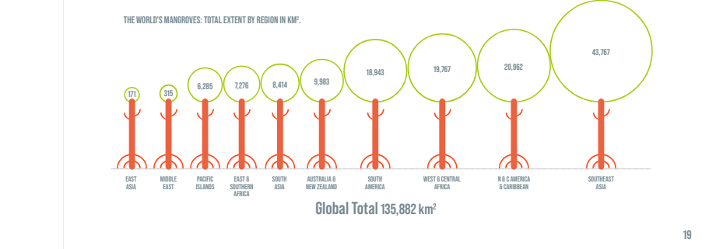

Figure 1: The world’s mangrove covers regionally in Km² (Source: The State of World Mangroves, 2021)
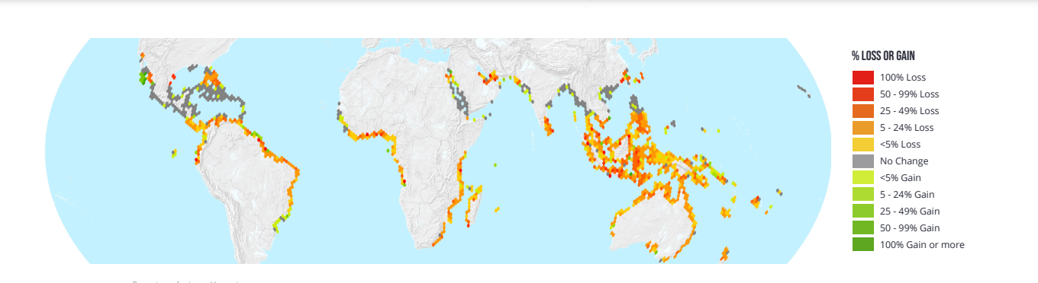
Figure 2: Percent gain or loss in mangroves worldwide from 1996-2016 (Source: The State of World Mangroves, 2021)

- Status of Mangrove Cover in India

- Mangroves in India are roughly 3.3% of the world mangrove vegetation cover.
- The Sundarbans in West Bengal accounts for almost half the total area under mangroves in India.
- The 2017 mangrove cover assessment carried by the Forest Survey of India show that the mangrove cover in the country is 4921 Km² which accounts for 0.15% of India’s total area.
- There has been an increase of 181 km² in India’s mangrove cover as compared to the 2015 assessment.
- The mangroves in India have been classified into three types (IFSR, 2017): -
  - Very dense mangroves- Covers 1481 Km² area which roughly accounts for 30.1% of the total mangrove cover.
  - Moderately dense mangroves- Covers 1480 Km² area which roughly accounts for 30.07% of the total mangrove cover.
  - Open mangroves- Covers 1960 Km² area which roughly accounts for 39.83% of the total mangrove cover.

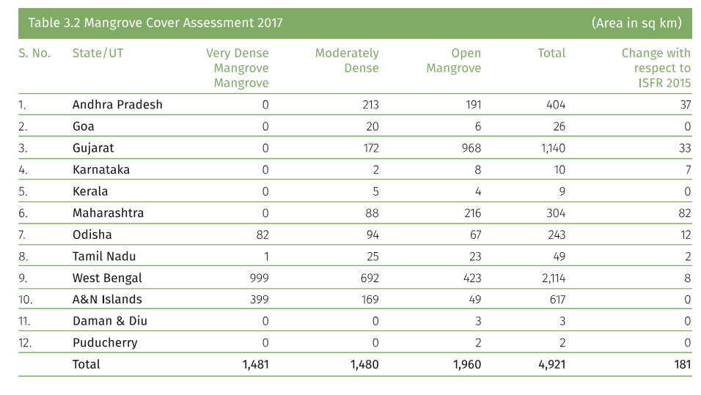
Figure 3: Mangrove area in India in accordance to state (Source: ISFR, 2017)
- Reason for Increase in Mangrove Cover in India: -
- Andhra Pradesh: Positive change of 37 km² is mainly due to afforestation and regeneration.
- Gujarat: Positive change of 33 km² in mangroves in mainly due to conservation efforts such as plantation and regeneration particularly in Bhavnagar, Jamnagar, Kutch and Junagarh.
- Maharashtra: Positive change of 82 km² mainly due to plantation and regeneration of mangroves.
- Odisha: A positive change of 12 km² in Bhadrak, Baleshwar and Kendrapara districts.
- West Bengal: A positive change of 8 km² in the mangroves of East Midnapore and South 24 Paraganas due to plantation and natural rejuvenation.

- Mangrove Zonation
Mangrove zonation is the term used to describe distinct areas of a mangrove forest that are dominated by members of the same family, genus, or species. Mangrove forests, both natural and artificial, exhibit this. Mangrove zonation is mainly represented by the following four types on the basis of the most abundant family in that zone, they are; red mangrove, black mangrove, white mangrove and buttonwoods. This zonation mainly occurs due to different levels of salinity tolerance of the different plants. Zonation is also affected by tidal flooding and land elevation as well. Along the same shoreline, red, black, and white mangrove trees, as well as buttonwood, may thrive. When these species coexist, they are restricted to distinct parts of the tidal zone. Tidal variations, land elevation, and soil and water salinity all contribute to this zonation.

- Red Mangroves
Red mangroves grow along the water's edge, where they are completely exposed to tidal variation and winds. With prop roots sprouting from the trunk and branches, they are well adapted to these conditions. These root tangles promote stability while also gathering sediments from the surrounding water. The unusual aboveground prop roots that convey air to their soggy belowground roots distinguish red mangroves, which are broad-leaved evergreen trees. Red mangroves can reach heights of more than 80 feet (24 meters) in the tropics. Red mangroves are commonly referred to as "walking trees" because their constantly expanding prop roots give the appearance that they are walking on water. They are found closest to the ocean because they are the most salt tolerant.
E.g.: Plants belonging to the family Rhizophoraceae, the most popular of them all is Rhizophora mangale.

- Black Mangroves
The black mangrove is found further inland, with pneumatophores spreading upwards from the soils surrounding the trunk. These root modifications are employed to provide oxygen to underground roots, which are frequently found in anaerobic (oxygen-free) sediments. They are named black mangrove due the dark colour of the bark of these trees. Black mangroves mainly grow on high tide shores, these plants can tolerate salinity up to 60 ppt and extremely anoxic conditions.
E.g.- Plants belonging to the family avicenniaceae, the common example being Avicennia germinans.

- White Mangroves
White mangroves are found in the interior of the mangrove forest, where they lack particular root adaptations. They grow higher up than red and black mangroves. They do not have aerial roots in general. However, when oxygen is limited due to flooding, unusual growth of peg roots occurs. Their bark is pale white in hue and prefers low salinity environments.
E.g.: Plants belonging to the genus Laguncularia and Lumnitzera of family combretaceae.

- Button Woods
The Buttonwood mangrove is an associate mangrove; it is not a real mangrove, but it is common in regions where mangroves grow. Buttonwoods and white mangroves share the same habitat. Salt is discharged through the two red notches at the leaf's base. The salt is carried away from the plant when it rains.
E.g.: Conocarpus erectus
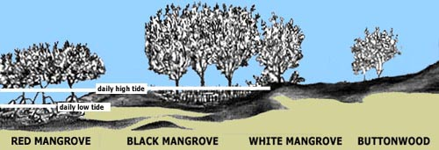

Figure 4: Mangrove Zonation (Source: https://www.floridamuseum.ufl.edu)

- MANGROVES- TRESAURE TROVES OF DIVERSITY
Mangrove environment plays a very vital role in the biology of its faunal component. But this unique ecosystem had not so far drawn the attention it deserved so far as its faunal component is concerned until recently. However, the floristic components of Indian as well as of Sundarbans mangrove forests have been well documented in the literature (Roxburgh, 1832; Mitra and Banerjee, 1979, Choudhury, 1979; Untawale, 1980; Naskar and Guhabakshi, 1982).
Earlier works on the fauna of this region had hardly made any reference to the mangroves, even though there appear to be about 700 publications, concerning bioecology, systematics and fishery aspects. Stoliczka (1869) was one of the early researchers in studying the malacofauna of lower Bengal's brackish water systems. It is followed by the works of Alcock (1896-1906) on crustaceans, Annandale (1907) on Hydrozoa, Polyzoa, Entoprocta etc., Kemp (1913) on crustaceans and Hora (1955) on fishes who have contributed much to our knowledge of these estuarine animals occurring in this part of Sundarban. It is followed by the studies of Alcock (1896-1906) on crustaceans, Annandale (1907) on Hydrozoa, Polyzoa, Entoprocta, and others, Kemp (1913) on crustaceans, and Hora (1955) on fishes, all of which have contributed significantly to our understanding of these estuarine species found in this portion of Sundarban.
- Floral Diversity
A total of 54 true mangroves (20 families); 60 associates from 46 genera. 25 of the 34 species that make up the primary components are members of just two families: Avicenniaceae and Rhizophoraceae.

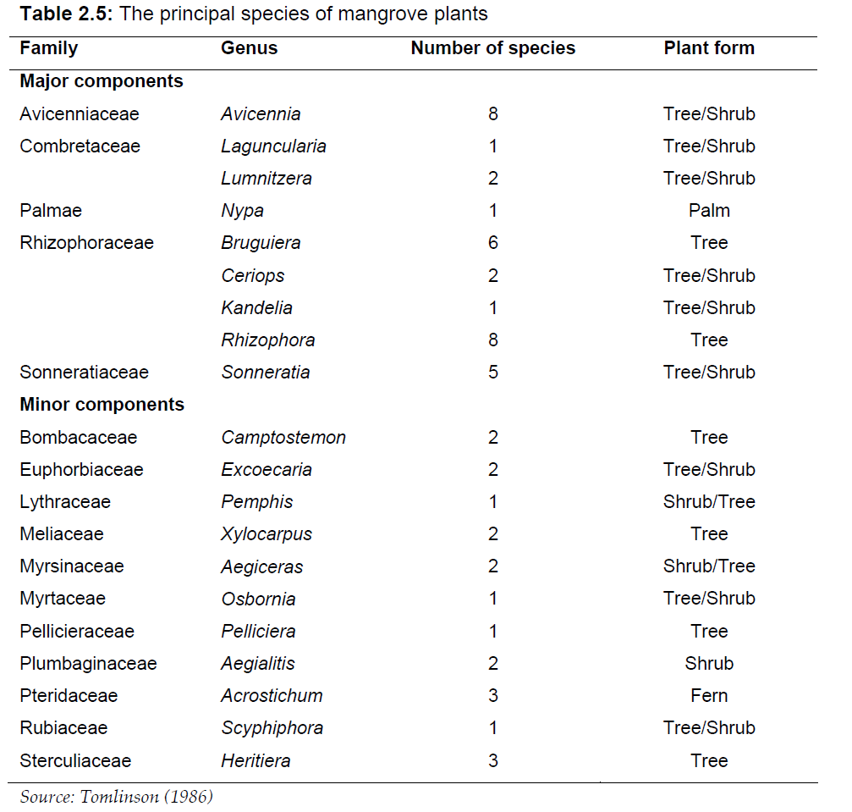
Figure 5: The Principal Species of Mangrove Vegetation

Figure 6: List of Mangrove (Exclusive) Plant Species Available in Sunderbans (Mandal and Nandi, 1989).

- Faunal Diversity

Terrestrial, brackish water and marine fauna constitute the major faunal components in this ecosystem. Mangrove fauna inhabit three distinct biomes: littoral or supra-littoral forests, intertidal mudflats, and estuaries. The littoral or supralittoral forest biome is a terrestrial ecosystem that comprises both aerial and arboreal forms as well as soil residents. Arboreal animals and soil dwellers may be categorized as epifauna and infauna. The intertidal mudflats are essentially semiterrestrial or semiaquatic habitat supporting mainly the soil forms and the benthos. While the estuary is inhabited by aquatic forms, comprising of planktons and nektons. The pattern of distribution of animals in mangrove ecosystem is influenced by the substratum, salinity, tidal amplitude, vegetation, light, temperature, etc (Mandal and Nandi, 1989).

Zooplankton is classified into three sizes: microzooplankton (organisms between 20 and 199 um), mesoplankton (organisms between 200 um and 2 mm), and macrozooplankton (organisms more than 2 mm).
Foraminiferans, ciliates, rotifers, copepod nauplii, barnacle nauplii, and veliger mollusks are among the microzooplankton. Copepods are the most common mesoplankton, while jellyfish are the most important macrozooplankton. Sponge, hydroids, anemones, polychaetes, bivalves, barnacles, bryozoans, and ascidians are attracted to the roots, trunks, and branches of mangroves.

Many of the fish are juveniles suggesting the mangrove habitat is a nursery area. Fish are important predators consuming amphipods, isopods, shrimp, nematodes, insects, gastropods, crabs, bivalves, other fish and planktonic larvae (Sasekumar et al., 1992). Mullets (Liza spp.) devour a large amount of debris. Similarly, mangrove red snappers (Lutjanus argentimaculatus) are consumers of fishes and shellfishes. Crocodiles (saltwater and mugger) form an important part of the nekton community as they are top predators.
The mangrove fauna can be divided into 4 major categories according to Mandal and Nandi (1989) which are as follows:
- Littoral or supra-littoral forest fauna
- Intertidal mudflat fauna
- Estuarine fauna
- Parasite fauna

- THE IMPORTANCE OF MANGROVES

- Mangroves create Diverse and Important Habitats

Mangrove trees and shrubs combine to build and shape a habitat on which countless species depend. The drier areas of the ecosystem are home to terrestrial fauna ranging from insects and reptiles to monkeys and tigers. Mangroves also provide habitat for fish, mollusks, crabs, and even sharks, crocodiles, and dugongs in the pools and channels around their roots. Mangrove forests contain intricate, meandering channels that transport water from inland rivers as well as transmit tidal motions upstream. These provide connections to many other ecosystems enabling larger creatures to visit, or to use mangroves as nursery grounds. Mangrove forests are places of exchange. Minerals and particles from inland or along the coast can be deposited in them, keeping the land in a continual state of change. And the rich productivity of the mangroves can also be exported to surrounding waters both from the migration of fish and other animals, and through the constant export of organic matter from the forests themselves.
For a few species, mangroves are a critical habitat—they either live nowhere else, or have found themselves using mangroves as a final refuge when other habitats have dwindled or been lost. Indeed, some 341 species that use mangroves are considered threatened—vulnerable, endangered or critically endangered—by the international community and IUCN. These include an extraordinary range, from tigers to seahorses, sawfish to sea eagles, orchids to sea cucumbers, and more.

- Rich Natural Resources

For coastal peoples, mangroves have long been recognized as a critical ecosystem because of the many benefits they bring. As well as coastal protection and climate change mitigation—two focal points of this report— other benefits abound. In a world beset by accelerating impacts from climate change, these benefits may be increasingly important and the safeguarding of mangroves may play a critical role in supporting coastal communities in adapting to change and uncertainty.

- Food Supplies

Mangroves are food factories. Their high productivity supports rich food webs, often enhanced by the nutrients brought in by rivers and streams. The habitat itself encourages that abundance. The roots provide a surface that oysters and other molluscs can colonize and grow on. And the complex structure of meandering channels enables fish to find shelter, or to live in relative safety from predation during their initial life phases.
Shrimp, oysters, and a variety of minuscule fish are among the primary species obtained from mangroves. Fishing here is dominated by small-scale or artisanal fishers, largely for local consumption. Often these fisheries are completely beyond the review of national governments— overlooked, but critically important. Other fisheries are better known. Certain species, such as mud crabs, oysters, and prawns, have great value and are marketed to big or even export markets. According to a new GMA-supported study, these forests support well over one-third of small-scale fishers in mangrove countries. That number rises to over 80% in many countries, notably in Central and West Africa. The numbers of mangrove fishers, worldwide, is estimated at 4.1 million. For every one of those fishers there may, in turn, be many others who rely on them, both for their jobs and for their main source of protein. Along with small-scale fishing, larger commercial fisheries rely on mangroves. Although adult prawns are abundant offshore, their larvae are reliant on nutrient-rich, mangrove-dominated estuaries for rapid growth and predator protection. Mangroves are also key nursery grounds for species like banana prawns, which are potentially the most important for trawl fishing in the Indo-West Pacific.

- Timber and Fuel

Mangroves are the only accessible wood in several regions. Even in areas where other trees are plentiful, mangrove wood is often highly prized due to its resistance to rot and termite damage. As timber, it is used in buildings, and as polewood for fencing and the production of fish traps. It is also burned as fuel for cooking, while the dense wood is widely converted to high grade charcoal. Although the harvesting of mangrove trees is, in many places, a cause of mangrove decline, there are other areas where sustainable harvesting has been maintained for a century or more.

- Filters

Mangrove forests trap sediments, helping to fortify coasts in some places, and also preventing the same sediments from smothering coral reefs offshore. At the same time, complex ecological pathways— of microbes and filter feeders—around mangrove roots help to purify the water that passes over them. These play a critical role in taking up both pollutants and nutrients, delivering considerable health benefits to adjacent ecosystems as well as to people.

- Tourist Hubs

Many mangroves are also popular destinations for visitors. GMA scientists recently conducted a survey of TripAdvisor data that identified nearly 4,000 mangrove 'attractions' in 93 countries and territories. While many were reviewed by international holidaymakers, it’s clear that mangroves are also very popular with local visitors. Activities range from simple walks or hikes—often on guided trails—to water-based boating activities and specialist wildlife watching. Some rather unusual activities are available, such as watching night-time firefly displays or in-water bioluminescence¹, for example. Recreational fishing in mangrove areas is also proving to be increasingly valuable. Top locations for fly fishing generate hundreds of dollars per day from discerning clients seeking good sport in undisturbed locations.
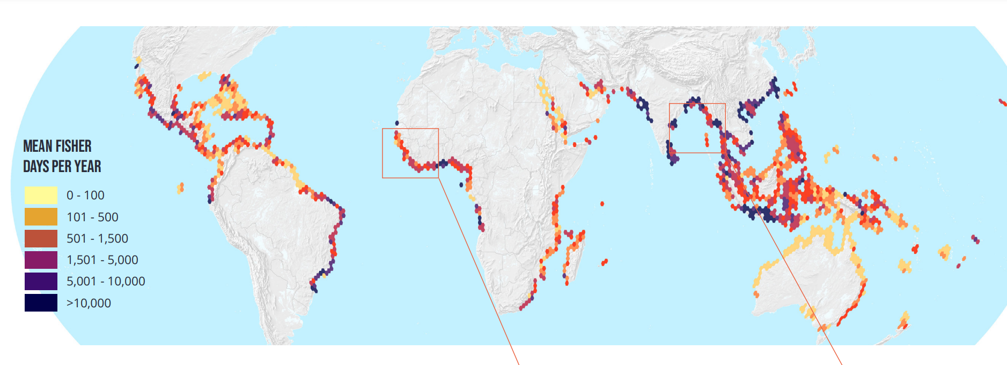
Figure 7: The numbers of fishers using mangroves, modelled as the total numbers of days individual fishers spend per km² of mangrove per year (Source: The State of World Mangroves, 2021)
- Defending Coasts

Mangroves thrive on the front lines, where they cross both land and sea. Coastlines are dynamic environments that change due to the erosion or deposition of sediments caused by storms, the influence of waves, surges, and winds. Mangroves can provide significant natural fortifications along the coast, minimising or lessening the effects of storms. In actuality, that job is varied and nuanced; its value varies but can be substantial.
In many tropical and subtropical regions mangroves reduce waves and storm surges, and serve as a first line of defence against flooding. Any wave passing over or through a complex structure will quickly lose its energy—slowing down and losing height. Mangrove forests are well-designed for this purpose due to their bottom friction, cross shore breadth, tree density, and tree structure (roots, trunks, and canopy). They form a rough, three-dimensional barrier with complicated roots, trunks, and canopy, reducing the force of oncoming wind and waves and thereby reducing flooding. It’s been shown that a wave passing through just 100 meters of mangrove forest can lose two thirds of its energy. And it works even when trees are relatively young or recently restored.
The aerial roots of mangroves hold sediments and prevent erosion. By delaying the flow of water, they assist sediment settlement and minimise the outflow of fallen leaves and branches, allowing mangrove soils to be preserved or even develop vertically upwards. In some places the vertical accretion can be sufficient not just to maintain mangroves, but to keep pace with rising sea levels.
Major storms are prevalent in several mangrove nations. Even in these extreme conditions, mangroves can help by attenuating waves and physically holding the land together. The forests can also act as a safety net, trapping large debris such as cars, boats and pieces of buildings which often cause significant damage once in coastal waters. In addition, tropical storms sometimes drive surges that can raise the entire sea surface by several meters. Mangroves can act like permeable dams, helping to hold back and dampen the surges, greatly reducing inland flooding. Not even purpose-built and engineered sea defences can be guaranteed to survive against all impacts. But one of the most valuable qualities of natural sea defences, such as coastal mangroves, comes from their ability both to build themselves, and also re-build themselves if they are damaged.

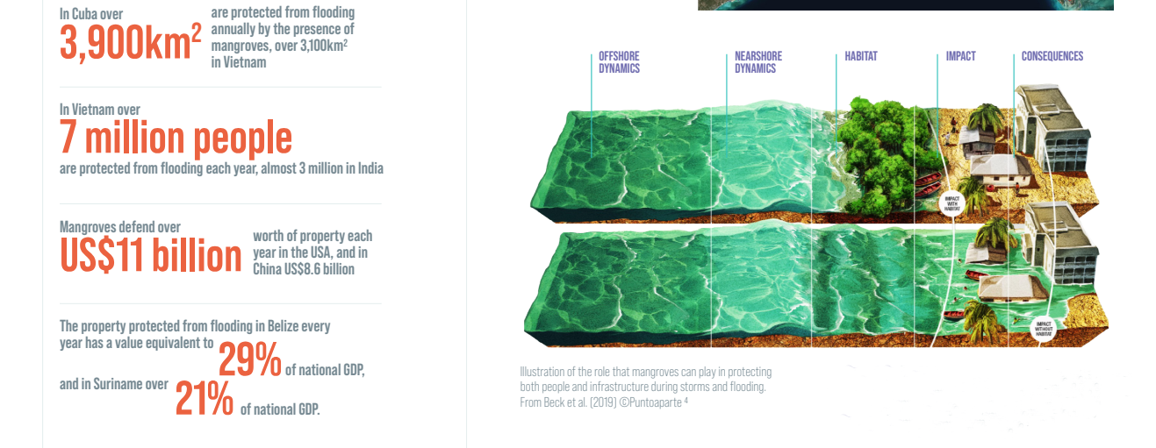
Figure 8 and 9: Protection of Property and People by Mangroves all over the Globe (Source: The State of World Mangroves, 2021)

- Storing Carbon

Mangrove forests are carbon sinks, storing carbon in both living plants and their rich peaty soils. Mangroves, like all forests, transform carbon dioxide collected through photosynthesis into leaves, wood, and roots, increasing their carbon stocks in biomass as they expand.
Indeed, mangroves are among the most productive carbon-capture ecosystems on the planet. They transform carbon dioxide to organic carbon faster than practically any other environment on the planet. Moreover, unlike many other forests, the carbon added to the soil through litterfall and root growth decomposes very slowly because soils are waterlogged with tidal water. That slow decomposition results in the build-up of carbon-rich soil over hundreds—to thousands—of years. Additionally, many species of mangrove trees have above-ground roots that trap sediment and other organic matter that enters the forest during tidal flooding. That further contributes to the burial and build-up of carbon-rich soil over time. As a result of high productivity, mangroves outperform most other ecosystems not only as carbon storage, but also as vital assets in CO2 sequestration schemes. When mangroves are cleared or degraded, they release their stored carbon. That carbon, released as CO2, can be considerable, particularly where soils are excavated—as when building shrimp aquaculture ponds.

Figure 10: A comparison of the carbon stored in various forest types (Mg/Ha), showing the contribution of aboveground plants, shallow and deep soil (Source: The State of World Mangroves, 2021).

- THREATS TO MANGROVES
Vast areas of mangroves were lost over the twentieth century and, although the rate of mangrove conversion decreased dramatically in the 21st century, climatic factors have become increasingly important drivers of global losses. A rigorous new analysis utilising over one million satellite pictures tracked the drivers of mangrove decline since 2000, revealing that over 60% of losses were mostly attributable to direct and indirect human influences.
The conversion of mangrove areas for the production of commodities was the number one cause of loss (47%). This is strongly driven by fish and shrimp aquaculture expansion, and by rice farming. The expansion of oil palm cultivation is also becoming significant. The second leading human cause of mangrove deforestation (12% of losses) is so-called nonproductive Conversion—where mangrove areas become unused land. Finally, mangrove conversion to infrastructure, urbanisation, and even coastal tourism lodging is a major force in mangrove decline, accounting for 3% of the total.
Nearly 80% of human-driven losses occur in just six nations: Indonesia, Myanmar, Malaysia, the Philippines, Thailand, and Vietnam. Naturally driven events such as erosion, sea level rise, hurricanes and drought—which are exacerbated by climate change—are also leading to the die-off and loss of mangroves Shoreline erosion, the second leading source of mangrove loss, accounted for 27% of global losses, while extreme weather events accounted for 11% of total losses. Looking more closely, erosion was the leading cause of loss in Bangladesh, contributing to nearly 80% of national losses. Also, catastrophic cyclones, though relatively infrequent, can contribute to substantial loss of mangrove forests—as seen in Papua New Guinea following Cyclone Guba in 2007.
Despite their strong adaptability to life in a stressful environment, mangrove ecosystems have faced unprecedented challenges in the Anthropocene, which in turn have threatened the very survival of some of the species that form the forests. Those species most at risk of global extinction include those at the interface with human activities, such as the high intertidal – Heritiera spp—or those with small localized populations, like Bruguiera hainsii and Sonneratia griffithii. Many species, including Camptostemon philippinense, Pelliciera rhizophorae, and Avicennia rumphiana, face long-term extinction due to limited range, patchy distribution, and features such as sluggish propagation rates. The IUCN Mangrove Specialist Group performs periodic reviews of all mangrove species' global conservation status to inform the IUCN Red List and the global community.
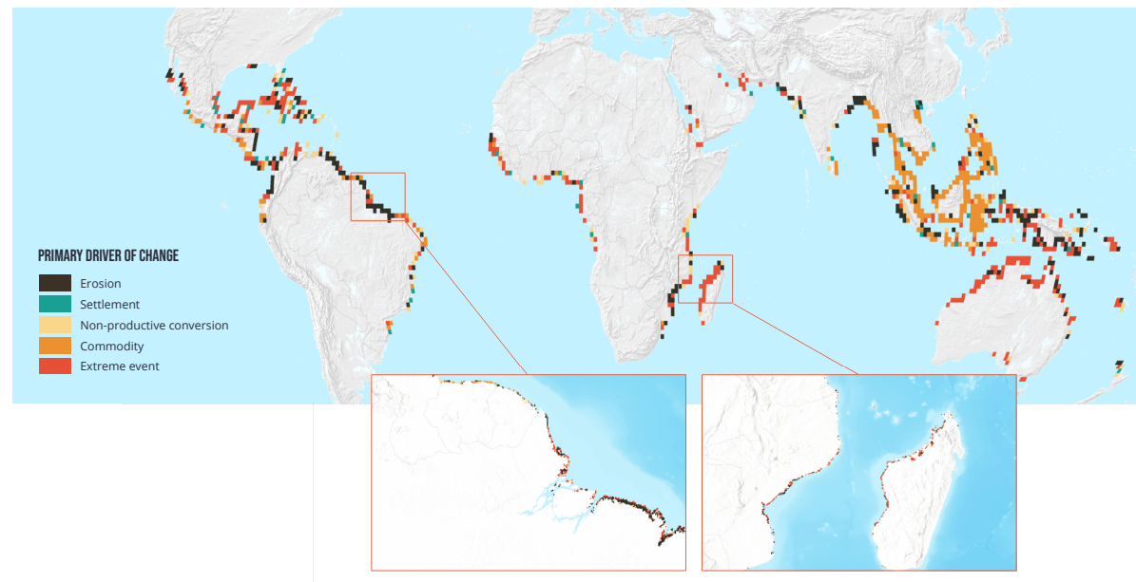
Figure 11: Primary Drivers of Mangrove Loss all over The Globe (Source: The State of World Mangroves, 2021)

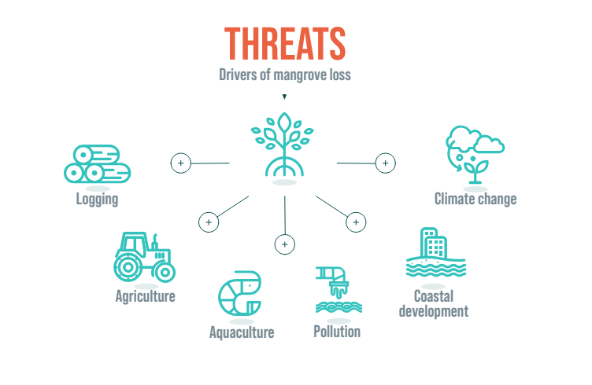
Figure 12: Threats to Mangroves (Source: The State of World Mangroves, 2021)
CASE STUDY: Mangrove loss due to shrimp aquaculture in Thailand: -
- Since 1975, it is estimated that shrimp farm development alone has resulted in the loss of 50-65% of Thailand's mangroves. Thailand has been a key player in farmed prawn production to serve the United States, Japan, and Europe.
- This has led to many negative impacts in coastal communities, including land degradation, loss of resource-based livelihoods, poverty, increased vulnerability to natural disasters, and the deterioration of artisanal fisheries.
- Worse, the production of prawn ponds generally falls over time, and many are abandoned, leaving large regions devoid of both mangroves and aquaculture.
- 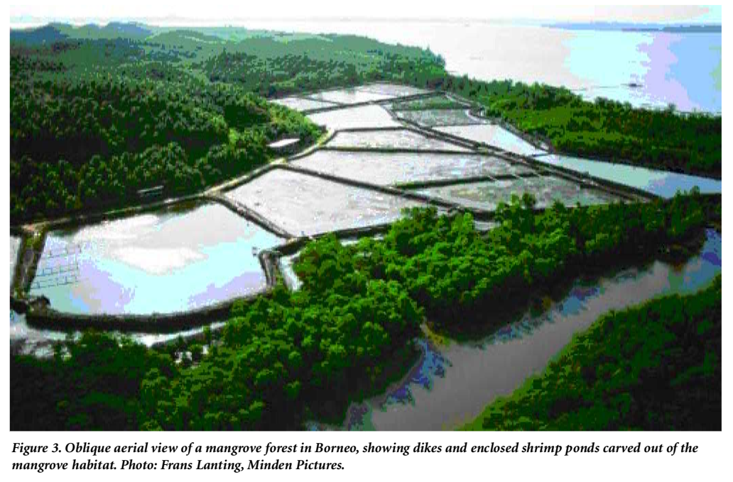

- SAVING AND CONSERVATION OF MANGROVES
During the past two decades, mangrove forests have gone from being one of the most rapidly disappearing environments on the planet to one of the best conserved. Currently some 42% of all remaining mangroves fall within legally designated protected areas, albeit recognizing that the levels of actual protection these provide can be variable. Such areas range from tiny, locally managed sites to vast nationally governed forests, such as the Sundarbans—which is protected across almost all its extent in both Bangladesh and India. Many of the remarkable creatures associated with mangroves are also safeguarded—from tigers and proboscis monkeys to sawfish and seahorses.
From a regional perspective, the most comprehensive coverage by protected areas is in South America where over 74% of all mangroves fall within them. On the contrary, only 13% of East Asian mangroves and 9% of Pacific Island mangroves are safeguarded. Of the larger mangrove nations, the very low coverage in Myanmar, Papua New Guinea and Nigeria is notable—these countries host almost 10% of all mangroves, but only have between 3% and 5% of those in protected areas.
Bangladesh (92%), Brazil (86%), and Mexico (75%), among the main mangrove nations, have some of the highest coverage. Even outside of protected areas, local or community ownership of mangroves can often lead to sustainable management practises. Other regulatory regimes can also be employed to avoid the loss of mangroves. Coastal setback restrictions restrict building within a certain distance of rivers and coasts in various regions. Other 'no net loss' restrictions demand that any loss or clearing be offset by an equal (or larger) area of equivalent habitat restoration. When implemented well, these areas can also protect human lives and livelihoods, enabling a sustainable supply of fuelwood, supporting fishing, slowing erosion, and cleaning watercourses. Many protected mangroves are also popular with tourists. Sites such as Can Gio in Vietnam, JN Ding Darling in Florida, USA, and the Nakama River in Iriomote, Japan, all receive over half a million visitors annually.

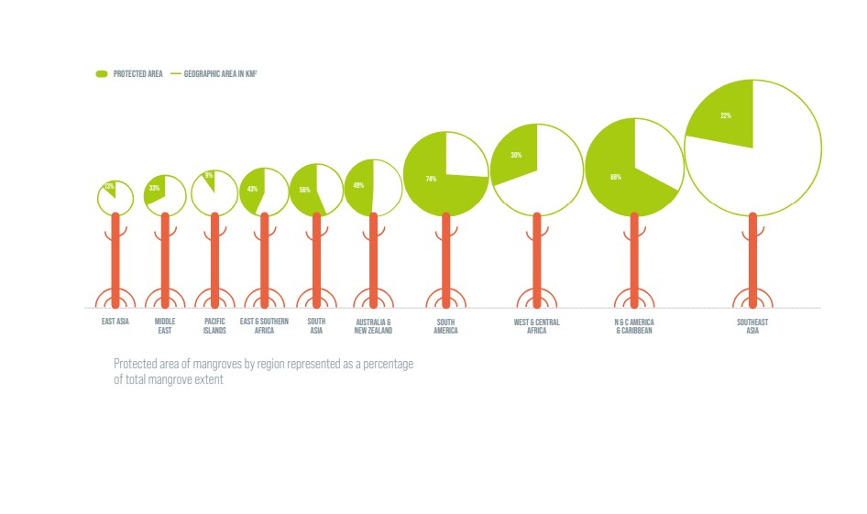
Figure 13: Percent of Mangroves under legal protection over the Globe (Source: The State of World Mangroves, 2021)

A. Threats to Protection
Unfortunately, not all designated protected areas provide strong protection. Global change maps show that losses still happen in many such areas, and that is confirmed by on the-ground observations. Much of this may be natural losses, driven by erosion or storms. Other sites, however, are compromised by ineffective management or capacity shortfalls, preventing proper implementation of regulations. Damage can also be driven by activities in adjacent areas—where changes to water flows may increase erosion, for example, or cut off freshwater or sediment supplies. In a few cases protected areas themselves might be downgraded or degazetted by governments in favour of new activities and developments.
CASE STUDY: REMOVING INVASIVE MANGROVES IN SHENZEN WETLANDS, CHINA:
- The Shenzhen Mangrove Wetlands Conservation Foundation (MCF) in China is striving to restore natural mangrove species after a nonnative plant, Sonneratia, took over.

- The Shenzhen Mangrove Wetlands Conservation Foundation (MCF) tested clear-felling these alien mangroves and replanted the area with native species in 2017. This resulted in an effort to restore a healthy mangrove ecosystem in 2020. In addition to clear-felling Sonneratia plants, this includes hydrological rehabilitation by reconstructing tidal streams, experimenting with and optimizing replanting methods, and protecting mudflats as feeding places for migratory birds.

CASE STUDY: THE WESTERN INDIAN OCEAN MANGROVES:
- Mangroves are vital to the environment and the livelihoods of millions of people in the Western Indian Ocean. Kenya, Tanzania, Mozambique, and Madagascar have about 700,000 hectares of mangroves, yet they have lost 30,000 hectares in the last 20 years.
- The most severe losses were reported in Mozambique, where more than 6% of mangrove cover was destroyed. In this light, GMA partners have begun to collaborate, and as part of the Save Our Mangroves Now campaign, have set the audacious goal of attaining 0 net loss by 2030 and establishing the region as a leader in mangrove conservation. Towards the end of 2021, we will produce a spin-off of this report focusing specifically on the Western Indian Ocean region, and disseminate results to policy makers.

CASE STUDY: MANGROVE SILVICULTURE— THE EXAMPLE OF MATANG:
- The Matang Mangrove Forest Reserve, established in Peninsular Malaysia in 1902, is being intensively examined since it has the most extensive documented track record of any managed mangroves.
- It manages its Rhizophora mangrove trees in 30-year cycles, with two thinning and one clear cutting followed by reafforestation. The aim is to maximize the yield of the monospecific stands, mainly for use in producing charcoal.
- The 120-year history of silviculture in this area is remarkable and is being examined closely from the perspectives of silviculture, ecology, socioeconomics, and public health.

- CONCLUSION
Rates of mangrove loss and degradation around the world have slowed in recent years, yet many areas still face significant threats— from coastal development, clearing for aquaculture and agriculture, pollution and over-exploitation. Natural changes, compounded by climate change, are also driving losses. The loss of mangrove habitats anywhere means a steep decline in the ecosystem services they provide—from fisheries and water quality to carbon sequestration and coastal protection. And that, in turn, threatens coastal communities, jobs and food security. Protecting all remaining mangrove cover is just one—albeit critical— part of the solution. We also need to enhance recovery, allowing natural regeneration and afforestation of new sediments as coastlines shift and change. And we need to restore lost cover. Evidence-based, community-led restoration at scale is key. We need to plan, fund and implement science-based restoration programs to start the needle moving in the right direction—toward global increases in mangrove cover. That means tackling the hard issues like land ownership or use-rights, halting unsustainable practices and reducing costs. The COVID-19 pandemic has brought into stark relief the need to get back into balance with nature. The road to our recovery is made when nature recovers.

REFERENCES
Alcock, A. 1896-1901. Materials for a carcinological fauna of India, (Nos. 1-6. The Brachyura, Oxyrhyncha, Oxystoma, Cyclometopa, Primigenia or Dromicea and Catemetopa or Grapsoidea). 1. Asia. Soc.Bengal 64: 157-291; 65: 134-296; ,67: 67-233; 68: 1-104; 68: 123-169; 69: 279-456. (Reprinted in 1984, International Books & Periodical Supply Service, New Delbi).
Alcock, A. 1902. A naturlist in the Indian Seas: Of four years with the Royal Indian Marine Ship Investigator. John Murry, London, 328 pp.
Alcock, A. 1905. Catalogue of the Indian Decapod Crustacea in the collection of the Indian Museum. Part 2. Fasciculus 1. Pagurides. The Trustees of the Indian Museum, Calcutta, 197 pp.
Alcock, A. 1906. Catalogue of the Indian Decapod Crustacea in the collection of the Indian Museum. Part 3. Macrura, Fasciculus 1. The prawns of the Penaeus group. The Trustees of the Indian Museum, Calcutta, 55 pp.
Annandale, N. 1907c. The fauna of brackish ponds at Port Canning, Lower Bengal. 4. Hydrozoa. Rec. Indian Mus., 1: 139-144.
Boulon Jr, R. H. (1992). Use of mangrove prop root habitats by fish in the northern US Virgin Islands.
Burke, L., Kura, Y., Kassem, K., Revenga, C., Spalding, M., & McAllister, D. (2000). Pilot analysis of global ecosystems: coastal ecosystems.
Choudhury, A. 1979. Mangrove environment of Sundar bans, West Bengal, India. Invited seminar paper in National Mangrove Workshop of Australia, 18-22. April, 1979.
Cintrón-Molero, G., & Schaeffer-Novelli, Y. (1992). Ecology and management of New World mangroves. In Coastal plant communities of Latin America (pp. 233-258). Academic Press.
Cohen, J.E., C. Small, A. Mellinger, J. Gallup, and J. Sachs. 1997. Estimates of coastal populations. Science 278: 1211–1212.
FSI, (2017) India State of Forest Report, Forest Survey of India, Dehradun.
Gommes, R., Du Guerny, J., Nachtergaele, F., & Brinkman, R. (1998). Potential impacts of sea-level rise on populations and agriculture. Food and Agriculture Organization of the United Nations, SD (Sustainable Development) Dimensions/Special, available online at http://www. fao. org/WAICENT/FAOINFO/SUSTDEV/Eldirect/Elre0045. htm.
Hora, S.L. 1955. Salinity in West Bengal rivers. - Effects on Pisciculture, Sci & Cult., 20 (9): 418-423.
Kathiresan, K. and Bingham B.L. (2001). [Advances in Marine Biology] Volume 40 || Biology of mangroves and mangrove Ecosystems. , (), 81–251. doi:10.1016/S0065-2881(01)40003-4
Kemp, S. 1913. An account of the Crustacea, Stomatopoda of the Indopacific region based on the collection of the Indian Museum. Mem Indian Mus., 4 (1): 1-217.
Macnae, W. (1968). A general account of the fauna and flora of mangrove swamps and forests in the Indo-Pacific region. Advances in Marine Biology 6, 73-270.
Mitra, R.L. and Banerjee, L.K. 1979. The genus Bruguiera Lamk. (Rhizophoraceae) in India. Bull bot. Surv. India, 21 (1-4): 142-150.
Naskar, K. and Guha Bakshi, D.N. 1982. Sundarbans - the World-famous mangrove forest of the district 24- Parganas in West Bengal (India). J. Econ. Tax. Bot., 3: 883-918.
Nicholls, R. J., & Mimura, N. (1998). Regional issues raised by sea-level rise and their policy implications. Climate research, 11(1), 5-18.
Odum, W. E., McIvor, C. C., & Smith, T. J. (1982). The ecology of the mangroves of south Florida: a community profile. The Service.
Roxburgh, W. 1832. Flora India: or description of Indian Plants. Repr. by Today and Tomorrow Co.
Spalding, Mark D and Leal, Maricé, (2021). The State of the World’s Mangroves 2021. Global Mangrove Alliance.
Stoliczka, F. 1869. The malacology of Lower Bengal and the adjoining provinces. I. On the genus Onchidium, J. Asiat. Soc. Bengal, 38: 86-111.
Thayer, G. W., Colby, D. R., & Hettler Jr, W. F. (1987). Utilization of the red mangrove prop root habitat. Mar Ecol Prog Ser, 35, 25-38.
Tomlinson, E B. (1986). "The Botany of Mangroves". Cambridge University Press, Cambridge, UK. 413 pp.
Untawale, A.G. 1980. Present status of mangroves along the west coast of India. Proc. Asian Symp. Mangrove Env. Res. management. Kuala Lumpur (In press).
Wolf, B. M. (2012). Ecosystem of the Mangroves. Wisconsin: University of Wisconsin-Stevens Point.

