Role of Artificial Intelligence in Microbiology: Implementations and Obstacles
Khalid Imran¹, Rajkumar N², Nikesh V V³
¹Department of Microbiology, Krupanidhi Degree College, Bengaluru, Karnataka, India
²Department of Computer Applications, Krupanidhi College of Management, Bengaluru, Karnataka, India
³Krupanidhi Degree College, Bengaluru, Karnataka, India

INTRODUCTION
Artificial intelligence (AI), which was first put forth by John McCarthy at the Dartmouth Conference in the summer of 1956, focuses on the simulation of extensions of human intelligence as well as the study and advancement of theoretical approaches, methods, and practical systems (Jiang et al., 2022). However, the possibility of machines being able to simulate human behavior and thinking was raised earlier by Alan Turing, who developed the Turing test to differentiate humans from machines. Since then, computational power has grown to instant calculations and the ability to evaluate new data, according to previously assessed data, in real-time (Mintz and Brodie, 2019). AI began as simple codes and has advanced over several decades to include more complex algorithms that perform similarly to the human brain (Kaul et al., 2020). Today, AI is integrated into our daily lives in many forms, such as personal assistants (Siri, Alexa, Google Assistant, etc.), automated mass transportation, aviation, and computer gaming (Mintz and Brodie, 2019). There are many subfields in AI, such as machine learning (ML), deep learning (DL), and computer vision (Kaul et al., 2020).
ML, first proposed by Arthur Samuel (Bell Labs, IBM, Stanford) in 1959, is a particular branch/subfield of AI to find features from large-scale heterogeneous data (Jiang et al., 2022). ML is the use of specific traits to identify patterns that can be used to analyze a particular situation. The machine can then “learn” from and apply that information to future similar scenarios. This prediction tool can be applied dynamically to clinical decision-making to individualize patient care rather than follow a static algorithm (Kaul et al., 2020). The essential thing is to use algorithms to parse the data, analyze the patterns in the data automatically, and then utilize these patterns to make predictions and decisions on real-world events (Jordan and Mitchell, 2015). Unlike traditional software programs that are hard-coded to solve specific tasks, ML takes enormous amounts of data and trains them using algorithms to learn how to accomplish tasks from the data (Domingos, 2012).
DL is a breakthrough ML approach that models high-level abstractions of data through a deep network with multiple layers of processing units, which are parametric models trained by gradient descent (Lecun et al., 2015). ML is a way to implement AI, and DL is a technology to implement ML, as shown in Figure 01.
AI was initially introduced by John McCarthy during the Dartmouth Conference in the summer of 1956. Its primary focus lies in simulating extensions of human intelligence and advancing theoretical approaches, methods, and practical systems (Jiang et al., 2022). However, the idea of machines emulating human behavior and thought was proposed earlier by Alan Turing, who devised the Turing test to distinguish between humans and machines. Over time, computational power has dramatically increased, enabling instant calculations and real-time evaluation of new data based on previously analyzed information (Mintz and Brodie, 2019). Initially, AI started with simple codes and has since evolved into more intricate algorithms that exhibit human-like performance (Kaul et al., 2020). AI is deeply ingrained in daily life, encompassing personal assistants (Siri, Alexa, Google Assistant, etc.), automated mass transportation, aviation, and computer gaming (Mintz and Brodie, 2019). AI comprises several subfields, including ML, DL, and computer vision (Kaul et al., 2020).
ML, originally introduced by Arthur Samuel at Bell Labs, IBM, and Stanford in 1959, represents a distinct branch of AI that aims to extract features from vast and diverse datasets (Jiang et al., 2022). ML involves using specific characteristics to detect patterns, enabling analysis of specific situations. Subsequently, the machine "learns" from this information and applies it to handle similar scenarios in the future. This predictive capability can dynamically impact clinical decision-making, enabling personalized patient care instead of following fixed algorithms (Kaul et al., 2020). The fundamental principle revolves around employing algorithms to parse and automatically analyze data patterns, leading to predictions and decisions concerning real-world events (Jordan and Mitchell, 2015). Unlike traditional software programs that are rigidly programmed for specific tasks, ML takes large datasets and employs algorithms to learn how to accomplish tasks directly from the data (Domingos, 2012).
DL represents an innovative ML technique that constructs intricate representations of data using a multi-layered network of processing units, known as parametric models, trained through gradient descent (Lecun et al., 2015). ML is a means to implement AI, and DL is a technology to implement ML, as depicted in Figure 01.

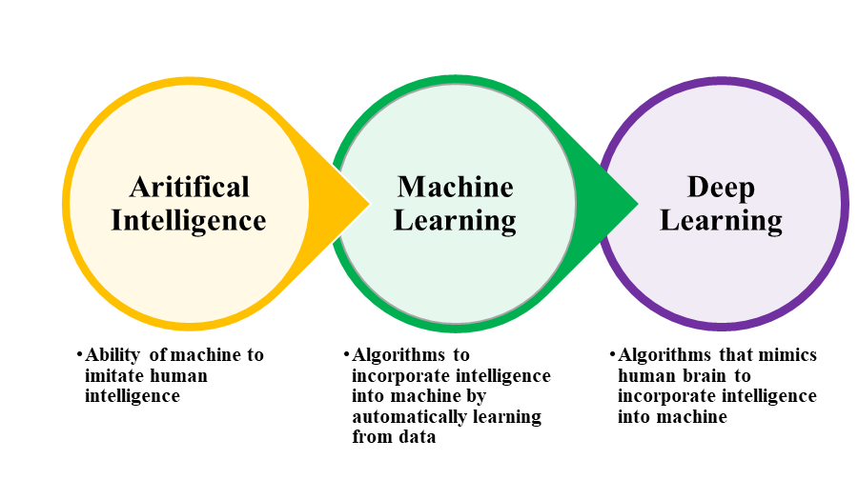
Figure 01: Relationship between AI vs. ML vs. DL (Zhao and Krauze, 2021)
In contrast to conventional ML, DL operates with higher dimensionality and aims to comprehensively capture relationships within the raw data, as illustrated in Figure 02. Depending on whether labeled data is necessary, DL can be categorized into supervised, unsupervised, and hybrid models. Hybrid models generally involve utilizing unsupervised model outcomes as input data or significant supplements to supervised models, as depicted in Figure 03.
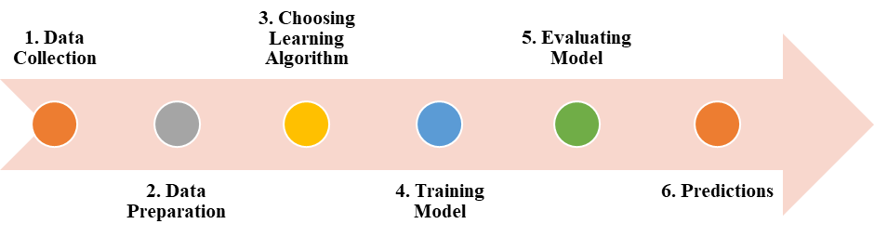
Figure 02: Machine Learning work flow (Kanade, 2022)

Figure 03: Machine Learning Types (Kanade, 2022).
The excessive use of antibiotics has resulted in a growing issue of drug resistance among pathogenic bacteria, posing a significant threat to human health. The conventional and main approach to discovering antibiotics involves screening soil microorganisms for secondary metabolites that can hinder the growth of pathogenic bacteria (Wright, 2017). However, the present challenge lies in the diminishing rate of new antibiotic discoveries, demanding urgent attention and resolution.
Contemporary drug discovery has transitioned into the era of extensive data resources. The application of AI to model dynamic, diverse, and extensive drug datasets has been a key driver of groundbreaking advancements in drug discovery methodologies (Zhu, 2020).
Methods for identifying and forecasting novel antibiotic structural classes through ML have been considerably advanced and extensively embraced (Camacho et al., 2018). DL expedites the screening of compounds with antibiotic characteristics from established chemical libraries (Dimasi et al., 2016). Antimicrobial peptides (AMPs) are promising candidates for combatting antibiotic resistance.
The successful development of antibiotics guided by deep neural network models relies significantly on the synergy between model predictions and suitable experimental design. This wet-dry combination approach has gained traction in scientific circles after the revelation of how complementary information and experimental techniques can enhance outcomes.
Recently, AI has been integrated into the medical field to enhance patient care through increased efficiency and improved precision, leading to advancements in overall healthcare delivery. ML is now utilized to assess radiological images, pathology slides, and patients' electronic medical records (EMR), assisting in diagnosis and treatment while enhancing the capabilities of physicians (Mintz and Brodie, 2019).
Microbiologists are presently experiencing a period characterized by the collection of biological data on an unparalleled scale through high-throughput intelligent technologies. This growing demand necessitates skills that extend beyond traditional laboratory and field experiments, as researchers must now employ computational techniques to extract valuable insights from these vast datasets.
AI is progressively becoming crucial in clinical microbiology informatics. Scientists, microbiologists, laboratory professionals, and diagnosticians are increasingly interested in AI-driven testing due to its potential to enhance test turnaround time, quality, and cost. Mathison et al. (2020) conducted a study using computer vision AI, but there are further opportunities for AI applications in the clinical microbiology laboratory.
Within clinical microbiology, extensive datasets suitable for developing AI diagnostics encompass genomic information from isolated bacteria (Nguyen et al. 2018), metagenomic microbial findings from primary specimens, mass spectra obtained from cultured bacterial isolates, and large digital images, the medium chosen by Mathison et al. (2020) AI, particularly computer vision, represents emerging tools that clinical microbiologists should explore, develop, and implement to enhance clinical microbiology practices.
ML has found applications in computationally demanding tasks, including forecasting drug targets and vaccine candidates, identifying microorganisms responsible for infectious diseases, categorizing drug resistance to antimicrobial medications, predicting disease outbreaks, and investigating microbial interactions. ML has been harnessed in various microbiology research fields, encompassing virology, parasitology, mycology, and bacteriology (Goodswen et al., 2021).
APPLICATIONS AND CHALLENGES OF AI IN MICROBIOLOGY LABORATORY
Understanding images is essential for clinical microbiology laboratory diagnostics. For instance, well-trained microbiologists and pathologists must interpret Gram stains, fecal and blood smears, and histopathologic slides. These specimens offer vital diagnostic data, such as identifying the types of microbes, the host's inflammatory response, and the specimen's quality. When viewed in a clinical context, this information is crucial for confirming the presence of an infection and often provides clues for a potential differential diagnosis that guides appropriate therapy.

The clinical microbiology laboratory faces an extra challenge due to a persistent shortage of medical laboratory scientists (Garcia et al. 2018). There is growing interest in automating visually demanding interpretative tasks within the workflow to address this issue. Until recently, previous attempts at automating image-based interpretative tasks were not satisfactory. However, the emergence of advanced AI algorithms capable of superior image discrimination has paved the way for automated clinical microbiology interpretation. This advancement promises to significantly improve efficiency and diagnostic accuracy.
In conjunction with automation, AI algorithms will be employed to preliminarily screen and categorize image data, enhancing productivity and facilitating more precise diagnoses through collaboration between AI and microbiologists. Once established, image-based AI analysis is cost-effective and adaptable for local and remote diagnostic applications.
Laboratory automation incorporating AI capabilities is becoming a standard practice for interpreting agar plate growth in clinical diagnostics. However, these applications are restricted to urine samples and infection control screening. Despite their integration, certain aspects related to algorithm development remain complex and need to be thoroughly grasped by laboratory professionals.
AI and sophisticated digital imaging applications provide the capacity to standardize certain aspects of interpretive microbiology. AI algorithms are developed based on numerous inputs, which are computationally modeled to generate an output with the highest probability of delivering accurate results for a specific application (Ford and McElvania, 2020).
Creating a dependable algorithm that undergoes thorough evaluation and is suitable for its intended purpose poses significant challenges, demanding stringent conditions and processes to establish an appropriate dataset for inputs and training. Furthermore, determining how to test, validate, and verify the algorithm's performance against a reference standard adds to the complexity of the task.
The demand for knowledge in AI among laboratorians is evident, and with the increasing number of comprehensive publications on the subject, there arises a necessity for education and training in AI strategies. This will enable a better understanding of the technology's limitations.

AI tools now show practical or possible usefulness in clinical microbiology laboratory practice. This article delves into the application of AI for image analysis, covering areas such as Gram stains, ova and parasite examination, and digital plate reading of bacterial cultures. Additionally, it explores how AI plays a role in the advanced analysis of matrix-assisted laser desorption-ionization/time of flight mass spectrometry (MALDI-TOF) mass spectral data and microbes’ whole genome sequence data.
Although there have been significant advancements in detecting medically important organisms through antigen, antibody, and molecular techniques, morphologic analysis remains the favored diagnostic method for the majority of parasitic infections (Garcia et al. 2018). The microscopic ova-and-parasite (O&P) examination is the "gold standard" for morphologic detection of most intestinal helminths and protozoa. In contrast, microscopic examination is the primary method for identifying bloodborne parasites such as Plasmodium and Babesia.
Microscopic examination for parasites is a laborious task, frequently requiring extended hours of examining slides that may or may not contain parasites, leading to decreased job satisfaction and increased burnout (George, 2010). The incorporation of AI has the potential to expedite this procedure, thereby making it more productive and profitable. Specifically, in malaria diagnostics, AI can be used to aid in identifying and characterizing parasites based on their morphology and quantifying the parasite burden. Implementing AI in malaria diagnostics offers potential benefits such as enhanced efficiency in busy laboratories and improved accuracy in settings with limited expertise, such as field hospitals.
The application of ML methods in MALDI-TOF MS has progressed swiftly, particularly in predicting antimicrobial resistance and investigating strain typing and relatedness. It is important to acknowledge that several studies have explored the use of MALDI-TOF MS in antimicrobial susceptibility testing without involving ML techniques. However, these investigations fall beyond the scope of this article and are discussed in a recent review.
MALDI-TOF MS, functioning as a proteomic tool, acts as an intermediary between a microbial isolate's genomic and phenotypic characteristics. Its intricate data structure makes it inherently compatible with implementing ML techniques. Although the existing data on the clinical effectiveness of MALDI-TOF MS combined with ML techniques are somewhat limited and contradictory, there is potential to create applications in the fields of antimicrobial resistance prediction and strain typing/outbreak investigation.
CHALLENGES OF AI IN MICROBIOLOGY LABORATORY
Although AI holds significant promise for microbiology laboratories, its successful implementation also poses several challenges that must be addressed. Some of the primary challenges include:
Data Quality and Availability: AI, ML, and DL models require large amounts of high-quality data for training and validation. In some cases, obtaining such data in microbiology can be challenging due to limited sample sizes, data variability, or issues with data standardization.
Interpretable Models: AI models, particularly DL, can be complex and difficult to interpret. In critical applications like disease diagnosis or drug discovery, it is essential to understand how the model arrived at a particular result. Achieving interpretability in AI models is an ongoing challenge in the field.
Domain-Specific Expertise: Developing effective AI solutions for microbiology requires collaboration between computer scientists, data scientists, and microbiologists who understand the nuances of the domain. Bridging the gap between these disciplines can be a challenge.
Algorithm Bias: If the training data used to build AI models are biased or unrepresentative, the models can also exhibit bias. This can lead to inaccurate results and unfair decision-making, which is particularly concerning in healthcare applications.
Model Generalization: Ensuring that AI models can generalize well to new, unseen data is crucial. Overfitting, where a model performs well on training data but poorly on new data, is a common challenge that needs to be addressed.
Data Privacy and Security: Microbiology labs handle sensitive patient data and proprietary research information. Implementing AI solutions without compromising data privacy and security is a significant challenge.
Cost and Infrastructure: Developing and deploying AI, ML, and DL solutions requires substantial computational resources, including high-performance computing and specialized hardware. These resources can be costly and only readily available in some labs.
Regulatory Compliance: In the realm of healthcare and clinical applications, AI solutions are required to adhere to rigorous regulatory requirements and rules, as established by the Food and Drug Administration (FDA). The procedure of ensuring compliance with these regulations is intricate.
Ethical Considerations: The integration of AI technologies within microbiology laboratories gives rise to a range of ethical considerations, including but not limited to issues of data ownership, informed consent, and the potential for biases to influence decision-making processes. The ethical challenges at hand need the imperative adoption of transparent and accountable practices in utilizing AI.
Integration with Existing Workflows: Integrating AI solutions into pre-existing laboratory operations is a formidable challenge. The technology must be seamlessly integrated with existing processes and tools to optimize productivity and promote user acceptance.
Continuous Learning and Adaptation: The microbiology domain is characterized by its dynamic nature, continuously generating new discoveries and data. In order to remain pertinent and efficient over time, AI models must possess the ability to engage in ongoing learning and adaptation.
The issues above necessitate the engagement of multiple disciplines, effective data management, continuous research and innovation, and a dedication to artificial intelligence's ethical and responsible utilization. The importance of addressing these difficulties must be addressed to fully harness the potential of AI in microbiology to advance scientific research and healthcare outcomes.
In summary, integrating AI with microbiology can fundamentally transform our comprehension of the microbial realm and its crucial contribution to preserving life on our planet. In the current epoch of significant change, it is imperative to prioritize the cultivation of conscientious and principled utilization of AI to fully exploit its capacity for advancing the welfare of mankind and the environment. By using the potential of AI to address microbiological concerns, a future can be envisioned wherein the control of infectious illnesses is improved, tailored medicine becomes the prevailing approach, and attainable solutions to environmental issues are realized. The expedition is in its nascent stages, with the most favorable outcomes still on the horizon.
References
Jiang, Y., Luo, J., Huang, D., Liu, Y., & Li, D. D. (2022). Machine learning advances in microbiology: A review of methods and applications. Frontiers in Microbiology, 13, 925454.
Mintz, Y., & Brodie, R. (2019). Introduction to artificial intelligence in medicine. Minimally Invasive Therapy & Allied Technologies, 28(2), 73-81.
Kaul, V., Enslin, S., & Gross, S. A. (2020). History of artificial intelligence in medicine. Gastrointestinal endoscopy, 92(4), 807-812.
Jordan M. I., Mitchell T. M. (2015). Machine learning: trends, perspectives, and prospects. Science 349, 255–260.
Domingos P. (2012). A few useful things to know about machine learning. Commun. ACM 55, 78–87.
Lecun Y., Bengio Y., Hinton G. (2015). Deep learning. Nature 521, 436–444.
Zhao R, Krauze AV. Survival Prediction in Gliomas: Current State and Novel Approaches. In: Debinski W, editor. Gliomas [Internet]. Brisbane (AU): Exon Publications; 2021 Apr 30. Chapter 9. Available from: https://www.ncbi.nlm.nih.gov/books/NBK570711/ doi: 10.36255/exonpublications.gliomas.2021.chapter9
Vijay Kanade, (2022), What Is Machine Learning? Definition, Types, Applications, and Trends for 2022, Retrieved from https://www.spiceworks.com/tech/artificial-intelligence/articles/what-is-ml/#lg=1&slide=0, Accessed on 28th July 2023.
Wright, G. D. (2017). Opportunities for natural products in 21st century antibiotic discovery. Nat. Prod. Rep. 34, 694–701. doi: 10.1039/c7np00019g
Zhu, H. (2020). Big data and artificial intelligence modeling for drug discovery. Annu. Rev. Pharmacol. Toxicol. 60, 573–589. doi: 10.1146/annurev-pharmtox-010919-023324
Camacho, D. M., Collins, K. M., Powers, R. K., Costello, J. C., and Collins, J. J. (2018). Next-generation machine learning for biological networks. Cell 173, 1581–1592. doi: 10.1016/j.cell.2018.05.015
Dimasi, J. A., Grabowski, H. G., and Hansen, R. W. (2016). Innovation in the pharmaceutical industry: new estimates of R&D costs. J. Health Econ. 47, 20–33. doi: 10.1016/j.jhealeco.2016.01.012
Mathison BA, Kohan JL, Walker JF, Smith RB, Ardon O, Couturier MR. 2020. Detection of intestinal protozoa in trichrome-stained stool specimens by use of a deep convolutional neural network. J Clin Microbiol 58:e02053-19. https://doi.org/10.1128/JCM.02053-19.
Nguyen M, Long SW, McDermott PF, Olsen RJ, Olson R, Stevens RL, Tyson GH, Zhao S, Davis JJ. 2018. Using machine learning to predict antimicrobial MICs and associated genomic features for nontyphoidal Salmonella. J Clin Microbiol 57:e01260-18. https://doi.org/10.1128/JCM.01260-18.
Goodswen, S. J., Barratt, J. L., Kennedy, P. J., Kaufer, A., Calarco, L., & Ellis, J. T. (2021). Machine learning and applications in microbiology. FEMS microbiology reviews, 45(5), fuab015.
Garcia E, Kundu I, Ali A, Soles R. The American Society for Clinical Pathology’s 2016e2017 vacancy survey of medical laboratories in the United States. Am J Clin Pathol 2018;149:387e400.
Ford, B. A., and McElvania, E. (2020). Machine learning takes laboratory automation to the next level. J. Clin. Microbiol. 58:e00012-20. doi: 10.1128/JCM.00012-20
Garcia LS, Arrowood M, Kokoskin E, Paltridge GP, Pillai DR, Procop GW, et al. Laboratory diagnosis of parasites from the gastrointestinal tract. Clin Microbiol Rev 2018;31.
George E. Occupational hazard for pathologists: microscope use and musculoskeletal disorders. Am J Clin Pathol 2010;133:543-8.

