An Overview of Bio Pesticides : Their mode of action against insect pests and Importance in Plant Protection for Organic Farming

GEETA BHANDARI PANDEY⁻¹, GURPREET KAUR⁻² and AMITA MAHAJAN⁻³

University School of Agricultural Sciences, Rayat Bahra University Mohali, Punjab, India
ABSTRACT
Biopesticides are environmentally safe biologically arising substances that are used to control many agricultural pests. The term 'biopesticide' encompasses a broad range of microbial pesticides , biochemicals derived from microorganisms and other natural sources, and plant incorporated protectants( the genetic incorporation of DNA into agricultural crops that confer protection against pest damage) . Biopesticides include entomopathogenic fungi, bacteria, viruses and nematodes, and plant secondary metabolites which are getting increasing importance as they are alternatives to chemical pesticides and are a major component of many pest control programs. Some microbial pesticides, for example Bacillus thuringiensis, have a long history of safe and impressive use as a biological pesticide. This paper reviewed the current state of knowledge on the potential use of biopesticides, their mode of action for pest control globally , highlighting the concept of biopesticides, their categories, utilisation in pest management, and importance in organic farming. The future of biopesticides in agriculture looks bright due to the increasing demand for organic foods.

Keywords: Agricultural pest, Biopesticides, Microorganisms, Organic farming

- INTRODUCTION

Biopesticides are an important component of IPM programmes. Reasons for the increased use of biopesticides include improved operator safety, greater specificity, reduced persistence in the environment and improved compatibility with biological controls than many of their synthetic counterparts. Microbial biopesticides, biochemical biopesticides, and plant-incorporated protectants (PIPs) are the well-known categories of biopesticides, and they command 5% share of the pesticide global market, with microbial biopesticide taking the lead (Pathma et al., 2021). The global market for biopesticides is valued at 3.0 billion USD, accounting for 5% of the global pesticide market (Marrone, 2014). With an annual growth rate of more than 15%, it is expected that biopesticide market share will equal to that of synthetic pesticides between 2040 and 2050 (Olson, 2015; Dalmas and Koutroubas, 2018).
Biopesticides are developed from naturally occurring living organisms such as animals, plants, and microorganisms (e.g., bacteria, fungi, and viruses) that can control serious plant- damaging insect pests by their nontoxic eco- friendly mode of actions, therefore reaching importance all over the World. Biopesticides and their by-products are mainly used for the management of pests injurious to plants (Mazid et al., 2011).
Biopesticides do not have any residue problem, which is a matter of considerable concern for consumers, particularly for edible fruits and vegetables. When they are used as a constituent of insect pest management, the efficacy of biopesticides can be equal to that of conventional
pesticides, particularly for crops like fruits, vegetables, nuts, and flowers. By combining synthetic pesticide performance and environmental safety, biopesticides execute efficiently with the tractability of minimum application limitations and with superior resistance management potential (Kumar 2012; Senthil-Nathan 2013). Copping and Menn (2000) reported that biopesticides have been gaining attention and interest among those concerned with developing Environmentally friendly and safe integrated crop management (ICM).
2. Microbial Pesticides
2.1 Entomopathogenic Fungi
Entomopathogenic fungi (EPF) are fungal species that are pathogenic to insects. Entomopathogenic fungi are a group of fungi living in soil that infect insects by penetrating their cuticle to penetrate their bodies to kill them and feed on them (Dara, 2017). Entomopathogenic fungi that are classified into the divisions e.g., Ascomycota, Zygomycota, Deuteromycota, Oomycota and Chytridiomycota (Esparza-Mora et al., 2017). Entomopathogenic fungi have been in active use for the management of an abduandance of economic pests of crop plants for approximately 200 years now. Beauveria bassiana was first isolated and identified approximately 170 years ago (Zimmermann, 2007b).
Several entomopathogenic fungi and their derivatives are also used as microbial pesticides. Metarhizium anisopliae are hyphomycete entomopathogenic fungi most widely used for insect pest control and are ever present worldwide. This species comprises a huge number of different strains and isolates of various geographical origins and from different types of hosts (Roberts and St. Leger 2004).
Driver et al., (2000) re-evaluated the taxonomy of the genus Metarhizium using sequence data from ITS and 28S rDNA D3 regions and also using RAPD patterns, revealing ten distinguishable clades. M. anisopliae var. anisopliae represents clade 9. These entomopathogenic fungi have been viewed as safe and regarded as an environmentally safe and satisfactory alternative to synthetic chemical pesticides (Domsch et al., 1980; Zimmermann 1993).These entomopathogenic fungi have been registered as microbial agents and are also under commercial development for the biological control of several pests (Butt et al., 2001a, b).
Entomopathogenic fungi enter through the cuticle directly (Sevim et al., 2015). This process occurs partly physically and enzymatically (Erkılıç and Uygun, 1993; Clarkson and Chamley, 1996). The action mechanisms of entomopathogenic fungi; firstly, the fungus spores settle on the insect cuticle, then the spores germinate and enter the cuticle by forming appressorium. Hyphae develop in hypodermis and they continue to reproduce in insect body and blood cells and cause the death of the insect. One of the most studied subjects about entomopathogenic mechanism is toxin secretion of fungi. For example, Beauveria bassiana and Metarhizium anisopliae secrete toxin in artificial environments. These substances can cause insect death even before spread and form spores in tissue of parasitic fungus. In most cases, the digestion of fungal propagules can cause death due to toxic effect rather than mycosis (Charnley, 2003)(Fig. 1).
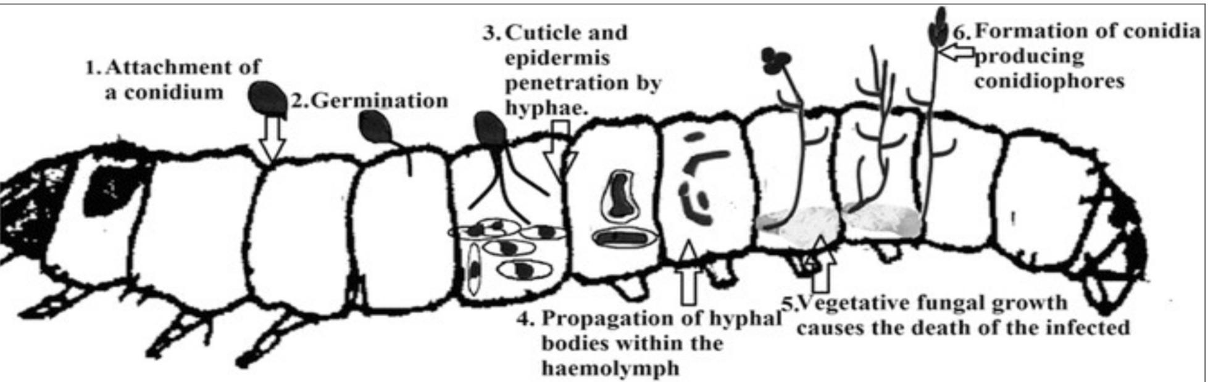
Fig .1 Mode of action of Entomopathogenic fungi

2.2 Entomopathogenic Bacteria
Entomopathogenic bacteria and their toxins are the most commercially successful microbial insecticides. They are used worldwide due to their cost-effective, mass production, specificity, persistence in the environment, and safety (Glare et al., 2017). Various bacterial species and subspecies, especially Bacillus, Pseudomonas etc., have been established as biopesticides and are primarily used to control insect and plant diseases.
Bacillus thuringiensis (Bt) is a highly specific for the control of insect species typically i) Lepidoptera (butterflies/moths), ii) Coleoptera (beetles),and iii) Diptera (flies/mosquitos). The Bt is effective when eaten in sufficient quantity by the specific insects with a alkaline gut pH (typically butterflies, moths, beetles, flies and mosquitoes). After ingestion, the spores feed on intestinal flora and later burst releasing the protein toxin (Crystalline protein) damaging the gut lining. Affected insects stop feeding and die from the combined effects of starvation, tissue damage and gastrointestinal infections by other pathogens like bacteria and fungi. (Copping and Menn 2000).

2.3 Entomopathogenic Virus(EPV)

Insect killing viruses are also known as EPV. Insects are attacked by a great diversity of viruses and their infection may cause the death of the infected individuals. Viruses are being used as a promising tool for the management of economically important insect pests. Baculoviridae : members of this viral family exclusively infect larvae of insect orders Lepidoptera, Hymenoptera and Diptera. Some members have been developed as biopesticides for controlling insect pests .
Various viruses, viz. Nucleopolyhedrovirus (NPV), Granulosis viruses (GV) and Cytoplasmic Polyhedrosis viruses were used for the management of insect pests throughout the world. The host-specific viral particles are ingested by the insects and the virions infect the gut wall cells, fat body, and hemolymph, leading to death of the insects. The characteristics of the entomopathogenic viruses and the molecular mechanisms by which they infect and kill the insects need to be explored in a detailed manner.
2.4 Entomopathogenic Nematodes (EPNs)

Entomopathogenic nematodes are soft bodied, non-segmented roundworms which belong to Species in two families (Heterorhabditidae and Steinernematidae) have been effectively used as biological insecticides in pest management programs (Grewal et al., 2005). Entomopathogenic nematodes fit agreeably into integrated pest management or IPM programs because they are considered non-toxic to humans, relatively specific to their target pest(s), and can be applied with standard pesticide equipment (Shapiro-Ilan et al. 2006).
The juvenile stage penetrates the host insect via the spiracles, mouth, anus, or in some species through intersegmental membranes of the cuticle, and enters into the hemocoel of the insect (Bedding and Molyneux 1982). Both Heterorhabditis and Steinernema are mutually associated with bacteria of the genera Photorhabdus and Xenorhabdus respectively (Ferreira and Malan, 2014). The juvenile stage of nematodes release cells of their symbiotic bacteria into the hemocoel of an insect. The bacteria multiply in the insect hemolymph and the infected host usually dies within 24 to 48 hours. After the death of the host, nematodes continue to feed on the host tissue, mature and reproduce and infect other hosts and continue their life cycle (Kaya and Gaugler, 1993)Fig.2.
Certain EPNs e.g., Steinernema glaseri, Steinernema kraussei,Heterorhabditis bacteriophora, Heterorhabditis indica etc., are being used as a commercial Biopesticides to control the White grubs , banana root borers etc.,
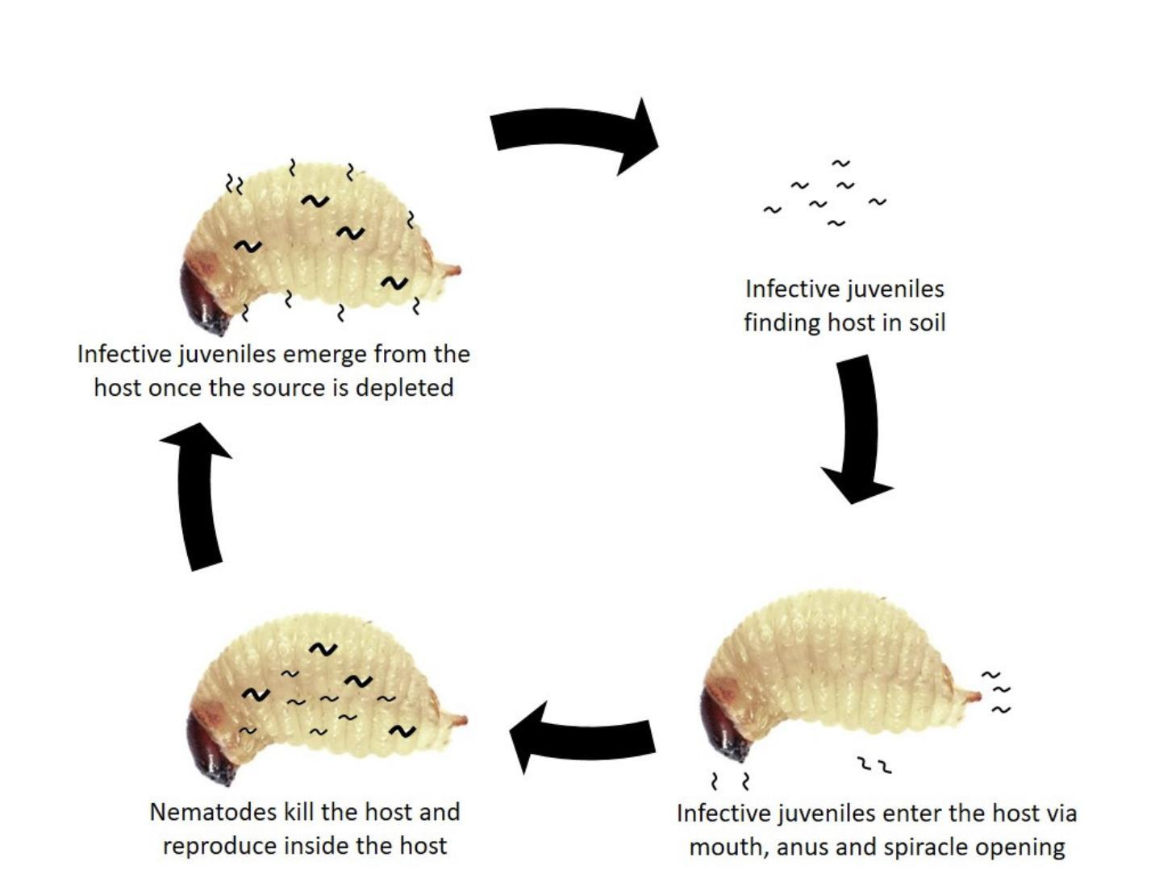
Fig 2: Mode of Action of Entomopathogenic Nematodes

3. Importance of Biopesticides in Organic Farming
Biopesticides exert their inhibitory effects through multiple mode of actions such as growth regulators, gut disruptors, metabolic poison, neuromuscular toxins, and non-specific multi-site inhibitors (Sparks and Nauen, 2015; Dar et al., 2021).In the nearest future, biopesticides could replace synthetic pesticides without significantly affecting productivity and yield, if their potentials are fully maximized (Mishra et al., 2020). It follows eco-friendly agricultural practices without making use of harmful chemicals.

4. Biochemical Pesticides
The plant products e.g., neem, pyrethrum, rotenone, etc are being used as a bio pesticides against various insects ,pests such as aphids, thrips, caterpillars,leaf hoppers etc. are being used globally. Vrikshayurveda is an ancient book written by Surpala in which certain plant products were described for insect pest management.

Conclusion
Biopesticides are important tools in sustainable agriculture. In this context use of natural products for pest control is highly recommended. Increasing consciousness regarding health among the human beings has also created the need of biopesticides and organic farming as overuse of chemical pesticides is degrading our environment. That is why More emphasis has been made in recent years on the prospect of employing natural enemies, such as entomopathogens, to manage insect infestations. They can be used to manage insect pests as biological control agents and increase agro-sustainability. In the domain of pesticides, the field of microbial pesticides provides a unique opportunity to conduct prospective and predictive research.
Organic farming is the best way for food safety. Therefore, the demands for bio-pesticides for organic farming are continuously increasing day by day. Thus the investigation of the bio-pesticide might generate organic farming methods in the field of agricultural study. Organic farming follows eco-friendly agricultural practices without making use of harmful chemicals.

References
- Bedding, R. and Molyneux, A. (1982) Penetration of insect cuticle by infective juveniles of Heterorhabditis spp. (Heterorhabditidae: Nematoda). Nematologica 28: 354-359.
- Butt, T.M., Jackson C. and Magan N. (2001b) Introduction-fungal biological control agents: problems and potential. Fungi as biocontrol agents: progress, problems and potential.CAB International, Wallingford, pp 1–9.
- Butt, T.M., Jackson C.W. and Magan, N. (2001a) Fungi as biocontrol agents: progress, problems and potential. CAB International, Wallingford.
- Charnley, A.K. (2003) Fungal pathogens of insects: cuticle degrading enzymes and toxins. Adv Bot Res, 40, 241–321.
- Clarkson, J.M. and Chamley, A.K. (1996) New insights into the mechanisms of fungal pathogenesis in insects. Trends Microbiol, 4-5.
- Copping, L.G. and Menn, J.J. (2000) Biopesticides: a review of their action, applications and effi cacy. Pest Manag Sci 56:651–676.
- Dalmas, C. A. and Koutroubas, S. D. (2018) Current status and recent developments in biopesticide use. Agriculture 8:13.
- Dar, S. A., Wani, S. H., Mir, S. H., Showkat, A., Dolkar, T. and Dawa, T. (2021) Biopesticides: mode of action, efficacy and scope in pest management. J. Adv. Res. Biochem. Pharmacol. 4, 1–8.
- Dara, S.k. (2017) Compatibility of the entomopathogenic fungus Beauveria bassiana with some fungicides used in California Strawberry. Open Plant Sci J 10:29-34.
- Domsch, K.H., Gams,W. and Anderson, T.H. (1980) Compendium. Accessed 23 July 2013 Faria MR, Magalhães BP (2001) O uso de fungos ento-of soil fungi. Academic, London, pp 413–415.
- Driver, F., Milner, R.J. and Trueman, J.W.H. (2000) A taxonomic revision of Metarhizium based on a phylogenetic analysis of rDNA sequence data. Mycol Res 104:134–150.
- Erkılıç, L. and Uygun, N. (1993) Possible uses of entomopathogenic fungi in biological control (Entomopatojen fungusların biyolojik mücadelede kullanılma olanakları). Türkiye Entomoloji Dergisi, 17, 117–128.
- Esparza Mora, A.M., Conteiro Castilho, A.M. and Fraga, M.E. (2017) Classification and infection mechanism of entomopathogenic fungi. Arquivos do Instituto Biológico 84, 1–10.
- Ferreira, T. and Malan, A.P. ( 2014) Xenorhabdus and Photorhabdus, bacterial symbionts of the entomopathogenic nematodes Steinernema and Heterorhabditis and their in vitro liquid mass culture: a review. African Entomology 22: 1-14.
- Grewal, P.S., Ehlers, R.U. and Shapiro-Ilan, D.I. (2005) Nematodes as Biocontrol Agents. CABI, New York, NY.
- Glare, et al., (2017) Basic and Applied Research: Entomopathogenic Bacteria in Microbial Control of Insect and Mite Pests (Lawrence A. Lacey) 47-67.
- Kaya, H.K. and Gaugler, R. (1993) Entomopathogenic nematodes. Annual Review of Entomology 38: 181-206.
- Kumar, S. (2012) Biopesticides: a need for food and environmental safety. J Biofertil Biopestic 3:4.
- Marrone, P. G. (2014) “The market and potential for biopesticides,” in Biopesticides: State of the Art and Future Opportunities, eds A. D. Gross, J. R. Coats, S. O. Duke, J. N. Seiber (Washington DC, USA: American Chemical Society), 245–258.
- Mazid, S., Kalida, J.C., Rajkhowa, R.C. (2011) A review on the use of biopesticides in insect pest management. Int JSci Adv Technol 1:169–178.
- Mishra, J., Dutta, V. and Arora, N. K. (2020) Biopesticides in India: technology and sustainability linkages. 3 Biotech 10, 1–12. doi: 10.1007/s13205-020-02192-7
- Olson, S. (2015) An analysis of the biopesticide market now and where it is going. Outlook. Pest Manag. 26, 203–206.
- Pathma, J., Kennedy, R. K., Bhushan, L. S., Shankar, B. K. and Thakur, K. (2021) “Microbial biofertilizers and biopesticides: nature's assets fostering sustainable agriculture,” in Recent Developments in Microbial Technologies (Singapore: Springer), 39–69.
- Roberts, D.W., St Leger,R.J. (2004) Metarhizium spp., cosmopolitan insect-pathogenic fungi: mycological aspects. Adv Appl Microbiol 54:1–70.
- Senthil-Nathan, S. (2013) Physiological and biochemical effect of neem and other Meliaceae plants secondary metabolites against Lepidopteran insects. Front Physiol 4:359.
- Sevim, A., Sevim, E. and Demirbağ, Z. (2015). General biology of entomopathogenic fungi and their potential to control pest species in Turkey (Entomopatojenik fungusların genel biyolojileri ve Türkiye’de zararlı böceklerin mücadelesinde kullanılma potansiyelleri). Erzincan Üniversitesi Fen Bilimleri Enstitüsü Dergisi, 8(1), 115–147.
- Shapiro-Ilan, D.I., Gough, D.H., Piggott,S.J. and Patterson Fife, J. (2006) Application technology and environmental considerations for use of entomopathogenic nematodes in biological control. Biological Control 38: 124-133.
- Sparks, T. C. and Nauen, R. (2015) IRAC: Mode of action classification and insecticide resistance management. Pest. Biochem. Physiol. 121, 122–128. doi: 10.1016/j.pestbp.2014.11.014.
- Zimmermann, G. (1993) The entomopathogenic fungus Metarhizium anisopliae and it’s potential as a biocontrol agent. Pest Management Sci 37:375-379.
- Zimmermann, G. (2007b) Review on safety of the entomopathogenic fungus Metarhizium anisopliae. Biocontrol Sci. Tech. 17, 879–920.

