DESIGN AND PERFORMANCE OF PV SYST
Mammula Venkatesh^{1*}, Mr. SIVA NAGENDRA NANDYALA ²
¹Assistant Professor, Department of Electrical and Electronics Engineering, Avanthi’s Research and Technological Academy, Basavapalem , bhogapuram(M), Vizianagaram, Andhra Pradesh,
²Assistant Professor, Department of Electrical and Electronics Engineering, Dr.
BVC college, amalapuram, Andhra Pradesh, India

venkatesh.mammula252@gmail.com, shiva.sonoframbabu@gmail.com

ABSTRACT
Solar power is one of the most important renewable resource of electrical energy that is used around this whole world. But it is very well known that the initial cost required to install a solar power plant for either commercial or domestic purposes is way much than any power source used. The aim of our project is to design any solar power plant with greater efficiency using PVsyst software along with making it economically affordable than it would be expected.
The proposed plant is at a location in basavapalem, bhogapuram, Vizianagaram District with 15 Deg Fixed tilt and detailed aspects of Engineering, procurement and construction were considered to generate a minimum 14000KWh per year and the same is captured within this paper.
Keywords- Carbon footprints, Mono facial PV Module, Photovoltaic Technology, Solar PV power plant, Sustainable energy system

INTRODUCTION
Electricity is one of the most important physical phenomena that is used in every step to run this world. There are many discoveries and many research programmers that are associated to find the best and efficient way to get the source for electricity. We now have many sources of electricity such as thermal, nuclear, hydro, geothermal, solar, wind, tidal etc. But it is very much observed that some of such sources use the non- renewable resources which cause pollution and lead to global warming. And using the renewable energy resources such as hydro energy may involve lot of expensiveness. Taking all such key points into consideration, there is one such resource that is neither expensive nor harmful to the world i.e., Solar power.
Solar power plants harness the energy from the sun to generate electricity. This renewable energy source has become increasingly popular in recent years as a way to reduce dependence on fossil fuels and mitigate the impacts of climate change. A solar power plant typically consists of solar panels, inverters, and other electrical components that work together to convert the sun's energy into usable electricity. This project aims to design and build a solar power plant that can generate a significant amount of electricity, while also being cost-effective and efficient. The plant will be located in an area with high levels of sunlight, and the design will take into account factors such as temperature, wind, and shading to ensure maximum energy production.
In a study report released by Citigroup Global Markets, it is predicted that India will increase installed capacity by up to 115 GW by 2017. Additionally, the capacity of renewable energy could rise from 15.0 GW to 37.0 GW. Major capacity expansions are planned for the private sector at Reliance Power (35 GW) and CESC (7 GW) (Table 1).
table 1: Average per capita consumption of energy in different countries.

Sl. No. | Country | Power Consumption
 |  | MWh/Year | Watts
1 | India | 488500000 | 489
2 | USA | 3816000000 | 3816
3 | Japan | 974200000 | 974
4 | Germany | 545500000 | 546
5 | China | 2859000000 | 2859

Solar energy is the energy obtained by capturing heat and light from the Sun. The method of obtaining electricity from sunlight is referred to as the Photovoltaic method. This is achieved using a semiconductor material. The process of converting solar energy into electricity so as to utilize its energy in day-to-day activities is given below-
- Absorption of energy carrying particles in sun’s rays called photons.
- Photovoltaic conversion, inside the solar cells.
- Combination of current from several cells. This is necessary since a single cell has a voltage of less than 0.5V.
- Conversion of the resultant DC to AC.
The software used in this project is PVsyst. which is a software tool that is designed exceptionally for the solar energy industries. PVsyst creates, simulates and analyses solar energy systems of all types. Also, it is famous for its accuracy, efficiency and flexibility.
ORGANIZATION OF THIS PAPER

This paper is organized as follows; Case study 1 in section-1, which consist the problem statement and its analysis of Avanthi’s Research and Technological Academy.. In section-2, it consists the Case study-2 that includes the problem statement and analysis of Avanthi Polytechnic College. In section-3, we have the Case study-3 that consists of problem statement of Avanthi institute of engg tech. Finally, in section-4, it consists case study-4 that includes the problem statement and analysis of a domestic property.
Case study-1(Avanthi’s Research and Technological Academy.):
Problem statement: Taking a note that the college power bill is considered to be commercial and various activities other than works related to studies are also included such as cultural events, big gatherings and so on, the power bill drawn per year is on an average of INR. 40,27,703 (ref. from Jan,2022 to Dec,2022). Below is the table of monthly power consumption bills and its total for the year 2022.

Month | Power bill (in Rs)
January | 2,11,591
February | 2,70,969
March | 3,39,871
April | 3,31,893
May | 2,76,372
June | 3,66,776
July | 4,11,347
August | 3,67,679
September | 3,89,664
October | 3,20,145
November | 3,79,593
December | 3,61,803
Total Cost | 40,27,703

So, now we analyse this power bill using PVsyst software and obtain the requirements and efficient implementation of a roof top solar power plant with a cost-effective design.

Proposed solution

Considering the problem statement, we understand the power consumption and bill acquired by the college. The details and requirements are as follows:

- Approximate Investment: 2.00 crores (upon further analysis, the cost can still be minimised)
- Annual Electricity Bill of 2022 : 40,27,703
- Time required to recover the initial capital will be approx.: 5 years
- On an average the lifespan of solar modules is: 20 – 25 years
- Space Requirement: 1.68 acres

The point is that we can recover our initial capital within the 5 to 6 years and that remaining 15 to 20 years, the electricity cost will be Rs. 0.00/- which can be considered as a profit. Currently, the maximum demand is 250KVA. In the upcoming future, it can be increased according to user requirement that we can increase the plant capacity. If we are able to add more modules, then it can generate revenue for us such as the generated electricity is sent to the grid where the energy is stored and we can withdraw whenever the power is needed and the amount is paid for the remaining electricity. So that this can also be considered as a business model.

Proposed Power Plant

College is proposing to build a 300KW grid-connected rooftop solar PV power plant in Andhra Pradesh, taking into account the good prospective available and the support provided by the Government of India and State Government to this national endeavor of utilizing conventional sources of energy for power generation.
The planned Power Plant location is conveniently located, and the area surrounding it has all the required infrastructure facilities. Crystalline modules, module mounting frameworks, inverters, and all necessary accessories will be the main components of the proposed plant. The Low Tension panel will receive the power that is produced. Accordingly, the Promoter believes that constructing the aforementioned power plant will significantly contribute to meeting the state and the nation's increasing energy needs [4].

SITE SELECTION

The importance of proper site selection in solar power plant establishment cannot be understated as it plays a significant role in determining the overall efficiency and profitability of a solar power project. A suitable site selection should meet criteria such as favorable weather conditions, adequate space, proper infrastructure, and proximity to the electricity grid. The weather conditions at the site influence the amount of sunlight received, which is critical for solar energy production, while adequate space is crucial for accommodating the solar panels on the ground or rooftop. Additionally, proximity to the energy grid can minimize transmission losses and lower the installation costs required. Investing in a proper site selection can maximize the productivity of a solar plant by optimizing the solar energy production and reducing operational costs, providing a considerable return on investment.

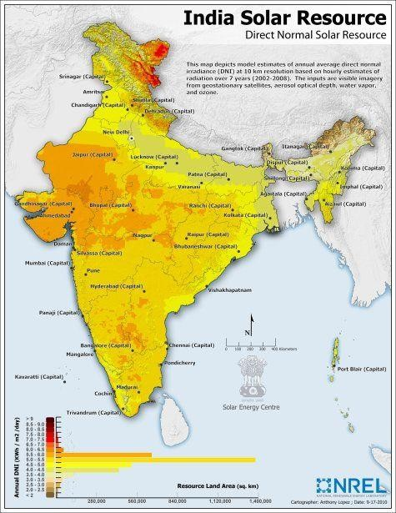

PROPOSED LOCATION AND LAND AVAILABILITY

Visakhapatnam is the largest industrial city in Andhra Pradesh. Topographical and Geological Conditions
Avanthi’s Research and Technological Academy IST is located at 17.9679N and 83.4565E.A building's average height is 34 metres Within the College grounds, the power produced by the Power Plant will be connected to the current grid line

SOFTWARE SIMULATION STEPS OF STANDALONE SYSTEM

This programmer was created with researchers, architects, and engineers in mind. Additionally, it is very beneficial for educational training. PVSYST software is used for Evaluation and sizing as shown in Fig.2, Along with normal solar power equipment, it works with grid-connected, standalone, pumping, and DC-grid PV systems. It also features a comprehensive weather database and a database of PV systems [6]

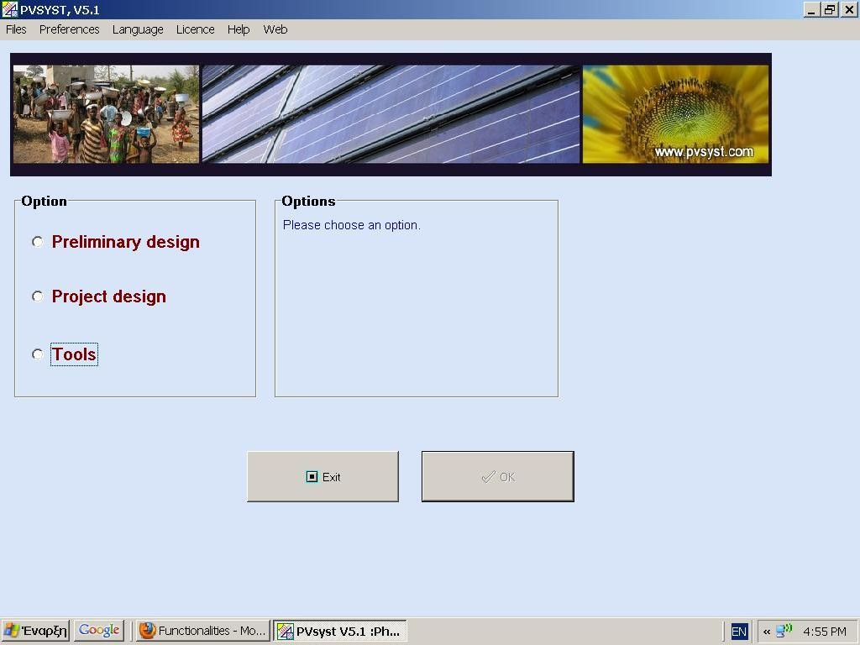

Figure 2: PVSYST software.

Metro Details of Location
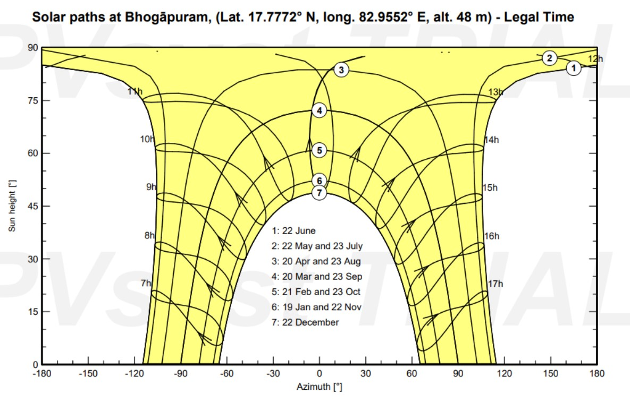
Fig. 3 shows the sun paths plot within PVsyst software. This plot is useful for an overview of the solar resource

Topographical and Geological Conditions

Avanthi’s Research and Technological Academy
Location: Basavapalem, bhogapuram. (M), Vizianagaram
Latitude: 17.78N Longitude: 82.96 E Altitude: 48 m Time Zone: UT +

Metro Details of Location

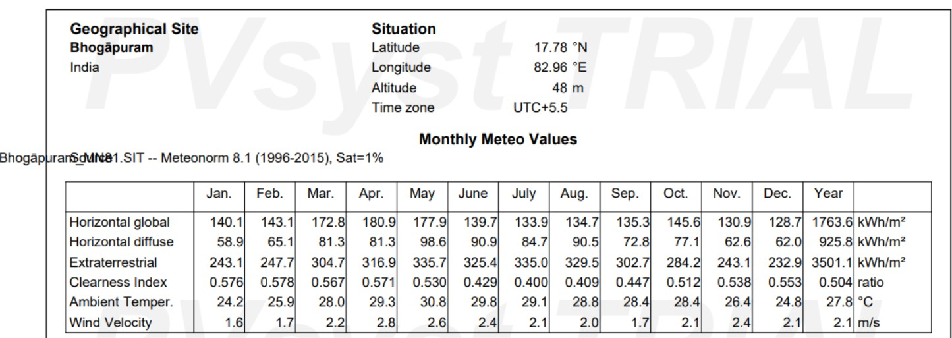

PV Module and Inverter Selection
The PV module and inverter specifications are shown in Fig. 4 below for modelling a standalone system. According to technical specifications, the inverter used is 229kWac, and just one unit of inverters is needed. The array power (STC) generated is 289 KWp, while the PV module chosen has a power of 555Wp. According to calculations, 520 units of modules are needed [7].

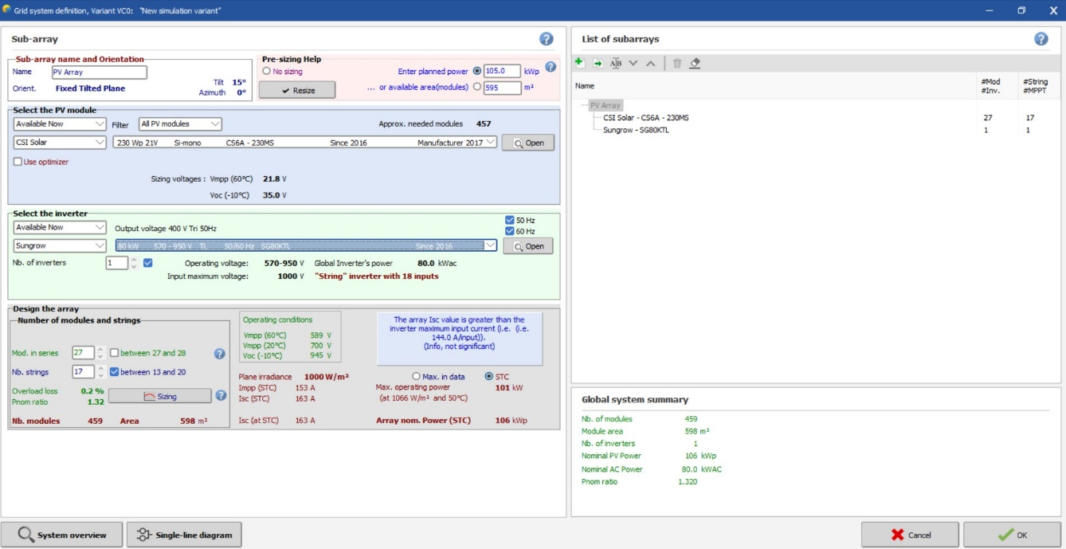

Figure 4: Selection of materials

New Simulation Variant

PVSYST V6.88 |  | Jinko Solar Co. Ltd. (China) |  |  |  |  |  |  |  |  |  |  |  |  | 06/07/23 |  |  | Page 1/5
Grid-Connected System: Simulation parameters

Project : 300KW -Vizianagaram
Geographica avanthi research and technological academy Country India Situation Latitude 17.78° N Longitude 82.96° E
Time defined as Legal Time Time zone UT+5.5 Altitude 48m Albedo 0.33
Meteo data: avanthi College- bhasavapalem-Vzm Meteonorm 7.2 (1981-2010) - Synthetic
Simulation variant : 550Wp-Monofacial-070223
Simulation date 07/02/23 12h27
Simulation parameters System type Unlimited sheds
Collector Plane Orientation Tilt 15° Azimuth 0°
Sheds configuration Nb. of sheds 5 Unlimited sheds
Sheds spacing 6.60 m Collector width 4.20 m
Inactive band Top 0.02 m Bottom 0.02 m Shading limit angle Limit profile angle 23.4° Ground cov. Ratio (GCR) 63.6 %

Models used Transposition Perez Diffuse Perez, Meteonorm
Horizon Free Horizon
Near Shadings Mutual shadings of sheds
User's needs : Unlimited load (grid)
PV Array Characteristics
PV module Si-mono Model JKM550M-72HL4-V
Custom parameters definition Manufacturer Jinkosolar
Number of PV modules In series 21 modules In parallel 26 strings Total number of PV modules Nb. modules 546 Unit Nom. Power 550 Wp
Array global power Nominal (STC) 300 kWp At operating cond. 274 kWp (50°C) Array operating characteristics (50°C) U mpp 786 V I mpp 349 A
Total area Module area 1408 m² Cell area 1298 m²

Inverter Model SG110CX
Custom parameters definition Manufacturer Sungrow
Characteristics Operating Voltage 200-1000 V Unit Nom. Power 100 kWac Max. power (=>45°C) 110 kWac
Inverter pack Nb. of inverters 2 units Total Power 200 kWac Pnom ratio 1.50
PV Array loss factors
Array Soiling Losses Loss Fraction 1.0 %
Thermal Loss factor Uc (const) 29.0 W/m²K Uv (wind) 0.0 W/m²K / m/s
Wiring Ohmic Loss Global array res. 37 mOhm Loss Fraction 1.5 % at STC LID - Light Induced Degradation Loss Fraction 2.0 %
Module Quality Loss Loss Fraction -0.8 %
Module Mismatch Losses Loss Fraction 1.0 % at MPP
Strings Mismatch loss Loss Fraction 0.10 %
Incidence effect (IAM): User defined profile

PVSYST V6.88
Jinko Solar Co. Ltd. (China)
06/07/23
Page 3/5

Grid-Connected System: Main results

Project :  Simulation variant : | 300KW ARTB-VZM  550Wp-Monofacial-070223
Main system parameters  PV Field Orientation | System type Sheds disposition, tilt | Unlimited sheds  15° | azimuth | 0°
PV modules | Model | JKM550M-72HL4-V | Pnom | 550 Wp
PV Array | Nb. of modules | 546 | Pnom total | 300 kWp
Inverter | Model | SG110CX | Pnom | 100 kW ac
Inverter pack | Nb. of units | 2.0 | Pnom total | 200 kW ac
User's needs | Unlimited load (grid)
Main simulation results  System Production | Produced Energy | 489.7 MWh/year | Specific prod. | 1631 kWh/kWp/year
 | Performance Ratio PR | 83.15 %

Normalized productions (per installed kWp): Nominal power 300 kWp Performance Ratio PR

7
Lc : Collection Loss (PV-array losses)
6 Ls : S m L (inverter, ...)
Yf
yste
roduc
oss
usef
: P ed ul energy (inverter output)
[kWh/kWp/day]

5

0.73 kWh/kWp/day
0.17 kWh/kWp/day
4.47 kWh/kWp/day

1.0

0.9

0.8

0.7
Performance Ratio PR

PR : Performance Ratio (Yf / Yr) : 0.831

4 0.6
0.5
Energy

3 0.4
Normalized

2 0.3

0.2
1
0.1

0
Jan

Feb

Mar

Apr

May

Jun

Jul

Aug

Sep

Oct

Nov

Dec

0.0

Jan

Feb

Mar

Apr

May

Jun

Jul

Aug

Sep

Oct

Nov

Dec

550Wp-Monofacial-070223 Balances and main results

 | GlobHor  kWh/m² | DiffHor  kWh/m² | T_Amb  °C | GlobInc  kWh/m² | GlobEff  kWh/m² | EArray  MWh | E_Grid  MWh | PR
January | 149.4 | 51.05 | 24.27 | 176.1 | 172.2 | 46.30 | 44.83 | 0.848
February | 153.5 | 54.27 | 25.79 | 172.1 | 168.2 | 44.39 | 42.95 | 0.831
March | 185.6 | 70.65 | 27.89 | 196.1 | 191.3 | 49.61 | 46.30 | 0.786
April | 192.1 | 74.49 | 29.05 | 192.1 | 187.2 | 48.75 | 47.23 | 0.819
May | 188.2 | 90.32 | 30.70 | 179.5 | 174.4 | 46.42 | 45.11 | 0.837
June | 146.9 | 91.03 | 29.47 | 138.7 | 134.3 | 36.32 | 35.36 | 0.849
July | 141.8 | 86.66 | 29.06 | 134.7 | 130.5 | 35.33 | 34.39 | 0.850
August | 140.3 | 97.73 | 28.69 | 136.8 | 132.2 | 36.05 | 35.11 | 0.854
September | 143.0 | 77.98 | 28.29 | 146.1 | 141.9 | 37.91 | 36.83 | 0.839
October | 152.1 | 75.69 | 28.18 | 164.2 | 159.8 | 42.57 | 41.32 | 0.838
November | 138.9 | 53.66 | 26.15 | 160.3 | 156.5 | 41.68 | 40.38 | 0.839
December | 138.0 | 50.92 | 24.62 | 164.4 | 160.6 | 43.47 | 39.93 | 0.809
Year | 1869.6 | 874.43 | 27.69 | 1961.3 | 1909.1 | 508.81 | 489.73 | 0.831

Legends: GlobHor Horizontal global irradiation DiffHor Horizontal diffuse irradiation T_Amb T amb.
GlobInc Global incident in coll. plane
GlobEff Effective Global, corr. for IAM and shadings EArray Effective energy at the output of the array E_Grid Energy injected into grid
PR Performance Ratio

PVSYST V6.88 | Jinko Solar Co. Ltd. (China) | 06/07/23 | Page 4/5
Grid-Connected System: Special graphs
Project : 300KW ARTB-VZM Simulation variant : 550Wp-Monofacial-070223
Main system parameters System type Unlimited sheds
PV Field Orientation Sheds disposition, tilt 15° azimuth 0°
PV modules Model JKM550M-72HL4-V Pnom 550 Wp PV Array Nb. of modules 546 Pnom total 300 kWp Inverter Model SG110CX Pnom 100 kW ac Inverter pack Nb. of units 2.0 Pnom total 200 kW ac User's needs Unlimited load (grid)
Daily Input/Output diagram

2000
1800 Values from 01/01 to 31/12 1600
1400

1200

1000

800

600

400

200

0
0 1 2 3 4 5 6 7 8
Global incident in coll. plane [kWh/m².day]

System Output Power Distribution
10000 Values from 01/01 to 31/12 8000

6000

4000

2000

0
0 50 100 150 200
Power injected into grid [kW]
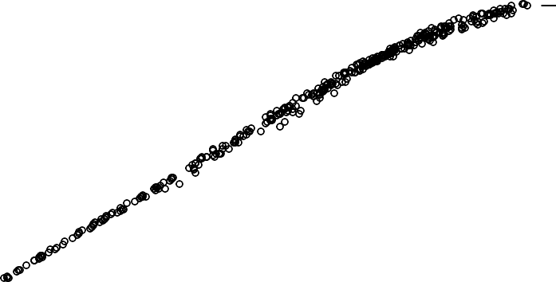
Energy injected into grid [kWh / Bin]
Energy injected into grid [kWh/day]

PVSYST V6.88 | Jinko Solar Co. Ltd. (China) | 06/07/23 | Page 5/5
Grid-Connected System: Loss diagram
Project : 300KW ARTB-VZM Simulation variant : 550Wp-Monofacial-070223
Main system parameters System type Unlimited sheds
PV Field Orientation Sheds disposition, tilt 15° azimuth 0°
PV modules Model JKM550M-72HL4-V Pnom 550 Wp PV Array Nb. of modules 546 Pnom total 300 kWp Inverter Model SG110CX Pnom 100 kW ac Inverter pack Nb. of units 2.0 Pnom total 200 kW ac User's needs Unlimited load (grid)
Loss diagram over the whole year

1870 kWh/m² Horizontal global irradiation
+4.9% Global incident in coll. plane

-0.06% Global incident below threshold
-1.26% Near Shadings: irradiance loss
-0.42% IAM factor on global
-1.00% Soiling loss factor
1909 kWh/m² * 1408 m² coll. Effective irradiation on collectors
efficiency at STC = 21.34% PV conversion

574 MWh Array nominal energy (at STC effic.)
+0.07% PV loss due to irradiance level

-7.10% PV loss due to temperature
+0.80% Module quality loss

-2.00% LID - Light induced degradation
-1.10% Mismatch loss, modules and strings
-1.02% Ohmic wiring loss
516 MWh Array virtual energy at MPP

-1.18% Inverter Loss during operation (efficiency)
-1.35% Inverter Loss over nominal inv. power 0.00% Inverter Loss due to max. input current 0.00% Inverter Loss over nominal inv. voltage 0.00% Inverter Loss due to power threshold 0.00% Inverter Loss due to voltage threshold 0.00% Night consumption
503 MWh Available Energy at Inverter Output

-0.79% System unavailability
-0.66% AC ohmic loss
-1.15% External transfo loss
490 MWh Energy injected into grid

RESULTS

Complete Turnkey of the Engineering and construction of a 300KW Solar PV Rooftop system was done on the premises of Avanthi’s Research and Technological Academy College in Basavapalem,bhogapuram(M ), Vizianagaram which can generate 489.7MWh per year.
1631 kWh per KWp is the expected Energy Yield by the end of 1st year from the installed 300KW Solar PV System.
- DC overloading of the system can be done up to 40%.
- The impact of losses specific to Ohmic and shading was captured.
- Grid availability and plant availability on 440V are limited to 97.5%.
- Expected Monthly Energy yield data was captured within the simulation report.
- 23.4 Deg Tilt was considered with the installed system due to space constraints.
- Aluminium profiles were used instead of Hot Dip Galvanized structures for Module Mounting Structures and can withstand 150 KMPH.

CONCLUSION

Engineering, procurement and construction of a 300KW Solar PV System were installed on the Rooftop of College bhogapuram, Vizianagaram on a fixed tilt of 15 deg with an aluminium extruded frame. Due to the fact of space constraints, the pitch between module rows was reduced with increased shading loss to accommodate higher installed capacity with a compromised ground coverage ratio.
- The proposed rooftop is not a shade-free zone and can accommodate only 2KWp for shade-free access installation.
- 10.3KWp was installed with a customized design of frame footings with a reduced pitch of 1.5 metres and reduced tilt of 23.4 Deg.
- The same can be increased to 15 Deg Tilt with the same pitch and with the increased shading loss within the existing space
- Future expansion on the same system can be done by going with elevated roof structures such that the existing loss factors can be reduced to increase the energy density of the existing location

References

1.Raveendhra, Dogga & Pathak, M.K. Recent trends in solar PV inverter topologies. Solar Energy. Vol no.183, pp.57-73, 2019
2.Albert, J. R., Ramasamy, K., Joseph Michael Jerard, V., Boddepalli, R., Singaram, G., & Loganathan, A. (2023). A Symmetric Solar Photovoltaic Inverter to Improve 3.Power Quality Using Digital Pulsewidth Modulation Approach. Wireless Personal Communications, 1-39, 2023.
3.Varma, Rajiv K. Smart solar PV inverters with advanced grid support functionalities. John Wiley & Sons, 2021.
4. H. Beltran, P. Ayuso, and E. Pérez, “Lifetime Expectancy of Li-Ion Batteries used for Residential Solar Storage”, Energies, 13, 568, 2020.
5. N. Narayan, T. Papakosta, V. Vega-Garita, Z. Qin, J. Popovic-Gerber, P. Bauer, M. Zeman, “Estimating battery lifetimes in Solar Home System design using a practical modelling methodology”, Applied Energy, Volume 228, 2018.
6. R. Xu, H. Wang, Z. Xi, W. Wang, M. Xu, “Recent Progress on Wave Energy Marine Buoys”, Journal of Marine Science and Engineering: 10(5):566. 2022.
7. H. Wang, W. Wu, L. Cui, Y. Wu, L. Zhu, E.G. Koutroulis, F. Blaabjerg, "A New Wave Energy Converter for Marine Data Buoy," in IEEE Transactions on Industrial Electronics, vol. 70, no. 2, pp. 2076-2084, March, 2022.
8. H. Wang, W. Wu, L. Zhu, E. Koutroulis, K. Lu and F. Blaabjerg, "Design and Experiment of a New Wave Power Conversion Device for Self-Powered Sensor Buoy," IECON 2021 – 47th Annual Conference of the IEEE Industrial Electronics Society, 2021,
9. J. Chen, Y. Li, X. Zhang and Y. Ma, “Simulation and Design of Solar Power System for Ocean Buoy”, Journal of Physics: Conference Series, 2018.
10. E. Kabir, P. Kumar, S. Kumar, A. A. Adelodun, and K. H. Kim, “Solar energy: Potential and future prospects,” Renew. Sustain. Energy Rev., vol. 82, pp. 894–900, 2018.

