Surveying On Ubi-Based Smart Fish Farming Aquaculture Monitoring System
Prof. Swetha K B Dr. Vishwanath K C Dr. Kavitha H
Assistant Professor Associate Professor Associate Professor
Dept. of Information Science & Engineering Dept.of Robotics & Automation Dept. of Information Science & Engineering
Sapthagiri college of Engineering Rajarajeswari college of Engineering Siddaganga Institute of Technology,
Bangalore -560057 Bangalore-74 Tumkur, Karnataka, India - 572103.
Swetha.kb@sapthagiri.edu.in vishwa8160@gmail.com hkavitha@sit.ac.in

Prof Manasa P M
Assistant Professor
Department of ISE
Sapthagiri college of Engineering
Bangalore -560057
manasapm_ise@sapthagiri.edu.in

Abstract - One of the main substances that significantly affects ecosystems is water. However, because to rapid industrialization, human waste, and haphazard use of pesticides and chemical fertilisers in agriculture, it is now widely utilised, which contaminates the water. In order to monitor the water quality across a wide area, such as a lake, river, or aquaculture, it is therefore required to install a water monitoring system. According to the state of the world today, Internet of Things (IoT) and remote sensing techniques are utilised in a variety of study fields to monitor, collect, and analyse data from distant locations. In this research, a real-time, low-cost water quality monitoring system in an IoT environment is suggested. This system includes a wide variety of sensors for measuring physical and chemical parameters. These sensors can be used to measure pH, turbidity, conductivity, and dissolved oxygen in water. This method allows for the analysis of data that has been posted online and the real-time assessment of water body quality.
- INTRODUCTION
Due to population increase and economic development, India is grappling with a serious issue of natural resource scarcity, particularly in the case of water [4]. The majority of water bodies are polluted by unnecessary contaminants, the majority of which are created by humans. It is therefore extremely difficult to confirm the purity of water. Rapid industrialization, a stronger focus on agricultural development using cutting-edge technology, increased fertiliser and pesticide use, and large-scale pollution of aquatic environments have all contributed to deteriorating water quality and the extinction of aquatic species [4]. Point and non-point sources of pollution, such as sewage discharge, industrial discharge, run-off from agricultural fields, urban run-off, and even floods, droughts, and a lack of user education and awareness, can contaminate water bodies [5]. Users' attention to issues including cleanliness, environmental sanitation, storage, and disposal are essential to maintaining the quality of water bodies. Nearly every component of the ecosystem is directly impacted by the biological diversity and tonicity of lakes, rivers, and other water bodies. Ecosystem elements are using polluted water, which is causing waterborne diseases to proliferate throughout the environment, killing people and halting socioeconomic development. Worldwide, waterborne illnesses have claimed the lives of about 5 million people (Water Resource Information System of India, 2017) [5]. Rainwater can wash agricultural pesticides and fertilisers through the soil and into nearby bodies of water. Additionally, industrial effluents wash into bodies of water. Once they reach toxic levels, these contaminants accumulate in the food chain and harm fish, animals, and birds. For irrigation and industry, the quality of the water can be flexible, but it should be of excellent quality for drinking. River water is used by industries to cool down equipment and energise it. Increase in water temperature reduces the amount of broken-down oxygen in the water, which affects biotic life (Central Ground Water Board, 2017) [5]. The importance of checking the water quality in our biological system is increased by the size of the aforementioned variables. In order to accurately characterise the ebb and flow conditions, water quality observation involves gathering data from the specified framework and deploying it at the designated locations at regular intervals. With a clear objective to recognise the variations in water parameters and to provide an early warning of the dangers, the main feature of a continuous water quality observation framework includes the evaluation of water quality metrics, such as physical, material qualities. The framework also provides a continuous analysis of the information gathered and suggests suitable medical interventions to lessen the water contamination. The purpose of this paper is to present a survey of the functions held in smart water quality monitoring systems with regard to application, communication technology used, sensors used, etc. and to illustrate a low-cost, periodic smart water quality monitoring system that uses an Arduino microcontroller with a Wi-Fi module to examine parameters like pH, turbidity, temperature, water level, and conductivity. The system also includes a feature for alerting users and relevant authorities about changes in water body metrics.
- LITERATURE SURVEY
1.Predictive Models for River Water Quality using Machine Learning and Big Data Techniques -A SurveyPredictive Models for River Water Quality using Machine Learning and Big Data Techniques - A Survey
Publication:
1] World Health Organization, Meeting the MDG drinking water and sanitation target: the urban and rural challenge of the decade, Geneva,
[2] L. Hu, C. Zhang, C. Hu, and G. Jiang, Use of grey system for assessment of drinking water quality: a case study of Jiaozuo city,China, Advances in Grey Systems Research, Springer Berlin Heidelberg, pp. 469-478, 2010
Authors:Jitha P Nair Vijaya M S
Abstract:Water is an important and essential element for the life on earth. Due to the growth of population and industrialization the water resources become more polluted. Waste disposal from industry, human wastes, automobile wastes, agricultural runoff from farmlands containing chemical factors, unwanted nutrients, and other wastes from point and non-point source flow to water bodies, which affects the quality of the water resources. etc. The increase in pollution influences the quantity and quality of water, which results high risk on health and other issues for human as well as for living organisms on the planet. Hence, evaluating and monitoring the quality of water, and its prediction become crucial and applicable area for research in the current scenario. In various researchers they have used traditional approaches; Now, they are using technologies like machine learning, big data analytics for evaluation and prediction of water quality. The advanced big data implementation using sensor networks and machine learning with the data related to environment, aids in building water quality prediction models. This paper analyses various prediction models developed using machine learning and big data techniques and their experimental results of water prediction and evaluation. Various challenges and issues are reviewed and possible solutions to some research issues are proposed.
2.Web-Based Management System of water pollution using Classification Techniques
Publication: Auckland University of Technology.
Author: Auckland University of Technology.
Abstract: This paper describes an implementation of a webbased system using classification techniques for prediction of water pollution type and appropriate treatments depending on the water quality Index. The benefits of data mining lie in the extraction of new knowledge automatically from the raw data to progress decision making. (C4.5) The decision tree was used for classifying water quality into five classes using fourteen parameters according to the World Health Organization's requirements. These parameters are taken for each sample of water in each ten water stations that selected for the investigations. First two classes were suitable for drinking water while other classes were not, therefore two types of classification techniques ((c4.5) decision trees and artificial neural network, millstone machine learning technique) were suggested to produce a decision concerning the type of pollution and devise proposition for the treatment of pollution. The experiment was carried on a real database validated by (Iraqi Ministry of Environment) gathered from ten authenticated treatment stations. The results show that using C4.5 decision tree classifier found to be the better in terms of the execution time while using NNT algorithm gave slightly better results in terms of the accuracy and error percentages. Also, the work shows that the techniques of data mining have the prospect to fast predict of the water quality class, as long as the given data are a true representation of the scope of knowledge.
3.Applications of IoT and Artificial Intelligence in Water Quality Monitoring and Prediction: A Review
Publication:uthorized licensed use limited to: Miami University Libraries. Downloaded on June 14,2021 at 19:35:51 UTC from IEEE Xplore. R
Author: AbdullahiSalisu, Aisha MustaphaHauwa ,Mohammed Mustafa
Publication:roceedings of the Sixth International Conference on Inventive Computation Technologies [ICICT 2021]
IEEE Xplore Part Number: CFP21F70-ART; ISBN: 978-1-7281-8501-9
Abstract:Currently, internet of things (IoT) devices like environmental sensors are used to capture real-time data that can be viewed and interpreted via a visual format supported by a server computer. However, to facilitate modeling and forecasting, artificial intelligence (AI) techniques are effective in statistically analyzing complex non-linear systems and a large amount of historical data series within a short period. This present review article covers selected research journals published from 2014 to 2020. The findings from previous research indicate that despite the limitations of artificial neural network (ANN) tools, ANN has proved to be useful and powerful techniques that can be used in the field of hydrology. Similarly, ANN tools have the ability to evaluate historical data collected from different river stations and wastewater treatment plants with minimum errors within a short time. Therefore, based on the selected past literature used for this review we found that different types of ANN algorithm such as feed-forward backpropagation (FFBP) algorithm, gradient descent, Broyden-Fletcher-Goldfarb-Shanno (BFGS), conjugate gradient, radial basis function neural networks (RBFNN), neural network fitting (NNF), cascade forward back propagation (CFBP), ensemble ANN (EANN) and single AAN (SANN) have been employed in the prediction and monitoring of water quality parameters with satisfactory outcome. Furthermore, modeling alongside forecasting of water quality parameters would act as a big leap for government agencies and independent organisations in monitoring, decision making and regulating waste discharged into natural water bodies in order to achieve a safe and improved water quality for users.
4.Dissolved Oxygen (DO) Meter Hydrological Modelling Using Predictive Algorithms
Publication:uthorized licensed use limited to: Auckland University of Technology. Downloaded on June 03,2020 at 07:45:46 UTC from IEEE Xplore
Author:Aljay R. Lorenzo1, Allysa Y. Dula2, Neil Aldrin C. Valeroso3, John David C. Munda4, Brian Noli G. Supang5
Abstract: Dissolved oxygen is one of the critical indicators of a body of water’s health and water quality. It refers to the presence of free, non-compound oxygen found in water. It also influences the growth and survival of the aquatic organisms living in it. This study aims to develop a lowcost, multi-function device that could determine the value of the dissolved oxygen (DO) level through hydrological modelling of water parameters such as temperature, pH, and conductivity using Decision Tree, Decision forest, and Multi-layer Perceptron machine learning algorithms. Using various metrics, the most efficient model was built using Random Forest algorithm, for it yielded the most reliable metrics when compared to the other two algorithms. The evaluated model has the following metrics: The Coefficient of Determination, or how well a model explains and predicts future outcomes, is 0.99. The Mean Absolute Error, or the average magnitude of the errors in a set of predictions, is 0.32. The Mean Squared Error, utilized in order to measure the performance of an estimator, is 0.36. The Root Mean Squared Error, or how concentrated the data is around the line of best fit, is 0.60. Relative to Atlas Scientific’s DO Sensor, the device can predict the dissolved oxygen level of a given water pond with 2.61% error. The final device is a handheld device consisting of the sensors for the highest- ranking parameters with respect to their relationship to DO: temperature, conductivity, and pH.
- METHODOLOGY
The average amount of fish consumed per person has increased from 9 kg in 1960 to 20 kg in 2020. Due to unforeseen climate vulnerability, which is causing water quality borders to shift and disease to spread, hydroponics is dealing with a number of problems. Sensors start to detect. The limit values for each sensor will then be determined at that point. If the value is more than the edge value, it will indicate an anomaly. The AI model should be sent off with the water quality. The suggested framework calls for the microcontroller to collect and manage the data from the sensor network. The suggested results are stored in the cloud. The managed data can be recovered from the cloud and used for research. The attributes acquired and the state of the water are made available. Hydroponics atomization can lead to quality improvement, advancements in ecological management, and a reduction in cost as well as production costs. The primary parameters that must be controlled and monitored in the framework unique to hydroponics are the rate of development, use of food feed, rate of development, Salinity, Temperature, and pH. The temperature shift affects fish development and sets a good model for caring. The rise in temperature could make fish sick and stressed. The oxygen consumption is correlated with the temperature, amount of activity, feed rate, and fish size. The decrease of oxygen that has been broken up is caused by an increase in temperature, and vice versa. For analysing the data pertaining to water quality, we are using the Random Forest Algorithm and Support Vector Machine in an AI model. 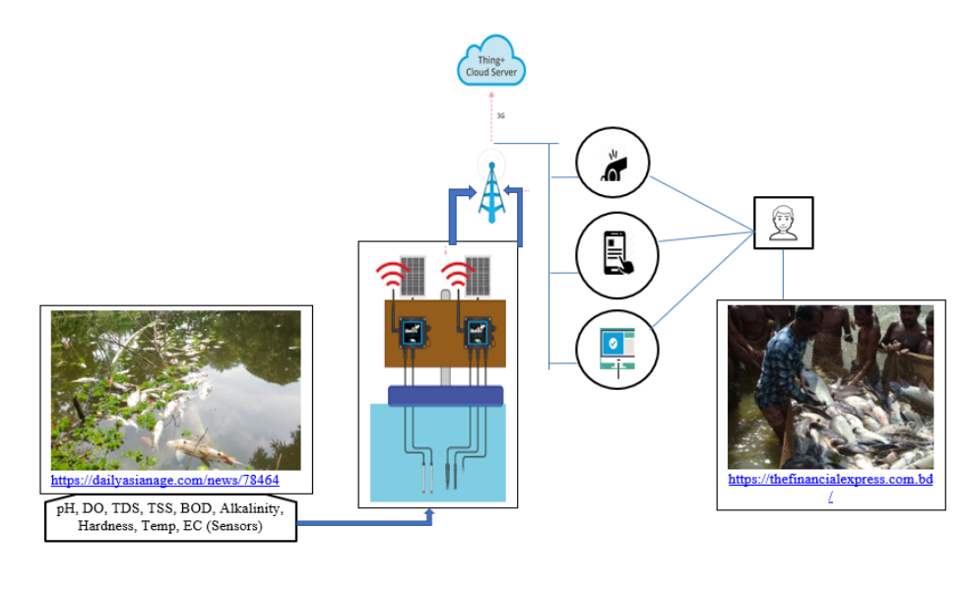
- CONCLUSION
The paper provides a brief overview of the technology employed in the current smart water quality monitoring system and provides a description of this technology. The system's standing on a global scale is also included. a comparison of the many monitoring systems utilised in real time. The relevant authorities can take action to improve the water quality and make it more useful by implementing the suggested system.These actions can reduce the pollutants in water, reducing the risks associated with using unclean water for daily use and ensuring the acceptable qualities of water.
REFERENCES
[1] Hauwa Mohammed Mustafa, Aisha Mustapha, Gasim Hayder, Abdullahi Sailsu, “Application of IOT and Artificial Intelligence in water quality and Prediction”.2020 6th International Conference Inventive ComputationTechnologies[ICICT].-IEEE.
[2] Al-Akhir Nayan, Muhammad Golam Kibria, Md.Obaidur Rahman, Joyeta Saha, “River Water Quality Analysis and Prediction Using GBM”.2020 2ndInternational Conference on Advanced Information and Communication Technology [ICAICT]-IEEE.
[3] Yuelai Su, Yining Zaho, “Prediction of downstream BOD based on Light Gradient Boosting Machine Machine Method”, 2020 International Conference on Communications, Information System and Computer Engineering[CISCE]-IEEE.
[4] Dr.Naveen Tewari and Dr.Mukesh Joshi, “Water Quality Predicting System (WQPS) and Method using Fog of Thing (FOT)”,2020 9th International Conference System Modeling and Advanced in Research Trends [SMART]-IEEE.
[5] Praveen C Menon, “IOT enabled Aquaponics with wireless sensor smart monitoring”, 2020 4th International Conference on I-SMAC [IOT in Social, Mobile, Analytics and Cloud]-IEEE.
[6] Maxime Lafont, Samuel Dupont, Philippe Cousin, Ambre Vallauri and Charlotte Dupont, “Back to the future: IOT to improve aquaculture”,2019 IEEE.
[7] Carlin C.F. Chu, S.C. Yuen, Y.K Wong, “Deep neural network for marine water quality classification with the consideration of coastal current circulation effect”, International Conference on Intelligent Sustainable System (ICISS 2017)- IEEE.
[8] Jitha P Nair, Vijaya M S, “Predictive Models for River Water Quality using Machine learning and Big Data Techniques”,2021 International conference on Artificial Intelligence and Smart System [ICIAS]- IEEE.
[9] Yi-Fan Zhang, Peter Fitch and Peter J.Thorburn, “Predicting the Trend of Dissolved Oxygen Based on kPCA-RNN Model”, 2020 February, MDPI -IEEE.
[10] Jianzhuo Yan, Ya Gao, Yongchaun Yu, Hongxia Xu, Zongbao Xu, “A Prediction Model Based on Deep Belief network and Least Squares SVR Applied to Croos Section Water Quality”, 2020 May, MDPI -IEEE.
[11] Lukman Adewale Ajao, Blessing Olatunde Abisoye, James Agajo,Abdulzeez Olorundare Ajao, Muhammed Bashir Mua’zu, Abdulazeez Femi Salami, “Automated Multiple Water Tanks Control System Using ATMEGA and FPGA Technology”, IEEE MAC 2019.
[12] Weijian Cao, Yuwan Gu, Juan Huan, Yilin Qin, “A Hybrid Model of Empirical Wavelet Transform and Extreme Learning Machine for Dissolved Oxygen Forecasting”, 2018 IEEE Confs on Iternet of Things, Green Computing and Communications, Cyber, Physical and Social Computing, Smart Data, Blockchain, Computer and Information Technology, Congress on Cybermatics.

