RNAseq and prime editing - A path towards human genome surgery

Rajagopal Ramya, Mariappan Balaganesan, Seerappalli Aran Shanmugam, Albin Jemila Thangarani
Institute of Fisheries Post Graduate Studies, Chennai, India
aymarpepsi@gmail.com

Rajagopal Ramila
Sun College of Pharmacy and Research Centre, Kanyakumari, India
ramilarajagopal2@gmail.com

ABSTRACT
The development of gene sequencing technology and prime editing (PE) techniques has made it possible to perform human genome surgery. Next-generation sequencing (NGS) has revolutionized the development of personalised medicine through rapid DNA and RNA sequencing. To detect genetic disorders and diseases, RNAseq is the basic technique needed for analysing the expressed genes in an individual. Machine learning models analyse RNAseq data to diagnose disease from the reference genome. Sequences provide information about mutations in the expressed genome. It is possible to edit genomes very precisely using the PE tool that has a prime editing protein and a prime editing guide RNA (pegRNA). All type of genome surgery/editing is possible with PE and it is therefore a one-size-fits-all solution to many genetic diseases and disorders. Several mutations were corrected using PE, and the tool is evolving rapidly to meet the needs. As molecular therapies advance, PE will ultimately become a cure for most genetic and epigenetic disorders that cannot be treated effectively with chemotherapy.

Keywords - Prime editing, RNAseq, pegRNA, CRISPR Cas 9, Machine learning algorithm, dual AAV, M-MLV RT, sgRNA, genetic disease, cancer therapy, delivery system
I. INTRODUCTION
Gene therapy or personalized medicine is still in its infancy, which requires biotechnology and medicine integration to progress. Personalised medicine (genomic medicine) initially focused on diseases caused by highly penetrant alleles. It has been demonstrated that genomic medicine can assist with diseases such as phenylketonuria, fragile X syndrome, thalassaemia major or homozygous familial hypercholesterolemia. Genomic testing to screen newborns and adults will identify individuals at high risk of imminent, serious, preventable, penetrant disorders with large health-care costs [1]. Currently, personalised medicine focuses on designing drugs for individuals to avoid adverse drug reactions and boost efficiency [2]. Genomics has recently become a part of medicine with the advancement in whole genome sequencing (WGS) both in efficiency and short duration. Based on the genome of an individual, personalised medicine can be designed using genomic techniques. Genome analysis has become feasible and applicable as a result of advances in genomics technology. RNAseq is the exome/ transcriptome sequencing technique that help in diagnosis of disease. It has been shown that clustered regularly interspaced short palindromic repeats (CRISPR) and CRISPR-associated protein 9 (Cas9) makes PE more efficient than homology directed repair (HDR) and base editing in molecular therapy [3,4]. The purpose of this chapter is to discuss RNAseq, PE and their application to human genetic disease therapy.
II. RNA SEQUENCING
- RNAseq
The RNAseq technique sequences expressed genes and requires isolation of RNA from individuals, creation of cDNA from isolated RNA, and sequencing of the cDNA using various techniques like single molecule sequencing, single molecule fluorescent sequencing, nanopore sequencing and slide sequencing. Data processing and storage of huge amounts of data must be addressed simultaneously (Fig. 1). Integration of information technology, bioinformatics and molecular technologies will solve issues in sequencing, data processing and data storage. WGS identifies genetic variations in DNA samples derived from individuals; however, RNAseq can also identify genetic variations caused by splicing during transcription that are not detected by WGS. Single cell RNAseq (scRNAseq) sequences the transcriptome of a single type of cell isolated by flow cytometry to study genes expressed in a single type of cell isolated from a heterogeneous population of cells. ScRNAseq helps to understand the cell-based model to understand the changes in cancer cells so that new therapeutic targets can be discovered [5]. Researchers at Massachusetts General Hospital and Broad Institute gathered RNA from 63 patients with suspected monogenic muscle disorders. 13 of these patients had genetic variants that affected transcription, and 50 patients were undiagnosed. Genotype-Tissue Expression (GTEx) Consortium researchers then performed RNA-seq on 184 skeletal muscle RNA-seq control samples and compared them to patients using the GTEx protocol. The RNA-seq approach identified splice aberrations caused by genetic variants known to cause disease in the 13 diagnosed patients, validating this approach that enabled novel diagnoses [6]. This study revealed a highly recurrent de novo intronic mutation in COL6A1 that leads to a dominantly acting splice-gain event, disrupting the critical glycine repeat motif of the triple helical domain. This pathogenic variant was identified in 27 genetically unsolved patients in an external collagen VI–like dystrophy cohort, explaining approximately 25% of patients clinically suggestive of collagen VI dystrophy for whom prior genetic testing was negative [7].
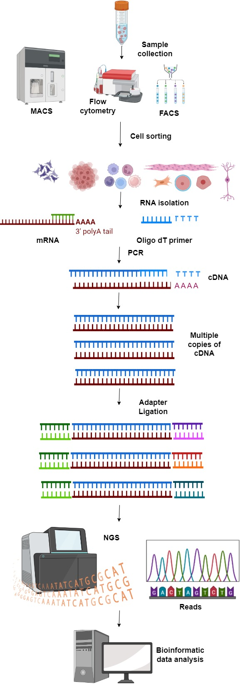
Figure 1: Single cell RNAseq

B. Machine learning analysis of disease diagnosis using RNAseq data
In order to diagnose and predict diseases such as cancer, RNAseq reads from patients are deposited in the NCBI and compared with the normal human genome. A machine learning algorithm (ML) is capable of predicting and diagnosing disease with an accuracy of more than 95%. In machine learning, canonical algorithms include k-Nearest Neighbour (kNN), Logistic Model Tree (LMT), Random Tree (RT), Random Committee (RC), Classification and regression trees (CART), Support Vector Machine (SVM), Bagging Support Vector Machines (bagSVM), Poisson linear discriminant analysis (PLDA) and Random Forest (RF) as well as Deep Learning (DL) classifiers such as the 1-D Convolutional Neural Network (1-D CNN), the Long Short-Term Memory (LSTM), and the Bidirectional LSTM (BiLSTM). Data preprocessing, feature extraction, model learning, and model evaluation comprise the ML workflow (Fig 2). A study done with RNAseq data of colon cancer patients and normal human RNAseq data from NCBI showed that the best accuracy in cancer prediction was obtained with RC, LMT, and RF canonical ML algorithms as 97.33% and the best accuracy in cancer stage classification was achieved with RF as 97.33%. The best accuracy in cancer prediction was obtained with 1-D CNN at 97.67%, and the best accuracy in cancer stage classification was achieved with BiLSTM at 98% [8].
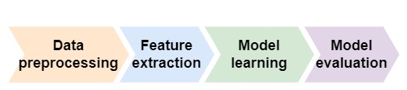
Figure 2: Pipeline of Machine Learning Algorithm

III. PRIME EDITING

- Prime editing tools
The PE process requires a Prime editing fusion protein (PEFP) called nCas9-RT that combines CRISPR-nCas9 with a reverse transcriptase (RT) and an RNA called pegRNA (Fig.3).

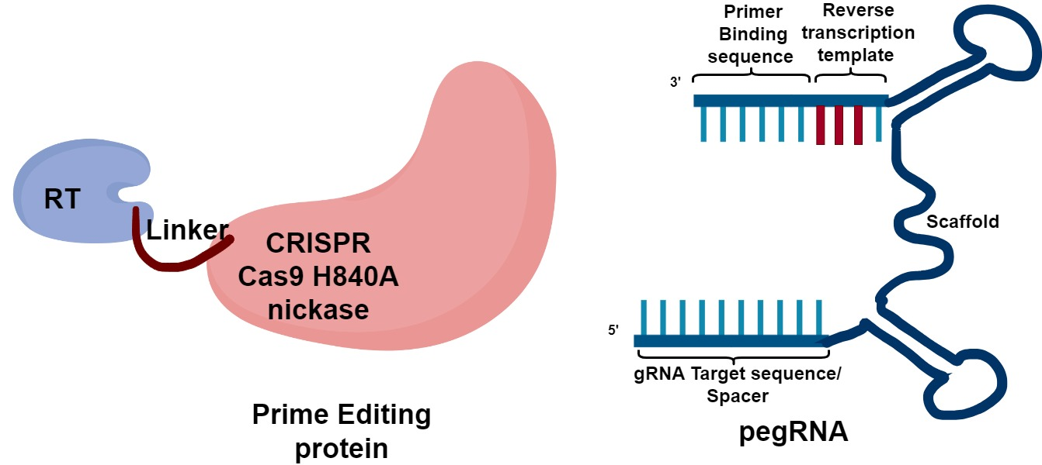
Figure 3: Prime editing tools

CRISPR nCas9 is an enzyme with cascade of protein that are originally present in bacteria as a defense sysytem and help to form single strand nick (SSN) . Reverse transcriptase (M-MLVRT) is an enzyme isolated from Moloney murine leukemia virus which helps to convert the RNA into DNA. The pegRNA consist of a 3’ extension, a scaffold and a 5’spacer or gRNA target sequence [9]. The 3’ extension consist of a primer binding sequence (PBS) and template containing edited RNA sequence called Reverse transcription template (RTT). The 5’ spacer or gRNA target sequence of the pegRNA carries the complementary sequence of the target DNA. Mechanism of PE is described in Fig.4.
-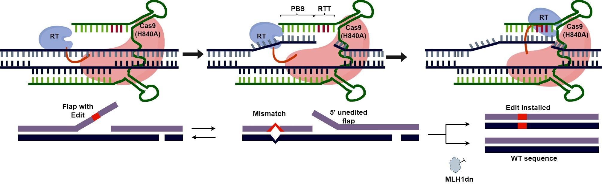
Figure 4: Mechanism of Prime editing

B. Prime Editing systems
There are five types of PE systems: PE1: wild type M-MLV RT, PE-2: M-MLV pentamutant, PE3: PE2 + nicking sgRNA, PE4: PE2 + MLH1dn, and PE5: PE2+ nicking sgRNA + MLH1dn. As the first PE system, PE1 was developed by combining the Cas9 H840A nickase and the wild-type M-MLV RT enzyme. The PE2 system consists of the PE2 enzyme, which consists of Streptococcus pyogenes Cas9 [SpCas9] H840A nickase fused with an engineered RT and a pegRNA. The PE2 system introduces five specific mutations to the RT component of the PEFP to improve its thermostability, processivity, and DNA-RNA substrate affinity. As part of the PE3 system, a single guide RNA (sgRNA) is used in addition to a pegRNA to nick the non-edited strand and improve the efficiency of editing. The additional sgRNA is a standard gRNA that directs the Cas9 H840A nickase element of the PEFP to nick genomic DNA at a nearby site, but on the opposite strand from the original nick. In the DNA mismatch repair pathway, MLH1 plays an important role. A genetic encoded MLH1 inhibitor, dominant negative mutant MLH1dn (truncated MLH1 D754–756 lacking endonuclease domain) is incorporated to prime editor to form PE4 (PE2 + MLH1dn) or PE5 (PE3 + MLH1dn+nicking sg RNA), which enhanced editing efficiency and reduced indels across a variety of cell types [10]. Engineered MLH1dn increases the efficiency and precision of PE by reducing the byproducts of PE that arise from mismatches. It is possible to perform all 12 base-to-base conversions, including both transversions and transitions, as well as additions and deletions of base pairs and indels in the human genome through PE [11].

IV. MOLECULAR THERAPY OF HUMAN DISEASE
Human genome surgery is carried out by two strategies viz., ex vivo PE and in vivo PE. Ex vivo PE involves reprogramming isolated cells from patients in the laboratory using PE tools and transplanting the edited/reprogrammed cells into patients. In contrast, in vivo PE involves injecting the PE tool directly into the patient.PE system efficiency can be evaluated by Western blotting of expressed protein, and off target editing can be assessed by NGS analysis of genome (Fig. 5).

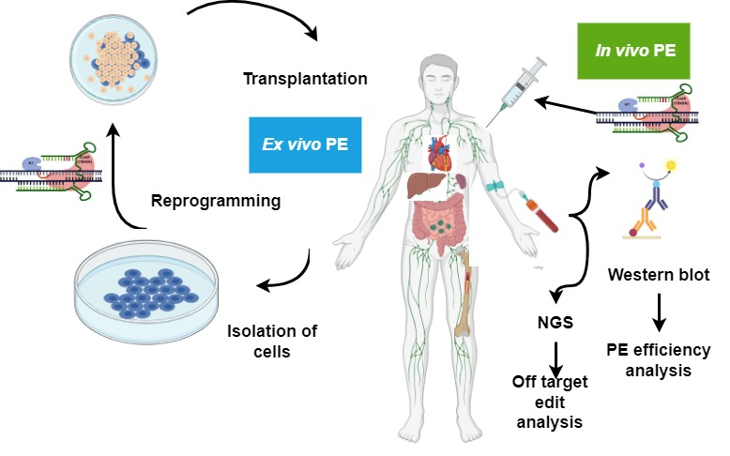
Fig 5. Strategies of human genome surgery

- Hepato-genetic disease
Diacylglycerol-acyltransferase (DGAT1) deficiency leads to lipotoxicity due to the incapability to form lipid droplets. DGAT1 mutations cause congenital diarrhoea and protein loss enteropathy upon lipid ingestion. By using intestinal tissue from a DGAT1 deficient patient, a 3D organoid was grown and PE was used to correct the mutation using PE3 and high editing rates were observed as well as low byproduct formation in both 3D-cultured adult stem cell organoids. The ABCB11D482G mutation, which is a frequent cause of bile salt export pump (BSEP) deficiency, and heterozygous in-frame deletions in CTNNB1, which are a cause of Wilson disease, were also prime edited in liver [12]. A new protein, PE2, (NLS-optimized SpCas9-based prime editor), enabled somatic genome editing in the liver of adult mice in order to correct pathogenic disease alleles and to enable the creation of cancer models by creating mutations that will drive the growth of tumours. The serpin family A member 1 (SERPINA1) gene contains a homozygous PiZZ mutation (1024 G > A, E342K), resulting in 1-antitrypsin (A1AT) deficiency. Patient-derived induced pluripotent stem cells (iPSCs) were prime edited with PE3 and found to be less efficient due to poor delivery [13]. In patients with phenylketonuria (PKU), phenylalanine amino acid accumulates in the body due to mutations in the PAH gene, which produces the enzyme to break down phenylalanine. A mouse model with the mutation Pahenu2 was treated using PE2 with a correction efficiency of 11.1% (up to 17.4%) in neonates with therapeutic reductions of blood phenylalanine and without induction of off-target mutations or prolonged liver inflammation [14]. A mouse model of hereditary tyrosinemia type 1 (HT1) with chemically derived hepatic progenitors (CdHs) was prime edited in vitro to correct the mutation. The reprogrammed hepatocytes were then transplanted into the same mouse to increase its survival. Cells that have been prime edited in vitro can be transplanted to cure liver disease [15]. PE2 and PE3 were delivered by hydrodynamic injection in mice with the genetic liver disease hereditary tyrosinemia. PE precisely corrected the disease-causing mutations and led to the amelioration of the disease symptoms without detectable off-target edits [16].
- Ophthalmic genetic disease
An inherited retinal disease, leber congenital amaurosis, can be corrected with up to 16% efficiency with the optimized dual-adeno-associated virus (AAV) split-intein system (AAV-Split PE3) in a precise manner, with no detectable off-target edits, restoring RPE65 gene expression, restoring retinal function and preserving photoceptors in rd12 mice [17]. In another study PE2 was delivered by an AAV vector, in mice with the genetic eye disease Leber congenital amaurosis and the disease symptoms were ameliorated without detectable off target edits [16]. Through microinjection of PE3 plasmids, a mouse with a cataract disorder was produced with a high G-deletion rate (38%) to produce disease model mouse, and the mutant mouse displayed nuclear cataracts [18]. Retinitis pigmentosa (XLRP) is the most severe form of Retinitis Pigmentosa. It is caused by a 4 bp deletion mutation in RPGR ORF15 with Sanger sequencing. This mutation is located in the same region as the missing X chromosome exome sequencing coverage. The cells that harbour the identified mutation were obtained from the patient and a cell line was created and the mutation was corrected using PE [19].
- Dermal genetic disease
Recessive dystrophic epidermolysis bullosa (RDEB) is caused by mutations in the COL7A1 gene that cause loss-of-function due to point mutations and insertion/deletion mutations. A PE procedure was performed on fibroblasts from two patients (Pat1 and Pat2) to correct the mutations in COL7A1. When these PE-corrected RDEB fibroblasts were transplanted to the skin of immunodeficient mice, C7 deposition and anchoring fibril formation were observed. This ex vivo gene editing strategy can treat RDEB [20]. Oculocutaneous albinism was created in zebrafish by creating the mutation P302L C>T by PE3 system [21].
D. Cardiac genetic disease
The genetic defect causing Duchenne muscular dystrophy (DMD) (c.8713C>T) prevents dystrophin protein from being produced under the sarcolemma. The gene mutation in the DMD gene was corrected using PE, and the effectiveness of different variations of the RTT sequence was tested. A modification of the PAM sequence (located at +6) and a silent mutation (located at +9) have also been added to the target sequence modification simultaneously. As a result of examining editing efficiency for different nucleotides, distance from target, nicking sites, and additional mutations, it was possible to achieve 22% modifications in myoblasts of a DMD patient, resulting in dystrophin expression, as detected by western blots in the myotubes that they formed, thereby restoring dystrophin protein [22]. DMD can also be caused by frameshift mutations in the DMD gene containing deletions of exon 52 or exons 45 to 52. It was found that HEK293T cells and human myoblasts were successfully edited using a PE strategy to correct the frameshift mutation, resulting in a specific substitution of GT nucleotides at the splice donor site of exon 53 in up to 32% of HEK293T cells and 28% of patient myoblasts. The modification of the splice donor sites for exon 51 and exon 53 resulted in exon skipping, which resulted in exon 50 connecting to exon 53 and exon 44 connecting to exon 54, respectively, resulting in the production of dystrophin protein [23].
- Spinal muscular genetic disease
Spinal muscular atrophy (SMA) is caused by mutations in the survival motor neuron 1 (SNMN 1) gene, which leads to infant mortality due to an autosomal recessive disease of the motor neurons. Even though SMA patients do not have SMN1, they do have SMN2, which is nearly identical to SMN1. As a result of its alternative splicing, SMN2 is unable to prevent disease development because of the absence of exon 7 in the majority of SMN2 transcripts caused by the intronic splicing silencer-N1 (ISS-N1). This results in an unstable truncated protein. PE-mediated targeted deletion of ISS-N1 in SMA patient-specific induced pluripotent stem cells (SMA-iPSCs) showed a 7/24 efficiency rate. There was a successful restoration of full-length-SMN in the targeted-deletion iPSCs clones and their derived motor neurons (iMNs) [24].
- Neurogenerative genetic disease
Tay-Sachs disease (TSD) is caused by insertion of four bases (TATC) into exon 11 of HEXA (HEXA ins TATC). In order to create a novel animal model with TSD that accurately mimics HEXA in TATC, various PE systems were used and their efficiency was evaluated [25]. The PE of primary post-mitotic mouse cortical neurons was performed with varying efficiencies in an attempt to correct a deletion in HEXA for the treatment of Tay-Sachs disease efficiently and to minimize the generation of byproducts [26].
- Cystic fibrosis
Cystic fibrosis is caused by the deletion of the phenylalanine residue due to mutations at position ΔF508 and R785 in the CFTR gene. A PE system was used to correct the cystic fibrosis CFTR-F508del mutation in an organoid. Cystic fibrosis CFTR-F508del mutation was functionally repaired by PE and WGS of prime edited organoids showed no off-target effects [27].
- Hemato-genetic disease
Beta-thalassemia is caused by the IVS-II-654 mutation (C > T), which creates an abnormal 5′ donor site in intron 2 of beta-globin, resulting in aberrant mRNA splicing. The PE3 system was microinjected into an embryo of a mouse model carrying the human beta-thalassemia IVS-II-654 mutation (C > T) to correct the mutation with an editing efficiency of 14.29% [28]. Sickle-cell disease (SCD) is caused by an A·T-to-T·A mutation in the haemoglobin subunit beta (HBB) gene resulting in a Glu 6 to Val substitution [29]. Despite the possibility of treating this disease through the use of allogenic hematopoietic stem cells transplantation, there is a lack of donors and graft rejection that prevents the procedure from being carried out. The SCD allele (HBBS) can be corrected by PE at a frequency of 15%–41% in haematopoietic stem and progenitor cells (HSPCs) from patients with SCD. The prime edited HSPCs were transplanted into immunodeficient mice, and HSPC-derived erythrocytes carried less sickle haemoglobin, contained HBBA-derived adult haemoglobin at 28% to 43% of normal levels, and were tolerant to hypoxia-induced sickling [30]. Human cells were edited to fix a transversion in HBB efficiently and with few byproducts [26]. To induce recombinant adeno-associated virus serotype 6 (rAAV6)-mediated HBB gene correction, a CRISPR-Cas9 gene targeting strategy using high-fidelity Cas9 precomplexed with chemically modified guide RNAs has been developed for preclinical trials. The feasibility, efficacy, and safety of HBB gene correction in plerixafor-mobilized CD34+ cells from healthy and SCD patient donors (gcHBB-SCD) were demonstrated in preclinical studies. In clinical-scale gcHBB-SCD manufacturing, we achieved up to 60% allelic correction. A 20% gene correction was achieved with multilineage engraftment after transplantation into immunodeficient NSG mice. It was concluded that the engrafted gcHBB-SCD drug product was safe, tumorigenic, and toxicology-free for long-term use. It did not exhibit abnormal hematopoiesis, genotoxicity, or tumorigenicity which led to the initiation of a phase 1/2 clinical trial in patients with SCD [31].
- X-linked genetic diseases
X-linked severe combined immunodeficiency (X-SCID) is caused by mutations in the interleukin-2 receptor gamma (IL2RG) gene. Using PE, an in vitro model of the disease was created using K-562 cells and T cells from healthy donors with the c. 458 T>C point mutation in the IL2RG gene. The strategies that were used to create model cells were used to correct the IL2RG c. 458T>C mutation in patient T cells that carry the mutation with revertant somatic mosaicism, but they did not result in satisfactory results due to limited in vitro proliferation of mutant cells as well as somatic reversal [32].
- Personalised oncology
CRISPR-engineered T cells were studied for their feasibility and safety in treating late-stage lung cancer, which showed very low off-target editing rates and no severe treatment-related adverse events, thus supporting its general safety for clinical use [33]. PD-1 gene-edited bulk autologous T cells were used to treat 12 patients with non-small-cell lung cancer (NSCLC), and the results supported both the feasibility and safety of gene editing for cell therapy [34]. Three patients with advanced cancer participated in a phase 1 clinical trial to assess the safety and feasibility of CRISPR-Cas9 gene editing. With the goal of improving antitumor immunity, CRISPR-Cas9 was used to disrupt three genes (TRAC, TRBC, and PDCD1) in T lymphocytes from patients. To recognize tumours, NY-ESO-1 was also introduced as a cancer-targeting transgene. Patients received engineered cells and were well tolerated, with durable engraftment observed throughout the study [35]. In Chimeric Antigen Receptor (CAR) T-cells cancer therapy, synthetic receptors composed of antigen recognition, signaling, and co-stimulatory domains are used to reprogram T-cells to target and destroy tumour cells. While CAR T-cell therapy has proven successful in treating refractory B-cell cancers, optimal potency has yet to be achieved for other cancers, particularly solid tumours. This approach has been hindered by factors such as T-cell exhaustion, lack of CAR T-cell persistence, cytokine-related toxicities, and manufacturing bottlenecks. PE and synthetic biology can be combined to optimize CAR T-cell therapy for future clinical trials [36]. KRAS, a mutated member of the RAS family, has a variety of molecular identities, making it difficult for cancer to be treated specifically. A universal pegRNA that can correct all types of G12 and G13 oncogenic KRAS mutations was developed for PE and successfully corrected 12 types of KRAS mutations, accounting for 94% of all known KRAS mutations, by up to 54.8% in HEK293T/17 cells. In human cancer cells, pegRNA was used to correct endogenous G13D mutations and they were successfully corrected to wild-type KRAS sequences with a 40% correction frequency without indel mutations. PE with the universal pegRNA has been proposed as a potential therapeutic strategy for KRAS oncogene variants on a 'one-to-many' basis [37]. An organoid biobank of 31 genetically distinct human pancreatic cancer (PDAC) lines that reflects the heterogeneity of primary pancreatic cancer tissue molecularly and phenotypically was utilized to study drug-gene interactions with tumour suppressor genes ARID1A and BRCA2 using CRISPR-Cas9 genome editing and drug screening. In the course of an automated drug repurposing screen using 1,172 FDA-approved compounds, 26 compounds were identified that effectively kill PDAC organoids, including 19 chemotherapy drugs currently approved for treatment of other cancer types. Using tumour organoid biobanks and genome editing, this proof-of-concept will advance precision oncology and identify drug repurposing candidates [38]. The PE tool was employed to revert a TP53 missense C > T mutation (L194F) in a T47D luminal A breast cancer cell line and to introduce the L194F mutation in HEK293T cells. To assess the PE efficiency in both cell lines, Sanger sequencing in the prime-edited cells pool and single cell-derived clones was preformed which did not detect any base substitution in these cell lines. The same was repeated with the more sensitive amplicon target sequencing and it identified the expected substitution in these T47D and HEK293T cells, albeit the editing efficiency was low [39]. Human clinical trials were conducted to evaluate the efficacy of PE ex vivo therapy in increasing the efficacy of T cell therapy. A total of 17 patients have been infused with PD-1-edited T cells obtained by co-transfection using electroporation of Cas9 and single guide RNA plasmids in ex vivo. Peripheral blood was detected with edited T cells following infusion. Based on NGS analysis, the median mutation frequency of off-target events was 0.05% (range, 0 to 0.25%). The median progression-free survival of edited T cells was 7.7 weeks and the median overall survival was 42.6 weeks [40].
V. DELIVERY SYSTEM
The efficiency of delivery of PE tools in vivo is less due to their large size [41]. The use of dual AAVs for the delivery of a PE2 system was shown to be effective in correcting a pathogenic mutation in the mouse liver [42]. A size-reduced SpCas9 prime editor lacking the RNaseH domain (PE2ΔRnH) and an intein-split construct (PE2 p.1153) for AAV-mediated delivery was used to deliver PE into the liver. This split construct consists of the PE tool being split into two AAVs which are combined inside a cell to produce a PE tool (Fig. 6) [14]. The delivery efficiency of dual-AAV systems, v1em and v3em PE-AAV, exceeded 42% in cortex, 46% in liver, and 11% in heart. In vivo PE with v3em PE-AAV did not result in any detectable off-target effects or significant changes in liver enzymes or histology [43]. In mouse models of hereditary tyrosinemia type 1 (HT-1 mice) and Leber congenital amaurosis (LCA mice), PE was administered hydrodynamically and subretinally, respectively [17]. Rather than using viral vectors, lipid nanoparticles (LNPs) conjugated with apolipoprotein E can directly target hepatocytes, improving gene therapy safety [44]. There was a 54% PE rate with enhanced LNPs (eLNPs) containing cholesterol analog β-sitosterol at optimal ratios of RNA cargoes. The polyhedral morphology of the eLNPs and the fluid state of the membrane led to improved endosomal escape, leading to the onset of editing within 9 hours and the maximum efficiency within 24 hours. Additionally, prime editors can be delivered as ribonucleoproteins to zebrafish embryos and human primary cells [21]. To confirm the long-term safety profile of PE, it is necessary to optimize the efficiency of PE delivery.

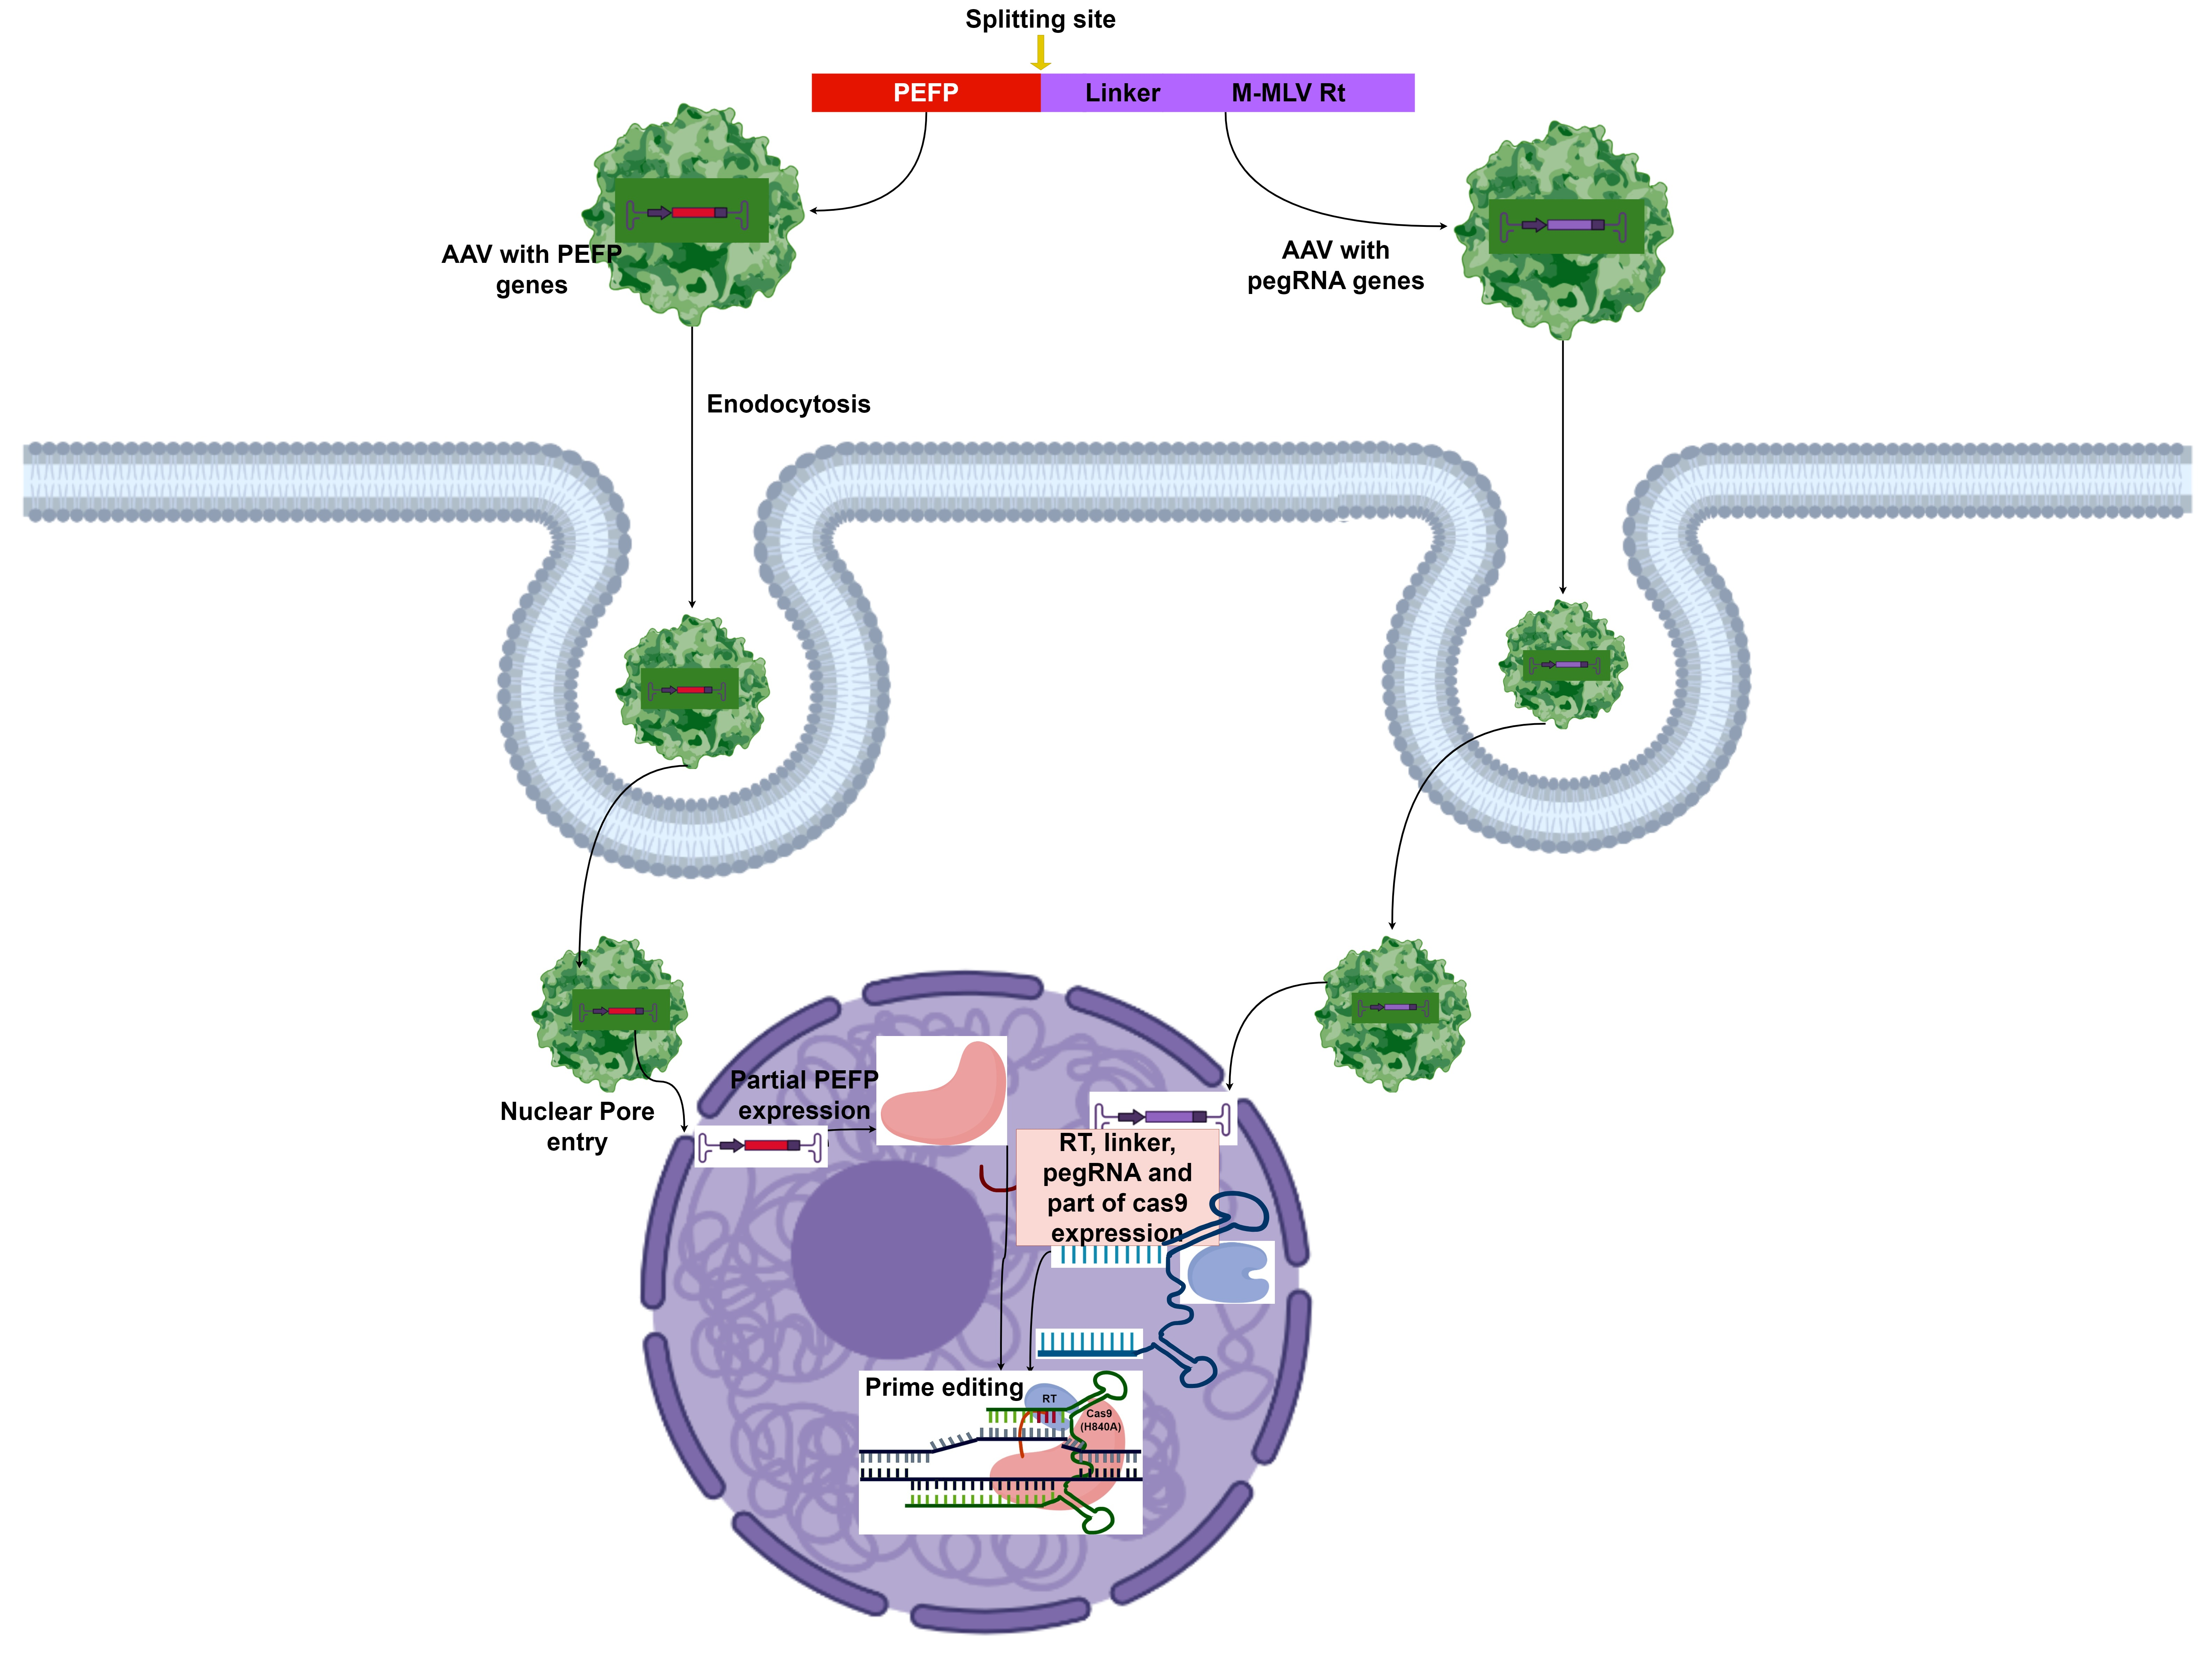
Figure 6: Dual AAV vector delivery system
VI. HURDLES
The major hurdles are induction of immune responses to the vector and the PE due to the high vector dose [14], Cas9-mediated off target, unwanted ssDNA deamination, random deamination, off target editing, both regional constitutive heterochromatin and local nucleosome occlusion of target sites impede editing [45], as well as the cellular repair mechanisms triggered by PE, which must be addressed before human molecular therapy can be delivered.
VII. CONCLUSION
According to current status, PE is used to create disease model animals, cell lines, and correct mutations in organoids, cells, and model animals. There were few human clinical trials carried out and the efficiency of PE was less than 50% which has to be improved. To overcome hurdles, molecular therapy requires more research in modification of PE tools to reduce its size and to design tissue specific delivery system. PE systems PE4 and PE5 are more efficient than PE2 and PE3 systems and demonstrate improved efficiency for substitution, small insertion, and small deletion [46]. In the near future, it could treat a variety of genetic diseases by genome surgery. However, there are still ethical questions to be answered before this technology can be widely adopted. Additionally, more research needs to be done to ensure safety and accuracy when using PE. There are also concerns about the potential for this technology to be utilized for eugenics or designer babies. Governments need to craft regulations and laws to ensure this technology is used ethically.
REFERENCES

- B. Doble, D.J. Schofield, T. Roscioli, and J.S. Mattick, “The promise of personalised medicine,” in Lancet (London, England) vol. 387,10017, 2016, pp. 433-434. doi:10.1016/s0140-6736(16)00176-8
- The Lancet. “Personalised medicine in the UK,” in Lancet (London, England) vol. 391,10115, 2018: e1. doi:10.1016/S0140-6736(17)33261-0
- I.G. Matsoukas, “Prime Editing: Genome Editing for Rare Genetic Diseases Without Double-Strand Breaks or Donor DNA,” in Frontiers in genetics vol. 11 528, 2020, doi:10.3389/fgene.2020.00528
- S. Crunkhorn, S, “Prime editing rescues mice from genetic disorders,” in Nature Reviews Drug Discovery vol. 20, 740, 2021. doi:10.1038/d41573-021-00149-w
- R. Wang, S. Song, J. Qin, K. Yoshimura, F. Peng, Y. Chu, et al., “Evolution of immune and stromal cell states and ecotypes during gastric adenocarcinoma progression,” in Cancer cell, S1535-6108(23)00215-5, 2023,, doi:10.1016/j.ccell.2023.06.005.
- K.H. Wrighton, “Genetic testing: The diagnostic power of RNA-seq,” in Nature reviews. Genetics vol. 18, 7, 2017, pp 392-393. doi:10.1038/nrg.2017.39
- B.B. Cummings, J.L. Marshall, T. Tukiainen, M. Lek, S. Donkervoort, A. R. Foley, et al., “Improving genetic diagnosis in Mendelian disease with transcriptome sequencing,” in Science translational medicine vol. 9,386, 2017: eaal5209. doi:10.1126/scitranslmed.aal5209
- E. Bostanci, E. Kocak, M. Unal, M.S. Guzel, K. Acici, and T. Asuroglu, "Machine Learning Analysis of RNA-seq Data for Diagnostic and Prognostic Prediction of Colon Cancer," in Sensors 23, vol. 6, 2023, p 3080. doi:10.3390/s23063080
- A. V. Anzalone, P. B. Randolph, J. R. Davis, A. A. Sousa, L. W. Koblan, J. M. et al., “Search-and-replace genome editing without double-strand breaks or donor DNA,” in Nature, vol. 576(7785), 2019, pp. 149–157. https://doi.org/10.1038/s41586-019-1711-4
- L. Jiang, and S. Yao, “Enhancing prime editing via inhibition of mismatch repair pathway,” in Mol Biomed vol.3, 7, 2022. doi:10.1186/s43556-022-00072-5
- S.C. Selvakumar, K.A. Preethi, K. Ross, D. Tusubira, M.W.A. Khan, P. Mani, et al., “CRISPR/Cas9 and next generation sequencing in the personalized treatment of Cancer,” in Mol Cancer vol. 21, 83 ,2022. doi:10.1186/s12943-022-01565-1
- I.F. Schene, I.P. Joore, R. Oka, M. Mokry, A.H.M. van Vugt, R.van Boxtel, et al., “Prime editing for functional repair in patient-derived disease models”, in Nat Commun vol.11, 5352, 2020. doi:10.1038/s41467-020-19136-7
- O. Habib, G.Habib, G.H. Hwang, and S. Bae, “Comprehensive analysis of prime editing outcomes in human embryonic stem cells,” in Nucleic Acids Res. vol. 50, 2022, pp. 1187–1197. doi: 10.1093/nar/gkab1295
- D. Bock, T. Rothgangl, L. Villiger, L. Schmidheini, M. Matsushita, N. Mathis, et al., “In vivo prime editing of a metabolic liver disease in mice,” in Science translational medicine, vol.14(636), 2022, eabl9238. doi:10.1126/scitranslmed.abl9238
- Y. Kim, S.A. Hong, J. Yu, J. Eom, K. Jang, S.Yoon, et al., “Adenine base editing and prime editing of chemically derived hepatic progenitors rescue genetic liver disease,” in Cell stem cell vol. 28,9, 2021, pp.1614-1624.e5. doi:10.1016/j.stem.2021.04.010
- H. Jang, D.H. Jo, C.S. Cho, J.H. Shin, J.H. Seo, G. Yu, et al., “Application of prime editing to the correction of mutations and phenotypes in adult mice with liver and eye diseases,” in Nature biomedical engineering, vol. 6(2), 2022, pp.181–194. doi:10.1038/s41551-021-00788-9
- K. She, Y. Liu, Q. Zhao, X. Jin, Y. Yang, J. Su, et al., “Dual-AAV split prime editor corrects the mutation and phenotype in mice with inherited retinal degeneration,” in Signal transduction and targeted therapy, vol. 8(1), 2023, p 57. doi:10.1038/s41392-022-01234-1
- J. Lin, X. Liu, Z. Lu, S. Huang, S. Wu, W. Yu, et al., “Modeling a cataract disorder in mice with prime editing,” in Molecular therapy. Nucleic acids, vol. 25, 2021, pp. 494–501. doi:0.1016/j.omtn.2021.06.020
- X. Lv, Z. Zheng, X. Zhi, Y. Zhou, J. Lv, Y. Zhou and B. Wu, “Identification of RPGR ORF15 mutation for X-linked retinitis pigmentosa in a large Chinese family and in vitro correction with prime editor,” in Gene Ther vol.30, 2023, pp. 160–166. doi:10.1038/s41434-022-00352-3
- S. A. Hong, S.E. Kim, A.Y. Lee, G.H. Hwang, J.H. Kim, H. Iwata, et al., “Therapeutic base editing and prime editing of COL7A1 mutations in recessive dystrophic epidermolysis bullosa,” in Molecular therapy : the journal of the American Society of Gene Therapy, vol. 30(8), 2022, pp. 2664–2679. doi:10.1016/j.ymthe.2022.06.005
- K. Petri, W. Zhang, J. Ma, A. Schmidts, H. Lee, J.E. Horng, et al., “CRISPR prime editing with ribonucleoprotein complexes in zebrafish and primary human cells,” in Nature biotechnology, vol.40(2), 2022, pp.189–193. doi:10.1038/s41587-021-00901-y
- C.H. Mbakam, J. Rousseau, Y. Lu, A. Bigot, K. Mamchaoui, et al., “Prime editing optimized RTT permits the correction of the c.8713C>T mutation in DMD gene,” in Molecular therapy. Nucleic acids, vol. 30, 2022, pp. 272–285. doi:10.1016/j.omtn.2022.09.022
- C.H. Mbakam, J. Roustant, J. Rousseau, P. Yameogo, Y. Lu, A. Bigot, et al., “Prime editing strategies to mediate exon skipping in DMD gene,” in Frontiers in medicine, 10, 2023, 1128557. doi:10.3389/fmed.2023.1128557
- M. Zhou, S. Tang, N. Duan, M. Xie, Z. Li, M. Feng, et al., “Targeted-Deletion of a Tiny Sequence via Prime Editing to Restore SMN Expression,” in International journal of molecular sciences, vol.23(14), 2022, 7941. doi:10.3390/ijms23147941
- Y. Qian, D. Zhao, T. Sui, M. Chen, Z. Liu, et al., “Efficient and precise generation of Tay-Sachs disease model in rabbit by prime editing system,” in Cell discovery, vol. 7(1), 2021, p 50. doi:10.1038/s41421-021-00276-z
- A.V. Randolph, P.B. Davis, J.R. Sousa, A.A. Koblan, L.W. Levy, J.M. Chen, et al., “Search-and-replace genome editing without double-strand breaks or donor DNA,” in Nature vol. 576, 2019, pp. 149–157. doi:0.1038/s41586-019-1711-4
- M.H. Geurts, E. de Poel, C. Pleguezuelos-Manzano, R. Oka, L. Carrillo, et al., “Evaluating CRISPR-based prime editing for cancer modeling and CFTR repair in organoids,” in Life science alliance, vol. 4(10), 2021, e202000940. doi:10.26508/lsa.202000940
- H. Zhang, R. Sun, J. Fei, H. Chen, and D. Lu, “Correction of Beta-Thalassemia IVS-II-654 Mutation in a Mouse Model Using Prime Editing,” in International journal of molecular sciences, vol. 23(11), 2022, 5948. doi:10.3390/ijms23115948
- C.A. Vakulskas, D.P. Dever, G.R. Rettig, R. Turk, A.M. Jacobi, M.A., Collingwood, et al., “A high-fidelity Cas9 mutant delivered as a ribonucleoprotein complex enables efficient gene editing in human hematopoietic stem and progenitor cells,” in Nat. Med. vol. 24, 2018, pp. 1216–1224. doi: 10.1038/s41591-018-0137-0
- K.A. Everette, G.A. Newby, R.M. Levine, K. Mayberry, Y. Jang, et al., “Ex vivo prime editing of patient haematopoietic stem cells rescues sickle-cell disease phenotypes after engraftment in mice,” in Nat. Biomed. Eng vol.7, 2023, pp. 616–628. doi:10.1038/s41551-023-01026-0

- A. Lattanzi, J. Camarena, P. Lahiri, H. Segal, W. Srifa, C.A. Vakulskas, et al., “Development of β-globin gene correction in human hematopoietic stem cells as a potential durable treatment for sickle cell disease,” in Science translational medicine vol. 13,598 (2021): eabf2444. doi:10.1126/scitranslmed.abf2444

- Y. Hou, G. Ureña-Bailén, T. Mohammadian Gol, P.G. Gratz, H.P. Gratz, A. Roig-Merino, et al., “Challenges in Gene Therapy for Somatic Reverted Mosaicism in X-Linked Combined Immunodeficiency by CRISPR/Cas9 and Prime Editing,” in Genes, 13(12), 2022, 2348. doi:10.3390/genes13122348
- Y. Lu, J. Xue, T. Deng, X. Zhou, K. Yu, L. Deng, et al., “Safety and feasibility of CRISPR-edited T cells in patients with refractory non-small-cell lung cancer,” in Nature medicine, vol. 26(5), 2020, pp.732–740. doi:10.1038/s41591-020-0840-5
- S.F. Lacey, and J.A. Fraietta, “First Trial of CRISPR-Edited T cells in Lung Cancer,” in Trends in molecular medicine vol. 26,8, 2020, pp. 713-715. doi:10.1016/j.molmed.2020.06.001
- E.A. Stadtmauer, J.A. Fraietta, M.M. Davis, A.D. Cohe, K.L. Weber, E. Lancaster, et al., “CRISPR-engineered T cells in patients with refractory cancer,” in Science, vol. 367, 2020. doi:10.1126/science.aba7365
- A. Dimitri, F. Herbst, and J.A. Fraietta, “Engineering the next-generation of CAR T-cells with CRISPR-Cas9 gene editing,” in Mol Cancer vol. 21, 78, 2022. doi:10.1186/s12943-022-01559-z
- G. Jang, J. Kweon, and Y. Kim, “CRISPR prime editing for unconstrained correction of oncogenic KRAS variants,” in Commun Biol vol. 6, 681, 2023. doi:10.1038/s42003-023-05052-1
- C.K. Hirt, T.H. Booij, L. Grob, P. Simmler, N. C. Toussaint, D. Keller, et al., “Drug screening and genome editing in human pancreatic cancer organoids identifies drug-gene interactions and candidates for off-label therapy,” in Cell Genomics, vol. 2(2), 2022, doi:10.1016/j.xgen.2022.100095.
- A.Y. Abuhamad, N.N.M. Zamberi, L. Sheen, S.N.H.M. Yusuf, A.A.Tajudin, et al., “Reverting TP53 Mutation in Breast Cancer Cells: Prime Editing Workflow and Technical Considerations,” in Cells vol. 11(10), 2022, 1612. doi:10.3390/cells11101612
- Y. Lu, J. Xue, T. Deng, X. Zhou, K. Yu, L. Deng, et al., “Safety and feasibility of CRISPR-edited T cells in patients with refractory non-small-cell lung cancer,” in Nature medicine, vol.26(5), 2020, pp.732–740. doi:10.1038/s41591-020-0840-5
- K. Godbout, and J.P. Tremblay, “Prime Editing for Human Gene Therapy: Where Are We Now?” in Cells, vol.12(4), 2023, p536. doi:10.3390/cells12040536
- P. Liu, S.Q. Liang, C. Zheng, E. Mintzer, Y.G. Zhao, K. Ponnienselvan, et al., “Improved prime editors enable pathogenic allele correction and cancer modelling in adult mice,” in Nature communications, vol. 12(1), 2021. doi:10.1038/s41467-021-22295-w
- J.R. Davis, S. Banskota, J.M. Levy, G.A. Newby, X. Wang, A.V. Anzalone, et al., “Efficient prime editing in mouse brain, liver and heart with dual AAVs,” in Nat Biotechnol, 2023. doi:10.1038/s41587-023-01758-z
- J.H. Shin, J. Lee, Y.K. Jung, K.S. Kim, J. Jeong, and D. Choi, “Therapeutic applications of gene editing in chronic liver diseases: an update,” in BMB reports, 55(6), 2022, pp. 251–258. doi:10.5483/BMBRep.2022.55.6.033
- S. Kim, J.B. Yuan, W.S. Woods, D.A. Newton, P. Perez-Pinera, and J.S. Song, Chromatin structure and context-dependent sequence features control prime editing efficiency,” in Frontiers in genetics, vol. 14, 2023, 1222112. doi:10.3389/fgene.2023.1222112
- P.J. Chen, J.A. Hussmann, J. Yan, F. Knipping, P. Ravisankar, P-F. Chen, et al., “Enhanced prime editing systems by manipulating cellular determinants of editing outcomes,” in Cell, vol.184 (22), 2021, pp.5635-5652. doi:10.1016/j.cell.2021.09.018.

