Contemporary Mathematics and its applications
Dr.P.Mahalakshmi
Assistant Professor Of Mathematics
V.H.N. Senthi kumara Nadar College(Autonomous)
Virudhunagar-626001
Mail id: mahalakshmi.p@vhnsnc.edu.in
Introduction :
Mathematics plays an important role in various fields. One of the important areas in Mathematics is graph theory which is used in structural models. This structural arrangement of various objects or technologies lead to new inventions and modifications in the existing environment for enhancement in those fields. Trends in contemporary Mathematics and its applications investigates the current state of mathematics and its applications and maximize its contribution to the allied fields. The applications of Mathematics arise in almost every branch of science and Engineering and all aspects of everyday life. The contemporary Mathematics is an important resource for keeping a breast of the latest findings and trends in Mathematics.
Before the Renaissance :
Mathematics was divided into two major areas ; arithmetic ; regarding the manipulation of numbers and geometry regarding the study of shapes. Some types of pseudoscience such as numerology and astrology were not then clearly distinguished from Mathematics.
During the Renaissance , two more areas appeared. Mathematical notation led to algebra which roughly consists of the study and the manipulation of formulas. Calculus, consisting of the two sub fields differential calculus and integral calculus is the study of continuous fractions which model the typically non linear relationships between varying quantities as represented by variables. This division is into four main areas such as arithmetic, geometry, algebra and calculus endured until the end of the 19th century areas such as Celestial mechanics and Solid mechanics were then studied by the mathematician but now are considered as belonging to Physics.
Contemporary Mathematics integrates technology, applications, projects and highlights a diverse group of contributors to Mathematics.
Statistics and related fields:
Historically the concept of a proof and its associated Mathematical rigour first appeared in Greek Mathematics , most notably in Euclid’s elements Since its beginning , mathematics was essentially divided into geometry and arithmetic (the manipulation of natural numbers and fractions) until the 16th and 17th centuries when algebra and infinitesimal calculus were introduced as new areas since then the interaction between Mathematical innovations and scientific discoveries has led to a rapid lockstep increase in the development of both. At the end of the 19th century the foundational crisis of mathematics led to the systematization of the axiomatic method which heralded a dramatic increase in the number of Mathematical areas and their fields of application.
The contemporary Mathematics subject classification lists more than 60 first level areas of Mathematics. The 2020 Mathematics subject classification contains no less than sixty three first level areas. Some of these areas correspond to the older division , as in true regarding number theory(the modern name for higher arithmetic) and geometry. Algebra and calculus do not appear as first level areas but are respectively split into several first level areas.
Geometry is the one of the oldest branches of Mathematics. It started with empirical recipes concerning shapes such as lines, angles and circles which were developed mainly for the needs of surveying and architecture but has since blossomed out into many other subfields.
Euclidean geometry is the study of shapes and their arrangements constructed from lines ,planes and circles in the Euclidean plane (plane geometry) and the three dimensional Euclidean space. Euclidean geometry was developed without change of methods or scope until the 17th century when Rene Descartes introduced what, is now called Cartesian coordinates. Geometry was split into two new sub fields : Synthetic geometry which uses purely geometrical methods and analytic geometry which uses coordinates systematically. Today’s subareas of geometry includes
Projective geometry introduced in the 16th century by Girard Desargues extends Euclidean geometry by adding points at infinity at which parallel lines intersect. This simplifies many aspects of classical geometry but unifying the treatments for intersecting and parallel lines.
The area of graph theory began with Euler in the year 1735 to solve the well known problem of the Konigsberg Bridge. In the modern age, graph theory is an integral component of Computer Science, Artificial engineering, Machine learning, Deep learning, Data Science and Social networks. Modern applications of graph theory discusses many cutting-edge applications of graph theory such as traffic networks navigable networks and optimal routing for emergency response and graph- theoretic approaches to molecular epidemiology.
Konigsberg Bridge
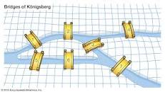

How does Graph Theory work:
Graph Theory is ultimately about studying the relationships between different nodes (Vertices, and connections[edges]).The study of graphs across a structure provides answers to numerous problems in layout, networking, optimization matching and operation.
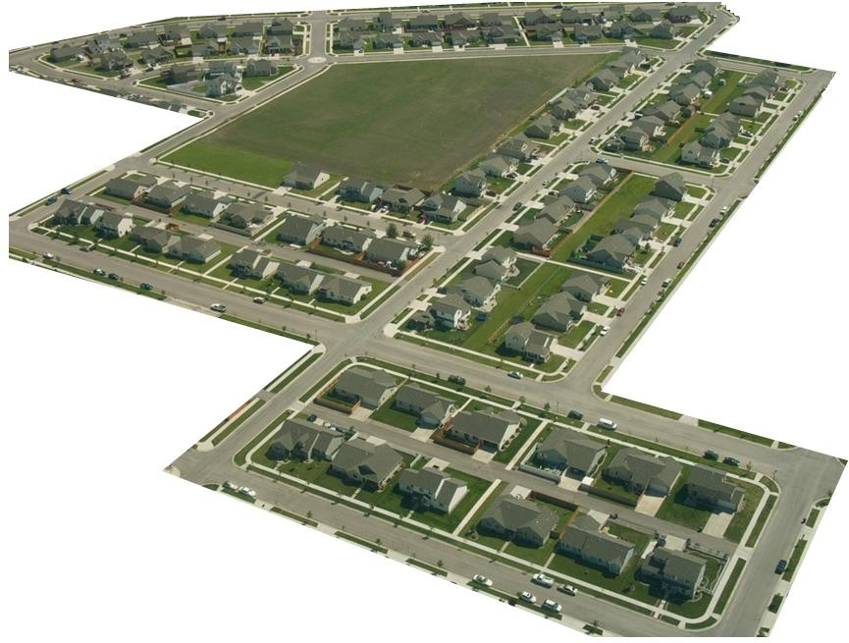
A
D
B
EEEE
C
F
M
G
H
N
O
I
J
K
P
L
Q
R
Algorithm for modern Real life application:
Google Maps:
Google Maps use graphs for construction and transport systems. The interpretation of two (or more) roads is considered a vertex and the road connecting two vertices are considered as an edge. Their navigation system then uses the algorithm to calculate the shortest path between two vertices. In GPS we also use different shortest path algorithm such as DFS(Depth First Search) and BFS ( Breadth first search) algorithm. By the Dijikstra algorithm, one can find the shortest route between a given node (source node) and all other nodes(destination node). In a graph this algorithm uses edge weights to find a way to reduce the total distance (weight between source node and all other nodes.
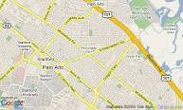

Face book and Linkedln:
Even words how facebook knows how a person is your mutual friend or how Linkedln knows if a connection is a second or third one; Face book and Linkedln model their users as a graph in which each vertex is a user profile. The edge between two persons is the fact that they are friends among themselves or follow one another. Face book and Linkedln friend suggestion algorithm algorithm uses graph theory. Face book is one example of an undirected graph.
World Wide Web:
On the world wide web ,web pages are considered as vertices. There is an edge between page ‘u’ and another page ‘v’ if there is a link from page v to page u. That is an example of a directed graph. That is the basic concept behind Google Page Rank algorithm.
Social Network:
On social networking sites, we use graphs to track user information. Liked showing preferred post suggestion, recommendations , etc: Thus, the development of algorithms is to manage graphs is of great interest in the field of information technology.

OTT:
Graph theory is used in Netflix and other OTT platforms to enhance recommendation systems. By representing users and content and content as nodes and their relationships as edges, graph theory helps to identify patterns and connections. It enables personalized recommendations by analyzing the user’s viewing history, ratings and similar preferences of other users with similar viewing patterns. By constructing a graph of inter connected content, OTT platforms can suggest relevant shows or movies based on the user’s interests and the preferences of similar users, leading to a more engaging and personalized streaming experience.

Conclusion :
Due to growing the application of Artificial intelligence, Machine learning ,Deep learning, Data Science and cryptography in various fields like Health Science ,Social Science , Manufacturing industry, Defence services and different government activities ,the graph theoretical approach and its application is a very demanding subject for the Researcher.
References:

1. Book Series: Contemporary Mathematics and Its Applications: Monographs, Expositions and Lecture Notes,ISSN (print): 2591-7668 | ISSN (online): 2591-7676

2. A. J. Dodd, The core model, London Math. Soc. Lecture notes, vol. 61, 1982.
3. Research Trends in Contemporary Mathematics Prof. (Dr.) S. K. Yadav D.Sc., FIETE, FNASc President Shri J. J. T. University, Rajasthan
4. Begle, Edward [1969]. “The role of research in the improvement of mathematics education”. Educational Studies in Mathematics 3, p 232-244.
5. Begle, Edward [1972]. “Teacher Knowledge and Student Achievement in Algebra”. SMSG Reports, No. 9.
6. D’Ambrosio, Ubiratan [1979]. “Overall goals and objectives for mathematical education”. UNESCO: New trends in mathematics teaching, Volume IV, pp. 180-198.
7. Dubinsky, Edward [1991]. “Reflective abstraction in advanced mathematical thinking”. Advanced Mathematical Thinking. Kluwer Academic Publishers, pp. 95-123.
8. Grouws, Douglas A. [1992]. Handbook of Research on Mathematics Teaching and Learning. New York. Macmillan.
9. Howson, A. Geoffrey [1973]. Developments in Mathematical Education – Proceedings of the Second International Congress on Mathematical Education. Cambridge University Press.
10. Howson, A. Geoffrey [1979]. “A critical analysis of curriculum development in mathematics education”. UNESCO: New trends in mathematics teaching, Volume IV, pp. 134-161.
11.Kilpatrick, Jeremy [1992]. “A History of Research in Mathematics Education”. Handbook of Research on Mathematics Teaching and Learning. Macmillan, pp. 3-38.

