Digital Twin Technology and its Application in Industrial Scheduling
Manjot S Sanghera¹ and M.S. Kulkarni²
1: Department of Mechanical Engineering (Mechatronics), Thapar Institute of Engineering and Technology, Patiala 147001, Punjab
2: Department of Mechanical Engineering, Indian Institute of Technology Bombay, Powai, Mumbai 400076, Maharashtra
Abstract
Industry 4.0 relies on the principles and precise application of automation, data integration, and Cyber-Physical Systems (CPS) of different manufacturing processes and systems. Among various technological innovations that have paid dividends in industrial sector revolutions, Digital Twins (DT) holds a promise in further enhancing the working efficiency of manufacturing industries. This technology is based on the ISO:23247 standards which incorporates real-time data acquisition, its visualization, and analysis using various technologies like RFID tagging, PLC programming, and software programming (python, MATLAB, C#, java etc.). The successful application of DT relies upon the precision in acquisition of real-time data and its proper handling to analyse the same through various improved analytical tools viz. throughput, OEE matrix, and quality parameters. Attempts have been made by researchers in this direction to evaluate the scheduling algorithm's efficiencies for various shop floor patterns for their optimization but the information regarding use of DT in this endeavour is scanty. Recently, various outcomes have demonstrated the potential of DT in enhancing shop floor scheduling, resource utilization, and decision-making under current industrial revolution that depicts its contribution in research and development of advanced scheduling strategies in manufacturing. In this chapter an attempt has been made to explore the potential of Digital Twin Technology and its Application in Industrial Scheduling, focusing especially on developing a Digital Twin (DT) for a virtual machining simulator to enhance shop floor scheduling to optimize its production efficiency under Industry 4.0.
Keywords: Industry 4.0, Digital Twin, Automation, Industrial Scheduling, Mechatronics systems, Cyber-Physical Systems.
- Introduction
Industrial revolution means change from an agrarian and handicraft economy to one dominated by industry and manufacturing [1]. Various generations of industrial revolution in past from mechanization (invention of steam engine) to automation (invention of programmable logic controller (PLC)) representing industry 3.0. With the advent of electricity as the prominent energy source industries adopted the improved technologies that utilized electrical energy , that remained fruitful during mid-19-century to early 20th century. In this period industry witnessed changes in assembly lines that impacted manufacturing factories worldwide. The adoption of such technologies were catalyzed in world wars where mass production of war engines became a per-requisite to the most powerful and influential governments of that time[2]. After World War II, the world realized the power of technological advancements for proper security, fast communication and processing of information. It was addressed by embedding electronic systems such as relays, computers and PLCs in the industries and utilizing them for fast processing and communication to drive the operations of industry, that give birth to the Third Industrial Revolution termed as Industry 3.0 in the year 1969 [3]. This revolution experienced the replacement of manual activities in industry by automation systems, that improved the productivity of industries and gave rise to new subjects of intelligent such as mechatronics and robotics [4]. The concept of a new industrial revolution (Industry 4.0) was coined by three engineers Hanning Kagermann, Wolfgang Wahlster and Wolf-Dieter Lukas [5] in the year 2011 at Hannover Trade Fair in Germany [5]. This concept was widely accepted as main motto of the World Economic Forum meeting held at Davos in 2016 [6]. Industry 4.0 mainly focused on digitizing the manufacturing industry, shifting the real-life systems into Cyber-Physical Systems(CPS) by using the technologies like IoT, cloud computing, machine learning (ML)and data analysis to create “smart factories” to increase their efficiency and productivity, save cost on resource optimization, enhance flexibility of industries and achieve sustainability [7]. Bauer and Horvath [8] documented that the potential and impact of this revolution can be witnessed from the statement which depicts that there is an expected increase of 23% (78.77 billion Euros) in Germany’s Gross Domestic Product (GDP) from 2013 to 2025 based on the implementation of Industry 4.0 technologies. This chapter attempts to explore and discusses the potential of digital Twin Technology and its Application in Industrial Scheduling, focusing especially on developing a DT for a virtual machining simulator that has emerged as a part of Industry 4.0 to optimize production efficiency and flexibility of manufacturing sector.
- Principles of Industrial Scheduling
Scheduling is a decision-making process that is used on a regular basis in many manufacturing and service industries. It deals with the allocation of resources to different tasks over given time periods and with its goal to optimize one or more objectives [9]. Scheduling itself is not a unique concept, but always remained a topic of research for many mathematicians and engineers to make some significant contributions in this field, some of the important principles of industrial scheduling are given below:
- Theory of Constraints: According to Eliyahu M. Goldratt, it is a methodology for identifying the most important factors called constraints that stands in the way of achieving a goal and systematically improve the weaker constraints which act as bottlenecks for the system [10]
- Just-In -Time: originating in Japan and specifically Toyota focuses on creating a sustainable competitive advantage by having the right items of the right quality and quantity in the right place and at right time[11].
- Critical Path Management: Developed in the late 1950s by Morgan R. Walker and James E. Kelly Jr, CPM is the most commonly used with all forms of projects to construct an optimal schedule of activities. It focuses on activity sequencing meaning “what tasks should take place before this task happen?”, “Which tasks should be completed at the same time as this task?” and “Which tasks should happen immediately after this task?” [12]
- Advanced Planning and Scheduling: this concept utilizes the scheduling algorithms like Earliest Dur Date, Cost Over time, Critical Ratio, Longest Processing Time to generate an optimal schedule that results in minimum penalty or losses, it also considers various factors such as processing times(PT), due date, set up time, removal time to evaluate the schedule for jobs.
The main objective of all these theories was to efficiently allocate resources, plan production processes, and manage tasks to optimize productivity, reduce costs, and meet production deadlines. Focusing only on the manufacturing aspect, the aim of scheduling shifts to create a well-organized and systematic plan that ensures smooth operations and maximizes the utilization of resources, such as machines, materials, and labour, to achieve the best possible outcome for the manufacturing process.
- Digital Twins (DT)
Many attempts have been made throughout the history to devise a rule or a technique that can deliver an optimised schedule but due to the dynamic nature of market it is impossible to achieve this without integrating the manufacturing industries with the market. This chapter discusses one of such technique of integration industry and market by making use of the technologies of Industry 4.0 and concept of Advanced Planning and scheduling to deliver best results. With the introduction of Industry 4.0 industries around the world started to shift from automation to digitisation, and Digital Twins is pioneering solution, the concept of DT was given in 2003 by Grieves [13] in his product lifecycle management course at the University of Michigan. He explained DT as a set of virtual information constructs that fully describes a potential or actual physical manufactured product from the micro atomic level to the macro geometrical level [13]. Initially, DT was adopted as conceptual basis in the domain of aeronautics and aerospace[14]. But its potential to increase their competitiveness, productivity, and efficiency has been identified by many industries [15] resulting in the rapid development of this technique [16]. Due to its novelty, there was lack of clarity on what digital twin actually due to this vagueness in the definition it was difficult for the industries to adopt DT so in the year 2021 ISO published set of reference architecture for the digital twins in the Standard ISO:23247. Thereafter, a digital twin is defined asa dynamic virtual copy of a physical asset, process, system or environment that looks like and behaves identically to its real-world counterpart. It ingests data and replicates processes so one can predict possible performance outcomes and issues that the real-world product might undergo. The goals and objectives of a digital twin includes predictive maintenance that can be used to monitor the performance and condition of physical assets, and to predict when maintenance or repairs may be needed. It can help the organizations to reduce downtime and improve the efficiency of their operations. Based on objectives and operational requirements DT technology can be divided into four distinct types, each of which has its own unique characteristics and benefits. These are component, asset, system and process twins.
- Designing Architecture of DT
ISO 23247 is a documentation of different frameworks for creating DTs, explaining what capabilities makes DT different from other Industry 4.0 technologies such as IoT dashboards, cloud computing and automation systems. For creation of manufacturing systems, engineers need to follow the ISO 23247-1, Automation systems and integration – Digital Twin framework for manufacturing, this framework are not the set of rules that must be followed these are guidelines for the developers which they can follow, modify or omit its features while developing their DT [Fig 1]. But every DT must have following functionalities for it to classify as a true DT. Figure 1 below depicts the essential parts of DT termed as entity which contain different functional entities (FEs), which are explained as follows:
  - Observable Manufacturing Element: OME refers to physical system or the real-life hardware components whose DT is to be created, it consists of sensors for data acquisition, actuators for controlling the motion or other components whose output needs to be visualized in DT.
  - Data Collection and Device Control Entity: This layer collates all the state changes of the observable manufacturing elements, and sends control programs to those elements when adjustments become necessary it consists of two sub entities.
  - Observable Manufacturing Element: OME refers to physical system or the real-life hardware components whose DT is to be created, it consists of sensors for data acquisition, actuators for controlling the motion or other components whose output needs to be visualized in DT.
  - Data Collection and Device Control Entity: This layer collates all the state changes of the observable manufacturing elements, and sends control programs to those elements when adjustments become necessary it consists of two sub entities.
  - Core entity: This layer models the digital twins. It reads the data collated by the device communication entity and uses the information to update its models. This layer decides the applications of DT, while it is not necessary for a DT to possess all the stated functionalities, it must provide at least one of these applications to act as DT of system otherwise it is just a data collection and visualisation tool.
  - User Entity: The fourth layer contains user entities. These are applications that use the digital twins to make your manufacturing more efficient. They are legacy applications such as Enterprise Resource Planning (ERP), Manufacturing Execution Systems MES, and new applications that make processes work more quickly.

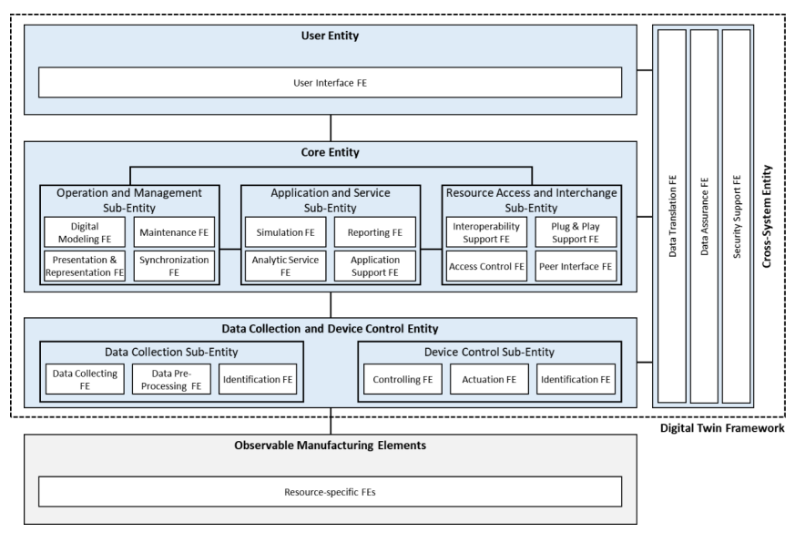
Fig 1. Frame work of ISO 23247-1 used for development of DT for manufacturing systems [17,18]
  - Cross-System Entity (CSE). The CSE resides across domains to provide common functionalities such as data translation, data assurance, and security support.
The study of Industrial Standards and the careful design of architecture are essential for constructing a successful Digital Twin (DT). Before developing a DT, understanding relevant standards is crucial as they provide foundational guidelines and benchmarks. A well-designed architecture based on these standards ensures seamless integration and communication within the manufacturing ecosystem, promoting interoperability and optimal performance.
Based upon above information a case study at IIT, Bombay [unpublished] as an example is presented in the figure [2] that depicts architecture of DT for a virtual machining simulator, adhering to Industrial Standards (ISO 23427-1) that ensures incorporation of all necessary functional entities, enabling effective replication and simulation of real-world machining processes.
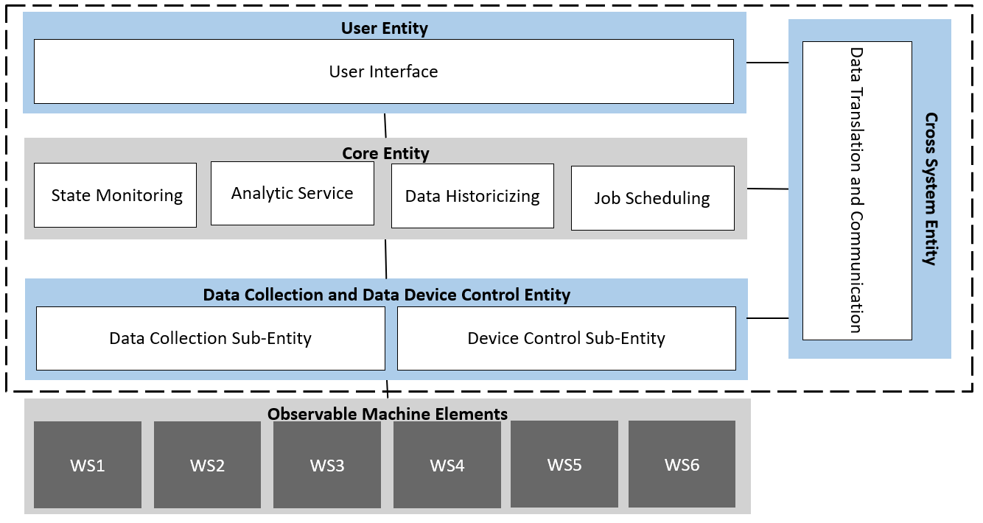
Fig 2. ISO23247 based DT architecture designed at IIT Bombay

- Observable Manufacturing Element
The observable manufacturing element of above architecture includes a six-workstation virtual manufacturing simulator developed by SMC International Training Pune (Kothrud) in collaboration with IIT-Bombay, which is basically a downsized version of a real-life manufacturing shop floor and is able to demonstrate/reflects all its functional operations as a unit shown in [Fig 3], except for the machining processes.
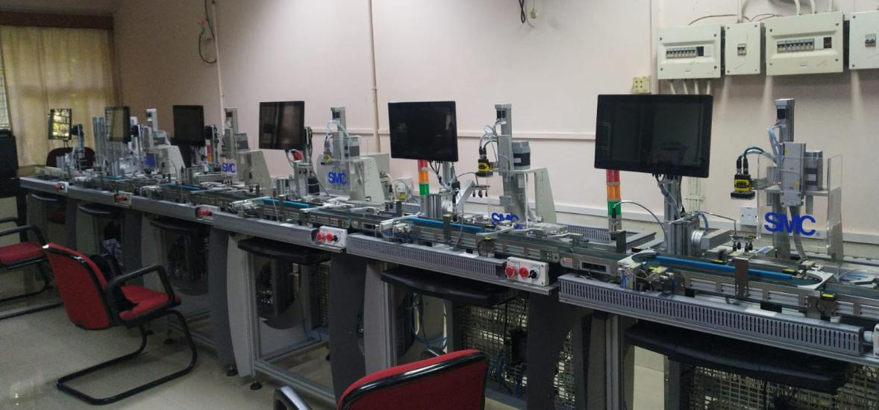
Fig 3. Virtual Machining Simulator developed in collaboration with SMC International Training at CAM Lab, IIT-Bombay
Virtual Machining Simulator for a manufacturing shopfloor comprised of differential set of workstations. However, the above Virtual Machining Simulator consists of six workstations referred as VM-KIT1 to VM-KIT6, each of these workstations are able to act as standalone processor or work in an integrated environment to produce single product or multiple products making this setup as extremely dynamic in nature. Every member of this simulator is an industrial grade appliance from the controller to every sensor used to know the operation details. The integrated model showing working of simulator and its associated workstations is presented in the flowchart [Fig. 4] and working of individual workstation is explained below:
a. VM-KIT1 Raw Material Feeding Station:
The first workstation is responsible for handling the function of providing raw materials (workpieces) to the rest of the workstations of the simulator, this workstation is comprised of five magazines, with each magazine capable of accommodating up to ten jobs simultaneously. Consequently, the workstation possesses a total capacity to store a maximum of 50 jobs at any given time.
b. VM-KIT2-6 Virtual Machining Stations:
The stations termed as VM-2 to VM-6 share a common objective and have same construct, all of them are installed to simulate an arbitrary industrial operation, there inspection member a camera is responsible for inspection and deciding whether the workpiece should be rejected or passed.

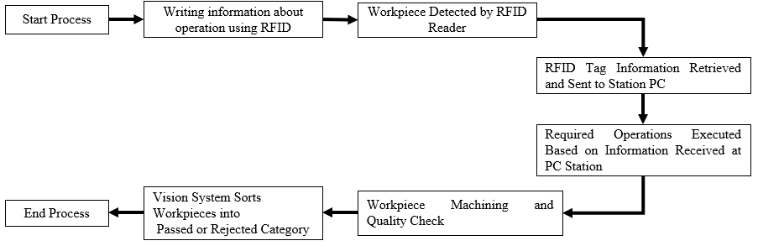
On VM-KIT1
On VM-KIT2 and rest

Fig. 4 Flowchart depicting the integrated working model of above simulator and its associated workstations.
- Data Collection and Device Control Entity (DCDCE)
For a physical system, the crucial component is data collection and device control entity. In above simulator the specific DCDCE is an industrial grade PLC developed by Beckhoff (Germany) known as C6030 IPC, which is an ultra-compact industrial PC that offers high-performance computing capabilities within a small form factor. It is designed to meet the demanding requirements of industrial automation applications where space is limited [19]. This controller works with multiple modules of Beckhoff that are given below:
- EK1100: EtherCAT Coupler: It is a device designed to enable communication and data exchange between EtherCAT I/O modules and a higher-level EtherCAT network. It serves as a gateway or interface that allows EtherCAT devices to connect and communicate with the EtherCAT master controller [20]. Following properties of this module makes it suitable for above simulator system:
  - EtherCAT connectivity: The EK1100 Coupler is specifically designed for EtherCAT networks, which is a high-performance industrial Ethernet technology widely used in automation and control systems. It supports the EtherCAT protocol, allowing for fast and deterministic communication between devices.
  - Real-Time Communication: EtherCAT is known for its real-time communication capabilities, enabling fast and synchronized data exchange between devices. The EK1100 Coupler ensures that the EtherCAT network maintains this real-time behaviour by efficiently handling the data transmission and synchronization tasks.
  - Configuration and Diagnostics: The EK1100 Coupler often includes configuration and diagnostic features to facilitate setup and troubleshooting. This may involve software tools or interfaces that allow users to configure parameters, monitor network status, and diagnose potential issues.

- EL9550 System terminal, surge filter system and field supply: It is a device that includes EtherCAT communication interface, protects devices from surges and transients, ensures reliable operation. Beckhoff Field Supply Device: Provides regulated power to field devices, ensures optimal performance in industrial automation systems [21]. It comprises of three sub-systems which serves different purposes given below:
  - EL9550 System Terminal: The EL9550 System Terminal is a device that acts as an interface between the field devices and the control system. It provides connections for power supply, communication, and control signals. This terminal allows for easy integration of field devices, such as sensors, actuators, and switches, into the overall automation system.
  - Surge Filter System: The Surge Filter System is designed to protect sensitive electronic equipment from voltage spikes and transient surges that can occur in industrial environments. These voltage disturbances can be caused by lightning strikes, power grid fluctuations, or switching operations within the system.
  - Field Supply: The Field Supply is a power supply unit dedicated to providing electrical power to the field devices located in the industrial environment. It ensures a stable and reliable power source for the operation of the field devices, even in challenging conditions.

- EL1809 HD EtherCAT Terminal: This device is a digital input terminal used in automation. It provides eight channels for digital input signals, allowing for the monitoring and control of various industrial processes and equipment [22]. Following are key features of this device:
  - Digital Inputs: The EL1809 HD EtherCAT Terminal offers 16 digital input channels, allowing for the connection and monitoring of 24 VDC signals. Each input channel can detect the status of a discrete signal, such as the presence or absence of voltage or a contact closure.
  - High-Density Configuration: This EtherCAT terminal is designed to provide a high-density input solution, allowing for efficient utilization of space and reduced wiring efforts. With 16 channels in a single module, it offers a compact and space-saving design for applications requiring a large number of digital inputs.
  - EtherCAT Communication: The EL1809 HD EtherCAT Terminal utilizes the EtherCAT communication protocol, a real-time Ethernet protocol widely used in industrial automation systems. EtherCAT enables fast and efficient communication between the terminal and the control system, ensuring real-time data exchange and synchronization.

- 16 Channel digital input 24 VDC, EL2809 16 Channel digital output terminal 24 VDC: It is a 16-channel digital output terminal designed for Beckhoff Automation systems. It provides 24 VDC digital output signals for controlling external devices or actuating outputs in industrial applications [23].
  - Digital Outputs: The EL2809 EtherCAT Terminal offers 16 digital output channels, each capable of switching a 24 VDC signal. These output channels can be used to control various devices or actuate components in an automation system, such as solenoid valves, relays, motors, or indicators.
  - High-Density Configuration: With 16 output channels in a single module, the EL2809 provides a high-density solution for applications that require a large number of digital outputs. This allows for efficient space utilization and reduces wiring efforts, resulting in a more streamlined and compact control system design.
  - EtherCAT Communication: The EL2809 terminal utilizes the EtherCAT communication protocol, which is a real-time Ethernet protocol widely used in industrial automation systems. EtherCAT ensures fast and synchronized communication between the terminal and the control system, enabling precise and timely control of the digital output signals

- EL6224 IO-Link terminal: It is an industrial input/output (I/O) module that supports the IO-Link communication protocol. It is designed to provide flexible and intelligent I/O connectivity in industrial automation systems [24] which have following salient features:
  - IO-Link Communication: The EL6224 terminal supports the IO-Link communication standard, which is a point-to-point serial communication protocol used for connecting sensors, actuators, and other devices in automation systems. IO-Link enables bidirectional communication between the terminal and IO-Link devices, facilitating advanced functionalities such as device identification, parameterization, and diagnostics.
  - High-Speed I/O: The terminal provides four digital inputs and four digital outputs, offering high-speed I/O capabilities for handling fast and time-critical signals. The inputs and outputs are designed to accommodate a variety of signal types, allowing for flexible integration of different types of sensors, switches, or actuators.
  - Device Monitoring and Diagnostics: With IO-Link support, the EL6224 terminal enables advanced device monitoring and diagnostics. It can retrieve detailed information from IO-Link devices, such as status, measurements, and diagnostic data, allowing for real-time monitoring of device health and performance. This feature helps in predictive maintenance, troubleshooting, and optimizing the overall system efficiency.
- EL3054 4-Channel Analog input terminal 4…20mA, single ended, 12bit: It is a 4-channel analog input terminal designed for industrial automation applications. It is specifically designed to measure analog signals in the range of 4 to 20mA [25]. Following points discusses the key features of this device due which it is compatible for above system:
  - Analog Input Channels: The EL3054 terminal offers four analog input channels, allowing simultaneous measurement of up to four analog signals. Each channel is capable of measuring signals in the range of 4 to 20mA, which is a common range used for various industrial sensors and transducers.
  - Single-Ended Inputs: The terminal supports single-ended inputs, which means each channel measures the voltage difference between the signal input and the terminal's reference potential. This configuration simplifies the wiring and installation process, as only one wire is needed for each analog input.
  - High Resolution: The EL3054 terminal provides a 12-bit resolution for analog measurements. This high resolution enables precise and accurate readings, allowing for detailed monitoring and control of analog signals. It ensures that even small changes in the input signals can be accurately detected and processed.

- EL 4004 4-Channel Analog output terminal 0…10V, 12 bits: It is a 4-channel analog output terminal designed for industrial automation applications. It is specifically designed to provide analog voltage output in the range of 0 to 10 volts [26]. Following are some key features of EL4004:
  - Number of Channels: The EL 4004 has 4 analog output channels, allowing you to control up to 4 independent analog signals simultaneously.
  - Analog Output Range: It supports a 0 to 10V analog output range, which means you can output voltage signals in the range from 0V to 10V.
  - Resolution: The terminal has a 12-bit resolution, providing fine granularity in voltage output levels.
Each of the above modules or boxes have unique desirable/specific characteristics which makes them highly suitable for the present simulator system used in case study. Detailed comprehensive study of above individual component is very essential for understanding the OME layer of architecture to know actual working of the physical system.
- Inputs required for industrial scheduling using DT
For improving the work efficiency of industry through the application of DT in industrial scheduling some pre-requisite data/inputs are required. Such inputs can be extracted from the available information in the workstation using specific sensors or can be synthesised by using different mathematical models/equations and/or through some coding techniques. In present study the information is generated by using different steps are explained below:
        - Selection of ideal sensors for physical system
For improvement in work efficiency of a physical system in era of Industry 4.0 automation of physical system plays a significant role. In this context an insight of the operations of that system is needed that can be obtained by using relevant/ideal sensors which are suitable to specific system. Selection criteria for ideal sensors should be based on the comprehensive knowledge by studying their data sheets. Some of desirable characteristics of sensors making them ideal are given below:
1. Sensing Principle: Understand the underlying sensing principle used by the sensor, such as resistive, capacitive, optical, or piezoelectric. This helps determine the sensor's working mechanism and limitations.
2. Measurement Range: Check the range of values the sensor can measure accurately. Ensure it covers the expected range of measurements for the intended application.
3. Accuracy: Evaluate the sensor's accuracy, which indicates how close the sensor's measurements are to the true value. Higher accuracy is crucial for precise applications.
4. Sensitivity: Consider the sensitivity, which refers to the smallest change in the measured parameter that the sensor can detect. Higher sensitivity is beneficial for detecting small variations.
5. Resolution: Assess the resolution, which defines the smallest incremental change in the measured quantity that the sensor can detect and display. Higher resolution provides finer measurement details.
6. Environmental Conditions: Consider the sensor's operating conditions, including temperature, humidity, and pressure range. Ensure the sensor can withstand the environment where it will be used.
7. Reliability and Lifespan: Consider the sensor's reliability and expected lifespan to assess its long-term usability and maintenance requirements.
By carefully considering these characteristics in sensor data sheets, engineers and users can make informed decisions to select the most suitable sensor for their specific application needs. The simulator used in the present study have following sensors embedded on the workstations to obtain the information about the operations that are being executed [30].
- BM-BJ100-DDT-P : A photoelectric sensor, is an equipment used to discover the absence, or presence of an object by using a light transmitter, often infrared, and a photoelectric receiver. The diffuse reflective type photoelectric sensor BM-BJ100-DDT-P is being used on the conveyors to detect the presence of the work piece at different locations
- BF4RP and BM-FD-420-05: The fiber optic type photoelectric sensors are best to use with complicated mounting places. Fiber optic amplifier BF4RP & fiber optic cable BM-FD-420-05 are being used to detect the presence of the material in the magazine
- BM-OBT150-R100-2EP-IO-0: The BM-OBT150-R100-2EP-IO-0 optical sensors are able to perform practically all standard automation tasks. In the virtual machine station 2 it performs the task of sensing the work piece on the entry side of the station and sends the data to PLC on IO-Link. And the entire series enables sensors to communicate via IO-Link.
- Cognex In-Sight 2000: Cognex In-Sight 2000 vision sensors combine the power of In-Sight vision systems with the simplicity and affordability of an industrial sensor. Ideal for solving error-proofing applications, these vision sensors set new standards for value, ease of use, and flexibility and can adapt to virtually any production line environment.
- IQT1-18GM-IO-V1: RFID read/write stations IQT1-18GM-IO-V1, in the virtual machine have IO-Link communication interface. The RFID read/write stations read and write tags using electromagnetic fields to automatically identify and track tags attached to objects. When triggered by an electromagnetic interrogation pulse from a nearby RFID reader device, the tag transmits digital data, usually an identifying inventory number, back to the reader.
- Read/Write Tags 13,56 MHz ISO15693: The read/write tags of an RFID system with 13.56 MHz offer significantly quicker access to the data than a comparable RFID system based on an operating frequency of 125 kHz. The 13.56 MHz system is standardized through ISO15693. All ISO15693-compliant read/write tags have a unique 8 byte read-only code.
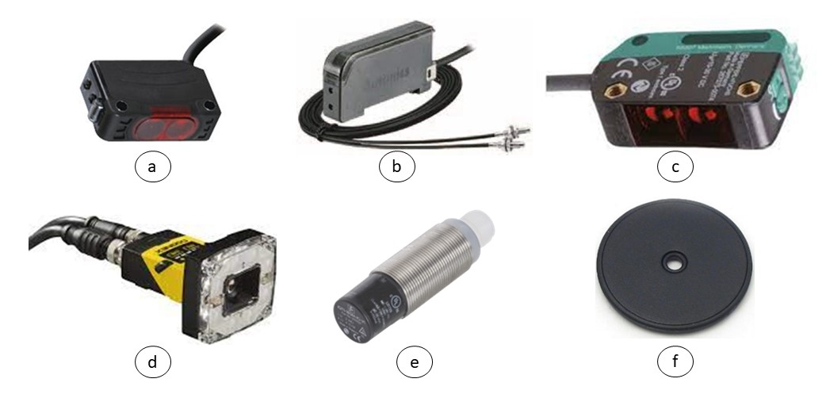
Fig. 7 Different sensors used for acquisition of real-time data in present case study at IIT-Bombay: a) BM-BJ100-DDT-P; b) BF4RP & BM-FD-420-05; c) BM-OBT150-R100-2Ep-IO-0; d) Cognex In-sight 2000; e) IQT1-18GM-VI and f) Read/Write Tags 13,56 MHz ISO15693
b. Retrieval of data from workstations
To acquire data or evaluate the data of interest mathematical models were developed using programming logic in Integrated Development Environment (IDE) specific to the PLC. Every PLC available in the market like PLC of Beckhoff, Siemens, Honeywell, Allen-Bradely etc. have their own unique IDEs used to program that PLCs. In present case study The Windows Control and Automation Technology (TwinCAT) IDE used and shown [Fig. 5]. Current model of this IDE is TwinCAT3 also known as TE1000 | TwinCAT 3 engineering which provides a convenient way for configuration of control, drive control and I/Os. In addition, this tool includes the configuration and programming of Twin SAFE, the safety solution from Beckhoff. It is integrated in a Visual Studio® version [27]. Following features distinguishes this product from others available in market:
- Pure configurations or PLC programming can be performed in the free Visual Studio® shell included.
- A connection to source code control tools is fully integrated.
- The programming of the PLC also takes place here.
- More than one PLC can be created and programmed.
- The inputs and outputs of the PLC can be linked to the inputs and outputs of the I/Os.
- The programs can be monitored and debugged online.
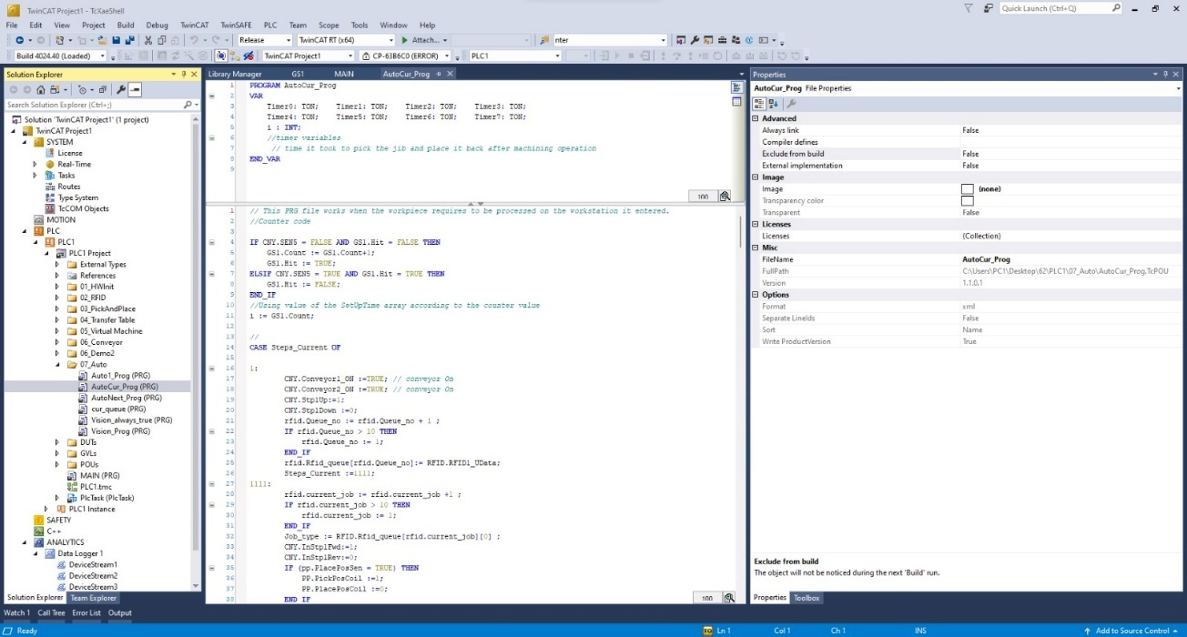
Fig. 5 Virtual image of the TwinCAT IDE used coding of simulator
The data retrieved from the workstation of any industrial unit/simulator needs to processed and analysed for its proper application in the industrial scheduling. The data can be characterised or classified into different groups based on learning from the concepts of Advanced Planning and Scheduling (APS). The data of interest for the physical system under study was divided into two categories viz workstation and job related as shown in Fig.6 and explained subsequently. The various mathematical equations/formulae developed and used for these categories are also elaborated below:
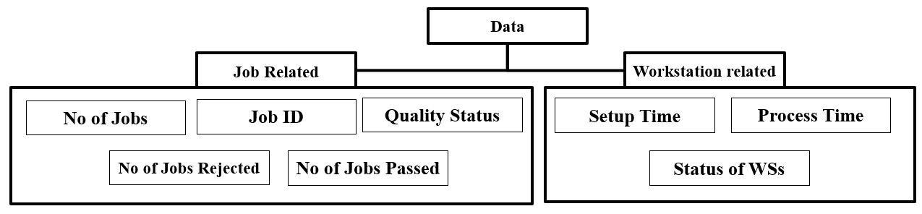
Fig. 6 Classification of retrieved data based upon the APS
- Acquisition of real-time data for core entity
Data acquired from the sensors embedded on the workstations related to job and workstation oriented was evaluated through mathematical modelling for which intensive study of the SMC operation program was worked out and based on the inputs from sensors a logic for acquiring the data was developed (equations I to III) for setup time, processing time and removal time as detailed below. To acquire the value for setup time, the controller (PLC) took into account the time when job enters the workstation and time when job is placed under the virtual machining tool using the following formula:
$ST=\left(STe-STs\right)×{10}^{-7}$ Equation-I
Where:
ST- is setup time (seconds)
STe-is the time when the job has been placed under tool and is ready for processing (seconds)
STs- is the time when job enters the workstation (seconds)

Each of these values of are extremely small as the TwinCAT function used to get these values, F_GetSystemTime() works with the precision of 100ns so the factor of 10⁻⁷ is multiplied to get the value of ST is seconds. Similarly, equation II and equation III below were developed and used for Processing Time and Removal Time, respectively.
$PT=\left(PTe-PTs\right)×{10}^{-7}$ Equation-II
$RT=\left(RTe-RTs\right)×{10}^{-7}$ Equation-III
Where:
PT- is the Processing Time (seconds)
PTe- is the time when the processing operation of the job has completed (seconds)
PTs- is the time when the machine is actually conducting the operation (seconds)
RT- is the Removal Time (seconds)
RTe- is the time when the job exits the system (seconds).
RTs- it the time when the removal of job starts (seconds).

- Communication and storage of real-time for core entity
Real-time data based on the variables from above equations I,II and III is acquired from different sensors needs to be properly stored for future processing and analysis through TwinCAT variables acquired in a form of data storage file format e.g., csv, excel spreadsheet, text file or a DBMS. To execute this assignment each workstation needs to communicate with the storage location device that must have a proper program with a communication protocol which ensures successful and secure data transfer. Some of the widely used communication protocols for Digital Twins designing are explained below:
- Open Platform Communication Unified Architecture (OPC UA): This communication protocol was released in 2008 as a data exchange standard that is widely used in industrial automation and manufacturing system for seamless and secure data transfer between different devices, machines and softwares [31]. It provides a platform-independent and interoperable solution for enabling data exchange and communication in diverse industrial environments. The basic operational model of this protocol is reflected below in Fig. 8.
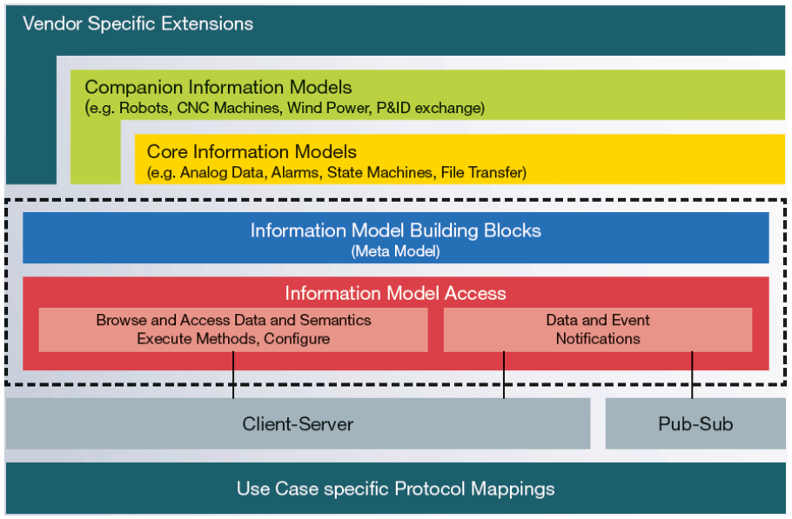
Fig. 8 Operational model of OPC UA communication protocol

- Message Queuing Telemetry Transport (MQTT): MQTT is a standard messaging protocol for the Internet of Things (IoT) based upon Organization for the Advancement of Structured Information Standards (OASIS). It is designed as an extremely lightweight publish/subscribe messaging transport that is ideal for connecting remote devices with a small code footprint and minimal network bandwidth [Fig. 9]. MQTT today is used in a wide variety of industries, such as automotive, manufacturing, telecommunications, oil and gas[32].

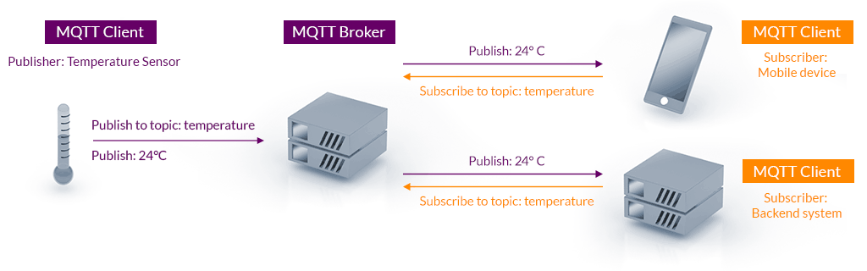
Figure 9 Elaborative structure of MQTT communication protocol
- Constrained Application Protocol (CoAP): CoAP is a specialized web transfer protocol for use in constrained nodes and networks in the Internet of Things. It is specially designed to enable simple & constrained devices to join the IoT even through limited networks with low bandwidth and low availability [Fig. 10]. It is generally used for machine-to-machine (M2M) applications such as smart energy and building automation. The protocol was designed by the Internet Engineering Task Force (IETF), and specified in IETF RFC 7252 [33].
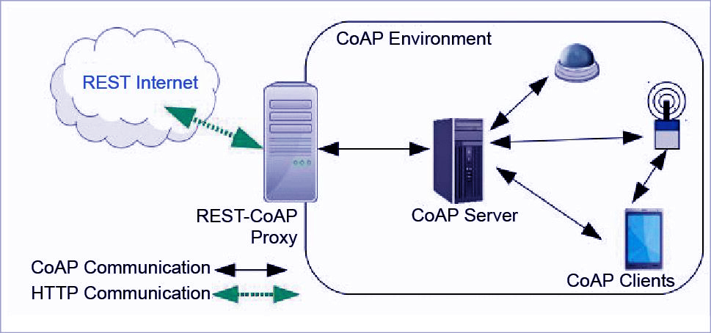
Fig. 10 Structure of CoAP communication protocol
Besides above, one of such communication protocol that is used by Beckhoff based systems is Automation Device Specification (ADS) which is a transport layer within the TwinCAT system. It was developed for data exchange between the different software modules, for instance the communication between the numerical control (NC) and the PLC. This protocol enables communication with other tools from any point within the TwinCAT [Fig. 11]. If it is necessary to communicate with another PC or device, the ADS protocol is used on top of Transmission Control Protocol/Internet Protocol (TCP/IP). Within a networked system it is thus possible to reach all data from any point. The ADS protocol runs on top of the TCP/IP or user datagram protocols (UDP/IP) protocols. It allows the user within the Beckhoff system to use almost any connecting route to communicate with all the connected devices and to parameterize them.
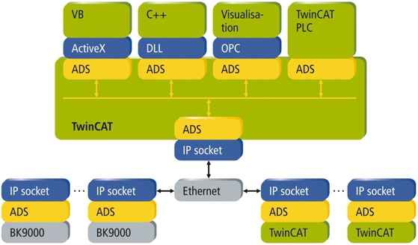
Fig 11 Automation Device Specification (ADS) communication protocol
These protocols are implemented using various programming languages and libraries are available to facilitate their usage [Table 1]. The choice of programming language depends on the requirement, target platforms, and availability of libraries and toolsets. Some the most common programming languages and libraries used for implementing these protocols are listed below:
Table 1 Programming languages and libraries for different communication protocols
Sno | Protocol | Programming Language | Library
1. | OPC UA | C++,C#,Java, Python, Node.JS | open62541 (C), Prosys OPC UA SDK (Java, C++), and python-opcua (Python)
2. | MQTT | Python, JavaScript(Node.JS), Java, C,C++,C# | Paho MQTT (Python, JavaScript, Java, C, C++, C#), MQTT.js (JavaScript), Eclipse Mosquitto (C
3. | CoAP | C, C++, Java, Python, JavaScript (Node.js). | Californium (Java), libcoap (C), aiocoap (Python), CoAPthon (Python)
In order to use ADS protocol through python programming there is a python library called pyADS, which is a python wrapper for TwinCATs ADS library. It provides python functions for communicating with TwinCAT devices. pyads uses the C API provided by TcAdsDll.dll on Windows adslib.so on Linux[34]. Following flowchart [Fig. 12] represents the methodology for using pyADS library to view data in a DataFrame and convert it into a csv file.
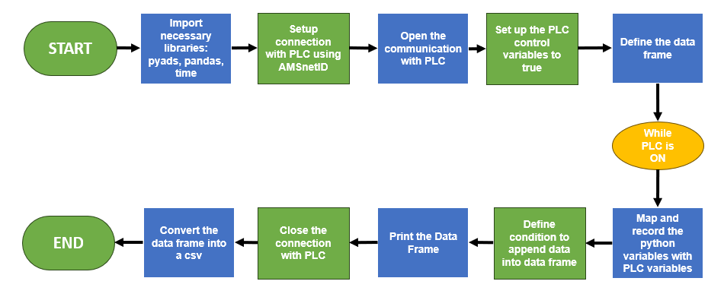
Fig. 12 Working flowchart for data acquisition and storing FE
- Assessment of simulator work efficiency using DT
To investigate the positive or negative effect of changes in the shop floor, a company has to assess shop floor performance. It is defined as a managerial key that integrates the tasks for the controlling event, which guides an organization to be within acceptable and desirable parameters [35]. However, Gunasekaran [36] stated that production performance has to be assessed to develop an efficient and effective shop floor. Performance measurement provides a means to capture performance data, which can be used to evaluate organizational performance. Thus, performance measurement and metrics are essential for objective setting, performance evaluation, and future work identification [35]. Some of the basic analysis that can be done to gain insight on the operation performance are:
- Throughput Rate: Throughput rate is defined as the rate of production in a process over a specific amount of time.[37] It is a measure of the number of parts completed per unit time and is expressed as
$Throughput rate= \sum_{i=1}^{T}{\frac{P_{i}}{T}}$
where $P_{i}$ is the number of parts completed in unit time $i$ and $T$ is the completion time.
- Machine Utilization. Machine utilization measures the machine usage intensity and is computed as the percentage of busy hours that a machine runs to complete the given tasks. The data can be acquired from the statistical report generated by the WITNESS simulation software[37]. Average machine utilization can be expressed as the sum of all the machine busy times divided by the total number of machines, which is represented as
$Average machine utilization=\frac{\sum{machine busy time (\%)}}{total number of machines}$
- Operator Utilization. Operator utilization reflects the overall performance or productivity of the process and refers to the percentage of busy hours that an operator requires to complete given tasks. The data can be obtained from the statistical report generated by the WITNESS simulation software[37]. The average operator utilization can be computed as the sum of all the operator busy times divided by the total number of operators, which is represented as
$Average operator utilization=\frac{\sum{operator busy time (\%)}}{total number of operator}$
- OEE Matrix: It is a metric used to measure the performance and effectiveness of a manufacturing or production system. The OEE matrix provides a structured approach to assess and analyse the overall equipment efficiency by breaking it down into three key components: Availability, Performance, and Quality [38].
- Availability: This component measures the actual operating time of the equipment compared to the planned or scheduled time. It considers factors such as equipment failures, setup time, changeovers, and unplanned downtime. The availability is calculated as the ratio of the actual operating time to the planned operating time.
- Performance: This component evaluates the equipment's speed or rate of operation compared to the ideal or designed speed. It accounts for factors like machine speed, slowdowns, and minor stoppages. The performance is calculated as the ratio of the actual production rate to the maximum achievable production rate.
- Quality: This component examines the quality of the produced parts or units compared to the desired or target quality. It considers factors such as defects, rework, scrap, and rejected parts. The quality is calculated as the ratio of good parts produced to the total parts produced .
- Quality Analyses: to determine how many of the jobs are processed passes the acceptance criteria, it is essential for a manufacturing plant to determine how many processed goods meet the criteria.

$Quality= \frac{No of jobs passed/rejected}{total number of jobs}$
Following the rules of analyses and depending on the type of data that is available, one can develop the analytics FE using any of the programming languages, but it is important that development of all the FEs of DT are done in same language.
- Data visualization in DT
In the realm of Digital Twin (DT) technology, visualization plays a vital role in providing a comprehensible format of data that allows users to gain insights into the system's processes and understand its behaviour, performance, and interactions. It serves as a means of communication between the machine and the human operator, facilitating the exchange of reliable data for analysis and decision-making. Implementation of visualization requires the adherence to proper communication protocols to ensure the stability and accuracy of the visualized data. By following established protocols, users can effectively identify patterns, anomalies, and trends that may not be readily apparent in raw data alone. There are several methods for implementing visualization in DTs. One approach is to replicate every motion component, creating a visual representation that closely mimics the physical system this type of visualization is not necessary in case of shop floor but can be essential for creating DTs of some mechanical system where motion of the parts in the space need to visualized. Another method involves developing a Human-Machine Interface (HMI), enabling bidirectional communication between the machine and the human operator, this type of Visualisation is highly used in the industry but the platform to develop these functionalities are subscription based paid services, thus not always ideal to create HMI for an early-stage DT.
Besides above visualization techniques, a Graphical User Interface (GUI) can be utilized that allows the machine to communicate information to the human operator without the ability for direct human-machine interaction. Though GUI is unidirectional, it offers advantages such as ease of development and versatility in visualizing raw data and status of physical system in-real time. By employing effective visualization techniques in a DT, users can derive valuable insights, make informed decisions, and optimize the system's performance. Whether through accurate replication, bidirectional communication, or one-way data visualization, which serves as a crucial tool in enhancing the understanding and utilization of DT technology. There are many ways to develop a GUI, one of such techniques which is widely used is web-based GUI, based in the principles of HTML, CSS, java, SQL and OPC UA communication protocol. But this one requires intensive knowledge of these programming languages. Even though it makes GUI interoperable it requires a lot of time. Another method for creating a GUI is by using Python IDE and its libraries. Python allows creation of highly dynamic GUI dashboards which are created by importing appropriate libraries [40] some of them are detailed below:
a. PyQT5
PyQT5 is a graphical user interface (GUI) framework for Python. It is very popular among developers and the GUI can be created by coding or a QT designer. A QT Development framework is a visual framework that allows drag and drop of widgets to build user interfaces. It is a free, open-source binding software and is implemented for cross platform application development framework. It is used on Windows, Mac, Android, Linux and Raspberry PI. For the installation of PyQT5 , you can use the following command: pip install pyqt5.
b. Python Tkinter
Another GUI framework is called Tkinter. Tkinter is one of the most popular Python GUI libraries for developing desktop applications. It’s a combination of the TK and python standard GUI framework. Tkinter provides diverse widgets such as labels, buttons, text boxes, checkboxes that are used in a graphical user interface application. The button control widgets are used to display and develop applications while the canvas widget is used to draw shapes like lines, polygons, rectangles, etc. in the application. Furthermore, Tkinter is a built-in library for Python, so you don’t need to install it like another GUI framework. Given below is an example of coding using Tkinter.
c. PySide 2
The third Python GUI libraries that we are going to talk about is PySide2 or you can call it QT for python. Qt for Python offers the official Python bindings for Qt (PySide2), enabling the use of its APIs in Python applications, and a binding generator tool (Shiboken2) which can be used to expose C++ projects into Python. Qt for Python is available under the LGPLv3/GPLv3 and the Qt commercial license. For the installation of PySide 2, you can use the following command: pip install pip install PySide2.
Engineers and programmers have advised that among above libraires, tkinter is generally for getting started with development of GUI because of below mentioned advantages:
- Built-in Library: Tkinter is a built-in library in Python, which means it comes pre-installed with most Python installations. This eliminates the need for additional installations or dependencies, making it readily available for GUI development. Availability of resources across the internet makes it easier for new users to understand it’s working.
- Easy to Learn and Use: Tkinter provides a simple and intuitive interface, making it easy for beginners to get started with GUI development in Python. Its straightforward syntax allows developers to create GUI components with minimal effort.
- Wide Adoption: Tkinter has been around for a long time and has a large user base, resulting in an active community and extensive documentation. Many resources, tutorials, and examples are available to help developers learn and troubleshoot.
- Customizable Widgets: Tkinter offers a wide range of customizable GUI widgets, including buttons, labels, text boxes, dropdown menus, and more. It allows developers to create aesthetically pleasing and interactive interfaces.
- Integration with Other Libraries: Tkinter can be easily integrated with other Python libraries and frameworks, enabling developers to add additional functionality and features to their GUI applications.
Since, Tkinter is integrable with other libraries, pyADS is utilized to capture the data for display directly from the variables of the TwinCAT operation code in present case study. GUI constructed in study comprised of following three sub parts:
- Time Parameters: Displayed the values of setup time, process time and removal time, for each workstation. The values are updated every second and changed if new values are present
- Job Parameters: Exhibited the quality of status of jobs at WS. It takes into account the number of jobs processed by the WS and the number of jobs that passed quality check and the ratio is expressed in percentage.
- Workstation Status: Finally, the operator can also monitor the status of each and every WS of the simulator. Such status can give insights regarding the working of simulator based on the data and is depicted in different categories like WORKING, ERROR or EMERGENCY conditions of workstations. An outline of simulator data generated for creating GUI using Tkinter and its interpretations are presented in Fig.13 which helps the operator to detect any remote anomaly and monitor quality of production of different workstations or simulator.
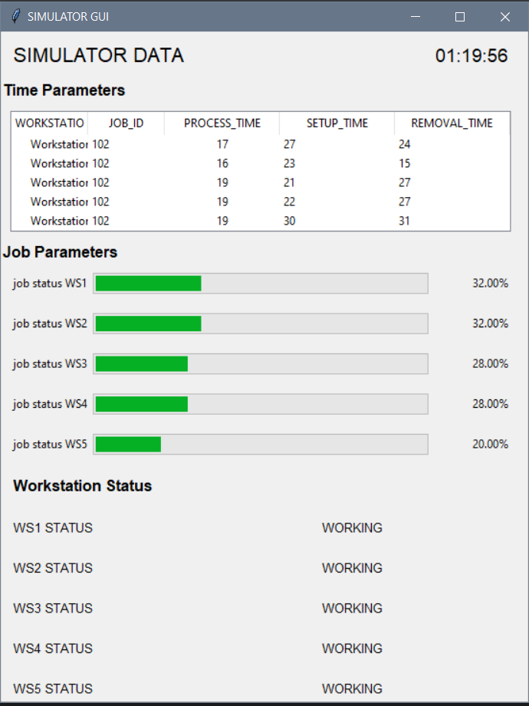
Fig. 13 Illustration on Tkinter created GUI of the simulator

- Integrated role of ML and DT in industrial scheduling
Industry 4.0 has given rise to an emerging sector in manufacturing called smart manufacturing that opens doors for analytics in the industry. It is a technology-driven approach that utilises the IoT and internet-connected devices to produce goods and monitor processes. Its goal is to automate the processes involved in manufacturing to maximise efficiency, increase sustainability, supply chain management, and identify the systems barriers even before they occur by generating, optimising, and implementing enormous volumes of data. With the application of advanced analytics such as artificial intelligence (AI) and machine learning (ML) on industrial data, manufacturers can gain insights to optimise the productivity of individual assets as well as the total manufacturing operation [41].
Machine Learning (ML) has revolutionised the traditional manufacturing era into the smart manufacturing era of Industry 4.0. This paradigm shift is creating and providing new opportunity to technocrats in industry. Industrial IoT (IIoT) is a subset of the IoT which refers to a network of physical devices that are digitally interconnected, facilitating the communication and exchange of data through the internet. IIoT interconnects machines through various sensors, radio frequency identification (RFID) tags, software, and electronics which are integrated with machines to collect real-time data [41]. The manufacturing environment offers enormous opportunities to leverage ML techniques for better decision-making [30]. Data analytics in the manufacturing industry can be used to amplify growth in the following domains (but not limited to):
- Improve assembly-line efficiency using data analytics.
- Improved Customer Experience, including personalisation and finding individualised value propositions.
- Inventory management by Real-time insights and visibility into inventory along the supply lines and Delivery route optimizations
- Minimise loss associated with delayed, damaged, or lost goods in transport and for providing real-time asset management include real-time alerts
- Reduce errors and corrections during product development and improve the product’s quality and packaging with, Analytics-backed simulations and Product modelling
- Predictive maintenance helps increase assets’ lifetime by, Asset Management, Improving asset availability, Detection of faults and defects and Prevention of unplanned downtimes.
For the scope of improving the scheduling efficiency of the simulator, the ML approach is applied on the data obtained from the DT such as quality analysis of jobs after processing and parameters like due dates, number of rejected jobs etc. whose data values results in a penalty. To optimise the efficiency of the existing scheduling algorithm, this factor of penalty should be minimum. In order to improve the efficiency, one must know the value of existing algorithm for which following methodology can be applied:
  - Automation of RFID tagging and Job Assignment
RFID tagging is a form of wireless communication that leverages the use of electromagnetic or electrostatic coupling in the radio frequency portion of the electromagnetic spectrum to either read data or write data[43]. This technique is used to assign unique job IDs to every job in the magazine and also employ the processing station. RFID reader/writer of the VM-1 is responsible for writing this information on the RFID tags. To deliver this function autonomously an algorithm is developed that arranges the job according to the scheduling algorithm by taking due dates as input.
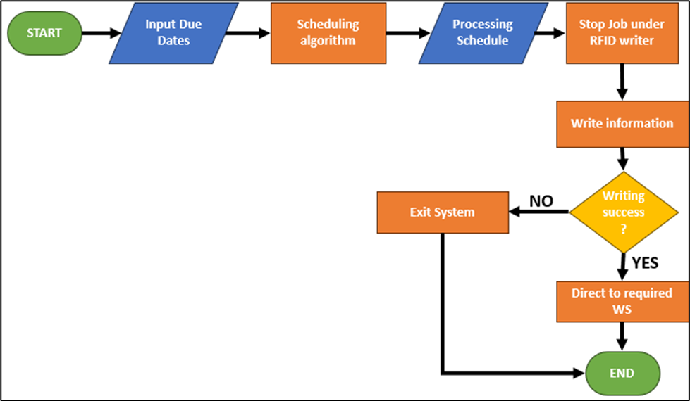
Fig. 14 Flow chart showing automation of RFID tagging and job assignment
  - Automation of TwinCAT operation code for assigning variable process time for jobs
To bring the system closer to reality, instead of writing and processing the jobs for a predetermined amount of process time, an algorithm was developed to hold the jobs for unique and undetermined amount of time, as in reality only the type of operation is known and time required to complete the operation depends on the job placement, movement of tool from home position to zero position and complexity of geometry. Therefore, automation of TwinCAT operation code was integrated to assign variable process time to resolve the issue of randomness and following alterations were made in the simulator:
- The code starts with a variable declaration (VAR section) that define variables used in the program, but the specific variables are not shown in this snippet.
- Inside the program, there is an IF-THEN block. It checks if the variable "GeneraterandomValue" is true. If it is true, the program generates two random numbers U1 and U2 using the RAND function. The RAND function generates random values between 0 and 1. After generating the random numbers, the "GeneraterandomValue" variable is set to FALSE, presumably to prevent generating new random numbers on each iteration.
- Next, the code calculates a value "Z0" using the random numbers U1 and U2. The calculation involves applying the Box-Muller transform [42] to generate a normally distributed random value "Z₀."
$Z_{0}= R\cos{θ= \sqrt{-2lnU_{1}}\cos{(2πU_{2})}}$
Where, U1 and U2 are independent sample chosen from uniform distribution on the unit interval (0,1).
Z₀ is independent random variables with standard normal distribution.
- After that, the code calculates the processing time "ProcessT" using the values from arrays M and SD, and a factor rPT, along with the random value "Z0." The specific details of the calculation depend on the actual values of the variables and arrays used in this code, which are not provided in the snippet.
- The LREAL_TO_TIME function is used to convert the calculated processing time from a real number (LREAL) to a time data type. The multiplication by 1000 suggests that the values in arrays M and SD are possibly in seconds, and the result is converted to milliseconds.
  - Efficiency Evaluation for Parallel Machine Problem
In this section, we focused primarily on parallel machine problem; where apart from the feeding workstation WS1 there were two more workstations WS2 and WS3 on which the jobs were processed parallelly, half of the jobs stored were processed by workstation WS2 and another half on WS3. We received output at workstations, instead of obtaining the output at the end of line. To address such type of issues written in the first step, the workstations are able to know whether to process the job or pass it to other member of the line. The job assignments need to be equally diverted among different workstations as per the model given in Fig.15 below that used a simple separation logic.
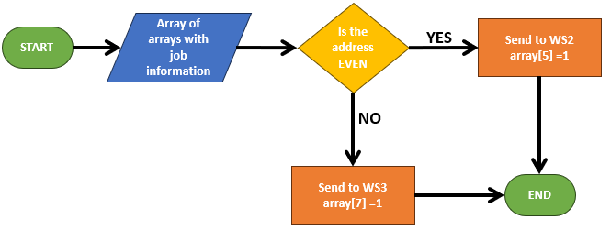
Fig.15 Logic flowchart for equal distribution of jobs on parallel systems
  - Utilization of DT data for Industrial Scheduling
From the data collection functional entity (FE) of the DT, relevant data is acquired and stored in the csv file format. This data is further used to conduct analysis which is mainly focused on identifying the useful trends which can help in scheduling the jobs according to the need of the customer. For example, in our project, we considered two types of demands be required by the customer i.e., Quality of job and Quantity of jobs.
- Quality means the quality of the jobs processed is the main parameter for the passing criteria of workstation/simulator.
- Quantity: When completion of order in quantum processed is the main concern with some tolerable defects is the main parameter for the passing criteria of workstation/simulator.
Based upon such type of DT data in industrial scheduling will help to achieve multiple production goals simultaneously that improves that working efficiency of system. An example in this regard has been presented in Fig.16 for quality and Fig.17 for quantity parameters.

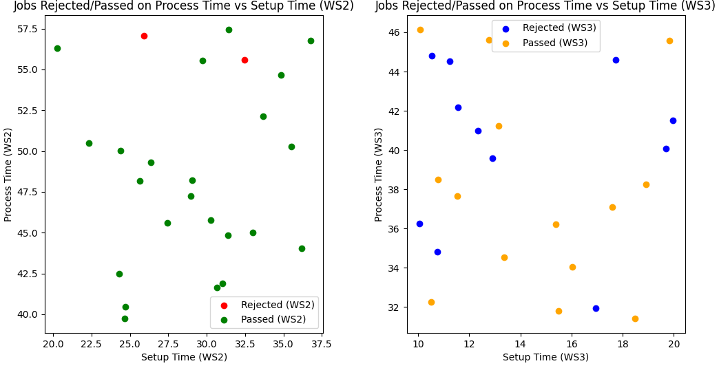
Figure 16 scatter plot for knowing relation between outputs and processing parameters for 50 jobs
For this simulation 50 jobs were equally divided among WS2 and WS3 and it is observed that jobs produced at WS2 have low chances of being rejected, about 8% of the total jobs were rejected. Whereas if the jobs are produced at WS3 the chances of rejection are much higher, it is observed that 44% of the total jobs were rejected.
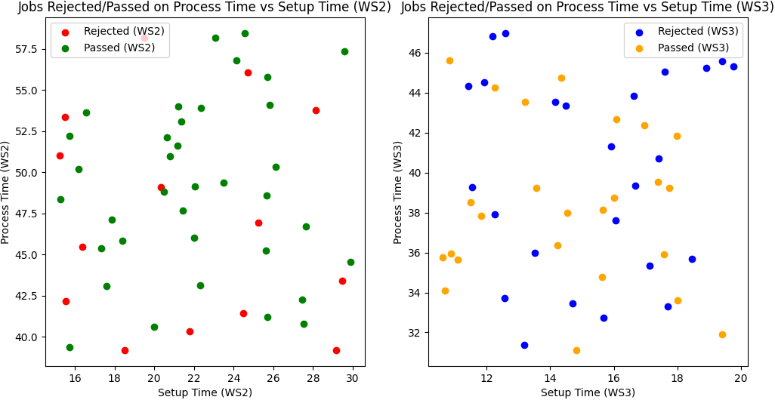
Figure 17 scatter plot for knowing relation between outputs and processing parameters for 100 jobs
Further on increasing the dataset it observed that WS3 is able to produce same number of jobs in less time. Therefore, WS3 is a favourable choice if there is demand of producing large batch in tight deadlines and some quality defects can be tolerable. Whereas, WS2 is favourable if quality is the main concern. Based on these parameters can be assigned position in the RFID array and depending on these the jobs will be assigned to specific workstation.
  - Scheduling algorithm Efficiency Evaluation using DT
To evaluate the efficiency of the scheduling algorithm on workstation, we look up the results from the analysis and prominent trends of multiple factors which are responsible for producing a particular result. Accordingly, weights were assigned to each of those factors, to work out the efficiency of existing scheduling algorithm in simulator. For example, if two factors viz. Due Date and Quality are the deciding parameters, and depending on the penalties caused by the processing of each workstation, the efficiency of the existing scheduling algorithm was evaluated. Assigning the weights to tardiness penalty and rejected penalty as 20 and 10, respectively; the scheduling efficiency( $η_{\%}$ ) was estimated as per equation given below:

$η_{\%}=\left(1- \frac{total penalty}{no of jobs\left(late job penalty+rejected job penalty\right)}\right)*100$
The score of evaluation of efficiency, provide valuable insights for further optimization and improvement in algorithm of scheduling for the simulator. If the value of $η_{\%}$ is low less than 50% means that the scheduling algorithm is inefficient, if the score is between 50-75% it is moderate and is good for handling a smaller number of jobs, and if score is more than 75% it is considered as an efficient. Therefore to improve the scheduling efficiency following majors needs to be adopted:
- Increase the number of processors: this will result in the distribution of jobs among multiple processors which enables the simulator to produce more jobs in less amount of time. But an efficient distribution algorithm needs to be developed also it can be expensive to add new workstations.
- Decrease the idle time: factors like setup time, removal time make up the factor of idle time, this is the time when there is no processing is conducted. Reducing this will improve the speed of production. Only downside of this method is that we can only reduce it to a certain value, if it reduced further, it will disrupt the synchronization among workstations.
- Improving the scheduling algorithm: this is the most reliable but toughest technique, to improve the efficiency. This method requires a deep understanding of industrial scheduling and python programming. The limitations of this method are that there is no guarantee that the new algorithm will result in better efficiency.

X . Future Prospectus and conclusion
Digital twin is a technology that is shaping all industries, due its ability to replicate all the abilities of a physical system it has become highly popular in the domain of simulation-based researches, understanding the behaviour of physical system under different conditions or even real time remote analysis of a system. All of applications makes DT highly favourable in the age of digitisation. The successful implementation of a DT is a highly complex and time-consuming process as it requires deep understanding of physical system, knowledge sensors and advanced programming skills. Further methodology of creating the FEs of the DT discussed in this chapter is not unique, as for creating the data acquisition FE instead of using hardware specific softwares and protocols one can utilise more generic tools like Node.JS of Java and OPC UA communication protocol to create their own data acquisition algorithm and capture the relevant data. Similarly, one can utilise technologies like HTML5, Java and CSS to create a web-based data visualization tool that is platform independent and is accessible on any sort of screen and once it is connected with the internet, users can access sit from anywhere. Machine Learning is a diverse subject and its application is limitless and ever expanding which adds to the complexity in its application. The FEs a DT possesses determines the bounds of Machine Learning, for example ML can be employed on the manufacturing line DT to predict failure of a machine after monitoring the quality, or ML can also be used to employ dynamic scheduling which sensitive towards the nature of market and availability of resources. Due such favourable characteristics DT finds its application not only in the field of manufacturing but also in the fields like agriculture, medical sciences, automobile engineering, smart city development and much more.

XI. References
[1] Britannica, The Editors of Encyclopaedia. (2023, June 8). Industrial Revolution. Encyclopedia Britannica. Retrieved July 24, 2023, from https://www.britannica.com/money/topic/Industrial-Revolution

[2] Hyde, C. K. (2013). Arsenal of democracy: The American automobile industry in World War II. Wayne State University Press.

[3] Gökalp, E., Şener, U., & Eren, P. E. (2017). Development of an Assessment Model for Industry 4.0: Industry 4.0-MM. Informatics Institute, Middle East Technical University, Ankara, Turkey.

[4] Kunii, T. L. (1997). The 3rd Industrial Revolution through Integrated Intelligent Processing Systems. In 1997 IEEE International Conference on Intelligent Processing Systems (pp. 1-6).

[5] Culot, G., Nassimbeni, G., Orzes, G., & Sartor, M. (2020). Behind the definition of Industry 4.0: Analysis and open questions. International Journal of Production Economics, 226, 107617. ISSN 0925-5273. https://doi.org/10.1016/j.ijpe.2020.107617.

[6] Pfeiffer, S. (2017). The Vision of "Industrie 4.0" in the Making—a Case of Future Told, Tamed, and Traded. Nanoethics, 11, 107-121. https://doi.org/10.1007/s11569-016-0280-3.

[7] World Economic Forum. (2016). The future of jobs: Employment, skills and workforce strategy for the fourth industrial revolution. Retrieved from http://www3.weforum.org/docs/WEF_Future_of_Jobs.pdf.

[8] Bauer, W., & Horváth, P. (2015). Industrie 4.0 - Volkswirtschaftliches Potenzial für Deutschland. Controlling, 27, 515-517.

[9] Pinedo, M. L. (2016). Introduction. In Scheduling. Springer, Cham. https://doi.org/10.1007/978-3-319-26580-3_1.

[10] Şimşit, Z. T., Günay, N. S., & Vayvay, Ö. (2014). Theory of Constraints: A Literature Review. Procedia - Social and Behavioral Sciences, 150, 930-936. ISSN 1877-0428. https://doi.org/10.1016/j.sbspro.2014.09.104.

[11] Cheng, T. C. E., & Podolsky, S. (1996). Just-In-Time Manufacturing: An Introduction (2nd ed.).

[12] Elmaghraby, S. E. (2003). Operations Research. In Encyclopedia of Physical Science and Technology (Third Edition).

[13] Grieves, M. (2016). Origins of the Digital Twin Concept. doi:10.13140/RG.2.2.26367.61609.

[14] Tao, F., Xiao, B., Qi, Q., Cheng, J., & Ji, P. (2022). Digital twin modeling. Journal of Manufacturing Systems, 64, 372-389. ISSN 0278-6125. https://doi.org/10.1016/j.jmsy.2022.06.015.

[15] Kritzinger, W., Karner, M., Traar, G., Henjes, J., & Sihn, W. (2018). Digital Twin in manufacturing: A categorical literature review and classification. IFAC-PapersOnLine, 51, 1016-1022.

[16] Melesse, T. Y., Di Pasquale, V., & Riemma, S. (2020). Digital Twin Models in Industrial Operations: A Systematic Literature Review. Procedia Manufacturing, 42, 267-272. ISSN 2351-9789. https://doi.org/10.1016/j.promfg.2020.02.084.

[17] Shao, G. (2021). NIST Advanced Manufacturing Series 400-2: Use case scenarios for Digital Twin Implementation Based on ISO 23247. Retrieved from https://doi.org/10.6028/NIST.AMS.400-2.

[18] Unknown. (n.d.). ISO Standard 23247. Retrieved from https://www.ap238.org/iso23247/

[19] Beckhoff. (2021). C6030| Ultra-compact Industrial PC. From Beckhoff Automation: https://www.beckhoff.com/en-en/products/ipc/pcs/c60xx-ultra-compact-industrial-pcs/c6030.html

[20] EK1100 | EtherCAT Coupler. From Beckhoff Automation: https://www.beckhoff.com/it-it/products/i-o/ethercat-terminals/ek1xxx-bk1xx0-ethercat-coupler/ek1100.html?pk_campaign=AdWords-AdWordsSearch-EtherCat_dynamic_EN&pk_kwd=

[21] EL9550 | System terminal, surge filter system and field supply. From Beckhoff Automation: https://www.beckhoff.com/en-en/products/i-o/ethercat-terminals/el9xxx-system/el9550.html

[22] EL1809 | EtherCAT Terminal, 16-channel digital input, 24 V DC, 3 ms. From Beckhoff Automation: https://www.beckhoff.com/en-en/products/i-o/ethercat-terminals/el1xxx-digital-input/el1809.html

[23] EL2809 | EtherCAT Terminal, 16-channel digital output, 24 V DC, 0.5 A. From Beckhoff Automation: https://www.beckhoff.com/en-en/products/i-o/ethercat-terminals/el2xxx-digital-output/el2809.html

[24] EL6224 | EtherCAT Terminal, 4-channel communication interface, IO-Link, master. From Beckhoff Automation: https://www.beckhoff.com/en-en/products/i-o/ethercat-terminals/el6xxx-communication/el6224.html

[25] EL3054 | EtherCAT Terminal, 4-channel analog input, current, 4…20 mA, 12 bit, single-ended. From Beckhoff Automation: https://www.beckhoff.com/en-en/products/i-o/ethercat-terminals/el3xxx-analog-input/el3054.html

[26] EL4004 | EtherCAT Terminal, 4-channel analog output, voltage, 0…10 V, 12 bit. From Beckhoff Automation: https://www.beckhoff.com/en-en/products/i-o/ethercat-terminals/el4xxx-analog-output/el4004.html

[27] Beckhoff. (n.d.). TwinCAT 3 Engineering. From Beckhoff Automation. Retrieved from https://www.beckhoff.com/en-en/products/automation/twincat/texxxx-twincat-3-engineering/te1000.html

[28] Patronabis, D. (2011). Sensors and Transducers. Prentice Hall India.

[29] Doebelin, E. O., & Manic, D. N. (2019). Measurement Systems: Applications and Design (7th ed.). McGraw-Hill.

[30] SMC International Training. (n.d.). OPERTION MANUAL_X1Z70010A.

[31] OPCUA Foundation. (n.d.). OPC Unified Architecture. Retrieved from https://opcfoundation.org/about/opc-technologies/opc-ua/

[32] MQTT.org. (n.d.). Retrieved from https://mqtt.org/

[33] Radiocrafts Embedded Wireless Solutions. (2021). COAP (Constrained Application Protocol). Retrieved from https://radiocrafts.com/technologies/coap-constrained-application-protocol/#:~:text=COAP%20is%20basically%20a%20client,the%20same%20used%20by%20HTTP.

[34] Lehmann, S. (2021). pyads 3.3.9 [Software]. Retrieved from https://pypi.org/project/pyads/

[35] Panjehfouladgaran, H., Yusuff, R., Hong, T. S., & Homayouni, S. M. (2010). Qualitative performance measurement of supply chain management using fuzzy logic controller. In Proceedings of the 11th Asia Pacific Industrial Engineering and Management System Conference.

[36] Gunasekaran, A., Patel, C., & Tirtiroglu, E. (2001). Performance measures and metrics in a supply chain environment. International Journal of Operations and Production Management, 21(1-2), 71-87.

[37] Jawahar, N., Ng, Y. W., Ren, J. J. C., & Kamaruddin, S. (2014, September 8). Analysis of Shop Floor Performance through Discrete Event Simulation: A Case Study. Journal of Industrial Engineering, 2014, 878906. doi:10.1155/2014/878906.

[38] Stamatis, D. H. (1997). The OEE Primer: Understanding Overall Equipment Effectiveness, Reliability, and Maintainability. CRC Press.

[39] Anu. (2020, August 20). Top 5 Best Python GUI Libraries. AskPython. Retrieved from https://www.askpython.com/python-modules/top-best-python-gui-libraries

[40] Rai, R., Tiwari, M. K., Ivanov, D., & Dolgui, A. (2021). Machine learning in manufacturing and industry 4.0 applications. International Journal of Production Research, 59(16), 4773-4778. doi:10.1080/00207543.2021.1956675.

[41] Scott, D. (2011, March 1). Box-Muller transformation. Wiley Interdisciplinary Reviews: Computational Statistics, 3. doi:10.1002/wics.148.

