CURRENT UPDATES ON ISOLATION, MAINTENANCE, IMPROVEMENT & PRESERVATION OF INDUSTRIAL STRAINS

Department of Biotechnology, Isabella Thoburn College, Lucknow, Uttar Pradesh, India

Amina Fatima, Anima Verma, Daniya Ahmad, Farhat Khan, Krishna Tripathi,

Dr. Vidya Meenakshi*

Corresponding Author: vidyameenakshi@gmail.com

ABSTRACT
Microbial strains play a pivotal role in various industrial processes, from biotechnology and pharmaceuticals to food production and environmental remediation. A comprehensive understanding of microbial strain diversity and classification is critical for realizing their full potential in addressing global challenges and improving human well-being is important. This paper presents a comprehensive exploration of the methods and strategies employed in the isolation, maintenance, improvement, and preservation of microbial strains, with a primary focus on their significance in industrial applications. This paper highlights the critical process of microbial strain isolation and delves into the maintenance of isolated strains, elucidating the importance of culture preservation and continuous propagation. This study also explores strategies for microbial strain improvement, encompassing both traditional and modern approaches and emphasizes the importance of strain preservation in ensuring the long-term availability and viability of industrially relevant strains. This paper underscores the indispensable nature of microbial strains in contemporary scientific research and industrial applications.
KEYWORDS – Microbial strains, biotechnology, strain preservation

INTRODUCTION

Microbial strains represent a vast and diverse reservoir of biological entities with profound implications across numerous scientific disciplines and industrial applications. These microscopic organisms, encompassing bacteria, archaea, fungi, and viruses, have been instrumental in shaping the Earth's ecosystems and continue to play pivotal roles in biotechnology, medicine, agriculture, and environmental science. In this introduction, we provide an overview of the significance of microbial strains, their genetic diversity, and their relevance in contemporary research, backed by key references from the scientific literature.

Given the vastness of microbial strain diversity and their multifaceted roles, this review paper aims to provide a comprehensive overview of microbial strains, encompassing their diversity, taxonomy, ecological functions, and practical applications. We will delve into the methods used to isolate, classify, improve, and preserve these strains for various industrial and scientific purposes.
Microorganism populations known as microbial strains are descended from a single, pure microbial isolate and share similar phenotypic and genetic traits. Their genetic make-up, metabolic capacity, and morphological characteristics are often used to classify and distinguish them. Microbial strains represent a treasure trove of biological entities, and their study is indispensable for advancing our understanding of life on Earth and addressing contemporary challenges. The following sections will explore the diverse facets of microbial strains and their relevance in greater detail.

MICROBIAL STRAINS AS DRIVERS OF EVOLUTIONARY AND ECOLOGICAL PROCESSES
Microbial strains are the fundamental units of microbial life, contributing to the diversity of life on Earth. They are key players in driving evolutionary processes through mechanisms such as horizontal gene transfer, which can rapidly disseminate genetic traits within and between species [2]. Furthermore, microbial strains actively participate in crucial ecological processes, including nutrient cycling, biodegradation of pollutants, and symbiotic interactions with higher organisms [3,4].

2.1. GENETIC DIVERSITY WITHIN MICROBIAL STRAINS
The genetic diversity within microbial strains is staggering, owing to their rapid replication rates, large population sizes, and adaptability to diverse environments. Recent advancements in genomics have unveiled the incredible genetic plasticity of microbial strains, including the discovery of cryptic genomic elements and novel metabolic pathways [5]. This genetic diversity serves as a source of unique functions and traits that are harnessed for various applications.

2.2. APPLICATIONS OF MICROBIAL STRAINS
Microbial strains find applications across a spectrum of fields. In biotechnology, they are essential for the production of biofuels, industrial enzymes, and pharmaceuticals[6,7]. In agriculture, they enhance soil fertility, protect plants from pathogens, and improve crop yields [11]. Additionally, microbial strains are central to the development of probiotics, disease treatments, and personalized medicine [12]. Here are some important details regarding microbial strains:

3. IDENTIFICATION AND ISOLATION
Biological samples from patients, natural habitats, or laboratory cultures are used to isolate microbial strains. Utilizing a variety of methods, including DNA sequencing, biochemical tests, and microscopic examination, they are recognised and classified. The technique of acquiring and purifying a single kind of microorganism from a mixed population of microorganisms in a sample or environment is known as the isolation of microbial strains.
- Sample Gathering: Start by obtaining a sample from the potential source. This source could come from the environment, a therapeutic setting, a workplace, or a lab culture.
- Dilution and Serial Dilution: In many instances, a sample may have a high concentration of microorganisms, necessitating dilution to lower microbial density. A known volume of the original sample is diluted repeatedly in tubes or other containers containing a sterile diluent (such as saline solution). The series' succeeding tubes are further diluted. This technique was first introduced by Koch (1881) and remains a fundamental method in microbiology.

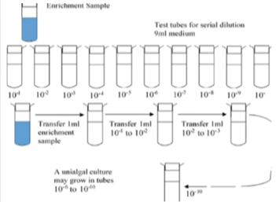

Figure 1: Schematic representation of the serial dilution method.[19]

- Inoculation: Transfer a tiny amount (about 0.1 mL) of liquid from each dilution tube onto the surface of a solid growth medium, such as agar plates, using aseptic methods. To evenly disseminate the microorganisms, the dilution plates are either spread or streaked. Inoculation describes this action.
- Incubation: Place the agar plates in an incubator with the right temperature and humidity levels for the target microorganism's growth. Depending on the organism and the growth medium employed, incubation times can change.
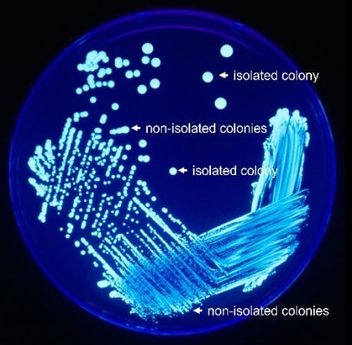
- Isolate Colonies: Individual microbial colonies will develop on the agar plates after incubation. Every colony is a group of microorganisms that developed from a single or a small number of cells. To guarantee the culture's purity, move a single colony to a fresh agar plate using a sterile loop or inoculating needle.
Figure 2: A petri plate with bacterial growth showing the distinction
between isolated colonies and non-isolated colonies.[20]
- Sub culturing: Continue isolating colonies and moving them to new plates in this manner until you are certain that you have a pure culture of the desired microbe. Sub culturing may be necessary in numerous stages for this.
- Characterization and Identification: Once you have a pure culture, you can use a variety of methods to characterize and identify the microbe, including microscopy, biochemical testing, molecular biology techniques (including PCR and DNA sequencing), and physiological assays.
- Preservation: Use the right techniques to retain the isolated strain in order to maintain its viability and purity. Ultra-low temperature freezing, freeze-drying, or storing in glycerol or other cryoprotectants are all common techniques of preservation.
It is significant to remember that the success of microbial strain separation depends on a variety of elements, including sample processing, culture conditions, and growth media selection. Additionally, it is essential to work under sterile circumstances to avoid contamination during the isolation process by other bacteria [13,14].

4. MAINTENANCE OF MICROBIAL STRAINS
The stability and long-term preservation of these priceless microorganisms depend on the preservation of microbial strains in a lab or culture collection. The loss of valuable strains and genetic drift are prevented by using proper maintenance techniques. The following are typical methods for keeping microbial strains alive:
- Subculture: To keep microbial cultures alive and expanding, periodically move a tiny piece of the culture onto new growth media. The growth rate of the microorganism and the particular needs of the strain determine how frequently subcultures are performed.
- Cryopreservation: To preserve microbial cultures for an extended period of time, cryopreservation involves freezing microbial cultures at extremely low temperatures [15]. Typical methods include:
Liquid Nitrogen Storage: Maintain cultures at -196°b (-321°F) in cryogenic containers filled with liquid nitrogen.
Freeze-drying (Lyophilization): Freeze the cultures and squeeze out the water to turn them into a stable, dry form that can be kept above freezing [16].
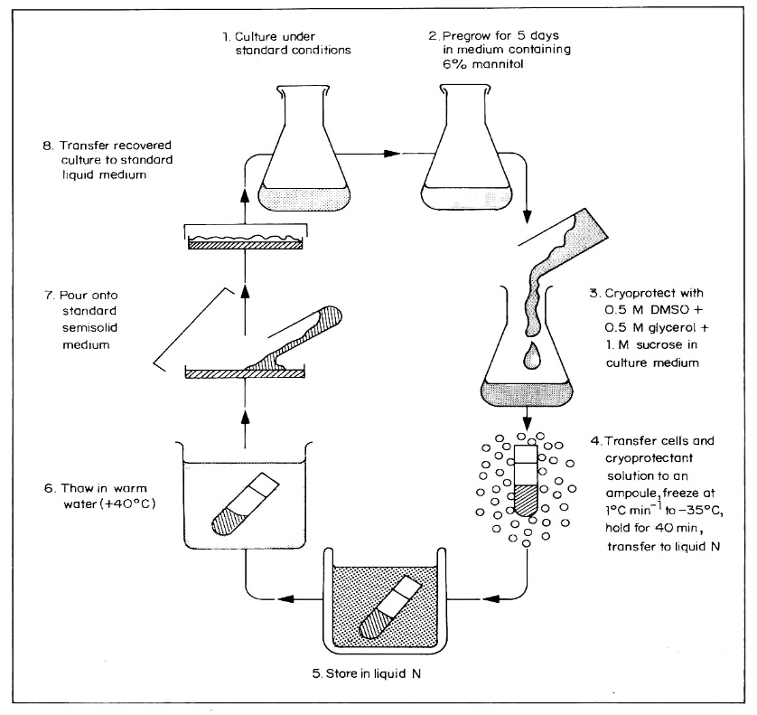
Figure:3 Cryopreservation procedure for cell cultures. Alternative treatments: (1) None; (2) Pregrow in standard medium; pregrow in medium containing 70% proline or 1M sorbitol; (3) Substitute 1Mproline for 1M sucrose; omit proline from mixture; ( 4 ) Transfer directly to liquid nitrogen from-35°C or a lower temperature; (5) None; (6) Thaw slowly; (7, 8) Wash in liquid medium before plating; culture in liquid medium on a shaker; pour into static liquid medium containing 1M sorbitol for 3 days before transfer to plain liquid medium on a shaker (32, 33, 34).[21]

Prepare stock cultures in a medium supplemented with cryoprotectants like glycerol or dimethyl sulfoxide (DMSO), and preserve them at -80°C (-112°F).
- Bead or Plate Storage: Use specialized preservation techniques like glycerol beads for bead storage or streak cultures onto agar plates and store them at -20°C (-4°F) or in the refrigerator.
- Slant or Agar Slant Tubes: Keep strains alive on agar slant tubes by introducing the culture into a slant of solid agar. Slants are normally kept in refrigerators (4°C, 39°F) for storage.
- Continuous Subculture: For strains with high demand, think about keeping a system that continuously supplies a growing culture with new media. The strain is kept alive and ready for use in industrial or research activities thanks to this technique.
- Periodic Viability Testing: Evaluate the purity and viability of conserved cultures on a regular basis to spot contamination or a decline in culture quality.
- Documentation and Records: Maintain thorough records of each strain, including its origin, traits, location of storage, and any pertinent data on sub culturing or viability tests.
- Backup Copies: To guard against unforeseen losses brought on by equipment malfunctions, mishaps, or natural calamities, keep duplicate or backup copies of crucial strains in several places or with other culture collections.
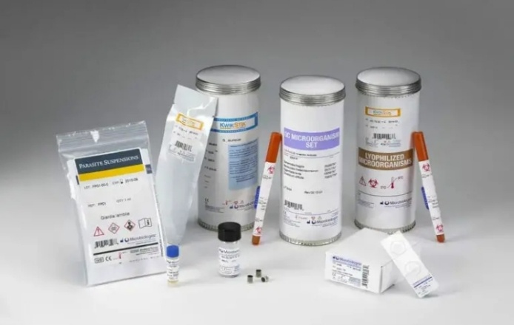
- Quality Control: Set up a quality control programme to make sure your strain collection is accurate. Verify the purity, identification, and properties of stored strains on a regular basis.
Figure 4: Quality control strains [22]

- Secure Storage: To avoid contamination or unintentional leakage, make sure that stored cultures are safely stored in the right containers.
- Access Control: To reduce the danger of contamination or misuse, strictly enforce access control mechanisms that restrict who can access and handle cultures. Laboratories and culture collections can conserve microbial strains successfully, preserving their availability and utility for research, biotechnology, and other applications for prolonged periods, by adhering to these maintenance approaches and practices.

5. IMPROVEMENT OF MICROBIAL STRAINS
Various methods and strategies are used to develop particular microbial strains in order to increase their performance and features for a variety of purposes. This may entail boosting their output, changing their metabolic processes, or strengthening their resistance to external challenges. The following are typical methods for enhancing microbial strains:
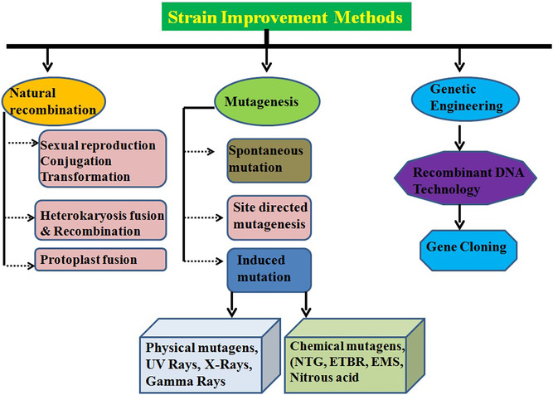
Figure 6: Overview of strain improvement [23]

- Genetic Engineering: A potent approach for improving microbial strains is genetic engineering or modification. Recombinant DNA technology, for example, enables scientists to add, remove, or alter particular genes in the microbial genome to produce desired features. This may entail improving metabolic pathways, raising the production of a certain molecule, or strengthening the strain [8].
- Directed Evolution: The microorganisms are put under selective pressure through multiple cycles of mutation and selection in this technique for strain enhancement. Selective pressure is then used to identify populations with desirable features after genetic variety has been introduced by mutagenesis methods or error-prone PCR. This approach is especially helpful when the desired feature is complex and challenging to directly build [1].
- Optimization of Culture Conditions: When grown under ideal conditions, improved strains can frequently attain increased production or efficiency. This involves achieving the optimum temperature, pH, nutrient concentrations, and oxygen levels to foster the growth and production of the microorganism.
- Metabolic Engineering: Change the metabolic processes of microorganisms to improve the synthesis of particular substances, such as biofuels, drugs, or enzymes. This may entail adding novel routes, down regulating or eliminating competitive pathways, or overexpressing important enzymes [10].
- Strain Selection: Selective breeding or the isolation of naturally occurring variants with desirable features can sometimes be used to improve strains. This method is frequently used in the fermentation business, where strains with better qualities are chosen over time.
- Adaptive Laboratory Evolution (ALE): In ALE, microbial strains are grown for an extended period of time in a controlled environment with the intention of promoting natural selection. The strains may develop improved features as they evolve and adapt to their environment throughout time.
- CRISPR-Cas9 Technology: The precise editing of microbial genomes made possible by the CRISPR-Cas9 system allows for the deletion, insertion, or change of genes to improve strain performance.
- High-Throughput Screening: To quickly assess a large number of microbial variations for desirable features, such as enzyme activity, production, or tolerance to particular stresses, use automated screening techniques.
- Systems Biology Approaches: To get a thorough grasp of microbial physiology and metabolism, use computer modelling and systems biology methods. This information can direct logical strain improvement techniques.
- Co-Culture and Synthetic Communities: Combining different strains to produce cooperative or synergistic effects can be used to create synthetic microbial communities that can improve the performance of the community as a whole.
- Evolutionary Engineering: Improve microbial strains by using evolutionary biology principles, such as selective breeding and ongoing cultivation.
- Omics Technologies: Identify objectives for improvement by utilizing omics technologies, such as genomics, transcriptomics, proteomics, and metabolomics, to acquire understanding of the molecular mechanisms controlling strain performance.

6. PRESERVATION OF INDUSTRIAL MICROBIAL STRAINS
The durability and consistency of industrial microbial strains in diverse biotechnological processes and industrial applications depends on their preservation. The strains' long-term viability and genetic stability are guaranteed by proper preservation. The following are typical techniques for keeping industrial microbial strains alive:
- Cryopreservation: Microbial cultures are frozen at extremely low temperatures during cryopreservation in order to prevent metabolic activity and maintain genetic stability [18]. Typical methods of cryopreservation include:
  - Liquid Nitrogen Storage: Cultures should be kept in cryogenic containers filled with liquid nitrogen at about -196°C (-321°F).
  - Freeze-Drying (Lyophilization): Cultures can be frozen and dried to produce a stable, dry form that can be kept above freezing throughout storage. Cultures that have been freeze-dried are normally kept at -20°C (-4°F).

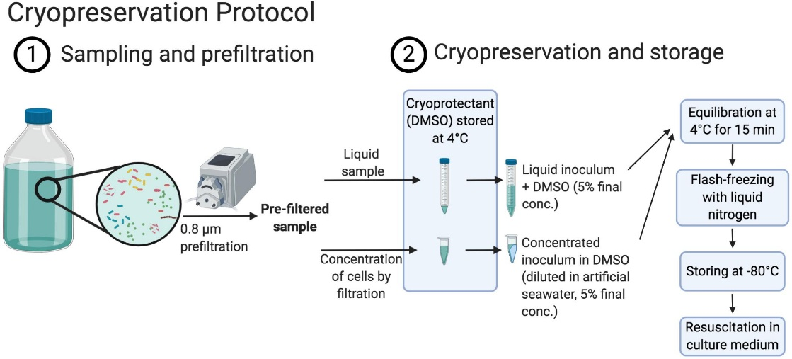
Figure 7: Schematic displaying the cryopreservation procedure [24]

- Glycerol or DMSO Storage: Stock cultures should be made and stored at -80°C (112°F) in a medium that has been treated with cryoprotectants such glycerol or dimethyl sulfoxide (DMSO). Glycerol stocks are frequently employed and offer a dependable way to keep industrial strains safe.
- Bead or Plate Storage: Use specialized preservation techniques, such as streaking colonies onto agar plates and storing them at 4°C, or 39°F, refrigeration temperatures. These techniques are appropriate for strains that must survive for brief periods of time and are often accessible.
- Continuous Subculture: Maintain a continuous subculture system whereby new media is continuously provided to a growing culture for industrial strains that are in high demand. This guarantees that the strain will continue to grow and be accessible for industrial procedures.
- Strain Banking: Create a special strain bank or culture collection where commercial strains can be methodically preserved, categorized, and kept under tight supervision. These culture collections are frequently kept at institutions or businesses that focus on the preservation of microbial strains.
- Backup Copies: To prevent against unforeseen losses brought on by equipment breakdowns, mishaps, or natural calamities, keep duplicate or backup copies of industrial strains in various locations or alongside other culture collections.
- Quality Control: Keep duplicate or backup copies of industrial strains in several places or with other culture collections to guard against unforeseen losses caused by equipment malfunctions, accidents, or natural calamities.
- Documentation and Records: Keep thorough records of each industrial strain, detailing its origin, traits, location of storage, and any pertinent details regarding sub culturing or viability tests.
- Secure Storage: To avoid contamination or unintentional spilling, make sure that stored cultures are securely stored in the right containers. Limit who can access and manage the cultures by putting in place stringent access control procedures.
- Periodic Revival and Testing: Reviving and testing preserved strains on a regular basis will ensure their performance and vitality. This makes it easier to spot any strains that might have gotten worse over time.
Industries may guarantee the long-term stability and vitality of their significant industrial microbial strains by adhering to these preservation techniques and best practices, lowering the danger of process disruptions and the loss of priceless strains. Maintaining the consistency and dependability of industrial operations depends on proper preservation.

7. PRINCIPLES OF STERILISATION OF MEDIA AND AIR FOR MICROBIAL STRAINS
A crucial step in microbiology and biotechnology is the sterilization of the media and the air to prevent the contamination of microbial cultures with undesirable bacteria. Sterilization practices attempt to remove or significantly diminish all microbiological life, such as bacteria, fungus, viruses, and spores, from surfaces, media, and tools. The main tenets and techniques for sterilizing media and air are as follows:
- Use of Heat: One of the most popular and efficient sterilization techniques is heat. The idea is to heat the item (such as media or equipment) for a long enough time to kill or inactivate microorganisms. Techniques like autoclaving and dry heat sterilization can be used to achieve heat sterilization.
- Moisture: Moisture aids in the heat sterilization process' ability to kill bacteria. Heat that is moist is more effective at penetrating and denatures microbial proteins. A popular technique for sterilization that combines heat and moisture is autoclaving, which uses high-pressure steam.
- Sterilization Time and Temperature: Effective sterilization depends on the interaction of time and temperature. While sterilization at lower temperatures requires longer exposure times, sterilization at higher temperatures requires shorter exposure times. Normally, autoclaving lasts 15 to 20 minutes at 121 °C (250 °F).
- Microbial Load: The necessary sterilization settings might be influenced by the initial microbial load on surfaces or in materials. Items that are highly polluted can need more stringent sterilization.
- Biological Indicators: To verify the efficacy of sterilization operations, biological markers (such as spore-forming bacteria like Bacillus or Geobacillus species) are used. After sterilization, if these markers are eliminated or rendered inactive, the procedure was effective.
- Aseptic Technique: To avoid contamination, thorough aseptic technique must be used when preparing and manipulating media. This includes operating in a clean setting, such as a laminar flow hood or biosafety cabinet, and using sterile tools.
8. METHODS OF STERILIZATION FOR MEDIA AND AIR
- Autoclaving: High-pressure steam is used in autoclaves to sterilise objects. Microorganisms, especially spores, are destroyed by the interaction of heat and moisture. Sterilization of equipment, glassware, and growing media is frequently accomplished using an autoclave.
- Dry Heat Sterilization: Items that are susceptible to moisture or high pressure can be sterilised with dry heat by using hot air or an open flame. It is frequently used for glassware, metal tools, and particular kinds of powders.
- Filtration: In order to sterilize heat-sensitive liquids like serum, medicines, and enzymes, sterile membranes with hole diameters tiny enough to catch microorganisms (usually 0.2 m) are used as a filter. In laminar flow hoods, it is also used to sterilize air by passing it through filters.
- Chemical Sterilization: Sterilization of heat-sensitive materials and equipment involves the employment of chemical agents like ethylene oxide and hydrogen peroxide vapour. For safe and reliable sterilization, these techniques need particular setups and tools.
- Ultraviolet (UV) Sterilization: Microorganisms can be killed or rendered inactive by UV radiation at a particular wavelength (254 nm), which damages their DNA. For air sterilization in biosafety cabinets and laminar flow hoods, UV sterilization is frequently utilized.
- Gamma Radiation: Materials can be efficiently sterilised by ionizing radiation from gamma sources because it can penetrate them. It is frequently used to sterilize disposable plasticware, certain medical equipment, and other single-use products.
- Electron Beam (E-beam) Sterilization: High-energy electrons are used in e-beam sterilization to render bacteria inactive. It is frequently used to sterilize medications, medical equipment, and some types of packaging.
- Chemically Defined Media: Using properly defined and contaminant-free medium components is crucial for avoiding microbial contamination during culture preparation.
Maintaining the purity and repeatability of microbial cultures and research depends on using proper sterilization procedures. The kind of material to be sterilised and the particular needs of the procedure or experiment will determine the method to use.
AUTHOR’S CONTRIBUTION
The authors confirm contribution to the paper as follows: A.F., A.V., F.K., D.A., K.T.: DATA COLLECTION AND MANUSCRIPT PREPARATION; Dr.Vidya Meenakshi.: STUDY CONCEPTION AND DESIGN, AND CRITICAL ANALYSIS. All authors reviewed the results and approved the final version of the manuscript.

ACKNOWLEDGEMENT
We express our gratitude to DEPARTMENT OF BIOTECHNOLOGY, ISABELLA THOBURN COLLEGE, for providing invaluable resources and facilities during the preparation of this research paper. Special thanks are extended to our Head of Department: Dr. (Maj.) Neerja Masih and other faculty members Dr. Deepika Delsa Dean, Dr. Vidya Meenakshi and Dr. Madhurima Tiwari for their valuable insights and assistance.

REFERENCES
- Arnold, F. H. (2018). Directed evolution: bringing new chemistry to life. Angewandte Chemie International Edition, 57(16), 4143-4148.
- Ochman, H., Lawrence, J.G., & Groisman, E.A. (2000). Lateral gene transfer and the nature of bacterial innovation. Nature, 405(6784), 299-304.
- Falkowski, P.G., Fenchel, T., & Delong, E.F. (2008). The microbial engines that drive Earth's biogeochemical cycles. Science, 320(5879), 1034-1039.
- Philippot, L., Andersson, S.G., Battin, T.J., et al. (2010). The ecological coherence of high bacterial taxonomic ranks. Nature Reviews Microbiology, 8(7), 523-529.
- Stewart, E.J., & O'Malley, M.A. (2018). Genetic exchange in the microbiome. Annual Review of Microbiology, 72, 487-505.
- Nielsen, J. (2019). Systems biology of microbial cells. Current Opinion in Microbiology, 51, 62-68.
- Jespersen, L., & Jespersen, L. (2015). The importance of the species concept in probiotics. Beneficial Microbes, 6(6), 609-613.
- Jinek, M., et al. (2012). A programmable dual-RNA-guided DNA endonuclease in adaptive bacterial immunity. Science, 337(6096), 816-821.
- Koch, R. (1881). Zur Untersuchung von Pathogenen Organismen. Mittheilungen aus dem Kaiserlichen Gesundheitsamte, 1(1), 1-48.
- Nielsen, J., & Keasling, J. D. (2016). Engineering cellular metabolism. Cell, 164(6), 1185-1197.
- Berendsen, R.L., Pieterse, C.M., & Bakker, P.A. (2012). The rhizosphere microbiome and plant health. Trends in Plant Science, 17(8), 478-486.
- Roberfroid, M.B., Gibson, G.R., Hoyles, L., et al. (2010). Prebiotic effects: metabolic and health benefits. British Journal of Nutrition, 104(S2), S1-S63.
- Saiki, R.K., et al. (1988). Primer-directed enzymatic amplification of DNA with a thermostable DNA polymerase. Science, 239(4839), 487-491.
- Tringe, S.G., & Hugenholtz, P. (2008). A renaissance for the pioneering 16S rRNA gene. Current Opinion in Microbiology, 11(5), 442-446.
- Benson, E. E. (2008). Cryopreservation of phytodiversity: a critical appraisal. Kew Bulletin, 63(4), 539-555.
- Williams, J. N., & Hallsworth, J. E. (2009). Limits of life in hostile environments: no barriers to biosphere function? Environmental Microbiology, 11(12), 3292-3308.
- Nicolaou, S. A., et al. (2017). Quality control of commercially available laboratory mice: pitfalls and opportunities. Veterinary Pathology, 54(1), 39-41.
- Mazur, P. (1984). Freezing of living cells: mechanisms and implications. American Journal of Physiology-Cell Physiology, 247(3), C125-C142.
- Potential production of biodiesel from green microalgae - Scientific Figure on ResearchGate. Available from: https://www.researchgate.net/figure/Schematic-representation-of-the-serial-dilution-method_fig1_318383308] [accessed 24 Sep, 2023
- Chapter Image: Legionella Plate 01.png by CDC/James Gathany is in the public domain.
- books.google.com.ph/books/irri?id=bpmNrtcPEboC&lpg=PA..
- https://i0.wp.com/microbeonline.com/wp-content/uploads/2022/05/Maintenance-and-Preservation-of-Microorganisms.png?ssl=1
- https://doi.org/10.1002/fft2.66
- https://doi.org/10.3389/fmicb.2020.597653

