OFDM System's BER Sensitivity to Carrier Frequency Offset

Amit Kumar

Research scholar
Electronics and Telecommunication Engg. Dept.
SVCET Rajuri, pune
Rajuri, Pune, India
amit150894@gmail.com

Manoj kumar
Assistant professor,
Electronics and Telecommunication Engg. Dept.
SVCET Rajuri, Pune
Rajuri, Pune, India
manoj1985.111@gmail.com

ABSTRACT
In this paper, bit error rate has been explored for the orthogonal frequency division multiplexing in the presence of carrier frequency offset. The expression of bit error rate in the presence of carrier frequency offset has been derived for FFT-OFDM system in additive white Gaussian noise, flat fading and frequency selective fading channels for binary phase shift keying and quadrature phase shift keying modulation scheme. Enumerative results of most of BER expressions have been given and verified through analytical as well as simulated results shown in plots. BER of 16-quadrature amplitude modulation of OFDM system also simulated in presence of CFO in frequency selective channel.

Keywords— Binary Phase Shift Keying (BPSK), Bit Error Rate (BER), Carrier Frequency Offset (CFO), Orthogonal Frequency Division Multiplexing (OFDM), Quadrature Phase Shift Keying (QPSK))

INTRODUCTION

OFDM is one of the Multi-Carrier Modulation (MCM) techniques that transmit signals through multiple carriers. These carriers (subcarriers) have different frequencies and they are orthogonal to each other. Fast Fourier Transform based OFDM has drawn major attention in broad band wireless communication due to its various advantages like less complex equalizer, high data rate, efficient bandwidth utilization, robustness against multi-path fading channel etc. It has been adopted by many wireless communication standards such as IEEE 802.11a [1]
OFDM is a special form of multi carrier modulation techniquee which is used to generate waveforms that are mutually orthogonal. In an OFDM scheme, a large number of orthogonal, overlapping, narrow band sub-carriers are transmitted in parallel. These carriers divide the available transmission bandwidth. The separation of the sub-carriers is such that there is a very compact spectral utilization. With OFDM, it is possible to have overlapping sub channels in the frequency domain, thus increasing the transmission rate. In order to avoid a large number of modulators and filters at the transmitter and complementary filters and demodulators at the receiver, it is desirable to be able to use modern digital signal processing techniques, such as FFT. After more than forty years of research and development carried out in different places, OFDM is now being widely implemented in high-speed digital communications. OFDM has been accepted as standard in several wire line and wireless applications. Due to the recent advancements in Digital Signal Processing (DSP) and Very Large-Scale Integrated circuits (VLSI) technologies, the initial obstacles of OFDM implementations do not exist anymore. In a basic communication system, the data are modulated onto a single carrier frequency. The available bandwidth is then totally occupied by each symbol.

II. SYSTEM MODEL
The basic principle of OFDM is to split a high data rate streams into a number of lower data rate streams and then transmitted these streams in parallel using several orthogonal sub-carriers (parallel transmission). Due to this parallel transmission, the symbol duration increases thus decreases the relative amount of dispersion in time caused by multipath delay spread. If 1/T is the symbol rate of the input data to be transmitted then the symbol interval in the OFDM system is increased to NT. For reducing the inter-symbol interference, a guard band is inserted between successive OFDM symbols. OFDM can be seen as either a modulation technique or a multiplexing technique [2-3]
The concept of OFDM is very much similar to the well known and extensively used technique of Frequency Division Multiplexing (FDM). OFDM uses the principles of FDM to allow multiple messages to be sent over a single radio channel. It is however in a much more controlled manner, allowing an improved spectral efficiency.

Input data
Modulation
S/P
Output
data
Demodulation
P/S
IFFT
Channel
Cyclic Prefix (CP)
Addition
CP
Removal
S/P
FFT

Fig.-1 OFDM Transceiver

A. Transmitter Section
The input bit stream is encoded into complex data symbols by the encoder, which is first block of the transmitter. Data encoding can be done by using any type of digital modulation techniques viz.
QPSK, QAM or FSK. After that, N such data symbols are applied to serial-to-parallel converter. These complex parallel data symbols $X\left(1\right),X\left(2\right),………X\left(N\right)$are then fed to the IFFT block. After taking N-point IFFT, the last G samples of${ N}_{G}$ duration are appended at the front as a cyclic prefix addition. The expression of $m^{th }$transmitted sample is given as [5] –
$x\left(m\right)=\sqrt{\frac{N}{N+N_{G}}}\sum_{k=0}^{N-1}{X\left(k\right)}F_{-α}\left(m,k\right), -N_{G}≤m<N$ (1)
Where, $X\left(k\right)$ representing the transmitted symbol.
B. Receiver Section
$r\left(n\right)=\sum_{m=0}^{N-1}{h\left(n,n-m\right)x\left(m\right)}e^{{j2πεn}/N}+W\left(n\right),$ $for n=0,1,…..,N-1$ (2)
where, $ε=\left(∆fT_{u}=∆f{NT}_{s}\right)$ is the CFO normalized by the sub-carrier spacing $1/{T_{u}}=1/{{NT}_{s}}$, $T_{u}={NT}_{s}$is the useful duration of one OFDM symbol,$∆f$ is carrier frequency offset, and$h\left(n,l\right)$ is the impulse response of multipath fading channel with$l$ path.
After removing the cyclic prefix, the FFT of received signal has been taken. The FFT of received signal $r\left(n\right)$ can be expressed as [2]
$S\left(q\right)=\sum_{n=0}^{N-1}{F_{α}\left(q,n\right)} r\left(n\right),$ $for q=0,1,…..,N-1$ (3)
Where, ${ F}_{α}\left(q,n\right)$is the kernel of the FFT [4]

III. BER ANALYSIS OF FFT- OFDM
A. Bit Error Rate
Bit Error rate (BER) is a performance parameter which is used in digital transmission. During the transmission of data over a link, there is a possibility of errors being introduced into the system. Presence of errors in data degrades the performance of the system. So for assessing the performance of digital system, BER is used to calculate the errors. It is the rate at which errors occur in a transmission system. The bit error rate is given as:
Bit Error Rate (BER) = Number of errors that occurred during transmission / Total number of transmitted bits.
The performance criterion and undoubtedly the most difficult to compute is average bit error rate (BER). On the other hand, it is the one that is most revealing about the nature of the system behavior and the one most often illustrated in documents containing system performance evaluations; thus, it is of primary interest to have a method for its evaluation that reduces the degree of difficulty as much as possible. The primary reason for the difficulty in evaluating average BER lies in the fact that the conditional (on the fading) BER is, in general, a nonlinear function of the instantaneous SNR, the nature of the nonlinearity being a function of the modulation/detection scheme employed by the system. For example, in the multichannel case, the average of the conditional BER over the fading statistics is not a simple average of the per channel performance measure as was true for average SNR [6]
In OFDM system, the BER is severely affected by the nonlinearity of the high power amplifier .For low SNR value, QPSK gives better BER performance whereas QAM results are better for high SNR value. BER can be defined in terms of the probability of error (POE). The POE is proportional to Eb/No and it is a form of signal to noise ratio. BER is inversely proportional to Signal to Noise ratio. High value of signal to noise ratio (SNR) indicates small value of BER and has no noticeable effect on the overall system [7]
B. Signal to Noise Ratio
Probably the most common and best understood performance measure characteristic of a digital communication system is signal-to-noise ratio (SNR). Most often this is measured at the output of the receiver and is thus related directly to the data detection process itself. Of the several possible performance measures that exist, it is typically the easiest to evaluate and most often serves as an excellent indicator of the overall fidelity of the system. Although traditionally, the term noise in signal-to-noise ratio refers to the ever-present thermal noise at the input to the receiver, in the context of a communication system subject to fading impairment, the more appropriate performance measure is average SNR, where the word average refers to statistical averaging over the probability distribution of the fading[8]
IV. SIMULATED RESULTS

This is dedicated for the FFT based OFDM system. In this chapter transmitter-receiver MATLAB simulation and theoretical MATLAB simulation are shown for different modulation schemes and channels in presence of CFO. Fig.-2, and Fig.-3 presents BER of BPSK OFDM system in AWGN channel Fig.-2, is the theoretical simulation for N=8, whereas Fig.-3, is Transmitter-receiver simulation for N=64

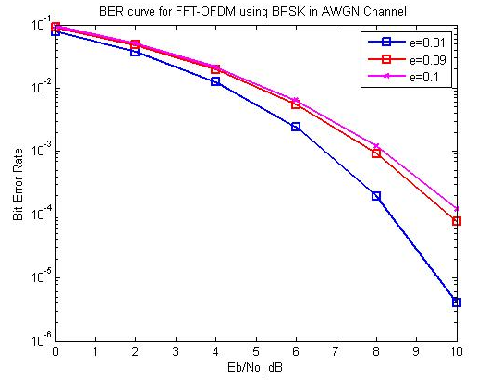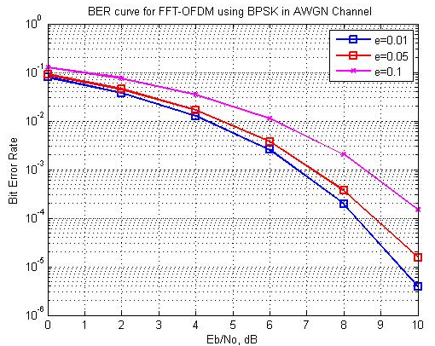

Fig.-2 BER expression of FFT-OFDM for BPSK Fig.-3 BER transceiver simulation of FFT-OFDM
over AWGN channel with N=8 For BPSK over AWGN channel with N=64

The simulation results agree with each other well for CFO equal to 0.1 and 0.01 although N- points of FFT are different. Fig.-4 and Fig.-5, shows the BER of BPSK OFDM system in Rayleigh Flat Fading channel. Fig.-4, shows theoretical and Fig.-5, shows transmitter-receiver simulations. Although for theoretical N=8 and for transmitter-receiver N=64 were used but they agree with each other for CFO equal to 0.1, 0.01. In Fig.-6, result of BER of BPSK OFDM transmitter-receiver is shown for frequency selective Rayleigh fading channel in presence of CFO where N=64 was taken. The result could be matched with fig.-3, of Mahesh & Chaturvedi (2010) for CFO =0.1. Although in the paper N=8 is used, but results agree with each other. One important thing about frequency flat fading and frequency selective fading is that in case of flat fading, channel bandwidth is smaller than coherence band but in case of frequency selective fading, channel bandwidth is greater than coherence band.
In fig.7, SER of OFDM using QPSK modulation over AWGN channel with N=8 is depicted in presence of CFO where CFO=0.01, 0.05, 0.1. This result is for theoretical expression derived in Dharmawansa et al. The result matches well with the results given in Dharmawansa et al (2009) for CFO=0.01.We can see a constant difference in the output of transmitter-receiver
Simulated by us and transmitter-receiver simulated in the paper. It may be because our transmitter-receiver was simulated with equalization process which enhanced its performance by decreasing SER.

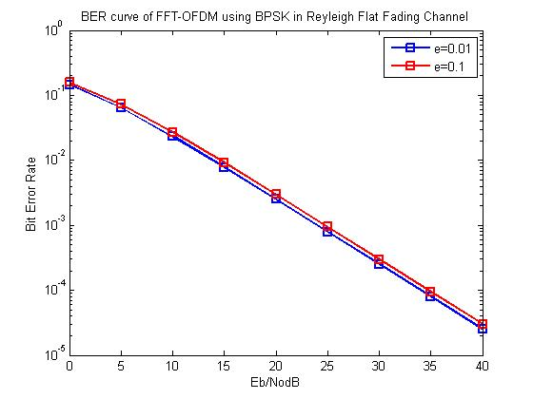
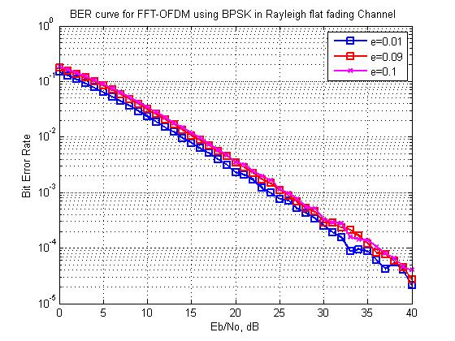Fig.-4 BER expression of FFT-OFDM for BPSK Fig.-5 BER Transceiver simulation of FFT- Rayleigh Flat Fading over AWGN channel OFDM for BPSK over Rayleigh flat fading channel with N=64 with N=64

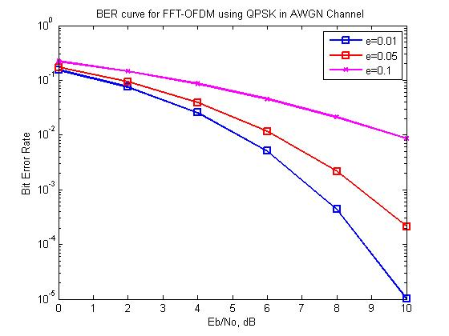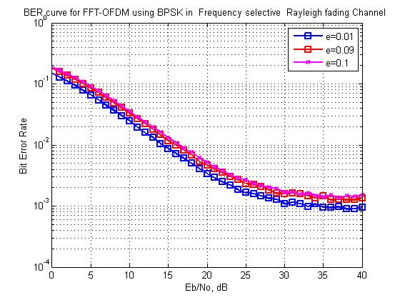
Fig.-6 BER Transceiver simulation of FFT-OFDM Fig.-7 BER expression for FFT-OFDM Using
fading channel with N=64 QPSK over AWGN channel with N=8
V. CONCLUSION
In this paper, OFDM is a special case of wideband multicarrier modulation in which multiple symbols are transmitted in parallel using different sub-carriers with overlapping frequency bands that are mutually orthogonal. An equivalent wideband
frequency band width is separated into a number of narrowband signals. The time dispersion caused by multipath delay is reduced because the symbol duration of band signal will be larger than that of a wideband transmission scheme .The overlapping multicarrier techniques can implement the same number of channels as conventional FDM system but with a reduced amount of band width. In conventional FDM, adjacent channels are separated using guard band.
In OFDM, each subcarrier has integer number of cycles within a given tine interval T, and the number of cycles by which each adjacent subcarrier differs is exactly one .this implementation adds orthogonality to the subcarriers. Because of these inherent properties (orthogonal sub carrier) it saves

the band width during the transmissions .In OFDM system the band width is divided into N slots and then data rate is increased by N- times. In $3^{rd}$ generation WCDMA and OFDM was used. Just because of these OFDM (multi carriers system) a large number of higher rates applications become possible like.
- DAB
- HDTV
- Wireless LAN networks
- IEEE 802.16 Broadband Wireless Access System
- Multimedia applications e.g. Video Games etc.

The subcarriers are data modulated using PSK and QAM. The amplitude spectrum of each modulated subcarrier using either PSK or QAM, narrowband channels where N is the number of subcarriers .However, if the delay spread is longer than the symbol duration multipath will affect performance. A guard time is introduced to eliminate ISI caused by delay spread. As a rule, the guard time is usually two to four time larger than expected delay spread. To reduce ICI, OFDM symbols are cyclically extended into the guard interval. As OFDM symbol will have a integer number of cycles in the FFT intervals as longer as the delay is less the guard time.
Our main objective was to evaluate the performance of the OFDM system on the basis of BER and ICI calculation. First of all, a carefully literature survey was done based on the FFT-OFDM system.

REFERRENCES
- Ahmed M. Hamza and Jon W. Mark, “Closed Form SER Expressions for QPSK OFDM Systems With Frequency Offset in Rayleigh Fading Channels,’’ IEEE Communications Letters, Vol. 18, pp 1687-1690, No. 10, Oct. 2014.
- Ahmed M. Hamza and Jon W. Mark, “ Closed-Form Expressions for the BER/SER of OFDM Systems With an Integer Time Offset,’’ IEEE Transactions On Communications, Vol. 63, pp 4461-4473, NO. 11, Nov. 2015.
- A. Peled and A. Ruiz (April 1980), “Frequency domain data transmission using reduced computational complexity modems,” Proceedings of IEEE International Conference on Accoustics, Speech, and Signal Processing (ICASSP), vol. 5, pp. 964–967.
- ANSICommittee T1-Telecommunications, A Technical Report on High-Bit-Rate Digital Subscriber Lines (HDSL), February 1994.Technical Report No.28.
- B. Hirosaki (July 1981), “An orthogonally multiplexed QAM system using the discrete Fourier transform,” IEEE Transactions on Communication Technology, vol. COM-29, no. 7, pp. 982 989.
- B. Sklar, “Digital Communications: Fundamentals and Applications,” 2nd Edition, Prentice Hall of India, 2002.
- Chong Wang and Junghwan Kim” On the Symbol Error Probability of 16-QAM Based OFDM Systems Impaired By Carrier Frequency Offset,” 2012 25th IEEE Canadian Conference on Electrical and Computer Engineering (CCECE).
- T. Keller and L.Hanzo, “Adaptive multicarrier modulation: A convenient framework fo time-frequency processing in wireless communications”, Proc. IEEE, vol. 88, no. 5, pp. 611-640, May 2000.
- W. C. Y. Lee, “Wireless and Cellular Telecommunications,” 3rd Edition, McGraw-hill International Edition, 2006.
- S.C. Pei and J.J. Ding, “Closed-from discrete fractional and affine Fourier Transform,” IEEE Trans. Signal Process., vol. 48, pp. 1338-1353, may 2003.
- H. Harada and R. Prasad, “Simulation and Software Radio for Mobile Communications,” 1st Edition, Artech House, Boston, 2002.
- S. Kumari, S. Kr. Rai, A. Kumar, H. D. Joshi, A. Kr. Singh and R. Saxena, “ Closed Form Relations for ICI and BER in FRFT Based OFDM System,” 2013 3rd IEEE International Advance Computing Conference (IACC), pp. 709-712.
- D. Chen, X. G. Xia, T. Jiang, and X. Gao, “Properties and power spectral densities of CP based OQAM-OFDM systems,” IEEE Transactions on Signal Processing, vol. 63, no. 14, pp. 3561–3575, July 2015.
- L. Zhang, A. Ijaz, P. Xiao, A. Quddus, and R. Tafazolli, “Single-rate and multi-rate multi-service systems for next generation and beyond communications,” in IEEE PIMRC, Sept. 2016, pp. 1–6.
- “3GPP TR 38.900 V14.3.1, “Study on channel model for frequency spectrum above 6 GHz,” Tech. Spec. Group Radio Access Network,”July 2017.
- “3GPP TS 38.101-1 v. 15.1.0,”NR; User Equipment (UE) radio transmission and reception; Part 1: Range 1 Standalone,” Tech. Spec. Group Radio Access Network, Rel. 15,” April 2018.

