Antimicrobial Activity of Newly Synthesized Nanoporous Terpolymer Resin Derived from o-Toluidine, Biuret and Formaldehyde

Sanjiokumar S. Rahangdale*¹, Kailash P. Jadhao¹, Wasudeo B. Gurnule², Yashpal U. Rathod³
Email: rahangdalessr@gmail.com
¹Department of Chemistry, Jagat Arts, Commerce and Indirabenhariharbhai Patel Science College, Goregaon-441801, India
²Department of Chemistry, Kamla Nehru Mahavidyalaya, Sakkardara Square, Nagpur-440024, Maharashtra, India
³Department of Chemistry, C. J. Patel College, Tirora-441911, Maharashtra, India
ABSTRACT
The copolymer o-TBF has been synthesized with different ratios of the reactants, by condensation of o-Toluidine and biuret with formaldehyde in the presence of hydrochloric acid as a catalyst in the 1: 1: 2 molar proportions of reactants. By using FTIR, 1H NMR spectroscopy, and elemental analysis, the copolymer o-TBF was identified. The inhibitory effect of the copolymer o-TBF against pathogenic bacteria and fungi was evaluated. Staphylococcus aureus, Escherichia coli, and fungi Aspergillus niger, Candida albicans.
Keywords: Antimicrobial screening, Copolymer, Synthesis, Characterization, Condensation.
I. INTRODUCTION
Terpolymers' novelty and adaptability have led to a significant growth in their application in all aspects of life in recent years. O-cresol-adipamide-formaldehyde copolymer resin's production and biological activities were investigated by Rahangdale et al. [1]. Newly synthesised Nanoporous Terpolymer Resin Derived from Dithiooxamide with Formaldehyde's Biological Activity and Electrical Behaviour [2]. Terpolymer resins' heat breakdown kinetics and resistance to microorganisms were investigated by Begum M. S. and colleagues [3]. Thermoanalytical and biological tests of a new copolymer made of salicylic acid and semicarbazide were conducted by J. Dontulwar et al. [4]. Bhagat D. S. and colleagues have made advancements in the production and anticancer potential of triazole-containing scaffolds [5]. An explanation of how Bumrah G. S. and colleagues' research on the anticancer properties of thiazole and 4-thiazolidinone-containing motifs was conducted [6]. SS Rahangdale investigated the thermal characteristics and antibacterial activity of a copolymer resin made from formaldehyde, 2, 2'-dihydroxybiphenyl, and dithiooxamide [7]. Copolymer resin made from formaldehyde, semicarbazide, and p-hydroxybenzoic acid is the subject of research by Nandekar and colleagues [8]. Shedmake D. et al. investigated antibacterial activity, characterisation, and thermal investigations [9]. The antibacterial characteristics of terpolymer are presented in the current work.

II. EXPERIMENTAL

A. Synthesis of o-TBF copolymer resin

Following a process based on prior literature [10], the o-toludine (0.1 mol), biuret (0.1 mol), and formaldehyde (0.1 mol) copolymer resin was created utilizing the polycondensation technique on DMF medium for 5 h at 120 ºC ± 2ºC for in an oil bath. Fig. 1 depicts the copolymer synthesis mechanism.
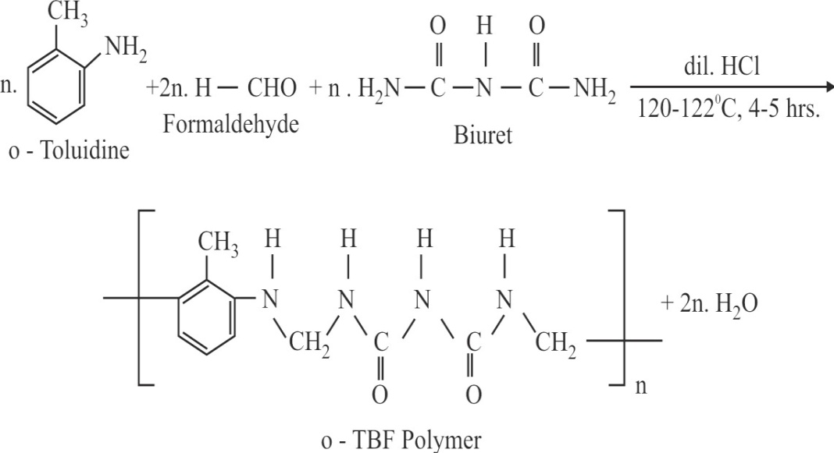
Fig. 1 : Structure of o-TBF Copolymer

B. Antimicrobial Screening
The basis of a biological assay is a comparison of the suppression of microorganism growth between the concentration of the material being tested and the known concentration of a reference antibiotic. The in vitro disc diffusion technique has been used for the antibacterial analysis. In this work, Aspergillus niger and Candida albicans, two Gram-positive human pathogenic bacteria, were used to assess the effects of the copolymer.
In order to examine the antibacterial activity, the nutrient agar medium was boiled and sterilised by an autoclave at 7 kg pressure (120 0C) for 20 min. 20 mL of media was added to the clean Petri plates, which were then left at room temperature for a short while for the medium to harden. After that, sterile swabs were used to inject it with microorganisms and incubate it for 12 hours. These manipulations were all performed in an aseptic environment with the utmost care. Using a micropipette, the medium was added to the test solution after the chemical had been dissolved in DMSO. The test solution was then incubated at 35 oC for 48 hours. For the antifungal investigations using potato dextrose agar as the medium, the identical approach was used.
As the test solution diffuses over time, it has been shown that inoculation bacteria such Staphylococcus aureus, Escherichia coli, Aspergillus niger, and Candida albicans grow more slowly. The diameter of the inhibited zone in millimetres was used to calculate the amount of activity that developed on the plate. For bacteria, ciprofloxacin was the gold standard, whereas nystatin was utilised for fungus.

III. RESULTS AND DISCUSSION

A. Elemental Analysis

It is an extremely effective method for examining the molecular structures of polymers. When standard solution characterization of the insoluble polymers is not practicable, elemental analysis is frequently performed to analyses the molecular structure of soluble and insoluble copolymer resins. Therefore, the carbon, hydrogen, and nitrogen contents of all the produced copolymer resins have been examined in order to explore their molecular architectures. The elemental analysis result, shown in Table 1, was used to assign the empirical formula and empirical formula weight. The calculated and observed elemental analysis were determined to be in excellent agreement.

Table 1: Elemental Analysis and Empirical Formulae of o-TBF Copolymer Resins
Copolymer | % of C Observed (Cal.) | % of H Observed (Cal.) | % of N Observed (Cal.) | % of O Observed (Cal.) | Empirical Formula repeated unit | Empirical Formula weight
o-TBF-I | 56.30  (56.41) | 5.92  (5.98) | 23.82  (23.93) | 13.62  (13.68) | C₁₁H₁₄N₄O₂ | 234

B. Intrinsic Viscosity

Tuan-Fuoss viscometers were used to test the viscosity at 300 K in distilled dimethyl sulfoxide at six different concentrations ranging from 1.00% to 0.031%. (Table 2). For each set of data, the reduced viscosity (sp/C) and the viscosity ln η rel /C were plotted vs concentrations to produce linear graphs. The corresponding charts were used to calculate the inherent viscosity (η). Huggins' (K1) and Kraemer's (K2) constants were calculated using equations 1 and 2 and the slope of the associated linear plots.
η sp /C = [ η ] + K1 [ η] 2C (1)
ln ηrel /C = [ η] − K2 [ η] 2 C (2)
Where, ηsp /C–Reduced viscosity andln η rel /C – Inherent viscosity.
The slopes of the linear plots of ηsp /C and ln η rel /C against C were K1 and K2, respectively. Intercepts on the axis of the viscosity function provide the value of intrinsic viscosity () in both plots, which have been shown to be in close agreement with one another by extending linear graphs to zero concentration. Most of the time, the estimated values of K₁ and K₂ (Table 2) favorably fulfil the relation K₁ + K₂ = 0.5.
It was observed that terpolymer resins having higher $M$_{n} show higher value of (η) which are in good agreement with earlier co- workers.

Table 2: Viscometric Data of o-TBF-I Copolymer Resin
Concentratio n (C) | Efflux time (t) sec. | Relative viscosity (η_{rel}) η_{rel} = t/t₀ | Specific viscosity (ηsp)  η_{sp} = (t-t₀)/t₀ | Reduced viscosity (ηred)  ηred = ηsp/C | Inherent viscosity (ηinh)  η_{inh} = lnη_{rel}/C
0.05 | 57.8 | 1.0140351 | 0.014034 | 0.352222 | 0.349466
0.1 | 58.7 | 1.0298244 | 0.029824 | 0.339180 | 0.330834
0.15 | 59.9 | 1.0508770 | 0.050876 | 0.327251 | 0.314733
0.2 | 61.4 | 1.0771928 | 0.077192 | 0.316953 | 0.298833
0.25 | 61.8 | 1.084211 | 0.084212 | 0.303143 | 0.283644
0.3 | 62.9 | 1.1035086 | 0.103508 | 0.294335 | 0.264371
Solvent: Dimethyle sulphoxide (DMSO); Temperature : 300 ± 0.1 K
Efflux time of pure solvent (t₀ : 51.92 sec.

C. UV-visible Spectra

The area 200-850 nm of the o-TBF copolymer resins' spectra (Fig. 2) were captured at a scanning rate of 100 nm min-1 and a chart speed of 5 cm min⁻¹. Samples of the o-TBF copolymer showed two distinctive bands at 260-310 nm and 310-340 nm. The absorption bands' measured locations are at various intensities. The quinoline ring's (n-σ*) permitted transition, which easily achieves co-planarity, the shoulder merging, which loses the fine structure, and chromophore groups like the >C=C and >C=N groups are all responsible for the more intense band between 260 and 310 nm. The (n-π*) prohibited transition of the -OH, -COOH, and -NH groups may be the cause of the less intense band between 310 and 340 nm.

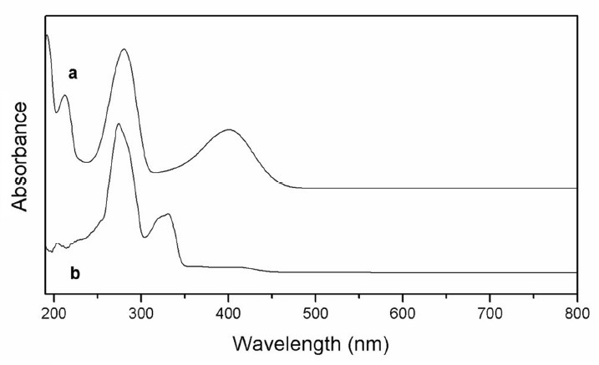
Fig. 2 Electronic Spectra of o-TBF Copolymer

C. Infra-Red Spectra

Figure 3 shows the FT-IR spectra of the o-TBF copolymer contains the spectral data. A band at 3506 cm⁻¹ in the spectra of the o-TBF copolymer is attributed to the aromatic ring's hydroxyl group of the -COOH, which participates in intramolecular hydrogen bonding.[16] This band appears to have combined with the band corresponding to the Ar-NH2 group's -NH stretching vibrations. The -NH bending vibrations are responsible for the prominent band that can be seen at 1582.8 cm⁻¹. A strong band at 1297.5 cm⁻¹ is related to Ar-NH2's C-N stretching, while the band at 3399 cm⁻¹ is associated with the aromatic ring (-CH) stretching mode. The bands support the 1,2,3,5-tetrasubstitution of the aromatic benzene ring.

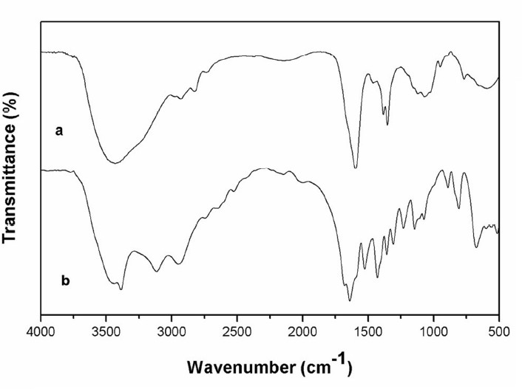

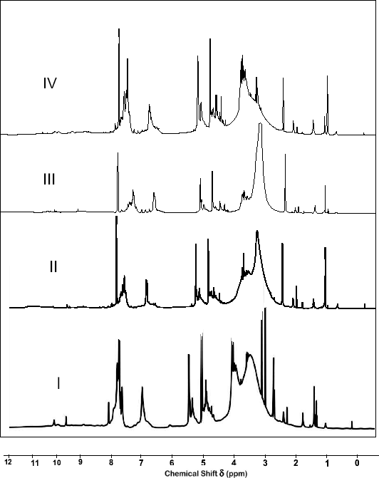

Fig. 3 (b) Infra Red Spectra of o-TBF-I Composite
Fig. 2 (b) Electronic Spectra of o-TBF Copolymer

Fig. 3 IR Spectra of o-TBF Copolymer Resins

D. ¹H NMR Spectra

In DMSO-d6 solvent, the proton NMR spectra of all four o-TBF copolymer resins were scanned. Fig. 4 displays the spectra, and Table 4 displays the spectral information. Since each o-TBF copolymer contains a set of proton atoms with a unique electronic environment, it is clear from the spectra that all four o-TBF copolymer resins produce distinct patterns of 1H NMR spectra. Based on information found in the literature, the chemical shift () ppm observed is assigned [12]. The methylene proton of the Ar-CH-N moiety may be the cause of the singlet seen in the range of 4.67-4.65 (ppm) [13]. The protons of the -NH bridge are said to be responsible for the signal in the range 7.45-7.43 (ppm) [15]. Aromatic proton (Ar-H) may be the cause of the weak multiplate signal (unsymmetrical pattern) in the range of 8.98-8.96 (ppm). The signal between 9.05 and 9.03 (ppm) may be caused by protons from phenolic hydroxyl groups. The intramolecular hydrogen bonds formed by the phenolic -OH group are clearly indicated by the significantly downfield chemical shift for this group. The proton of the -SO3H group is responsible for the signal that emerged between 10.02 and 10.01 ppm.
Fig. 4: ¹H NMR Spectra of o-TBF Copolymer Resins

E. Scanning electron microscope (SEM)
SEM were utilized to examine the superficial characteristics of the copolymer and its composite. SEM images of the copolymer and its composite are presented in Figure 4. The composite and its copolymer, as seen in the image, have bigger pore architectures that can act as a more effective site for increased heavy metal ion adsorption. The copolymer's structure in Figure 5 includes a significant amount of surface void space, which suggests that metals can easily be adsorbed there. The large dimple and the reinforcing particles were combined to create the copolymer structure. High porosity and permeability can be found in the copolymer's surface microstructure. A SEM image of the copolymer composite is shown in Figure 3.16. The pores in the composite are diverse. The copolymer and carbon have been bonded, as shown by the micrograph, which also displays a new active site adhesive in a sputter cluster on the surface. The composite's surface area grows more than the copolymer's does.

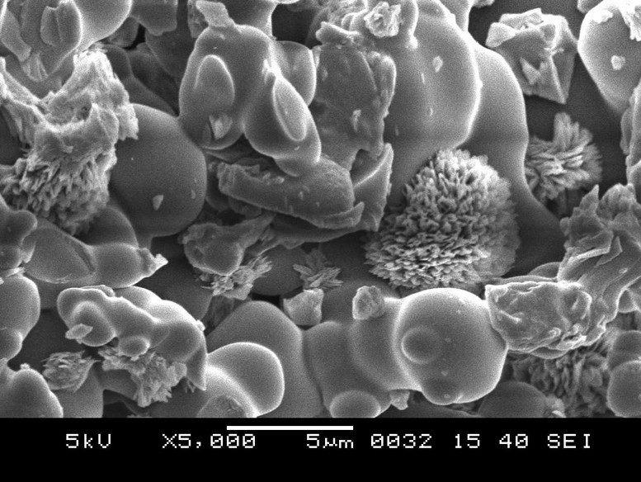
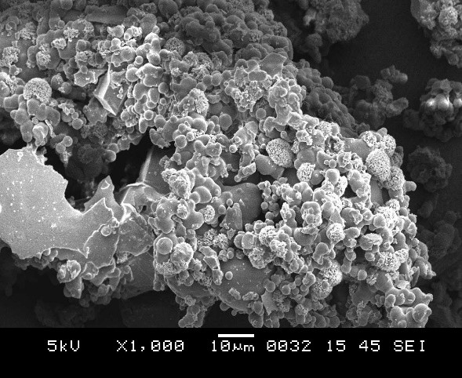

- (b)
Fig. 5: SEM Photographs of (a) o-TBF-I Copolymer.
F. Antimicrobial Screening
The o-TBF copolymer ligand's increased activity is caused by the donor atoms in the copolymer and the delocalization of the π-electrons, according to the findings of the microbial screening (Table 5). This has the consequence of increasing lipophilicity, which facilitates the penetration of bacterial and fungi membranes through the lipoid layer [17]. The presence of - OH and the aromatic ring may also contribute to the increased activity [18]. The enhanced activity of metal complexes is thought to have different causes, including solubility, conductivity, dipole moment, and cell permeability mechanisms [19]. The development of Gram-negative bacteria that cause tumours is effectively slowed down by the copolymer. The copolymer may thus have anticancer properties. The Gram-positive bacteria are invasive and harmful. The copolymer offers effective growth suppression properties against this pathogen. Aspergillus niger is the fungus that causes aspergillosis, and polymeric chelates can somewhat regulate how much it grows. Diseases can be brought on by the Candida albicans, which can enter the intestinal walls. According to the results, adding o-TBF copolymer resin inhibits the development of Candida albicans.

Table 5. Antimicrobial activities of o-TBF copolymer.
Copolymer | Diameter of zone of inhibition (mm)
 | S. Aureus | E. Coli | A. Niger | C. Albicans
o-TBF  Solvent (DMSO) | 14  -- | 15  -- | 16  -- | 14  --

CONCLUSIONS
In this chapter, we have synthesized novel nanoporous copolymer with different ratios of the reactants, by condensation of o-Toluidine and biuret with formaldehyde in the presence of hydrochloric acid as a catalyst in the 1: 1: 2 molar proportions of reactants. By using FTIR, 1H NMR spectroscopy, and elemental analysis, the copolymer o-TBF was identified. The inhibitory effect of the copolymer o-TBF against pathogenic bacteria and fungi was evaluated. Staphylococcus aureus, Escherichia coli, and fungi Aspergillus niger, Candida albicans.
The activity has been assayed against bacteria such as Staphylococcus aureus, Escherichia coli, and fungi Aspergillus niger, Candida albicans.

REFERENCES:
[1] S. S. Rahangdale, “Synthesis and biological activity of o-cresol-adipamide-formaldehyde copolymer resin”, JOCPR, 5(1), 45-48, 2013.
[2] S. S. Rahangdale, Murlidhar K. Rahangdale, Wasudeo B. Gurnule, “Biological Activity and Electrical Behavior of Newly Synthesized Nanoporous Terpolymer Resin Derived from Dithiooxamide with Formaldehyde”, IJFANS, 11(13), 153-159, Nov. 2022.
[3] M. S. Begum, W. B. Gurnule, “Thermal degradation kinetics and antimicrobial studies of terpolymer resins”, Arabian Journal of Chemistry, 9, s296-s305, 2016.
[4] J. Dontulwar, K. Nandanwar, W. Gurnule, “Thermoanalytical and biological studies of novel copolymer derived from salicylic acid and semicarbazide”, Pharma Chemical, 5, 160-168, 2013.
[5] D. S. Bhagat, G. S. Bumbrah, P. A. Chawala, W. B. Gurnule, S. K. Shejal, “Recent advances in synthesis and anticancer potential of triazole containing scaffolds”, Anticancer Agents in Medicinal Chemistry, 22(16), 2852-2875, 2022.
[6] D. S. Bhagat, G. S. Bumbrah, P. A. Chawala, W. B. Gurnule, S. K. Shejal, “An insight into synthesis and anticancer potential of thiazole and 4-thiazolidinone containing motifs”, Current Organic Chemistry, 25(7), 819-841, 2021.
[7] Sanjiokumar S. Rahangdale, Wasudeo B. Gurnule, “Antimicrobial activity and thermal properties of copolymer resin derived from 2, 2’-dihydroxybiphenyl, dithiooxamide and formaldehyde”, Der Pharma Chemica, 3(4), 314-322, 2011.
[8] K. Nandekar, W. Gurnule, “Synthesis and antimicrobial study of copolymer resin derived from p-hydroxybenzoic acid, semicarbazide and formaldehyde”, Journal of Physics Coference Series, 1913(1), 012063, 2021.
[9] D. Shedmake, J. V. Khobragade, W. B. Gurnule, “Synthesis, characterization and antimicrobial activity and their thermal studies”, IJRBAT, XI (2), 67-79, 2023.
[10] Sanjiokumar S. Rahangdale, Narayan C. Das, Kiran Vajpai, Wasudeo B. Gurnule, “Synthesis, Characterization And Thermal Degradation Studies Of Copolymer Derived From 2,4-Dihydroxy Propiophenone And 4-Pyridylamine” . International Journal of Recent Scientific Research, 10 (4A) 31772-31778, 2019.
[11] Sanjiokumar S. Rahangdale, Nisha Tiwari, Manish Tiwari, Wasudeo B. Gurnule, “ Antimicrobial Screening of Polymeric Resin Derived From 2, 2’-Dihydroxybiphenyl, Bouret and Formaldehyde”, Alochana Chakra. IX (V), 74-84, 2020.
[12] Sanjiokumar S. Rahangdale, Narayan C. Das, Kiran S. Vajpai And Wasudeo B. Gurnule, “Synthesis, Characterization And Thermal Degradation Study Of Copolymer Resin-Ii: Resulting From 2-Hydroxy, 4-Methoxybenzophenone, 1, 5-Diaminonaphthalene And Formaldehyde”. IJRBAT, VIII (1), 194-204, 2020.
[13] Santosh P. Chakole, S. S. Rahangdale, Ketki S. Misar, Kiran S. Vajpai, W. B. Gurnule, “Synthesis and Characterization of Copolymer Resin Derived from 2, 2’-Dihydoxybiphenyl, Ethylenediamine and Formaldehyde”, Alochana Chakra. IX (V), 666-673, 2020.
[14] Sanjiokumar S. Rahangdale, Dinesh D. Kamdi, Jyotsna V. Khobragade And Wasudeo B. Gurnule, “Separation Of Toxic Metals Ions From Waste Water Using Pyrogallol-Biuret-Formaldehyde Copolymer Resin”. IJRBAT, VIII (3) 259-268, 2020.
[15] S. S. Rahangdale, S. P. Chakole, K. S. Vajpai and W. B. Gurnule, “Synthesis, Characterization And Photoluminescent Studies Of Organic Copolymer Derived From 2, 2’-Dihydroxybiphenyl And Propylenediamine”. JETIR, 8(9) 174-180, 2021.
[16] Sanjiokumar S. Rahangdale, Santosh P. Chakole, Jyotsna V. Khobragade, And W. B. Gurnule, “Thermal Degradation Studies of 2,2’-Dihydroxybiphenyl-Ethylenediamine-Formaldehyde Copolymer”. RJPBCS, 12(6) 1-12, 2021.
[17] M. B. Patel, S. A. Patel, A. Ray, R. M. Patel, J. Appl. Polym. Sci., 89, 895, 2003.
[18] N. Singh, S. Gupta, G. Nath, Central National De La Recherche Scientifique (CAT. INIST),14, 484, 2000.
[19] G. B. Bagihalli, S. A. Patil, P. S. Badami, J. Iran. Chem. Soc., 6 (2), 259, 2009.

