Electrical Properties of Thin films : An Overview
M. Sathya¹, G. Selvan¹, M. Karunakaran², P. Baskaran²
¹PG and Research Department of Physics, Thanthai Hans Roever College (Autonomous),
Perambalur, Affiliated to Bharathidasan University, Trichy, India - 621 220.
²Thin Film and Nanoscience Research Lab, PG and Research Department of Physics, Alagappa
Government Arts College, Karaikudi, India - 630 003.
²Department of Physics, Government Arts and Science College, Veppanthattai, Perambalur,
India- 621 116.
Abstract:
Thin film technology and thin film devices are significant importance in the advancement of contemporary scientific research. The thin film refers to a planar structure composed of solid material, characterised by having one dimension, known as the thickness, much less than the other two dimensions. The formation of the thin film occurs by a condensation process, when atoms or molecules come together in a step-by-step manner. The thicknesses of these objects are often below a few microns. The field of thin film deposition technology is significant interest in scientific study due to its extensive array of applications spanning microelectronics, optics, space science, aircrafts, superconductivity, and photovoltaics. Multiple techniques may be used for the synthesis of thin films. Hence, a comprehensive understanding of the many physical and chemical characteristics of these materials has significant significance. The determination of whether a certain material exhibits conductive or insulative behaviour may be made by evaluating its electrical characteristics. The electrical characteristics of a substance provide insights into its atomic composition.

Keywords: Thin films, Electrical properties, Thermal properties, Chemical Properties.

I. Introduction:
Atoms of a substance are deposited onto a substrate to create thin films during the manufacturing process. Condensing atomic, molecular, or ionic species of matter one at a time is the process that gives rise to a thin film, which is a low-dimensional substance. The study of thin film materials and devices cannot proceed without first doing a measurement of the characteristics of thin films. In order to properly evaluate thin films, one must take into account their crystalline structures, chemical compositions, optical qualities, electrical properties, and mechanical properties [1]. The selection of a preferable deposition process is mostly determined by the required material qualities of the deposited films [2,3]. In several cases, and maybe in the majority of cases, the properties of a thin film can exhibit notable distinctions from those of the corresponding bulk material due to the significant ratio of surface area to volume in thin films. Additionally, the morphology, structural, physical, and chemical properties of the thin film might be considerably different from those of the bulk materials. These differences can occur in a variety of ways. The surface and/or interface properties of the substrate can have a significant effect on the characteristics of thin films due to contamination at the surface, growth impacts, surface mobility, chemical surface effects, adsorbed gases, catalytic or inhibitory impacts on film development, surface topography, as well as crystallographic orientation, in addition to stress effects due to thermal expansion mismatch.
The following is a brief overview of the most significant physical and chemical traits of the thin film: [4]

- Electrical property:
- Conductivity for conductive films
- Resistivity for resistive films
- Dielectric constant
- Dielectric strength
- Dielectric loss
- Stability under bias
- Polarization
- Permittivity
- Electromigration
- Radiation hardness

- Thermal property:
- Coefficient of expansion
- Thermal conductivity
- Temperature variation of all properties
- Stability or drift of characteristics
- Thermal fusion temperature
- Volatility and vapor pressure

- Mechanical property:
- Intrinsic, residual, and composite stress
- Anisotropy
- Adhesion
- Hardness
- Density
- Fracture
- Ductility
- Hardness
- Elasticity

- Morphology property:
- Crystalline or amorphous
- Structural defect density
- Conformality/step coverage
- Planarity
- Microstructure
- Surface topography
- Crystallite orientation

- Optical property:
- Refractive index
- Absorption
- Birefringence
- Spectral characteristics
- Dispersion

- Magnetic property:
- Saturation flux density
- Coercive force
- Permeability

- Chemical property:
- Composition
- Impurities
- Reactivity with substrate and ambient
- Thermodynamic stability
- Etch rate
- Corrosion and erosion resistance
- Toxicity
- Hygroscopicity
- Impurity barrier or gettering effectiveness
- Carcinogenicity
- Stability

This paper presents several approaches used for the establishment of electrical properties.

II. Conductivity \ Resistivity for thin films
The measurement of electrical conductivity in thin films is often conducted using the four-probe technique followed by Van der Pauw method. A current source with high impedance is used to provide current through the outer probes, therefore establishing an electric field inside the sample. The measurement of the potential difference across the inner probes, which do not carry any current owing to the presence of a high input impedance voltmeter in the circuit, is conducted using two inner probes.

- Four-probe method

The method often used for determining the resistivity of a material entails the utilisation of four probes that are evenly distributed and placed in contact with a substance of uncertain resistance. This methodology may be used in either bulk or thin film samples. This method offers a means of quantifying the resistivity of a specimen that exhibits a wide range of forms, while maintaining a consistent cross-sectional area. This approach employs four probes to assess the resistivity of the materials. As an example, a pair of the outside probes is used to transmit the current originating from the source metre, while another pair of inner probes is utilised to quantify the voltage decrease across the specimen.The schematic representation of the four probe approach is shown in Figure 1. Four tungsten metal points, uniformly spaced and supported by springs, are used to attach the sample surface without causing any harm.
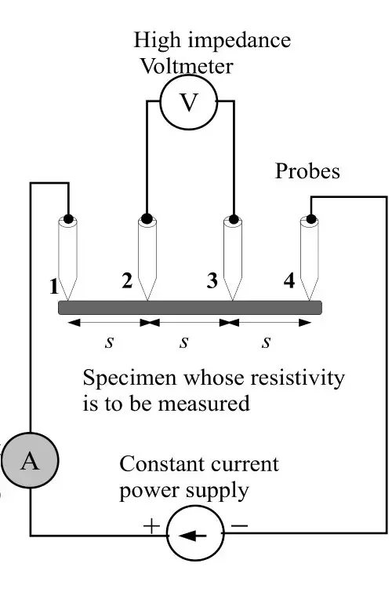
Fig 1. Four probe method of measuring resistivity of a specimen

Resistivity for bulk material,
ρ = $\left(\frac{V}{I}\right)$ (2πs)
Resistivity for thin sheet,
ρ = $\frac{Vtπ}{I In2}$

Using a four-probe resistivity apparatus, Gaikwad et al.[5] measured the electrical resistivity of ZnO thin films deposited at varied precursor concentrations.This sheet's resistance decreases as precursor concentration increases from 0.2M to 0.45M, resulting in a change in resistivity from 14.62 x 10⁻² to 1.88 x 10⁻² Ω-cm. But as the concentration of precursor is increased to 0.6M, the resistivity rises to 38.6 x 10⁻² Ω-cm. The resistivity of a ZnO thin film deposited at 0.45M precursor concentration revealed the formation of an excellently conducting film.

- Van Der Pauw Method
The Van der Pauw technique is a significant four-point probe approach. This measurement technique is capable of assessing not only the resistivity of semiconductor devices, but also the doping kinds, majority carrier mobility, and material concentration. When using this technique, it is crucial to carefully consider whether the sample satisfies the criteria of the van der Pauw approach.
There are several requirements that need to be met in order to use this strategy:[6]
The sample must have
- a uniformly thickened flat shape
- have no isolated holes
- characterised by homogeneity and isotropy
- Each of the four contacts has to be situated along one of the sample's borders.
- the connections are tiny enough

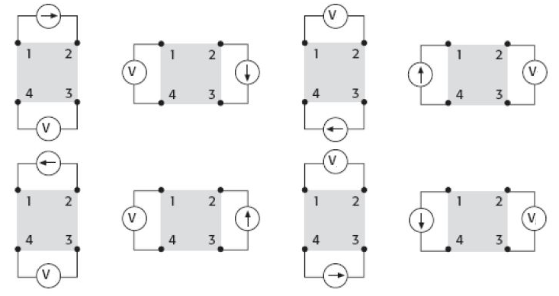
Fig 2. Assembly of a four point probe that operates under the Van Der Pauw method

Vertical Measurements Horizontal Measurements

R_{12,43} = $\frac{V_{43}}{I_{12}}$
R_{21,34} = $\frac{V_{34}}{I_{21}}$
R_{34,21} = $\frac{V_{21}}{I_{34}}$
R_{43,12} = $\frac{V_{12}}{I_{43}}$
R_{23,14} = $\frac{V_{14}}{I_{23}}$
R_{32,41} = $\frac{V_{41}}{I_{32}}$
R_{41,32} = $\frac{V_{32}}{I_{41}}$
R_{14,23} = $\frac{V_{23}}{I_{14}}$

R_{v =} $\frac{R_{12,43}+R_{21,34}+R_{34,21}+R_{43,12}}{4}$ R_{H =} $\frac{R_{23,14 }+R_{32,41}+R_{41,32}+R_{14,23}}{4}$
When, R_{v}=R_{H}=R, then,
Resistivity ρ = $\frac{πR}{In2}$
The study conducted by Tiwari et al. [7] examined the microstructural, optical, luminescent, and electrical characteristics of Sn-Ga co-doped ZnO films with varying fractions. These films were synthesised using the sol-gel spin-coating process. The researchers used several characterisation techniques to analyse the aforementioned features. The van der Pauw four-point probing technique was used to ascertain the electrical resistivity of the films. Compared to the undoped ZnO film, the 1GZO and 1TZO films exhibit a significant increase in conductivity, with magnitudes two orders higher, measuring 2.17x 10⁻¹ (Ω-m)⁻¹ and 7.13x 10⁻¹ (Ω-m)⁻¹, respectively.

II. Dielectric constant
The dielectric constant is a measurement of the amount of electric potential energy that is stored in a particular volume of material as induced polarisation when subjected to the influence of an electric field. This electric potential energy is measured in terms of the dielectric constant. It is measured as the proportion of the material's dielectric permittivity to the dielectric permittivity of a vacuum or dry air [8].

- Terahertz Time-Domain Spectroscopy (TDS)
Terahertz time-domain spectroscopy, often known as TDS, is a well-established method that may be used to problems that include frequencies between gigahertz and terahertz. The TDS method measures the dielectric constant by using an extremely brief Electromagnetic (EM) pulse for both detection and emission. Temporal forms of reflected or transmitted terahertz pulses, as well as those input into the system, are determined by the cross-correlation across a probing optical pulse and an EM pulse. The EM pulse detector is very sensitive, to the point that it can detect even a nanowatt signal with relative ease. The absence of thermal background radiation is a result of the rapid modification of the femtosecond optical gated probe pulse by the detected electromagnetic pulse. In the past, transmission geometry was used in conjunction with TDS in order to determine the dielectric constant of freestanding thick films and bulk materials.
In comparison to ellipsometry, the Goniometric Time-Domain Spectroscopy (GTDS) method of detection is considered to be a more sophisticated approach. Measurements of complex reflectance are taken using this technique at a number of different sites within a Brewster angle range. The terahertz beam is p-polarized, but the optical beam used for the probe is set to have an s-polarization. The angular dependence of the terahertz reflectance is what establishes the value of the dielectric constant of the thin film. The dielectric constant of thin films that are deposited on a substrate may be measured with the use of GTDS. The approach calls for the use of an ultrafast optoelectronic system that has either a detector or an emitter unit in conjunction with a θ–2θ goniometer [9]. Using the information provided by the reflection of EM waves, GTDS is able to ascertain the dielectric characteristics of a thin layer. The Drude equation may be used to represent the complex reflectance that is achieved when a polarised electromagnetic wave is reflected off a film.

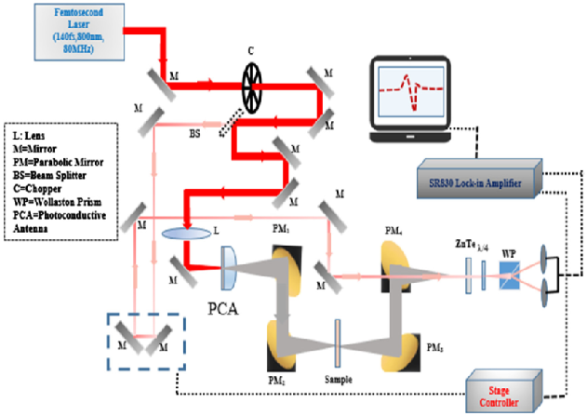
Fig 2. Experimental arranngement of GTDS

The Fresnel formulae provide a mathematical representation of the p-polarized waves that are present. Through the use of the Fresnel formulae and the Drude equation, the complex reflectance may be represented as a function of the incidence angle. Using this method, it is possible to independently determine the phase and amplitude of thin films with a variety of dielectric constants that are deposited on silicon substrates. Using the data from the complicated reflectance curve, one may calculate the dielectric constant of the films using a variety of different ways. As an example, the phase curve fit may be used as a tool for determining the dielectric constant value of the thin film.
The value may also be derived from the slope of the angle-phase curve in the sensitive area, which is located close to the Brewster angle and is the location where the phase shift is finished. The relationship between the dielectric constant and the Phase Relaxation Angle Width (PRAW) may be found by solving the Drude equation. A Phase Relaxation Angle Width (PRAW) is determined by two phases that are located near the Brewster angle. On the other hand, this kind of examination works well for a film that does not absorb light. The technique of curve fitting is the one that is most suited for the characterisation of an absorptive film.
In their study, Calvo et al. [10] used Terahertz Time-Domain Spectroscopy to determine the optical constants of CuO and ZnO particles embedded in polyethylene pellets. The mean actual permittivity values for CuO and ZnO are reported as 5.41 and 3.55, respectively.

IV. Dielectric Strength
Insulators are characterised by their electrical properties, which may be quantified by looking at their dielectric strengths. It is defined as the highest voltage that must be applied to the material in order to bring about a dielectric breakdown and is given in terms of volts for each unit of thickness.
Dielectric strength = V/m
where, V is the voltage and m is the thickness per unit.
It is the goal of a test of dielectric strength to bring the subject to the point of breakdown, often known as failure. This takes place whenever there is an abrupt shift in the material's resistance to the test voltage. The dielectric strength of the material refers to the amount of voltage at which the barrier begins to allow current to pass.
The study conducted by Saenkhumwong et al.[11] examines the breakdown voltage of two different kinds of natural ester oils, namely palm oil and soybean oil, in the presence of ZnO nanofluids. The measurement of the breakdown voltage was conducted in accordance with the ASTM D877 standard. The voltage breakdown of palm oil is recorded at 31.8 kV, whereas soybean oil, when combined with mixed nanoparticles, exhibits the highest voltage breakdown at 32.7 kV.
V. Dielectric Loss
This is not the case with the vast majority of insulating materials. When an insulator is hit with an AC voltage, there is a certain amount of energy that is lost due to the process of dissipation. The term "dielectric loss" refers to the energy that is lost when it is dispersed.
Leakage current in commercial insulators does not always trail the applied voltage by precisely 90ᵒ. The phase angle is never equal to or greater than 90ᵒ. The complementary angle, denoted by the equation δ = 90 – θ, is referred to as the dielectric loss angle. Calculating the dielectric power loss for an insulator with a capacitance of 'C' and having a voltage of 'V' applied to it at a frequency of 'f' Hz allows for the following formula to be used:
P = V²2πfC tan δ watts
As can be seen from the aforementioned equation, power loss is directly proportional to tan δ, provided that all other parameters remain same. The power factor of the insulator is denoted by the symbol tan δ.
It is the same as charging a perfect capacitor with alternating current when perfect insulation is exposed to alternating current energy. In this scenario, the charging current will trail the applied voltage by precisely 90ᵒ, and there will be no loss of power due to consumption. This level of perfection can only be approached by a vacuum or by gases that have been cleansed.
According to research conducted by Saravanan et al. [12], dielecetric loss (tan δ) at 1KHz for ZnO, Zn(Hg)O, Zn(Cu)O, Zn(Mn)O, Zn(Ni)O, and Zn(Cd)O are 4.4, 4.6, 2.0, 1.3, 2.3, and 1.9, respectively.
VI. Conclusion
This chapter's objective is to provide a condensed summary of the electrical characteristics. Having a broad understanding of what these features are might help the reader build an appreciation for the importance of thin films. Because thin films may be used for so many different things, there has been a lot of interest in studying them.

References

[1] Adachi, H., & Wasa, K. (2012). Thin films and nanomaterials. Handbook of Sputter Deposition Technology: Fundamentals and Applications for Functional Thin Films, Nano-Materials and MEMS,, 3-39.
[2] Bunshah, R. F., (ed), Deposition Technologies for Films and Coatings: Developments and Applications, Noyes Publications, Park Ridge, NJ (1982)
[3] Ghandhi, S. K., VLSI Fabrication Principles, John Wiley & Sons, New York (1983)
[4] Kern, W., & Schuegraf, K. K. (2001). Deposition technologies and applications: Introduction and overview. In Handbook of Thin Film Deposition Processes and Techniques (pp. 11-43). William Andrew Publishing.
[5] Gaikwad, R. S., Jagdale, S. B., Pol, P. B., Mohite, K. C., & Pawar, B. N. (2014). Effect of concentration of precursor on intrinsic ZnO thin films by spray pyrolysis. Asian Journal of Multidisciplinary Studies, 2(5), 110.
[6] Prachurya Bharadwaj.(March 2017). Van der Pauw Resistivity Measurements. From
https://www.researchgate.net/publication/314402032_Van_der_Pauw_Resisitivity_Measurement
[7] Tiwari, A., & Sahay, P. P. (2020). Sn–Ga co-doping in sol-gel derived ZnO thin films: Studies of their microstructural, optical, luminescence and electrical properties. Materials Science in Semiconductor Processing, 118, 105178.
[8] Ilic, J. (2001). Wood: electrical properties. Encyclopedia of materials: science and technology, 9629-9633.
[9] Dam, Samudrapom. (2022, December 21). Measuring the Dielectric Constant in Thin Films. AZoM. Retrieved on July 21, 2023 from https://www.azom.com/article.aspx?ArticleID=21674
[10] Calvo-de La Rosa, J., Locquet, A., Bouscaud, D., Berveiller, S., & Citrin, D. S. (2020). Optical constants of CuO and ZnO particles in the terahertz frequency range. Ceramics International, 46(15), 24110-24119.
[11] Saenkhumwong, W., & Suksri, A. (2015). Investigation on voltage breakdown of natural ester oils based-on ZnO nanofluids. Advanced Materials Research, 1119, 175-178.
[12] Saravanan, R., Prakash, T., Gupta, V. K., & Stephen, A. (2014). Tailoring the electrical and dielectric properties of ZnO nanorods by substitution. Journal of Molecular Liquids, 193, 160-165.

