The Future of Healthcare in the Metaverse
ABSTRACT
Rapid advances in digitization and automation have fueled rapid growth in the healthcare sector, creating new models that create new channels for cheaper treatment, enhanced patient experience, and expand access to healthcare. Metaverse is an emerging technology, which is the confluence of several assistive technologies such as Artificial Intelligence, Virtual Reality, Augmented Reality, the Internet of Things (IoT), Robots, Quantum Computing, etc. through which new avenues can be explored for the delivery of quality healthcare services. However, in an industry wherein a patient’s record is critical and is held to the very best levels of security, there is no guarantee that it will remain intact. Therefore, this article aims to explore the use of the Metaverse in the healthcare industry as well as its current state, challenges, issues, and prospects. Problems in adapting Metaverse for healthcare practices are also identified with plausible solutions.
KEYWORDS: Healthcare, Metaverse, Emerging Technology, Future Trends
INTRODUCTION
The Metaverse has been the focus of industry and science in recent years. The term "Metaverse" was first introduced by Neal Stephenson in the 1992 science fiction novel ‘Snow Crash’, which is about an alternative and immersive virtual reality. The Metaverse is a virtual environment that combines physical and digital reality. It is an internet-based three-dimensional (3D) virtual world in which people go about their daily activities with avatars that represent their "real" or imaginary identity (Petrigna & Musumeci, 2022). In short, the virtual space has become a real world of alternative life, where digital avatars or profiles participate in social activities and virtual cultural events, but also conduct economic life.
Metaverse service applications in the healthcare industry have been launched and have become an increasingly promising and important area (Lee, 2022) and are expected to be worth $800 billion by 2024 (Marr B. 2022). They have the potential to revolutionize digital healthcare, access, education, and patient outcomes (Chen & Zhang, 2022). Artificial intelligence technology has shown its potential during the pandemic by accurately forecasting the emergence of coronavirus disease 2019 (COVID-19) and helping in the selection of suitable locations for vaccine trials. Radically changing social interactions, social distancing rules, mandatory lockdowns, and quarantines during the pandemic has been the key driver and this technological mediation of communication has experienced an unprecedented acceleration, revolutionizing the way we interact and connect. (Thomason, 2021). The post-pandemic era has brought about major fundamental changes in the healthcare sector. For example, current-generation consumers have started to actively participate in healthcare decision-making, and then embrace virtual healthcare systems and associated digital innovations. Experts predict it will be more intuitive than current computer systems. A simple example: instead of locating a document in drives and folders, attaching it to an email, and then sending it to a colleague, the user can instead browse through stacks of documents on a virtual desktop, select a document and send it directly to the avatar of a colleague for review. The Metaverse, with its immersive, customizable, and secure features, plays an important role in the future of healthcare. Through individualized, predictive, and empathetic engagement models, technology can help deliver hyper-personalized, data-driven care that can lead to early disease detection and tailored interventions that lead to better outcomes (Wiederhold & Riva, 2022). Metaverse has the potential to solve problems in various areas by changing the way devices and users communicate with modern technologies. (Chengoden et al., 2016). However, in the absence of robust national and global healthcare governance and accountability mechanisms, digital healthcare ecosystems are at risk of breaches of physician confidentiality and privacy, leading to the sharing and exploitation/re-use of data by companies or governments' overall scope and limitations of patient consent. (Curtis & Brolan, 2023). As consumers of healthcare services are increasingly willing to share their sensitive data, the need has developed for organizations to ensure interoperability between organizations and maintain consumer trust by being trustworthy, transparent, and empathetic in their operations. The utilization of a simulated, interoperable virtual environment for remote viewing of sensitive information presents various challenges and vulnerabilities, primarily due to the shared platform experience Moreover, external factors like body sensor networks and smart devices introduce numerous risks to the healthcare system. By identifying these potential risks and vulnerabilities, it becomes possible to implement robust measures to enhance trustworthiness and utilization. (Mejia & Rawat, 2022). Nevertheless, there are still many obstacles and tackling these challenges is crucial as it will lay down the foundation for the future of healthcare. This paper offers an in-depth examination of the importance of the Metaverse in addressing the challenges faced in the healthcare domain. By exploring the features of the Metaverse, existing applications, and the obstacles to realizing its full potential in healthcare, it sheds light on how the Metaverse can play a pivotal role in resolving healthcare issues.
METAVERSE FRAMEWORK AND BUILDING BLOCK TECHNOLOGIES
The Metaverse is an interdisciplinary ecosystem created by integrating various other technologies at various levels all through the architecture. It's a 3D version of today's internet. Within the Metaverse environment, several components facilitate interactions between the physical and virtual realms. Among these components, users play a pivotal role. Through devices like AR/VR glasses or head-mounted displays (HMDs), users can engage with virtual worlds and carry out various tasks. Additionally, IoT networks, Virtual Service Providers (PSPs) serve as crucial elements for bridging the gap between the real and virtual domains. Data is collected in the real world through IoT and sensor networks, which is then utilized to generate digital twins. The Virtual Service Providers (VSP) and Physical Service Providers (PSP) contribute to the management of both virtual and real Metaverse environments.

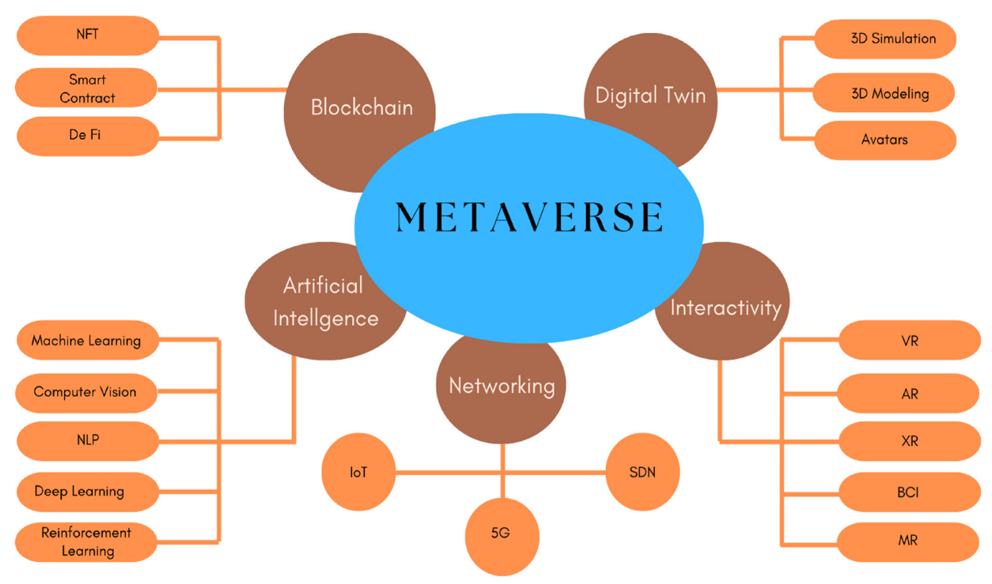
Fig 1 Building Blocks Technologies for Metaverse
Source: (Ali et al., 2023)

2.1 Block Chain
Block chain is a type of DLT that logs transactions using an immutable cryptographic signature called a hash. That is, when a single block in the chain is modified, it is immediately evident that it has been modified. For hackers to compromise the block chain system, they would need to alter every block in the chain across all distributed copies of the chain. The utilization of block chain technology enables the creation, ownership, and utilization of decentralized digital assets such as non-fungible tokens and cryptocurrencies. The Metaverse concept is intrinsically linked to block chain technology, as centralized data storage gives rise to concerns regarding data security, privacy, and transparency. By incorporating block chain, the Metaverse becomes a decentralized digital asset that can operate across various platforms and on a global level, addressing these issues effectively (Bamakan et al., 2022). The block chain-enabled Metaverse will provide physicians with accurate patient data so they can make more accurate decisions.
Block chain serves as a safeguard against the alteration or manipulation of sensitive information by attackers. However, it is important to acknowledge that the Metaverse-backed healthcare block chain also has certain limitations. Adopting this technology poses challenges due to its huge resource requirements and cost. This technology is completely unrestricted and unregulated, putting patients at risk. The complexity of the technology will make it difficult for end users or patients to adapt. Because all data must be stored on every node connected to the chain, a block chain-enabled Metaverse can be very slow (Yaqoob et al., 2022) Small hospital networks cannot use this technology due to excessive power consumption and complexity.
2.2 Digital Twin
Digital twin coined in the year 1991 in the book Mirror Worlds by David Gelernter is a virtual representation that acts as the digital counterpart of a physical object or process in real-time (Moyne et al., 2020). Digital twins are the outcome of the ongoing advancement in product design and engineering practices, serving as digital representations of real-world objects, processes, or services. They can encompass various entities, ranging from machinery and medical equipment to expansive structures like skyscrapers or even entire cities. Conversely, Metaverse technology constitutes a virtual realm where interactions parallel to those of the physical world. Within the Metaverse digital twins serve as fundamental components by replicating every object, thus forming a digital replica of the entire Metaverse. (Han et al., 2023)
Operating strategies, staffing, and models of care can be explored by establishing a digital twin of the entire hospital in the Metaverse to identify needs (Alazab et al., 2022). In scenarios such as bed shortages, the transmission of pathogens, doctor scheduling, or the availability of operating rooms, these virtual Metaverse models can be helpful. Patient care, costs, and staff productivity can be improved with Metaverse using digital twins, to provide a risk-free environment. The Metaverse, with support for digital twins, will also help create custom artificial organs. A Metaverse supporting digital twins can also help create custom artificial organs. A Metaverse supporting digital twins can assist brain and heart surgeons to virtually simulate surgical procedures before performing complex operations in the real world. (Chengoden et al., 2016).

2.3 Artificial Intelligence
AI, also known as artificial intelligence, emphasizes developing and managing technologies that can learn to make decisions for themselves and perform tasks on behalf of humans. (Gupta et al., 2021). Artificial Intelligence will aid in bolstering the infrastructure of the Metaverse, improving immersive 3D experiences, and improving the integrated service of the virtual world. The integration of AI technology will play a pivotal role in enhancing the service and ecosystem of the Metaverse, thereby improving its overall quality. With the help of artificial intelligence, health data from patients are analyzed/ diagnosed. Metaverse uses artificial intelligence to support physicians with high-quality 3D images and patient scans needed for procedures. AI can assist physicians by offering crucial information that aids in prioritizing critically ill patients, reducing potential errors in electronic health record analysis, and delivering more accurate diagnoses. (Huynh-The et al., undated 2022).

2.4 Networking
2.4.1 The Internet of Things (IoT) encompasses a range of technologies including sensors, wireless networks, and nanotechnologies, enabling seamless connectivity and communication among a vast array of devices such as smartphones, smartwatches, medical devices, and more. (Aghdam et al., 2021). The IoT, along with other technologies, is changing people's lives by making things easier and thereby improving the quality of life. Healthcare establishments use it frequently to serve patients and doctors. Through the utilization of diverse IoT devices, patients can undergo remote monitoring, leading to an enhancement in the quality of healthcare services while simultaneously reducing costs. (Mistry et al., 2020). This technology is also an integral part of the Metaverse ecosystem. The possibilities of the Metaverse are expanded through the integration of IoT technologies. These devices will be encouraged to capture and track the physical state of objects, which will help virtual service providers synchronize the digital twins.
2.4.2 Edge/Cloud Computing is an innovative computing paradigm that executes operations at the edge of the network. This technology is designed to bring IT services in proximity to the data’s origin, optimizing efficiency and reducing latency.(Satyanarayanan, 2017). The rapid advancement of the Internet of Things (IoT) and edge devices has led to a significant increase in data volume, consequently presenting various challenges such as power consumption, privacy, security, and real-time latency. To tackle these obstacles effectively, the concept of edge computing emerged. Edge computing represents a novel computing approach that operates closer to the network device’s edge, providing benefits like enhanced security and privacy, optimized data processing, and support for real-time activities.
2.5 Interactivity
2.5.1 Virtual Reality (VR) offers a simulated experience through the utilization of a head-mounted display (HMD) or VR glasses. (Dicelli & Yayla, 2022). Through a combination of software and hardware components, users can fully immerse themselves in a three-dimensional digital world. It allows users to immerse themselves in a 3D digital world through software and hardware components. In addition, it offers advanced technical capabilities and seamless immersion, giving users the freedom of the moment in the virtual world (McGill et al., 2016). While virtual reality (VR) technology is not a recent innovation, it garnered significant attention following the introduction of the Metaverse. Within the healthcare sector, VR technology finds applications in various areas such as surgery, physical therapy, stress and pain reduction, cognitive rehabilitation, and more. (Alizadehsalehi et al., 2020).
2.5.2 Extended Reality (XR) serves as a comprehensive umbrella term that encompasses various technologies and concepts like Virtual Reality, AR, and Mixed Reality (MR). It includes all connected virtual and real environments. The term extended reality was first used in history in 1960 (Alizadehsalehi et al., 2020). Subsequently, the technology is used in almost all industries like healthcare, education, manufacturing, mining, etc. (Logeswaran et al., 2021).
2.5.3 Augmented Reality (AR) has revolutionized the way we perceive the world around us. By seamlessly blending digital overlays with the users’ real-world views, AR enhances and enriches their experiences, connecting them with artificial objects and augmenting their surroundings. The users’ real‑world views are strengthened by augmented reality (AR) with digital overlays that blend artificial objects. Users' real-world views are enhanced by augmented reality (AR) in the digital world to enrich them with digital overlays connecting man-made objects. Medical professionals, including doctors and surgeons, utilize augmented reality during surgeries to magnify specific areas of the body requiring intervention. This technology aids them throughout the procedure, providing, valuable assistance and guidance. (Fida et al., 2018). Google Glass, Microsoft HoloLens, and Magic Leap represent some of the highly acclaimed AR devices.
3. APPLICATIONS IN THE HEALTHCARE SECTOR

Recognizing the transformative potential of the Metaverse in the realm of healthcare, four primary applications on medical imaging were identified as examples of Medical technology and AI (MeTAI): Virtual benchmarking, raw data sharing, advanced regulatory science, and medical intervention with the meta version. While there are precursors to these applications, their new facets are exciting in scope, scale, depth, and integration mechanisms. Metaverse adopters would be represented by avatars (their digital twins) that enable them to engage and interact seamlessly across various virtual spaces, all while maintaining cross-platform user accounts. Avatars represent us, reproducing many objects that surround us such as medical imaging equipment, and can cover different disciplines (Wang et al., 2022). To ensure the reliable production of accurate images, medical imaging systems make use of phantoms with predetermined geometries and material composition. These phantoms enable the reproducible and precise characterization of the system’s capabilities. Nowadays, a diverse range of commercial phantoms are available, offering various shapes, materials, and applications. Three-dimensional reconstruction technologies play a crucial role in the advancement of the Metaverse, particularly in facilitating real-time data exchange between digital twins (DTs) and their real-world counterparts. This integration is essential for seamless communication channels within the Metaverse ecosystem. 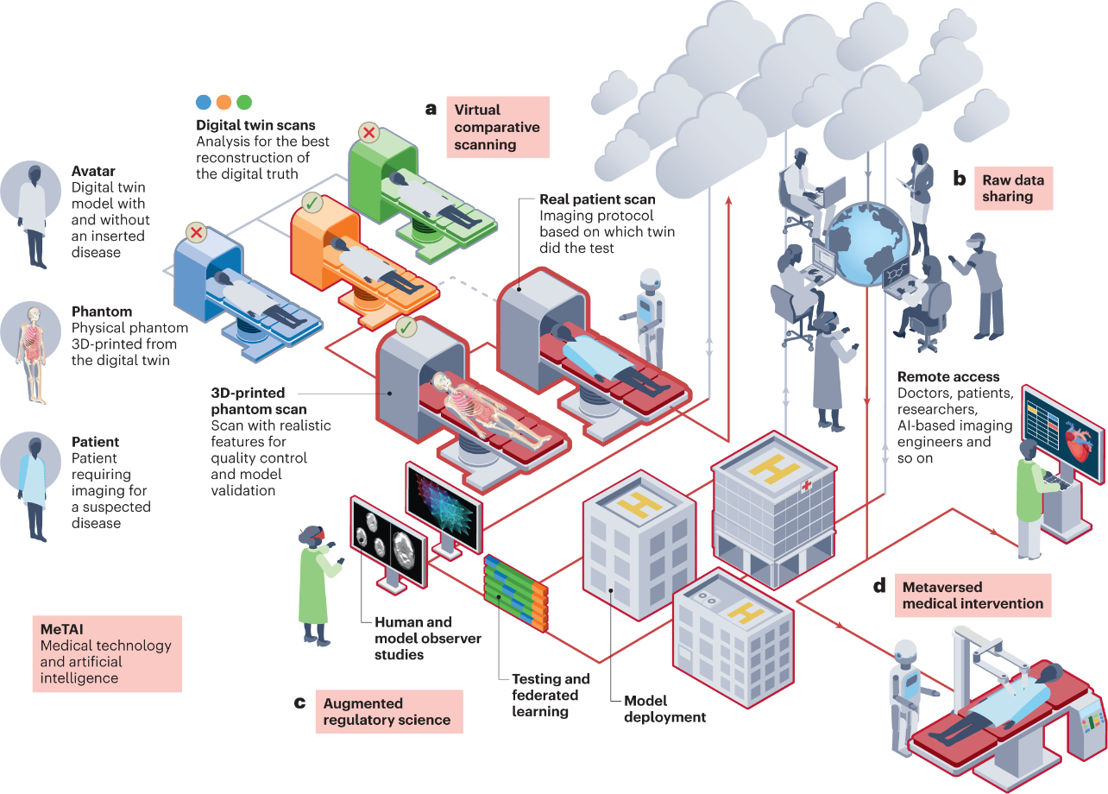
Fig 2 A Metaverse of ‘medical technology and AI’ (MeTAI) Healthcare Applications
Source: (Wang et al., 2022)

4. CHALLENGES
The healthcare industry has been slow in accepting, promoting, and implementing emerging information technology. Every time a new technology is introduced, the technology's impact on patients will be assessed carefully. The challenges may involve multiple aspects, such as technology (interoperability, portability, and stakeholder customization), human factors (skills, resistance, distrust, and cyber-attacks), legislation, and regulation.
In the future, the problems and challenges facing the Health Metaverse include:
4.1 Existing online platforms require additional upgrades
The global COVID-19 pandemic has fundamentally fuelled the development of digital and mobile health, but the authority and effectiveness of these platforms are still worth exploring. Doctors and medical institutions are now participating in the Metaverse but not everyone should be able to create their own diagnostic and treatment standards, as regular users may lack the clinical knowledge of the Metaverse. Existing online platforms are not yet able to integrate medical knowledge into the decision-making processes of platform users.

4.2 Gamification and entertainment of health services
The gamification of reputable healthcare services sometimes creates a medical ethics crisis. Its social consequences can be severe, even threatening the lives and health of patients. Many people still assume Metaverse is a platform for fast and engaging game-based learning, but this understanding is dangerous (Getchell, Oliver, Miller, & Allison, 2010). We can't just let gaming companies or social media companies create, define, and maintain the essential content of the Health Metaverse. For example, Roblox is a VR platform compatible with virtual worlds, casual games, and user-generated content, and is very similar to the Metaverse concept (Bhugaonkar et al., 2022). However, the entertainment features of the platform are not suited to Health Metaverse. It still needs to be reformed and monitored. The health Metaverse is based on user-generated content, which must be professional and credible to avoid misinformation. Similar to existing strategies for assessing the effectiveness of the online health community, we need to explore a post-diagnosis virtual three-dimensional assessment mechanism with physicians and patients in one-to-one or one-to-many interactions in the Metaverse.
4.3 Concerns about user privacy, security, and personalization.
Promising applications of the health Metaverse are essentially changing the way medical practice is done. When constructing the Metaverse, however, the protection of users' privacy, as well as physical and psychological safety, must be taken into account at an early stage. In a Metaverse where devices and individuals are closely interconnected, there inevitably arise significant security vulnerabilities, promoting the question of what surveillance measures can effectively ensure ethical containment (Blobel, 2020; Kim et al., 2019). The technology stack of the Health Metaverse also highlights the risks and challenges associated with safeguarding a system against potential compromises by hackers. These risks pose a threat to the personalized doctor-patient relationship that the health Metaverse aims to hold.
4.4 Censorship and Regulation Issues.
The Metaverse is presently being predominantly advocated by tech giants such as Facebook, Microsoft, and others. However, there are concerns that once the Metaverse is fully established, people may become susceptible to various forms of censorship and commercial interests. The business model design of the Metaverse tends to favor platform owners, potentially undermining competitors and posing challenges to long-term platform sustainability. (Zhou, Leenders & Cong, 2018). The Metaverse was originally conceived as a place where people deal with reality without experiencing it, trying to create a world that replaces the real world. Metaverse relies on its technology and tremendous user benefits to lead the global expansion of its Metaverse platform, raising concerns about data security, sovereignty, privacy, and ethics. These issues are particularly evident in the health Metaverse, which contains massive multimodal and sensitive health and medical data. As with eHealth communities, related technologies in the healthcare Metaverse will gradually evolve into a safe, reliable, and patient-centric environment to effectively meet patient needs. However, the social price to be paid in this process deserves to be considered in the future
5. DISCUSSION
The findings suggest that the available literature on the subject is constrained to a limited number of reviews, literature, and editorials. The research included is new and the Metaverse has been used for various purposes that will require further research in the near future. Notwithstanding these limitations, the Metaverse holds the potential for preventing and treating clinical conditions. It can be effectively employed in educational and training settings, and researchers can utilize this tool to expedite research and manage more extensive global studies. Deploying Metaverse using virtual reality and augmented reality in the healthcare sector has proven essential in improving the efficiency of the medical community in terms of patient services, medical education, and distance learning.
6. CONCLUSION AND FUTURE DIRECTIONS
The healthcare industry operates within a well-regulated system that aims to deliver comprehensive care to patients. However, there are several challenges associated with integrating healthcare with the Metaverse. These challenges include ensuring privacy and trust, achieving interoperability of cloud data information systems and addressing the need for scalable technology to support sustainable environmental medicine. However, the prospects for this area look very promising. The advancements in the Metaverse hold tremendous potential for revolutionizing healthcare, bringing forth new possibilities and introducing innovations that can significantly enhance the quality of care. Successful integration of the Metaverse into healthcare and education can bring about substantial improvements in these domains.
REFERENCES
Aghdam, Z. N., Rahmani, A. M., & Hosseinzadeh, M. (2021). The Role of the Internet of Things in Healthcare: Future Trends and Challenges. Computer Methods and Programs in Biomedicine, 199, 105903. https://doi.org/10.1016/j.cmpb.2020.105903
Ali, S., Abdullah, Armand, T. P. T., Athar, A., Hussain, A., Ali, M., Yaseen, M., Joo, M. Il, & Kim, H. C. (2023). Metaverse in Healthcare Integrated with Explainable AI and Blockchain: Enabling Immersiveness, Ensuring Trust, and Providing Patient Data Security. Sensors, 23(2), 1–17. https://doi.org/10.3390/s23020565
Bamakan, S. M. H., Nezhadsistani, N., Bodaghi, O., & Qu, Q. (2022). Patents and intellectual property assets as non-fungible tokens; key technologies and challenges. Scientific Reports, 12(1), 1–13. https://doi.org/10.1038/s41598-022-05920-6
Bhugaonkar, K., Bhugaonkar, R., & Masne, N. (2022). The Trend of Metaverse and Augmented & Virtual Reality Extending to the Healthcare System. Cureus, 14(9). https://doi.org/10.7759/cureus.29071
Blobel, B. (2020, September). Application of industry 4.0 concept to health care. In pHealth 2020: Proceedings of the 17th International Conference on Wearable Micro and Nano Technologies for Personalized Health (Vol. 273, p. 23). IOS Press.
Chen, D., & Zhang, R. (2022). Exploring Research Trends of Emerging Technologies in Health Metaverse: A Bibliometric Analysis. SSRN Electronic Journal. https://doi.org/10.2139/ssrn.3998068
Chengoden, R., Victor, N., Huynh-the, T., Yenduri, G., Hjhaveri, R., Member, S., Alazab, M., Bhattacharya, S., Hegde, P., Kumar Reddy Maddikunta, P., Maddikunta, reddy, & Reddy Gadekallu, T. (2016). Metaverse for Healthcare: A Survey on Potential Applications, Challenges, and Future Directions. IEEE Access, 4(November 2022), 1–28.
Curtis, C., & Brolan, C. E. (2023). Health care in the metaverse. Medical Journal of Australia, 218(1), 46. https://doi.org/10.5694/mja2.51793
Mejia, J. M. R., & Rawat, D. B. (2022). Recent Advances in a Medical Domain Metaverse: Status, Challenges, and Perspective. International Conference on Ubiquitous and Future Networks, ICUFN, 2022-July, 357–362. https://doi.org/10.1109/ICUFN55119.2022.9829645
Moyne, J., Qamsane, Y., Balta, E. C., Kovalenko, I., Faris, J., Barton, K., & Tilbury, D. M. (2020). A Requirements Driven Digital Twin Framework: Specification and Opportunities. IEEE Access, 8, 107781–107801. https://doi.org/10.1109/ACCESS.2020.3000437
Thomason, J. (2021). Journal of Metaverse MetaHealth-How will the Metaverse Change Health Care? Journal of Metaverse, 1(1), 13–16. https://www.influencive.com/flickplays-3d-social-media-platform-
Wang, G., Badal, A., Jia, X., Maltz, J. S., Mueller, K., Myers, K. J., Niu, C., Vannier, M., Yan, P., Yu, Z., & Zeng, R. (2022). Development of metaverse for intelligent healthcare. Nature Machine Intelligence, 4(11), 922–929. https://doi.org/10.1038/s42256-022-00549-6
Wiederhold, B. K., & Riva, G. (2022). Me t a v e r s e C r e a t e s. June.
Yaqoob, I., Salah, K., Jayaraman, R., & Al-Hammadi, Y. (2022). Blockchain for healthcare data management: opportunities, challenges, and future recommendations. Neural Computing and Applications, 34(14), 11475–11490. https://doi.org/10.1007/S00521-020-05519-W/METRICS

