Performance Improvement in solar water heater using various methods: A review
Punam Agade Dr. Rahul Agrawal
Ph.D Scholar, Associate Professor
Department of Mechanical Engineering Department of Mechanical Engineering
Madhyanchal Professional University, Bhopal, Poornima University, Jaipur
Madhya Pradesh, India Rajasthan, India
agade.punam288@gmail.com rahul.agrawal@poornima.edu.in
Contact No: 8770524995 Contact No: 9982006374

ABSTRACT
An inexpensive and environmentally favourable human development system in the present period is the solar water heater (SWH). Both homes and businesses utilise SWH. This review study provides an overview of several SWH efficiency estimates, including how thermal parameters like enthalpy and entropy are calculated as well as heat loss coefficient. It provides academics from different countries with a thorough and organised examination of the solar energy equations. The creation of SWH's efficiency equations is covered in this essay, along with the effectiveness of SWH's numerous components and the technology used to comprehend the values of SWH equations and its many building methods.
Keywords: Efficiency. Solar water heater, Energy, Productivity, Water

- INTRODUCTION
Solar energy is freely available and abundant to us. The solar energy that strikes the earth's surface may easily be put to use for the good of human civilisation. Solar hot water systems (SHWS) are among the commonly used solar energy harvesting equipment [1]. The most effective alternative energy source is solar energy. Solar energy is viewed as an appealing form of renewable energy that may be utilised for water hearing in both households and industries due to increased energy demand and the expense of fossil fuels (such as petrol or oil). Nearly 20% of a typical family's energy use goes towards heating water [2]. The least expensive and most accessible sustainable energy option for households, solar water heating systems may provide the majority of the hot water a family needs.
Solar water heaters (SWH) are essentially a system that heats water or air using solar radiation and may be utilised in both household and commercial settings. It is not a new technology; in the 19th century, black paint was used to cover tanks in order to collect solar radiation. The absence of insulation back then, however, was a drawback as it caused a quick loss of heat [3]. Year after year, this technology underwent numerous advancements, beginning with Clarence Kemp's addition of a metal panel to the tank in 1891 to increase system efficiency. In 1909, William Bailey sold a significant number of SWHs thanks to his model, which included a coiled pipe collector inside a glass-covered box and comes with an insulated indoor storage tank for heated water [3]. Because of the worsening energy crisis, skyrocketing fuel costs, and rising CO2 emissions that are extremely damaging for the planet's ecology, more of this technology is now being deployed.
- DIFFERENT SOLAR WATER HEATING SYSTEM TYPES
Solar water heaters come in two varieties:
- Active SWH
- Direct-Circulation Systems: These are mostly employed in regions where it doesn't often freeze. A pump is used to move water via collectors into the house. [4]
- Indirect circulation systems: a pump is used to circulate a non-freezing, heat-transfer fluid between the collectors and a heat exchanger, which warms the water used inside the house. This kind is typically employed in subfreezing conditions [5].
- Passive SWH
- Thermosiphon Systems: With this kind, water rises naturally from the collectors to the storage tank after being heated, and the colder water sinks down. This type does not require an external force to move the water, such as a pump[5].
- Storage for the Integral Collector Passive Systems: Using the pressure of ordinary water, water flows through big tubes within the collector and remains there to heat while also serving as a water storage. The difference between active and passive solar water heaters is summarised in the following figures 2, 3. When hot water is needed, heated water is cycled by cold pressure that replaces it in the tubes [5].
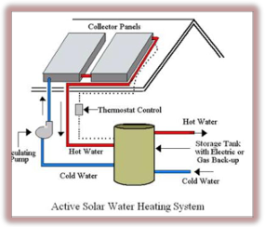
Fig.1 Active Solar Water Heater [6]

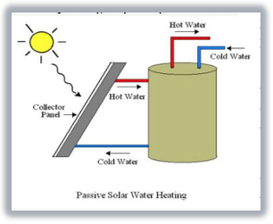
Fig. 2 Passive Solar Water Heater [6]
- Types of Collectors in SWH
There are two main types:
- Non-Concentrating Collectors
- Flat Plate Collector (FPC)
- Evacuated Tube Collector
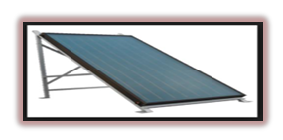
Fig. 3 Flat Plate Collector
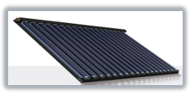
Fig. 4 Evacuated Tube Collector
- Concentrating Collectors
- Parabolic Trough:
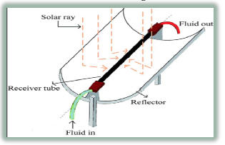
Fig. 5 Parabolic Trough
- LITERATURE REVIEW
A overview of the numerous solar thermal collector types and uses is provided by Kalogirou et al.in their article [7]. The solar collectors utilised in these systems, such as flatplate, compound parabolic, evacuated tube, parabolic trough, Fresnel lens, parabolic dish, and heliostat field collectors, are essential to all solar systems that harness solar energy. Domestic, commercial, and industrial uses all encompass solar collectors. These include the following: space heating and cooling; space heating and service hot water; air and water systems; heat pumps; refrigeration; industrial process heat; desalination; thermal power systems; the parabolic trough; power tower and dish systems; and solar florescence. Solar water heating also includes the thermosiphon, integrated collector storage, direct and indirect systems, and air systems.
Using experimental research, Mustafa AKTA et al. [8] present the best fin size that may be employed in heat exchangers for solar energy systems. Two systems, one traditional and the other finned, were created specifically for this purpose. The six-day-long testing tests show that the fin-equipped system is 7% more effective than the conventional approach. Therefore, it has been determined that using fins in solar energy systems of the right size is beneficial.
The design of solar water heaters to provide hot water for home and industrial uses is covered in Patil et al. [9]. To ensure that consumers receive the most possible advantage from a solar water heating system, designers pay close attention to and analyse the absorber plate materials, absorber and glazing coating, as well as any modifications to the design. The proper choice of each component of the desired capacity and installation location for the solar water heater to produce hot water is necessary when designing a solar water system. We quickly address a number of variables and correlations that affect collector, storage tank, and insulating material design. It is important to acquire superior thermal performance, as demonstrated by the precisely specified operating features and constructional elements of flat plate solar collectors.
By altering the shape of the fin, Ganesh et al. [10] performed experimental research on solar flat plate collectors. Different types of fins, including standard fins (900 area of contact), inverted riser tubes with standard fins, riser tubes with modified fins (2700 area of contact), and inverted riser tubes with modified fins, have been utilised to increase the rate of heat transmission. Experimental studies were done on the system to compare the thermal performance of plain and finned tube absorber plates. The finned tube absorber plate gave greater output water temperature than plain tubes, according to the results. More outlet water temperature is provided by standard fins than by plain tubes, but less so than by modified raiser tube fins. More outlet water temperature comparisons are made with an inverted modified raiser tube. More thermal performance is always provided by expanding here.
Chittireddy et al. [11] investigated the use of an air conditioning radiator in conjunction with a flat plate solar collector as a heat sink for a home water heater. The radiator from an air conditioner was used to make the reception plate (see fig 6). The collector's efficiency will depend on the number of layers and the kind of glassing used, varying with each.
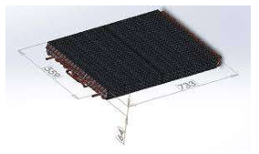
Fig. 6 Air conditioning radiator coupled with a flat plate solar collector
In their experiment study of a flat plate collector and performance comparison with a tracking collector, Prasad et al. [12] describe their findings. To carry out the experimental work, a flat plate water heater that is commercially available and has a capacity of 100 liters/day is instrumented and converted into a test-rig. Data was gathered for both the fixed and tracked states of the flat plate collector during experiments that lasted for a week with nearly consistent air conditions. The findings indicate that the output temperature has increased by an average of 40C. The efficiency of both circumstances was assessed, and a comparison of the results reveals a 21% gain in efficiency overall.
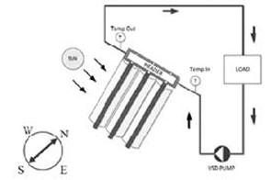
Fig. 7 Diagram of Test Arrangement [5]

- CONSTRUCTIONAL FEATURES OF SWH
- Parts used to build Flat Plate Collector

Table 1. Different components for building the FPC
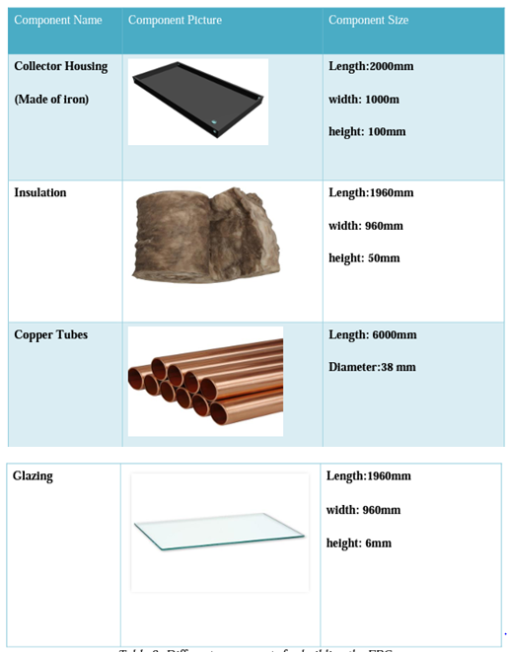

- Construction of the flat plate collector
It comprises of a solar thermal panel with a collector that gathers, traps, and holds solar heat radiation.
The heat exchanger is housed inside the water tank and is built of a coil of copper pipes.
The hot water going through the copper pipe in the heat exchanger is utilised to transmit heat energy to the cold water in the water tank using a heat exchanger.
The heat exchanger's cold water is pumped to the thermal panel's collector using an electric pump.
The controller unit, which is used to
- Fill the water with Auto cut-off in the tank, regulates the whole system.
(ii) Turn the electric pup on and off as needed.
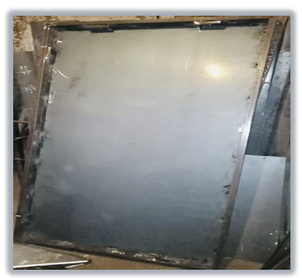
Fig. 8 Collector housing

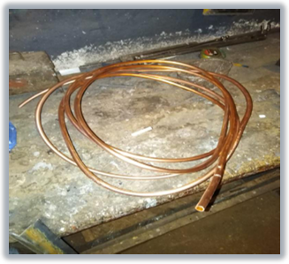
Fig. 9 Meter Copper Tube
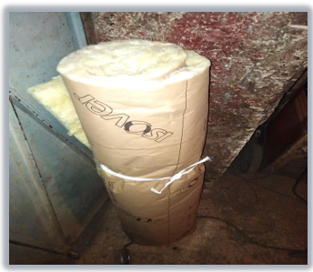
Fig. 10 Insulation Material
The insulation serves to reduce heat losses, absorb part of the energy wasted, and improve the efficiency of the flat plate collector, as shown by figures 9 and 10. The water will be circulated inside the collector by the copper tubes, which will also absorb the sun's rays and convert them into heat that the water can utilise. Because black has a high solar radiation absorption rate, it will be painted on the copper tubes to boost their absorption rate. Inside the collector, the copper tubes will be bent and then reshaped into a serpentine.

- Advantages and disadvantages of FPC

Table 2: Advantages/ Disadvantages of the FPC [19]
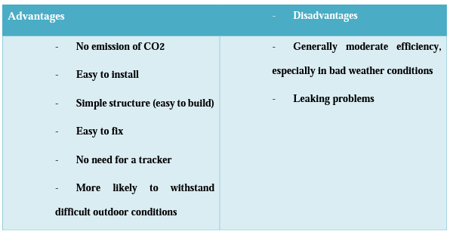

ADVANTAGES OF SOLAR WATER HEATERS
Although all types of solar water heaters utilise the same process to collect solar radiation and convert it into heat for various liquids, each form differs from the others in terms of the thermal efficiency rate due to the materials and components that were used to construct it. Depending on the ambient temperature, each type of collector performs differently, and we may divide the temperature range into three categories as follows:
Systems for low temperatures:
- Frequently use an unglazed collector.
- Operates in locations with low temperatures of up to 10 °C.
- Frequently used to heat swimming pools.
Mid-temperature systems:
- Used for liquid heating and interior heating systems.
- They typically employ flat plate collectors and operate between 10 and 50 °C.
High-temperature systems:
- They are typically used for absorption cooling, electricity production, as well as water heating systems. They typically employ evacuated tubes collector and operate at temperatures more than 50 °C.
- The effectiveness of each of the aforementioned collectors is therefore summarised in the following figure 8, which shows how the temperature of the collection relates to the temperature of the surrounding air:
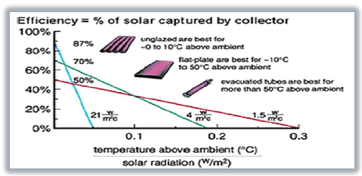
Fig. 8 Efficiency of the Unglazed, Flat Plate and Evacuated tubes collector [10]
- THERMAL EFFICIENCY OF THE COLLECTOR
After constructing the collector, the calculations phase begins, where we may use various formulae to determine the thermal efficiency of the collection. Solar water heater thermal performance is not constant. The ratio of "useful energy out" to "energy available" is used to compute it. The radiation that reaches the surface of the collection has energy accessible. A symbol for it is AI. The net thermal energy contained in the hot fluid exiting the collection output pipe is the useful energy out.
The following formula may be used to determine thermal efficiency:
$ƞ= \frac{Q}{AI}$ [1]
Where, Q is the useful energy out, A is the area of the collector in [m²], I is the solar radiation in the collector plane in [W/m²]
The following equation is used to determine how quickly heat is transferred through each riser tube [13-14]:
$Q= {mc}_{p}\left(T_{out}−T_{in}\right)= U_{o}A_{o}(T_{wo}−T_{m}$) (2)

Where the following equation, which connects the heat transfer rate Q to total heat transfer, has been used to get the internal convective heat transfer coefficient:
$Q=$ $U_{o}A_{o}(T_{wo}−T_{m})$ (3)

Where
$$\frac{1}{{(U}_{O}A_{O})}= \frac{1}{{(h}_{i}A_{i})} + \frac{in(\frac{D_{o}}{D_{i}})}{(2πk_{w}L)} (4)$$

Conclusion:
Climate, financial constraints, and water use needs are three crucial considerations when choosing the best solar water heating system for a company. Solar water heating systems are cost-effective, particularly in commercial buildings where a lot of energy is required to heat the water. Although the sun may heat water, when many elements like safety, maintainability, and system efficiency are taken into account, its uses in water heating will be considerably more successful. Systems for heating water with solar energy are now installed with various settings and agreements. Research into the core technology of these devices reveals the necessity to improve the created layout approach in order to choose, install, and monitor the solar water heating scheme in accordance with accessibility.
REFERENCES
- Mohamed Abu Waseem, "Numerical analysis of absorber tube of solar parabolic trough collector with and without insertion by using Ansys Fluent", Journal of Engineering Research and Application, Vol. 8, Issue 12, Dec 2018, pp 01-04.
- S. Sadhishkumar, "Thermal performance of water-in-glass evacuated tube solar Collector with and without phase change material", Indian Journal Sciences, 20(2), 193-201, 2018.
- K.Balaji , S.Iniyan and A.Idrish khan Thermodynamic analysis of a solar flat plate water heater using extended surface absorber tube (2015)
- Energy.gov. (2019). Solar Water Heaters. [online] Available at: https://www.energy.gov/energysaver/water-heating/solar-water-heaters [Accessed 11 Feb. 2019].
- Gujarat, A. (n.d.). Solar Collector - Solar Flat Plate Collector Manufacturer from Ahmedabad. [online] https://www.dimanoverseas.net/solar-collector.html#solar-flat-plate-collector.
- Jignesh A. Patel, Tejendra B. Patel, Sadanand Namjoshi,"Comparative Study of Thermal Performance of Spiral Tube Solar Water Heater with Straight Tube Solar Water Heater", International Journal for Scientific Research & Development, Vol. 3, Issue 03, 2015.
- Soteris A. Kalogirou, ―Solar thermal collectors and applications.‖, Progress in Energy and Combustion Science 30 (2004) 231–295.
- Mustafa AKTAẞ, Olhan CEYLAN,Hikmet DOĞAN ― The Thermal Effectiveness Compression Of The Classical And Finned Solar System‖ Isı Bilimi ve Tekniği Dergisi, 26, 2, 29-33, 2006. J. of Thermal Science and Technology ©2006 TIBTD Printed in Turkey ISSBN 1300-3615.
- Ankit S. Gujrathi, Sachin P. Ingale, Sudhir U. Patil, "Analysis of Parabolic Trough Collector using Ansys Fluent Software", Volume 5, Issue 4 December 2017.
- Ganesh K. Badgujar, Sachin Nimbulkar, Rajesh Dahibhate, "Experimental Investigations on Solar Flat Plate Collector by changing Geometry of Fin", Journal of Mechanical Engineering, Vol 2, 2017, Pages 52-62.
- Vikas Reddy Chittireddy, Ahmed ElSawy and Stephen Idem study of a flat plate solar collector with an air conditioner radiator as a heat absorber for a domestic water heater March 2018
- P.Rhushi Prasad, H.V. Byregowda, P.B.Gangavati, ―Experiment Analysis of Flat Plate Collector and Comparison of Performance with Tracking Collector‖ European Journal of Scientific Research, ISSN 1450216X Vol.40 No.1 (2010), pp.144 -155, EuroJournals Publishing, Inc. 2010.
- Varun, K., U.C. Arunachala, D.N. Elton. Trade-off between wire matrix and twisted tape: SOLTRACE® based indoor study of parabolic trough collector Renewable Energy 156 (2020): 478-492, https://doi.org/10.1016/j.renene.2020.04.093.
- Hong, Y., J. Du, S. Wang, W.B. Ye, S.M. Huang. Turbulent thermal-hydraulic and thermodynamic characteristics in a traverse corrugated tube fitted with twin and triple wire coils International Journal of Heat and Mass Transfer 130 (2019): 483-495, https://doi.org/10.1016/j.ijheatmasstransfer.2018.10.087.

