Organic Farming in India and Current Status and challenges of Organic Farming
B.M. Satale¹, Dr. W.N. Narkhede² and Pritam Bhutda³
¹Ph.D. Scholar Department of Agronomy, VNMKV, Parbhani,
²Head of Department of Agronomy, VNMKV, Parbhani,
³Assistant professor Sorghum research centre, VNMKV, Parbhani

ABSTRACT

Since the organic revolution was started more than ten years ago, due to numerous challenges, it has not been able to attain the growth in popularity that was expected. Most people think of organic farming as stopping to use synthetic inputs and substituting them with organic ones, such as utilizing organic manures and natural plant protection techniques in substitution for synthetic fertilizers and pesticides. Instead of using harmful inputs, organic agriculture utilizes natural processes, biodiversity, and cycles that are adapted to local conditions. The main objective of organic farming is to create a self-sustaining agricultural system that works in balance with nature, produces healthy food that is both environmentally and economically feasible and enhances the local biodiversity and all of its components. Among the 172 nations that practice organic agriculture, India stands out due to its 6, 50,000 organic producers, 699 processors, 669 exporters, and 7,20,000 cultivated hectares. The expanding domestic market will allow India to grow more quickly. India's local markets must expand for the organic movement to be successful there. India has a great deal of potential to produce crops organically and establish itself as a significant provider of certified organic products in the worldwide organic market thanks to the large area under naturally organic/default organic production.
Keywords: Organic Agriculture, Production, Status and challenges
- Introduction

Defination of Organic Farming
Organic farming is a production system which avoids or largely excludes the use of synthetically compounded fertilizers, pesticides, growth regulators, genetically modified organisms and livestock food additives. To the maximum extent possible organic farming system rely upon crop rotations, use of crop residues, animal manures, legumes, green manures, off farm organic wastes, biofertilizers, mechanical cultivation, mineral bearing rocks and aspects of biological control to maintain soil productivity and tilth to supply plant nutrients and to control insect, weeds and other pests.
- Principle of Organic farming by IFOAM,
- Principle of Health
Organic farming should maintain and improve the health of the land, plants, animals, people, and planet as a whole.
- Principle of Ecology
Based on live ecological processes and cycles, organic agriculture should cooperate with them, reproduce them, and contribute to their sustainability.
- Principle of Fairness
Organic farming should be based on relationships which ensure fairness with regard to the environment as a whole and a likelihood for life.
- Principle of Care
With the goal to maintain the health and welfare of both present and future generations and to protect the environment, organic agriculture should be managed with caution as well as accountability.
- Advantages of organic farming
• It improves to environmental health by reducing pollutants.
• By reducing the amount of residues in the product, it lowers the risks to human and animal health.
• It aids in maintaining agricultural production at a level which is sustainable.
• It enhances soil health and lowers the cost of agricultural output.
• It makes sure that natural resources are used as effectively as possible for immediate advantages and aids in their conservation for future generations.
• It improves the soil's physical properties, such as granulation, good tilth, good aeration, easy root penetration, improves water-holding capacity, and reduces erosion.
• It improves the soil's chemical properties, such as supply and retention of soil nutrients, reduces nutrient loss into water bodies and the environment, and promotes beneficial chemical reactions.
• It reduces the risk of crop failure in addition to saving energy for both animals and machines.
- Status of Organic Farming in India
Globally, the popularity of organic farming and food has increased. Since 1985, the total amount of agricultural land used for organic farming has continually increased (Willer and Lernoud, 2020). 72.3 million hectares of land have been recorded globally in 2019 that were managed organically, including conversion areas. Argentina is second in size, with 3.7 million hectares, below Australia, which has 35.7 million hectares of the highest organic fields. Oceania, comprising up half of all organic agricultural land in worldwide, has 35.9 million hectares, which is followed by Europe, with 16.5 million hectares, as the regions with the largest number of organic agricultural land areas. Asia (5.9 million hectares), North America (3.6 million hectares), and Africa (2 million hectares) follow Latin America in in terms of total land area (8.3 million hectares) (Figure 1). India ranks first in terms of the overall number of organic producers with 1,366,226 (Figure 3), but it ranks fifth in terms of the total area of organic agriculture (2.3 million hectares).
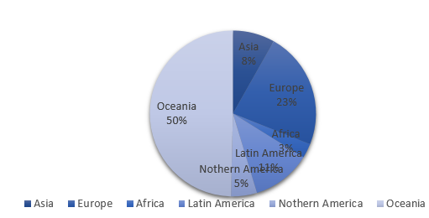
Fig.1 Distribution of organic arable cropland by region (Source: FiBL & IFOAM, 2021)

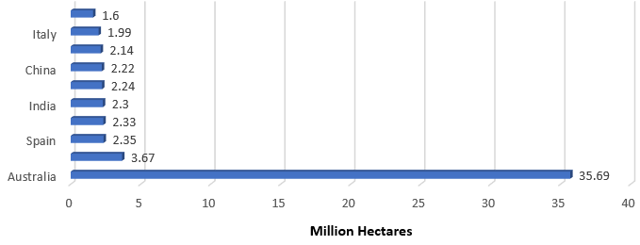
Fig.2.Ten Countries with largest areas of organic agricultural land (Source: FiBL & IFOAM, 2021)

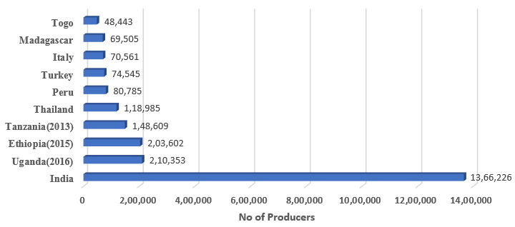
Fig.3. The ten countries with the most organic producers (Source: FiBL & IFOAM, 2021)
The National Programme for Organic Production (NPOP), which was launched in 2001 under the Agricultural and Processed Food Products Export Development Authority (APEDA) of the Ministry of Commerce and Industry, Government of India, encourages the national-level organic farming movement. It was primarily supported by a third-party certification system and pushed at the government level with an export-centric strategy (Amit Khurana and Vineet Kumar, 2020). In 2005, the Government of India established its first organic agricultural policy. The Ministry of Agriculture and Farmers' Welfare (MoAFW) will start the National Mission for Sustainable Agriculture later in 2014–15 to promote organic farming. These institutions, policies, and numerous programs have allowed organic farming to rapidly expand over many of India's agro-ecological zones, particularly in rain-fed areas, hills, as well as arid zones (Vaidya S, et al., 2007). India has a total of 2.3 million hectares of land specialized to organic farming as of March 2020. Out of this, more than 70 percent of the land is covered by NPOP. According to FiBL & IFOAM (2021) and other sources, 1.3 percent of all agricultural land is organic. In India, organic farming has increased by 18.6 percent since 2018. Due to the efforts of the government and other organizations, organic farming is growing in popular across India's many agro-ecological zones, particularly in the rain-fed regions, the hills, and the dry regions (Vaidya S, et al., 2007). The organic and natural farming sector now gets a budget of Rs 687.5 crore, which is an increase from Rs 461.36 crore in the previous financial year (Union Budget 2020-21, GOI). The NPOF (12.5 crores), the Paramparagat Krishi Vikas Yojana (500 crores), and the Organic Value Chain Development for the North East Region each get some of this funding. Madhya Pradesh has certified more area among all the states, followed by Rajasthan, Maharashtra, Gujarat, Karnataka, Odisha, Sikkim, and Uttar Pradesh. A total of 2.75 million MT (2019–20) of certified organic products were produced in India, including oil seeds, sugar cane, cereals and millets, cotton, pulses, aromatic and medicinal plants, tea, coffee, fruits, spices, dried fruits, vegetables, and processed foods. Around Rs 4686 crore was earned through the export of organic foods. According to APEDA, certified organic products are exported to the United States, the European Union, Canada, Switzerland, Australia, Japan, Israel, the United Arab Emirates, New Zealand, and Vietnam.
- Reasons To Go For Organic Farming
- It boosts the nutritional quality of food
Organic crops are cultivated on soils that are safe and biologically active. Compared to crops grown by industrial agriculture, crops on organic farms take longer to grow as well as yield less per acre. In addition, crops grown on organic farms are more likely to have crops that are nourished by larger amounts of minerals, antioxidants, and vitamins.
- Organic food gives the best results for health issues
The normal food system has so many issues that affect everyone, including learning difficulties, water pollution, birth malformations, suffering farm animals, and much more. The certified organic label stands for providing what people in today's society need, such as healthy food, pure water, items made without the use of agrochemicals etc.
- Decreases the intake of antibiotics and unnecessary hormones
A large number of conventional farmers use a number of toxic, drugs, growth hormones, and supplements to make their animals grow faster, bigger, and produce more milk than would be produced naturally, which causes us to consume more of these products daily and increase our use of antibiotics. Organic farming can help in lowering consumption of all these. Since practically all synthetic animal treatments are strictly forbidden by the National Organic Program regulation, healthy animals will ultimately produce healthy milk, meat, dairy products, eggs, etc.
- Maintenance for healthy soil
The key to all successful organic farms is having good soil. After comparing the results of numerous studies conducted over the years, it has been determined that organic farms, which practice organic management and improve soil quality, rotate their crops, restore organic components, and use nitrogen to help dispute global warming, have healthier soil than conventional farms.
- Create a healthy environment in the workplace and neighbouring areas
The second-most hazardous occupation after mining is farming. Caustic fertilizers, harmful insecticides, and several other chemicals provide a risk to many individuals who live or work near farms until and until adequate measures are taken. By moving to organic farming, producers use considerably less harmful Agrochemicals, which means that neither the employees nor the rural neighbors need to worry about their health.
- Scope of Organic Farming
- Organic farming is becoming more and more popular in India. This is mostly a result of recent agricultural study and experimentation. Inventions of new methods are wholly beneficial to the soil's health.
- The quality of the product has increased due to the drastic decrease in harmful substances caused by these new production methods. In addition, more and more individuals are moving to organic farming methods in the current environment due to the rising illnesses brought on by the artificial production of crops.
- Another important reason for moving to organic farming is the health of humans. Because so many people are changing their lifestyles to improve their health, organic farming has a large market.
- As consequence, there is a significant likelihood that consumers would respond favorably to organic products, which will also boost the farmers' opportunities. In addition, because organic farming does not include the use of synthetic fertilizers or pesticides, maintenance expenses are also quite low.
- Opportunities In Organic Farming
- There are several categories in organic farming. Any of these can be chosen, and then the person can focus on that particular category. By doing this, one would know exactly what they need to concentrate on and may succeed in the market.
- Vegetable and fruit production, which accounts for 75% of the market in organic farming, is an option. However, this area is a terrific choice if you have a solid financial foundation because this sector occasionally suffers losses due to the perishable nature of its products.
- An other viable option for increasing income is the production of organic medicines. When it is produced organically, medicines are also in great demand. In order for patients to recover at a rapid rate, a lot of medical experts suggest natural treatments.
- Although it is a brand-new idea to many, organic farming has a lot of potential for success and may be used wisely to make money. From a commercial perspective, the items' demand is considerably higher than their limited supply. In light of this, organic food is more expensive than usual, yet despite this, consumers continue to purchase it because they believe it to be advantageous.
- Future of Organic Farming
- By 2030, India's organic crop production would thrive and provide food for 1.5 billion people. Organic farming is growing at a 25–30% year pace. India would have 1.35 billion acres under organic farming by 2020. Comparing organic and conventional farming, the former is 35% more profitable.

- More farmers are moving to organic farming because it enhances biodiversity and makes use of high-quality soil and air. Many investors are interested in establishing a business in organic farming since there are Lots of people nowadays have shifted to organic and vegetarian diets since eating conventional and poisonous foods has a serious negative impact on their health.

- Because organic crops are more naturally grown and healthy than conventional crops, organic farming will continue to be extremely effective and successful in the years to come. Organic farming has a wide range of applications because it is cheaper and doesn't involve the use of harmful substances, medicine, or other things.
- Need for Organic Farming
The concept "sustainability" is increasing importance across various sectors, with organic farming being a proponent of agriculture. In the 21st century, an organic lifestyle is progressively taking center stage. Organic farming tries to have a favorable impact on the environment and human health. a study by Elayaraja [2], moving to organic farming is essential if you want to stay free from pesticides and fertilizers made by chemicals. The method has a focus on using sustainable methods to eradicate weeds and pests. Chemicals may also leave residues in items and food that might have disastrous effects on the environment and our health. likewise moving to organic farming is appropriate for conserving the environment, according to Kumari [4]. The larger global issue of climate change shows how dangerous it is to our ecosystem and calls for actions to keep nature pure and plentiful, such organic farming in the agricultural sector. In comparison to traditional production methods, ecological production practices greatly support the development of biodiversity. In addition, Karunakaran [5,4] highlights that organic farming, as opposed to conventional farming, might enhance the nutritional value of foods and food products. Additionally, moving to organic farming is suitable for conserving the environment, according to Kumari [4]. The wider global issue of climate change indicates the risk to our ecosystem and suggests actions to keep nature pure and plentiful, such organic farming in the field of agriculture. compared to conventional production methods, ecological production practices substantially enhance the development of biodiversity. In addition, Karunakaran [5,4] highlights that organic farming, as opposed to conventional farming, may increase the nutritional value of foods and food products.
- Limitations and Suggestions
There are several limitations to take into consideration, even if the studies under evaluation offer important information about the potential of organic farming in India. First off, most of the studies were restricted to one area of India, which may limit the applicability of the results to other parts of the nation. More study is required to completely understand the long-term consequences of organic farming because the majority of studies mainly looked at the short-term effects of organic farming on food security and associated issues. Future study should concentrate on making additional comparisons between organic and conventional agricultural practices in India and investigating the unique possibilities and problems faced by organic agriculture in various Indian areas and climates. This will make it easier to understand the possible advantages and disadvantages of converting to organic farming in India, as well as the social and economic factors that influence the adoption and efficacy of such practices. In terms of legislation and practical consequences increasing government support for organic farming and permitting organic farmers in India more access to markets may have a substantial impact on the industry's development. To evaluate the long-term effects of organic farming on food security, crop productivity, and the economy of India, further study is required. Government policies and programs should be established to fund research and development, infrastructure development, and market access. practices and ensure its success in India. To assist farmers and increase consumer access to their goods, it is essential to build a strong infrastructure and supply chain for organic farming in India. Promoting the use of organic farming practices and ensuring their effectiveness in India need cooperation between farmers, researchers, and policymakers.

