CONDUCTING POLYMERS FOR ELECTRONIC APPLICATIONS

Jesslyn John. P

Department of Chemical Sciences

Indian Institute of Science Education and Research

Kolkata, West Bengal, India

Princy K.G
Department of Chemistry
Carmel College(Autonomous),
Mala, Kerala, India.
Email: princy.k.g@carmelcollegemala.ac.in

ABSTRACT
Investigations into conducting polymers have been thorough due to their remarkable characteristics, such as adjustable electrical property, outstanding optical and mechanical properties, simple synthesis and fabrication processes, as well as superior environmental stability when compared to traditional inorganic materials. The synergistic benefits of utilizing conducting polymer composites have enabled them to be widely implemented in the electrical, electronics and optoelectronic industries. This chapter provide an explanation about the conduction mechanism, methods of synthesis, properties and applications of conducting polymers like polyacetylene, polyaniline, polypyrrole, polythiophene etc. Microwave conductivity and mechanism of electrical conduction in conductive polymers and conductive rubber blends are also discussed.
Keywords- conducting polymers, conduction mechanism, polyacetylene, polyaniline, polypyrrole, polythiophene, poly(p-phenylene), microwave conductivity and conductive elastomers.
- INTRODUCTION
Polymer is a substance or material consisting of very large molecules called macromolecules, composed of many repeating subunits called monomers. The possibility of improving the conductivity of polymers, which are conventionally insulators, to metallic levels has attracted not only chemists, but also physicists and even material scientists. Many researchers have tried to combine the processability and other attractive properties of polymers with the electronic properties of metals or semiconductors[1].
As the name suggests organic polymers that conduct electricity are known as conducting polymers. They are also known as intrinsically conducting polymers (ICPs) and they have alternating single and double bonds along the polymer backbone (conjugated bonds). Such compounds can have either metallic conductivity or can be semiconductors. These materials are generally not thermoplastics. They can offer high electrical conductivity but do not show similar mechanical properties to other commercially available polymers. The electrical properties can be modified by the methods of synthesis and by advanced dispersion techniques. Typical conducting polymers include polyacetylene (PA), polyaniline (PANI), polypyrrole (PPy), polythiophene (PTH), poly(para-phenylene) (PPP), poly(phenylenevinylene) (PPV), polyfuran (PF) etc.
A major breakthrough in the search for conducting polymers occurred in 1977 with the discovery that polyacetylene could be readily oxidized by electron acceptors such as iodine or arsenic pentafluoride or reduced by donors such as lithium. The resulting material had a conductivity that was orders of magnitude greater than the original, untreated sample. The redox reaction can be carried out in the vapour phase, in solution, or electrochemically[2].
A significant development occurred in 1979 with the discovery that poly (p-phenylene) could also be doped with AsF₅ to high conductivity. It demonstrated that polyacetylene is not unique and this led to the development of a number of new poly aromatic-based conducting systems, including poly (p-phenylene sulphide), polypyrrole, polythiophene, and polyaniline

- TYPES OF CONDUCTING POLYMERS

Conducting polymers are of two basic types:- intrinsically conducting polymers where the polymeric material itself conducts and extrinsically conducting polymers which are composites where a conductive material such as carbon black is embedded in a non-conducting polymer such as poly(ethene)[3].
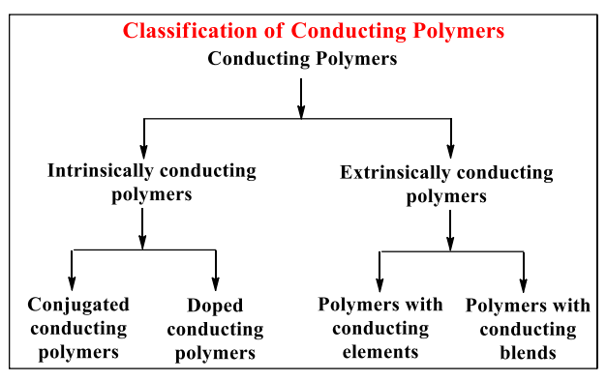
- Intrinsically Conducting Polymers
Conjugated conducting polymers are conducting polymers having alternate single and double bonds. Conjugated polymers have a sigma bond backbone formed by the overlap of sp² hybrid orbitals. The remaining orbital of the carbon atoms overlap sidewise with the neighbouring p_{z}-orbital to form π –bonds. The electrons involved in π –bond formation are delocalized over the entire polymer chain which results in the formation of valence band and conduction band. When the energy gap between the two band is low, the electrons undergo excitation from the low energy valence band to the high energy conduction band and show increased conductivity.
Conjugation alone is not sufficient to make a polymer conducting. The conductivities of pristine polymers (pure conjugated polymers) can be increased from insulating type (10⁻¹⁰ – 10⁻⁵S/cm) to conducting type (0.1 – 10⁵ S/cm) by a process called ‘Doping‘.

Doping
The conductivity 'Ϭ', of any conducting material is proportional to the product of the free-carrier concentration, n; and the carrier mobility, µ,
Ϭ = ne µ
where 'e' is the unit electronic charge. Since conjugated polymers have relatively large band gaps, the concentration of free carriers is very low at normal temperatures. Therefore, even though conjugated polymers have high carrier mobility, the low carrier concentration results in low conductivity[3].
Doping is a process in which a virgin polymer is treated with a strong oxidizing or reducing agent that either abstracts electrons from the polymer or donates electrons to it through the formation of a charge carrier into the polymer for the enhancement of it’s conductivity.
Polymer + acceptor dopant → polymer ⁺ dopant ⁻
Polymer + donor dopant →polymer ⁻ dopant ⁺
The doping of conjugated polymers increases the carrier concentration. Doping in polymers is a redox process involving charge transfer with subsequent creation of charged species. With polymers, electronic excitations are accompanied by a disorder or relaxation of the lattice around the excitation, and thus structural and electronic excitation will result in structural defects along the polymer chain. Removal of an electron leaves an unpaired spin near the valence band (p- doping) and addition of an electron shifts the corresponding state near the conduction band (n- doping)[4]
Oxidative dopants are usually electron-attracting substances. The common p-type dopants are Br₂, AsF₅, H₂SO₄, HClO₄, PF₅, SbF₆, CH₃F, NOF, NO₂, NO⁺SbCl₆⁻, SO₃, FeCl₃, etc. Reductive or n-type dopants are electron donating substances like sodium naphthalide, Na/K alloy, molten potassium, Lil etc. There are a number of ways by which doping can be carried out. Essentially, these different methods can be broadly summarized as being solution doping, vapour phase doping and electrochemical doping.
In conducting polymers, the doping process can be reversed, i.e., the conducting polymer can be converted to insulator by neutralization back to the uncharged state. This return to neutrality is called compensation. Exposure of oxidatively doped polymer to electron donors, or, conversely, of reductively doped polymers to electron acceptors effects compensation. This property is made use of in the construction of rechargeable batteries.
- Extrinsically Conducting Polymers
Conductive element filled polymers are obtained by blending an insulating type of polymer with suitable conducting elements such as carbon black, metallic fibers, metallic oxides etc. to make the polymer conducting. The minimum amount of the conducting element required for an insulating polymer to make it conducting is called percolation threshold.
Blended conducting polymers are obtained by blending a conventional polymer with a suitable conducting polymer. Polymers obtained by this method possess better physical, chemical, electrical and mechanical properties which can also be easily processed.
An example for extrinsically conducting polymer consists of a matrix of poly(ethene) containing conducting carbon black incorporated in it. When the carbon black particles are close enough to be in contact with each other, the material conducts. When the particles are not in contact, it is an insulator. This means that the degree of electrical conduction depends on temperature. At high temperature, the poly(ethene) matrix expands and pulls the particles of carbon black away from each other, decreasing the conductivity. At lower temperatures the poly(ethene) contracts, the carbon black particles are closer and the material conducts well.
- THEORY OF ELECTRICAL CONDUCTIVITY
In conventional polymers such as polyethylene, the valence electrons are a part of sp³ hybridized Carbon atoms. Such “sigma-bonding electrons” are firmly bound and localized. So , they do not contribute to the electrical conductivity of the material. In this polymers, the energy gap between the valence band and conduction band (band gap) is large, and these are electrically insulators.
Conducting polymers are part of sp² hybridized carbon atoms containing an unpaired electron in a p_{z} orbital . All the p_{z} orbitals are parallel to each other, as a result they can overlap with each other to form a delocalized set of orbitals. The electrons in these delocalized orbitals have high mobility when the material is “doped” by oxidation, which removes some of these delocalized electrons. Thus, the conjugated p-orbitals form a one dimensional electronic band, and the electrons within this band become mobile when it is partially emptied. Semiconducting polymers (conjugated materials) are having the energy gap between the valence band and conduction band (band gap) are not so large and not so small. They have low conductivity; a small amount of electric current can flow at room temperature[2].
- ELECTRICAL CONDUCTIVITY OF COMMON CONDUCTING POLYMERS
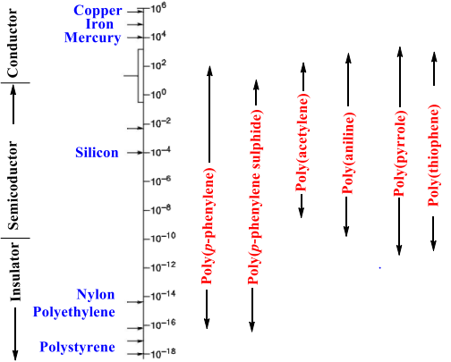
- SYNTHESIS OF CONDUCTING POLYMERS
Since the conductivity of conducting polymers are known to depend on the method of synthesis, a large number of preparatory methods have been developed to improve the conductivity. Addition, condensation, electrochemical, ring opening, and plasma polymerization are the most notable and widely used techniques in this regard. Other methods include Diels-Alder elimination, Wittig reaction, Ziegler Natta catalysis, Friedel Crafts reaction and nucleophilic displacement reaction. In designing polymer synthesis, the incorporation of extended pi-electron conjugation is of foremost importance[1].
- Polyacetylene
Poly(acetylene), PA is the simplest conjugated polymer which was first synthesized. Polyacetylene (IUPAC name: polyethyne) is an organic polymer with the repeating unit [C₂H₂]_{n}. Polyacetylene has a conductivity in the range of 10⁻⁵ Scm⁻¹ , but when the doping level increases, its conductivity rises drastically to 10² to 10³ Scm⁻¹. It is synthesized by the polymerization of acetylene. It’s conductivity is comparable with metals on doping with oxidizing agents like iodine vapour. Oxidation forms charge carriers on the conjugated polyene structure, especially of p-type conductivity. PA exists in two isomeric forms: trans and cis. The trans form is the thermodynamically stable form at room temperature[1, 5].
There are different methods to synthesize polyacetylene: catalytic polymerization, non-catalytic polymerization, catalytic polymerization of other polymers, precursor-assisted synthesis etc., from pure acetylene and other monomers. One of the most common methods uses a Ziegler–Natta catalyst, such as Ti(O-nBu)₄/Al(C₂H₅)₃, with gaseous acetylene. It exists predominantly as the cis isomer with a high degree of crystallinity. Isomerization to the more stable trans form can be induced by heat or dopants.
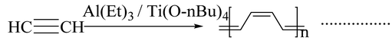
Luttinger catalysts are also used for the preparation of polyacetylene which consist of a combination of a hybrid reducing agent and a complex of a group [VIII] metal such as nickel chloride and uses hydrophilic solvents like water–ethanol, tetrahydrofuran (THF) or acetonitrile as a solvent for catalytic action.
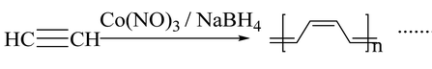
Electrochemical polymerization of acetylene comes under the heading of non-catalytic polymerization. Anodic oxidation of a monomer precursor in the presence of suitable electrolytes on an inert metal surface is regarded as an electrochemical synthesis. Polyacetylene can also be synthesized by the retro Diels Alder reaction.
Korshak et al. synthesized polyacetylene films by ring-opening polymerization of 1,3,5,7-cyclooctatetraene which is an example of the synthesis of polyacetylene without using an acetylene monomer. Light-induced synthesis, i.e., irradiation of acetylene gas with UV also produces polyacetylene.

Properties of Polyacetylene
- Films of cis-polyacetylene are flexible and can be readily stretched while trans-polyacetylene is much more brittle.
- Both cis and trans-polyacetylene show high thermal stability.
- They are insoluble in common solvents.

Applications of Polyacetylene
- Doped polyacetylene offers a particularly high electrical conductivity therefore it can be used in electric wiring or electrode material in lightweight rechargeable batteries.
- Tri-iodide oxidized polyacetylene can be used as a sensor to measure glucose concentration.
- Poly(diacetylene)s
Poly(diacetylene)s (PDAs) are conducting polymers which are closely related to polyacetylene. They are synthesized by the 1,4 topochemical polymerization of diacetylenes[1].
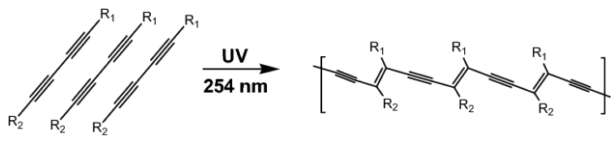
- Poly(p-phenylene)
Polymers containing phenyl group constitute a large class of conducting polymers, which are thermally, and oxidatively more stable than other polymers. Phenyl rings(benzoid aromatic nuclei) are there in the polymer backbone as repeat units. Direct oxidation of benzene molecules is widely using for the synthesis of poly(p-phenylene)s. The synthesis is carried out by using reagent consisting of a binary or a single system. The binary system consists of both a Lewis acid and an oxidant system, and in the case of a single reagent system (FeCl₃), the system acts as both a Lewis acid and an oxidative system by itself. Poly(p-phenylene) is obtained when benzene is coupled by aluminium chloride/cupric chloride at 35⁰ C in benzene solvent[6].
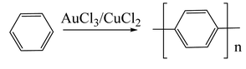
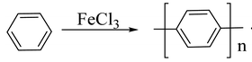
The first chemical synthesis of poly(p-phenylene) was carried out using a Wurtz–Fittig reaction, which is a metal coupling reaction.
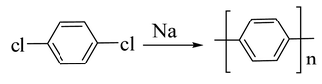
The Ullman reaction can also be used for the preparation of poly(p-phenylene)s.
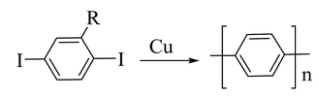
- Polyaniline
Polyaniline is the most promising and most explored among conducting polymers, because of its high stability, high processability, tunable conducting and optical properties. The conductivity of polyaniline depends on concentration of the dopant, and it shows metal-like conductivity when the pH is less than 3. Polyaniline exists in three different forms. According to their oxidation state, they are classified as leucoemeraldine, emeraldine, and pernigraniline. In the fully oxidized state, it acts as an insulator and becomes conductive only when it is in a moderately oxidized state[1, 7].
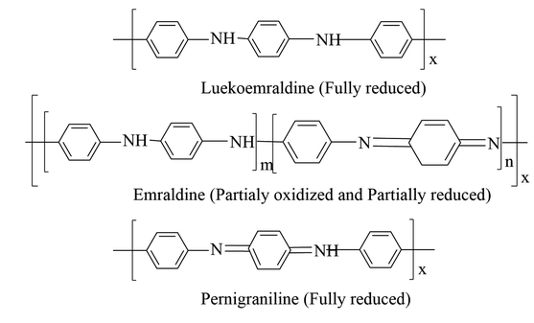
In the chemical oxidation method to synthesize polyaniline, the monomer aniline is mixed with an oxidizing agent in the presence of a suitable acid at low temperature. The change in color of the reaction medium to green indicates the formation of polyaniline. Common oxidizing agents like ammonium persulphate, ammonium peroxydisulphate, ceric nitrate, ceric sulphate, potassium dichromate, etc. can be used.
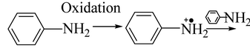
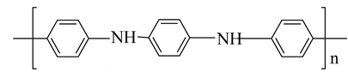
Polyaniline can be synthesized by interfacial polymerization, in which an aniline monomer is solubilized in an organic solvent like toluene, an oxidant solution and a dopant acid-containing aqueous solution. In the micro emulsion technique for the synthesis of polyaniline, the polymerization takes place in the interface between two immiscible liquids, but the difference is in the surfactant used. The electro polymerization technique and electrospinning method are also used to synthesize fibrous polymer morphologies of nano or micro diameters.

Properties of Polyaniline
- It has great electrical conductivity in the range of 10⁻¹⁰ to 10² s/cm.
- It has band gapes of 4.3 and 2.7 ev in its reduced and oxidized forms respectively.
- It has high chemical stability.
- Polyaniline-based composition can withstand high temperatures like 230-240 ℃ without significant change in electrical properties.

Applications of Polyaniline
- It is used in the manufacturing of printed circuit boards.
- Polyaniline and its derivatives are used as the base element for the production of N-doped carbon materials.
- The color change of polyaniline in different oxidation states can be used in sensors and electrochromic devices.
- Printed emeraldine polyaniline-based sensors have wide application in the electronic sector.
- Poly(p-phenylene sulphide)
Poly(phenylenesulphide), PPS is an organic polymer consisting of aromatic rings linked by sulphides. The polymer is synthesized by the reaction of sodium sulphide with 1,4-dichlorobenzene in a polar solvent such as N-methylpyrrolidone at high temperature (250°C)[1,8]
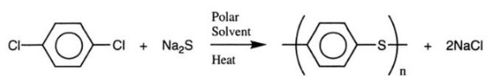
Polyphenylene sulphide can be prepared by homopolymerization of thiophenol in the presence of H₂SO₄ or by oxidative condensation of thiophenol in the presence SOCl₂ and a Lewis acid.
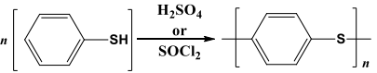
Polyphenylene sulphide can also be synthesized by self-condensation of metal-p-halogenothiophenoxide.
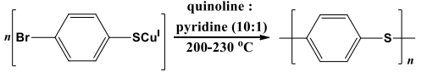

Properties of poly(p-phenylene sulphide) (PPS):
- PPS is a rigid and opaque polymer with a high melting point (280 ℃).
- It is resistant to heat, acids, alkalies, bleaches, sunlight, and abrasion.
- It absorbs only a small amount of solvent and resists dyeing.
- It has good conducting properties if doped with dopants or by oxidation.
- It has exceptional mechanical strength and good dimensional stability.

Applications of poly(p-phenylene sulphide) (PPS):
- It is used in automotive industries for the manufacturing of fuel injection systems, water pump impellers, electric brakes, bulb housing, etc.
- It is used in electronic industries for the manufacturing of connectors, hard disk drives, sockets, switches, etc.
- It is used in the medical industry like surgical instruments, medical fibers, and membranes.
- It is used in fiber extrusion and non-stick and chemical-resistant coatings.

- Polypyrrole
Polypyrrole is unique due to its increased commercial interest because of its high stability and enhanced conductivity. It behaves like an insulating material in its undoped virgin state, and it shows an electrical conductivity of 10⁻⁵ Sm⁻¹ when doped with halogenic electron acceptors such as bromine or iodine[9].
Polypyrrole was first prepared by the chemical oxidation of pyrrole monomer in the presence of hydrogen peroxide, and it is a black powdery material.
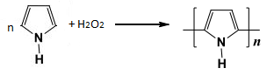
Polypyrrole can be synthesized by electrochemical method.
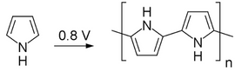
Polypyrrole has been synthesized by chemical polymerization technique using oxidative polymerization of the monomer by chemical oxidants in aqueous or non-aqueous solvents or by chemical vapour deposition. In general, aqueous or anhydrous FeCl₃, or other salts of iron(III) or copper(II), ammonium persulphate, are widely used as chemical oxidants. Apart from metallic salts, polypyrrole has been synthesized using a halogen electron acceptor, such as bromine or iodine, in various solvents. Iron (III) chloride has been found to be the best chemical oxidant and water is the best solvent for chemical polymerization with respect to desirable conductivity characteristics.
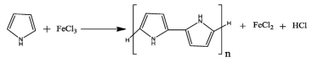
Due to the presence of highly reactive N-H group, in order to prevent side reactions and crosslinking, poly(pyrrole) can be prepared by Stille Coupling or thermolysis sequence.

Properties of Polypyrrole:
- It is an insulator but its oxidized derivatives are good electrical conductors having conductivity in the range of 2 to 1000 s/cm.
- It attains good thermal stability if treated with an acid or base like sulphuric acid and sodium hydroxide.
- It is corrosion resistant and also chemically stable due to cross-linking.
- Its glass transition temperature is 160-170 ℃.

Applications of Polypyrrole:
- Polypyrrole and its related polymers are used in electronic devices and chemical sensors.
- It can be used as a potential vehicle for drug delivery.
- It can be used as catalyst support for fuel cells.
- It is used to coat silica and reverse-phase silica to yield a material capable of anion exchange.
- Polythiophene
Polythiophene and its derivatives are important because of their environmental stability, thermal stability and high optical property compared with other conducting polymers. It was chemically synthesized in the early 1980s by the Yamamoto and Lin–Dudek routes[1, 10].
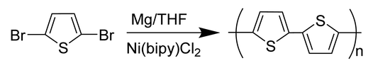
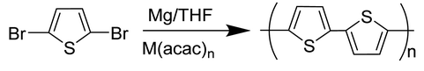
Polythiophene can be synthesized by a standard chemical oxidation procedure by using Ferric chloride (FeCl₃) as an oxidizer.
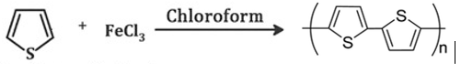
Other advanced techniques, like direct sol–gel, oxidative synthesis, organometallic coupling reaction, electropolymerization, template-assisted synthesis, and hydrothermal and solvothermal techniques can also be used.

Properties of Polythiophene:
- It is an excellent intrinsic conducting polymer having conjugated double bonds in the backbone.
- It has high environmental and thermal stability.
- It is a colored solid but tends to be soluble in organic solvents.
- It is transparent having good optical properties.

Applications of Polythiophene
- They are widely used in solar cells due to their ability to form better contact with metal electrodes.
- They are also used in polymer batteries and electrochromic devices.
- They can also work with receptors for detecting metal ions or chiral molecules.
- They show potential in the treatment of prion diseases.
- Poly(p-phenylene vinylene)
Poly(p-phenylene vinylene), PPV was the first electroluminescent material used for the fabrication of organic light-emitting diodes due to its high optical property. It is generally prepared by Wittig coupling reaction involving the coupling between an aromatic bisphosphonium salt and a bisaldehyde[1, 11].
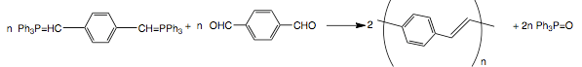
The couplings of ethylene with a variety of aromatic dibromides via a Heck reaction can be used for the synthesis of poly(p-phenylene vinylene).
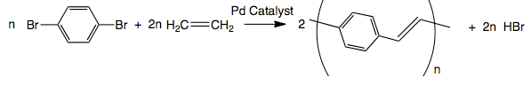
A Suzuki coupling reaction can also be used for the synthesis of poly(p-phenylene vinylene) by Pd-catalyzed coupling of alkyl-substituted aryldiboron acids with dibromo aromatic compounds. Other synthesis methods include electro polymerization, benzoin condensation, ring-opening polymerization, metathesis polymerization, and chemical vapor deposition.
- Poly(p-phenylene oxide)
Poly(p-phenylene oxide)s, poly(p-phenylene ether)s, PPO, often referred to simply as polyphenylene oxides, are useful materials for engineering thermoplastic applications because of their thermal, oxidative and chemical stability. They are generally prepared from phenols by a variety of oxidative coupling methods and step-growth polymerization reactions. The copper-catalyzed oxidation of 2,6- dimethylphenol in the presence of oxygen to synthesize PPO was first reported by Hay in 1959[12].
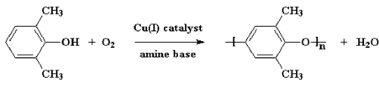
- TEMPERATURE CHARACTERISTICS OF CONDUCTORS
The temperature characteristics are of importance when considering possible applications for conductors. Generally speaking, the conductivity of a metal falls as the temperature is raised because of the scattering of the carriers and this is recognized by an increase in resistance. In this case, the temperature coefficient of the resistance is positive (PTC). If the temperature of a semiconductor such as silicon is raised the conductivity increases because of the rise in the number of carriers. Such materials are said to have a negative temperature coefficient (NTC). The situation with a typical macromolecular conductor such as polyacetylene differs according to the doping concentration.
Even though many conducting polymers show metallic level of conductivity, the temperature dependence of conductivity is not like metal. In most of the cases, the dependence is like that of a semiconductor. The semiconductor like behaviour of conductivity can be explained on the basis of the existence of potential barriers between highly conducting regions. These barriers are due to conjugational defects or other inhomogeneities in the polymer chain. The charge carriers will have to hop or tunnel through the potential barriers. Since tunneling by itself is a temperature independent process, the temperature dependence of conductivity must arise from other processes influencing the charge transfer between highly conducting regions. The mode!s of Sheng, take into account the charging energy of conducting regions of the random thermal motion of charge carriers on both sides of the tunnel junction and the derived transport characteristics have been the most successful ones in describing the conductivity of highly doped conjugated polymers.
When the size of highly conducting regions or islands are sufficiently small (less than 20nm), the energy required to move an electron from an electrically neutral island become significant. If the voltage between two adjacent islands is small, charge carriers can be generated only by thermal activation, making conductivity temperature dependent and limited only by the charging energy. The charge carriers will then percolate along the path with least resistance.
If the size of the highly conducting regions is larger than about 20nm, charging energy becomes negligible. Sheng's second model for inhomogeneous conductors is based on fluctuation-induced tunneling of charge carriers between highly conducting islands. This model applies to larger conducting regions, typically of the order of a micrometer. The theory assumes that the random thermal motion of the charge carriers within the conducting islands induces a randomly alternating voltage across the gap between neighbouring islands. Effects such as doping resulting in inhomogeneously distributed dopants, fibriliar morphology, interchain transport, transport through grain boundaries etc. can be well explained by the above mentioned models[13,14].
The values of the conductivity at zero temperature are a distinguishable difference between tunnelling and hopping conduction. Since tunneling between localized electronic states is phonon assisted, the hopping conductivity vanishes as the temperature fans to zero. Since tunnelling process is temperature independent, and depends only on the height and shape of the potential barrier separating the carriers, conductivity does not extrapolate to zero. As the temperature is decreased, fewer states fall within the allowed energy range and the average hopping distance increases. As a result, the hopping probability and thus, conductivity decrease.
- ELECTRICAL CONDUCTIVITY AND CARRIER TRANSPORT
A great deal of work had been done for the characterization and understanding of electrical transport in conducting polymers. The factor limiting the conductivity is the carrier mobility, along with the carrier concentration. The doping process produces a generous supply of potential carriers, but to contribute to conductivity, they must be mobile. There are at least three elements contributing to the carrier mobility: single chain or intramolecular transport, interchain transport, and interparticle contact. These three elements comprise a complicated resistive network, which determines the effective mobility of the carriers. Thus, the mobility and therefore the conductivity are determined on both a microscopic (intra- and interchain) and a macroscopic (interparticle) level.
In conjugated polymers, ionization results in substantial distortion of the lattice around the ionized states, similar to all organic materials. So, as a charge carrier moves through the polymer, due to this distortion of the lattices, mobility is reduced. Since disorder plays such a dominant role in conducting polymer systems, the mechanism of carrier transport is more akin to that in amorphous semiconductors (hopping transport)[15,16]
- CHARGED DEFECTS IN CONJUGATED POLYMERS:
THEORY OF CONDUCTION
The theoretical work on conducting polymers has been mainly concerned with radical and ionic sites, referred to as neutral and charged defects, respectively. The movement of the defect can be described mathematically as a solitary wave, or "soliton" in the language of field theory. The radical defect is referred to as a neutral soliton; the anion and cation defects are charged solitons. Charged solitons (anions or cations) can explain the spin less transport, since they carry charge but no spin.
The initial species formed on the ionization of a conjugated polymer is a radical ion, which possess both spin and charge. In the language of solid-state physics, the radical ion is referred to as a polaron. A polaron is either a positively charged hole site (radical cation) or a negatively charged electron site (radical anion), plus a lattice relaxation (distortion) around the charge. Theoretical models demonstrate that two radical ions (polarons)on the same chain react exothermally to produce a dication or dianion (bipolaron), which are responsible for spin less conductivity in these polymers[17-20].
- MICROWAVE CONDUCTIVITY
All dielectric materials are characterized by their dielectric parameters such as dielectric constant, conductivity and polarization. In conjugated polymers, ionization results in substantial distortion of the lattice around the ionized states, similar to all organic materials. So, as a charge carrier moves through the polymer, due to this distortion of the lattices, mobility is reduced. Since disorder plays such a dominant role in conducting polymer systems, the mechanism of carrier transport is more akin to that in amorphous semiconductors (hopping transport)
Microwave technology owes its origin to the design and development of Radar. In the earlier stages of development, phased array technique is used for the beam steering in Radar. It is a very complicated design and it needs mechanical work for the beam steering. Poly O-toluidine can easily undergo a dipolar polarization when the microwave frequency is applied. This property can be utilized for developing systems for electronic beam forming in Radar. The materials with low D.C. conductivity, but high microwave conductivity can be used to develop microwave communication link. It is also very useful in satellite communication, i.e, to prohibit stray signals and to allow the passage of microwave signals.
The determination of the complex permittivity and conductivity is based on the theory of perturbation. When a dielectric material is introduced in a cavity resonator at the position of maximum electric field, the contribution of magnetic field for the perturbation is minimum[21-24].
- CONDUCTING POLYMER BLENDS
Conducting polymer composites have drawn considerable interest in recent years because of their numerous applications in a variety of areas of electrical and electronic industry. Most of the conducting polymers are insoluble in common organic solvents and so the casting of it into film or other forms that are useful for different applications is very difficult. Similarly, conducting polymers like polyacetylene are unstable in air and their conductivity changes with time due to their interaction with air, oxygen, etc. The major drawbacks of conducting polymers like environmental instabiiity and difficult processability can be overcome by preparing their composites with other polymers. Incorporation of conducting polymers into a host polymer substrate, forming a blend, composite or interpenetrated bulk network has been used as an approach to combine electrical conductivities with desirable mechanical strength of polymers. Interpenetrating network conducting composites result though in situ polymerization of monomers of conducting polymers inside the matrices of the conventional linear polymers[25,26].
Conducting polymer blends with unusually low percolation threshold has been reported for polyaniline and styrene -butyl acrylate copolymer blends. Polyaniline -Epoxy Novolac Resin composite has been reported to be useful for antistatic applications. Interpenetrating networks of poly(pyrrole) filaments in swellable insulating plastic matrices have been produced in electrochemical cells.
- ELECTRICALLY CONDUCTIVE ELASTOMERS
Elastomers and plastics are insulators to which conductivity is imparted by the addition of finely divided or colloidal filler of high intrinsic conductivity, such as carbon black. Conductive rubber compounds were first put to use for the prevention of corona discharge in cables. Large quantities of graphite or other coarse carbon blacks or powdered metals were employed to produce conductivity in rubbers. Addition of acetylene black and other conductive blacks yielded conductive rubber with improved mechanical properties. Rubbers filled with furnace black showed antistatic properties. Non-insulating antistatic rubbers are now used in many situations where explosive (or inflammable) vapours, liquids, or powders are being handled. Effect of temperature on conductivity follows Arrhenius type of equation and estimation of activation energy for electrical conduction is possible. Conductive rubbers are used in various disciplines. E.g. sensors, electrochromic displays, EMI shielding, electrostatic discharge dissipation (ESDD), conductive pressure sensitive rubbers, fuel cells, circuit boards etc[27,28].
The basic and generally accepted concepts of conductivity are based on the fact that carbon black forms aggregates or network structures in the compositions. The degree of conductivity depends on the nature of these chain structures. Various factors influencing the conductivity of polymer compositions containing carbon black include type of carbon black, concentration of carbon black, type of polymer, temperature, mixing time and degree of dispersion of carbon black in the polymer matrix.
- ELECTRICAL CONDUCTION IN CARBON BLACK LOADED RUBBER VULCANIZATES
The particles of carbon black are not discrete but are fused 'clusters' of individual particles. These aggregates are the working unit in vulcanized rubber. At low loadings of carbon black, the conductivity of the composite is very low. It is shown that starting at a certain level, an increase in the amount of carbon black in a composition leads to a marked increase in conductivity and this then tends asymptotically to a finite value. The entire region of conductivity increase is called the percolation region. In this region, conductivity is limited by barriers to passage of the charge carries (electrons) from one carbon black aggregate to another, which is close but not touching. The electron must surmount a potential barrier to get out of the carbon black aggregate and cross the gap. In 1957 Polley and Boonstra proposed that electrons "jump" across this gap. Five years later van Beek and van Pul proposed that electron passage in these systems is due to tunneling which is a special case of internal field emission. In the case of carbon black filled composites, Sheng, Sichel and Gittleman, have shown that a special type of tunneling, activated by thermal fluctuations of the electric potential, is the dominant mechanism[28].
According to Medalia , the tunneling current is an exponential function of the gap width; thus tunneling takes place between very closely neighbouring carbon black aggregates, with virtually no conduction between aggregates, which are separated by somewhat larger gaps. As the loading density is increased, the aggregates are more tightly packed and pressed against each other. This results in reduction of internal contact resistance, and hence conductivity increases. Once a high enough loading is reached, so that contact resistance between aggregates is no longer significant, further increase in loading would not be expected to cause any significant increase in conductivity. Thus at high loading, "through going chains" are formed.
In summary, it appears that for composites at normal loadings and normal temperatures, the dominant mechanism of conduction is either tunneling through the gam assisted by thermal fluctuations, or thermal activation of electrons over the potential barrier of the gap. For conductive blacks at high frequencies and high loadings, conduction is not limited by the electron transport across the gap but by the intrinsic conductivity of the carbon black (i.e., within the carbon black aggregates).
The "structure" or bulkiness of the carbon black aggregates also affect the conductivity similar to that of loading, since aggregate of higher structure occupy, in effect, a higher volume of the composite". Janzen's theory predicts that highstructure blacks should have a low percolation threshold, and at a given loading, a high- structure black would have a higher conductivity than a low-structure black.
The conductivity depends considerably on the state of dispersion of the black in the percolation region. Experimentally, the conductivity of a carbon black-rubber composite increases rapidly during the very stages of mixing, as carbon black is incorporated and pathways are established between the islands of rubber-filled pellet fragments; and the conductivity then decreases gradually during the later stages of mixing, as the agglomerates are broken down and the gap between individual aggregates is increased
Particle size of the carbon black also influences the conductivity of carbon black loaded rubbers. The conductivity decreases with increasing particle size of the carbon black It has been argued on purely geometric grounds, that smaller particle size should lead to smaller gap width and leads to more conducting paths per unit volume. It has also been suggested that the smaller particles arrange themselves more easily into chains than do the coarser types.
The variation of conductivity of various elastomer-carbon black composites with temperature below the percolation threshold was characterized by thermally activated behavior above a certain temperature. The temperature dependence of conductivity above the percolation threshold was attributed to both breakdown and re-formation of carbon clusters with temperature. At ordinary and elevated temperatures, rubber compounds with normal loadings of carbon black show a decrease in conductivity with increase in temperature. This is due to increase in gap width due to the thermal expansion of the rubber. Compounds with very low loadings show the reverse behavior. At relatively high temperature, conductivity is increasingly activated with increasing temperature. Here rubbers behave like semiconductors. In this region, the distance between carbon black aggregates becomes large enough to give rise to extrinsic conduction, and the conductivity originates mainly in the charge carriers of the rubber matrix[29, 30].
- CONDUCTIVE ELASTOMER BLENDS

The amount of electrically conductive fillers required to impart high electrical conductivity to an insulating polymer can be dramatically decreased by the selective localization of the filter in one of the phase or at the interphase of a continuous two-phase polymer blend. Not only the final cost of the material is decreased, but the problems associated with an excess of filler on the processing and mechanical properties of the final composites are alleviated. The localization of carbon black in an immiscible polymer blend is basically controlled by the mutual polymer-polymer and polymer- filler interaction. When carbon black is localized at the interface of continuous polyethylene/polystyrene and polystyrene/polyisoprene blends, the carbon black percolation threshold may be as small as 0.2 %. Sircar has observed that carbon black originally dispersed in a rubber migrates to the interface with another immiscible rubber as a result of more favourable interactions with this second polymeric component. An improved electrical conductivity is observed when several conditions are fulfilled (i) the two rubbers must be immiscible, (ii) there must be a large difference in the carbon black-rubber interactions and (iii) the rubber less interacting with carbon black should be less viscous[30].
- REFERENCES

Namsheer K and Chandra Sekhar Rout, Conducting polymers: a comprehensive review on recent advances in synthesis, properties and applications, RSC Adv., 11, 5659-5697, 2021.
- Abhishek Kumar Mishra, Conducting Polymers: Concepts and Applications, Journal of Atomic, Molecular, Condensate and Nano Physics Vol. 5, No. 2, 159–193, 2018.

- https://en.wikipedia.org › wiki › Conductive_polymer.
- Hari Singh Nalwa, Handbook of Organic Conductive Molecules and Polymers, Vo!.2, John Wiley and Sons, England, 11, 1997.
- V.A. Lopyrev , G.F. Myachina , O.I. Shevaleyevskii and M.L. Khidekel, Polyacetylene. Review, 30, (10), 2151-2173, 1988.
- Martin B. Jones and Peter Kovacic, Polyphenylene, Comprehensive Polymer Science and Supplements, 5, 465-472, 1989.
- A.G. Macdiarmid, J.C. Chiang, A.F. Richter and A.J. Epstein, Polyaniline: a new concept in conducting polymers, Synthetic Metals, 18, (1–3), 285-290, 1987.
- Peiyuan Zuo, Abbas Tcharkhtchi, Mohammadali Shirinbayan, Joseph Fitoussi and Farid Bakir, Overall Investigation of Poly (Phenylene Sulfide) from Synthesis and Process to Applications-A Review, Macromolecular Materials and Engineering, 304 (5), 1-27, 2019.

Tat'yana V Vernitskaya and Oleg N Efimov, Polypyrrole: a conducting polymer; its synthesis, properties and Applications, Russ. Chem. Rev., 66, 443, 1997.

R. D. McCullough, The chemistry of conducting polythiophenes, Adv. Mater., 10(2), 1998.

Ruyu Li, Yanjiao Mo, Rong Shi, Peng Li, Chengyu Li, Zhenjiang Wang, Xun Wang, and Shengbiao Li, Synthesis and properties of poly(p-phenylene vinylene) derivatives with hyperbranched structure and containing a nitro substituent, Monatsh Chem., 145(1), 85–90, 2014.
- Dwain M. White, Poly(p-phenylene oxide)s, Comprehensive Polymer Science and Supplements, 5, 473-481, 1989.
- P.Sheng and J. Klafter, Hopping conductivity in granular disordered systems, Phys.Rev., B 27 ,2583, 1983.
- Sheng, E.K.Sichel and J. l. Gittleman , Carbon Black Polymer Composites, Phys.Rev. Lett., 40, 1197, 1978.
- Encyclopaedia of Polymer science and Engineering, second edition, Vol.5i Mark Bikales over Berger Menges John Wiley and Sons Inc., 1986.
- N. F. Mott and E. A. Danis, Electronic Processes in Non crystalline Materials, 2 ed., Clarendon press, Oxford, 1979.

W. P. Su, J. R. Schrieffer, and A. J. Heeger, Solitons in Polyacetylene, Phys. Rev. Lett. 42,1698, 1979.
- M. J. Rice, Solitons and polarons in conducting polymers, Phys. Left. A. 71, 152, 1979.
- Y. R. Lin-Liu, and K. Maki, Continuum model for solitons in polyacetylene, Phys. Rev. B 26, 955, 1982.
- J. Tinka Gammel, and J. A. Krumhansl, Theory of optical absorption in trans-polyacetylene containing solitonsPhys. Rev. B 24, 1035, 1981.
- M. Martinetlit P.A. Rolla and E. Tombari, IEEE Trans. Microwave theory and Techniques, 33, 779, 1985.
- Y. Xu, F.M. Ghannouchi and R.C.Bosisio, IEEE Trans. Microwave theory and Techniques, 40, 143, 1992.
- S. Biju Kumar, Honey John, Rani Joseph, M. Hajian, L.P. Ligthart, K.T. Mathew, Journal of the European Ceramic Society, 21, 2677, 2001.
- Honey John, K.T.Mathew and Rani Joseph, Proceedings of the fourteenth Kerala Science Congress, 518, 2002.
- T.A. Skotheim, Handbook of conducting polymers, Marcel Dekker, New York, 1986.
- J. Margolis, Conducting Polymers and Plastics, Chapman and Hall,London, 1993.
- J. A. Chilton, and M. T. Goosey, 'Special Polymers for Electronics and Optoelectronics', London, Chapman and Halt, 18, 1995.
- K. G. Princy, Rani Joseph and C. Sudha Kartha, Studies on conductive silicone rubber compounds ,J. Appl. Polym- Sci., 69 1043 1998.
- A. l. Medalia, Electrical Conduction in Carbon Black Composites, Rubber Chem. Technol., 59, 432, 1986.
- K. Sircar, Electrical conductivity of polystyrene-rubber blends loaded with carbon black . Rubber Chem. Technol., 54, 820, 1981.

