Vibration Analysis of Ball Nose End Mill Tool during Milling of Sculptured Surfaces

Varun Jain¹, Dr K.K Jain², S.K Pradhan³
M.E. Student, Mechanical Engineering Department, NITTTR Bhopal-462002, INDIA
Professor, Mechanical Engineering Department, NITTTR Bhopal-462002, INDIA
Associate Professor, Mechanical Engineering Department, NITTTR Bhopal-462002, INDI
Abstract

Optimization of parameters such as tool path, cutter geometry, feed rate optimization, tool path/feed rate Integration for sculptured surface machining and computer-aided process modelling has been an active area of research for the past few decades. The next development stage is to integrate the research with the new area e.g. effect of vibration in tool during milling machining of the sculptured surface. Machining processes such as milling, which is characterized by interrupted cutting, are often susceptible to problems involving vibration of the machine-tool-workpiece fixation device system because of the proximity between their natural frequency harmonics and the frequency of tool entry on the workpiece. To enhance the high product quality, high-speed machining has gained popularity in manufacturing industry higher values of cutting parameters used in high-speed machining, which adversely affect the surface finish of workpiece and Material Removal Rate. Tool vibration reduces tool life and further lowers the component quality. In this work, primarily experimentally measurement of time domain signals amplitude of vibration (Acceleration) using Arduino Uno (microcontroller board) with MPU6050 (MEMS accelerometer). These signals are then used to calculate the frequency of acquired signals using NI DIAdem software. Such an analysis can also be helpful in fault diagnosis of CNC milling machine parts.

Keywords- Milling machine, Vibration monitoring, Ball nose end mill tool, Machine Condition Monitoring, damage detection.

I. INTRODUCTION

Vibration is a mechanical phenomenon whereby oscillations occur about an equilibrium point. Vibration is undesirable, wasting energy and creating unwanted sound in many situations. Vibrations could be caused by imbalances in the rotating and reciprocation unbalanced forces and couples. Careful designs usually minimize unwanted vibrations. Such problems can be resolved by vibration testing and analysis. Machine Condition Monitoring (CM) helps in ensuring the reliability and low-cost operation of industrial facilities. Condition monitoring can provide early detection of machine faults so that appropriate action can be taken before that fault cause early breakdown. Continuous CM allows a machine repair and maintenance to be planned, which should improve economical operation and reduce possible harmful effects. Many technologies have been used to enhance the applicability, accuracy and reliability of CM systems. Monitoring vibration amplitude of milling machine during working with ball nose end mill tool is one of the methods to reduce the machine failure.
Spindle and tool vibration measurements are of great importance in both the development and monitoring of high-speed milling. Measurements of cutting forces and vibrations on the stationary spindle head is the most used technique today. But since the milling results depend on the relative movement between the workpiece and the tool, it is desirable to measure on the rotating tool as close to the cutters as possible. In this paper the use of MPU6050 (MEMS accelerometer sensor) for milling tool vibration measurements during cutting is demonstrated.

II. Experimental design and Setup

2.1 Milling Machine

A DECKEL MOHA DMU 60 Mono Block was used in the experiment. The detailed specification of the machine tool is as follows.

Main drive (motor spindle) | RPM range | Up to 24,000 min⁻¹
Workspace | Rapid traverse/federate | 30min⁻¹  730/560/560 mm
 | Traverse path X/Y/Z
Nc rotary table | Clamping surface  Rapid | Ø 600 mm
 | traverse/federate | 40 min⁻¹  500 kg
 | Max. workpiece weight
Workpiece | Controller | Heidenhain ITNC 530
 | Dimensions | 80 x 80 x 175 mm
 | Material | Aluminium
Table 1. Specification of milling machine used

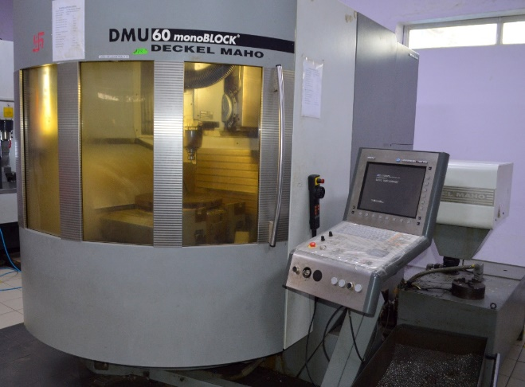
Fig 1. Deckel Moha DMU 60 Mono Block

2.2 Accelerometer Setup

MPU 6050 sensor is used as the vibration measurement device or accelerometer. This sensor was calibrated to collect the vibration during machining in form of Acceleration (m/s2). Arduino Uno is used as the DAQ (Data acquisition) system and controller board for our sensor. Program code is loaded on the Arduino Uno board which control input and output of the sensor.
All the values collected by the sensor were directly on the computer attached to it. A MPU-6050 three directional accelerometer type was used to measure the resulting tool vibration in the feed and radial directions. The accelerometer was mounted on the small acrylic sheet and acrylic sheet was mounted near the tool on the workpiece using C-clamp.
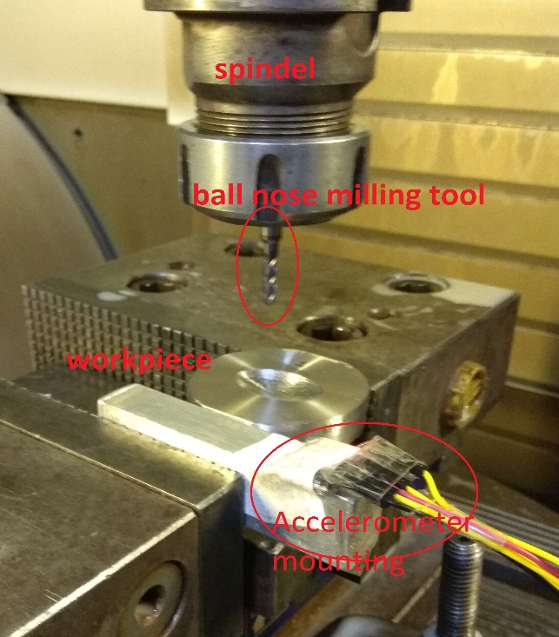
Fig 2. Accelerometer mounting, workpiece and tool

2.3 Cutting parameter and workpiece dimensions

A To conduct CNC milling operation spindle speed, feed and depth of cut and ball end mill dia. are selected as input process parameters. The levels of the independent variable are shown in table below. The levels were selected to cover the normal cutting operations. Material for workpiece was AISI 304N Stainless Steel with hardness of 25-32 hrc.
Independent  Parameters | Units | Levels of parameters
1.Ball Mill Dia. | mm | 4 | 5 | 6
2.Spindle Speed | rpm | 3500 | 5000 | 6000
3.Depth of cut | mm | 0.030 | 0.035 | 0.040
4.Feed | mm/rev | 1000 | 1200 | 1500
Table 2. Cutting parameter and their levels

A fractional factorial design implementing an L9 Taguchi orthogonal array (OA) was established to conduct machining experiments with the use of a computer-aided manufacturing (CAM) software. Fractional factorial design specifics involve the statistical elimination of unimportant parameters, thus reducing experimental runs without the loss of useful information. The workpiece material was free cutting steel with the following specification.

Properties | Metric
Tensile strength | 620 MPa
Yield strength | 330 MPa
Elastic modulus | 193-200 GPa
Hardness, Rockwell B | 85
C | 0.08
Cr | 18-20
Fe | 66.345-75
Mn | Max 2
Ni | 8-10.5
P | Max 0.045
S | Max 0.03
Si | Max 1
Table 3. Workpiece material specification

2.4 Tool parameters

Selected tool material is Cemented Carbide for milling of selected work piece material. The specification of selected tools are in following tables. During our experimental work two type of milling tools were used, End mill tool and Ball nose end mill tool. End mill was used in roughing process and ball nose end mill was used in finishing operation.
In our experimental work 5 mm End mill was used in roughing process and 4mm, 5mm, 6mm ball nose end mill tool was used in finishing operation. The material of ball nose end mill tool was Cemented Carbide.

S. No | Specification/ ball mill | 4 mm ball nose end mill | 5 mm ball nose end mill | 6 mm ball nose end mill
1 | Mill diameter (mm) | 4 | 5 | 6
2 | Shank diameter (mm) | 4 | 5 | 6
3 | Overall Length (mm) | 50 | 50 | 50
4 | Length of cut (mm) | 14 | 16 | 19
5 | Material | Carbide | Carbide | Carbide
6 | No. of flutes | 4 | 4 | 4

Table 4. Ball end mill tool specification

III. Analysis Procedure
An experimental work consisted of three main parts: cutting parameters, vibration measurement
and surface roughness measurement. The machining condition such as tool nose radius, feed, speed, depth of cut, workpiece length, workpiece dimension were selected to cover the normal machining condition. The second part was the vibration measurement use done using MPU-6050 sensor and Arduino UNO microcontroller. The third part was the surface roughness measurements using Mitutoyo surface roughness tester SJ-210 and its controlling software, which provide surface roughness parameters.

Exp No | In-Put Process Variables
 | Factor A  {Ball Dia (mm)} | Factor B  {Speed (RPM)} | Factor C  {DOC (mm)} | Factor D  {Feed (mm/rev)}
1 | 4 | 3500 | 0.030 | 1000
2 | 4 | 5000 | 0.035 | 1200
3 | 4 | 6000 | 0.040 | 1500
4 | 5 | 3500 | 0.035 | 1500
5 | 5 | 5000 | 0.040 | 1000
6 | 5 | 6000 | 0.030 | 1200
7 | 6 | 3500 | 0.040 | 1200
8 | 6 | 5000 | 0.030 | 1500
9 | 6 | 6000 | 0.035 | 1000
Table 5. In Put Process Variables

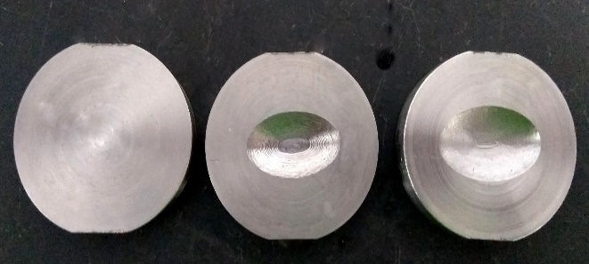
Fig 3. Workpiece at three stages a) Before machining b) After Roughing c) After Finishing

3.1 Vibration measurement

Equipment required for Vibration analysis is
1) Sensors such as transducers (typically accelerometers, load cells), or non-contact via a Laser vibrometer, or stereo photogrammetric cameras.
2) Data Acquisition System and an analogue-to-digital converter frontend (to digitize analog instrumentation signals)
3) Host PC (personal computer) to view the data and analyze it.
The tool vibration level is measurement using a 3D accelerometer (MPU-6050) mounted on the small acrylic sheet and acrylic sheet was mounted near the tool on the workpiece using C-clamp.

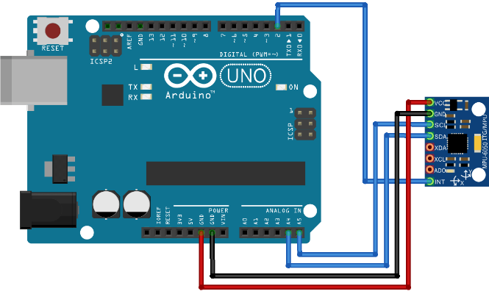
Fig 4. MPU-6050 sensor and Arduino UNO

The accelerations, measured were saved using putty software on the laptop in the form of notepad file. The first was the acceleration in the time domain, and the other is the autocorrelation of the acceleration in the frequency domain. The frequency domain was obtained using National Instruments DIAdem software. The acceleration data was the then put in excel file and separated in different columns.

3.2 Surface roughness measurements

The surface roughness was measured by Mitutoyo surface roughness tester SJ-210 and its controlling software. The output was noted down manually.

3.3 Generation of Frequency graph

The frequency domain graph was obtained using National Instruments DIAdem software. Individual experiment data was loaded in the software. Analysis was done in signal analysis tab (Full Spectrum FFT). Their time and acceleration data was loaded in two different input channels and the graph was generated between Frequency vs acceleration.
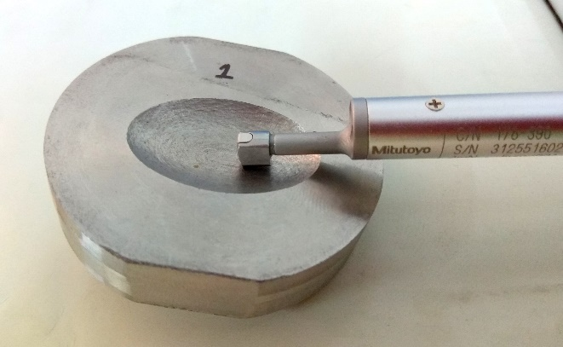
Fig 5 Surface roughness measurement

VI Analysis of vibration and roughness measurement

All the set of values were obtained for all 9 experiments. Now we have nine values for time response of vibration and nine values for surface roughness. For Both frequency of vibration and roughness values small the better is function is applied and signal to noise ratio is obtained.
Since we want the frequency of vibration to be less and surface roughness to be minimum we are using smaller the better function.

s/n ratio = -10*LOG10((value)^2)

This function will give us the least value of s/n ration. Following table show the selected input parameters and the obtained output parameters of the conducted experiment.

Exp No | In-Put Process Variables |  |  |  | Out Put Factors |  | Signal to Noise Ratio
 | Ball Dia (mm) | Speed (RPM) | DOC (mm) | Feed (mm/rev) | FFT (STB) m  (Z direction) | SF(STB)  Ra | s/n ratio for FFT | s/n ration for SF
1 | 4 | 3500 | 0.030 | 1000 | 0.000159344 | 4.309 | 75.95331 | -12.68753
2 | 4 | 5000 | 0.035 | 1200 | 0.00011354 | 3.924 | 78.897 | -11.87458
3 | 4 | 6000 | 0.040 | 1500 | 0.000124492 | 3.2095 | 78.09716 | -10.12875
4 | 5 | 3500 | 0.035 | 1500 | 0.000381367 | 3.495 | 68.37313 | -10.86894
5 | 5 | 5000 | 0.040 | 1000 | 0.000213626 | 4.5275 | 73.4069 | -13.11717
6 | 5 | 6000 | 0.030 | 1200 | 0.000168091 | 3.346 | 75.48914 | -10.49052
7 | 6 | 3500 | 0.040 | 1200 | 0.000449799 | 9.4515 | 66.93963 | -19.51001
8 | 6 | 5000 | 0.030 | 1500 | 0.000934363 | 9.215 | 60.58969 | -19.28991
9 | 6 | 6000 | 0.035 | 1000 | 0.000175864 | 8.366 | 75.09647 | -18.45036
Table 6. In-Put and Output process Variables and Signal to Noise Ratio
SURFACE ROUHNESS AND PROFILE IDENTIFICATION

4.1 Surface roughness and profile identification for 4 mm ball nose end mill tool in experiment 1.

Profile Graph Bearing Ratio Curve Distribution Curve
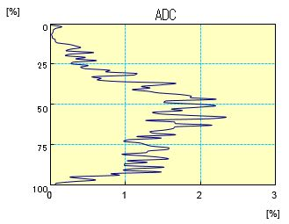
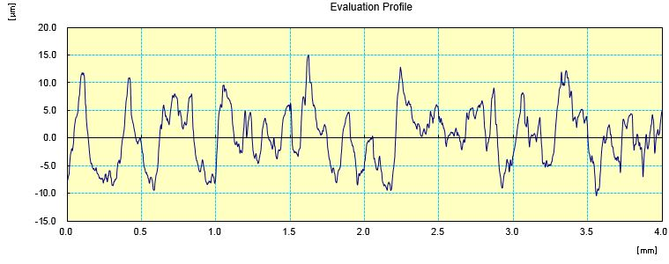
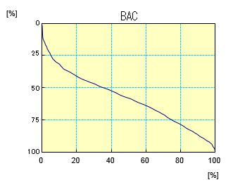
Traveling Along Traverse Length (mm) Bearing Ration (%) Amplitude Density (%)

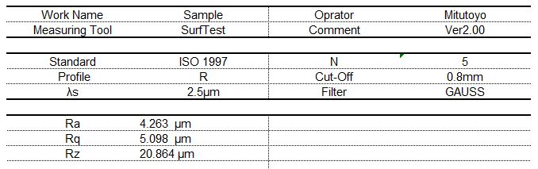

4.2 Surface roughness and profile identification for 5 mm ball nose end mill tool in experiment 4.

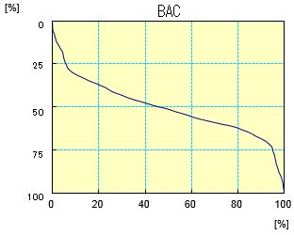
Profile Graph Bearing Ratio Curve Distribution Curve

Traveling Along Traverse Length (mm) Bearing Ration (%) Amplitude Density (%)
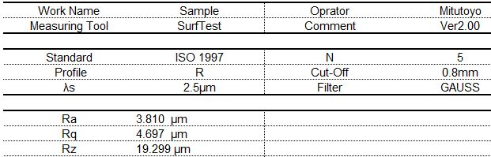

4.2 Surface roughness and profile identification for 6 mm ball nose end mill tool in experiment 7

Profile Graph Bearing Ratio Curve Distribution Curve
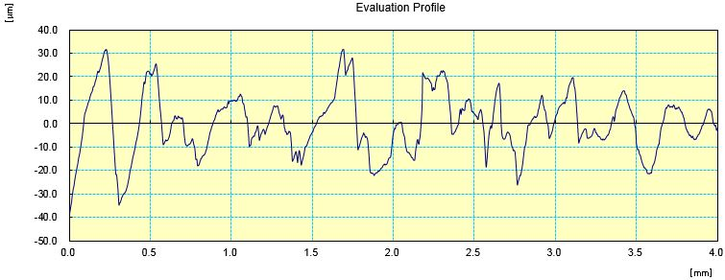
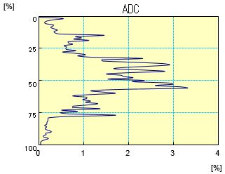
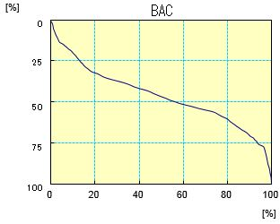
. Traveling Along Traverse Length (mm) Bearing Ration (%) Amplitude Density (%)

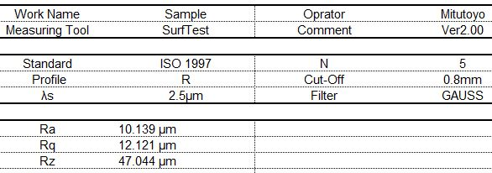
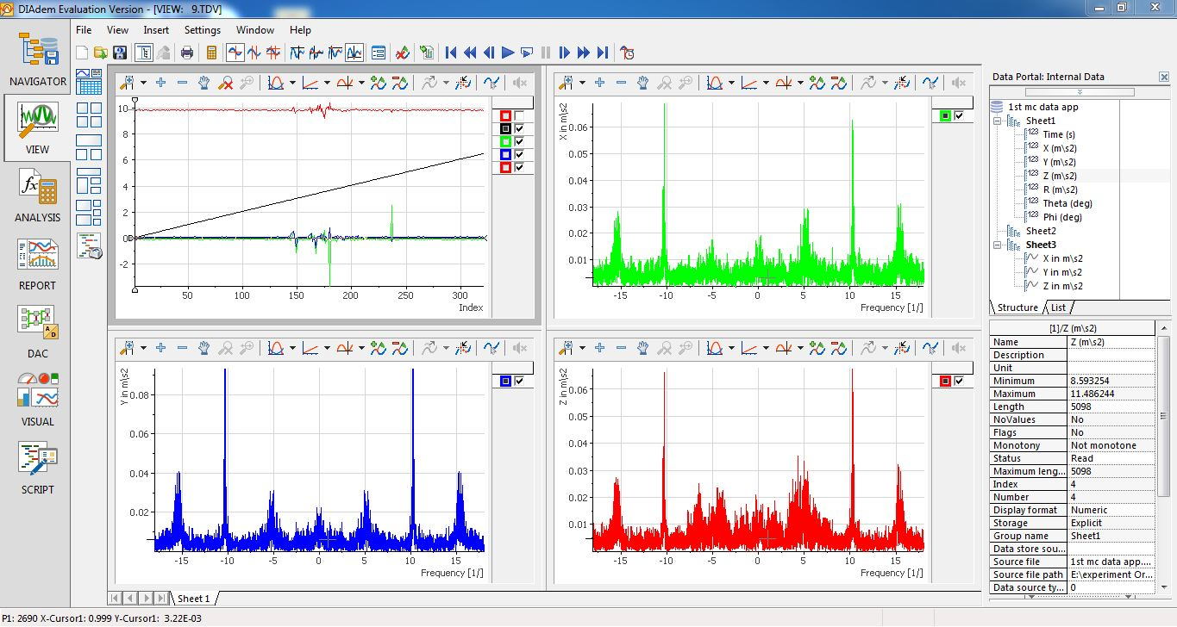

Fig 6. Frequency response of the vibration data in X, Y, Z direction with time on y axis

First graph show the increasing time during experimentation, second top right graph show the frequency in x direction. Bottom left graph show the frequency in y direction. Bottom right graph show the frequency in y direction. Now showing the individual graph of the FFT for all nine experiment.

tool dia. | 4
Speed | 3500
DOC | 0.030
Feed | 1000
Acceleration | 0.000159344
Ra | 4.309
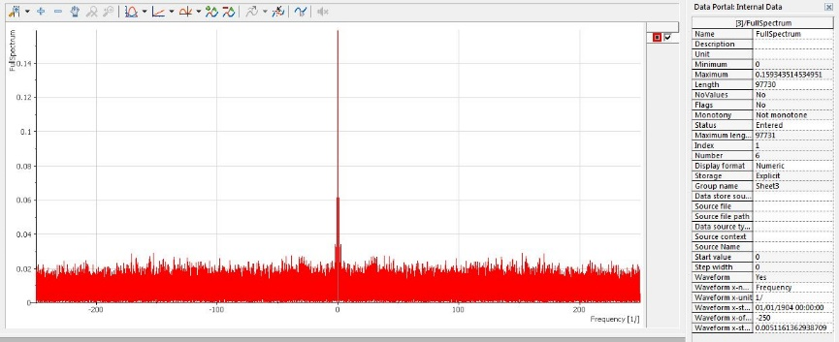
Experiment 1

Fig 7. Frequency and amplitude graph of experiment 1
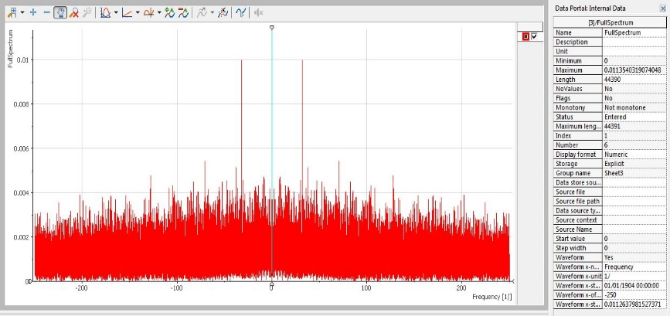
tool dia. | 4
Speed | 5000
DOC | 0.035
Feed | 1200
Acceleration | 0.0001135403
Ra | 3.924
Experiment 2

Fig 8. Frequency and amplitude graph of experiment 2

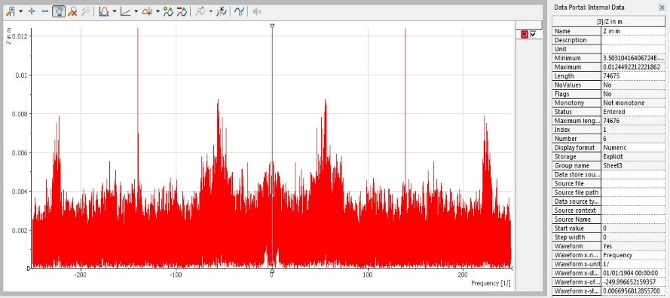
Experiment 3
tool dia. | 4
Speed | 6000
DOC | 0.040
Feed | 1500
Acceleration | 0.000124492
Ra | 3.2095

Fig 9. Frequency and amplitude graph of experiment 3
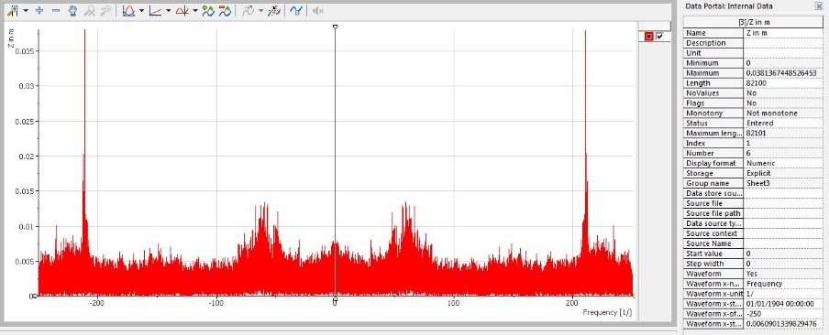
Experiment 4
tool dia. | 5
Speed | 3500
DOC | 0.035
Feed | 1500
Acceleration | 0.00038136744
Ra | 3.495

Fig 10. Frequency and amplitude graph of experiment 4
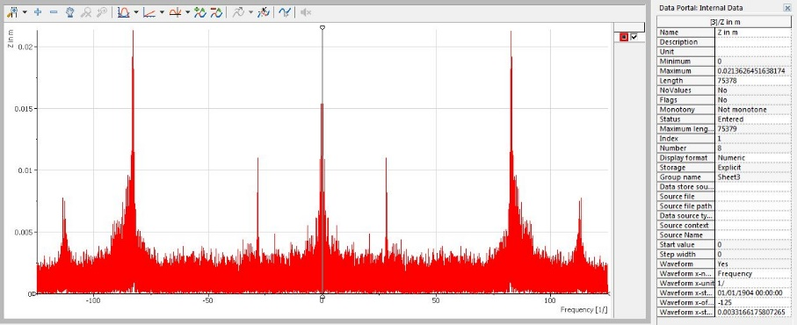
Experiment 5
tool dia. | 5
Speed | 5000
DOC | 0.040
Feed | 1000
Acceleration | 0.000213626
Ra | 4.5275

Fig 11. Frequency and amplitude graph of experiment 5
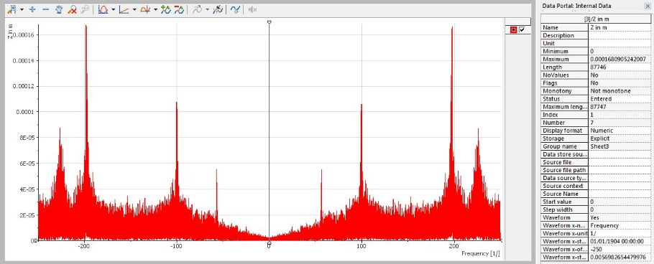
Experiment 6
tool dia. | 5
Speed | 6000
DOC | 0.030
Feed | 1200
Acceleration | 0.0001680905
Ra | 3.346

Fig 12. Frequency and amplitude graph of experiment 6

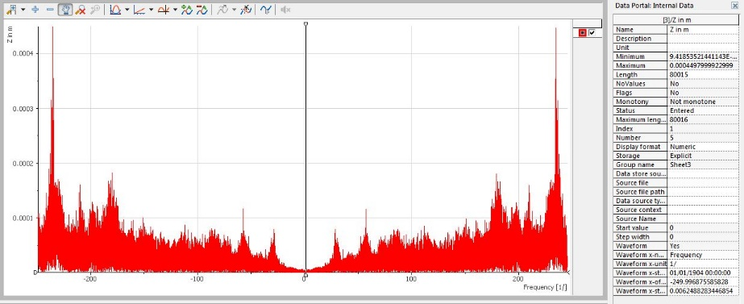
Experiment 7
tool dia. | 6
Speed | 3500
DOC | 0.040
Feed | 1200
Acceleration | 0.000449799
Ra | 9.4515

Fig 13. Frequency and amplitude graph of experiment 7
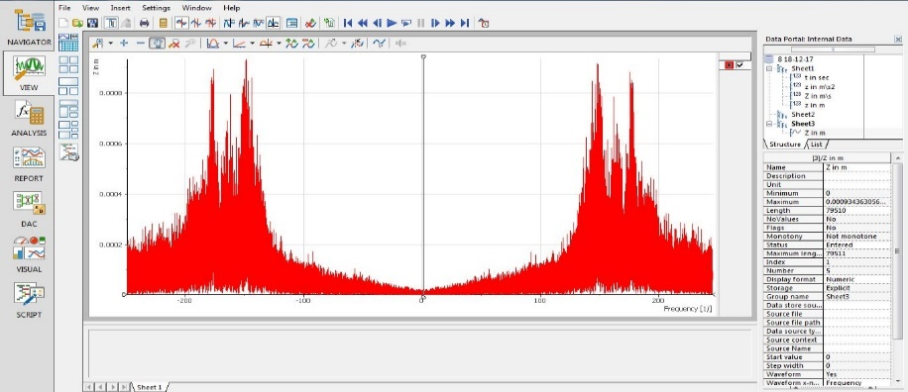
Experiment 8
tool dia. | 6
Speed | 5000
DOC | 0.030
Feed | 1500
Acceleration | 0.000934363
Ra | 9.215

Fig 14. Frequency and amplitude graph of experiment 8
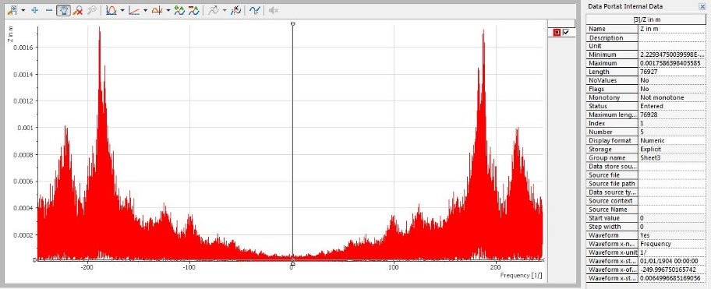
Experiment 9
tool dia. | 6
Speed | 6000
DOC | 0.035
Feed | 1000
Acceleration | 0.000175864
Ra | 8.366

Fig 15. Frequency and amplitude graph of experiment 9

V Results and Discussion
Parameters | % effect
Cutter dia. (mm) | 52.775
Speed (RPM) | 21.241
Depth of cut (mm) | 6.247
Feed (mm/rev) | 18.737
Calculating effect of individual process parameters on the frequency domain vibration amplitude. Table below show the effective of parameters in form of percentage.

Table 7. Parameters and their % effect for Vibration Amplitude
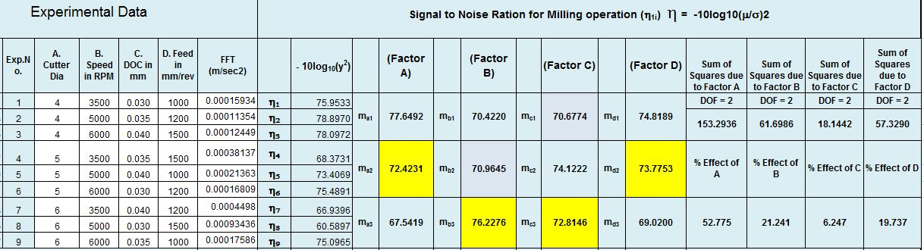
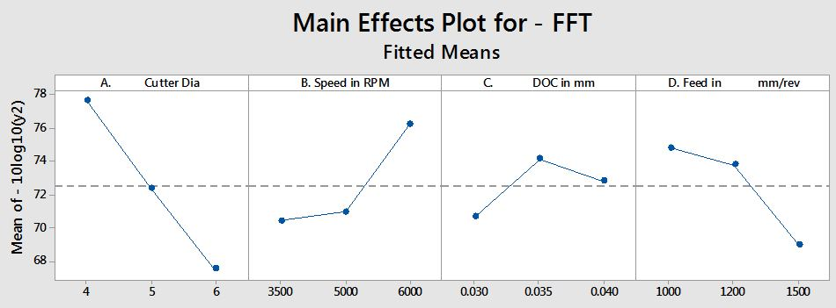
Table 8. Experiment data, s/n ratio and percentage values for vibration amplitude
Fig 16. Main Effects Plot for FFT

It clear from the percentage table that the cutter diameter has major effect on the vibration amplitude during manufacturing. After cutter speed there comes Speed of the revolution of tool which is 21.241%. Effect of feed is 18.737 % and the Depth of cut is 6.247%.
Now calculating effect of individual process parameters on Surface roughness. Table below show the effective of parameters in form of percentage.

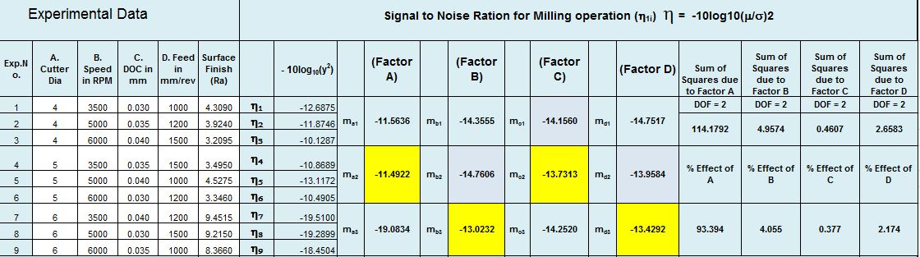
Table 9. Experiment data, s/n ratio and percentage values for Surface roughness
Parameters | % effect
Cutter dia. (mm) | 93.394
Speed (RPM) | 4.055
Depth of cut (mm) | 0.377
Feed (mm/rev) | 2.174

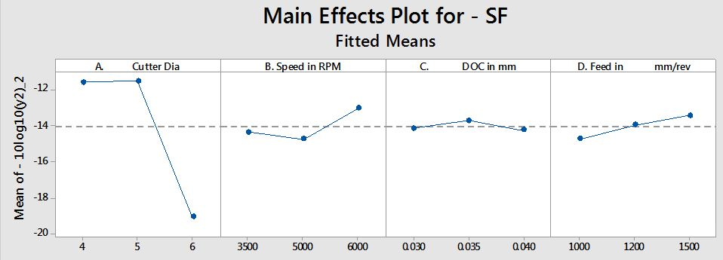
Table 10. Parameters and their % effect for Surface roughness
Fig 17. Main Effects Plot for Surface finish

Cutter diameter has very large impact on the surface roughness higher diameter have low surface roughness values. Hence to obtain good surface finish with less vibration in tool 5mm ball end mill tool can be used.

VI. Conclusion
On the basis of the experiment carried out, the following conclusions have been formulated. The machining parameters in CNC milling of AISI 304 stainless steel machining with ball nose carbide tool have been optimized using smaller the better function. A fractional factorial design implementing an L9 Taguchi orthogonal array (OA) was and nine experiments are carried out. The primary object is to find out the effect of different process parameters on tool vibration amplitude and surface roughness.
Experimental results, were obtained for surface roughness and cutting tool vibration. We can conclude the there is a major effect of cutting tool diameter of the vibration amplitude and surface roughness, so optimizing the values of cutting tool. The optimum value of culling tool was 5mm diameter ball nose end mill tool for milling of sculptured surface.
Conflict of Interests
The authors declare that there is no conflict of interests regarding the publication of this paper.

References
[1] Sukhdev s. Bhogal, Charanjeet Sindhu, Sukhdeep S. Dhami and B.S. Pabla,, ”Minimization of Surface Roughness and Tool Vibration in CNC Milling Operation” Journal of Optimization Volume 2015, Article ID 192030, 13 pages.
[2] W. A. Kline, R. E. Devor, and I. A. Shareef, “The prediction of surface accuracy in end milling,” Journal of Engineering for Industry, vol. 104, no. 3, pp. 272–278, 1982.
[3] A. Hamdan, A. A. D. Sarhan, and M. Hamdi, “An optimization method of the machining parameters in high-speed machining of stainless steel using coated carbide tool for best surface finish,” International Journal of Advanced Manufacturing Technology, vol. 58, no. 1–4, pp. 81–91, 2012.
[4] J. P. Kumar and K. Thirumurugan, “Optimization of machining parameters for milling titanium using Taguchi method,” International Journal of Advanced Engineering Technology, vol. 3, no. 2, pp. 108–113, 2012.
[5] J. Z. Zhang and J. C. Chen, “Tool condition monitoring in an end-milling operation based on the vibration signal collected through a microcontroller-based data acquisition system,” The International Journal of Advanced Manufacturing Technology, vol. 39, no. 1-2, pp. 118–128, 2008.
[6] B. C. Routara, A. Bandyopadhyay, and P. Sahoo, “Roughness modeling and optimization in CNC end milling using response surface method: effect of workpiece material variation,” International Journal of Advanced Manufacturing Technology, vol. 40, no. 11-12, pp. 1166–1180, 2009.
[7] X. Cui and J. Zhao, “Cutting performance of coated carbide tools in high-speed face milling ofAISIH13 hardened steel, ”The
International Journal of Advanced Manufacturing Technology, vol. 71, no. 9–12, pp. 1811–1824, 2014.
[8] K. V.M. K. Raju,G.R. Janardhana, P. N. Kumar, and V.D.P.Rao, “Optimization of cutting conditions for surface roughness in CNC end milling,” International Journal of Precision Engineering and Manufacturing, vol. 12, no. 3, pp. 383–391, 2011.
[9] N. V. Prajina, “Multi response optimization of CNC end milling using response surface methodology and desirability function,” International Journal of Engineering Research and Technology, vol. 6, no. 6, pp. 739–746, 2013.
[10] M.-Y. Wang and H.-Y. Chang, “Experimental study of surface roughness in slot end milling AL2014-T6,” International Journal of Machine Tools and Manufacture, vol. 44,no. 1, pp. 51–57, 2004.
[11] P. V. S. Suresh, P. V. Rao, and S. G. Deshmukh, “A genetic algorithmic approach for optimization of surface roughness prediction model,” International Journal of Machine Tools and Manufacture, vol. 42, no. 6, pp. 675–680, 2002.

