Automation of indexing head for milling machine
Amruta Pasarkar¹, Balaguru S^{2*} , Ashok Choudhary¹ , Mayur Dedwal¹, Rushikesh Dandale¹
1- Bharati Vidyapeeth’s College of Engineering Lavale, Pune
2 - VIT Bhopal University, Sehore, Madhya Pradesh, 466114, India
*balaguruiitm@gmail.com

Abstract
Indexing heads are widely used in milling machines for cutting complex shapes. The process of indexing the head manually can be time-consuming and error prone. Therefore, this paper proposes the automation of the indexing head for milling machines using a stepper motor and a microcontroller. The proposed system provides high precision and reduces the setup time required for indexing the head. The system is designed and implemented using open-source hardware and software tools. The experimental findings demonstrate that the suggested system is reliable and accurate, and it can significantly improve the efficiency of milling operations.

Keywords
Stepper motor, Motor Controller, Chuck, Microcontroller, Horizontal Milling machine

- INTRODUCTION
An indexing head is a critical component of a milling machine used for accurately and precisely machining complex workpieces. It is essentially a device that enables the milling machine to rotate the workpiece around a fixed axis while simultaneously changing its position in a controlled manner.
The indexing head is made up of several components, including a worm gear, a worm wheel, and a set of indexing plates. The worm gear and worm wheel work together to provide a controlled rotation of the workpiece, while the indexing plates are used to position the workpiece at specific intervals, typically in increments of degrees. These plates have pre-drilled holes that align with a pin on the indexing head to ensure accurate and consistent positioning of the workpiece. The indexing head is an indispensable tool for machining gears, splines, and other precision components that require intricate shapes and precise positioning. The three systems that make up a programmable indexing head are the mechanical, electrical, and application software systems.
The newly created indexing head eliminates the requirement for the indexing plates that are used in standard indexing heads to cut the gear, which reduces the amount of time needed to change the indexing plate [1, 2]. The electronic indexing head ought to be far more user-friendly and, ideally, less expensive. It is a good advance to decrease the sources of mistake to use a computer to perform the math and direct a stepper in precise motions [3-5]. A step motor can be thought of as a synchronous AC motor with more poles added to the rotor and stator, as long as there is no common denominator between them. Additionally, we talked about its attributes, grouping, mode of operation, benefits, and electric magnetic impacts [6-8].

- OBJECTIVES
- To create a mechanical system with programmable indexing head.
- To create the electronic circuit and attach the electronic parts to the circuit board.
- Create a program for the programmable indexing head's microcontroller.
- To connect the hardware and software.
- To assess the effectiveness of a created programmable indexing head.
In this paper, we propose an automated indexing head system (Fig.1(a), (b)) for milling machines. The proposed system uses a stepper motor and a microcontroller to rotate the indexing head at precise angles. The system is designed and implemented using open-source hardware and software tools, which makes it affordable and accessible to small and medium-sized businesses.
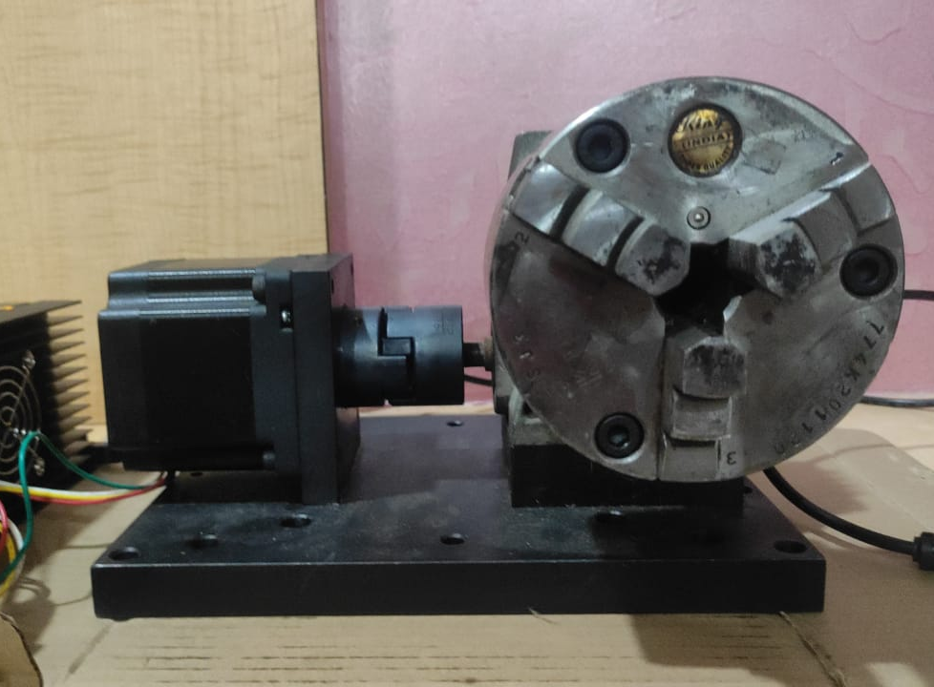
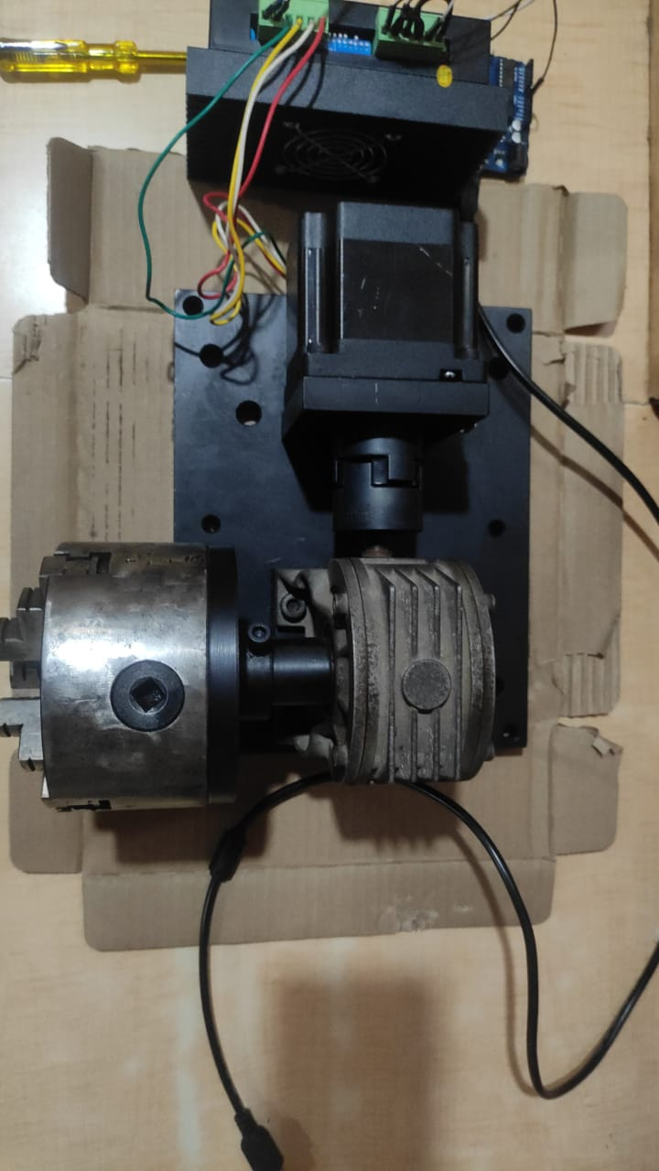
The automation of indexing heads involves the integration of various technologies, such as computer-aided design (CAD) and computer-aided manufacturing (CAM) software, as well as sensors and control systems. This allows for more accurate and efficient operation of the milling machine, while also reducing the need for manual intervention. In recent years, there has been a significant amount of research in this area, as manufacturers look for ways to improve their productivity and competitiveness [9, 10].

- METHODOLOGY
Fig. 3. depicts the experimental process used to create the programmable indexing head. The development of mechanical systems is discussed in the sections that follow electronic system, software system, mechanical system interface, and evaluation of it.
(a) (b)
Fig. 1. (a) Automated Indexing Head (Top View) (b) Automated Indexing Head (View)
The first step is to define the requirements for the indexing head automation system. This includes the desired accuracy and precision, the types of workpieces to be machined, and the expected production rates.
Once the requirements have been defined, the hardware components of the system can be selected. This includes selecting the type of indexing head, the sensors, the control systems, and the motors.
The next step is to develop the program required to control the indexing head. This includes programming the control algorithms, developing the user interface, and integrating the software with the CAD/CAM software used to generate the tool paths.
Once the program has been developed, a prototype of the system can be built and tested. This involves testing the accuracy and precision of the indexing head, as well as the performance of the control algorithms.
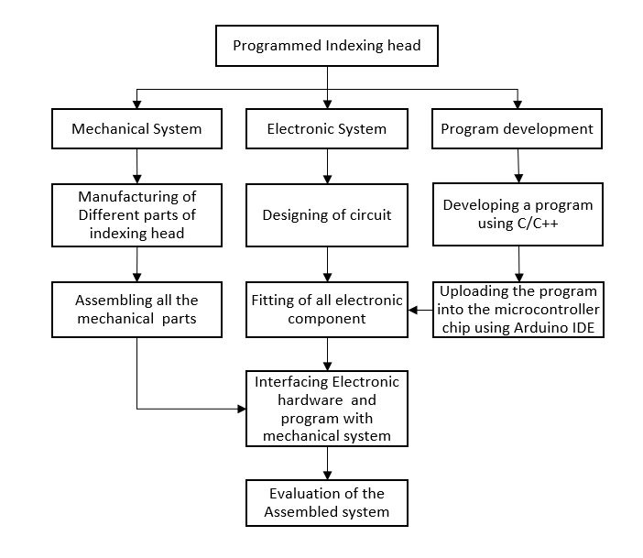
Fig. 2. Experimental Procedure
Overall, the methodology for automation of indexing head for milling machine involves a combination of hardware selection, software development, and testing, with a focus on improving accuracy, precision, productivity, and safety while reducing costs and enabling new manufacturing capabilities.

- RESULTS AND DISCUSSION
The motorized control system was successfully integrated into the milling machine's indexing head. The system enabled precise positioning of the workpiece by rotating the head to specific angles. The results showed that the motorized control system achieved accurate and consistent positioning, reducing human error and increasing overall productivity.
To evaluate the precision and accuracy of the automated indexing head, a series of test cuts were performed on different workpieces. Measurements were taken using precision instruments to compare the programmed angles with the actual machining results. The results indicated that the automated indexing head achieved a high level of precision, with minimal deviations between the programmed and actual angles.
The automation of the indexing head significantly improved the speed and efficiency of milling operations. The system allowed for quick and precise repositioning of the workpiece, eliminating the need for manual adjustments. This resulted in reduced setup time and improved overall productivity.
Table 1 - Time required by the skilled worker on traditional Indexing head
Sr. No. | Numbers of teeth produced | Average Time required to change indexing plate  (seconds) | Number of gears produced
1 | 13 | 260 | 1
2 | 13 | 242 | 1

Table 2 - Time required by the skilled worker on Automated Indexing head
Sr. No. | Numbers of teeth produced | Average Time required to change indexing plate  (seconds) | Number of gears produced
1 | 13 | 80 | 1
2 | 13 | 75 | 1

From the aforementioned data, it has been shown that when comparing the production rate, the created indexing head saves a total of 173.5 seconds of time while producing one gear as opposed to the regular indexing head.
Fig. 3. Actual Job prepared on indexing head

- CONCLUSIONS

The automation of the indexing head for milling machines project offers numerous benefits and advancements in the field of machining and manufacturing. By implementing automated indexing, the project enhances productivity, accuracy, and efficiency in milling operations.
Automation eliminates the need for manual intervention in the indexing process. This reduces human error and ensures consistent and precise positioning of the workpiece, leading to improved machining quality and dimensional accuracy. The automated indexing system can perform repetitive tasks with high precision, reducing the likelihood of mistakes and increasing overall productivity.
The project streamlines the milling process by reducing setup time. The automated indexing head can swiftly and accurately position the workpiece at various angles, allowing for quick changeovers between different machining operations. This significantly reduces downtime, increases machine utilization, and enables manufacturers to respond more effectively to changing production requirements.
The automation of the indexing head enhances operator safety. By removing the need for manual adjustments and handling of heavy workpieces, the risk of accidents and injuries is minimized. Operators can focus on monitoring and supervising the machining process, ensuring smooth operations and maintaining a safe working environment.
Additionally, the project contributes to overall cost savings. The increased efficiency and productivity gained through automation lead to higher output and reduced production time. This translates to cost reductions in labour, energy consumption, and material waste. Moreover, the improved accuracy and quality achieved with automated indexing reduce the occurrence of rework and scrap, further minimizing costs.
The automation of the indexing head aligns with the broader trend of Industry 4.0 and smart manufacturing. It integrates the milling machine into a connected and digitized manufacturing ecosystem, enabling data collection, analysis, and optimization. This data-driven approach facilitates predictive maintenance, real-time monitoring, and continuous process improvement.
The automation of the indexing head for milling machines project brings substantial advantages to the machining industry. It enhances productivity, accuracy, and efficiency, reduces setup time, improves operator safety, generates cost savings, and aligns with the principles of Industry 4.0. By embracing this automation technology, manufacturers can stay competitive in a rapidly evolving global market and pave the way for future advancements in machining and manufacturing.

References
- S. Kumar, D. Goyal and S. S. Banwait, "Development of low cost programmable indexing head for horizontal milling machine," 2017 IEEE International Conference on Mechatronics and Automation (ICMA), Takamatsu, Japan, 2017, pp. 2028-2033, doi: 10.1109/ICMA.2017.8016130.
- P. Jain, Balaguru S, Ritik Pendse 2023, ‘Design Authentication of a Novel Common Interconvertible Pallets for Automobile Engine - A Finite Element Study’, International Journal on Interactive Design and Manufacturing (IJIDeM), https://doi.org/10.1007/s12008-023-01294-9
- Jha, NK, & Amin, MM. "Design and Analysis of Manufacturing Component Under Sustainability Considerations: A Case Study of Electronic and Mechanical Indexing Head for Milling Operation." Proceedings of the ASME 2018 International Design Engineering Technical Conferences and Computers and Information in Engineering Conference. Volume 4: 23rd Design for Manufacturing and the Life Cycle Conference; 12th International Conference on Micro- and Nanosystems. Quebec City, Quebec, Canada. August 26–29, 2018. V004T05A034. ASME.
- Deenadayalan G, Balaguru S, Vijay 2018, ‘Standard task duration calculation and Ergonomic Analysis of Human Jack in Engine Assembly’, International Journal of Pure and Applied Mathematics, vol. 119, 16003-16009.
- Meenakshi CM, Balaguru S & Senthil kumar N, 2013, ‘Spur Gear Model Developed with CAD and Stress Analysis with FEM’ Middle-East Journal of Scientific Research, vol. 18, pp. 1832-1836, 2013.
- Roy, Tanu Shree & Kabir, Humayun & Chowdhury, Md. (2014). Simple Discussion on Stepper Motors for the Development of Electronic Device. 5. 1089-1096.
- Balaguru S, Elango Natrajan, Ramesh S & Muthuvijayan B 2019, Structural and model Analysis of Scooter Frame for Design Improvement, Materials Today Proceedings, vol. 16, pp. 1106-1116.
- Balaguru S, Siva Kumar K, Deenadayalan G, & Sathishkumar P 2018, “Effect of Sheet Thickness during Superplastic Forming of AZ31B Alloy into a Hemispherical Die”, International Journal of Engineering & Technology, vol. 7, 612-615.
- Balaguru S and J. Venkataramana, 2020, ‘Experimental Study on Tyre Dynamics and Properties of Heavy Load Transporting Vehicle’, Lecture Notes in Mechanical Engineering, vol. 1, pp. 179-190.
- Sivakumar K, Saravanan TM & Balaguru S, 2015, ‘Mechanical characteristics of gas metal arc welding of ASTMA 516 grade 70 steel’ International Journal of Applied Engineering Research, vol. 12, pp. 822-828.

