Minor cosmetic procedures depend on the patient's aesthetic sensibility and medical necessity. When it comes to analyzing a patient's smile in orthodontics today, several factors are typically taken into account. These include the vertical position of the front teeth in relation to the upper lip both at rest and during a smile, ensuring an adequate display of the incisors without excessive gumminess. Additionally, the transverse dimension of the smile and the presence of buccal corridors, as well as the arc of the smile and the vertical alignment of the gum margins, are all important considerations.^{[1]}
Botulinum toxin (BTX) and dermal fillers have become progressively popular in recent years because they offer a less invasive alternative to surgical procedures for achieving regenerative and aesthetic enhancements. Patients can benefit from these treatments at a lower cost and with minimal or no downtime required for recovery, which has contributed to their widespread use. Due to the encouraging results obtained in restoring a beautiful smile and improving facial aesthetics, dentists have recognised the benefits of Botox and dermal fillers and have integrated them into clinical dentistry.^{[2]}
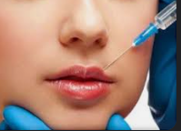
Fig. 10.1- Lip Fillers
Botulinum toxin (BTX) is a commonly used treatment to address the effects of muscular contraction in the lower and middle regions of the face and neck, including cases of excessive gum exposure during smiling, also known as a "gummy smile." This treatment is often the preferred approach for addressing wrinkles on the upper portion of the face. However, finding a solution for a gummy smile can be challenging as there is no single straightforward approach. Over-contraction of the levator labii superioris alaeque nasi muscle, which is responsible for lifting the upper lip, is often the underlying cause of this condition..^{[3]}
The Rubenstein, Miskinyar, Kostianovsky, , and LaTrenta and Rees surgical procedures, among others, have been described in the literature for the repair of hyperfunctional elevator muscles of upper lip, but they are not frequently utilised to cure a gummy smile. Nonsurgical alternatives to osteotomies would be preferable for minimising excessive gingival show brought on by muscle hyperfunction.^{[3]}
In essence, fillers are substances that can provide volume to the skin that has largely lost its natural volume. There are essentially two sorts of fillers: synthetic and biodegradable. The biodegradable ones are transient and are eventually reabsorbed by the body, whilst the synthetic ones are more durable and are not capable of being reabsorbed. The ability to induce antigenicity and the source of the dermal fillers allow for differentiation between them.^{[3]}
Fillers should not be put into muscles like Botox is. Orthognathic or orthodontic treatment may not be sufficient to address all modest lip asymmetry. To make the lower border or the vermillion border on both sides symmetrical, fillers could be needed. Additionally, it can be utilised to compensate for minor defects in the skeletal element that affect the soft tissues that cover it. Dermal fillers, for instance, can be used to improve modest jaw asymmetry brought on by differences in ramal height.^{[4]} For those who are not interested in a genioplasty, fillers may be an option to amplify the chin. Though not a long-term fix, similar results can still be obtained. Botulinum Toxin A can be utilised to anesthetise the elevator muscles of upper lip in people who have gummy smiles to lessen the display of gums when they smile.
The advancements in cosmetic procedures and surgeries are being brought in practice to help attain the utmost aesthetics possible for a lot of patients without much of the invasions.
- SOFT TISSUE FILLERS
Botulinum toxin type A (BTX-A) is recognized as the most potent neurotoxin within the various botulinum toxin variants. The process of obtaining this toxin involves stimulating a strain of Clostridium botulinum to release the toxin, followed by its collection from the culture medium after dissolution. Subsequently, the toxin undergoes a series of steps, including filtration, acceleration, purification, and crystallization through the use of ammonium sulfate. It's important to store BTX-A at refrigeration temperatures but not to freeze it in this state. After reconstitution, it should be diluted with saline and used within a four-hour window. ^{[3]}
MECHANISM OF ACTION
Following ingestion, Botulinum toxin is absorbed into the bloodstream through the gastrointestinal tract. Its mechanism of action involves the inhibition of acetylcholine (ACH) release, a neurotransmitter responsible for muscle contraction and glandular secretion. This inhibition leads to reduced muscle tone in the treated area, although not all nerve terminals are affected, allowing the dystonic muscle to contract with decreased force. This ultimately leads to an improvement in muscle posture and function. The muscle weakness induced by the toxin typically lasts for approximately 3-4 months. ^{[5]}

TYPES
Botulinum toxin (BTX) is classified into seven different serogroups: A, B, C, D, E, F, and G. There are six distinct formulations of BTX available on the market, including BTA (Dysport, Botox, PurTox Xeomin, , and Prosigne) and the BTX-B (Neuroblocs/Myobloc). Unlike Dysport and Botox, that are in form of a white powder that requires dilution, Myobloc is available as a solution. Since the formulation and potency of each brand of BTX may differ, the appropriate dosage of BTX needed for a particular treatment is determined based on the brand or practitioner's recommendations..^{[6]}

APPLICATION IN ORTHODONTICS
Botulinum toxin (BTX) is often used for the treatment of facial pain and temporomandibular joint (TMJ) disorders in the oral and maxillofacial area. It is also utilized for dental therapeutic and aesthetic purposes.
- TEMPOROMANDIBULAR DISORDERS
Temporomandibular disease (TMD) often involves the presence of one or more muscle trigger points. Palpation of these trigger points can elicit pain that is transmitted along the associated muscle or nerve pathways. Injections of sterile saline and local anesthetic are typically administered directly to these trigger points to achieve short-term relief by disrupting the muscle contraction. However, the effects of saline or anesthetic injections are limited and typically only last a few minutes to a few days. In contrast, BTX injections at these trigger points have been shown to be highly effective in reducing muscle contraction strength, with the effects lasting up to three months..^{[7]}
- FACIAL PAIN
Neurotoxins are frequently employed in the treatment of TMD (Temporomandibular Disorder) and facial pain, with the aim of targeting various muscles involved in chewing. These muscles include the temporalis, masseter, medial and lateral pterygoid muscles, as well as facial muscles such as orbicularis oculi, sternocleidomastoid, orbicularis oris, depressor anguli oris, mentalis, trapezius, splenius capitis, frontalis, procerus, and corrugator muscles. In cases where only one side of the temporalis and masseter muscles is affected, neurotoxinsmay be administered to both sides of the face.
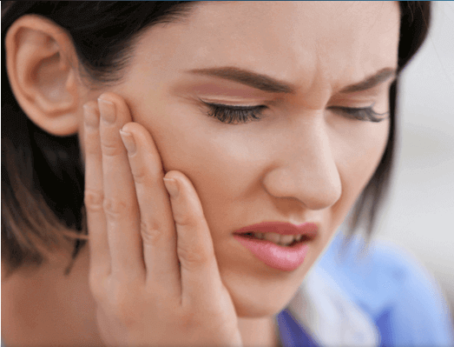
Fig.10.2- Facial Pain
- BRUXISM
Bruxism refers to the repetitive clenching or grinding of teeth, a behavior that can result in Temporomandibular Disorder (TMD), headaches, facial discomfort, dental health deterioration, and even exacerbation of periodontal disease. In patients who suffer from both bruxism and TMD, medical professionals often administer bilateral injections of neurotoxins into the masseter and temporalis muscles. These injections, when administered in appropriate amounts, can effectively reduce muscle contractions during chewing, thereby improving the patient's ability to eat and speak. Furthermore, the use of neurotoxins contributes to the treatment of periodontal diseases by alleviating facial pain, TMD symptoms, and addressing the bruxism component.
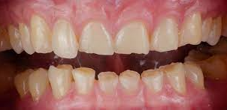
Fig. 10.3- Bruxism
- MASSETERIC HYPERTROPHY
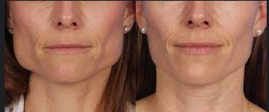
Fig. 10.4- Bilateral Masseteric Hypertrophy
Masseteric hypertrophy is a condition marked by the enlargement of the masseter muscles, often resulting in clenching and bruxism. The administration of neurotoxin injections into the masseter muscle belly is a successful method for treating masseteric hypertrophy. This treatment leads to a decrease in the strength of masseter muscle contractions and a noticeable reduction in facial volume in the treated area. Similar to other botulinum treatments, this procedure necessitates repeated injections at monthly intervals for optimal results.^{[7]}
- GUMMY SMILE
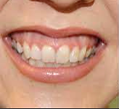
Fig. 10.5- Gummy Smile
A gummy smile is a cosmetic concern characterized by the visibility of excess gingival tissue during smiling. To address this issue, Hwang et al. proposed the use of the Yonsei point, situated at the central point of the triangle formed by the zygomaticus minor, levator labii superioris alaeque nasi, and levator labii superioris muscles. It is recommended to administer 3 units of the neurotoxin at each injection site.^{[8]}
- RELAPSE AFTER ORTHODONTIC TREATMENT
Following orthodontic treatment, individuals who exhibit excessive muscle activity may experience teeth recession. In such situations, Botox can be employed to diminish the muscle strength, thereby guiding them toward a more typical movement pattern during the treatment process.
TRISMUS
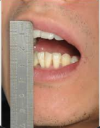
Fig. 10.6- Trismus
Individuals dealing with Temporomandibular Disorder (TMD) might encounter challenges when trying to open their mouths, often stemming from inflammation and tension within the masticatory muscles. The use of Botulinum Toxin Type A (BTA) injections has proven effective in reducing muscle inflammation and inducing relaxation in the adjacent masticatory muscles. This leads to improved jaw mobility and facilitates easier mouth opening. The injection of BTA into the muscles responsible for mastication has demonstrated favorable therapeutic outcomes in the treatment of TMD patients. ^{[9]}

DRUG INTERACTION
d-Penicillamine, cyclosporine, aminoglycosides, aminoquinolones, muscle relaxants. Lincosamide and quinidine are all pills that affect the outcomes of neurotoxin management.^{[10]}
CONTRAINDICATIONS
- Patients who are psychologically ill
- patients suffering from a neuromuscular condition
- individuals with asthma and arrythmia
- individuals who are allergic to BTX and fillers
- Pregnant and lactating women who have to keep away from the usage of BTA
COMPLICATIONS
Because therapeutic doses of Botulinum Toxin Type A (BTA) are typically higher than those used for cosmetic purposes, complications are more frequently encountered in therapeutic applications. Research indicates that approximately 7% of patients treated with BTA develop resistance, prompting researchers to explore alternative treatments involving Botulinum Toxin (BTX). Common adverse effects include sensations such as palpitations, fever, tingling, and nausea, typically resolving within two days. Additional potential complications associated with BTA therapy encompass pain, ecchymosis, and erythema at the injection site, facial asymmetry, ptosis, mouth drooping, lip swelling, muscle weakness, difficulty swallowing (dysphagia), aspiration, dry mouth (xerostomia), and hepatitis.^{[10]}

DERMAL FILLERS

Dermal fillers are substances that are used to restore volume to skin that has lost some of its natural fullness. These fillers are classified based on their source and their potential to cause an immune reaction, or antigenicity..^{[1]}
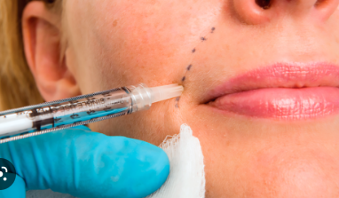
Fig.10.7- Dermal Fillers

CLASSIFICATION^{[11]}
1. Classification based on the characteristics of materials:
• Autologous: Materials obtained from the patient's own body
• Heterologous: Materials derived from multiple species
• Alloplastic: Materials such as metal, plastic, or ceramic that are not biological in nature.

2. Classification based on biodegradability:
• Biodegradable: Fillers that can be broken down into non-hazardous substances.
• Non-biodegradable: Fillers that do not composed in the natural environment.

3. Classification based on the duration of the filler's action:
• Temporary: Fillers with effects lasting less than 6 months.
• Long-lasting: Fillers with effects lasting 6 months to 2 years.
• Semi-permanent: Fillers with effects lasting 2-5 years.
• Permanent: Fillers with effects that do not disappear over time.
INJECTION PLANES
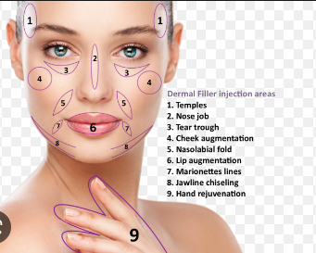
Fig. 10.8- Injection Sites
The injection techniques for fillers and Botox differ significantly. While Botox is administered directly into the muscles, it's essential not to inject fillers into muscle tissue. Instead, the recommended approach is to introduce dermal fillers into the fatty tissue regions. This choice is based on the fact that fat naturally serves as a filler in these areas. Facial fat is typically divided into two layers: the superficial and deep fat layers. The superficial fat runs parallel to the skin, while the deep fat layer is adjacent to the muscle layer. Injecting fillers into the superficial fat layer at a depth of approximately 3mm ensures both longer-lasting effects and a reduction in the overall volume of filler required.^{[12]}
HYALURONIC ACID
Hyaluronic acid (HA) is a significant component of the extracellular matrix and is found in various parts of the body such as the skin, synovium, and eyes. In a previous study, De Maio described the effectiveness of HA fillers in modifying muscle activity. He suggested that HA fillers could potentially impact muscular contraction either by aiding or inhibiting it.
COLLAGEN
Collagen is the primary structural component of the skin. Bovine collagen and the bioengineered human collagen dermal fillers are both FDA-approved and are less painful for patients during injection, eliminating the need for any anesthesia and even nerve blocks..^{[13]}
CALCIUM HYDROXYLAPATITE (CAHA)
Calcium hydroxylapatite (CaHA) is a synthetic microparticle that is enclosed in a carrier gel and has been approved by the FDA for treating facial wrinkles and the atrophy in the HIV patients since 2006. CaHA comprises about 30% gel, while the remaining 70% is the carrier gel. Compared to other fillers, injections of CaHA result in faster visible improvements due to the long-lasting collagen accumulation around the microparticles, which can last up to 15 months.
POLY-L-LACTIC ACID
PLLA is a synthetic, polymeric, and biodegradable polymer that is safe for use in the body. When injected, it stimulates the growth of collagen by activating fibroblasts, leading to an increased facial volume. The process of soft tissue augmentation involves inducing inflammatory response in the tissue, which then leads to the deposition of collagen.
POLY (METHYL METHACRYLATE)
Polymethyl methacrylate (PMMA) consists of 80% bovine collagen and 20% PMMA microparticles. Once collagen undergoes degradation, which typically occurs within three months, the microspheres remain enclosed within a delicate fibrous capsule. Silikon, a non-biodegradable material, is also employed in individuals, encouraging collagen production around the silicone particles. However, its application can lead to several challenging-to-treat issues. In the field of dentistry, fillers find application in addressing concerns such as gummy smiles, gingivectomy, periodontal and implant surgeries, as well as enhancing lip and perioral volume.^{[15]}
- INJECTION TECHNIQUES-
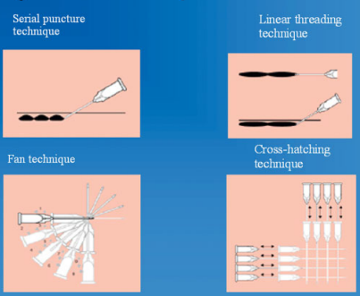
Fig. 10.9- Injection Techniques

LINEAR THREADING TECHNIQUE:
During injection, the needle's length should correspond to the wrinkle's length, and it is injected while the needle is pulled slowly backward to position the threads of the gel lengthwise in the wrinkle..^{[16]}
SERIAL PUNCTURE TECHNIQUE:
Several injections are administered consecutively along the wrinkle or fold's extent, positioned closely to merge into a seamless, uninterrupted line, effectively addressing and elevating the wrinkle. ^{[16]}.
FAN TECHNIQUE:
The periphery of the treatment area is targeted by inserting the needle, similar to the linear threading method. Once a line has been injected, the direction of the needle is adjusted and a new line is treated in the same way..^{[16]}
CROSS HATCHING TECHNIQUE:
The linear threading technique involves the injection of filler, starting with the insertion of a needle at the outer edge of the targeted augmentation area, followed by injection. Subsequently, the needle is removed and reintroduced 5-10 mm away from the initial puncture site, where it is injected similarly. This procedure can be repeated at perpendicular angles to the initial lines.
TOWER TECHNIQUE:
The perpendicular injection technique is an innovative approach used to administer hyaluronic acid fillers. This method involves depositing the filler at a perpendicular angle to the deep tissue plane, with gradual reduction of product deposition while the needle is withdrawn. As a result, a series of struts or towers are created, which provide support to the overlying soft tissue, resulting in a more youthful appearance. This technique is particularly effective for treating areas such as the lateral brow, marionette lines, nasolabial folds, prejowl sulcus, and mental region..^{[16]}
INTRAORAL APPROACH:
Before the procedure, the skin on the targeted area is cleaned with an antiseptic. Patient is then positioned upright and the treatment area is marked using the Hinderer's method.
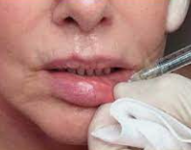
Fig. 10.10- Intraoral Approach
To determine the location for volume enhancement, two intersecting lines are drawn on the target area. One line extends from the tragus to the alar cartilage of the nose, while the other runs from the outer canthus of the eye to the labial commissure. The upper outer quadrant formed by this intersection is selected for implant placement. Prior to the procedure, the skin covering the treatment site is thoroughly cleaned with a topical antiseptic, and the patient is positioned in an upright posture. The Hinderer's method is employed to mark the treatment areas.

COMPLICATIONS OF DERMA FILLERS
Early side effects of dermal filler injections may include redness, swelling, and bruising. To minimize pain, small amounts of local anesthetics are delivered gradually during the injection. Topical creams containing arnica, aloe vera, or naphthoquinone may help to alleviate bruises. In rare cases, patients with previous sensitization may experience allergic reactions shortly after the injection. If a filler is injected improperly, lumps and bumps may develop.
Both botulinum toxin (BTX) and dermal fillers have been approved for both diagnostic and therapeutic purposes. In 2014, the Michigan Board of Dentistry and the New Jersey State Board of Dentistry also approved the use of BTX and dermal fillers for dental applications..^{[17]}
Polo conducted a study in which he administered 0.25 U of Botox to five patients experiencing excessive gingival display due to the overactivity of the upper lip elevator muscle. Freund et al. also employed dermal fillers alongside Botox injections to address patients with gummy smiles, leading to both aesthetic enhancements and functional improvements. This combination approach was also employed for the treatment of lipstick lines by modifying the contraction of the orbicularis oris muscle. Daines and Williams utilized interdental soft tissue fillers in conjunction with Botox injections to address black triangles, resulting in outcomes lasting approximately 3-4 months.
Initial side effects of these procedures commonly encompass erythema, edema, and bruising, but these can be minimized by employing a slow injection technique and delivering local anesthetics in small volumes. There have been reports suggesting the effectiveness of Arnica, aloe vera, and naphthoquinone creams in mitigating bruising. Allergic reactions may arise within hours in cases where the patient has a prior sensitization. If an incorrect filler is superficially injected or placed in incorrect areas, the potential for developing lumps and bumps exists. In 2014, both the Michigan Board of Dentistry and the New Jersey State Board of Dentistry granted approval for the utilization of BTX and dermal fillers in addressing diagnostic as well as therapeutic concerns.^{[18]}
Studies conducted by Freund et al. found that administering BTXA into the muscle temporalis and masseter muscles in TMD-related complications led to symptom relief lasting 2-4 months. In addition, BTX has anti-inflammatory properties as reported by Erdal et al. and Cersosimo et al. Injecting into the masticatory musculature reduces hyperfunctional or spastic muscles. Elcio reported that Botox injections also alleviated the throbbing pain associated with trigeminal neuralgia of the face..^{[19]}
- LIP AUGMENTATION
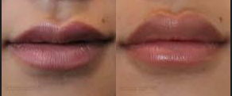
Fig. 10.11- Lip Augmentation
Lip augmentation is a cosmetic procedure that can enhance thin lips and give them a more youthful appearance. Different methods are available such as lip fillers, implants, fat transfers, and lip lifts. Each method has varying recovery time, effects, and potential risks. This in-office procedure offers different options to suit individual needs, including non-surgical procedures that use temporary fillers to plump up the lips or surgical procedures that involve small incisions for longer-lasting results..^{[20]}

VARIOUS APPROACHES TO LIP AUGMENTATION^{[20]}
- AUTOLOGOUS FAT GRAFTING (Fat Transfer): Plastic surgeons harvest fat from another part of your body, typically the abdomen, purify it, and then inject it into your lips.
- DERMAL LIP FILLERS: A medical professional administers lip filler, also referred to as dermal filler, into your lips or the surrounding areas of your mouth.
- LIP IMPLANTS: Plastic surgeons create small incisions at the corners of your mouth and insert implants into your lips.
- LIP LIFT: Plastic surgeons remove excess skin between your nose and upper lip or at the corners of your mouth to elevate your lips.
VARIETIES OF LIP FILLERS: Medical practitioners commonly utilize lip fillers containing hyaluronic acid, a natural substance naturally present in your body. Popular hyaluronic acid fillers include Restylane and Juvéderm. Certain fillers may also incorporate lidocaine, which serves to numb the skin and minimize discomfort or pain during the procedure.
DURATION OF LIP AUGMENTATION-
Lip fillers typically provide results that last from six months to a year, while fat grafting can yield results lasting at least five years. A lip lift procedure is considered permanent, as are lip implants, although the latter can be removed at any time.
The most suitable lip augmentation method varies from person to person. The choice of the right procedure depends on your individual goals, lip shape, and desired size. For instance, lip implants or a lip lift may be preferred if you seek permanent results. However, it's important to note that implants may not be suitable for very thin or unevenly shaped lips. Collaborating with your healthcare provider will help you determine the optimal approach for your unique needs.
INDICATIONS FOR LIP AUGMENTATION-
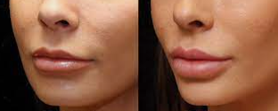
Fig.10.12- Lip Augmentation
- Patients who are in proper fitness.
- Don’t smoke or can give up smoking before the process.
- Don’t have an lively contamination like a chilly sore.
- Don’t have a persistent situation like diabetes or lupus.
- Have practical expectations approximately your results.
Lip fillersnwhile getting lip injections, the doctor uses a pleasant needle to inject filler into your lips. The injections usually take 10 to half-hour.^{[20]}
- FAT TRANSFER
Fig. 10.13- Fat Transfer
If the injected material includes fat harvested from your body, a liposuction procedure will be performed to remove the fat, typically from your abdominal area. After purifying the fat, a plastic surgeon will inject it into your lips. The entire process typically requires about 60 to 90 minutes to complete.^{[21]}
- LIP IMPLANT^{[22]}
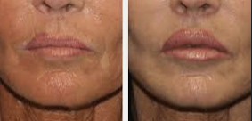
Fig. 10.14 - Lip Implant
This manner typically lasts approximately half-hour. throughout lip implant surgical treatment, your plastic health care provider:
- Local anesthesia administered on the lip
- Makes a tiny incision in each corner of the mouth.
- Creates a tunnel via inserting a clamp through one incision and threading it to the opposite aspect.
- Pulls the implant via the tunnel the use of the clamp.
- Closes the incisions with stitches.

- LIP LIFT^{[22]}
This method commonly takes approximately an hour. throughout a lip carry, your plastic health care professional:
- Anaesthetize the vicinity.
- Makes an incision below the nose.
- eliminates a small strip of pores and skin.
- Lift the upper lip.
- Closes the incision with stitches.
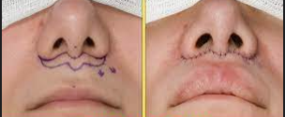
Fig. 10.15- Lip Lift Procedure
Possible risks and complications include:
- Allergic reactions like redness and itching.
- Bleeding.
- Bruising.
- Infection.
- Lip stiffening.
- Scarring.
- Swelling.
- Uneven lips.
The primary objective of a comprehensive plan is to present the most practical choices to the patient and create a personalized treatment plan. A seasoned professional in the field of Maxillofacial surgery might attest that often, Orthognathic surgery, Orthodontics alone, or even a combination of both may not be sufficient to achieve optimal outcomes. It becomes imperative to consider supplementary strategies in order to attain the best possible results.
REFERENCES
  - Sinha A, Hurakadli M, Yadav P. Botox and derma fillers: The twin-face of cosmetic dentistry. International Journal of Contemporary Dental and Medical Reviews. 2015 Feb;2015:131214.
  - Patel D, Mehta F, Trivedi R, Thakkar S, Suthar J. Botulinum toxin and gummy smile-a review. IOSR J Dent Med Sci. 2013 Jan;4(1):1-5.
  - Dalati MH, Koussayer LT. An introduction to botulinum toxin and dermal fillers for dentists: Part 1. EC Dental Science. 2020;19(8):142-57.
  - Garber DA, Salama MA. The aesthetic smile: diagnosis and treatment. Periodontology 2000. 1996 Jun;11(1):18-28.
  - Meunier FA, Schiavo G, Molgó J. Botulinum neurotoxins: from paralysis to recovery of functional neuromuscular transmission. Journal of Physiology-Paris. 2002 Jan 1;96(1-2):105-13.
  - AlAhmary AW, Alqhtani SM, Alshahrani BA, Alkaram WA, Alhadad BS, Elmarakby AM. Clinical Applications of Botulinum Toxin in Oral and Maxillofacial Surgery: Clinical Applications of Botulinum Toxin in Oral and Maxillofacial Surgery. Open Access Macedonian Journal of Medical Sciences. 2020 Oct 5;8(F):260-71.
  - Kurtoglu C, Gur OH, Kurkcu M, Sertdemir Y, Guler-Uysal F, Uysal H. Effect of botulinum toxin-A in myofascial pain patients with or without functional disc displacement. Journal of Oral and Maxillofacial Surgery. 2008 Aug 1;66(8):1644-51.
  - Hwang WS, Hur MS, Hu KS, Song WC, Koh KS, Baik HS, Kim ST, Kim HJ, Lee KJ. Surface anatomy of the lip elevator muscles for the treatment of gummy smile using botulinum toxin. The Angle Orthodontist. 2009 Jan;79(1):70-7.
  - Bhat PR, Janiani P, Trasad VA. Botox: An advancement in dentistry: An overview. AOHDR. 2018;1:1-5.
  - Food U. Administration D. Information for healthcare professionals: OnabotulinumtoxinA (marketed as Botox/Botox Cosmetic), AbobotulinumtoxinA (marketed as Dysport) and RimabotulinumtoxinB (marketed as Myobloc). FDA Alert Rockville, MD: FDA. 2009.
  - Dastoor SF, Misch CE, Wang HL. Botulinum toxin (Botox) to enhance facial macroesthetics: a literature review. Journal of Oral Implantology. 2007 Jun;33(3):164-71.
  - Ashok D, Gnanashanmugam SK. Dermal fillers in orthodontics. Eur J Mol Clin Med. 2020;7:1626-9.
  - Zielke H, Wölber L, Wiest L, Rzany B. Risk profiles of different injectable fillers: results from the Injectable Filler Safety Study (IFS Study). Dermatologic surgery. 2008 Mar;34(3):326-35.
  - Fitzgerald R, Vleggaar D. Facial volume restoration of the aging face with poly‐l‐lactic acid. Dermatologic therapy. 2011 Jan;24(1):2-7.
  - Pallua N, Wolter TP. A 5-year assessment of safety and aesthetic results after facial soft-tissue augmentation with polyacrylamide hydrogel (Aquamid): a prospective multicenter study of 251 patients. Plastic and reconstructive surgery. 2010 Jun 1;125(6):1797-804.
  - Vedamurthy M. Soft tissue augmentation-Use of hyaluronic acid as dermal filler. Indian Journal of Dermatology, Venereology and Leprology. 2004 Nov 1;70:383.
  - Haneke E. Managing complications of fillers: rare and not-so-rare. Journal of cutaneous and aesthetic surgery. 2015 Oct;8(4):198.
  - Polo M. Botulinum toxin type A in the treatment of excessive gingival display. American journal of orthodontics and dentofacial orthopedics. 2005 Feb 1;127(2):214-8.
  - Cersósimo MG, Bertoti A, Roca CU, Micheli F. Botulinum toxin in a case of hemimasticatory spasm with severe worsening during pregnancy. Clinical neuropharmacology. 2004 Jan 1;27(1):6-8.
  - Byrne PJ, Hilger PA. Lip augmentation. Facial plastic surgery. 2004 Feb;20(01):31-8.
  - Groen JW, Krastev TK, Hommes J, Wilschut JA, Ritt MJ, Van Der Hulst RR. Autologous fat transfer for facial rejuvenation: a systematic review on technique, efficacy, and satisfaction. Plastic and Reconstructive Surgery Global Open. 2017 Dec;5(12).
  - Brody-Camp S, Raggio BS. Lip Implants.

