Biotechnology plays the key roles in the regulation of fungal secondary metabolism
¹Amit Kumar, ²Rakesh Singh Sengar, and Rajeev Kumar³
¹Department of Agriculture,
Keral Verma Subharti College of Science,
Swami Vivekanand Subharti University, Meerut – 250005(U.P)
²Department of Agriculture Biotechnology
Sardar Vallabhbhai Patel University of Agriculture and Technology
Meerut-250110(U.P)
³Department of Botany (Genetics and Plant Breeding)
C.S.S.S.(P.G.) College Machhra (Meerut) U.P. INDIA - 250106

Email-amit.agbiotech1582@gmail.com

Abstract
Fungi produce a massive array and variety of secondary metabolite. Fungal secondary metabolites are important in both fields, industry as well as in medicine. Secondary metabolites are low molecular weight compounds, which are produced from the derivative of primary metabolites. First secondary metabolite was reported in the late nineteen century. Today Fungal Biotechnology is a major participant in global industry. Recombinant DNA technology which includes yeast and other fungi as hosts has markedly increased markets for microbial enzymes. Fungi are used in many industrial processes such as production of enzymes, vitamins, polysaccharides, polyhydric alcohols, pigments, lipids and glycolipids. Some of the products are produced commercially and others are potentially valuable in biotechnology. Rapid advance in transformation methodologies has been a consequence of well defined protoplasting protocols for a large number of filamentous fungi. The molecular manipulation of filamentous fungi has resulted in some exciting developments in the area of biotechnology. Recombinant DNA technology has taken advantage of the filamentous fungal species for homologous and heterologous protein secretion on account of their ability to release high levels of secondary metabolites. In this chapter we conclude that the biotechnology plays key role for the regulation of the secondary metabolite.
Key words: Fungi, secondary metabolite, RDT, Biotechnology.

It has often been observed that certain common phenolic compounds that are toxic to pathogens are produced and accumulate at a faster rate after infection, especially in a resistant variety of plant relative to a susceptible variety. Chlorogenic acid, caffeic acid, and ferulic acid are examples of such phenolic compounds. In peach, chlorogenic acid is present in quite high concentration in both immature fruit and in fruit of varieties resistant to the brown rot disease caused by the fungus Monilinia fructicola (Boehm et al., 1991). The fruit is resistant in both cases, not because of the toxicity of the acid to the causal fungus, but rather because it inhibits the production of fungal enzymes that cause degradation of host tissue. In date palm tree roots, cell wall – bound hydroxybenzoic acid and sinapic acid increased 11 – 12 times as much in cultivars resistant to fusarium than they did in susceptible cultivars. In plants such as vetch (vicia sativa), resistance to the higher parasitic plant Orobanche aegyptiaca appears to result from higher levels of free and bound phenolics, lignin and peroxidase activity produced in the roots of resistant varieties following infection, comparaed to susceptible ones. In cacao infected with the witches’ broom fungus Crinipellis perniciosa, infected young stems contain 7 – 8 times as much caffeine, which inhibits growth of the fungus in culture, than healthy stems. In another polygenic disease, the black sigatoka disease of banaqna caused by the fungus Mycosphaerella fijiensis , plat defenses included an activation of phenylalanine ammonia lyase and a subsequent accumulation of phenolic compounds. It also caused early activation of a banana response to the fungal compound trihydroxytetralone (THT) which, in resistant varieties, caused necrotic microlesions and elicitation of infection – induced defense reactions leading to incompatibility (resistance) between the pathogen and the host plant (Hoss et al., 2003). In susceptible varieties, however, the fungus produced necrotizing levels of THT only at the later stages of pathogenesis after a compatible interaction had been established and typical symptoms had developed(Hoss et al., 2003).. Although some of the common phenolics may each reach concentration that could be toxic to the pathogen, it should be noted that several of them appear concurrently in the same diseased tissue, and it is possible that the combined effect of all fungi toxic phenolics present, rather than that of each one separately, is responsible for the inhibition of infection in resistant varieties. It has even been proposed that because of the universal uniform or strategic location of phenolics – strong plant cells, these cells can, be decompartmentation and rapid oxidation of their phenolic contents, self – sacrifice, leading to the first line of defense – cell death – or leading to the production of a slower defense line – a peridermal defense layer.
Toxic Phenolics from Nontoxic phenolic glycosides
Many plants contain nontoxic glycosides, i.e., compounds consisting of a sugar (Such as glucose) joined to another, often phenolic, molecule. Several fungi and bacteria are known to produce or to liberate from plant tissue the enzyme glycosidase that can hydrolyze such complex molecules and release the phenolic compound from the complex. Some of the released phenolics are quite toxic to the pathogen, especially after further oxidation, and appear to play a role in the defense of the plant against infection.
Role of phenol – oxidizing enzyme in disease resistance
The activity of many phenol oxidizing enzymes (polyphenol oxidases) is generally higher in the infected tissue of resistant varieties than in infected susceptible ones or in uninfected healthy plants. The importance of polyphenol oxidase activity in disease resistance probably stems from its property to oxidize phenolic compounds to quinines, which are often more toxic to microorganisms than the original phenols (Burton et al., 1993). It is reasonable to assume that an increased activity of polyphenol oxidases will result in higher concentrations of toxic products of oxidation and therefore in greater degrees of resistance to infection (Steffens et al.,2002). A complex interation occur during fruit ripening in which levels of lipoxygenases increase and break down diene, a compound that is present I young, immature fruit and is toxic to fungi. These events normally result in infection (loss of resistance) of the ripening fruit. In some fruit, however, elicitors from nonpathogenic fungi stimulate production of the phenolic compound epicatechin, which inhibit the activity of lipoxygenases (Ryuichi et al., 2015). As a result, epicatechin decreases degradation of the antifungal diene, thereby preventing decay of the ripening fruit by anthracnose fungi.
Another phenol oxidase enzyme, peroxidase, both oxidizes phenolics to quinines and generates hydrogen peroxide. The latter not only is antimicrobial in itself, but it also releases highly reactive free radicals and in that way further increases the rate of polymerization of phenolic compound into lignin like substances. These substances are then deposited incell walls and papillae and interfere with the further growth and development of the pathogen.

Biotechnology in fungal secondary metabolism
In addition to needing genes for producing infection structures and for degrading structural obstacles, fungal pathogens need genes that will help them overcome the many secondary metabolites plants produce, some of which have antimicrobial properties and help protect the plant against attack. Secondary metabolite compounds produced constitutively are called phytoanticipins, whereas those produced in response to attack by a pathogen are called phytoalexins. Pathogens respond to these chemical defenses of the host plant through genes that help pathogens avoid them, degrade them, alter their physiology, or though other mechanisms(Yu et al., 2023).
Phytoanticipins: They include primarily the saponins avenacin and tomatine. saponins are glycosides with soap like properties. That can disrupt membranes. One saponin, avenacin A-1, is localized in the epidermis of oat roots but not of wheat roots. The fungus Gaeumannomyces graminis var. avena can infect oats because it has a gene that codes for the enzyme avenacinase, which degrades the saponin. When the avenacinase gene is disrupted, however, the avenacin – less mutants of the fungus fail to infect oats while they can still infect wheat, which does not produce avenaccin. Another saponin, α-tomatine, is produce in tomato and has antimicrobial activity against many fungi. The fungus in sequence to the avenacinase gene that encodes the enzyme tomatinase, which degrades the saponin tomatine. Disruption of the tomatinase gene, however, did not reduce the pathogenicity of Septoria on tomato, possibly because the fungus has other enzymes that can degrade the saponin. The latter happens in the oat – Stagonospora avenae interaction in which the fungus has three genes encoding for enzymes that can degrade the particular saponin.
Cyanogenic glycosides and Glycosinolates:
These compounds are separated in the plant from the enzymes that can degrade them. Upon wounding of a plant, these compounds and their enzymes mingle and interact, producing cyanide, isocyanates, nitriles, and thiocyanates, all toxic against all organisms and also to fungi. Their role, however, in pathogenesis of fungi and how the latter defend themselves, are not known.

Phytoalexins:
Phytoalexins have been known for several decades to be produced by plants under attack but few fungal enzymes have been found that degrade them during fungal attack( Hammerschmidt R, Dann E K. 1999). One such enzyme is pisatin demethylase, which is produced by the fungus Nectria haematococca and degrades the pea phytoalexin pisatin (Alan P. Maloney, Hans D. VanEtten, 1994). Pisatin demethylase is encoded by one of six such genes of the fungus but disruption of the gene caused only a slight reduction in pathogenicity (Coleman JJ, 2011). However, disruption of one out of four fungal genes that detoxify the phytoalexin maakiain from chickpea resulted in a reduction of pathogenicity, whereas the insertion of additional copies of the same gene in the pathogen isolates resulted in greater disease severity.
Some fungal genes protect the fungal and its pathogenicity enven after it is growing inside the plant. Numerous such genes are involved in the efflux and influx of fungal molecules into the plant. Disruption of such a gene in M. grisea resulted in loss of pathogenicity (Jian‐Ping Lu, 2006). Because the same gene is induced by toxic drugs and by the rice phytoalexin sakuranetin, perhaps it plays a role in the efflux of plant metabolites from the fungus.
Because some fungal pathogenicity genes, when mutated, result in auxotrophic strains, it is apparent that levels of nutrients can affect the ability of fungi to colonize plants. It has been known for many years that auxotrophy is linked to a lack of pathogenicity in the corn sumut fungus Ustilago maydis, whereas adenine auxotrophs of the apple scab fungus Venturia inaequalis are nonpathogenic on apple (Parisi L, 2004). Similarity, auxotrophs of fusarium sp. in arginine and of Stagonospora sp. in ornithine decaroxylase also lost their ability to cause disease (Coleman JJ,2011).
Phytoalexins are toxic antimicrobial substances produced in appreciable amounts in plants only after stimulation by various types of phytopathogenic microorganisms or by chemical and mechanical injury (Ahuja et al., 2012). Phytoalexins are produced by healthy cells adjacent to localized damaged and necrotic cells in response to materials diffusing from the damaged cells (Jeandet et al., 2013). Phytoalexins are not produced during compatible biotrophic infections. Phytoalexins accumulate around both resistant and susceptible necrotic tissues. Resistance occurs when one or more phytoalexins reach a concentration sufficient to restrict pathogen development (Jeandet et al., 2013). Most known phytoalexins are toxic to and inhibit the growth of fungi pathogenic to plants, but some are also toxic to fungi, bacterial and other organisms. More than 300 chemicals with phytoalexinlike properties have been isolated from plants belonging to more than 30 families (Schmelz et al., 2014). The chemical structure of phytoalexins produced by plants of a family are usually quite similar; e.g., in most legumes, phytoalexins are isoflavonoids, and in the solanaceae they are terpenoids (Jeandet et al., 2010). Most of the phytoalexins are produced in plants in response to infection by fungi, but a few fungi have also been shown to induce the production of phytoalexins. Some of the better studied phytoalexins include phaseollin in bean; pisatin in pea; glyceollin in soybean, alfalfa, and clover; rishitin in potato; gossypol in cotton; and capsidiol in pepper (Schmelz et al., 2014, Motoyama et al., 2021).
Phytoalexin production and accumulation occur in health plant cells. Surrounding wounded or infected cells and are stimulated by alarm substances produced and released by the damaged cells and diffusing into the adjacent healthy cells (Wu et al., 2004). Most phytoalexin elicitors are generally high molecular weight substances that are constituents of the fungal cell wall, such as glucans, chitosan, glycoproteins, and polysaccharides(Wu et al., 2004). The elicitor molecules are released from the fungal cell wall by host plant enzymes. Most elicitors are nonspecific, i.e., they are present in both compatible and incompatible races of the pathogen and induce phytoalexin accumulation irrespective of the plant cultivar. A few phytoalexin elicitors, bowever, are specific, as the accumulation of phytoalexin they cause on certain compatible and incompatible cultivars parallels the phytoalexin accumulation caused by the pathogen races themselves. Although most phytoalexin elicitors are thought to be of pathogen origin, some elicitors, e.g., oligomers of galacturonic acid, are produced by plant cells in response to infection or are released from plant cell walls after their partial breakdown by the cell wall degrading enzymes of the patformation of phhogen. Toalexins in a susceptible host following infection by a pathogen seems, in some cases, to be prevented by suppressor molecules produced by the pathogen. The suppressors seem to also be glucans or glycoprotens, or one of the toxin produced by the Pathogen.
The mechanisms by which phytoalexin elicitors, phytoalexin production, phytoalexin suppressors, gene for resistance or susceptibility, and the expression of resistance or susceptibility are connected are still not well understood. Several hypotheses have been proposed to explain the interconnection of these factors, but much more work is needed before a satisfactory explanation can be obtained.
Species or races of fungi pathogenic to a particular plant species seem to stimulate the production of generally lower concentration of phytoalexins than nanopathogens. For example, in the case of pisatin production by pea pods inoculated with the pathogen Ascochyta pisi, pea varieties produce concentration of pisatin that are approximately proportional to the resistance of the variety to the pathogen. When the same pea variety is inoculated with different strains of the fungus, the concentration of pisatin produced is approximately inversely proportional to the virulence of each particular fungal strain incoculated on the pea variety. Also, in soybean plants infected with the fungus phytophthora megasperma f. sp. glycinea, incoculations of fungal races on incompatible host cultivars resulted in earlier accumulations and higher concentration of the phytoalexin glyceollin than inoculation of fungal races on compatible cultivars. It has been suggested that the higher concentration of glyceollin in incompatible host pathogen combinations are the result of reduced biodegradation combinations are the result of reduced biodegradation rather than increased biosynthesis of the phytoalexin. In some host pathogen systems, however, e.g., in the bean/colletotrichum lindemuthianum and the potato/phytophthora infestans systems, the respective phytoalexins, such as phaseollin and rishitin, reach equal or higher concentration in compatible (susceptible) hosts compared to incompatible (resistant) ones.
However, pathogenic races or species of fungi seem to be less sensitive to the toxicity of the phytoalexin produced by their host plant than nonpathogenic fungi (Jeandet et al.,2013). It has been suggested that pathogens may have an adoptive tolerance mechanism that enable them to withstand higher concentration of the host phytoalexin after earlier exposures to lower concentrations of the phytoalexin (Jeandet et al.,2013). It is known, however, that many pathogenic fungi can metabolize the host phytoalexin into a nontoxic compound, thereby decreasing the toxicity of the phytoalexin to the pathogen (Schmelz et al., 2014).. It is also known that numerous pathogenic fungi are successful in causing disease, although they are sensitive to or unable to metabolize the host phytoalexins. Furthermore, some fungi that can either degrade or tolerate certain phytoalexins are unable to infect the plants that produce them (Browne et al., 1991).
In general, it appears that phytoalexins may play a decisive or an auxiliary role in the defense of some hosts against certain pathogens, but their significance, if any, as factors of disease resistance in most host pathogen combinations is still unknown.
Pathway for secondary metabolite production
Secondary metabolites are biosynthesized of structure obstructs that are put together in different metabolic pathways. The pathways are normally named after intermediates included and are regularly likewise used to characterize secondary metabolites. The assorted variety and multifaceted nature of the structures that these moderately few structure blocks can give is both amazing and fascinating. Secondary metabolites production is interconnected with primary metabolism because it needs energy and vital quantity of carbon and nitrogen.
In distinction to the many hundred primary metabolites, microbial secondary metabolites comprise tense of thousands of proverbial compounds and their variety is rising each year. This wide selection of product is achieved by slight variation of the synthesis pathways, whereas the backbones square measure originating from solely some key precursors derived from primary metabolism like amiao acid and acetyl Co A(Lei Shi and Benjamin P. Tu, 2015).
As opposed to the couple of hundred basic metabolites, microbial auxiliary metabolites contain tense of thousands of known blends and their number is rising every year. This wide extent of thing is practiced by slight variety of the biosynthesis pathways, however the spines are starting from only two or three key predecessors got from fundamental assimilation, for instance, amiao corrosive and acetyl Co A (Lei Shi and Benjamin P. Tu, 2015, Rokas et al., 2020)
Biosynthesis of Polyketides
The polyketides is a huge group of auxiliary metabolites found in microscopic organisms like fungi and plants. They are especially significant for micro organism (fungi) as the most plentiful fungal secondary metabolites and a considerable lot of them have significant biological activity. The cholesterol bringing down compound lovastatin, delivered by the fungi Aspergillus terreus and Monascus ruber, serves as a decent model. It functions as an inhibitor of the catalyst HMG-CoA reductase which is dynamic in the development of MVA and was the primary statin to be promoted (Dewick, 2009; Keller et al., 2005). Polyketides are gotten from poly-β-keto chains, framed by stepwise buildup of for mainly malonyl-CoA (extender unit) and acetyl-CoA (starter unit). The responses engaged with the development of the poly-β-keto chain are catalyzed by polyketide synthase (PKS), a group of multidomain proteins or protein edifices. There are a few sorts of PKSs found in various life forms however the principal of developing the poly-β-keto chain are the equivalent in all PKSs . The primary step is the stacking, as thioesters, of both the starter unit and the extender unit to the separate site on the PKS. Acetyl-CoA is bound to a ketoacyl-CoA synthase (KS) domain though the extender unit is bound to an acyl carrier (ACP) domain. condensation at that point happens between malonyl-ACP and acetyl-KS by a Claisen-type response and concurrent decarboxylation of the ACP-bound extender unit. The resulting β-ketothioester bound to the ACP domain would then be able to be moved to a KS domain and reached out by another malonyl-ACP. This cycle repeats β-keto chain has achieved the ideal length. When the chain is finished it very well may be folded and enacted at desired positions to allow intramolecular responses. This is exemplified in Figure: 1 by the biosynthesis of orsellinic acid and phloracetophenone. Other progressively entangled sweet-smelling mixes like the anthraquinones can be synthesise in the identical sequence but with a length of β keto chain as Precursor (Dewick, 2009; Hanson, 2003, Zhang 2021).
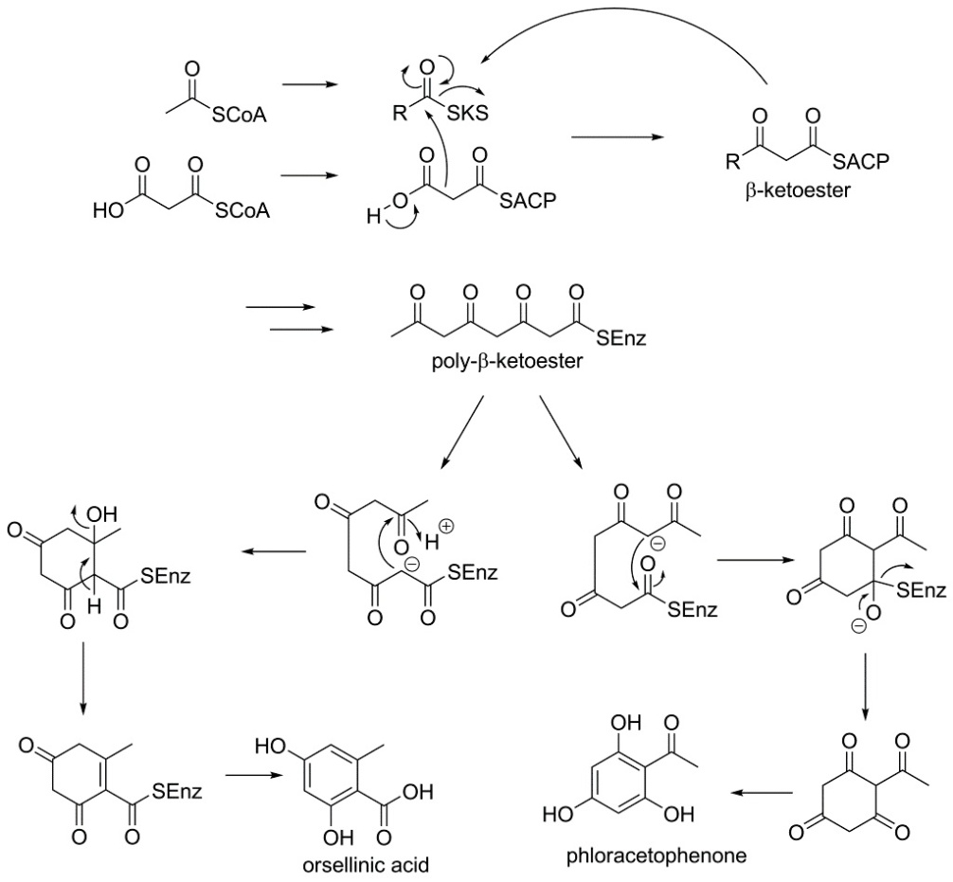
Figure1: Biosynthesis of Polykitides
Biosynthesis chorsmic acid by shikimic acid pathway
The shikimic acid pathway is a significant biosynthetic pathway in fungi, bacteria and also different microorganisms for the generation of sweet-smelling mixes, especially the fragrant amino acids L-tryptophan and L-phenylalanine. The shikimic pathway is, be that as it may, not shows in animals, in this way are these amino acids delegated basic for people. Phenylalanine and tyrosine are thus significant antecedents for some alkaloids yet in addition for phenylpropanoids, perceived by their C₆ C₃ carbon skeleton and found in numerous basically different secondary metabolites.
The primary step of the shikimic pathway (Figure 2) is the buildup of erythrose 4-phosphate and phosphoenolpyruvate to give shikimic acid by two aldol-type responses, one intermolecular and one intramolecular, pursued by disposal of water and a decrease response. Shikimic acid is at that point phosphorylated and another PEP atom is appended to the 5-hydroxy group of shikimic acid 3-phosphate. Two successive disposals of phosphoric acid pursue and lead to the final result of the shikimic acid pathway is the formation of chorismic acid. (Dewick, 2009; Hanson, 2003).
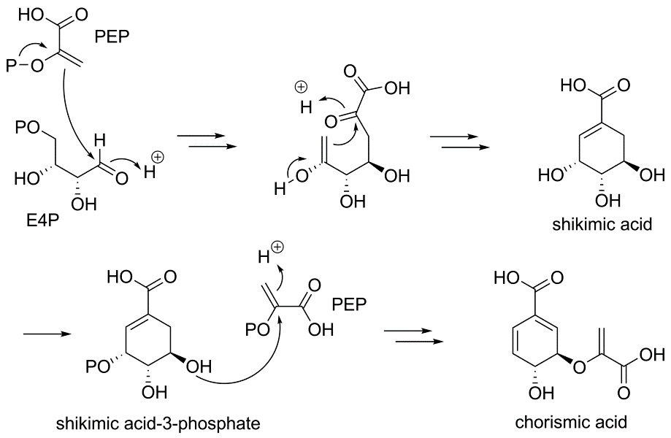
Figure-2 Biosynthesis of Chorismic acid via shikimic acid pathway
Conclusion
In this chapter we studied the biotechnology play a important role in the production of secondary metabolite. Numerous microorganisms like fungi and bacteria produce huge quantities of secondary metabolites and the multifaceted nature and assorted variety is some of the time shocking. Secondary metabolites have had incredible effect on society for a considerable length of time in conventional drug and in present day times, as pharmaceuticals, aromas in cosmetics agents, enhance in flavouring like drinks, agrochemicals, and so forth. Secondary metabolites are low molecular weight compounds, which are produced from the derivative of primary metabolites. First secondary metabolite was reported in the late nineteen century. Today Fungal Biotechnology is a major participant in global industry. Recombinant DNA technology which includes yeast and other fungi as hosts has markedly increased markets for microbial enzymes. Fungi are used in many industrial processes such as production of enzymes, vitamins, polysaccharides, polyhydric alcohols, pigments, lipids and glycolipids.

References:
- Ahuja I, Kissen R, Bones AM (2012) Phytoalexins in defense against pathogens. Trends Plant Sci. 17, 73–90.

Alan P M, Hans D V (1994) A gene from the fungal plant pathogen Nectria haematococca that encodes the phytoalexin-detoxifying enzyme pisatin demethylase defines a new cytochrome P450 family. Molecular and General Genetics MGG. 243(5):506
- Boehm E W A, Ma Z Michailides T J (2001) Species-specific detection of Monilinia fructicola from California stone fruits and flowers. Phytopathology 91, 428–439.
- Browne L M, Conn K L, Ayert W A, Tewari J P (1991) The camalexins: New phytoalexins produced in the leaves of Camelia sativa (Cruciferae). Tetrahedron 1991, 47, 3909–3914.
- Burton SG, Duncan JR, Perry T (1993) Activity of mushroom polyphenol oxidase in organic medium Biotechnol Bioeng 42(8): 938 – 944.

Coleman JJ, Wasmann CC Usami T, White GJ, Temporini ED, McCluskey K, VanEtten HD (2011) Characterization of the gene encoding pisatin demethylase (FoPDA1) in Fusarium oxysporum. Mol Plant Microbe Interact. 2011,24(12):1482-91.
- Dewick PM (2009) Medicinal natural products: a biosynthetic approach. 3rd.ed. Chichester, UK: John Wiley & Sons, Ltd. ISBN 9780470741689.

Hammerschmidt R, Dann EK (1999) The role of phytoalexins in plant protection. Novartis Found Symp. 223:175-87
- Hanson, J.R. (2003). Natural products: the secondary metabolites. Cambridge, UK: Royal society of chemistry. ISBN 0854044906.
- Hoss R, Helbig J, Bochow, Helmut (2003) Function of Host and Fungal Metabolites in Resistance Response of Banana and Plantain in the Black Sigatoka Disease Pathosystem (Musa spp. –Mycosphaerella fijiensis). Journal of Phytopathology. 148. 387 - 394.
- Jeandet P, Clément C, Courot E, Cordelier S (2013) Modulation of phytoalexin biosynthesis in engineered plants for disease resistance. Int. J. Mol. Sci. 2013, 14, 14136–14170.
- Jeandet P, Delaunois B, Conreux A, Donnez D, Nuzzo V, Cordelier S, Clément C, Courot E (2010) Biosynthesis, metabolism, molecular engineering and biological functions of stilbene phytoalexins in plants. BioFactors. 36, 331–341.
- Jian‐Ping Lu, Tong‐Bao Liu, Fu‐Cheng Lin (2006) Identification of mature appressorium‐enriched transcripts in Magnaporthe grisea, the rice blast fungus, using suppression subtractive hybridization, FEMS Microbiology Letters, 245, (1), 131-137.
- Keller N P, Turner G, Bennett J W (2005) Fungal secondary metabolism - from biochemistry to genomics. Nature Reviews Microbiology 3(12), 937- 947.

Lei Shi, Benjamin P Tu (2015) Acetyl-CoA and the Regulation of Metabolism: Mechanisms and Consequences. Curr Opin Cell Biol,33: 125–131.
- Motoyama, T.; Yun, C.-S.; Osada, H.(2021) Biosynthesis and Biological Function of Secondary Metabolites of the Rice Blast Fungus pyricularia Oryzae. J. Ind. Microbiol. Biotechnol. 2021, kuab058.
- Parisi L, Fouillet V, Schouten H J, et al.(2004) Variability of the pathogenicity of Venturia inaequalis in Europe. Acta Horticulturae.663:107–113
- Ryuichi M, Torayuki O (2015) The role of lipoxygenases in pathophysiology; new insights and future perspectives. Redox Biol. 2015 Dec; 6: 297–310.
- Schmelz E A, Huffaker A, Sims J W, Christensen S A, Lu X, Okada K, Peters R J (2014) Biosynthesis, elicitation and roles of monocot terpenoid phytoalexins. Plant J. 79, 659–678.
- Steffens JC, Li L (2002) Overexpression of polyphenol oxidase in transgenic tomato plants results in enhanced bacterial disease resistance. Planta 215: 239 – 247.

Víctor M, Luque-Almagro, Purificación Cabello, Lara P, Sáez Alfonso Olaya-Abril, Conrado Moreno-Vivián, María Dolores Roldán (2018) Exploring anaerobic environments for cyanide and cyano-derivatives microbial degradation. Appl Microbiol Biotechnol. 102(3): 1067–1074.
- Wu Q, Van Etten H D (2004) Introduction of plant and fungal genes into pea (Pisum sativum L.) hairy roots reduces their ability to produce pisatin and affects their response to a fungal pathogen. Mol. Plant-Microbe Interact. 17, 798–804.
- Yu, Wenbin & Pei, Rongqiang & Zhou, Jingyi & Zeng, Bin & Tu, Yayi & He, Bin. (2023). Molecular regulation of fungal secondary metabolism. World Journal of Microbiology and Biotechnology. 39. 10.1007/s11274-023-03649-6.
- Rokas, A.; Mead, M.E.; Steenwyk, J.L.; Raja, H.A.; Oberlies, N.H.(2020). Biosynthetic Gene Clusters and the Evolution of Fungal Chemodiversity. Nat. Prod. Rep. 2020, 37, 868–878.
- Zhang, X.; Guo, J.; Cheng, F.; Li, S. (2021) Cytochrome P450 Enzymes in Fungal Natural Product Biosynthesis. Nat. Prod. Rep., 38, 1072–1099.

