The Evolution of Corporate Social Responsibility in India
CH.VIJAYALAKSHMI, Assistant professor
TJPS COLLEGE, Guntur.
E mail :- vijayalakshmich2434@gmail.com
Ph no:- 8186006584

Abstract
Corporate Social Responsibility (CSR) refers to the concept that companies voluntarily choose to contribute to a better society and a cleaner environment. It is the concept that companies voluntarily incorporate social and other beneficial concerns into their operations for the benefit of their stakeholders and society at large. CSR promotes efforts to create a better world and improves the image of society by increasing the chances of being noticed by consumers. If your company participates in communities of all kinds, CSR can help your company differentiate itself from its competitors. The CSR Policy describes the activities companies must carry out and spend in accordance with Annex VII of the law. Many companies such as TATA and Birla volunteer to his CSR. The law introduces a corporate social responsibility (CSR) culture to Indian companies and obliges companies to develop CSR policies and spend funds on social promotion activities. The present paper focuses on how companies helping society, how responsible to the country in spite of several challenges.
keywords:-
Corporate Social Responsibility, Stakeholders, Communities, Business, CSR Policy, Consumers, Competition.

Introduction :
India became the first country in the world to make Corporate Social Responsibility (CSR) mandatory with her 2013 amendments to the Companies Act in April 2014. Under the proposed amendments to the Companies Act 2013, companies with net assets of 5 billion rupees (US$70 million) or more, annual sales of 10 billion rupees (US$140 million) or more and net profits of 50 million rupees (US$699,125) or more are required to spend 2 percent of their average net profit over a three-year period on CSR. Her CSR in India was traditionally considered a philanthropic activity until the Companies Act 2013 was enacted. And, following Indian tradition, all corporations were considered to have a moral responsibility to play an active role in fulfilling their social obligations, depending on the financial health of the corporation. India is the first country to legislate the need to implement her CSR activities under the new Companies Act of 2013 and mandate reporting on CSR efforts. This is the beginning of a new era of CSR in India. Previously, if a company was unable to spend the entire CSR fund in a particular year, it could carry over that amount and spend it in the next fiscal year in addition to that year's funding.
The CSR changes introduced by the law required the company to pay his unused CSR funds within the financial year to the fund set out in Annex VII of the law. This amount must be used within three years from the date of transfer. Otherwise, the amount must be paid to one of the designated funds.
Corporate Social Responsibility (CSR ) is a management concept that has been used by companies for decades to provide back to society. CSR is largely a twentieth-century phenomenon, beginning to emerge in the early fifties. Although CSR has gained popularity in recent years, it has its roots in the Industrial Revolution, with responsible companies already existing more than a hundred years ago. The term ‘corporate social responsibility’ was first used in 1953 by an American economist, Howard Bowen, in his book, ‘The Businessman’s Social Responsibilities’. He is widely regarded as the ‘father’ of CSR

CSR trends in India:-
CSR spending by Indian companies has increased significantly since the mandatory CSR provisions came into force in 2014. The study found that companies spent 47% more in 2018 than in 2014-2015 and donated $1 billion to CSR initiatives.
Listed Indian companies have spent 100 billion rupees (US$1.4 billion) on various programs such as education programs, skills development, social welfare, health care and environmental protection, while CSR contributions to the Prime Minister's Relief Fund increased by 139 per cent last year.
The CSR Act requires companies with net assets over Rs.50 crore to spend 2% of their average net profit over the last three years on CSR projects. In 2021-22, India Co. spent Rs 14.558 billion on CSR projects, slightly less than last year's Rs. 14.615 billion. However, an analysis of CSR spending by NSE-listed companies found that the number of companies in the CSR field increased to 1,278 from 1,251 last year.
Figure :- 1 CSR expenditures per year

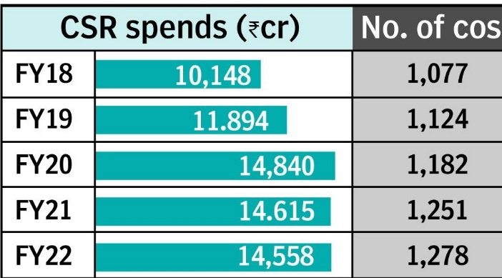

Examples of CSR in India :-
Tata group
Indian conglomerate Tata Group runs a range of CSR projects, mostly community improvement and poverty reduction programs. Through self-help groups, the company addresses women's empowerment, income generation, rural community development and other community service program activities. In the field of education, the Tata Group provides grants and donations to numerous institutions. Other areas include agricultural programs, environmental protection, provision of sports scholarships and economic empowerment through the development of infrastructure such as hospitals, research centers, educational institutions, sports academies and cultural centers.

Ultra Tech Cement
Ultra tech Cement, India's largest cement company, is engaged in social projects in 407 villages across the country with the aim of creating sustainability and self-reliance. His CSR activities focus on health and family welfare programs, education, infrastructure, environment, social care and sustainable living.
The company organizes medical camps, vaccination programs, disinfection programs, registration programs, plantation campaigns, water conservation programs, industrial training and organic farming programs.
Mahindra & Mahindra
Indian automaker Mahindra & Mahindra (M&M) founded his K.C. In 1954 the Mahindra Educational Trust was established, followed in 1969 by the Mahindra Foundation for the promotion of education. The company primarily focuses on educational programs to help economically and socially disadvantaged communities.
His CSR program at the company invests in scholarships and grants, livelihood training, remote healthcare, water conservation and disaster relief programs. M&M operates programs such as Nanhi Kali, which focuses on girls' education, Mahindra Pride School for industrial training, and Lifeline Express for medical services in remote areas.
ITC Group
The ITC Group, a conglomerate with operations in hotels, fast-moving consumer goods, agriculture, IT and packaging, has focused on creating sustainable livelihoods and environmental programs. Through its CSR activities, the company has been able to build sustainable livelihoods for 6 million people.
Their e-choupal program aims to connect rural farmers to source their produce via the internet, with 40,000 villages and her more than 4 million farmers participating. Its social forestry and agricultural forestry programs help farmers convert fallow land into pulp plantations. Social empowerment programs through micro-enterprises and loans create sustainable livelihoods for her more than 40,000 women in rural areas.

Figure:-2 List of Permitted Activities To Be Included in Accordance With Schedule VII of the Companies Act, 2013
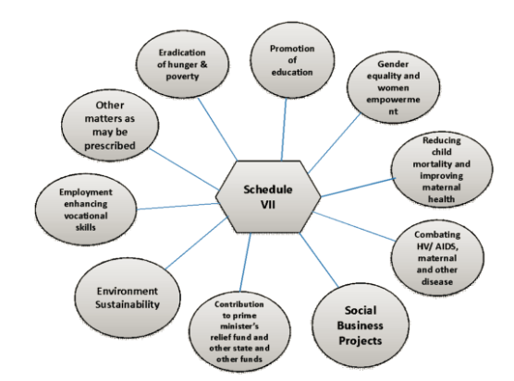
CSR activities:-
1 Contribute to Swach Bharat Kosh, established by the central government to eradicate poverty, hunger and malnutrition, promote health care including sanitation and preventive care, promote sanitation and provide safe drinking water.
2 Improving education, including special education and employment; strengthening vocational skills for children, women, the elderly and persons with disabilities; and livelihood improvement projects.
3. Take measures to improve gender equality, establish homes and hostels for women and orphans, nursing homes, day care centers and similar institutions for the elderly, and reduce inequalities between socially and economically disadvantaged groups.
4 Ensuring environmental sustainability, ecological balance, protection of flora and fauna, animal welfare, agroforestry, protection of natural resources, preservation of soil, air and water quality, including contribution to the revitalization of the Ganges.
5 Protection of national heritage, arts and culture, including the restoration of historically significant buildings, sites and works of art. Establishment of a public library. Promotion and development of traditional crafts.
6. Measures to Benefit National Armed Forces Veterans, War Widows and their Families, Central Armed Police Force (CAPF) and Central Para Military Forces (CPMF) Veterans and their Families, including Widows.
7 Training to promote rural sports, nationally recognized sports, Paralympic sports and Olympic sports.
8 Contributions to the Prime Minister's State Aid Fund, Prime Minister's State Aid Fund (PM-CARES) or other socio-economic development funds established by the Central Government to provide support and welfare to the nominee castes, nominees and underclasses, minorities and women.
9 Contributions to incubators or research and development projects in the fields of science, technology, engineering or medicine funded by central or state governments, public sector companies or agencies of central or state governments.
10 Donations to publicly funded universities established under the DAE, DBT, DST, Pharmacy, AYUSH Department, Department of Electronics and Information Technology, IIT, national laboratories, self-governing institutions, and organizations such as DRDO, ICAR, ICMR, CSIR that conduct research in science, technology, engineering and medicine ahead of the Sustainable Development Goals (SDGs).

11 Rural development projects.

12 Slum area development.
13 Disaster management, including relief, rehabilitation and reconstruction activities.
THE CSR ACTIVITIES SHALL BE UNDERTAKEN BY THE COMPANY, AS PER ITS STATED CSR POLICY:
(a) a company established under section 8 of the Act or a registered trust or a registered society, established by the company, either singly or along with any other company, or
(b) A company established under section 8 of the Act or a registered trust or a registered society, established by the Central Government or State Government or any entity established under an Act of Parliament or a State legislature.
(c) Company may also collaborate with other companies for undertaking projects or programs or CSR activities in such a manner that the CSR Committees of respective companies are in a position to report separately on such projects or programs in accordance with these rules.
(d) Companies may build CSR capacities of their own personnel as well as those of their Implementing agencies through Institutions with established track records of at least three financial years
FOLLOWING ACTIVITIES SHALL NOT BE CONSIDERED AS CSR ACTIVTIES:
a). Contribution of any amount directly or indirectly to any political party shall not be considered as CSR activity.
b). The CSR projects or programs or activities that benefit only the employees of the company and their families shall not be considered as CSR activities in accordance with section 135 of the Act.
Conclusion:-
CSR means that a company contributes to society. Company secretaries are expected to understand the legal and technical requirements related to CSR in order to guide management and the board of directors. Finally, globalization combined with economic reforms in the 1990s fundamentally changed India's view of CSR. Companies operating in India no longer approach his CSR only in limited ways through sporadic philanthropy. Now they are more involved in developing a stakeholder-oriented approach, and in addition to providing funding, they are also leveraging their core competencies to achieve their CSR goals. They recognize that the long-term success of a business depends on the satisfaction of many stakeholders in the community.
References:-
https://scholar.smu.edu/cgi/viewcontent.cgi?article=1317&context=til#:~:text=After%20a%20detailed%20analysis%2C%20the,sustainability%20in%20the%20world%20economy.
https://www.businessnewsdaily.com/4679-corporate-social-responsibility.html
https://www.managementstudyguide.com/corporate-social-responsibility.html
https://hbr.org/2015/01/the-truth-about-csr
https://www.bdc.ca/en/articles-tools/entrepreneur-toolkit/templates-business-guides/glossary/corporate-social-responsibility
https://www.frontiersin.org/articles/10.3389/fpsyg.2022.893193/full

