Hypervalent Iodine Reagents: Versatile Reagents in Synthetic Chemistry

Dr. Nitya Kaushik*
*Department of Chemistry
Mukand Lal National College
Yamuna Nagar, Haryana, India
*nityasharma@mlncollegeynr.ac.in
ABSTRACT

The plethora of reactions that may be carried out with organohypervalent iodine reagents in outstanding yield and selectivity has made them more desirable and adaptable organic synthesis reagents in recent years. Hypervalent iodine reagents in comparison with toxic heavy metal reagents are milder and having similar reactivity. Heterocyclic compounds are biologically active molecules and are generally used in the formation of, agrochemicals, drugs, polymeric materials and dyes. Organic chemists have been engaged in developing a number of newer reagents to synthesize such kind of heterocyclic compounds. Due to their low toxicity, simple handling, and generally benign nature, organohypervalent iodine compounds have garnered a great deal of interest for use in organic synthesis.
Keywords: Organohypervalent iodine reagents, heterocyclic compounds, iodobenzene diacetate, iodosylbenzene, dichloroiodobenzene, [hydroxy(tosyloxy)iodo] benzene.

- INTRODUCTION

These compounds are referred to as "hypervalent" because they contain donor atoms that have more valences than would be predicted by conventional theory. The strong electrophilic character of the iodine combined with the phenyliodonio group's tendency to leave groups make these chemicals more reactive to nucleophilic attack.
Our and other research groups' numerous beneficial oxidative changes using iodine(III) have demonstrated that [hydroxy(tosyloxy)iodo] benzene (HTIB; Koser’s reagent), dichloroiodobenzene (PhICl₂), iodobenzene diacetate (IBD), iodosylbenzene (PhIO)_{n}, 2-iodoxy-benzoic acid (IBX) etc. discover motivating uses for the production of heterocyclic compounds.

Numerous studies have shown that the oxidizing nature of organic iodine reagents is their most crucial characteristic. In the synthesis of numerous selective oxidative transformations of many complicated chemical molecules, these reagents are now often utilized. Organohypervaleniodine reagents have grown significantly over the past several decades in synthetic organic chemistry. Despite the fact that the topic has been extensively covered in the literature through numerous review articles ^{[1-6]} and books ^{[7]}, there is a rising need to investigate fresh uses for these reagents. These substances have been employed to perform a wide range of organic transformations, including oxidative cyclizations, oxidative coupling, oxidative rearrangements, and alpha functionalization of carbonyl compounds. Iodine(III)-mediated oxidative approach from several sources results in several beneficial changes.
Here, synthetic utility of hypervalent iodine reagents particularly, HTIB and iodosobenzene (IB) has been described.

Heterocyclic compounds are considered one of the most important and extensively studied divisions of organic chemistry. Theses play a crucial role in medicinal chemistry and are of great interest to researchers in the pharmaceutical industry. The increasing research interest in heterocycles can be attributed to their wide range of properties and potential applications. ^{[8, 9]}
This chapter has been structured in various segments according to the types of the heterocyclic compounds.

II. SYNTHESIS OF HETEROCYCLIC COMPOUNDS
A. Sythesis of oxazoles

Nachtsheim and Hempel developed an effective way to make oxazoles through oxidative cyclization by treating N-styrylbenzamides with [bis(trifluoroacetoxy)iodo]benzene and TMSOTf (Scheme 1). ^{[10]} Similar to this, Boto and colleagues reported on the one-pot synthesis of oxazoles from N-acylamino acids (Scheme 1). ^{[11]}
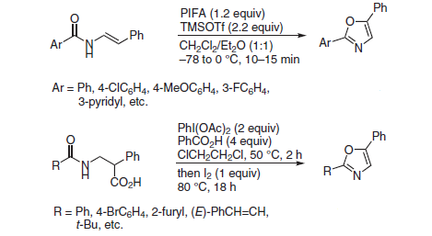
Scheme 1

Treatment of 3-hydroxybut-2-enimidates with IBD in the presence of benzotriazole (BTA) led to the production of the rearranged 2,4,5-trisubstituted oxazoles (Scheme 2). ^{[12]}
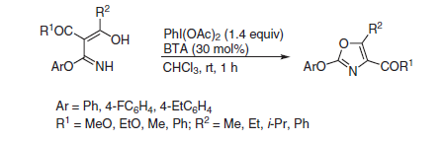
Scheme 2

Oxazoles have just recently been synthesized by irradiating arylimidates with IBD and CsI (Scheme 3). ^{[13]}
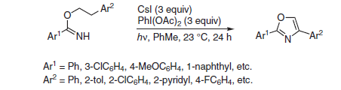
Scheme 3

B. Synthesis of isoxazoles
The synthesis of 3,5-disubstituted isoxazoles has been said to be possible using nitrile oxide and alkynyliodonium salts (Scheme 4) ^{[14]}
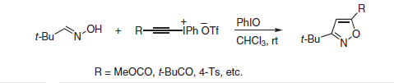
Scheme 4

3,4-disubstituted isoxazoles are synthesized by the regioselective cycloaddition reaction of aldoximes with enaminones and HTIB (Scheme 5). ^{[15]}
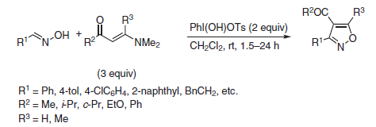
Scheme 5

C. Synthesis of fused 1,2,4-triazolopyridines
Triazolopyridines were produced through the oxidation of 2-pyridylhydrazones in CH₂Cl₂ by PhI(OAc)₂ (Scheme 6) ^{[16]}
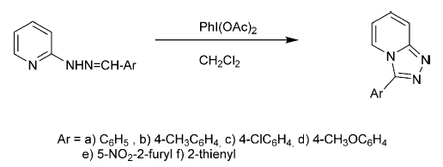
Scheme 6

D. Synthesis of fused benzo-oxazolo-triazoles
IBD-mediated production of benzo[4,5]oxazolo[2,3-c][1,2,4]triazoles has been demonstrated by Demmer and co-workers (Scheme 7). ^{[17]}
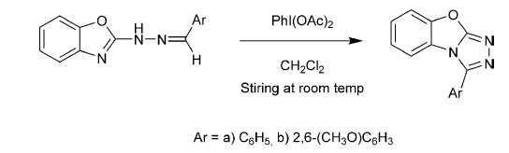
Scheme 7

E. Synthesis of fused thiazolotriazoles

Hydrazones have been subjected to oxidative cyclization with the help of IBD to produce thiazolotriazoles (Scheme 8). ^{[18]}
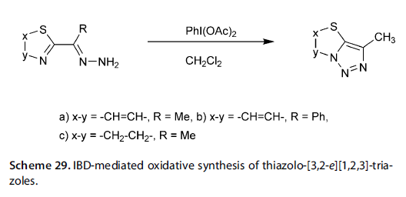
Scheme 8

F. Synthesis of fused triazolopyrazines

Demmer et al. have described the production of 3-Aryl/heteroaryl-[1,2,4]-triazolo[4,3-a]pyrazines from 2-chloro-3-hydrazinylpyrazine via IBD (Scheme 9). ^{[19]}
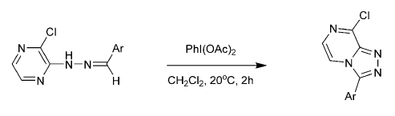
Scheme 9

G. C–H alkynylation of indoles and pyrroles

By utilizing the TIPS-EBX, Brand et al. described the gold-catalyzed direct alkynylation of pyrroles and indoles (Scheme 10). ^{[20]}
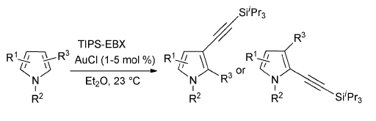
Scheme 10

H. Synthesis of Azirines

Utilizing innovative hypervalent iodine(III/V), Zhang and colleagues demonstrated the effective synthesis of 2-unsubstituted 2H-azirines by intramolecular oxidative azirination (Scheme 11). ^{[21]}
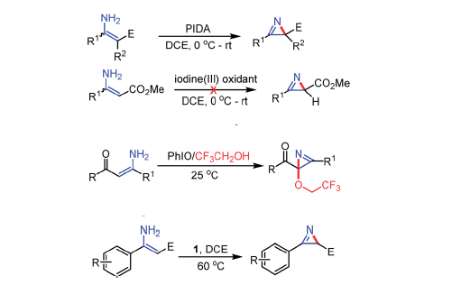
Scheme 11

I. Synthesis of flavonoids

Kumar and coworkers created 2,3-dimethoxy-3-hydroxyflavanones by oxidizing several flavonol derivatives with polymer-supported HTIB (Scheme 12). ^{[22]}
Scheme 12

IBD caused the synthesis of 2,3-dimethoxy-3-hydroxy-2-(1-phenyl-3-aryl-4-pyrazolyl)chromanones when it was applied to 3-hydroxy-2-(1-phenyl-3-aryl-4-pyrazolyl)chromones (Scheme 13). ^{[23]}
Scheme 13

Ganguly et al. have described a one-pot procedure for producing 3',5'-diiodoflavone by iodinating the o-hydroxychalcone by using PhI(OAc)₂ (Scheme 14). ^{[24]}

Scheme 14

According to a recent study by Muthukrishnan et al., the oxidation of flavanones with HTIB in the presence of ionic liquid ([bbim]⁺Br⁻) produced flavones (Scheme 15). ^{[25]}
Scheme 15

Juhasz and colleagues described how to create methyl 2-aryl-2,3-dihydrobenzofuran-3-carboxylates by employing IBD to carry out the reaction of racemic and chiral (laevorotatory) flavanone (Scheme 16). ^{[26]}
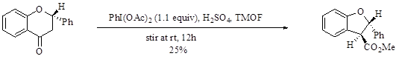
Scheme 16

The oxidative cyclization and rearrangement of DHA happens directly from its chalcone counterparts (Scheme 17). ^{[27]}
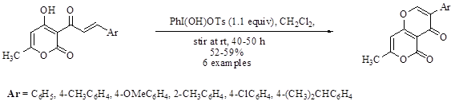
Scheme 17

From o-benzoyloxychalcones synthesis of isoflavones by using HTIB (Scheme 18). ^{[28]}

Scheme 18

Recently, Zou and coworkers reported the first total synthesis of C-glycoside, 6-tert-butylpuerarin (isoflavone), by oxidative cyclization and rearrangement of C-glucosylchalcone with IBD and p-toluenesulfonic acid (Scheme19). ^{[29]}

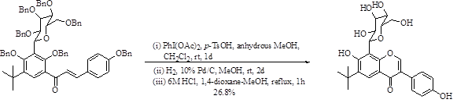Scheme 19

III. CONCLUSION

The substantial group of heterocycles addressed in this chapter has recently attracted the attention of many medicinal, biological, and pharmacological chemists. The majority of heterocycles have bioactive properties that have ushered in a new era of therapeutic medicines for conditions like leprosy, cancer, hypertension, allergies, inflammatory diseases, fungal infections, and bacterial infections.

This chapter has described the useful and effective abilities of hypervalent iodine reagents in this area through the synthesis of heterocyclic compounds using organohypervalent iodine. In the coming years, there will be major research effort on the synthesis of heterocyclic compounds utilizing hypervalent iodine reagents to examine the significance of heterocycles in a variety of domains, including pharmaceutical chemistry, biochemistry, and others. It is anticipated that this coverage will lead to further substantial research in this area.

REFERENCES

[1] G. Grelier, B. Darses and P. Dauban, “Hypervalent organoiodine compounds: from reagents to valuable building blocks in synthesis,” Beilstein J. Org. Chem., 2018, 14, pp. 1508–1528.
[2] V. V. Zhdankin, “Hypervalent iodine compounds: reagents of the future” Arkivoc, 2020.
[3] S. R. Kandimalla, S. P. Parvathaneni, G. Sabitha and B. V. Subba Reddy, “Recent Advances in Intramolecular Metal-Free Oxidative C-H Bond Aminations using Hypervalent Iodine(III) Reagents.” European Journal of Organic Chemistry, 2019, pp. 1687-1714.
[4] R. Kumar, N. Sharma and O. Prakash, “Hypervalent Iodine Reagents in the Synthesis of Flavonoids and Related Compounds” Current Organic Chemistry, 2020, 24, pp. 2031-2047.
[5] Z. S. Zheng, D. Zhang-Negrerie, Y. F. Du and K. Zhao Kang, “The applications of hypervalent iodine(III) reagents in the constructions of heterocyclic compounds through oxidative coupling reactions”, Science China Chemistry, 2014, pp. 189–214
[6] J. Sun, D. Zhang-Negrerie and Y. D. K. Zhao, “Hypervalent reagents for heterocycle synthesis and functionalization” Reports in Organic Chemistry, 2016, pp.25–45.
[7] R. M. Moriarty and O. Prakash, “Hypervalent Iodine in Organic Chemistry: Chemical Transformations”, Wiley-Interscience 2008.
[8] W. Bawazir, “A Mini review on 5-Amino-N-substituted pyrazoles as building blocks for bioactive molecules,” International Journal of Organic Chemistry, 2020, pp. 63-76.
[9] E. Kabir and M. Uzzaman, “A review on biological and medicinal impact of heterocyclic compounds”, Results in Chemistry, 2022, pp. 1-11.
[10] C. Hempel and B. J. Nachtsheim. "Iodine (III)-promoted synthesis of oxazoles through oxidative cyclization of N-styrylbenzamides", Synlett, 2013, pp. 2119-2123
[11] I. Romero-Estudillo, V. R. Batchu, A. Boto, "One‐Pot Conversion of Amino Acids into 2, 5‐Disubstituted Oxazoles: No Metals Needed" Advanced Synthesis & Catalysis, 2014, pp. 3742-3748.
[12] Q. Liu, X. Zhang, Y. He, M. I. Hussain, W. Hu, Y. Xiong and X. Zhu "Oxidative rearrangement strategy for synthesis of 2, 4, 5-trisubstituted oxazoles utilizing hypervalent iodine reagent", Tetrahedron, 2016, pp. 5749-5753.
[13] A. D. Chen, J. H. Herbort, E. A. Wappes, K. M. Nakafuku, D.N. Mustafa, and D.A. Nagib, “Radical cascade synthesis of azoles via tandem hydrogen atom transfer” Chemical Science, 2020, pp.2479-2486.
[14] P. J. Stang, and P. Murch, "[3+ 2]-Cycloaddition reactions of alkynyl (phenyl) iodonium triflates with ethyl diazoacetate, Nt-butyl-α-phenyl nitrone and t-butylnitrileoxide as 1, 3-dipoles." Tetrahedron letters, 1997, pp. 8793-8794.
[15] A. Yoshimura, M. E. Jarvi, M. T. Shea, C. L. Makitalo, G. T. Rohde, M. S. Yusubov, A. Saito and V. V. Zhdankin, "Hypervalent Iodine (III) reagent mediated regioselective cycloaddition of aldoximes with enaminones." European Journal of Organic Chemistry, 2019, pp. 6682-6689.
[16] A. K. Sadana, Y. Mirza, K. R. Aneja and O. Prakash, "Hypervalent iodine mediated synthesis of 1-aryl/hetryl-1, 2, 4-triazolo [4, 3-a] pyridines and 1-aryl/hetryl 5-methyl-1, 2, 4-triazolo [4, 3-a] quinolines as antibacterial agents." European journal of medicinal chemistry, 2003, pp. 533-536.
[17] C. S. Demmer, M. Jorgensen, J. Kehler and L. Bunch, "Study of Oxidative Cyclization Using PhI (OAc)₂ in the Formation of benzo [4, 5] thiazolo [2, 3-c][1, 2, 4] Triazoles and Related Heterocycles–Scope and Limitations." Synlett, 2014, pp. 1279-1282.
[18] O. Prakash, H. K. Gujral, N. Rani and S. P. Singh, “Hypervalent iodine oxidation of hydrazones of some nitrogen heterocyclic ketones and aldehydes: an efficient synthesis of fused 1, 2, 3-triazoloheterocycles,” Synthetic Communications, 2000, pp. 417-425.
[19] C. S. Demmer, M. Jorgensen, J. Kehler, L. Bunch and L. K. Rasmussen, “Synthesis and Selective Functionalization of [1, 2, 4] Triazolo-[4, 3-a] pyrazines,” Synlett, 2015, pp.519-524.
[20] J. P. Brand, J. Charpentier and J. Waser, “Direct alkynylation of indole and pyrrole heterocycles,” Angewandte Chemie International Edition, 2009, pp. 9346-9349.
[21] G. Zhang, Y. Wang, J. Xu, J. Sun, F. Sun, Y. Zhang, C. Zhang and Y. Du, “A new hypervalent iodine (III/V) oxidant and its application to the synthesis of 2 H-azirines,” Chemical Science, 2020, pp. 947-953.
[22] D. Kumar, and S. Kumar, “Oxidation of 3-Hydroxyflavanones using Polymer-Supported [Hydroxy(tosyloxy)iodo] benzene” Asian Journal of Chemistry, 2007, pp. 2857-2860.
[23] O. Prakash, R. Kumar, and R. Sehrawat, “Synthesis and antibacterial activity of some new2,3-dimethoxy-3-hydroxy-2-(1-phenyl-3-aryl-4-pyrazolyl)chromanones,” European journal of medicinal chemistry, 2009, pp. 1763-1767.
[24] N. C. Ganguly, S. Chandra and S. K. Barik, “Sodium perborate tetrahydrate–mediated transformations of 2′-hydroxychalcones to flavanones, flavones, and 3′, 5′-diiodoflavone under mild, environmentally friendly conditions”, Synthetic Communications, 2013, pp. 1351-1361.
[25] M. Muthukrishnan, P. S. Patil, S.V. More and R. A. Joshi, “Facile oxidation of flavanones to flavones using [hydroxy (tosyloxy) iodo] benzene in an ionic liquid,” Mendeleev Communications, 2005, pp. 100-101.
[26] L. Juhasz, L. Szilagyi, S. Antus, J. Visy, F. Zsila, and M. Simonyi, “New insight into the mechanism of hypervalent iodine oxidation of flavanones,” Tetrahedron, 2002, pp. 4261-4265.
[27] O. Prakash, A. Kumar, A. K. Sadana,and S. P. Singh, “A novel synthesis of new 3-aryl-7-methylpyrano [4, 3-b] pyran-4H, 5H-diones using hypervalent iodine (III) reagents,” Synthesis, 2006, pp. 21-23.
[28] N. Sharma, “Organohypervalent iodine reagents in organic synthesis” Ph.D. Thesis, 2013, Kurukshetra University, Kurukshetra.
[29] Y. Zou, S. Zhang, G. Wang, X. Wen, S. Liu, T. Peng, Y. Gao and L. Wang, “Total synthesis of an isoflavone C-glycoside: 6-tert-butylpuerarin”, Journal of Carbohydrate Chemistry, 2016, pp. 387-395.

