AI-Powered Teacher Assistant for Student Problem Behaviors'
Contents
1. Introduction
2. Theoretical Framework for System Design
2.1 Need Deficiency
2.2 Problem Behavior
2.3 External Environmental Factors
2.4 Individual Factors
3. System Design
3.1 Diagnose Module
3.2 Question Answering Module
3.3 Case search Module
4. Discussion and Conclusion
References

- Introduction

Pupil hassle behavior has been considered for many years of studies subject matter with the aim of how to assist college students with their undesirable conduct and actions (Jessor 2016). College students’ problems cause issues in schools and require assistance and guidance from instructors. In this chapter, we present how synthetic intelligence (AI) technology can be hired to assist teachers diagnose college students’ trouble behaviors. The Project-oriented talk gadget era is applied to develop an AI-powered assistant for hassle-conduct prognosis. Task-oriented talk systems have been broadly followed in many other fields, along with price ticket reserving (Li et al. 2017), eating place looking (Wen et al. 2016), and online purchasing (Yan et al. 2017). Moreover, the talk system has been used for the computerized prognosis of disorders in the clinical area properly.

Stimulated by the huge utilization of the assignment-oriented speak system in other fields, we layout and develop an undertaking-oriented communication device for the automatic identification of students’ want deficiencies and goals helping teachers to handle scholarly problem behaviors. Maslow (1943) states that human beings’ behaviors are pushed by means of their mental wishes, and for this reason, the hassle behaviors are regularly because of unfulfilled mental needs, which might be termed as need deficiencies. The students’ hassle behaviors thus can be treated by means of identifying their need deficiencies (Harper et al. 2003), timely diagnosing the reasons at the back of them, and engaging in essential interventions. The device layout is primarily based on a theoretical framework that summarizes the applicable psychology locating for student want deficiency and utilizes herbal language processing strategies to enable the natural communique between teachers and the system.

- Theoretical Framework for System Design

Research had been carried out to research the causes underlying students’ trouble behaviors. Consistent with the classical theory of Maslow (1943), human beings’ behaviors are driven with the aid of mental needs, which means need deficiencies are the motives for trouble behaviors. Jessor (2014) finds that students’ behaviors are motivated by the interactions between students’ character systems and their perceived surroundings systems. Harper and Stone (2003) display that the students’ psychological wishes may be laid low with various factors like herbal screw-ups, violence, abuse, poverty, loss of school and network resources, and emotional deprivation. Dennis et al. (2005) unearths that the interplay between character traits and environmental factors influences scholarly development.

Fig 1: Theoretical Framework for System Design

Those studies’ findings are informative and beneficial however are too scattered for systematic packages. Subsequently, a theoretical framework summarizing all the applicable factors is important, and the designed system explicitly considers distinction instructions of need deficiencies, hassle behaviors, and external environmental factors, in addition to personal factors.

2.1 Need Deficiency

Fig 2: Classification of Student basic needs

We define and classify college students’ need deficiency into five categories: physiological desires, protection desires, belongingness and love want, esteem desires, and cognitive desires. The listing of the category of college students’ simple desires is summarized in Fig 2.
2.2 Hassle Behavior
Problem behaviors are categorized into 3 categories: externalization troubles, internalization troubles, and other troubles.
Table 1: Classification of Student Problem Behavior
Problem Behaviors | Category | Specific factor
 | Externalization problems | Aggressive behavior, rule-breaking behavior
 | Internalization problems | Social withdrawal, depression, anxiety
 | Other problems | Learning problem, Egocentricity, special problem

2.3 External Environmental Elements
External environmental factors particularly refer to elements that have an effect on students’ boom and therefore notably affect the formation of trouble behavior.
Table 2: Classification of External Environmental factors
External environmental factors | Category | Specific factor
 | Family factors | Family structure, parenting style, education background, health condition, delinquent behaviors, socioeconomic status
 | School factors | Teacher leadership style, peer acceptance, peer influence
 | Society factors | Mass media, cultural custom

2.4 Character Factors
External environmental factors particularly talk to elements that affect students’ increase and consequently notably have an effect on the formation of trouble behavior.
Table 3: Classification of individual factors
Individual factors | Category | Specific factor
 | Demographic information | Grade, gender, health condition, social group
 | Personality | Neuroticism, extraversion, openness, agreeableness, conscientiousness

3. System Design
Our talk help machine includes 3 main modules, particularly, the prognosis module, the query-answering module, and the case seek module. we are able to tricky on them in this section, respectively.

Fig 3: Classification of System Design

3.1 Diagnosis Module
This module adopts the generation of an undertaking-oriented communication system for behavior analysis. The mission-oriented communication system is designed to finish a particular mission via herbal language interaction with customers (Gao et al. 2019). The diagnosis procedure considers both outside environmental elements and character elements.
Table 4: Uses of Dialogue System
Dialogue System | Movie-ticket booking
 | Help users search and reserve restaurants
 | Solve information-searching tasks
 | Automatic diagnosis of medical disease

As shown in Fig. 4, it consists of four main functional components:
  - Natural language understanding,
  - Dialogue state tracking,
  - Dialogue policy learning, and
  - Natural language generation.

The herbal language understanding component translates the instructor’s utterance to extract the motive as well as mission-related semantic records. Especially, strategies in a teacher’s response to extract the student’s records, together with whether or not he has competitive behaviors. On this trainer’s assistant, the long short-term memory (LSTM) (Hochreiter and Schmidhuber 1997) network is followed to interpret the teacher’s utterances. An LSTM community is a typical recurrent neural network that has been broadly utilized in natural language processing currently. The talk nation monitoring component tracks the communicate country that represents all of the undertaking-related statistics captured. This speak kingdom represents college students’ records obtained to that point and is utilized to determine the next machine action. In particular, this module updates the talk country with any other LSTM community based totally on the output of the natural language understanding element.
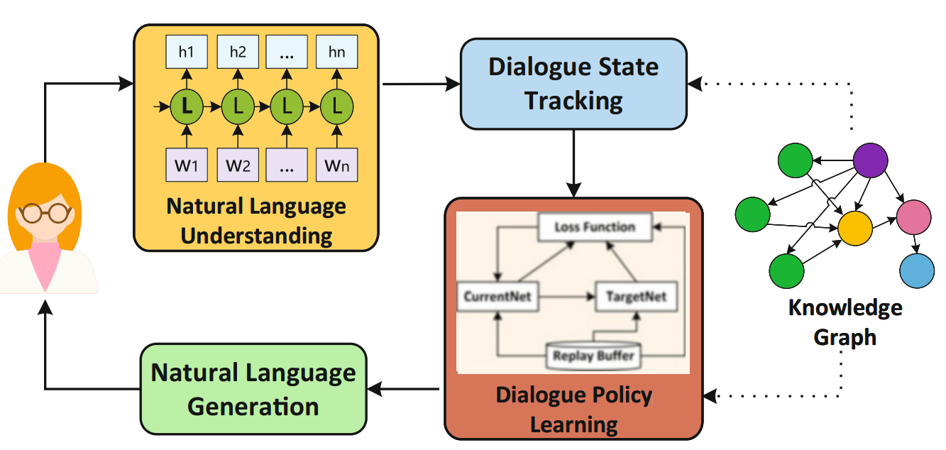
Fig 4. Diagnosis module for analyzing student problem behavior

The dialogue coverage getting to know module takes the rate of making choices on the next system motion primarily based on the current talk kingdom, which includes inquiring for records or informing sure consequences. Based on the present-day communication country, we adopt a reinforcement studying model, especially a deep Q-learning network (DQN) model (Mnih et al. 2015), to learn the communication policy that makes a decision whether to request more statistics from the instructor or give the derived need deficiency to the instructor. The DQN is an average deep reinforcement getting-to-know model that makes use of a deep neural network to calculate the Q-value within the model. In the end, the herbal language era aspect makes use of a template-based model to transform system motion into text reaction.

3.2 Question Answering Module
Not like the prognosis module that objectives reading the problem behaviors for the unique pupil, this module pursuits to provide widespread recommendations on typical trouble behaviors by using answering questions like “What are the standard trouble behaviors for high faculty ladies?”. The community query answering (CQA) generation is employed to answer such questions. CQA is an internet-based totally provider to help humans who are looking for facts by means of answering their questions based on know-how shared by others inside the community (Srba and Bielikova 2016). Unlike the prognosis module that targets analyzing the trouble behaviors for the unique scholar, this module objectives to offer standard recommendations on typical hassle behaviors by answering questions like “What are the standard hassle behaviors for excessive college women?” The community question answering (CQA) era is hired to reply such questions. CQA is an internet-based totally provider to assist humans seek facts by means of answering their questions based totally on understanding shared with the aid of others inside the community (Srba and Bielikova 2016). CQA machine aims to pick out the maximum suitable answer from more than one answer to the given question and normally includes two most important obligations: locating the same questions and locating the relevant solutions (Joty et al. 2018). Conventional technique makes a specialty of the syntactic analysis of the textual content of questions and answers. For instance, Cui et al. (2005) proposed a widespread tree-based total method calculating tree-edit distance to suit questions and solutions. these days, with the improvement of deep gaining knowledge of, diverse deep neural community fashions have been proposed. As an example, Zhou et al. (2018) propose a recurrent convolutional neural community (RCNN) to capture each semantic matching between question and solution and the semantic correlations embedded inside the collection of solutions. For this reason, we're inspired to expand our CQA model with deep mastering algorithms. The shape of the designed CQA model is illustrated in Fig. 5. Specifically, the version offers phase processing. The first one is the query selection section aiming to locate the candidate questions much like the incoming question. The second one is the answer selection segment which ranks all the answers to the candidate questions generated by means of phase I and then selects the maximum suitable solution as output.

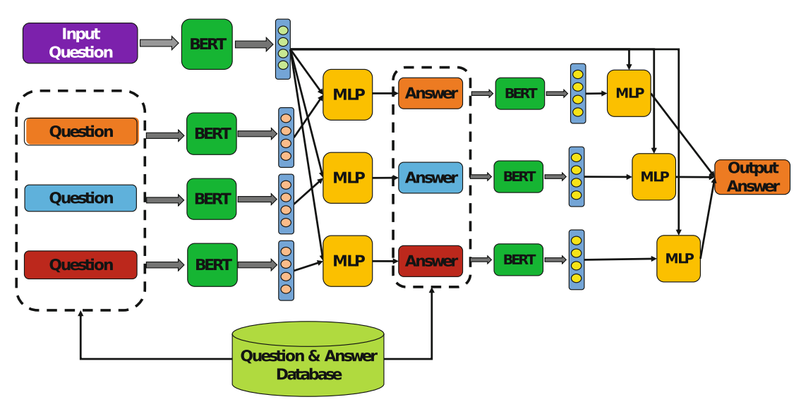
Fig 5: The CQA model used in question answering module
The first phase identifies the candidate questions similar to the incoming query from the present ones. We used the pre-trained BERT (Devlin et al. 2018) version for herbal language processing to investigate the semantics of questions and solutions. It first learns the semantic vectors of the prevailing questions and creates a database for all the query semantic vectors. Every time a brand-new incoming question arrives, the equal BERT framework is followed to study its semantic vector. Sooner or later, the version is exceptional-tuned by way of a multilayer perceptron (MLP) network to compute the similarity among incoming questions and each existing query. Consequently, it computes a similarity value for each current question. With a predefined similarity threshold value, a hard and fast of comparable questions are decided on as applicants.
The second phase then begins to become aware of the most suitable solution. Firstly, a set of candidate answers is generated based totally on the first-class solution of each candidate question inside the first phase. Secondly, the semantic vector of every candidate solution is found through the use of the BERT framework like the first segment. Thirdly, through concatenating the query vector and answer vector, an MLP community is hired to quality-tune the model to compute the matching degree between a question and a solution. Subsequently, the candidate questions are ranked in steps with the multiplication of question similarity and answer matching stage, and the one with the biggest calculated value is chosen because of the very last output.

3.3 Case Search Module
This module evolved with the era of information retrieval. As an average herbal language processing mission, statistics retrieval targets to find the carefully associated information in keeping with consumer necessities. It explores the way to represent, save, prepare, and get admission to records nicely for information searching (Chowdhury 2010). Numerous models have been proposed for behavior information retrieval. This module makes use of a deep natural language processing model to compute the similarity between the instructor’s textual content description and case files. Unlike the semantic similarity calculation in the query answering module targeting computing similarity between sentences, this situation engine computes the similarity among two one-of-a-kind files inside the shape of a series of sentences. As illustrated in Fig. 6, a hierarchical BERT version is designed and implemented to compute the semantic similarity between the instructor’s text description and every case file.

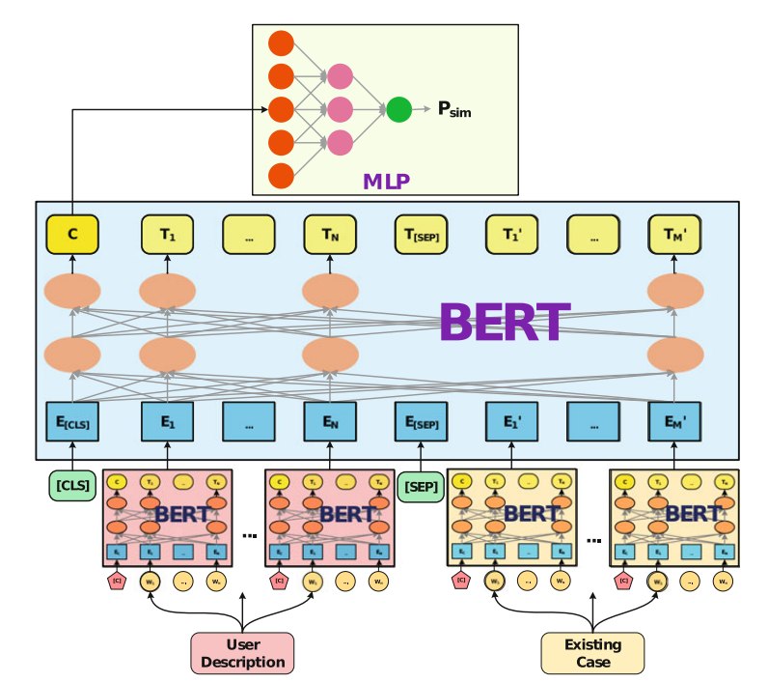
Fig. 4 The hierarchical BERT model used in the case search module
In this mode, the lowest layer especially learns the semantic vector of each sentence in teachers’ text descriptions and case files. Mainly, parameters of the pre-trained BERT model are adopted directly for this backside layer BERT. The top layer objectives on gaining knowledge of the semantic similarity among the instructor’s textual content description and every case document. By way of taking the semantic vectors of sentences generated with the backside BERT layer as input, we upload inside the unique token “[CLS]” at the start and “[SEP]” inside the center to concatenate the 2 sequences into one series. Eventually, the model can technique it like an ordinary sequence, and generate a semantic similarity vector at the start role. After generating the semantic similarity vector, one MLP community model is hired to compute the similarity between the instructor’s textual content description and the case document. Just like the query answering module, all cases are ranked in step with the computed semantic similarity after which return returned to the instructor.

4. Discussion and Conclusion
The main concept of present-day AI algorithms is the mixture of the data-pushed paradigm with the expertise-driven paradigms. Primarily based on the understanding-pushed paradigm, the ideas and theories in psychological studies are employed to build the theoretical framework, which publications the machines to remedy the focused pupil conduct problem in a theoretical manner. By means of leveraging the information-driven paradigm, the wealthy and valuable instructor reports embedded in the text records may be extracted and utilized. The mixing of those two paradigms provides the answer, and its ambitions to make certain the reliability and validity of the developed trainer assistant for pupil hassle behaviors. Especially, the system can examine college students’ need deficiencies behind their hassle behaviors and perceive the corresponding outside environmental and character elements that end result in the deficiencies. It also allows teachers to find solutions or similar resolved instances in many usual scholarly problem behaviors. By taking these solutions and instances as references, teachers can learn how to help their college students. The machine interacts with instructors through herbal language, which substantially improves its usability as properly.

References
- Achenbach, T. M., & Rescorla, L. A. (2014). The Achenbach system of empirically based assessment (ASEBA) for ages 1.5 to 18 years. In The use of psychological testing for treatment planning and outcomes assessment, 179-214, Routledge.
- Chen, P., Lu, Y., Peng, Y., Liu, J., & Xu, Q. (2020). Identification of Students’ Need Deficiency Through a Dialogue System. International Conference on Artificial Intelligence in Education, 59-63. https://doi.org/10.1007/978-3-030-52240-7_11
- Chen, P., Lu, Y., Yu, S., Xu, Q., Liu, J. (2021). A dialogue system for identifying need deficiencies in moral education. Journal of Pacific Rim Psychology, 15. https://doi.org/10.1177/ 1834490921998589
- Chowdhury, G. G. (2010). Introduction to modern information retrieval. Facet publishing.
- Cui, H., Sun, R., Li, K., Kan, M. Y., Chua, T. S. (2005). Question answering passage retrieval using dependency relations. The 28th ACM SIGIR Conference on Research and Development in Information Retrieval, 400-407. https://doi.org/10.1145/1076034.1076103
- Dake, J. A., Price, J. H., & Telljohann, S. K. (2003). The nature and extent of bullying at school. Journal of School Health, 73, 173-80. https://doi.org/10.1111/j.1746-1561.2003.tb03599.x
- Devlin, J., Chang, M. W., Lee, K., Toutanova, K. (2018). Bert: Pre-training of deep bidirectional transformers for language understanding. arXiv preprint arXiv:1810.04805.
- Dennis, J. M., Phinney, J. S., & Chuateco, L. I. (2005). The role of motivation, parental support, and peer support in the academic success of ethnic minority first-generation college students. Journal of College Student Development, 46(3), 223-236. https://doi.org/10.1353/ csd.2005.0023
- Fomby, P., & Christie, A. S. (2013). Family structure instability and mobility: The consequences for adolescents’ problem behavior. Social Science Research, 42(1), 186-201. https://doi.org/ 10.1016/j.ssresearch.2012.08.016
- Gao, J., Galley, M., & Li, L. (2019). Neural Approaches to Conversational AI: Question Answering, Task-oriented Dialogues and Social Chatbots. Now Foundations and Trends. https:/ /doi.org/10.1561/1500000074
- Harper, F. D., Harper, J. A., & Stills, A. B. (2003). Counseling children in crisis based on Maslow’s hierarchy of basic needs. International Journal for the Advancement of Counselling, 25(1), 11- 25. https://doi.org/10.1023/A:1024972027124
- Harper, F. D., & Stone, W. O. (2003). Transcendent counseling: An existential, cognitivebehavioral theory. Culture and counseling: New approaches, 233-251.
- Hochreiter, S., & Schmidhuber, J. (1997). Long short-term memory. Neural computation, 9(8), 1735-1780. https://doi.org/10.1162/neco.1997.9.8.1735
- Hoffmann, J. P. (2006). Family structure, community context, and adolescent problem behaviors. Journal of Youth and Adolescence, 35(6), 867-880. https://doi.org/10.1007/s10964-006-9078-x
- Jessor, R. (2014). Problem Behavior Theory: A half century of research on adolescent behavior and development. In R. M. Lerner, A. C. Petersen, R. K. Silbereisen, & J. Brooks-Gunn (Eds.), The Developmental Science of Adolescence: History Through Autobiography, 239-256. Psychology Press.
- Jessor, R. (2016). The origins and development of problem behavior theory. Advancing Responsible Adolescent Development.https://doi.org/10.1007/978-3-319-40886-6.

