Effects of Surkhi on GSB Layer of Flexible Pavement

Rupjyoti Bordoloi¹ Rhitwika Barman² Gitartha Kalita^{3*}
¹Assistant Professor, ²Assistant Professor, ³Assistant Professor,
Assam Engineering College, Assam Engineering College, Assam Don Bosco University,
Guwahati-13, Assam, India Guwahati-13, Assam, India Guwahati-781017, Assam, India
*Corresponding Author *gitartha.kalita@dbuniversity.ac.in,
*+919707488554

ABSTRACT

With the increasing demand of materials for road construction, the need has arisen to explore various alternatives to the conventional materials. Surkhi is a form of brick dust and has been collected from local brick kilns at nominal cost. The study tries to investigate whether locally available Surkhi can be used in road construction in the granular sub base (GSB) layer or not. The study has been conducted on four types of GSB trial mixes formed by partially and completely replacing the stone dust content with that of Surkhi. The proportion of Surkhi varies from 0 to 25% by weight of total mix in these GSB mixes. The study evaluates gradation and plasticity of fine aggregates used and OMC, MDD and CBR of various GSB mixes. The MDD is found to increase with increase in proportion of surkhi from 0 to 10% after which it decreases. The maximum MDD is found to be for GSB mix with 10% surkhi and 15% stone dust. The findings of the test results of the four GSB mixes indicate that they meet the requirements of MORTH in terms of gradation, CBR, and plasticity. Therefore, these combinations are suitable for utilization in the GSB construction of road works. The incorporation of locally available Surkhi in the construction of GSB layer of flexible pavement not only leads to cost-effectiveness in road projects but also reduces environmental degradation by decreasing mining pollution and energy consumption in the quarrying of sand/stone dust.

Key words: Optimum Moisture Content, Maximum Dry Density, CBR, GSB

- INTRODUCTION

In the case of a flexible pavement, a layer of granular sub-base is implemented between the sub-grade and the granular base course. When the base course thickness surpasses the standard due to an inadequate sub-grade, it is bifurcated into two layers: granular base course and GSB. The material utilized to fabricate the GSB layer is of inferior quality compared to that employed in constructing the granular base course, thus the implementation of the GSB layer results in cost savings during road construction. Additionally, this layer performs an essential role in serving as a drainage layer for the pavement, preventing excessive saturation and sub-grade deterioration. In terms of strength, it surpasses that of the sub-grade. The sub-base course is constructed using a variety of materials and methodologies. The utilization of available local and industrial waste materials in the construction of low-volume roads, such as rural pavements, has been highlighted by the Ministry of Road Transport and Highways (MORT&H) and the National Rural Roads Development Agency (NRRDA). This approach effectively addresses the issue of disposing of large quantities of industrial waste.

One such locally available waste material is Surkhi, which is essentially brick dust from the brick kiln industry. It can be utilized as Granular Sub Base (GSB) material, replacing sand. India's brick sector is the second largest in the world, producing approximately 54% of the world's annual brick production with an annual growth rate of 10%, just behind China. The sector is continuously expanding due to the growing demand for bricks in the construction industry. In India, the brick industry employs approximately 9 to 10 million workers, many of whom lack sufficient skill. Despite having over 50% more brick units than China, India produces only 27% of the bricks produced by China due to inadequate organization, massive size, lack of technology, poor quality control, and untrained labor. These factors contribute to reduced brick production, high fuel consumption, and the generation of significant amounts of waste in the form of broken, deformed, over-burnt, or dusty bricks, as well as fly ash or coal ash, depending on the fuel used. Numerous studies have demonstrated the recycling value of fly ash or coal ash, which is utilized in various construction activities. The residual waste produced by brick kilns is often utilized for purposes of land filling or road side dumping, resulting in a detrimental impact on the environment. The brick industry bears responsibility for not only contaminating the surface of the earth but also exacerbating air pollution, thereby raising environmental concerns. In light of these concerns, it is imperative to implement effective waste management. This study aims to explore the potential for Surkhi to be utilized as GSB material in a manner that is both efficient and effective.

- Aim of the Study: The goal of the present investigation is to determine the suitability of brick dust on the GSB layer over stone dust.

- Objectives:

- The primary aim of the current investigation is to fabricate GSB blends employing Brick Dust, both with or without stone dust. Within the scope of this inquiry, stone dust shall be substituted by Brick Dust, in percentages of 0%, 10%, 15%, and 25%.
- The GSB blends, which contain different ratios of Surkhi, undergo testing for the CBR at the highest degree of dry density and optimal moisture content. This assessment serves to assess the efficacy of Surkhi and subsequently aid in the conservation of sand for other construction purposes. Additionally, it helps to minimize the waste produced by brick kilns, while promoting efficiency in road construction and reducing environmental pollution. This study thus seeks to achieve a dual objective of enhancing economic viability and environmental sustainability.
- In GSB blends, materials such as natural sand, stone dust, moorum, gravel, crushed stone, or a combination thereof are utilized. However, in regions where there is an ample supply of Surkhi available at a low cost from brick kilns, it may be used in conjunction with sand or in lieu of sand. Surkhi, however, is primarily utilized in road construction for sub-grade and WMM constructions. The current study has opted to assess the suitability of Surkhi, in conjunction with stone dust, in the GSB layer of road construction.

II. SCOPE OF THE STUDY

- To achieve the desirable engineering properties of GSB mixes the project has been planned to carry out in the following manner:
- The design and construction procedure for GSB trial mixes was according to MORTH specifications.
- Crushed aggregates of size 53mm, 20mm along with brick dust and stone dust were processed.
- The proportion of SURKHI and STONE DUST varies between 0-25%
- The Maximum dry densities of all the GSB trial mixes are compared with their corresponding Optimum moisture content.
- The CBR values of all the trial mixes are determined at 98% dry density and compared with the requirements of MORTH specification.

III. LITERATURE REVIEW

Many tests conducted on SURKHI and STONE DUST show significant outcomes when it is used as subbase material. In a “Laboratory study on Brick Dust for GSB layer of Flexible Pavement” by Bhim Sen and Er. Shashi Sharma, found out that gradation of the fine aggregates indicates that both Stone Dust and Brick Dust fall in grading Zone-II. The fineness modulus for stone dust and Brick Dust are found to be 2.22 and 3.05 respectively. Both stone dust and brick dust exhibit a liquid limit of less than 21% and possess a non-plastic nature. Such attributes satisfy the requisite level of plasticity for their application in road construction. MDD (heavy compaction) for various GSB mixes is found to be varying between 2.194 gm/cc to 2.346 gm/cc. It is found to be maximum for GSB Mix – 3 with Brick Dust and stone dust in the ratio 10:15. OMC is found to increase with increase in proportion of Brick Dust from 0% to 25%. The findings of the test results on all six GSB mixes reveal that they are in compliance with the MORTH requirements for gradation, CBR, and plasticity. This indicates that these specific combinations are suitable for utilization in the construction of GSB for road works.
In 2014, Nishant Kumar, Vikas Kumar, Akash Priyadarshee and Anil Kumar Chhotu conducted a study on “Impact of Surkhi on GSB Layer as Replacement to the Stone Dust,” The study evaluates gradations and plasticity of fine aggregates used and OMC, MDD and CBR of various GSB mixes. OMC is found to increase with increase in proportion of surkhi from 0 to 25%. The MDD is found to increase with increase in proportion of surkhi from 0 to 10% after which it decreases. The maximum MDD is found to be for GSB Mix – 3 with 10% surkhi and 15% stone dust. The OMC is found to increase with increase in proportion of surkhi from 0% to 25%.
In his journal Laboratory Studies on Granular Sub Base published in 2014, Manjunatha H, (Asst. Professor, Dept. of Civil Engineering, Govt. Engineering College, Karnataka), conducted some laboratory tests on three different GSB mixes. The conclusion drawn from the laboratory studies was that gradation specifications are to be suitably changed so that locally available materials are to be used in the specified range of 75.00 to 2.36 mm with permeability criteria along with strength parameter - the CBR value. The co-efficient of permeability values obtained are 1.038 x 10⁻³ cm/sec, 2.50 x 10⁻³ cm/sec and 1.28 x 10⁻³ cm/sec.
In the year 2021, Karma Tempa of Civil Engineering Department, College of Science and Technology, Rinchending: Bhutan, conducted a study on “Study on Riverbed Sediments as Road Construction Material: GSB and WMM.” His study on the riverbed sediments of Toorsa river in Bhutan for suitability of use in road construction as GSB and WMM indicates that the mechanical properties are well up to the standard requirement with acceptable specific gravity ranges and water absorption potential of less than 2%. However, the flaky natural aggregates are in a substantial amount and hence initial screening and prior shape test are highly recommended. The mix proportion indicated in this paper however can also be used for batching purposes but gradation should be checked before execution or laying at the site.
In an experimental study in 2014 by K. V. Subrahmanyam, U. Arun Kumar and Dr. P.V.V. Satyanarayana on “A Comparative Study on Utilization of Waste Materials in GSB Layer”, they tried to establish the possibility of using Granulated Blast Furnace Slag (GBFS) and also with Waste Rubber Tyre (WRT) with various blended mixes of conventional aggregates in subbase layer with different percentages separately. They also studied the result of experimental investigation on the influence of Rice husk ash (RHA) on the index properties of red soil which is used as filler material in subbase layer. It was concluded that with the addition of RHA to the red soil, the Liquid limit of the soil decreases and Plastic limit of the soil decreases and the plasticity index gets decreased. And it was also found that GBFS can be used for the partial replacement of unmodified aggregate upto 20-30% in the construction of granular sub base layer. Also, aggregates when partially replaced by 2% waste rubber tyre pieces showed considerable decrease in abrasion value, crushing value and impact value which proves them to be better composite material in the subbase layer of the pavement system.
In October 2013, Anil Sinha, Sudhir Mathur and Vashant G. Havanagi from CSIR Central Road Research Institute conducted a study on the “Steel slag waste material for the construction of road,” to check the feasibility of using steel slag in different layers of road construction. The material was mechanically stabilized with the locally available soil in the range of 25-75%. The study of the geotechnical properties of the sub base layer was also the part of the investigation. It was concluded that steel slag may be used for the construction of embankment and sub grade. It was also concluded that about 40 to 50 % of steel slag material may be replaced conventional aggregate for the construction of granular sub base layers and it is not suitable for the use in bituminous layers.

IV. METHODOLOGY
The above objectives could only be reached if acted upon with a planned approach. The first step towards a goal always starts with knowing everything about it. Thus, we began with the literature review. The books, journals, papers proved a rich source of knowledge in regard and were thoroughly studied and learned. This was followed by collection of samples from various sources. Samples were collected and brought to the laboratory for analysis and testing. The samples that include coarse aggregates, brick dust and stone dust. Various tests were undertaken to know about their properties as per the IS codes and compared with the MORTH specifications. Conclusions were drawn out from these results and recommendations for better safety were given.
Aggregates used in GSB layers are of two types
    - Coarse Aggregate (CA)
    - Fine Aggregate (FA)
Coarse aggregate of size 53 mm and 20 mm are used in our project that is collected from Rani, Assam. Aggregates should be screened crushed rock, angular in shape, free from dust particles, clay, and vegetation. They should have following properties as per MORTH Specification:
      - The impact value should not be more than 40%
      - The water absorption should not be more than 2%.
Fine aggregate should consist of crushed or naturally occurring mineral material, or a combination of the two, passing 4.75 mm sieve and retain on 75 micron sieve. It should be hard, durable, dry and free from clay, loam, vegetation or organic matter. Natural sand shall not be allowed in binder courses. Fine aggregate should have the following properties:
      - Liquid limit should not be more than 25%
      - Plasticity Index should not be more than 6
Dumping of Stone and other waste brick particles, flakes etc., not only occupy land but also create environmental problems. The problems could be reduced to a large extent by using these waste materials in highway construction as filler material. Dust of broken or pounded bricks graded to the required grading can be used as filler. We collected the Surkhi from the local Brick kiln in Majir Gaon, Palashbari.
Stone dust is a waste material obtained from crusher plants. It has potential to be used as partial replacement of natural river sand in concrete. Use of stone dust in GSB not only improves the quality of GSB but also conserve the natural river sand for future generations. In our project we used the stone dust collected form the stone crushing factory in Pamohi, Guwahati.
The work was divided into 3 stages
        - Characterising the materials.
        - Prepare the trial mixtures with different sizes of aggregates.
        - Evaluate the suitability of use of Surkhi and Stone Dust for the GSB layer.
In the first stage the properties of aggregates i.e., Surkhi, Stone Dust and coarse aggregates were determined. Different tests like fineness modulus test, specific gravity test, plasticity test, impact value test, etc are done.
In the next stage different trial mixtures are prepared using trial and error method. The % passing of each of different sizes of aggregates are determined and trial mixtures are by mixing all these aggregates such that their overall gradation lies within the limit as described by the MORT&H Table 400-1. The mixtures designed are such that the proportions of Stone Dust and Surkhi remain different in each mix.
Thirdly, the optimum moisture content and the maximum dry density of the trial mixtures are determined. Using these values of OMC, the CBR test is done for all the trial mixtures
Aggregate plays an important role in pavement construction. Aggregates influence, to a great extent, the load transfer capability of pavements. Hence, it is essential that they should be thoroughly tested before using for construction. Not only that aggregates should be strong and durable, they should also possess proper shape and size to make the pavement permeable for drainage.
In order to evaluate the effect of Surkhi as replacement of Stone dust on the GSB layer, a series of compaction tests and CBR tests were conducted. Different proportion of the aggregates, stone dust and surkhi were taken to prepare the specimen, Job Mix Design is done in order to combining the aggregates and proportioning of aggregates to obtain the required gradation. For the construction of Granular Sub Base, coarse aggregates of size 53 mm, 20 mm, stone dust and Surkhi are used as per the MORTH specifications. The various GSB mixes prepared for the study are presented in the following table:
- Constituents of Samples
Table 1: Material Constituents in % by weight

GSB mix | Material constituents in % by weight
 | 53mm | 20mm | Stone Dust | Surkhi | Total
S1 | 40 | 35 | 25 | 0 | 100
S2 | 40 | 35 | 15 | 10 | 100
S3 | 40 | 35 | 10 | 15 | 100
S4 | 40 | 35 | 0 | 25 | 100

In order to decide the suitability of the aggregate for use in pavement construction, the following tests are carried out:

- Tests performed on Coarse Aggregates-
  - Impact Value Test
  - Water Absorption Test
  - Specific Gravity Test
- Tests performed on Fine Aggregates-
  - Liquid Limit Test
  - Gradation Test
  - Specific Gravity Test
- Heavy Compaction Test
- CBR Test

- Test Performed on Coarse Aggregates:
Impact Value Test

AIV = 17.516 %
As per Table 400-2 of MORTH 5th Revision (2013), the maximum Aggregate Impact Value of 40% is allowed for GSB materials. In this test we found the impact value for the coarse aggregate as 17.516 %. So the aggregates are considered as strong and can be used for construction.

Water Absorption Test:
Water Absorption = 0.75 %
As per MORTH specification, maximum 2 % of water absorption for coarse aggregate is allowable for Dense Bituminous Macadam. So, the tested aggregates are good enough to construct the DBM course.

Specific Gravity Test of Coarse Aggregates:
The specific gravity of aggregates normally used in road construction ranges from about 2.5 to
3.0. Aggregates having low specific gravity are generally weaker than those with higher specific gravity values. As we have found the specific gravity of the aggregates as 2.614, so the aggregates have higher strength are suitable for road construction.

- Test Performed on Fine Aggregates:
Liquid Limit Test: (Cone Penetration Method)
Result and discussion: A graph representing water content on the Y-axis and the cone penetration on the X-axis shall be prepared. The penetration corresponding to 20 % water content is 19 mm. So, the liquid limit of the stone dust is 19 %.

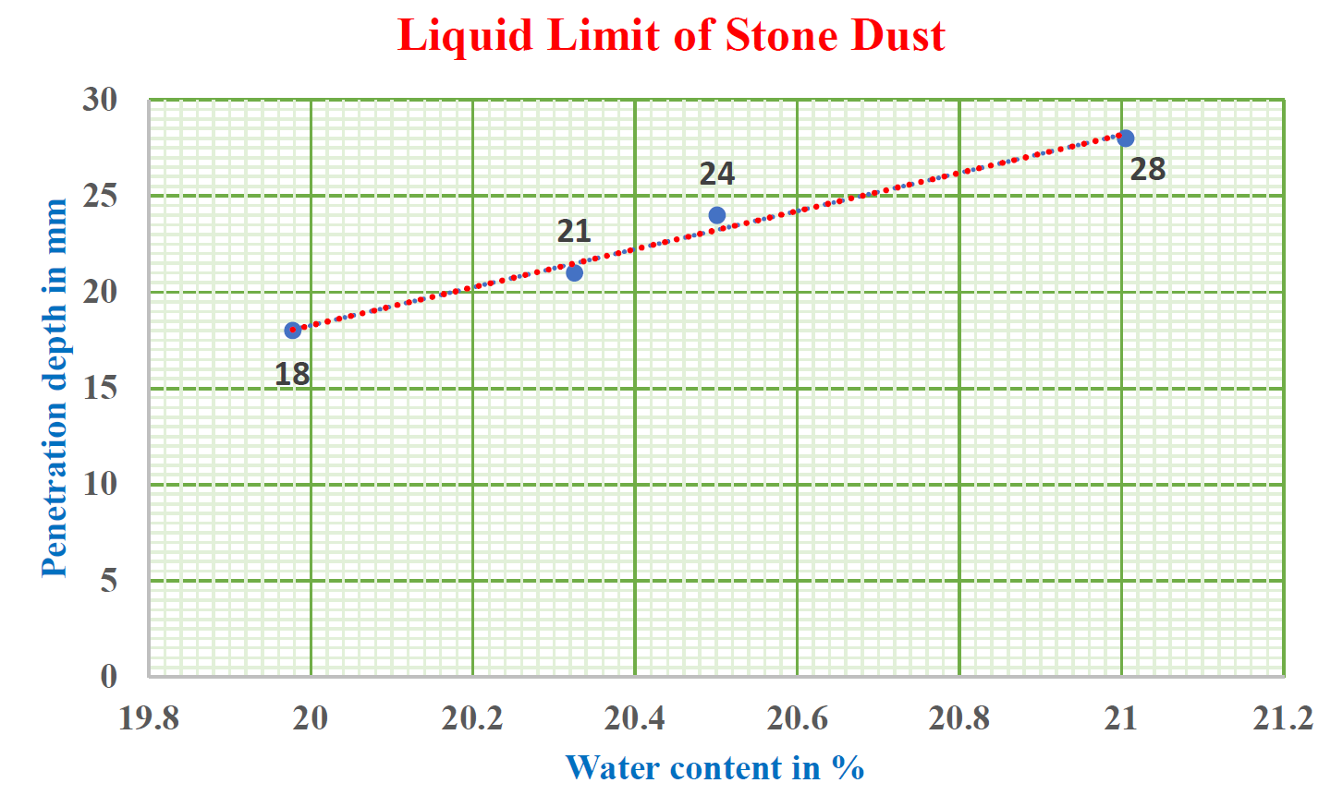
Figure 1: Liquid Limit test of Stone Dust
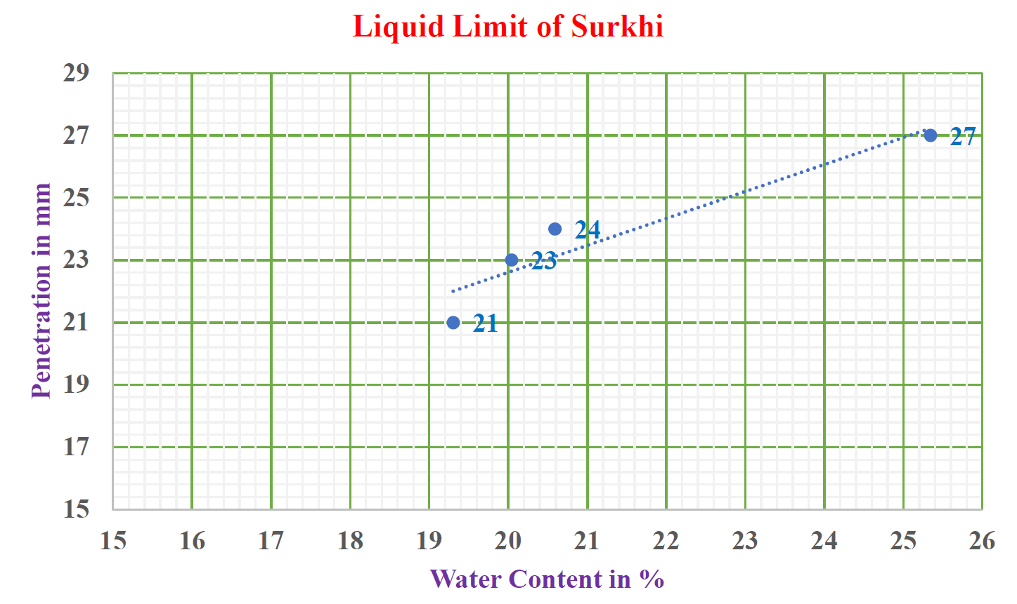
Figure 2: Liquid Limit of Surkhi
The penetration corresponding to 20 % water content is 22.5 mm.
So, the liquid limit of the stone dust is 22.5 %.
Gradation and Fineness Modulus Test:
The gradation and fineness modulus test is done to find out the zone to which the aggregates belongs, This is because their sizes influence the drainage properties of the Granular Sub Base layer.
This test is done as per the IS code : 383-1970. Gradation of Surkhi:
FM of Surkhi = 2. 472 (Zone II)

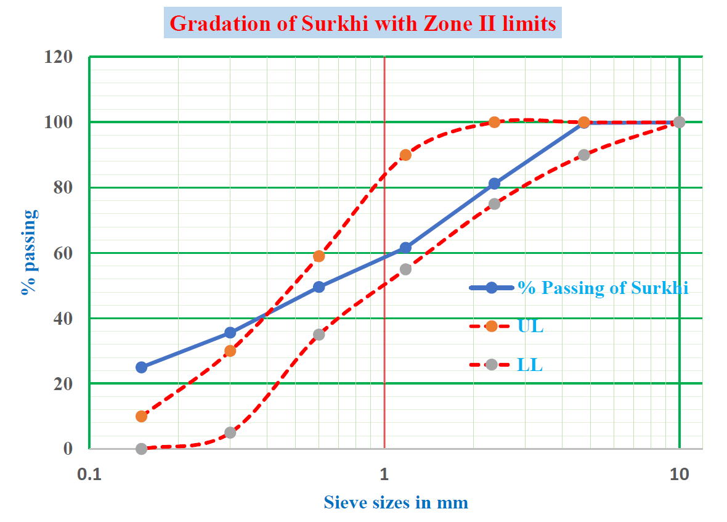
Figure 3: Gradation of Surkhi with Zone II limits
Fineness Modulus of Stone Dust = ∑Cumulative percentage weight retained/100
= 236.9/100
= 2.369 (Zone II)
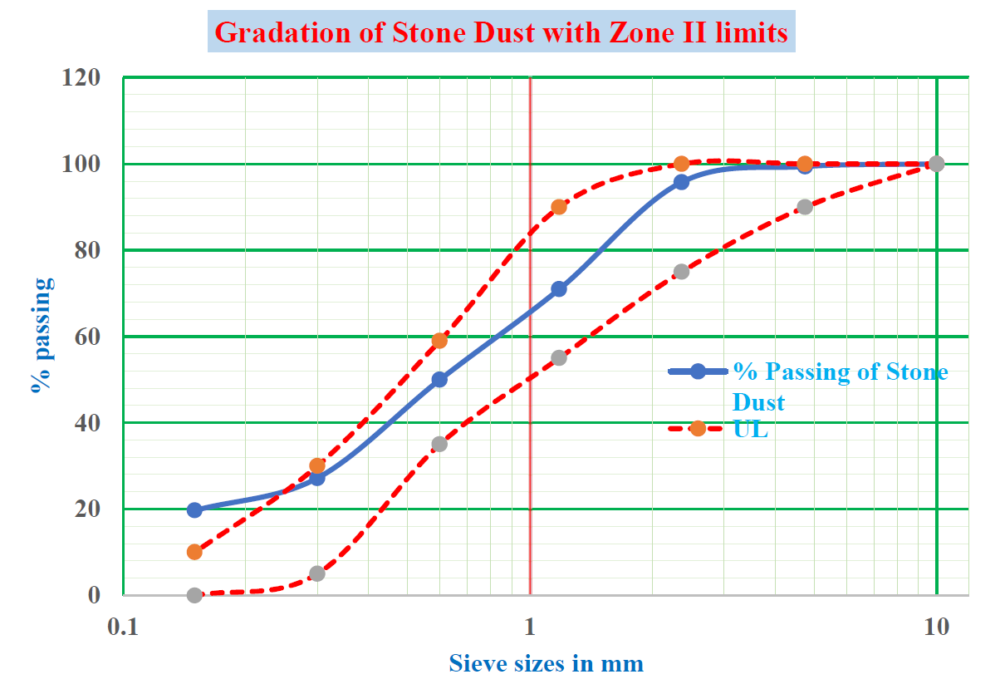
Figure 4: Gradation of Stone Dust with Zone II limits

Specific Gravity Test of fine aggregates:

Specific gravity Test (by using density bottle)

Specific Gravity of stone dust = 2.786

Specific Gravity of Surkhi = 2.599

The specific gravity of aggregates normally used in road construction ranges from about 2.5 to
3.0. As we have found the specific gravity of the aggregates as 2.786 and 2.599, so the specific gravity of both the stone dust and Surkhi are within the required limits.

Modified Proctor Test:

Heavy Compaction Test
The modified Proctor test is employed to conduct a rigorous compaction analysis of soil, with the aim of comprehending the compaction characteristics of diverse soil types, vis-à-vis alterations in moisture content. This laboratory test, commonly referred to as the Proctor compaction test or heavy compaction test, is utilized to ascertain the optimal moisture content (O.M.C.) of soil, at which point a given soil specimen will attain maximum dry density by eliminating air voids.

Test Description:
We have utilized a total of 5.7 kilograms of air-dried soil that has successfully passed through the 19 millimeter IS test sieve. After which, we have diligently mixed this soil with 5 percent water, ensuring complete and thorough blending. The resulting mixture was then compacted with a rammer weighing 4.9 kilograms, employing a five-layer approach, with each layer subjected to precisely 55 blows. Following the aforementioned process, we have proceeded to repeat all steps, incrementally increasing the amount of water by 2 percent on each occasion. The weight of the soil along with the mould is measured for each compaction. The soil sample is taken from three different layers for determining the water content
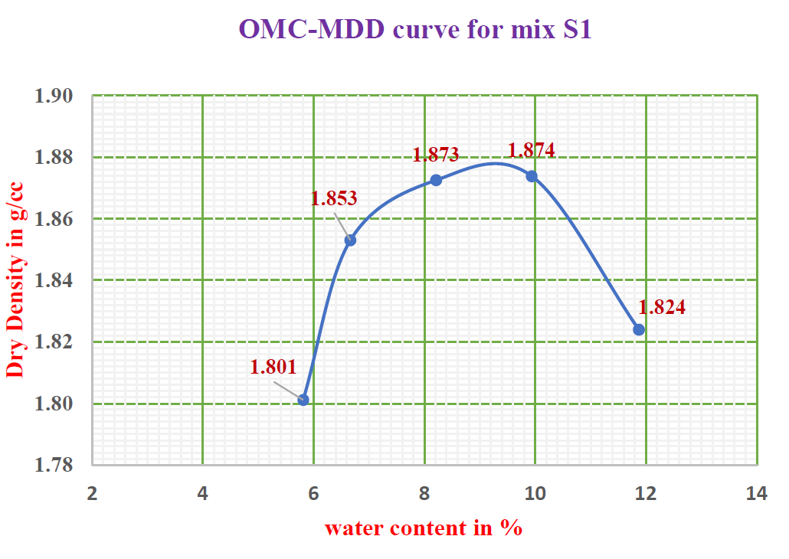
Figure 5: Compaction curve for mix S1

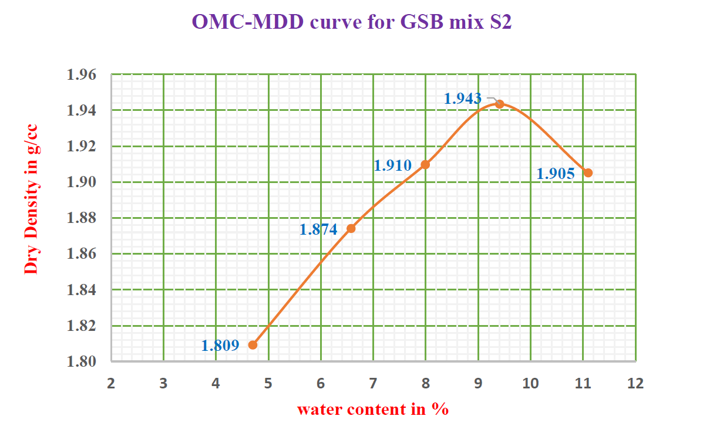
Figure 6: Compaction curve for mix S2
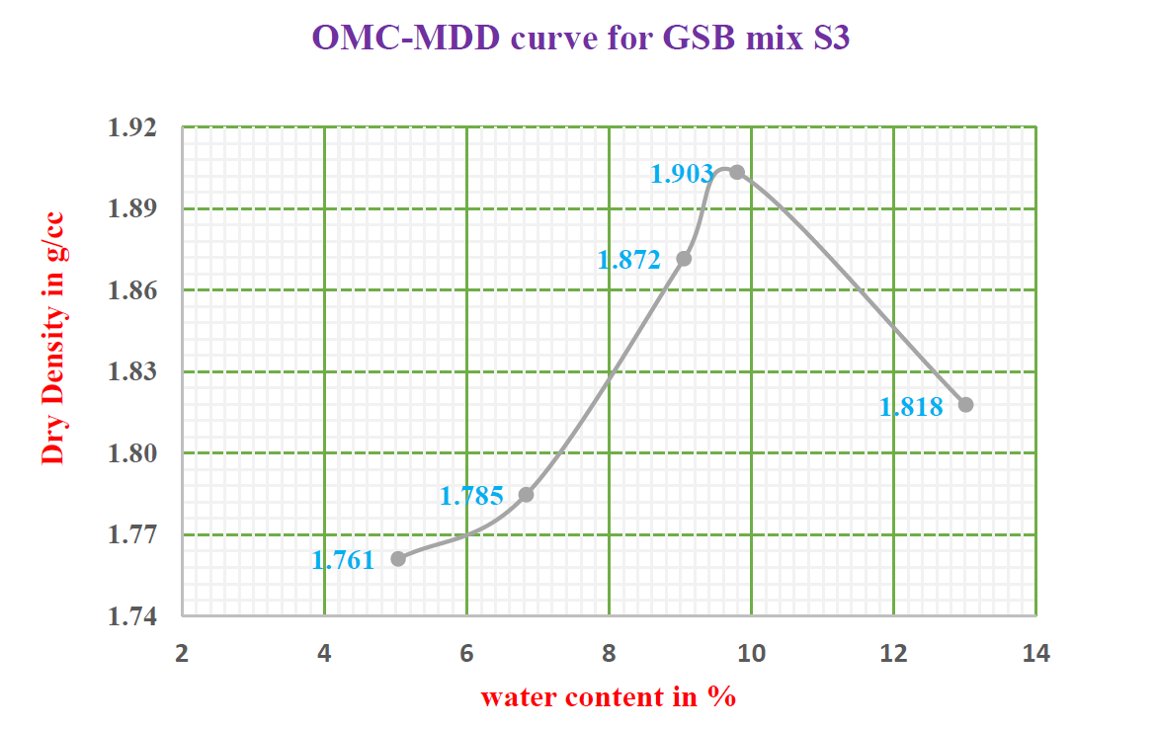
Figure 7: Observation for GSB mix S3
OMC-MDD curve for GSB mix S3
1.92
1.903
1.89
1.872
1.86

1.83
1.818
1.80
1.785
1.77
1.761
1.74
2
4
6
8
10
12
14
water content in %

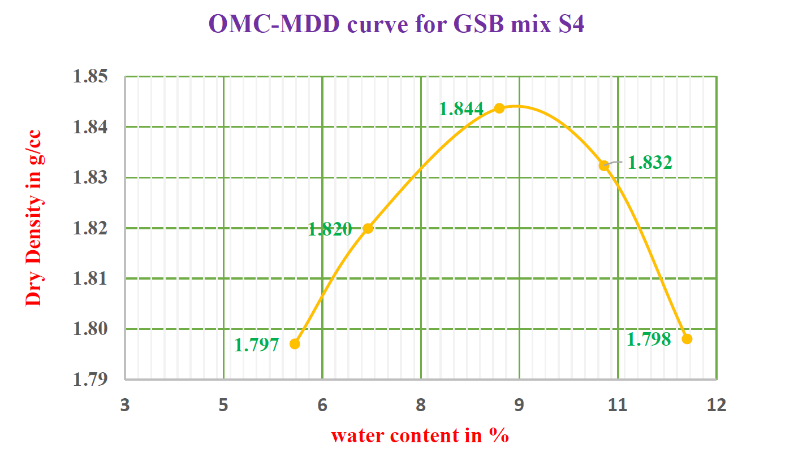
Figure 8: Observation for GSB mix S4

CBR Test:
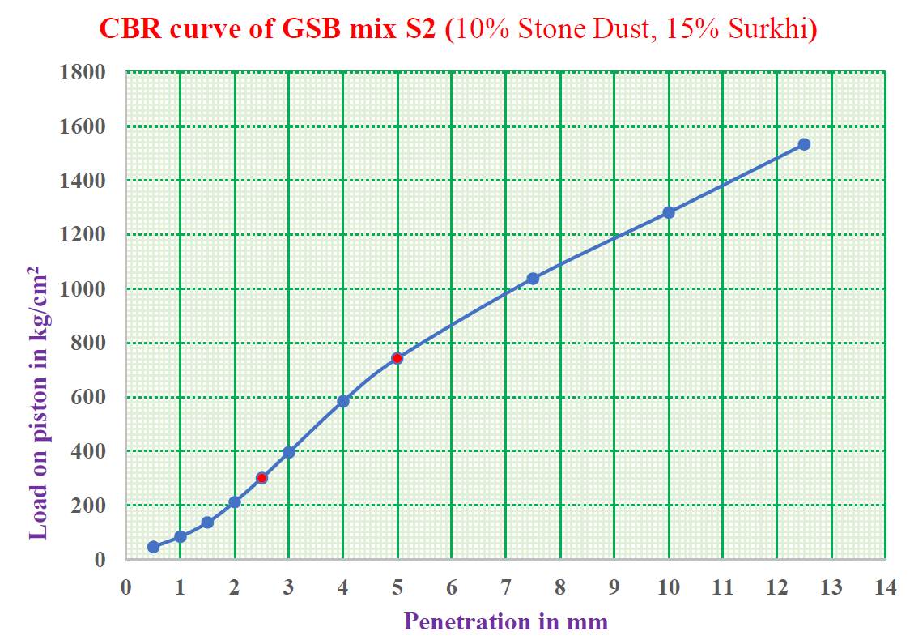
Figure 9: CBR curve for GSB mix S2

V. ANALYSIS OF RESULTS

Grading Results of GSB mixes:
The grading results of all the four GSB mixes are compared with the limits of Grading III of the Table 400-1 of section 400 of the MORTH guidelines (5th Revision). The result if presented in the graph as shown in fig 7.1
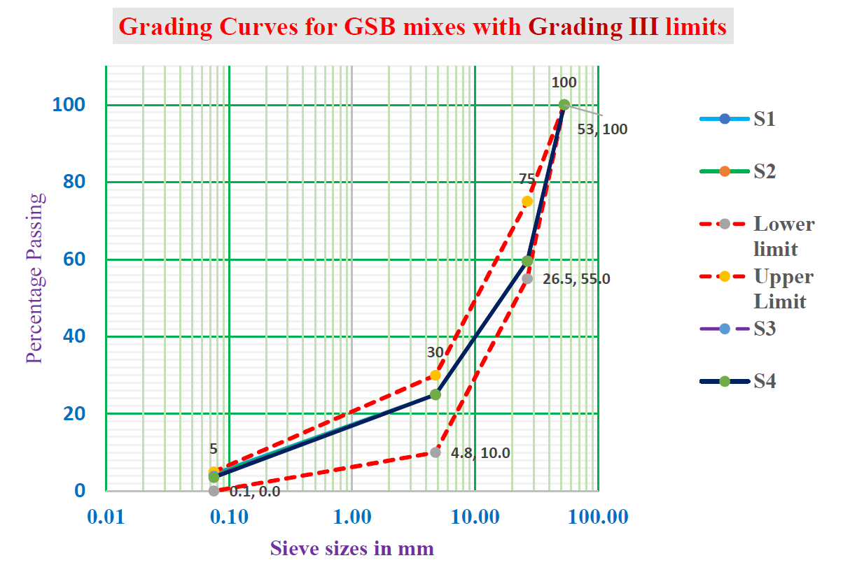
Figure 10: Grading Curves for GSB mixes with Grading III limits

Comparison of Maximum Dry Densities:
The results of all the four samples for the heavy compaction test are tabulated in Table 7.2 and presented their compaction curves in the fig 7.2.

Table 2: Compaction Result for all the GSB mixes:

GSB mix | Proportion of FA |  | OMC (%) | MDD (g/cc)
 | Stone Dust | Surkhi
S1 | 25 | 0 | 9 | 1.88
S2 | 15 | 10 | 9.4 | 1.94
S3 | 10 | 15 | 9.8 | 1.92
S4 | 0 | 25 | 8.7 | 1.845

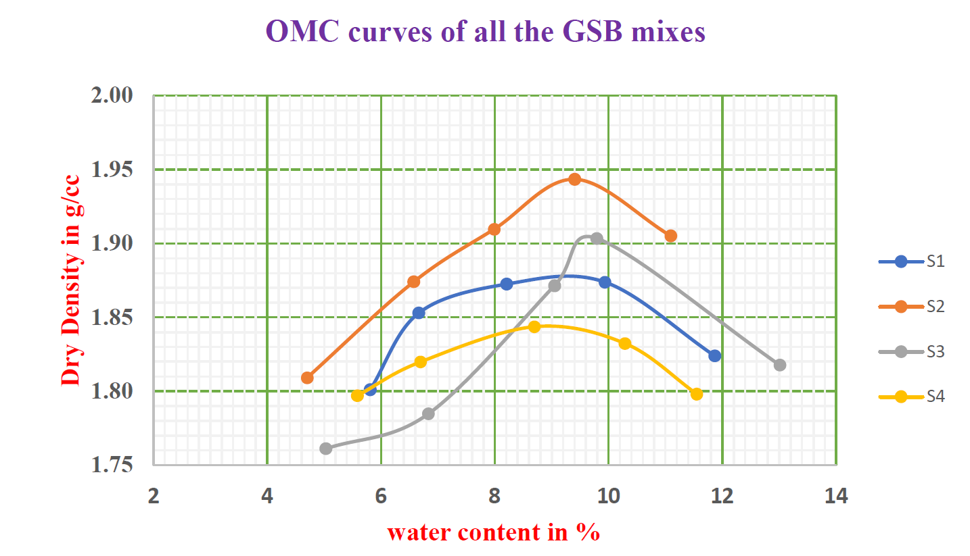
Figure 11: OMC curves of all the mixes
The maximum MDD is found to be 1.94 g/cc for the corresponding to GSB trail mix S2 having the mixture of Stone Dust to Surkhi in the proportion of 15:10. So, the S2 sample is adopted for cost analysis.
From the study of the effect of Surkhi on the GSB layer, we summarize the following:-

    - As per the MORT&H specification for GSB materials, the aggregate impact value (AIV) should be less than 40 which is fulfilled by the aggregates.
    - The Liquid Limit test results of fine aggregates done according to IS 2720 (Part 5) satisfy the MORT&H specifications.
    - The gradation curves of all the trial mixes were within the limits as mentioned in the specifications.
    - The maximum MDD among all the mix samples is found to be 1.94 g/cc for the corresponding to GSB mix S2 (10% Surkhi and 15% Stone Dust).
    - OMC is found to increase with increase in proportion of Surkhi.
    - There may be slight error in the results obtained because of the following reasons-
      - Instruments and machine were very old.
      - Machines had to be operated manually.
      - Observation error due to parallax.
      - Oven is not operated continuously.
      - Lack of proper maintenance of instruments due to which they were rusted.

VI. CONCLUSION
The present study has been carried out with a view to judge the suitability of locally available Surkhi in GSB road construction works as per MORTH Specifications. For this purpose, four types of GSB mixes were prepared by partially and completely replacing stone dust with that of Surkhi. The main conclusions drawn from the study are:
- Gradation of both Stone Dust and Surkhi fall in grading Zone-II. The fineness modulus for Stone Dust and Surkhi are found to be 2.472 and 2.369 respectively, and can be used for structural works.
- Liquid limit of Stone Dust and Surkhi are 19 % and 22.5% respectively, and both are non-plastic in nature.
- Maximum dry density (heavy compaction) for various GSB mixes is found to be varying between 1.845 gm/cc to 1.940 gm/cc. It is found to be maximum for GSB Mix – S2 with 10% Surkhi and 15% Stone Dust.
- OMC is found to increase with increase in proportion of surkhi from 0% to 25%
- The results of the tests conducted on all six GSB mixes have demonstrated that they satisfy the MORTH specifications with respect to gradation, CBR, and plasticity. This indicates that these particular combinations are suitable for employment in the construction of roadworks utilizing GSB.
- The CBR value of GSB Mix – S2 for unsoaked condition is found to be 36.14%.
- Use of locally available surkhi in road construction in GSB will decrease the cost of construction of the GSB layer by 30% and also save on environmental degradation by reducing mining pollution and energy used in quarrying sand/stone dust.

Future Scope:
A trial section of a pavement with the mixture of Surkhi and Stone Dust in required proportion as GSB filler materials be prepared and investigated. This trial filler can be evaluated and analysed based on their performance and can be compared with conventional fillers such as lime, sand and cement.
Dumping of Surkhi is of great concern for the society, hence use of Surkhi as filler in road construction can solve the problem as well as economic. Stone dust is a residual substance derived from the process of crushing plants. Its utilization as a substitute for natural river sand in concrete has the potential to be highly advantageous. Incorporation of stone dust in the construction of GSB not only enhances the quality of the material, but also serves to preserve the finite resource of natural river sand for posterity. Since Surkhi and Stone Dust are already in use in different engineering fields it is no threat to the environment.
Hence the present and future scenario is demanding use of non-conventional fillers in place of conventional fillers. At last, we would like to recommend that more studies should be carried out on this topic taking different types of fillers.

REFERENCES
- Kumar, N., Kumar, V., Priyadarshee, A. and Chhotu, A.K., (2014): “Impact of Surkhi on GSB layer as replacement to the Stone Dust,” Proceedings of National Conference ‘GEPSID’ held on October 11-12, 2014, Ludhiana.
- Havanagi, V. G., Mathur, S. and Sinha, A. (2013): “Steel slag waste material for the construction of road,” https://www.researchgate.net/publication/305866301.
- Manjunatha, H., (2014): “Laboratory Studies on Granular Sub Base,” International Journal of Engineering Research & Technology (IJERT), ISSN: 2278-0181, Vol. 3 Issue 4, April – 2014.
- Sen, B., Sharma, S., (2022): “A Laboratory Study on Brick Dust for GSB layer of Flexible Pavement,” International Journal of Creative Research Thoughts (IJCRT)- Vol. 10, Issue 9 September 2022.
- Subrahmanyam, K. V., Kumar, U. A. and Satyanarayana, P. V. V. (2014): “A Comparative Study on Utilization of Waste Materials in GSB Layer,” SSRG International Journal of Civil Engineering (SSRG-IJCE) – Vol. 1, Issue 3, August 2014.
- Tempa, K., (2021): “Study on Riverbed Sediments as Road Construction Material: GSB and WMM,” https://www.researchgate.net/publication/356536948.
- MORTH (Ministry of Road Transport and Highways (2013): Specifications for Road and Bridge Works, ), Fifth Revision, Indian Roads Congress, New Delhi.
- IS: 383-1970, Specification for Coarse Sand and Fine Aggregate from Natural Source for Concrete.
- IS: 2386 (Part-I)-I963, Method of Test for Aggregate for Concrete, Part-I, Particle Size and Shape.
- IS: 2386 (Part-III)-1963, Method of Test for Aggregate for Concrete, Part-III, Specific Gravity, Density, Voids, Absorption and Bulking.
- IS: 2720 (Part-IV)-1985, Method of Test of Soil, Grain Size Analysis.
- IS: 2720 (Part-V)-1985, Method of Test for Soils, Part-V, Determination of Liquid and Plastic Limit.
- IS: 2720 (Part-VIII)-1987, Method of Test for Soils, Part-VIII Determination of Water Content-Dry Density Relation Using Heavy Compaction.
- IS: 2720 (Part-XVI)-I987, Method of Test for Soils, Part XVI, Laboratory Determination of CBR.

