**Growth Characteristics and Microbial population of *Azadirachta indica* A. Juss and *Eucalyptus camaldulensis* Dehnh Shelterbelt at Kiyawa, Dutse, Jigawa State**

1, **2**Salami, K. D. and 1Lawal, A. A.

1Department of Forestry and Wildlife Management, Federal University Dutse, Jigawa State, Nigeria

2Forest Ecology and Conservation Unit, Center for Arid Zone Ecology, Federal University Dutse, Jigawa State, Nigeria

**\*Corresponding Author:** [*foristsalam@yahoo.com*](mailto:foristsalam@yahoo.com)*, +234*7034294371

### ABSTRACT

This study was carried out in Kiyawa community; aimed to determine growth attributes, identifying fungi, bacteria and determining the microbial load in the neem and eucalyptus shelterbelts. Line transect measuring 1km long was established, four plots of 30 x 30m at 100m interval were laid for growth parameter measurements. Soil sample were studied within 1×1m mini-plots. Height and Dbh were measured using Haga altimeter and meter rule while volume and Basal area were calculated using established equation model. Potato Dextrose Agar and Nutrient Agar media were used for the isolation of fungi and bacteria. The collected data was analysed using t-test and presented in tables.  The *neem* plots had the highest Dbh, Basal area, Height, and volume of 82.25cm±1.23, 0.90m2±0.15, 15.90m±0.2, 970.78m3±4.27m3followed by *eucalyptus* hotspot which had the lowest value of 62.50±0.93cm, 0.463±3.43m, 3.75±0.03m, and 347±2.43m.The findings revealed the presence of three (3) bacteria species in each study site. Staph avenus and *Bacillus cereus* were found in the Eucalyptus shelterbelt, while *Bacillus subilis* and *E. coli* were found in the neem hotspot. Both hotspots have been linked to *Pseudomonas spp*. However, *Aspergillus flaming* occurred in eucalyptus hotspot while *Fusarium oxysporum* was found in Neem shelterbelt. Result showed that grand mean microbial load of fungi (eucalyptus 1.45x 106; Neem 1.50 x106) is higher than bacteria (eucalyptus 1.24 x 106; neem 1.3 x106). There was significant difference between the bacterial microbial loads across the study sites at (p≤ 0.05). The hotspots support growth attributes of neem tree and fungal growth. Therefore, interplanting of tree with arable crops is recommended for improved economic production and enhancement of shelterbelt.

**Keywords:** Comparative, Growth characteristics, Kiyawa, Microbial population and Shelterbelts.

**INTRODUCTION**

Forest inventory has been defined by Husch *et al.,* (1972) as the procedure for obtaining information on the quantity and quality of the forest resource and many of the characteristics of the land area on which trees grow. A complete forest inventory for timber resources evaluation provides the following basic information: a description of the forested area including ownership and accessibility, estimates of timber quality and quantities and estimates of growth and drain. Non-timber information may also be included on wildlife, areas of recreational and touristic interest, soil and land use capabilities on water shed values.

Forest biodiversity protection relies on the ability to assess hot spots, quantify and predict spatial and temporal trends of key species which maintain a natural disturbance regime and limit harmful human activities (Thompson *et al*., 2009). Protected areas made to known by the International Union for Conservation of Nature (IUCN) as an area of land and/or sea especially dedicated to the protection and maintenance of biological diversity, and of natural and associated cultural resources, and managed through legal or other effective means (IUCN, 1994). Forest protected areas help conserve ecosystems that provide habitat, shelter, food, raw materials, genetic materials, a barrier against disasters, a stable source of resources and many other ecosystem goods and services and thus can have an important role in helping species, people and countries adapt to climate change. They can thus continue to serve as a natural storehouse of genetic material into the future. They help in the conservation of indigenous species that are resistant to pests, diseases and pathogens, environmental stresses and nutrient loss.Soil is a complex and dynamic ecosystem where substantial physical, chemical, and biological processes take place (Jelena *et al*., 2018). According to Nannipieri *et al.* (2003), the most important biological processes in soil (80-90%) occur due to microbial enzyme systems reactions. Rousk *et al*. (2008), stated that soil chemical and physical characteristics are major factors of soil microbial community structure. The physicochemical properties of soil are ultimately related to soil fertility which affects the floristic composition of forest. There is a mutual connection between the soil microflora and the vegetation of an ecosystem. Microorganisms help in mineralization and decomposition of plant materials to a form that can be absorbable by plants (Pietikainen, 1999). Sigstad *et al*., (2002) also pin pointed that bacterium as the most occurrence and it is through their metabolic activity that minerals and soil organic matter are transformed in a way that important nutrients such as N, P, and S are simultaneously converted into useable forms for plant and other micro-organisms.

*E. camadulensis* tree has phyto-chemicals that are known to possess antitermic repellent activities (Jibo *et al.,* 2021; Geoff, 2007) and releases compounds which inhibit the germination or growth of other potential competitor’s plants. Outside their natural ranges, eucalyptus is both lauded for their beneficial economic impact on poor populations (Luzar, 2007).According to "Merriam Webster" Shelterbelt are barrier of trees and shrubs that provide protection (as for crops) from wind and storm and lessens erosion. A shelter belt is a planting usually made up of one or more rows of trees or shrubs planted in such a manner as to provide shelter from wind and to protect soil from erosion. Shelter belts can also be known as windbreak because they are commonly planted in hedge rows around the edges of field on farms. It's uses cannot be unnoticed and it plays a vital role in our daily lives and specially as farmers. Some of the uses are to: Providing habitat for wildlife and serve as woods if the trees are harvested, Windbreaks within one's environment reduces the cost of heating and cooling and saves energy. This research seeks effort to generate information on the essence of utilizing shelter belts. Therefore, the aim of the study is to access the growth variables and microbial population of Katika Shelterbelt, along Kiyawa-Jahun road, Jigawa State, Nigeria with the view of providing better management and conservation strategies for the shelterbelts.

**MATERIALS AND METHOD**

**The study area**

The two protected areas i.e shelter belts are located in Kiyawa Local Government Area. The shelter belt was established in 1989 by the Department of Forestry, Ministry of Environment Kano State. Kiyawa is located in the southern region of the state (Fig 1). The region is about 500-600m above the sea level Maryam *et al.,* (2019). Jigawa and Kano were ruled under the same government and later fall under Dutse Emirates. It covered an area up to 3 hectares. The Shelterbelts comprises of Neem and Eucalyptus tree species which are planted in rows (JARDA, 2016). The Shelterbelt is located at the coordinate of Latitude 11°47'05"N, 09°36'30"E and Longitude 11°78°472°N, 9°08°33°E. The annual mean temperature is about 25oC but the mean monthly value ranges between 21oC in the coolest month and 31oC in the hottest month (Azare *et al.,* 2019) and also soil type is sandy (Salami and Lawal, 2018; Jibo *et al.,* 2021).

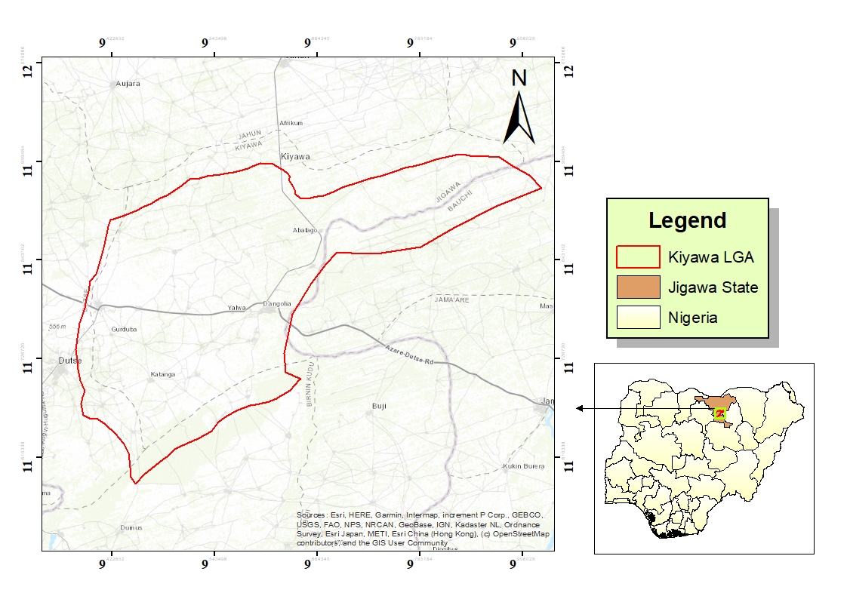

**Figure 1:** Showing map of Kiyawa

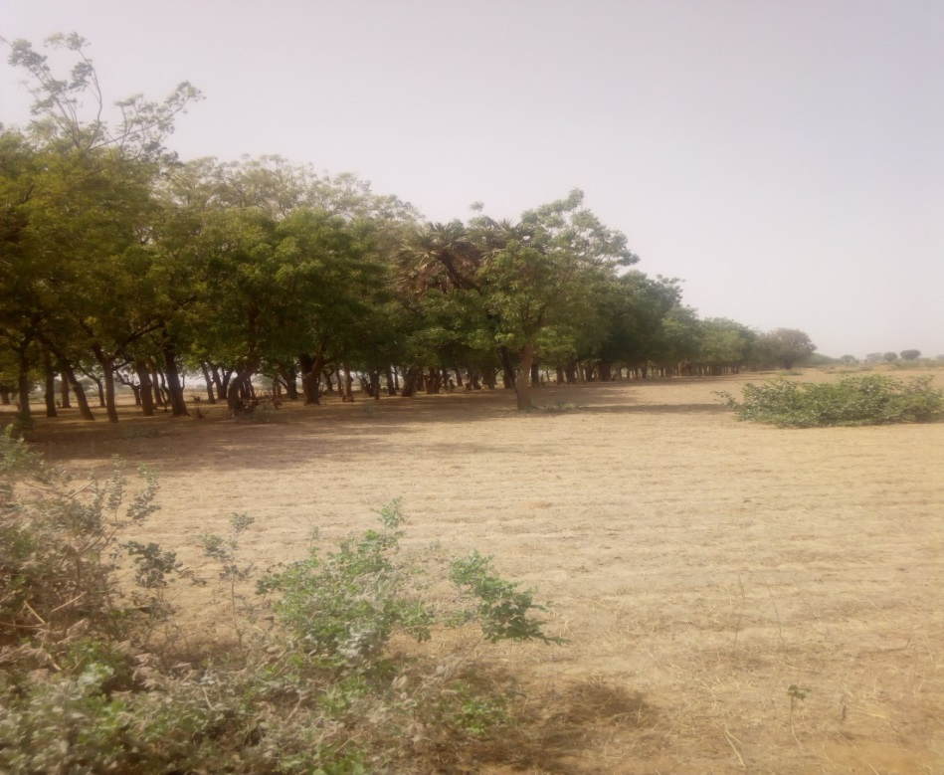

**Source:** Field survey (2021)

**Plate 1:** Shelter belt of *Azadirachta indica* (Neem)

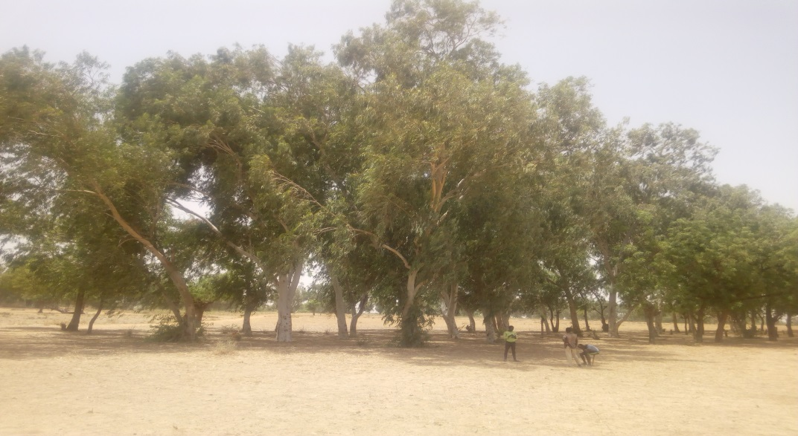

**Source:** Field survey, (2021)

**Plate 2**: shelter belt of *Eucalyptus camaldulensis*

**Data collectionSampling Layout and procedure**

Systematic sampling design (systematic line transects) was used in laying out of the plot. A line transects of 1km with four samples of size 30m × 30m was laid in each shelterbelt. Eight sample plots were assessed during experiment for both studies. All woody plants within transects were enumerated while 1m x 1m sample plot was laid within each of the sample plot for soil collection (Aminu, 2021; Salami, 2017)

1m

30m

100m

**Fig 2:** Systematic sampling layout

**Source**: field survey, (2021).

**Tree enumeration**All Woody plants with DBH of above 10 cm were enumerated. Tree growth variables such as the diameter at the base (Db), Diameter at breast height (DBH), diameter at the middle (Dm), Diameter at the top (Dt) and height was measured with Haga altimeter. Basal area and volume were determined using equation 1 and 2.

**Soil collection**

The sample plots laid in the shelter belts, thus, was used for soil collection. Soil samples were collected at 0-20cm depths along the diagonal for each of the sample plot with the aid of a soil auger. The soil sample was collected at soil depth of 0-20cm only, because the number of count of bacteria and fungi always decrease with the depth of soil sample (Lawal *et al.,* 2018)

**Identification of Micro-Organisms**

Fungi Morphology was studied with aid of microscope by observing colony features (Colour and texture) and by staining with lacto phenol cotton blue and observed under compound microscope for the conidia, conidiophores and arrangements of spores (Ameba, 2001).Gram's staining was carried out on the growth culture plate to differentiate gram's negative organism from gram's positive organism. Biochemical test was carried out base on Gram's result.

**Isolation of Micro-organisms**

Potato Dextrose Agar (P.D.A) media was used for the isolation of fungi, the plate was kept at room temperature for 7 days. Dilution was prepared and used for the isolation of Bacteria. One (1g) of soil sample was taken and serial dilution was carried out in distilled water. Nutrient Agar (N.A) medium was used to isolate bacteria sterilized in autoclave for 15 minutes at 121°C. After 2 hours of incubation at 37°C. Streaking plate method was used to get single colonies of the culture, (Shanmugam *et al.,* 2013).

**Data analysis**

The data collected was analyzed using descriptive statistics such as tables while inferential such as independent T- test was employed to compare fungi, bacterial and microbial population in the study sites.

Basal area calculation

The basal area of all trees in the sample plots was calculated using this formula:

 ……………………………………....................................................(*eqn 1*).

Where **BA** = Basal area (m2), **D** = Diameter at breast height (cm) and Pie (3.142).

The total basal area for each of the sample plot was obtained by adding the BA of all trees in the plot while mean BA for the plot (*BAp*) was obtained by dividing the total BA by the number of sample plots. Basal area per hectare was obtained by multiplying mean basal per plot with the number of 30 x 30m plots in a hectare (4).

Where *ha BA* = Basal area per hectare.

Where BA = Basal area (m2),

D = Diameter at breast height (cm) and

Pie (3.142).

### Stem Volume estimation

Volume of individual trees encountered in the plots. Mean volume for sample plots were calculated by dividing the total plot by the number of sample plots. Volume per hectare was obtained by multiplying mean volume per plot (VP) with the number of 30×30m plots.

The volume of all trees in the sample plots was calculated using this formula:

**V = 0.42 × B.A H ………………………………………..……..(***eqn 2*). (Keshaws , 2014)

**RESULTS**

**Table 1:** Growth Variables of Neem and Eucalyptus Species in the Shelterbelts

|  |  |  |  |  |  |  |
| --- | --- | --- | --- | --- | --- | --- |
| **Parameters** | **Study site** | **Min** | **Max** | **Total** | **Mean** | **Stand Error** |
| **DBH(cm)** | Neem  Eucalyptus | 19.5  18.0 | 145  107 | 8441.75  6562.25 | 82.25  62.50 | 1.23  0.93 |
| **Basal area (m2)** | Neem  Eucalyptus | 0.15  0.025 | 1.65  0.90 | 92.70  48.56 | 0.90  0.463 | 0.15  3.43 |
| **Height (m)** | Neem  Eucalyptus | 2.90  1.20 | 13.00  6.30 | 818.85  393.75 | 15.90  3.75 | 0.24  0.03 |
| **Volume (m3)** | Neem  Eucalyptus | 56.55  21.60 | 1885  674.1 | 99,989.8  36,524.25 | 970.78  347.85 | 1.27  2.43 |

**Source:** Field survey, (2021)

**Table 2: Occurrence of Soil bacteria in Eucalyptus and Neem Shelterbelts**

|  |  |  |  |
| --- | --- | --- | --- |
| **SN** | **Species** | **Eucalyptus hotspot** | **Neem hotspot** |
| 1 | *Staph averus* | V |  |
| 2 | *Bacillus cereus* | V |  |
| 3 | *Pseudomonas spp* | V | V |
| 4 | *Bacillus subilis* |  | V |
| 5 | *E.coli* |  | V |
| **Total** |  | **3** | **3** |

**Note**: V= *present*

**Source:** Field survey, (2021)

**Table 3: Occurrence of Soil Fungi in Eucalyptus and Neem Shelterbelt**

|  |  |  |  |
| --- | --- | --- | --- |
| **S/N** | **Species** | **Eucalyptus hotspot** | **Neem hotspot** |
| 1 | *Aspergillus niger* | V | V |
| 2 | *Aspergillus flamings* | V |  |
| 3 | *Penicillum spp* | V | V |
| 4 | *Fusarium oxysporun* |  | V |
| **Total** |  | **3** | **3** |

**Note**: V= *present*

**Source:** Field survey, (2021)

**Table 4 :** Mean microbial population of soil bacteria in Eucalyptus and Neem shelterbelt

|  |  |  |  |
| --- | --- | --- | --- |
| **SN** | **Species** | **Eucalyptus hotspot** (CFU/g) | **Neem hotspot** (CFU/g) |
| 1 | *Staph averus* | 1.32x106 |  |
| 2 | *Bacillus cereus* | 9.2 x105 |  |
| 3 | *Pseudomonas spp* | 1.48 x106 | 2.18 x106 |
| 4 | *Bacillus subilis* |  | 1.46 x106 |
| 5 | *E.coli* |  | 1.56 x106 |

**Grand mean 1.24 x 106 1.3 X106**

**Note**: CFU/g is colony forming unit

**Source:** Field survey, (2021)

**Table 5:** Mean microbial population of soil fungi in Eucalyptus and Neem shelterbelt

|  |  |  |  |
| --- | --- | --- | --- |
| **SN** | **Species** | **Eucalyptus hotspot**(CFU/g) | **Neem hotspot**(CFU/g) |
| 1 | *Aspergillus niger* | 1.30x106 | 1.88 x106 |
| 2 | *Aspergillus flamings* | 1.01 x106 | Nil |
| 3 | *Penicillum spp* | 2.04 x106 | 1.38 x106 |
| 4 | *Fusarium oxysporun* | Nil | 1.23 x106 |

**Grand mean 1.45 x106 1.50 x106**

**Note**: CFU/g is colony forming unit

**Source:** Field survey, (2021)

**Table 6:** t-Test: Two-Sample Assuming Equal Variances (Bacteria)

**Eucalyptus Neem**

**Mean** 1240000 1733333.333

**Variance** 83200000000 1.52133E+11

**Observations** 3 3

**Pooled Variance** 1.17667E+11

**Hypothesized Mean Difference** 0

**df** 4

**t Stat**  -1.761405568

**P(T<=t) one-tail** 0.07648284

**t Critical one-tail** 2.131846782

**P(T<=t) two-tail** 0.15296568

**t Critical two-tail** 2.776445105

**Table 7** t-Test: Two-Sample Assuming Equal Variances (Fungi)

|  |  |  |
| --- | --- | --- |
|  | **Eucalyptus** | **Neem** |
| **Mean** | 1180000 | 1496667 |
|  |  |  |
| **Variance** | 22900000000 | 1.16E+11 |
|  |  |  |
| **Observations** | 3 | 3 |
|  |  |  |
| **Pooled Variance** | 69366666667 |  |
| **Hypothesized Mean Difference** | 0 |  |
| **Df** | 4 |  |
| **t Stat** | -1.47255854 |  |
| **P(T<=t) one-tail** | 0.107428042 |  |
| **t Critical one-tail** | 2.131846782 |  |
| **P(T<=t) two-tail** | 0.214856084 |  |
| **t Critical two-tail** | 2.776445105 |  |

**Discussion**

**Growth parameter indices**

The results showed that *A. indica* plots had the highest Dbh, Basal area, Height, and volume of 82.25±1.23cm, 0.90±0.15m2, 15.90±0.24m, 970.78±4.27m3 followed by the *E. camaldulensis* hotspot which had the least value of 62.50±0.93cm, 0.463±3.43m2, 3.75±0.03m and 347.85±2.43m3 respectively. However, the results were obtained from two different studies sites. It showed that *A. indica* had the greatest volume not only even volume even in terms of richness, height and growth compared to *E. camaldulensis*.Mean basal area obtained was 0.90±0.15m2 from Neem shelterbelt which implied that the study area had a high values of trees density and values that can be useful when properly managed and harvested for human purposes such as the construction of furniture’s, electric poles, foal fuel, charcoal production followed by 0.463±3.43m2. The inventory count of different species in the study area was fifty (50) in number. The result disagrees with the finding of Salami *et al*., (2021), whose reported higher mean volume and Basal area (14126.59m3 ; 339998m2) at Warwade plantation in the area. No documentation on the growth assessment of shelterbelt in the past years.

**Presence of fungi and bacterial**

Table 2 and 3 revealed the presence of soil bacteria and fungi in the study sites. The findings showed the presence of three (3) species of bacteria in the study site. Eucalyptus shelter belt had *Staph avenus* and *Bacillus cereus* while *Bacillus subilis* and *E. coli* were presence in Neem hotspot. *Pseudomonas spp* can be traced to both hotspots. This implies that this species can thrive and found in many habitats despite nature habitat. The presence of fungi: *Aspergillus niger* and *Penicillum species* were present in both study sites. However, *Aspergillus flaming* occurred in Eucalyptus hotspot while *Fusarium oxysporum* present in Neem shelterbelt. Four different species of fungi present in both sites. Two (2) was common to both while a species found in each of the sites respectively.

**Relationship between Microbial populations of the study sites**

The findings of the comparative analysis of the microbial load of both fungi and bacteria were influenced by physical features of the soil. This agrees with finding of (Ateh *et al.,* 2020) who reported that the texture of the soil determine the nature of microbes present. Microbial organism plays importance roles in the decomposition of organic matter, nitrogen fixation and nutrient cycling (Lawal *et al*., 2017; Ateh *et al.,* 2019). The effects of the soil microbes are influenced by their population classes (Archana *et al.,* 2015). Microbial population in forest soils are determined by both chemical and physical properties of the soil (Seeley, 1981).The results from table 4 and 5 showed the relationship between microbial loads of bacteria and fungi found in the study site. The study revealed that five (5) species of bacterial were found which are *Staph averus, Bacillus cereus, Pseudomonas spp, Bacillus subilis and E.coli.* Microbial load of *Pseudomonas spp* in the Neem hotspot recorded higher mean value of 2.18 x106 followed by Eucalyptus hotspot with load of 1.48 x106. The grand mean of Neem hotspot was recorded to be 1.3 X 106 which is higher than Eucalyptus hotspot with value of 1.24 X106. This implies that bacterial microbial load is prominent and active in the neem than Eucalyptus hotspot. There is no significant difference between the bacterial microbial loads between the study sites at (p≤ 0.05).

Furthermore, there is similarity in the microbial load values of fungi recoded in the two study sites with values of 1.45 x106 and 1.50 x 106 respectively. *Aspergillus niger* is higher in Neem than Eucalyptus shelterbelt with the microbial load of 1.88 x 106 and 1.3 x 106 respectively while for *Penicillum spp*, the microbial load is higher in Eucalyptus (2.06 x 106) than Neem shelterbelt (1.38 x106). The weight of the fungi is lower in Eucalyptus hotspot due to the effect of allele-chemicals which is higher in eucalytus than neem hot. The results from table 4 and 5 revealed that fungi load was higher than bacteria load at both study sites. This is in accordance to (Barbour *et al,* 1987; Zhou *et al,* 2018) who revealed that nature of physical properties of the forest soil determines the population and microbes in the soils. The dominant and structural organization of the sand textural class in the study provided a spatially heterogeneous habitat for fungal community because of smaller size fraction (silt and clay) host higher bacterial community than larger size particle (size). Ateh *et al.,* (2019) supported the study carried that microbial load of fungi was higher than bacteria with the value of 4.49 x105 and 3.43 x105 respectively at the same soil profile level (0-15cm) in Girea soil of Adamawa. This study also agrees with Nkereuwem *et al*., (2020) who reported that fungi did better than bacteria in adapting to drying rewetting stress across the different soil locations during the drying rewetting cycle. However, Adekunle *et al.* (2005), disagreed with the finding and reported that the amount of bacterial microbial load is higher than fungi microbial load in Akure Forest Reserve in southwestern, Nigeria with the range of (26.14 x106, 360x106MPNg-1) and (2.50x106 to 23.34 x106MPNg-1) respectively.

**Biochemical elements**

The biochemical elements of the study area shows that some elements can be present in both study areas and some are not present in both, the rest are moderately present or not present at all. Catalase and Citrate are present in both study areas. Coagulase and Urease are moderately present in eucalyptus site and not present at all in Neem site. Oxidase is present in both but in minute quantity

**Conclusion**

The neem hotspot supports the growth bacteria and fungi microbial load. Bacteria microbial load is not prominent unlike fungi. Therefore, this study gives a basis for further research especially on degree of allelo-chemicals characteristics on the growth of arable crops/plants between neem and eucalyptus shelterbelt since there is no documentation at Kiyawa Shelter belt. Therefore, neem tree is recommended for economic and ecological reasons; adaptive arable crops should also intercrop with tree crops for improved economic value of shelterbelt and land user

**REFERENCES**

Adekunle, V. A. J., Dafiewhare, H. B. and Ajibode, O.F (2005): Microbia population and Diversity as influenced by soil ph and organic matter in different forest ecosystem. *Pakistan Journal of Biological Science* 8(10): 1478-1484

Archana B., Bishwoyog B and Sunil, P. (2015). Variation of soil microbial population in different soil horizons *Journal of Microbiology & Experimentation* V2:(2)56-67

Ateh, G. O. Saka, M. G., Dishan, E. E. and Meer, B. B. (2020) Evaluation of Physicochemical Properties and Microbial Populations of Soil of Bagale Forest Reserve, Girei Local Government Area, Adamawa State, Nigeria. *Asian Journal of Research in Agriculture and Forestry* 5(1): 13-21, 2020; Article no. AJRAF.53430ISSN: 2581-7418

Azare, I. M, Adebayo, A. and Saddiq, A. M. (2019). Effect of Selected Soils Properties On The Performance Of Pearl Millet Varieties In Parts of Jigawa State, Nigeria. *Ife Research Publications in Geography,* Volume 17 (1): 76-85

Barbour, M.G, Lugard, J.H, and Pitt, W.D. (1987) Terrestrial plant ecology 2nd edition. Benjamin Cummings, New York. pp1-3.

Geoff, N. P. (2007). Eucalyputus oil and market Technical report.

Husch B., Beers T.W. & Kershaw J.A.Jr. (2003). Forest mensuration, 4th, 443 Hoboken, NJ: John Wiley and Sons, Inc

IUCN (1994). Guidelines for Protected Area Management Categories. Gland and Cambridge: IUCN.

JARDA, (2016). Shelterbelts comprise Neem and Eucalyptus tree species which are planted in rows.

Jelena M., Dragana , B., Jordana B., Jovica B., Branislava B AND Milorad Z (2018) Effect of different soil usage on the microbial properties in the soil of Cental Serbia *Ratar Potvt* 55(2): 58-64

Jibo, A. U., Salami, K. D., Kareem Akeem, A. Muhammad, Y. K. and Musa, F. Y: (2021) Impact of Provenances on Seed Germination, Early Growth Performance and Survival Rate of *Tamarindus indica*(L) in North Western Nigeria/ *Nigerian Journal of Horticultural Science (NJHS)Volume 26 Issue 1 and 2 pp 87-104*

Lawal, A.A, Usman, A. Karage, M. Y. Ilu K. J. and Khalid, S. I. (2017) Assessment of soil microbial diversity Under canopies of neem tree in University of Marduguri, Borno state, Nigeria. 4(2): 269-275

Luzar, J. (2007) The political –ecology of a Forest –transition. Eucalyptus forestry in the Southern Peruvian Andes. *Ethno-botany Research and application* V5: 85-93

Maryam, A.D., Dawud, I. I., Angarawai, P.B. Tongonako., K. O., John, S.Y. and Eleblo, B.E (2019). Farmer’s production constraints, Knowledge Striga and preferred trait of pearl millet in Jigawa state. *Global Journal of Science of Frontier*

Nannipieri P., Ascher J., Ceccherini M.T., Landi L., Pietramellara G. & Renella G. (2003). Microbial diversity and soil functions. *European Journal of Soil Science,* 54: 655-670.

Nkereuwem, M. E., Adeleye, A. O., Edem, I. D., Abubakar, M. Z., Onokebhagbe, V. O. and Abubakar, A. (2020) Response of Indigenous Microbial Community To Drying-Rewettin Stress: Evidences From Warwade Dam Irrigation Scheme Soil In Dutse*. Dutse Journal*

Pietikainen J. (1999). Soil microbes in boreal forest humus after five. Finish forest Research Institute, pp. 78.

Rousk, J., Demoling L., Bahr A. and Baath E. (2008). Examining the fungal and bacterial niche overlap using selective inhibitors in soil. FEMS Microbiology Ecology, 63: 350-358.

Salami, K. D and Lawal, A. A (2018) Tree species Diversity and Composition in the Orchard of Federal University Dutse, Jigawa State.*Journal of Forestry Research and Managemen*t. ISSN 0189-8418, *www.jfrm.org.ng*,Vol 15(2):112-122

Salami, K.D., Kareem Akeem A., Ahmed B., Gidado A. H., Harisu, S and Umaru A (2021) Growth Assessment and Regression Models for the Tree Volume Prediction of *Azardirachta indica*(A. Juss) at Warwade Forest Reserve, Dutse, Jigawa State, Nigeria. *Journal of Research in Forestry, Wildlife and Environment.*13(1):239-250

Salami K. D. (2017) Tree species Diversity and Soil status of Omo Biosphere and Gambari Forest Reserves in South western Nigeria. Ph.D Thesis, Department of Forest Resources Management, University of Ibadan, Nigeria

Seeley, W. H, Van Demark, P. J. (1981) Microbes in action. A laboratory manual of microbiology 3rd edition. WH Freeman & company USA. pp350.

Sigstad E., Bajas A., Amoroso M. & Garcia I. (2002). Effect of deforestation on soil microbial activity a worm-composite can improve quality? Thermo Chimicaacta, 394: 171-178.

Thompson, I., Mackey, B., McNulty, S., Mosseler, A. (2009). Forest Resilience, Biodiversity, and Climate Change. A synthesis of the biodiversity/resilience/stability relationship in forest ecosystems. Secretariat of the Convention on Biological Diversity, Montreal. Technical Series no. 43, 67 pages.

Zhou, M. and Chen, J. L. (2018) Comparison of soil physicochemical properties and mineralogical compositions between non collapsible soils and collapsed gullies. Geoderma. 2018;317:56-66

**Appendix 1:** Bio- chemical test for shelterbelt A (Eucalyptus)

|  |  |  |  |  |  |  |  |  |  |
| --- | --- | --- | --- | --- | --- | --- | --- | --- | --- |
| **Samples** | **Catalase** | **Oxidase** | **Indole** | **Methyl red** | **Vogesprokau** | **Nitrile reduction** | **Coagulase** | **Citrate** | **Urease** |
| **S1** | + | _ | _ | + | + | + | + | + | + |
| **S2** | + | _ | _ | + | + | + | + | + | + |
| **S3** | + | _ | _ | _ | + | _ | _ | + | _ |
| **S4** | + | + | _ | _ | _ | + | _ | + | _ |

**Appendix 2:** Biochemical test for shelterbelt B (Neem)

|  |  |  |  |  |  |  |  |  |  |
| --- | --- | --- | --- | --- | --- | --- | --- | --- | --- |
| **Samples** | **Catalase** | **Oxidase** | **Indole** | **Methyl red** | **Vogesprokau** | **Nitrile reduction** | **Coagulase** | **Citrate** | **Urease** |
| **S1** | **+** | **+** | **_** | **_** | **_** | **+** | **_** | **+** | **_** |
| **S2** | **+** | **_** | **_** | **_** | **+** | **_** | **_** | **+** | **_** |
| **S3** | **+** | **_** | **_** | **_** | **+** | **_** | **_** | **+** | **_** |
| **S4** | **+** | **_** | **+** | **+** | **_** | **+** | **_** | **+** | **_** |