Futuristic Trends in Renewable & Sustainable Energy
Aarti Maurya¹, Ajay Kumar Chohan², Amit Kumar Chaurasia^{1*}
¹Amity Institute of Biotechnology, Amity University Uttar Pradesh, Noida, India
²International Centre for Genetic Engineering & Biotechnology, New Delhi, India
*Corresponding author: Tel: +91-120- 4392410, E-mail: akchaurasia@amity.edu

Keywords: Renewable energy, Sustainable development, the environment, Strategies to enhanced the efficient energy utilization, Energy Management and Enabling technologies.

Abstract: Increasing, urbanization and industrialization leads to the generation of huge amount of waste. Around the globe more than 80 percentage of the waste were discharge in to the ecosystem without being treated. Whereas, the global energy ingesting is currently exceeding the limitations of installable energy generation capacity. Thus, the development of sustainable fuel and energy sources are the global concern. In addition, it is also required the upgradation of current technologies and process into the greener and sustainable technologies and process. Also, future energy demands must be utilized in the efficient manures to meet the sustainable goals of the United Nations. Data reported in 2022, show that renewable energy's share to global primary energy is inadequate to meet global energy demands. There are enormous potential attempts were made across the globe to reform their energy industries. The main issues for the development of renewable energy are cost, market share and policy. Many countries plan to promote sustainable development at the economic, social and economic level through their energy policies. In this section, new technologies related to green energy production and use are discussed in this chapters. New energy marketplaces are unquestionably required.

Abbreviations
RES | Renewable energy sources
CO2 | Carbon dioxide
SDGs | Sustainable Development Goals
ICTs | Information and Communication Technologies for environmental sustainability
B2B | Business to Business
Ref. | Reference

- Introduction
Industrial revolution and population growth have led to a surge in the global energy demand as well as generation of huge amount of wastewater in recent years. The call for energy is growing by leaps and limits. Industrialized countries account for 28% of the world's population and devour 77% of the sector's energy manufacturing. The modern international populace is predicted to grow 1.3 instances to nine.7 billion by 2050. emerging economies make up most of the people of the world's population and account for 90% of population boom. even though rich countries will take more powerful strength conservation measures by using 2050, their electricity intake will remain constant. humans in underdeveloped international locations, alternatively, generally want to construct their personal energy generation facilities. Fossil fuels will offer approximately seventy five% of very last energy demand and sixty seven% of strength supply in 2016. Coal is a prime electricity supply global, and its use is expected to increase by means of 27% over the next twenty years. Fossil gasoline supplies are predicted to run out evidently (Kachroo et al., 2022). As a result, opportunity and renewable electricity assets will be the arena's most vital electricity resources inside the close to destiny. This circumstance will provide an impetus to create new jobs and build future industries. due to rising enterprise and human labor, the environment is turning into more and more infected. The usage of renewable energy, electricity protection, strength pricing, strength policy, renewable power programs, and smart grid era are all part of sustainable development (Chaurasia & Mondal, 2021a).
There are two current trends related to fossil resource use and global climate change. Renewable energy is rapidly becoming a solution to both of these problems.. Data from areas such as economics, politics and, to a lesser extent, the environment and human existence are linked to current energy systems. The basic principles of most energy strategies are to save energy and use domestic energy sources. In the future, however, there will be a close relationship between energy use and the environment. The design and construction of industrial facilities should consider their environmental impact in order to improve the economy, support the environment, and save energy. Energy expenditures for environmental conservation will require significant financial resources. The success of any new technology will be determined by the cost-benefit ratio(Chaurasia et al., 2022).
New results and new insights enable energy managers and companies to think critically from a new business perspective to make better decisions and support new technologies. The results of technology analysis can be analyzed and divided into sustainable energy, advanced materials and nanotechnology, manufacturing technology, technology application output, life sciences, technology and biotechnology, global change, green energy and ecosystems. The strategy segment is also supported by this technology to drive market growth and solve societal problems.

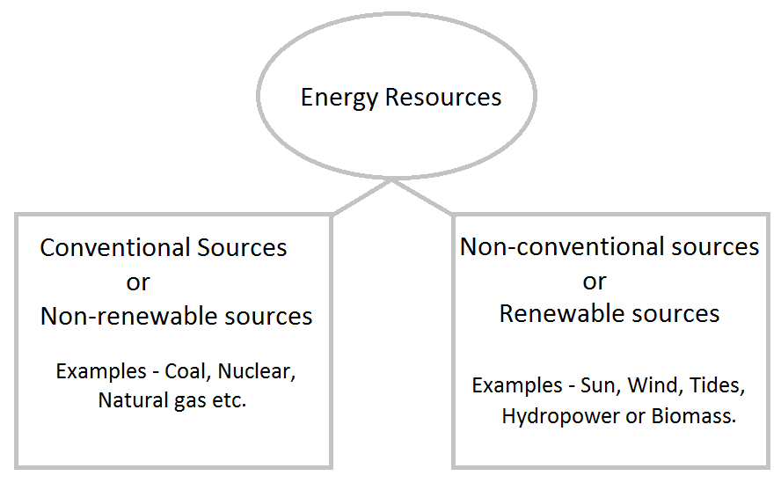

- Management of Smart Energy
Continued population growth and increasing urbanization have driven up global energy consumption. The various energy management concepts such as green energy, sustainable energy, renewable energy, etc. have been developed in recent decades to address the problems associated with increasing energy consumption(Chaurasia & Mondal, 2021b). The main goal of the green energy concept was to reduce the negative environmental and socio-economic impacts of non-renewable energy use. The result is that the need for clean energy is met while minimizing carbon emissions, greenhouse gas emissions, health problems, etc.
The concept of sustainable energy was developed with the intent of conserving and preserving non-renewable energy resources for the benefit of current and future generations. Sustainable energy generally combines renewable energy production and energy conservation. Renewable energy is another popular concept that uses renewable energy to meet global energy needs. Some of the most extensively utilized RESs include solar energy, wind energy, and tidal energy. The cost of RES has decreased over time and continues to fall. Smart energy is a comprehensive strategy that incorporates green, sustainable, and renewable energy ideas.

Figure. Smart energy idea integration
Non-conventional energy resources such as petroleum, coal, natural gas, and nuclear energy currently supply a large portion of the world's energy needs. Nevertheless, intensive efforts by professionals have significantly increased the contribution of renewable energy sources to global energy demand. As a result, the traditional paradigm of energy management is evolving into a hybrid model that incorporates both renewable and nonrenewable energy sources(Chaurasia et al., 2021). Although technological advances have transformed traditional distribution grids into smart grids that intelligently coordinate the behavior of all connected customers and utilities, hybrid energy generation requires certain additional capabilities. Therefore, the smart grid paradigm continues to expand to include renewable energy generation, renewable energy storage, distributed energy storage, and other related technologies.
- Overall energy resource distribution
Renewable energy currently makes only a small contribution to primary energy and electricity supply. Adequate cost reductions, renewable energy industry growth, and technological advances depend on government policy accuracy, private sector ingenuity, and investment(Singh Thakur et al., 2023). The first level in [Table 1] is the share of petroleum in total primary energy supply, with fossil fuels accounting for about 81%. Renewable energy is expected to replace fossil fuels because it is both environmentally safe and economically viable.

Resources | Properties | Share (%)
Oil | Oil is a finite resource. An oil is any nonpolar chemical compound that is hydrophobic and lipophilic and is made up largely of hydrocarbons. | 31.9
Coal | Resources that cannot be replenished. Coal is a flammable black or brownish-black sedimentary rock heavy in carbon and hydrocarbons. | 27.3
Natural gas | Natural gas is not a source of renewable energy. Natural gas is an energy source derived from fossil fuels. | 22.4
Biofuel & gas | Biofuels are a type of sustainable energy that is obtained from living matter. | 9.2
Nuclear | Nuclear energy is commonly regarded as a nonrenewable energy source. | 4.9
Solar, wind, geothermal & tidal | Wind power, solar power, bioenergy (organic matter used as a fuel), and hydropower (including tidal energy) are examples of renewable energy sources. | 1.9

Table 1. Global energy share vs energy supply
The largest renewable energy source, which includes solid fuels, biofuels, and charcoal, is found in developing countries at 60.7%, as it is used for heating and cooking. Figure 1 shows that hydropower is the second largest source, accounting for 18.5% of renewable energy. The other renewables account for a smaller share (Chaurasia et al., 2021).
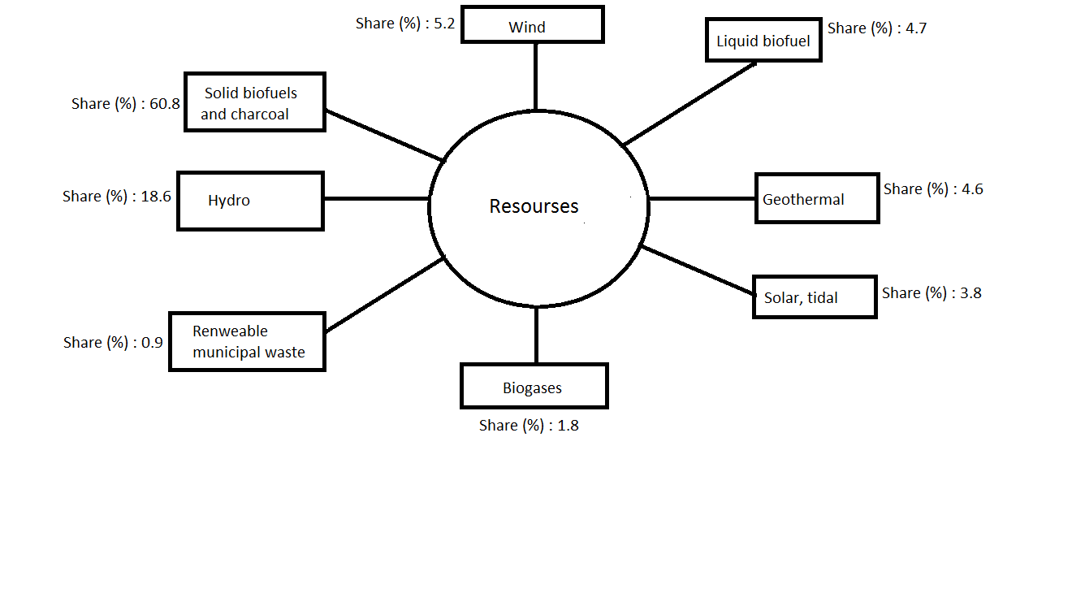
Figure 1 . Product shares in world renewable energy supply (2017).
The majority of renewables, on the other hand, are consumed in the residential, commercial, and public services sectors, as seen in figure 2.
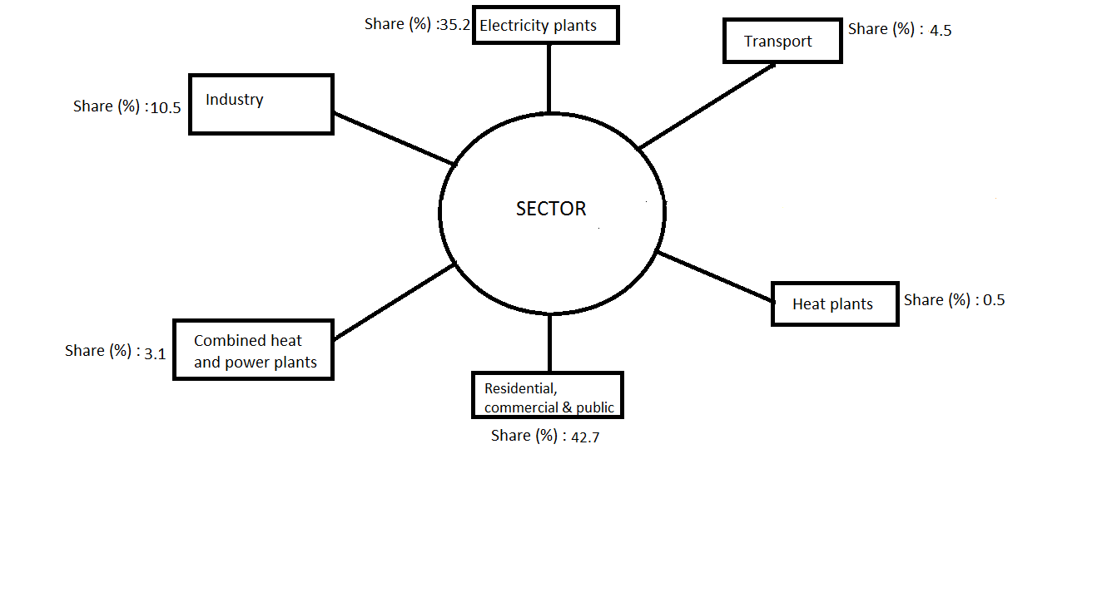
Figure 2 : energy utilization share

Figure3. shows the average figures for global total final consumption by sector in 2017. Industrial, transportation, and residential energy use account for 37, 29, and 22% of total energy use, respectively.
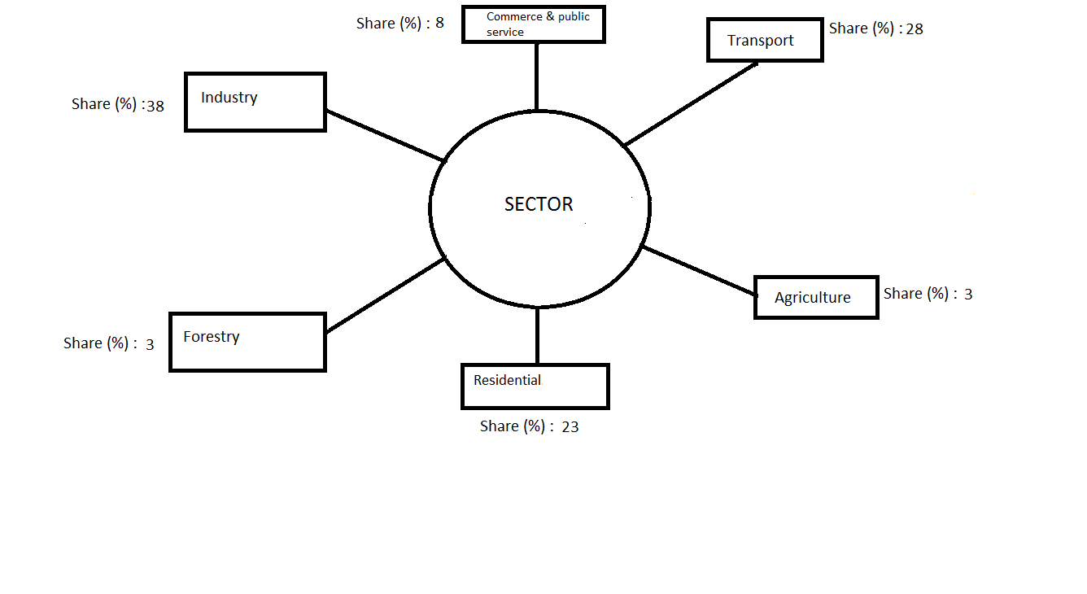

Figure 3: Total global final consumption by sector in 2017.

According to the figures, renewable energy will increase the quickest in the electrical sector, accounting for 29.4% of power consumption in 2023, up from 23.9% in 2017.
Table 2: Renewables share in 2017 and 2023.
Bioenergy (as solid, liquid or gaseous fuels) will nevertheless account for 30% of the increase in renewable energy consumption from 2018 to 2023, due to the use of bioenergy in the heating and transport sectors. In contrast, the remaining renewables, which account for 80% of total final energy consumption, have less impact on the heat and transport sectors. Although photovoltaic and wind energy continue to grow in the electric industry, bioenergy will remain in the lead. Renewables such as photovoltaic, wind, hydropower, and bioenergy are forecast to account for more than 70% of the increase in global electricity generation between 2018 and 2023. Hydropower (16%), wind power (6%), photovoltaics (4%), and bioenergy (3%) will meet global electricity demand through 2023. Biofuels in road transport have the lowest share of renewable energy, at 3.4% in 2017 and 3.8% in 2023. The increase in the use of renewable energy in the transport and heating sectors is slowing due to reduced legislative support and higher impediments to implementation(Chaurasia et al., 2020).
- Energy and long-term development
Energy utilization have significant ecological impacts in most of the developing countries. Therefore, a sustainable global energy system such as green technologies for its utilization should optimize efficiency while minimizing emissions.
Global environmental problems are ineluctable as energy consumption, especially from fossil energies, increases. Both developed and developing countries intend to enable the most applicable energy systems while perfecting the mortal, profitable, social, and environmental conditions for long- term growth. There are numerous issues presently facing the long- term sustainability of global energy systems, including demographic, social, profitable, and technological development( Kadier etal., 2020). To move toward sustainable energy systems, it concludes, vigorous action should be taken primarily in the areas of energy diversity and effectiveness, security of force, public trust, request- grounded interventions, request- grounded responses to climate change, cost- grounded pricing, technological invention and development, and indigenous integration of energy systems. The unborn artificial investments should go towards clean technology. The quality of a cleanser terrain will be told by profitable and political considerations, depending on technology advancements. Domestic renewable energy coffers similar as hydro, wind, solar, geothermal, and biomass should produce further power to offer resource variety. When compared to typical reactionary energy shops, geothermal power shops are more environmentally friendly. Adulterants emitted by the power factory might beget environmental damage. As a result, cooled geothermal fluids are pumped back into the soil, lowering the threat to the terrain. When compared to the environmental consequences of fossil energies, wind power has a modest environmental impact. Depending on the conditions, the position and operation of wind turbines may have a negative impact on the health of those who live hard( Escapa etal., 2016). Solar energy is getting decreasingly popular across the world. There are, still, several arrangements on solar thermal and PV installed power, and the same is imaged for concentrating solar power systems. Bio-energy is deduced from biomass, which is a clean energy resource in terms of the type of biomass and conversion fashion employed. 5. Energy security, problems, and bournes in terms of sustainability To epitomize, energy is pivotal to the problem of sustainability in terms of social, profitable, and environmental aspects. As a result, the shift to sustainable energy coffers and systems is coupled with a number of environmental, profitable, and development conditions. Original renewable coffers, installation costs, and policy frame will all be important considerations. Although the environmental counteraccusations of energy product and consumption are original, considerable impacts associated with pollution movement in the atmosphere can do on indigenous, international, and indeed international confines. While global electricity demand and sustainable development are fleetly adding , energy policy pretensions that take into account energy blend, effectiveness, request and environmental norms should also be established in order to give several recuperation on unlicensed electricity generation and renewable energy coffers( Energy, 2015). The following are some of the programs' primary factors ● Feed- in tariffs are used to secure advanced free request pricing. ● To give farther impulses for deals of locally made corridor of renewable energy power shops. ● When connecting to the grid, renewable energy should be prioritized. Energy difficulties for developing countries are serious and growing. still, numerous developing nations have some benefits in seeking to reform their energy sectors and may have an occasion to establish cleaner and more effective technology. It's apparent that the situation for arising countries is more grueling than that of fat bones
in numerous aspects. Due to resource limits, a considerable portion of the population may face problems penetrating essential energy services. numerous conventional technologies are anticipated to stay less precious than sustainable energy druthers
. Renewable energy sources should be supplied for any country's sustainable growth owing to abating reactionary energy situations, rising global reactionary energy prices, and reduced environmental impacts. Solar, wind, hydro, and biomass are significant forms of renewable energy sources with enormous pledge for meeting unborn energy enterprises. As mentioned, there are colorful characteristics that must be met in order to have a sustainable energy force, including climatic comity, resource sparing, minimum hazards, social equivalency, and public adequacy. Need of contemporaneous treatment of waste and wastewater The ultramodern period of the industrialization increases the energy extremity and wastewater generation that caused a serious life hazard for the entire ecosystem and mortal life. To alleviate these challenges contemporaneous treatment of wastewater and energy product is needed. therefore, it's demanded to develop clean and sustainable energy conversion technologies similar as product of energy from wastewater. Energy( Hydrogen) product from the wastewater won't run out ever while other sources of energy are finite and will eventually be deplete.. reactionary energies arenon-renewable resource The fact remains same as the reactionary energy is a finite resource. So, renewable source of energy must be discovered similar as electricity/ hydrogen from the wastewater. Fossil energy has adverse goods on terrain and climate Fossil energies are generating a number of adulterants similar as GHGs emigration leads to climate change generating solid waste, radioactive waste, as well as colorful adulterants are generated. By discrepancy, electricity/ hydrogen from wastewater has nearly zero emigrations or secondary adulterants generation. Energy from wastewater is generally sustainable for the terrain Power shops induce GHGs, fossil energies are also responsible for it. Beside this they also defiled the air, water and soil. Electricity/ hydrogen from the wastewater is the most important part of the sustainable development. Little to No Global Warming Emigrations mortal exertion is overfilling our atmosphere with GHGs emigration. Which has consequence of global warming, impacts on health and our terrain. Other hand renewable energy sources are sustainable. Enhance Public Health with Environmental Hydrogen from wastewater offer significant benefits similar as reduction of adulterants in the submarine system reduce impacts on the living system. It reduced water born dieses and give option for the exercise of the water for the irrigation purpose along with reduction in overall healthcare costs.

6.2 Types of the Industrial Wastewater and their Characterization
Industrial wastewater is the major source of pollutants that contaminants the aquatic environment and wastewater discharge rate is increasing day by day. These have adverse impacts over water environment, aquatic life and human beings. A variety of industries generated particulars types of pollutants in the wastewater that depends on the types of process of those industries. The major wastewater generating industries are the sugar industry, paper industry, beverage industry and food- processing industry. The wastewater of these industries consist of many organic nutrients, dyes, lignin, complex compound, and heavy metals that are low biodegradable in nature (Kumar Mishra and Mohanty, 2020; Northey et al., 2019; Sen et al., 2005). Thus, the characteristic of generated wastewater varies with types of industries and they required specific process for their waste disposal.
Usually, industrial wastewater is classified as the organic industrial wastewater and inorganic industrial wastewater. Organics present in the industrial wastewater is the potential source of energy generation. The organics content present in the wastewater are expressed in terms of COD, BOD and TOC content, while other parameter of the wastewater conductivity, pH, salinity, TDS, TS, SOx, NOx and metals ions. The COD, BOD and TOC content of the wastewater are converted in the various form of the energy with suitable wastewater treatment technology that are described in the Table 2.5 and Fig. 2.2, whereas other parameters do not contribute to the energy generation process but they have direct or indirect impacts on the efficiency of the wastewater treatment technology.

Table 2. Organic load and type of organics in the wastewater of some major industries
Industry type | Organic load (mg/L) | Impurities and other constituents | Reference
Paper | COD: 4000–40000  BOD: 1000-12000 | lignin: 20-40%  Other organics: 10-15%  TDS: 1100-6800 (mg/L)  TSS: 400-2000 (mg/L)  Total sugar: 300-4000 (mg/L) | (Ashrafi et al., 2015)
Sugar | COD: 4000–20000  BOD: 1000-9000 | Glucose, Fructose  Other organics: 10-20%  TDS 1000-8000 (mg/L)  TSS 300-1500 (mg/L)  Total sugar: 500-6000 (mg/L) | (Sahu, 2017; Vaithiyanathan and Sundaramoorthy, 2017)
Distillery | COD: 110000–190000  BOD: 50000–60000 | Sugar, acids | (Parthasarathy and Narayanan, 2014)
Oil refinery | COD:1965  BOD: 685 | Oil contents, total solids, phenol | (Ren et al., 2013)

6.4 Characteristics of industrial Wastewater
Paper industry is a highly water intensive and generates around 70 cubic meter of wastewater per ton of paper produced. Suspended solid (mainly fibers), chlorinated compounds (measured as AOX), lignin and its derivatives, phenols and its derivatives, fatty acid, tannins, resin acid, SOx compounds are normally present in paper industry wastewater that have low biodegradability index (< 0.4). The paper industries effluents have toxic compound like phenols, lignin derived compound, xenobiotic etc., that are carcinogenic in nature. Similarly, the sugar industry is involved in sugarcane processing process that generate high amount of wastewater by utilizing sugarcane and agro-based raw materials. The sugar mill industries that have created significant socio-economic impact on rural agro-based economy. The wastewater of these industries consists of high amount of organic nutrients, color, oil and grease, carbonate, bicarbonate, nitrite, phosphate and complex compound. The sugar processing industry is a highly water intensive and generates around 65 m³ of wastewater per ton of sugar produced (Jain et al., 2015). The sugar industry wastewater has relatively higher biodegradability index than paper industry because of sugar industry wastewater have higher concentration of carbohydrates and simple sugar containing compounds. The organic load in the sugar processing wastewater in the relatively higher range (COD 4,000– 20,000 mg/L, BOD: 1,000–12,000 mg/L) than paper industry wastewater. The nature of organic compounds and effluent’s quality of sugar industry vary considerably with end products, process condition and raw material being utilized. The range of constituent present in the sugar industry wastewater is summarized in the Table 2.2. The amount of wastewater generated in sugar and paper industries are higher and it must be treated to meet the permissible limit of the discharges. Minimum National Standards (MINAS) for treated sugar and paper industry wastewater is provided in Table 2.3.
Table MINAS for the discharge of sugar and paper industry wastewater (CPCB,2017)
Parameter | Paper industry | Sugar industry
BOD at 27 ⁰C (mg/L) | <30 | <30
COD (mg/L) | <250 | <250
Oil and grease (mg/L) | <10 | <10
Suspended solids (mg/L) | <100 | <30
pH | 6.5-8.5 | 5.5-9.0
N (mg/L) | <100 | <100

- Obstacles to renewable energy
There are several challenges and impediments to overcome while creating renewable energy. Some technologies have been capitalized and industrialized to some extent, and the scale and speed of development of diligence in developing nations are necessary and have enormous gaps. The following challenges to renewable energy product may be distributed into three orders Cost- cutting measures Traditional energy sources are less precious and less precious than renewable powers. Because the cost of producing renewable energy is advanced than that of producing fossil energies using the same technology, there are significant hurdles to commercialization and distribution of renewable energy. The major causes for renewable energy's high product costs are limited scale and low manufacturing technology. ii. Obstacles to request share The current advancement of renewable energy involves pricing constraints. A advanced request, on the other hand, may give system operating trustability while also lowering manufacturing costs. iii. Policy constraints Policy enactment and perpetration are different corridor of the policy process. Renewable energy should be developed to an artificial scale in the future. As a result, depending on policy backing, renewable energy's request share must be raised. walls associated with societal and artistic patterns must be avoided in order to have further sustainable lives, and hence charming and more sustainable druthers , as well as other impulses, will be necessary. Because of the prevailing supposition in endless natural coffers and continuing profitable expansion, the current profitable system continues to be a hedge to change. The present construction business, on the other hand, is a veritably conservative enterprise. It's extensively conceded that new and more sustainable designs, erecting accoutrements , and construction processes are just gradationally appearing and being applied. Another difficulty for erecting energy effectiveness is the high cost and extended vengeance period for upgrades. 6. Renewable energy development strategies, programs, and criteria Renewable energy has come a significant volition for governments in espousing sustainable plans. It's necessary that energy will be the driving force behind social and profitable progress. still, because reactionary energy is extensively used, the frugality and terrain's sustainability suffer. Renewable energy arenon-polluting and pure. They encourage and promote the ideal of sustainable development. As a result, the development of renewable powers is whisked by making laws and regulations that give significant impulses. Renewable energy's strategic points are basically to increase energy competitiveness, secure force, and guard the terrain. Renewable energy coffers are also named to replace fossil energies in order to organize the energy structure and ameliorate energy force security. Because renewable coffers are available locally, they may be converted directly or laterally into energy or liquid energies. In pastoral regions, the development of renewable energy coffers may attack the problem of energy consumption while also combining with agrarian affair, adding planter income. Renewable energy is anticipated to regard for around 30 of global energy structure by 2050. Renewable energy product is dependent on technological invention and the advancement of new high technology situations associated with industrialisation and commercialization. It's true that the expenditure of developing renewable energy is kindly precious. Countries won't help to cut costs, raise gains, maintain responsibility, and ameliorate the value of renewable energy if the government's support and policy donation can not assure large- scale development. Renewable energy is the foundation of the unborn energy system, meeting pressing demands for its environmental benefits, sustainable development, and use. Due to present energy and environmental issues, it's vital to accelerate the growth and trends of renewable powers. 7. Global Renewable Energy Future Trends According to, global energy trends and their implicit consequences are linked to issues similar as force and demand, energy access, the terrain, and air pollution. Current programs are being developed to fulfill long- term climate targets under the Paris Agreement, and they will serve to reduce air pollution and give universal energy access. Renewable technologies are the top choice in electricity requests due to lowering prices and favorable government regulations. It's likely that an ambitious mileage will seek to deliver renewable energy at a cheap and set price in order to attract investment. By 2040, renewables are prognosticated to regard for further than 40 of worldwide electricity generation. still, coal and gas will continue to be the most important energy coffers. unborn electricity requests will be flexible and adaptable due to change in force and power systems. To be engaged in renewable energy sharing, request changes, grid investments, and new enabling technologies are necessary. Energy technologies, as noted, have concentrated on the proliferation of clean energy technology in terms of possibilities and constraints. Global technological trends have an impact on assiduity competitiveness and unborn growth. By relating difficulties for invention and technology, artificial reliance on foreign technology may be lessened. To ameliorate technological growth at the moment, the following introductory transnational trends may be linked ● Technology collaboration ● ICT stands for information and communication technology. ● Digitisation ● The emphasis is on high- tech diligence. ● Recognising the significance of transnational enterprises. While it's preferable to use an applicable energy source in the energy blend, variables similar as specialized invention, cost savings, energy storehouse technology, and rising consumer demand are critical for the operation of renewables and indispensable coffers. On the other hand, the expanding significance of coastal wind will attract new investors and may beget further onshore wind providers and inventors to shift their focus to the sector. The worldwide eventuality of algal biofuel Encyclopedically, there's a drive to use algal biofuel since it has enormous implicit as a unborn green transportation energy. The US government has begun to move its attention from food crops to algae- grounded biofuel product. Since 1982, the ASP( Submarine Species Programme) has accepted several studies on algae- grounded biofuel in Hawaii, California, and New Mexico, yielding a 100 times advanced affair than oil painting win. Algae- grounded biodiesel performance and emigrations, numerous scientists have successfully synthesized biodiesel from colorful Algae factory species and studied its performance and emigration parcels in CI machines. One of the easiest conversion processes is the transesterification of algal lipid content into biodiesel. Geographically, India has a vast bank and a tropical terrain that are ideal for large- scale algae husbandry. expansive exploration has been conducted in India on the use of microalgae for culinary and pharmaceutical purposes. 8. Technologies and operations that make it possible While global energy demand is adding and new power shops are necessary, energy security and responsibility should be enhanced, and indispensable energy sources should be delved . As stated, factors similar as high exploration and development intensity, quick invention cycles, high capital investment, and largely trained workers are supplied to make enabling technologies. Enabling technologies that are interdisciplinary and probative of technology leaders' exploration sweats meet the procedures for products and service invention. Enabling technologies are substantially chosen in the following manner ● Addressing global issues similar as low- carbon energy or resource effectiveness ● to prop in the creation of new particulars ● to promote profitable growth and employment creation To reduce prices and increase integration, a blend of enabling and demand trends is needed to realize global renewable energy trends. The following are current enabling technologies ● High- tech accoutrements ● Systems for advanced manufacturing ● Microelectronics and nanoelectronics ● Nanotechnology ● Biotechnology in the plant ● Photonics As stated, innovative accoutrements , sophisticated manufacturing systems, and artificial biotechnology are needed to meet social enterprises and speed the growth of the frugality and the energy transition. Digital technologies are being incorporated into process technologies, material development, and business model creation as a result of the present digital elaboration and its great benefits. Enabling technology will also quicken the development of new requests, growth, and jobs. The following are the crucial technological advances and enterprise that are needed ● Developing advanced accoutrements for use in energy effectiveness(e.g., light weight), renewable energy generation and storehouse(e.g., battery factors), or smart features that respond to stimulants(e.g., tone- form). Accoutrements for structure, energy, mobility, food, health, and electronics are also created by advanced accoutrements . Polymer accoutrements for 3D printing are employed in the automotive, featherlight design, medical, and 3D printing diligence. ● Creating advanced process technologies and artificial biotechnology for further sustainable energy product and indispensable energy coffers. ● Using digital technology to give better process control, business models, and innovative consumer gests . Digital technologies grease the move from batch to nonstop boosted operations that are adaptable and nonstop. On the other hand, the development of technology to convert CO2 into a precious resource and to use it in the product of polymers can help minimize the consumption of petroleum. Process technologies allow raw accoutrements to be converted into products with a different chemical composition, structure, and rates than the input raw accoutrements . Advanced process technologies are a subset of enabling technologies that enable the chemical assiduity to supply accoutrements ( solid, gas, and liquid) and new parcels to all artificial value chains(e.g., construction, automotive, medical, electronics, and energy). As described, solar energy may be converted to both electricity and thermal energy at the same time by a mongrel photovoltaic/ thermal( PV/ T) system, which can also meet erecting energy demands. Performance study of PV/ T systems is critical when developing them to fit the functional circumstances. profitable constraints and operations should be considered while conducting an energy inflow study. Solar power, as prognosticated, offers colorful advantages and is more competitive than conventional energy sources. There may be a land acceptability issue for onshore wind turbine installation. As a result, if the place is suitable, an coastal wind turbine with lesser profitable charges is an alternate option these days. Wind energy has major technological, social, and environmental hurdles. Wind energy, on the other hand, has surfaced as a feasible option for both established and developing countries in sustaining a green terrain. The following are introductory developing generalizations for unborn sustainable cultures ● To transfer the focus of design, planning, and action down from the individual and towards the community, allowing communities to take power. For illustration, if a community is innovated on equity, collective backing, and stakeholder engagement, it's possible to produce further connected communities and sustainable neighborhoods. ● The sharing of products and services contributes to the development of cooperative structure. As a result, community- grounded consumption has eased the negative goods of individual consumption. For illustration, smart renewable energy backing for distributed renewable energy generation and consumption. ● Sustainable results must be regularized without reducing people's freedom of choice. Several options can make sustainable opinions easier and appealing, as well as changing the necessity for individual conduct. People will, for illustration, coordinate their conduct grounded on consumption situations and resource application. There's a strong emphasis on invention in enabling technologies that can prop in the integration of variable renewable coffers into energy networks.

- Conclusions
Fossil fuels preserve to account for the general public of energy utilization and are at the rise the world over. Environmental infection is unavoidable in this situation, and renewable strength plants make no direct contribution.
it is was hoping that inside the destiny, the number one electricity resources could be revolutionary and renewable energies. even as fossil fuels will ultimately run out, renewables will become extra essential. they're powerful in a spread of regions, inclusive of chronic cost savings, process advent, the development of latest businesses, and satisfying energy and environmental standards.
Renewable power manufacturing and usage will benefit strength protection, the environment, the financial system, mechanical production, construction, transportation, and enterprise, in addition to serve to create new employment. sun, wind, and biomass energies can satisfy neighborhood energy needs whilst additionally supporting to enhance environmental safety. The contemporary power demand state of affairs fosters a big marketplace for renewable energy. Renewable strength will account for 12.4% of global energy consumption by using 2023, as expected.
Renewable electricity has the capability to make fundamental contributions to energy demands inside the lengthy destiny if investments in renewable generation keep. moreover, biofuels and gasoline cells can contribute to the warmth, transportation, and electricity industries.
In 2023, the percentage of fossil fuels in overall primary power supply is predicted to be approximately 81%. Renewable energy will account for kind of 30% of world strength structure by using 2050.
the share of home and renewable power assets in the producing system can be improved to the finest diploma possible by means of imparting international locations with balanced useful resource range for number one power sources. objectives should be attained in time for helping, growing, and inspiring new environmentally pleasant practices in generation and services, as is likewise sought in many countries' existing strategic plans. The pinnacle industrialized nations, inclusive of America, Japan, and Europe, have the highest marketplace proportion and the maximum state-of-the-art renewable energy era.
Many electricity-efficient enabling technology are used to make use of less and purifier energy in energy flowers, buildings, industrial centers, and transportation networks. these technologies have the capacity to reduce fees by way of as much as 80%, shop strength by as much as 30%, and help in halting global warming in the destiny. As a end result, the countries could continue to be price-powerful at the same time as making long-term development. advertising renewable energy will also be characterized as the ability of knowing purchasers and their demands.
Energy management has arisen as a carrier in smart settings with the goal of using strength extra effectively and sustainably. The advantages of electricity control are diverse and observe to any smart surroundings. The cause of this essay was to provide an outline of the relationship among clever environments and energy control.
Chaurasia, A. K., Goyal, H., & Mondal, P. (2020). Hydrogen gas production with Ni, Ni–Co and Ni–Co–P electrodeposits as potential cathode catalyst by microbial electrolysis cells. International Journal of Hydrogen Energy, 45(36), 18250–18265. https://doi.org/10.1016/j.ijhydene.2019.07.175
Chaurasia, A. K., Mohapatra, S., Shankar, R., & Thakur, L. S. (2022). Technologies for the clean and renewable energy production for the sustainable environment. Clean Technologies and Sustainable Development in Civil Engineering, 141–178. https://doi.org/10.4018/978-1-7998-9810-8.ch007
Chaurasia, A. K., & Mondal, P. (2021a). Hydrogen production from waste and renewable resources. Hydrogen Fuel Cell Technology for Stationary Applications, 22–46. https://doi.org/10.4018/978-1-7998-4945-2.ch002
Chaurasia, A. K., & Mondal, P. (2021b). Hydrogen production from waste and renewable resources. Hydrogen Fuel Cell Technology for Stationary Applications, 22–46. https://doi.org/10.4018/978-1-7998-4945-2.ch002
Chaurasia, A. K., Siwach, P., Shankar, R., & Mondal, P. (2021). Effect of pre-treatment on mesophilic anaerobic co-digestion of fruit, food and vegetable waste. Clean Technologies and Environmental Policy, 1–23. https://doi.org/10.1007/s10098-021-02218-5
Energy, U. S. D. of. (2015). DOE Technical Targets for Hydrogen Production from Electrolysis | Department of Energy. U.S. Department of Energy. https://www.energy.gov/eere/fuelcells/doe-technical-targets-hydrogen-production-electrolysis
Escapa, A., Mateos, R., Martínez, E. J., & Blanes, J. (2016). Microbial electrolysis cells: An emerging technology for wastewater treatment and energy recovery. from laboratory to pilot plant and beyond. Renewable and Sustainable Energy Reviews, 55, 942–956. https://doi.org/10.1016/j.rser.2015.11.029
Hieminga, G., & Patterson, W. (2021). Energy outlook 2021. The Bipartisan Policy Center, 2021(January), 1–22. Annual Energy Outlook 2021
Kachroo, H., Chaurasia, A. K., Chaurasia, S. K., & Yadav, V. K. (2022). Sustainable Clean Energy Production from the Bio-electrochemical Process Using Cathode as Nanocatalyst. Handbook of Green and Sustainable Nanotechnology, 1–30. https://doi.org/10.1007/978-3-030-69023-6_58-1
Kadier, A., Chaurasia, A. K., Sapuan, S. M., Ilyas, R. A., Ma, P. C., Alabbosh, K. F. S., Rai, P. K., Logroño, W., Hamid, A. A., & Hasan, H. A. (2020). Essential Factors for Performance Improvement and the Implementation of Microbial Electrolysis Cells (MECs). In Bioelectrochemical Systems (pp. 139–168). Springer Singapore. https://doi.org/10.1007/978-981-15-6872-5_7
Shankar, R., Pathak, N., Chaurasia, A. K., Mondal, P., & Chand, S. (2017). Energy production through microbial fuel cells. Sustainable Utilization of Natural Resources, 354–380. https://doi.org/10.1201/9781315153292
Singh Thakur, L., Parmar, H., Kumar Varma, A., Kumar Chaurasia, A., & Mondal, P. (2023). Removal of manganese from synthetic wastewater by Vetiveria zizanioides. Materials Today: Proceedings, 72(xxxx), 2687–2690. https://doi.org/10.1016/j.matpr.2022.08.395
Tan, C. W., Tan, K. H., Ong, Y. T., Mohamed, A. R., Zein, S. H. S., & Tan, S. H. (2012). Energy and environmental applications of carbon nanotubes. Environmental Chemistry Letters, 10(3), 265–273. https://doi.org/10.1007/s10311-012-0356-4

