An assessment of subsurface geological study using square array and magneto telluric method in Thamirabarani river basin, Thoothukudi district, Southern India
Richard Abishek S^{1, 2}, Antony Ravindran A¹, Muthusamy S¹, Mohamed Afzal J³,Moorthy GM¹
¹ Department of Geology, V.O.Chidambaram College, Thoothukudi – 628008
² (Reg.no19212232221046) Research scholar in affiliated by Manonmaniam Sundaranar University, Tirunelveli
³Department of Geology, University of Madras, Guindy campus, Chennai, India
*Corresponding author: Richard Abishek S
E-mail: richardabishek9710@gmail.com

Abstract

A comprehensive study focuses on surface water in the Thamirabarani river channel, Thoothukudi district. In this section of the Thamirabarani river channel into the Bay of Bengal, coastal terrace sediments, black soil, red sandy soil, and river alluvium completely fill the studied region. This area includes the meta-sedimentary formation quartzite, weathered gneissic, granitic intrusion, and charnockite. A square array and the magneto-telluric method were used in the area to analyze the river basin surface and subsurface. Decision-makers can better plan for the management and maintenance of water resources if they have a clear understanding of the geographic areas of high water quality. The fractured quartzite has an ohm.m value of 0.15-0.18 and charnockite has an ohm.m value of 0.02-0.32. The water bearing zone is clearly mapped in the Magneto telluric profile at 50m depth. The investigation took place in regions where thick alluvium has been present in the geological record. According to the data, groundwater lowers the resistivity value, and silt lowers the resistivity value even more than groundwater. Groundwater reservoirs are found in saturated sand, saturated sandy clay, and saturated silt, clay, and sand.
Keywords: Thamirabarani river basin, Square array, Magneto telluric, Saturated rock

1. Introduction
The importance of geophysical technologies in groundwater exploration is critical. The objective is to entirely and completely understand the hidden subsurface hydrogeological conditions. Any geophysical method has been constructed on measuring the difference in physical attributes between the target and its surroundings. The better the contrast or anomaly, the better the geophysical response and thus the identification. Thus, the success of any geophysical approach is determined on its ability to detect and resolve hidden subsurface hydrogeological heterogeneities or variation. The Thamirabarani River is a perennial river in Tamil Nadu. The electrical resistivity of topography variation was researched in the Mannar Gulf coastline near the Thamirabarani river channel, Thoothukudi, Tamilnadu (Figure 1). Basheer, A. A., and Alezabawy, A. K. (2020) use the azimuth square lattice method to locate the cracked zone of quartzite rock for an aquifer mapping undertaking. Resistivity experiments were carried out to evaluate the optimum soil and dunes thickness in the research region, as well as groundwater and saltwater infiltration (Antony Ravindran 2012). The study includes clay, alluvium, and sandstone soil, as well as Kankar and Caliches, weathered gneissic rock, and bedrock. In general, river basins are extremely vulnerable to contamination from various transport and absorption processes. The resistivity method simply measures the distribution of resistance in subsurface materials. The resistivity of several common rocks, soils, and water (Keller and Frischknecht, 1996) High resistivity metre and laptop computer resistivity values are common in igneous and metamorphic rocks. The resistivity of these rocks is mostly determined by the degree of fracture. Electrical resistivity methods have been used to investigate groundwater (Olorunfemi and Fasoyi, 1993; Olasehinde, 1999; Alile et al., 2008). As a result, despite significant interpretation limits, the application of such approaches for groundwater exploration has earned an important role in recent years (Dogara et al., 1998; Singh et al., 2006). Therefore, it is anticipated that the findings of this study will provide extensive information about the groundwater environment, allowing for the recommendation of specific areas within the observatory for the emplacement of deep tube wells (Nmankwo, 2011).
2. Study Area
The study region is located in Thoothukudi District, Tamil Nadu, between 8°43'03.2"N of latitude and 77°50'03.1"E of longitude, and 8°38'45.1"N of latitude and 78°07'15.5"E of longitude. Water-bearing formations include quaternary alluvium, Teri sands (sand dunes), tertiary sediment sand, weathered zones in gneisses, and charnockite. Marine and river marine deposits make up the majority of the litho units in coastal areas. The Thamirabarani delta is supported by Archean-age rocks such as gneisses, granites, and charnockite. The coastal region is underlain by marine, fluvial marine and eolian sediments. The hydrogeological deposits in the research area are porous and fissured. Hard rock formations of Archean age that have been worn and fractured as well as porous sedimentary formations from the Tertiary and more recent eras make up the main aquifer systems. In the studied area, the surface layer occurs, which is primarily covered by alluvium deposits (Figure 1).
3. Materials and Methods
An azimuthal square array with electrical resistivity is used to find cracks in quartzite, gneiss, and charnockite. This technology allows for greater penetration depth than the Wenner and Schlumber gratings. The measurement of cracked quartzite in the study region was made possible by 360° rotation of the Alfa, Beta, Gamma, Alfa ', Beta', Gamma 'directions (Figure 2). The ADMT-300S low-frequency magnetotelluric equipment is used to locate quartzite and gneisses, shale, and granite rocks beneath the surface of deeper structural formations, which are plotted on a 2D image (Ravindran, A. A., Kingston, J. V., & Premshiya, K. H. 2020). The natural electromagnetic field's strength correlates to the subterranean creation of the earth's rock and changes in resistivity recorded in the field (Figure 4).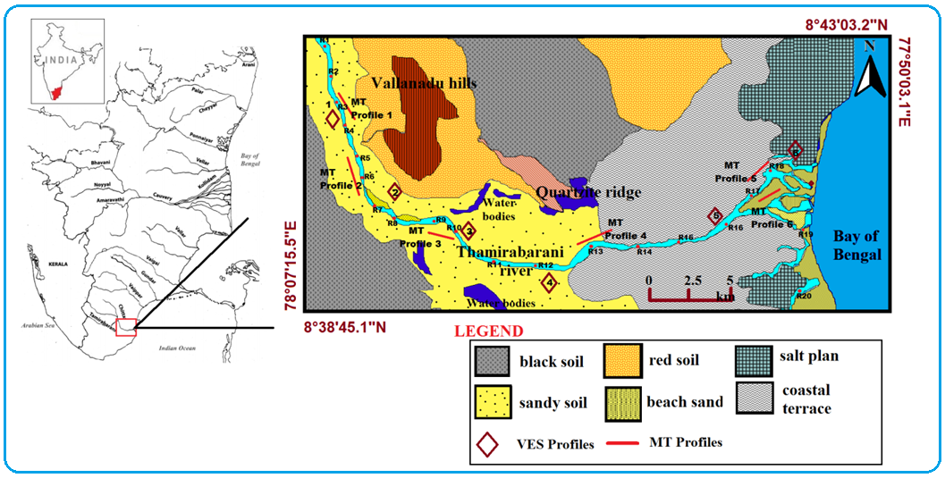
Fig.1 Location Map of the study area
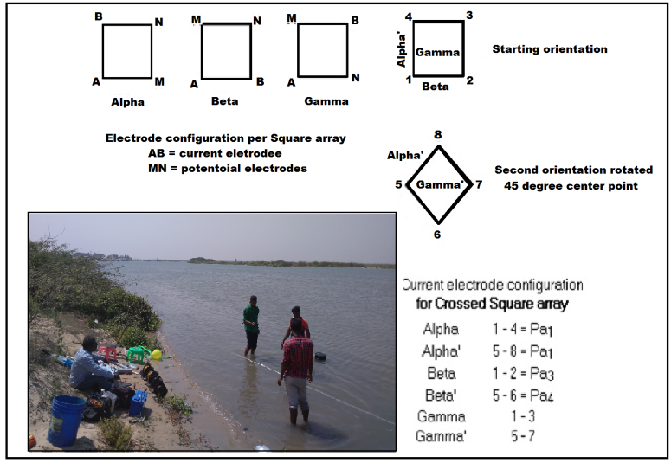
Fig.3 Square array data collection
4. Result and Discussion
4.1Square array method
In the study area, a six-square sounding of the electrical resistance in depth was carried out (Figure.3). It is a useful method and azimuthal variation of the groundwater zone, quartzite, gneisses, and granitic rock intrusions in the study area (Ravindran, A.A., 2018). Totally 6 VES profiles was carried from the Thamirabarani river basin area Table 1.

Table 1.Discussion about the VES profiles.
No.of.VES Profiles | Electrode spacing and depth (m) | Discussion
Profile 1 | 10m and 100m | A shallow freshwater aquifer at a depth of 45-50m is indicated by an apparent resistivity range of 110-120 ohm.m. The curve of a gradual increase in high resistivity shows quartzite and large charnockite rock.
Profile 2 | 10m and 100m | The apparent resistivity ranges from 100 to 130 ohm.m, indicating the presence of a shallow freshwater aquifer at depths ranging from 35 to 45 m. The cal-granulite, quartzite, and large charnockite rocks are identified by the curve of a progressive increase in high resistivity.
Profile 3 | 10m and 100m | The presence of a shallow freshwater aquifer at a depth of 25-55 m is indicated by apparent resistivity in the range of 110-120 ohm.m. The gneiss, quartzite intrusion, and huge charnockite rock are indicated by the curve of a steady increase in high resistivity.
Profile 4 | 10m and 100m | The apparent resistivity ranges between 100 and 126 ohm.m, indicating the presence of a shallow freshwater aquifer at depths ranging from 45 to 65m. The large charnockite rock is indicated by the curve of a progressive increase in high resistivity.
Profile 5 | 10m and 100m | The apparent resistivity ranges between 100 and 120 ohm.m, indicating the presence of a shallow freshwater aquifer at depths ranging from 50 to 65m. Massive charnockite and weathered rock are shown by the curve of a progressive increase in high resistivity.
Profile 6 | 10m and 100m | The presence of a shallow freshwater aquifer at depths of 25, 40, and 55 metres is indicated by apparent resistivity in the range of 110-120 ohm.m. The large charnockite rock is indicated by the curve of a progressive increase in high resistivity.

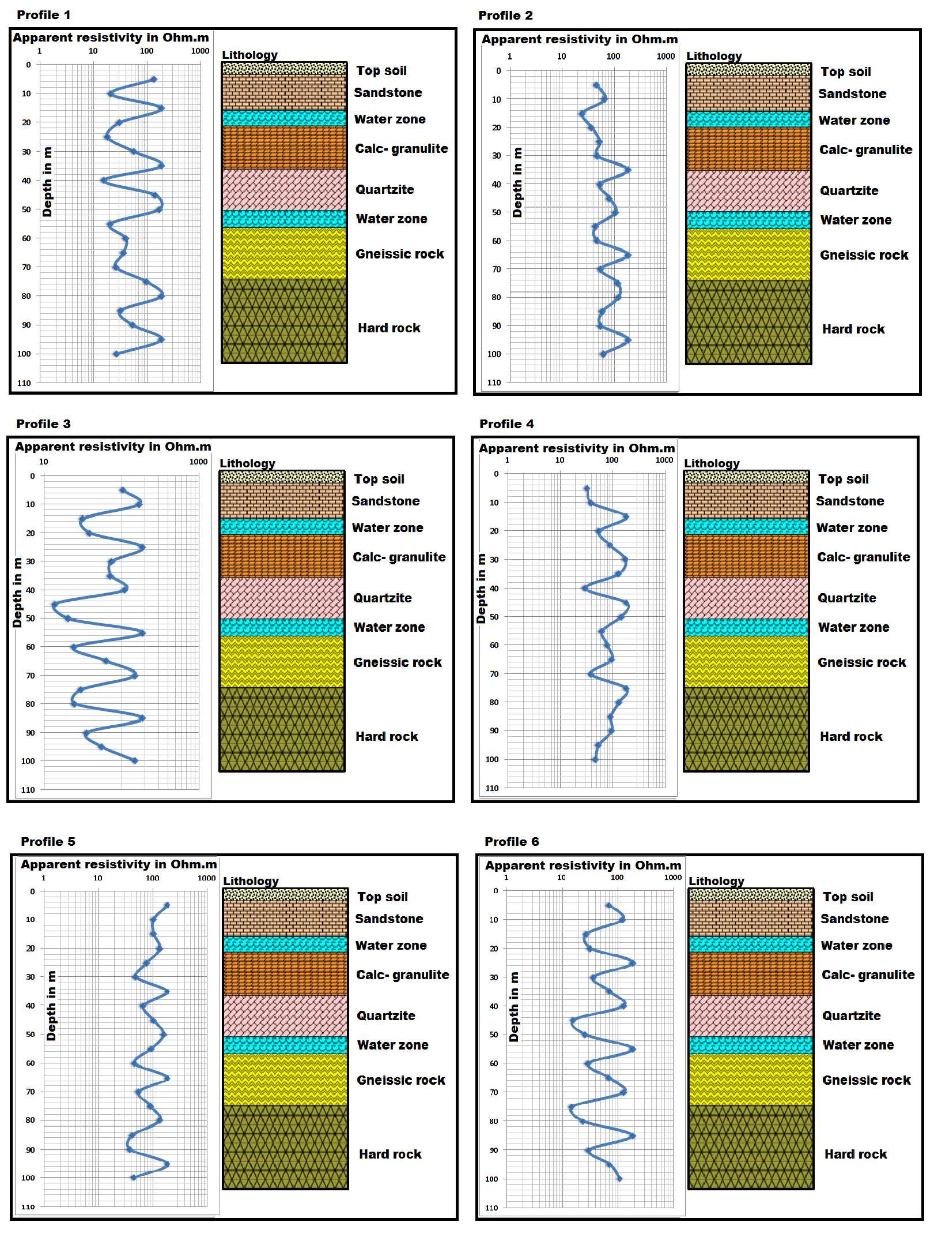
Fig.3 Square array data collection and profiles
4.2 Magneto Telluric Method:
Two copper electrodes are used for M, N electrodes for transmitting diversity to increase it and obtain greater depth information up to 300m (Jeyapaul VK, Jebamalai ARA, Selvam RA, 2020).The Magneto Telluric method carried out from 6 profiles was parallel to the Thamirabarani river basin Table 2.
Table 2.Discussion about the MT profiles.
No.of.MT Profiles | Distance and depth (m) | Discussion
Profile 1 | 120m and 300m | The profile was traversed at a distance of 110m at a depth of 300m. The high resistivity of 0.24-0.32 Ohm/m indicates sandy formations and a number of sandbars present in the area. The range of low resistivity is 0.03-0.12 Ohm.m, which indicates moisture in the soil and underground aquifers at a depth of 130m. Weathered formation indicates 0.19–0.25 ohms in lime concrete and gneiss rocks at a distance of 70m.
Profile 2 | 120m and 300m | The profile was traversed at a distance of 110m at a depth of 300m. A high resistivity of 0.27–0.32 ohms indicates sand formations and vertical formations at a distance of 80–90 m in the area. The range of low resistivity is 0.03-0.12 Ohm.m, which indicates moisture in the soil and groundwater aquifers at a depth of 50m. Weathered formation indicates 0.12-0.21 ohm in calc-granulite and gneiss rocks.
Profile 3 | 120m and 300m | The profile was traversed at a distance of 110m at a depth of 300m. The high resistivity of 0.28–0.32 ohms indicates sandy formations in the area. The range of low resistivity is 0.04-0.16 ohm.m, which indicates the moisture content of the soil and underground aquifer at a depth of 190–240 m. The weathered formation indicates the intrusion of lime concrete and some quartzite and gneiss rocks at 0.19–0.25 ohms at a depth of 140m.
Profile 4 | 120m and 300m | The profile was traversed at a distance of 110m at a depth of 300m. The high resistivity of 0.12-0.15 ohms indicates sandy formations in the area. The range of low resistivity is 0.04-0.07 ohm.m, which indicates the moisture content of the soil and underground aquifers at a depth of 280m. Weathered formation indicates the presence of 0.09–0.011 ohms in the intrusion of quartzite and gneiss rocks at a depth of 90 m.
Profile 5 | 120m and 300m | The profile has a length of 140m and a depth of 300m. The high resistivity of 0.26-0.32 ohms indicates the presence of river alluvium or sandy formations in the area. The range of low resistivity is 0.10-0.18 ohm.m, which indicates moisture in the soil and underground aquifers at distances of 80m, 90 m, and 100 m. Weathered formation indicates penetration of gneiss rocks to a depth of 30 m and 90 ohms into 0.20-0.24 ohms.
Profile 6 | 120m and 300m | The profile has a length of 120m and a depth of 300m. The presence of river alluvium or sandy formations in the area The range of low resistivity is 0.09–0.21 ohm.m, which indicates soil moisture and groundwater penetration to a depth of 120m. Weathered formation indicates calc granulite penetration and gneiss rocks at 0.25-0.32 ohm per depth of 30 and 90 metres.

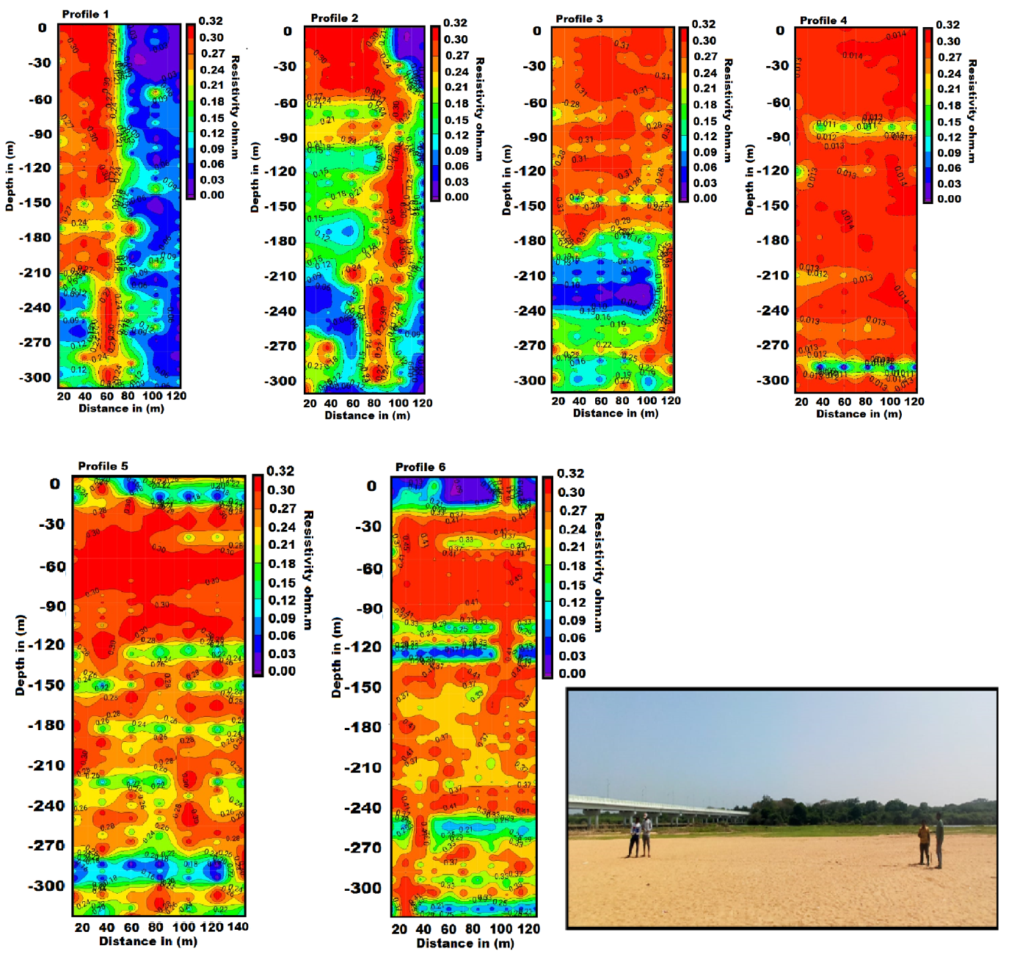
Fig.4 Magneto telluric survey and profiles

5.Conclusion

The Azimuth square array is a helpful resistivity array for aquifer mapping for drinking and agriculture reasons. In quartzite, fresh water is indicated by an apparent resistivity range of 110–123 ohm.m. The apparent resistivity ranges of 14-75 ohm.m. (red and sandy soil with rock fragments), 25-100 ohm.m. (weathered gneissic rock), 100-200 ohm.m. (quartzite rock), and 200-1000 ohm.m. (massive charnockite) are used for subsurface geological formation and aquifer characteristics at shallow and deeper levels. The magneto telluric approach is used to map subterranean and deeper aquifers. The average resistivity of the aquifer is 0.03-0.12 ohm/m. The broken quartzite has a resistance of 0.15-0.18 ohm.m, while charnockite has a resistance of 0.021-0.32 ohm.m. The magneto telluric profile at 50m depth clearly maps the water-bearing zone. Rainwater infiltration occurs during both monsoon and dry seasons. A little amount of the precipitation that infiltrates is artificially refilled, along with irrigation and monsoon water. The impact of irrigation water penetration on aquifer recharge is particularly substantial in shallow aquifers. Rock-water interaction studies are used to distinguish the sources of gneiss and quartzite for drinking water and fresh water for agriculture. A zone of shattered quartzite is additionally added by the Tamirabarani channel tributary.

Acknowledgements
The First author expresses his sincere thanks to Mr. A.P.C.V. Chock lingam, Secretary and our Principal, Dr. C. Veera Bhahu, V.O.C. College, Tuticorin. The helps extended by Dr. P. Sivasubramanian, Professor and Head, PG and Department of Geology, V.O. Chidambaram College, Thoothukudi.

References
Ali, A., Rehman, K., Tayyab, O., Zaman, T., Jameel, M., Khan, A., ... & Irfan, M. (2020). Exploring Placer Gold Deposits through Integrated Geophysical and Geochemical Techniques at the Confluence of the Indus and Kabul Rivers, NW Pakistan. Acta Geologica Sinica‐English Edition, 94(5), 1440-1450. https://doi.org/10.1111/1755-6724.14584
Alile, M. O., Jegede, S. I., & Ehigiator, O. M. (2010). Underground water exploration using electrical resistivity method in Edo State, Nigeria. Asian Journal of Earth Sciences, 3(1), 57-61.
Dogara, M. D., Dewu, B. M., & Ajayi, C. O. (1998). Groundwater potential of Romi, Kaduna, Nig. J. Physics, 10, 85-90.
Jeyapaul, V. K., Jebamalai, A. R. A., Selvam, R. A., Krishnaveni, A. S., & Johnson, A. A. P. A. (2020). A case study of freshwater discharge in porous calcarenite formation in coastal terrace at Manapad, South India. Carbonates and Evaporites, 35(4), 1-14. https://doi.org/10.1007/s13146-020-00641-1
Kammoun, S., Trabelsi, R., Re, V., & Zouari, K. (2021). Coastal Aquifer Salinization in Semi-Arid Regions: The Case of Grombalia (Tunisia). Water, 13(2), 129. https://doi.org/10.3390/w13020129
Keller, G. V., & Frank, C. (1966). Electrical methods in geophysical prospecting.
Mondal, P., Schintu, M., Marras, B., Bettoschi, A., Marrucci, A., Sarkar, S. K., ... & Biswas, J. K. (2020). Geochemical fractionation and risk assessment of trace elements in sediments from tide-dominated Hooghly (Ganges) River Estuary, India. Chemical Geology, 532, 119373. https://doi.org/10.1016/j.chemgeo.2019.119373
Nwankwo, L. I. (2011). 2D resistivity survey for groundwater exploration in a hard rock terrain: A case study of MAGDAS observatory, UNILORIN, Nigeria. Asian Journal of earth sciences, 4(1), 46.
Olasehinde, P. I. (1999). An integrated geological and geophysical exploration techniques for groundwater in the basement complex of west central part of Nigeria. Journal of National Association of Hydrogeologist (Water Resources), 10(1), 46-49.
Ravi, R., Aravindan, S., Ramachandran, C., Balabantaray, S. K., Selvaraj, B., & Santhakumar, K. (2021). Pore resistivity variation by Resistivity imaging technique in sedimentary part of main Gadilam river basin, Cuddalore District, Tamil Nadu, India. Journal of Applied and Natural Science, 13(1), 268-277. https://doi.org/10.31018/jans.v13i1.2541
Ravindran, A. A. (2012). Azimuthal square array method and groundwater potential zone in hard rock area in Thoothukudi District, Tamilnadu. Archives of Applied Science Research, 4(2), 971-979.
Ravindran, A. A., Kingston, J. V., & Premshiya, K. H. (2020). Mitigation Dredging in Seabed Geotechnical Engineering Study Using Marine 2D ERI and Textural Characteristics in Thengapattanam Harbour, South India. Geotechnical and Geological Engineering, 1-11. https://doi.org/10.1007/s10706-020-01530-z(01
Ravindran, A. A., Muthusamy, S., Moorthy, G. M., Vinothkingston, J., & Mohana, P. (2018). Groundwater–quartzite area study using square array method in Puthukottai, Tuticorin District, Tamilnadu, India. International Journal of Advanced Multidisciplinary Scientific Research (IJAMSR) ISSN: 2581-4281 Vol, 1, 43-54. https://doi.org/10.31426/ijamsr.2018.1.10.1016
Sendrós, A., Himi, M., Lovera, R., Rivero, L., Garcia‐Artigas, R., Urruela, A., & Casas, A. (2020). Electrical resistivity tomography monitoring of two managed aquifer recharge ponds in the alluvial aquifer of the Llobregat River (Barcelona, Spain). Near Surface Geophysics, 18(Geoelectrical Monitoring), 353-368. https://doi.org/10.1002/nsg.12113
Suresh, U., & Basha, U. I. (2020). Geophysical studies on the Shallow Groundwater Aquifer in drought prone Somavathi River basin, Ananthapuramu district (Andhra Pradesh), India: A case study. J. Ind. Geophys. Union, 24(5), 36-44.

