AUTHOR NAME : ASST. PROF. MUBINA SHAIKH
(M.COM, DHRM, PGHRM, B.ED)
CHAPTER NO. 01
NAME OF THE CHAPTER:- FINTECH IN INDIA: OPPORTUNITIES AND GROWTH.

LEARNING OUTCOMES:-
- To understand the relationship between FinTech and the development of financial markets
- Analyse the development and management of FinTech is linked to the wellbeing of the society
- Understanding the review of FinTech and identify the underling institutional supports necessary for its growth.

- ABSTRACT :-
All across the world, FinTech (financial technology) has taken off. Therefore, over the past five years, there has been a huge increase in the amount of academic writing on fintech. Lacking a unified research goal, research is frequently fragmented. Important research gaps and open questions remain. Before this field is acknowledged as an academic discipline, there is still a lot of work to be done. This study offers a critical overview of the literature, as well as recurrent research themes that were gleaned through conversations in focus groups with academics and policymakers. We point out seven significant study gaps and put forward some queries that might form the basis of more scholarly investigation. This area will be on its path to becoming a respected academic discipline if these problems are resolved.

Keywords: FinTech, industrial structure, obstacles, vulnerable customers, identification, AI, cyber security, financial stability, regulation of cryptocurrencies, payments, business models, Bitcoin, and Blockchain.
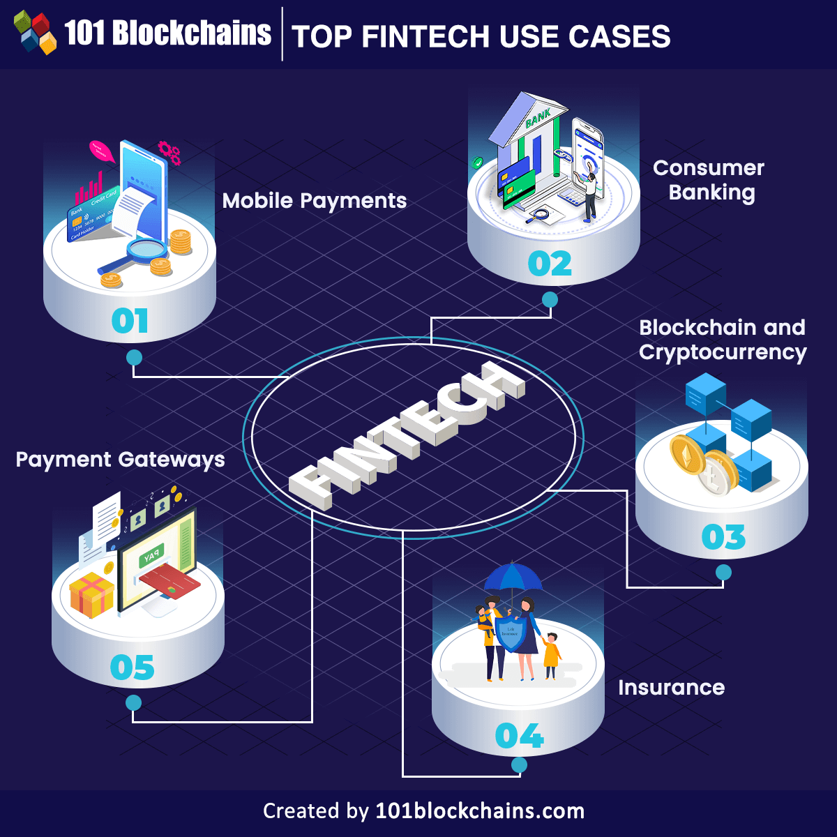

1.1 WHAT IS FINTECH?
By combining the words "financial" and "technology," the term "fintech" describes companies that employ technology to improve or automate financial services and procedures. The phrase refers to a quickly expanding sector that benefits both consumers and companies in various ways. Fintech offers a plethora of uses, ranging from cryptocurrencies and investment apps to mobile banking and insurance.

For instance, mobile banking is a type of fintech that enables users to access their bank accounts and perform financial tasks like money transfers and bill payment using their mobile devices.

1.2 DEFINITION OF FINTECH :-
The term “fintech company” describes any business that uses technology to modify, enhance, or automate financial services for businesses or consumers. Some examples include mobile banking, peer-to-peer payment services (e.g., Venmo, CashApp), automated portfolio managers (e.g., Wealthfront, Betterment), or trading platforms such as Robinhood. It can also apply to the development and trading of cryptocurrencies (e.g., Bitcoin, Dogecoin, Ether).

2.1 HISTORY OF FINTECH :-
The role of technology in the financial sector has always been key, so where do we start talking about fintech? AILabPage identifies the following key periods in fintech's timeline:

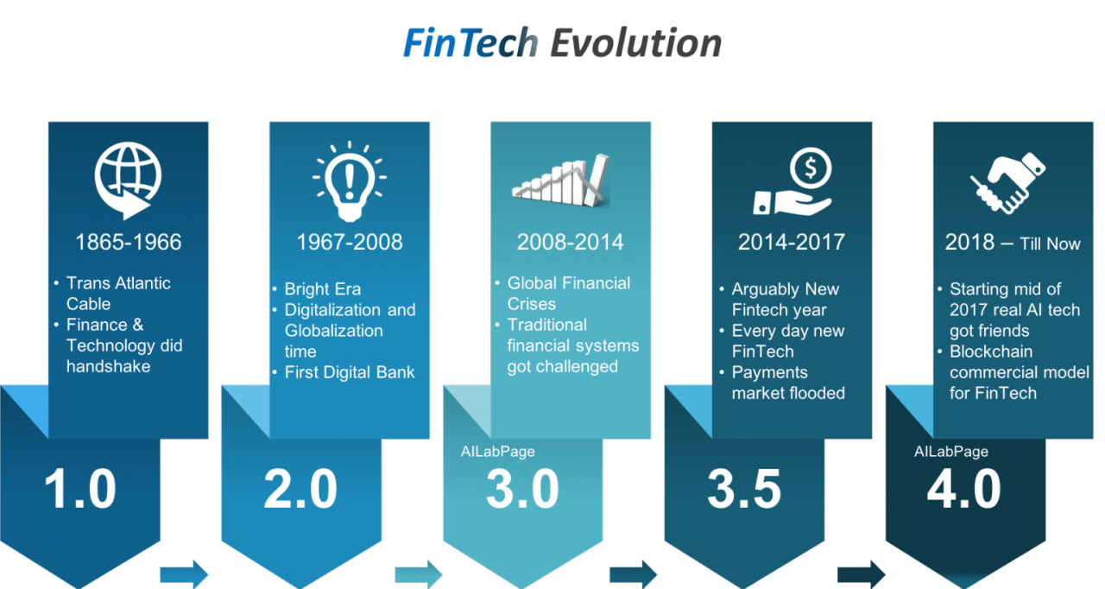
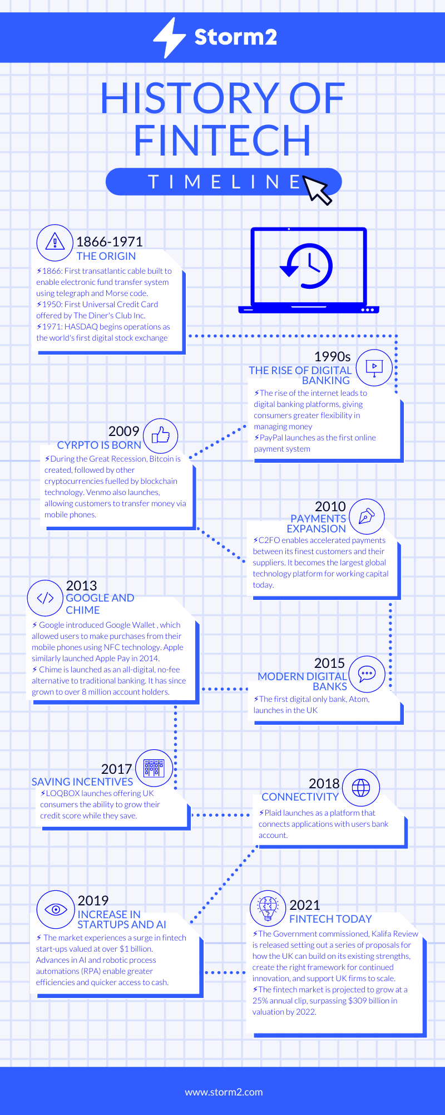

DIFFERENCES BETWEEN FINTECH AND TRADITIONAL BANKS?
Fintech and banking have many differences, despite their similarities:
- Approaches: The traditional banking industry is more process-focused, whereas fintech start-ups place a great priority on the comfort of the customer experience.

- Regulations: While fintech companies are not need to adhere to tight regulations, traditional banks are subject to them.

- Customers: While fintech companies provide credit cards to people with bad credit histories or financial histories and consider ways to raise their scores, traditional banks focus on customers with strong credit histories and proven track records.

THE BENEFITS OF FINTECH FOR BUSINESSES IN INDIA :-
Digital transformation is an unavoidable journey for enterprises in India. The fintech sector is actively contributing to facilitate this shift by offering ground-breaking solutions that empower businesses to propel their growth, enhance efficiency, and embrace operational flexibility.
Here are some of the key benefits of fintech for businesses in India:
1. Improved Customer Experience: Fintech solutions play a pivotal role in empowering Indian businesses to deliver exceptional customer experiences, with the inclusion of cutting-edge features like instantaneous payments, seamless integration of mobile wallets, and AI-driven chatbots. Remarkably, this advancement has led to a significant surge in customer contentment, resulting directly in enhanced loyalty and satisfaction levels.
2. Cost Reduction: Fintech solutions assist organizations in automating processes and eliminating manual involvement. This results in cost savings in terms of both time and resources. Furthermore, fintech firms are offering competitive pricing strategies, lowering business costs even further.
3. Enhanced Security: Fintech solutions include strong security features that shield firms from data breaches and cyber assaults. This ensures that businesses can function with confidence, knowing that their data and processes are secure.
4. Improved Regulatory Compliance: Fintech solutions are assisting organizations in more successfully meeting ever-changing regulatory standards. This ensures that firms avoid expensive penalties while also maintaining a strong compliance record.

5. THE CHALLENGES OF FINTECH IN INDIA :-
The Indian fintech industry is now facing a number of obstacles that are impeding its growth. One of the most significant issues is a lack of access to high-quality data. This is a serious issue because data is required in order to provide new financial services and products. When it comes to innovation, fintech companies are at a disadvantage if they do not have access to trustworthy data.
Another issue for fintech startups in India is traditional financial institutions' sluggish acceptance of new technologies. Many of these institutions continue to use antiquated methods and are resistant to change. This makes it harder for fiFinally, another challenge for Indian fintech firms is the high cost of customer acquisition. Because of the country's low penetration of financial services, fintech companies frequently to invest a large sum of money in marketing and advertising to draw potential customers.
Despite these obstacles, the Indian fintech industry has enormous development potential. With the appropriate rules and regulations in place, India has the potential to become a global leader in this field.

5.1 THE FUTURE OF FINTECH IN INDIA :-
Fintech has been one of the fastest expanding areas in the Indian economy in recent years. India today has a slew of world-class fintech firms and start-ups, and the industry is playing a growing role in propelling the country's digital economy.
The development of fintech in India will likely be influenced by a number of issues in the next years. For starters, government's aim for a cashless society will almost certainly increase demand for fintech products and services. Second, as more Indians gain access to smartphones and internet connectivity, there is a sizable untapped market for fintech firms to exploit. Finally, as India's middle class expands, there will be a greater demand for financial services that meet their needs.
As a result, it is apparent that the future of fintech in India is quite promising. The sector has enormous potential and is expected to grow rapidly in the next years.

5.2 Fintech Apps Examples
Mobile Payments. SPeople who own smartphones now use mobile payments in their daily lives. There are numerous services available that allow users to transfer money online or over mobile devices. Examples include Paytm, G-Pay, and PayPal.

Insurance. The insurance business has not lagged behind; insurtech, as it is now known, encompasses everything from house insurance to vehicle insurance.These insurtech start-ups are receiving a lot of cash.

Crowd funding Platforms. These systems, such as Patron and others, enable users to transfer and receive money from other users on the same platform, as well as amass funds from many sources all in one place. It is now possible to approach investors directly in order to gain their support for your project or company.

Investment Management. Investors' life have been made easier by the invention of apps that allow traders to stock because people can now purchase, sell, and trade equities from their mobile devices.

- MORE EXAMPLES OF FINTECH?
- Robo-advisors apps or online platforms
- Investment apps
- Payment apps
- Personal finance apps
- Peer-to-peer (P2P) lending platforms
- Crypto apps
- Insurtech

- FINTECH USERS
There are four broad categories of users for fintech:
- Banks' business-to-business (B2B) transactions
- Customers of B2B banks
- B2C (business-to-consumer) for small enterprises Consumers

- KEY REGULATORS :
Financial sector undertakings, including fintech businesses, are usually regulated by the RBI, SEBI, the Insurance Regulatory and Development Authority of India (IRDAI), the Pension Fund Regulatory and Development Authority (PFRDA), and IFSCA.

¹ THE LAWS AND REGULATIONS THAT MAY APPLY TO FINTECHS IN INDIA ARE LISTED BELOW:
RBI
- Payment and Settlement Systems Act, 2007.
- Master Directions on Prepaid Payment Instruments (MD-PPIs), 2021.
- Framework for Scale Based Regulation for Non-Banking Financial Companies, 2021.
- Directions for opening and operation of Accounts and settlement of payments for electronic payment transactions involving intermediaries, 2009.
- Guidelines for Licensing of Payments Banks, 2014 and Operating Guidelines for Payments Banks, 2016.
- Framework for Recognition of a Self-Regulatory Organisation for Payment System Operators, 2020.
- Guidelines on Regulation of Payment Aggregators and Payment Gateways, 2020.
- Circular on Processing of e-mandate on cards for recurring transactions, 2019.
- Circular on Tokenisation – Card transactions, 2019.
- Guidelines on Digital Lending, 2022.
- RBI Master Directions on Credit Card and Debit Card – Issuance and Conduct, 2022.
- National Payments Corporation of India (NPCI)
- Various circulars on Unified Payments Interface (UPI) payments.
SEBI
- Circular on Mutual Funds, 2021.
IRDAI
- Guidelines on Insurance Repositories and Electronic issuance of Insurance Policies, 2015.
- Guidelines on lnsurance e-commerce, 2017.
- Insurance Regulatory and Development Authority of India (Issuance of e-Insurance Policies) Regulations, 2016.
IFSCA
- International Financial Services Centres Authority Act, 2019.
- Framework for FinTech Entity in the International Financial Services Centres (IFSCs), 2022.
¹https://iclg.com/practice-areas/fintech-laws-and-regulations/india

- ADVANTAGES AND DISADVANTAGES OF FINTECH

8.1 ADVANTAGES OF FINTECH :-
- Improved accessibility : As everyone with internet access can open an account and apply for a loan, this equates to a rise in the banked population.

- Response times: Fintech companies typically respond to applications within 10 minutes to 48 hours.

- Time management :As all processes are completed via the Internet, it is not always necessary to visit a physical branch.

- Various services: : Fintech has successfully segmented services, allowing both users and providers of financial services to access a diverse range of services.

- Availability to Consumer : A variety of financial services are available to consumers, including establishing a savings account, obtaining a credit card and investing in companies seeking funds for expansion.

- Payment System : Financial service providers use fintech to analyse credit applicants' profiles, store data on the cloud, and to simplify payment processes.

- Cost savings : Aside from offering lower commissions than banks, one of the key differences between fintech and traditional financial organizations is that the majority of them want to compete with traditional financial firms.

  - DISADVANTAGES OF FINTECH :-
- Lack of physical branches. In the event of a service failure, all communications must be addressed via email or social media, which can be inconvenient.

- Security issues :- In this regard, some fintech organizations use blockchain technology to boost security, but not all of them do, compromising the confidentiality of consumer data.

- Lack of Access : For others, it may appear as simple as using a smartphone, but the reality is that this condition excludes a big portion of the people who do not have access to the Internet, making it difficult for them to become banked even with Fintech.

- Lack of supervision. Due to its widespread recognition, governing bodies worldwide extensively research and create legislation to address various aspects of this phenomenon. Consequently, the regulations governing fintech globally are not flawless, leaving room for potential fraudulent activities in the absence of appropriate regulations.

THE COMBINATION OF FINTECH AND OTHER SECTORS:

Finance and Accounting
The intersection of Financial Technology (FinTech) and HR goes beyond salary management and offers opportunities to enhance employees' financial health. Particularly in times of economic uncertainty, FinTech solutions enable HR and accounting managers to empower employees with greater control over their finances.
For instance, companies can implement flexible payment options, giving employees easy access to their wages. Additionally, online calculators can be provided to help individuals track their earnings and pension contributions.

Personal employee development
By incorporating eLearning platforms into staff training programs, FinTech HR can stimulate personal development. These platforms offer online courses and training sessions on a variety of topics, such as financial literacy, cyber security, and technological competency. Employees can continuously upgrade their skills and knowledge by gaining access to these eLearning tools, resulting in enhanced job performance and job satisfaction. Companies can also provide training on how to use FinTech products for personal and professional objectives.

Productivity and management
Several businesses employ time-tracking software to enable employees to accurately record their working hours and receive appropriate compensation, while also allowing HR managers to monitor attendance. This aspect of using time-tracking tools intersects with the realm of Financial Technology (FinTech) as these tools play a vital role in determining salary payments.
For Instance,A time-tracking solution that is directly linked to your payroll system can help to speed the process and provide complete transparency. This makes tracking breaks and overtime easy, as well as complying with labor rules. Employees need to know that they will be adequately compensated for their efforts.

- ²ARTICLE ON FIN-TECH :-
“ECONOMIC TIMES NEWSPAPER & MONEYCONTROL”
Economic Survey 2023: India outpaces world in fintech adoption, driving financial inclusion

According to the survey the latest Global FinTech Adoption Index said that the world average is 64%, India has achieved 87% fintech adoption
HARSH KUMAR JANUARY 31, 2023 / 03:53 PM IST

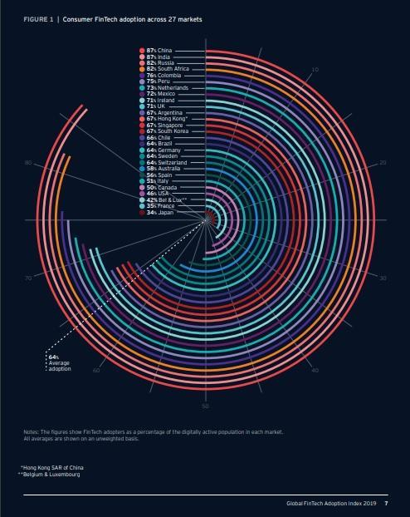

Representative image
India has outgrown the global average in terms of digital adoption, giving a fillip to the on-going financial inclusion efforts, showed the Economic Survey 2023.
Quoting the latest Global FinTech.
This leap is made possible by developing technology and inventive solutions that democratize access and encourage product personalization., the Survey said.
“With a strong foundation provided by the Jan Dhan-Aadhaar-Mobile (JAM) trinity, UPI, and other regulatory frameworks, "The pandemic has aided in the acceleration of digital adoption and given a boost to digital financial services solutions by banks, NBFCs, insurers, and fintech," according to the Survey.
"Due to vast unmet market prospects, the market has experienced high values..."Historically, fintech growth has been driven by an organic and collaborative ecosystem that has been supported by key government initiatives," according to the research.
However, Sharat Chandra, Co-Founder, of India Blockchain Forum, an industrial body, said that the economic survey expects CBDCs to boost digital financial services. Collaboration between fintech and banks will be the key to ensuring the adoption of use cases built on top of CBDC, Chandra said.
According to the Economic Survey, the average rise in UPI-based transactions in value and volume terms between 2019 and 2022 was 121 percent and 115 percent, respectively. In December 2022, UPI reached a new peak with 782 crore transactions totaling Rs.12.8 lakh crore.
According to the poll, UPI accounted for 17% of the country's total digital transactions of 3,100 crore in FY19. UPI's share increased to more than 27% the following fiscal year, when it processed 1,250 crore transactions out of 4,600 crore digital transactions. According to the report, UPI accounted for 52% of total 8,840 crore financial digital transactions in FY22.

- CONCLUSION :-
In India, Fin Techs are rising in all categories of financial services. By examining the rate at which fin technologies are emerging, it is clear that India has huge entrepreneurial potential. In India, there are approximately 1500 Fin Tech start-up companies, over half of which were founded in the last two years. Fintech businesses must be technically and financially prepared. The bulk of successful start-ups are in the payments market, and the same is expected in the other financial segments. The government and other regulatory agencies must continue to support the fintech industry through various measures.

- ³FAQ :

Who is at risk of the security risks associated with fintech?
Anyone who uses fintech services, including individuals and businesses, is at risk of security risks such as data theft and cyber-attacks.

What are the legal and regulatory challenges facing fintech?
Fintech companies must navigate a complex web of legal and regulatory requirements, which can vary by jurisdiction. This can be challenging and time-consuming.

How can fintech companies address the lack of physical branches?
Fintech companies can offer virtual services, such as online banking and mobile payment solutions, as alternatives to physical branches.

What is the objection to fintech’s reliance on digital technologies?
Fintech’s reliance on digital technologies can compromise privacy, as extensive data is collected and stored electronically.

How can fintech companies address the challenges of software quality?
Fintech companies can invest in high-quality software development and testing processes, as well as hiring competent software developers.

What is the objection to the global competition faced by fintech companies?
Fintech companies face intense global competition, which can make it challenging to differentiate themselves from competitors and succeed.

³https://www.consumer-action.org/downloads/english/FinTech_Savvy_FAQs.pdf

REFERENCES :-
https://www.moneycontrol.com/news/business/economic-survey-2023-india-outpaces-world-in-fintech-adoption-driving-financial-inclusion-9971651.html

https://101blockchains.com/fintech-examples/#:~:text=For%20example%2C%20mobile%20banking%20or,use%20in%20our%20daily%20lives.

https://www.google.com/search?q=Fin+tech&rlz=1C1CHBF_enIN869IN869&oq=Fin+tech+&gs_lcrp=EgZjaHJvbWUyBggAEEUYOTIMCAEQABgKGMkDGIAEMgYIAhBFGDsyCggDEAAYkgMYigUyCggEEAAYkgMYigUyDQgFEC4YrwEYxwEYgAQyCQgGEAAYChiABDIJCAcQABgKGIAEMgkICBAAGAoYgAQyCQgJEAAYChiABNIBCjEzNTA2ajBqMTWoAgCwAgA&sourceid=chrome&ie=UTF-8

https://www.dpublication.com/wp-content/uploads/2022/02/5-9124.pdf

https://papers.ssrn.com/sol3/papers.cfm?abstract_id=3354094

https://www.mdpi.com/1911-8074/16/2/122

https://www.ashwinanokha.com/resources/v20-3-3-%20%20Sumeet%20gupta.pdf

https://www.onlinelegalindia.com/blogs/fintech-laws-regulation-in-india#:~:text=The%20Reserve%20Bank%20of%20India%20Act%20and%20a%20set%20of,and%20NBFCs%20associated%20with%20FinTech.

https://cleartax.in/g/terms/financial-technology

https://bootcamp.cvn.columbia.edu/blog/what-is-fintech/

https://www.investopedia.com/

https://iclg.com/practice-areas/fintech-laws-and-regulations/india

https://www.fintechweekly.com/

https://www.dpublication.com/wp-content/uploads/2022/02/5-9124.pdf

https://www.researchgate.net/publication/348435968_Fintech_Industry_In_India_The_Revolutionized_Finance_Sector

