The evolving role of biotechnology in education

Shamima Khatoon¹, Kavita Malik², Iqra Hakeem², Mohan Kamthan³, Asghar Ali³*

¹ Department of Education, Deen Dayal Upadhyaya Gorakhpur University, Gorakhpur-273009, India.
² Department of Biosciences, Ramanujan Block, Jamia Millia Islamia, New Delhi-110025, India.
³ Department of Biochemistry, School of Chemical and Life Sciences, Jamia Hamdard, New Delhi-110062, India.

Authors Details

Shamima Khatoon
Department of Education
Deen Dayal Upadhyaya Gorakhpur University
Gorakhpur-273009, India.
shamimak61@gmail.com

Kavita Malik
Department of Biosciences
Ramanujan Block
Jamia Millia Islamia
New Delhi-110025, India.
k.malik1407@gmail.com

Iqra Hakeem
Department of Biosciences
Ramanujan Block
Jamia Millia Islamia
New Delhi-110025, India.
hakeemiqra58@gmail.com

Dr. Mohan Kamthan
Department of Biochemistry
School of Chemical and Life Sciences
Jamia Hamdard
New Delhi-110062, India.
mohan.kamthan@jamiahamdard.ac.in

Dr. Asghar Ali
Department of Biochemistry
School of Chemical and Life Sciences
Jamia Hamdard
New Delhi-110062, India.
asgharalijmi@gmail.com

ABSTRACT
The integration of biotechnology in education is revolutionizing teaching methodologies and student learning outcomes. Biotechnology enhances critical thinking and problem-solving skills by providing hands-on experiences and interdisciplinary connections. It prepares students for future careers in biotechnology and related fields while addressing the need for scientific literacy. However, challenges such as equipment access and teacher training must be overcome. Embracing the evolving role of biotechnology in education equips students with the knowledge and skills required for success in a biotechnologically driven world.

Keywords: Integration, Hands-on learning, Interdisciplinary, Critical thinking, Problem-solving skills, Scientific literacy, Careers, Challenges, Equipment access, Transformative impact, Teaching methodologies, Ethical considerations, Professional development.

- Introduction

The integration of biotechnology in education has emerged as a transformative force, reshaping teaching methodologies and redefining the learning experience for students. With its vast potential to impact various industries and aspects of our lives, biotechnology has become a crucial field of study that necessitates its inclusion in educational settings. This chapter provides an overview of the role of biotechnology in education, highlighting its significance and the benefits it brings to students, educators, and society. Biotechnology encompasses a range of scientific techniques and tools that involve the manipulation of living organisms or their components to create useful products and solve complex problems. From advancements in genetic engineering and pharmaceutical development to agriculture and environmental sustainability applications, biotechnology plays an increasingly central role in addressing global challenges and driving innovation [1].
In the realm of education, integrating biotechnology offers unique opportunities for students to engage in hands-on, experiential learning. Students gain practical skills and a deeper understanding of scientific concepts by actively participating in laboratory experiments, genetic analysis, and bioinformatics research. Biotechnology education fosters critical thinking and problem-solving abilities and nurtures creativity, collaboration, and scientific literacy. Moreover, integrating biotechnology in education promotes interdisciplinary connections, bridging the realms of biology, chemistry, physics, and engineering. This multidisciplinary approach encourages students to explore the interconnections between these fields and understand the real-world applications of biotechnology across diverse industries [2]. Figure 1 shows the role of biotechnology in education.
As the role of biotechnology in society continues to evolve, it is essential to embrace its educational implications fully. However, challenges such as access to advanced laboratory equipment, the need for specialized teacher training, and the integration of updated curricula must be addressed to ensure effective implementation.
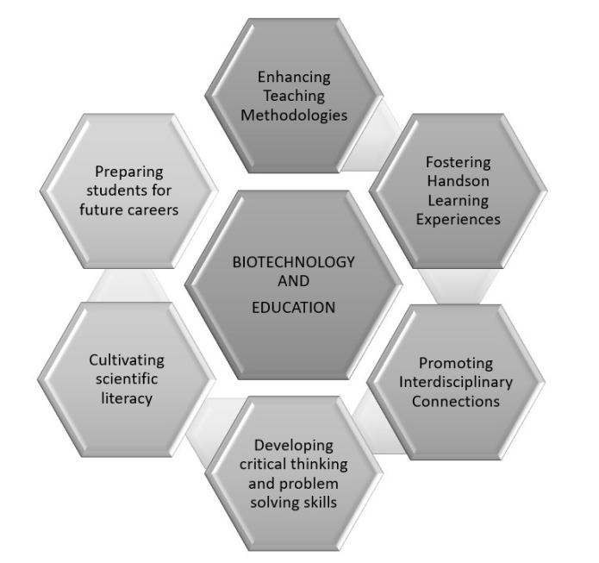
Figure 1. Role of Biotechnology in Education

The integration of biotechnology in education holds great promise for empowering students with the knowledge, skills, and mindset required for success in a biotechnologically driven world. By embracing this transformative role, educational institutions can prepare students for future careers, foster scientific literacy, and contribute to the advancement of biotechnology and its applications [3].

- The Transformative Role of Biotechnology in Education

Biotechnology has assumed a transformative role in education, revolutionizing teaching methodologies and redefining the learning experience for students. The various ways in which biotechnology brings about positive changes in education are as follows.

  - Enhancing Teaching Methodologies

Enhancing teaching methodologies in biotechnology education involves a shift from traditional didactic approaches to more student-centered, active learning strategies. By incorporating these methodologies, educators can create engaging learning environments that promote critical thinking, problem-solving, and collaboration, ultimately fostering a deeper understanding of biotechnological principles and their applications [4].

A.1. Incorporating Active Learning Strategies

Problem-Based Learning: Engaging students in real-world scenarios and challenges that require the application of biotechnological principles and problem-solving skills (Figure 2). Inquiry-Based Learning: Encouraging students to explore and investigate biotechnological concepts through questioning, experimentation, and analysis. Project-Based Learning: Guiding students in extended projects involving research, experimentation, and presentation of biotechnology-related topics [5].

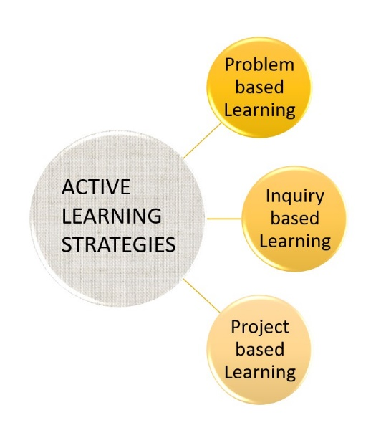
Figure 2. Effective Learning Strategies for Active Learning

A.2. Utilizing Technology and Multimedia Resources

Interactive Simulations and Virtual Laboratories: Providing virtual environments that simulate biotechnological experiments, enabling students to practice techniques and analyze outcomes (Figure 3). Online Resources and Databases: Accessing vast repositories of scientific information, DNA sequences, and research articles to enhance understanding and stimulate exploration. Multimedia Presentations and Videos: Engaging students through visually appealing and interactive content that explains complex biotechnological concepts and processes [6].
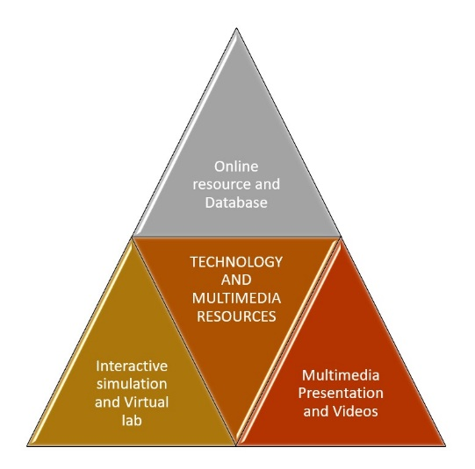
Figure 3. Technology and Multimedia Resources in Biotechnology

A.3. Incorporating Collaborative Learning

Group Projects and Teamwork: Encouraging students to work together in teams to solve problems, conduct experiments, and present findings, fostering communication and collaboration skills. Peer-to-Peer Learning: Promoting knowledge sharing and cooperative learning among students, allowing them to learn from each other's perspectives and experiences [7].

A.4. Authentic Assessment Methods

Performance-Based Assessments: Evaluating students' practical skills and application of biotechnological techniques through hands-on experiments, presentations, and demonstrations (Figure 4). Research Projects and Presentations: Assessing students' ability to conduct independent research, analyze data, and communicate findings effectively. Portfolios and Reflections: Encouraging students to document their learning journey, showcase their growth, and reflect on their understanding of biotechnological concepts [8].

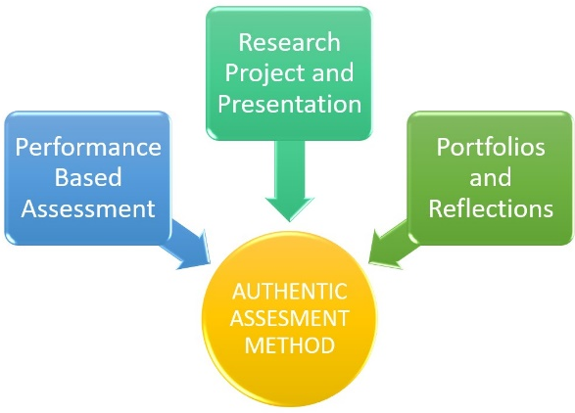
Figure 4. Assessment Methods

  - Fostering Hands-on Learning Experiences

Fostering hands-on learning experiences is a key aspect of integrating biotechnology in education. By fostering hands-on learning experiences, biotechnology education enables students to develop practical skills, gain a deeper understanding of biotechnological concepts, and appreciate the applications of biotechnology in real-world scenarios. It cultivates a sense of inquiry, curiosity, and scientific exploration, preparing students to be active contributors to the biotechnological advancements of the future. The various ways biotechnology promotes experiential learning and practical skills development. Figure 5 represents various learning experiences.

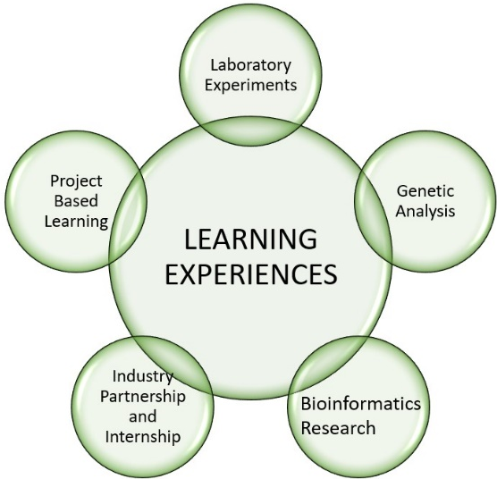
Figure 5. Learning Experiences

B.1. Laboratory Experiments

Biotechnology offers students the opportunity to engage in laboratory experiments, where they can perform techniques such as DNA extraction, gel electrophoresis, PCR amplification, and protein analysis. By actively participating in these experiments, students gain first-hand experience in biotechnological procedures, develop laboratory skills, and learn to handle scientific equipment and reagents [9].

B.2. Genetic Analysis

Hands-on learning in biotechnology includes genetic analysis activities. Students can explore genetic traits, DNA sequencing, and genetic variation through activities such as DNA profiling, genetic engineering, and gene expression analysis. These practical experiences enable students to understand genetic concepts, analyze data, and draw conclusions based on their findings.

B.3. Bioinformatics Research

Biotechnology education extends beyond the laboratory to include bioinformatics research. Students can engage in computer-based activities, utilizing bioinformatics tools and software to analyze DNA and protein sequences, predict gene functions, and study genetic relationships. This hands-on approach in bioinformatics fosters computational skills and data analysis competencies essential in modern biotechnology research [10].

B.4. Industry Partnerships and Internships

Fostering hands-on experiences can also involve collaborations with industry partners or internships at biotechnology companies or research institutions. These partnerships provide students with real-world exposure, allowing them to work alongside professionals, engage in cutting-edge research, and gain insights into the practical applications of biotechnology. Such experiences bridge the gap between classroom learning and industry practices, preparing students for future careers [11].

B.5. Project-Based Learning

Project-based learning is an effective approach to fostering hands-on experiences in biotechnology education. Students can undertake research projects, individually or in teams, where they design and execute experiments, analyze data, and present their findings. This hands-on approach promotes critical thinking, problem-solving skills, and collaborative teamwork while allowing students to explore specific biotechnological topics of interest [12].

  - Promoting Interdisciplinary Connections

Promoting interdisciplinary connections is a significant aspect of integrating biotechnology in education. By promoting interdisciplinary connections, biotechnology education provides students with a holistic understanding of the interconnected nature of scientific disciplines. Students develop the ability to approach complex problems from multiple angles, appreciate the collaborative nature of scientific research, and recognize the broader implications of biotechnological advancements in various fields. This interdisciplinary perspective equips students with a well-rounded skill set and prepares them for the interdisciplinary demands of the biotechnology industry and beyond [13]. Here we learn how biotechnology education encourages students to explore the interconnections between biology, chemistry, physics, engineering, and other scientific disciplines (Figure 6).

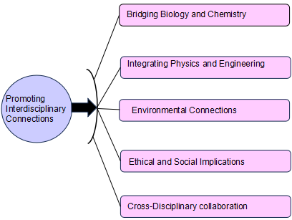
Figure 6. Interdisciplinary Connections

C.1. Bridging Biology and Chemistry

Biotechnology education emphasizes the interdependence of biology and chemistry. Students learn how chemical principles underpin biological processes such as enzyme kinetics, DNA structure, and protein interactions. By understanding the chemical foundations of biotechnology, students gain insights into the mechanisms and applications of biotechnological techniques [14].

C.2. Integrating Physics and Engineering

Biotechnology often involves physical and engineering principles, such as microfluidics, bio instrumentation, and bioprocess engineering. Students explore the physical properties of biomolecules, the mechanics of biological systems, and the design of biotechnological devices. This interdisciplinary approach bridges the gap between physics, engineering, and biology, fostering a comprehensive understanding of biotechnological applications [15].

C.3. Environmental Connections

Biotechnology education also highlights the interconnectedness between biotechnology and environmental science. Students learn about bioremediation, sustainable agriculture, and bioenergy production, examining the environmental impact and ethical considerations of biotechnological practices. This interdisciplinary perspective encourages students to consider the environmental implications of biotechnology and seek sustainable solutions [16].

C.4. Ethical and Social Implications

Biotechnology education encourages students to critically examine the ethical and social dimensions of biotechnological advancements. They explore the impact of biotechnology on society, including issues related to genetic engineering, cloning, and personalized medicine. This interdisciplinary exploration enables students to understand the complex ethical and social implications associated with biotechnology [17].

C.5. Cross-Disciplinary Collaboration

Promoting interdisciplinary connections in biotechnology education often involves collaborative projects and activities. Students from different scientific backgrounds collaborate to solve biotechnological challenges, integrating their knowledge and expertise to develop comprehensive solutions. This collaboration fosters communication skills, teamwork, and appreciation for diverse perspectives [18].

  - Developing Critical Thinking and Problem-Solving Skills

Developing critical thinking and problem-solving skills is a fundamental goal of biotechnology education. By engaging in critical thinking and problem-solving activities within the context of biotechnology education, students develop essential skills applicable across various domains (Figure 7). They learn to approach complex problems systematically, analyze data objectively, evaluate evidence critically, and make informed decisions. These skills not only contribute to their scientific literacy but also prepare them to address challenges in the biotechnology field and navigate real-world issues with analytical thinking and creative problem-solving strategies [19]. Let’s explore how the integration of biotechnology fosters these essential skills among students.

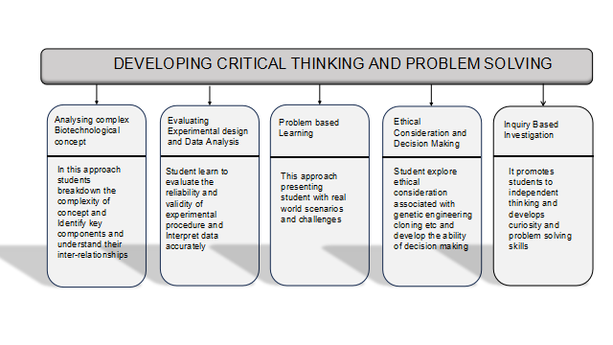
Figure 7. Developing Critical Thinking and Problem Solving

D.1. Analyzing Complex Biotechnological Concepts

Biotechnology education challenges students to analyze complex concepts and processes, such as genetic engineering, bioinformatics, and bioprocessing. Students are encouraged to break down these concepts, identify key components, and understand their interrelationships [20]. This analytical approach promotes critical thinking and enables students to grasp the intricacies of biotechnological principles.

D.2. Evaluating Experimental Design and Data Analysis

Students engage in experimental design and data analysis, where they learn to evaluate the reliability and validity of experimental procedures and interpret data accurately. They are encouraged to question assumptions, identify sources of error, and draw logical conclusions based on evidence. This process hones critical thinking skills and develops a scientific mindset [21].

D.3. Problem-Based Learning

Biotechnology education often incorporates problem-based learning approaches, presenting students with real-world scenarios and challenges. Students are required to analyze and solve biotechnological problems by applying their knowledge, critical thinking, and problem-solving skills [22]. This approach encourages students to think creatively, consider multiple perspectives, and develop innovative solutions.

D.4. Ethical Considerations and Decision-Making

Biotechnology education prompts students to navigate ethical dilemmas and make informed decisions. They explore ethical considerations associated with genetic engineering, cloning, and bioprospecting. Students develop the ability to critically evaluate the ethical implications of biotechnological practices, weigh different perspectives, and make ethically responsible decisions [23].

D.5. Inquiry-Based Investigations

Biotechnology education promotes inquiry-based investigations, where students formulate questions, design experiments, and explore scientific phenomena. This process encourages independent thinking, curiosity, and problem-solving skills [24]. Students learn to develop hypotheses, plan experiments, analyze data, and draw evidence-based conclusions.

  - Cultivating Scientific Literacy

Cultivating scientific literacy is a crucial aspect of biotechnology education. Cultivating scientific literacy through biotechnology education empowers students to actively participate in scientific advancements, engage in evidence-based decision-making, and contribute to societal discussions (Figure 8). By understanding and critically evaluating biotechnological concepts and information, students develop a scientific worldview that enables them to make informed choices, appreciate the impact of biotechnology on society, and pursue further scientific endeavors [25]. It is important to understand the integration of biotechnology fosters scientific literacy among students.

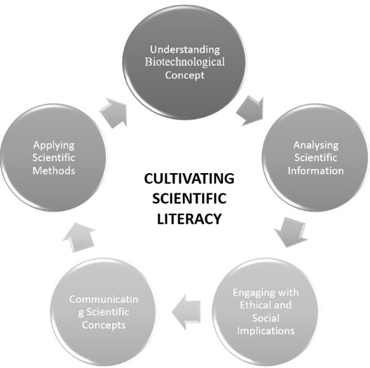
Figure 8. Cultivating Scientific Literacy

E.1. Understanding Biotechnological Concepts

Biotechnology education provides students with a solid foundation in biotechnological concepts, methodologies, and principles. Students learn about DNA structure and function, genetic engineering techniques, bioprocessing, and the applications of biotechnology in various industries. This comprehensive understanding enables students to navigate scientific literature, communicate effectively, and make informed decisions [26].

E.2. Analyzing Scientific Information

Biotechnology education equips students with the skills to critically analyze and interpret scientific information. They learn to evaluate research articles, scientific reports, and experimental data to identify reliable sources, assess the validity of claims, and draw evidence-based conclusions [27]. This analytical approach enhances their ability to think critically and discern credible scientific information.

E.3. Engaging with Ethical and Social Implications

Biotechnology education prompts students to engage with biotechnological advancements' ethical and social implications. They explore debates surrounding genetically modified organisms, gene editing, and personalized medicine, developing an understanding of the ethical considerations associated with biotechnology [28]. This cultivates their ability to navigate and contribute to discussions on the societal impact of biotechnology.

E.4. Communicating Scientific Concepts

Effective communication is a fundamental component of scientific literacy. Biotechnology education emphasizes developing communication skills, allowing students to convey complex biotechnological concepts to diverse audiences. Students learn to articulate their ideas, present scientific findings, and engage in scientific discourse through written reports, oral presentations, and collaborative projects [29].

E.5. Applying Scientific Methods

Biotechnology education emphasizes the application of scientific methods and principles. Students learn to design experiments, collect and analyze data, and draw valid conclusions. Students develop a scientific mindset by engaging in these practices, understanding the importance of evidence, objectivity, and reproducibility in scientific inquiry [30].

  - Preparing Students for Future Careers

Preparing students for future careers is a significant objective of biotechnology education. By preparing students for future careers, biotechnology education equips them with the necessary knowledge, skills, and mindset to excel in the biotechnology industry. Whether pursuing careers in research, development, production, quality control, or entrepreneurship, students are well-prepared to contribute to scientific advancements, innovate, and address the challenges of a biotechnologically driven world [31]. Here we explore how the integration of biotechnology equips students with the necessary knowledge and skills to thrive in biotechnology-related fields. A future career related to biotechnology in education is represented in Figure 9.

F.1. Technical Proficiency

Biotechnology education provides students with hands-on experiences and practical skills in laboratory techniques, genetic analysis, and bioinformatics. Students develop technical proficiency in working with advanced laboratory equipment, conducting experiments, and analyzing data [32]. This technical competence prepares them for the technical demands of biotechnology careers.

F.2. Knowledge of Emerging Technologies

Biotechnology is a rapidly evolving field with constant advancements. Biotechnology education exposes students to emerging technologies, such as CRISPR-Cas9 gene editing, next-generation sequencing, and synthetic biology. By staying abreast of these developments, students are prepared to adapt to new technologies and contribute to the ongoing advancements in the field [33].

F.3. Industry-Relevant Skills

Biotechnology education focuses on developing skills relevant to the biotech industry. Students learn about bioprocessing, quality control, regulatory compliance, and the principles of Good Laboratory Practices (GLP) and Good Manufacturing Practices (GMP). This knowledge equips students with industry-specific skills required for careers in biotechnology research, development, production, and quality assurance [34].

F.4. Problem-Solving and Analytical Thinking

Biotechnology education hones students' problem-solving and analytical thinking skills. Through engaging in laboratory experiments, data analysis, and critical evaluation of scientific information, students develop the ability to approach challenges with a systematic and analytical mindset. This problem-solving orientation prepares them to tackle complex problems encountered in research and industry settings [35].

F.5. Entrepreneurial Mindset

Biotechnology education fosters an entrepreneurial mindset among students. Students learn about the commercialization of biotechnology, intellectual property rights, and the process of bringing biotech innovations to market. This understanding encourages students to think innovatively, identify market opportunities, and consider entrepreneurship as a viable career path [36].

F.6. Research and Collaboration Skills

Biotechnology education emphasizes research skills and collaboration. Students engage in research projects, work in teams, and collaborate with peers and industry professionals (Figure 9). These experiences enhance their research competencies, teamwork abilities, and communication skills, all of which are vital in research-oriented careers and industry collaborations [37].

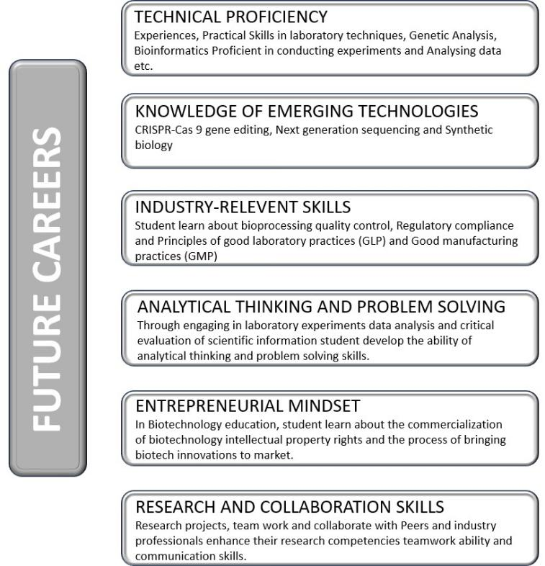

Figure 9. Future Career in Biotechnology

- CHALLENGES AND CONSIDERATIONS

The integration of biotechnology in education is not without its challenges (Figure 10). Addressing these challenges and considerations requires collaboration among educational institutions, policymakers, industry stakeholders, and the scientific community. By addressing resource limitations, providing adequate teacher training, adapting curricula, emphasizing ethics and safety, promoting equity, and staying up-to-date with advancements, successful integration of biotechnology in education can be achieved, empowering students with the knowledge and skills needed to thrive in a biotechnologically driven world [38].

  - Access to Equipment and Resources

One significant challenge is the availability and accessibility of advanced laboratory equipment, reagents, and materials necessary for biotechnology experiments. Limited resources can hinder hands-on learning experiences and limit the scope of practical activities. Ensuring adequate funding and resource allocation is essential to overcome this challenge [39].

  - Teacher Training and Professional Development

Biotechnology education requires well-trained, knowledgeable educators who can deliver biotechnology concepts and guide students through laboratory experiments. Teacher training programs and professional development opportunities are crucial to enhance teachers' understanding of biotechnology principles, laboratory techniques, and emerging technologies [40]. Continued support and access to updated resources are necessary to keep educators abreast of advancements in the field.

  - Curriculum Integration and Adaptation

Integrating biotechnology into existing curricula can be challenging, as it requires careful alignment with established educational standards and objectives. Curriculum development must include relevant biotechnology topics, hands-on activities, and interdisciplinary connections. Adapting curriculum to incorporate emerging technologies and changing industry needs is necessary to ensure the relevance and effectiveness of biotechnology education [41].

  - Ethical and Safety Considerations

Biotechnology education raises ethical considerations and safety concerns that need to be addressed. Educators must ensure that students understand the ethical implications of biotechnological practices, including issues related to genetic manipulation, privacy, and environmental impact. Implementing strict safety protocols and guidelines for laboratory activities is crucial to safeguard the well-being of students and maintain ethical standards [42].

  - Equity and Access

Ensuring equitable access to biotechnology education is a key consideration. Disparities in resources, equipment, and opportunities may limit access for certain schools or regions. Efforts must be made to bridge these gaps and provide all students equal access to biotechnology education, regardless of their background or location [43].

  - Keeping Pace with Advancements

Biotechnology is a rapidly evolving field, constantly emerging new discoveries and technologies. Keeping pace with these advancements and incorporating them into the curriculum can be challenging. Regular updates to teaching materials, collaboration with industry partners, and staying informed about the latest research are necessary to ensure that biotechnology education remains relevant and prepares students for the evolving demands of the field [44].

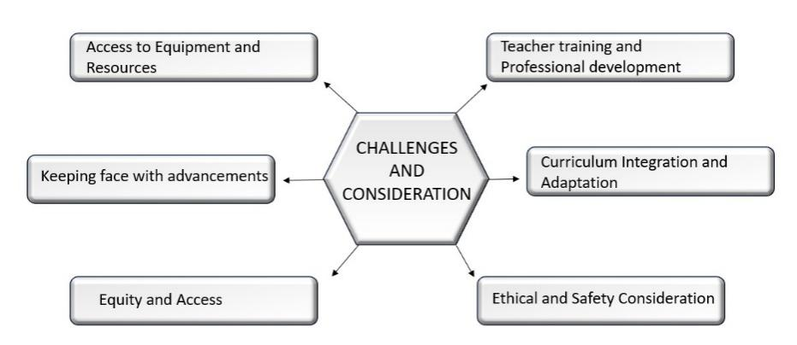
Figure 10. Challenges in the field of Biotechnology

- EMBRACING THE EVOLVING ROLE OF BIOTECHNOLOGY IN EDUCATION

The evolving role of biotechnology in education presents new opportunities and challenges that need to be embraced and addressed. By embracing the evolving role of biotechnology in education through addressing challenges, fostering collaborations, and leveraging technology, educational institutions can unlock the full potential of biotechnology education (Figure 11). This proactive approach equips students with the knowledge, skills, and mindset needed to excel in a biotechnologically driven world [45]. Embracing this evolving role ensures that biotechnology education remains dynamic, and relevant, and prepares students to become active contributors to scientific advancements, innovation, and the betterment of society as a whole.
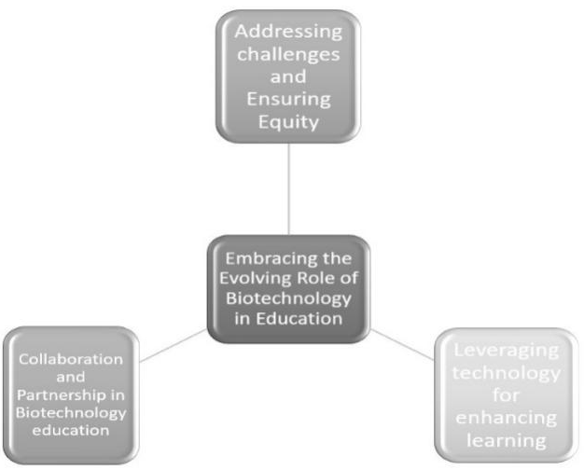

Figure 11. Evolving Role of Biotechnology and Education

  - Addressing Challenges and Ensuring Equity

To embrace the evolving role of biotechnology in education, addressing the challenges associated with resource limitations, teacher training, curriculum integration, and equitable access is essential. Adequate funding should be allocated to ensure access to advanced laboratory equipment, materials, and resources for all educational institutions. Providing comprehensive teacher training programs and professional development opportunities equips educators with the necessary skills and knowledge to effectively deliver biotechnology education. Curriculum integration should be a collaborative effort involving educators, curriculum developers, and industry professionals, ensuring alignment with educational standards and emerging trends. Efforts must be made to bridge equity gaps, ensuring all students have equal opportunities to engage in biotechnology education regardless of their background or location [46].

  - Collaboration and Partnerships in Biotechnology Education

Embracing the evolving role of biotechnology in education involves fostering collaborations and partnerships among educational institutions, industry stakeholders, research organizations, and professional societies. Collaboration with industry partners can provide students real-world exposure, internships, and research opportunities, bridging the gap between academic learning and industry practices. Partnerships with research organizations allow students to engage in cutting-edge research projects, contributing to scientific advancements. Professional societies can offer guidance, resources, and networking opportunities for educators and students, keeping them updated with the latest developments in biotechnology [47].

  - Leveraging Technology for Enhanced Learning

The evolving role of biotechnology in education necessitates the effective utilization of technology to enhance learning experiences. Virtual laboratories, interactive simulations, and online resources provide students with opportunities to engage in hands-on activities and explore biotechnological concepts in a virtual environment. The integration of bioinformatics tools and software enables students to analyze complex biological data and make meaningful interpretations. By leveraging technology, biotechnology education can reach a broader audience, facilitate remote learning, and keep pace with the rapidly evolving field [48].

- CONCLUSION

The integration of biotechnology in education enhances teaching methodologies by promoting active learning strategies. Through problem-based learning, inquiry-based learning, and project-based learning, students actively apply biotechnological principles to real-world challenges. This approach fosters critical thinking, problem-solving skills, and creativity.

[1] O. Nordqvist and H. Aronsson, “It Is Time for a New Direction in Biotechnology Education Research,” Biochemistry and Molecular Biology Education, vol. 47, no. 2, pp. 189–200, Mar. 2019, doi: 10.1002/bmb.21214.
[2] K. M. A. Gartland and J. S. Gartland, “Opportunities in biotechnology,” J Biotechnol, vol. 282, pp. 38–45, Sep. 2018, doi: 10.1016/j.jbiotec.2018.06.303.
[3] M. Cornelissen et al., “Biotechnology for Tomorrow’s World: Scenarios to Guide Directions for Future Innovation,” Trends Biotechnol, vol. 39, no. 5, pp. 438–444, May 2021, doi: 10.1016/j.tibtech.2020.09.006.
[4] T. Orhan and N. Sahin, “The Impact of Innovative Teaching Approaches on Biotechnology Knowledge and Laboratory Experiences of Science Teachers,” Educ Sci (Basel), vol. 8, no. 4, p. 213, Dec. 2018, doi: 10.3390/educsci8040213.
[5] A. M. Kim, C. J. Speed, and J. O. Macaulay, “Barriers and strategies: Implementing active learning in biomedical science lectures,” Biochemistry and Molecular Biology Education, vol. 47, no. 1, pp. 29–40, Jan. 2019, doi: 10.1002/bmb.21190.
[6] V. Gupta, M. Sengupta, J. Prakash, and B. C. Tripathy, “An Introduction to Biotechnology,” in Basic and Applied Aspects of Biotechnology, Singapore: Springer Singapore, 2017, pp. 1–21. doi: 10.1007/978-981-10-0875-7_1.
[7] K. Scager, J. Boonstra, T. Peeters, J. Vulperhorst, and F. Wiegant, “Collaborative Learning in Higher Education: Evoking Positive Interdependence,” CBE—Life Sciences Education, vol. 15, no. 4, p. ar69, Dec. 2016, doi: 10.1187/cbe.16-07-0219.
[8] A. Van Wart et al., “Applying Experiential Learning to Career Development Training for Biomedical Graduate Students and Postdocs: Perspectives on Program Development and Design,” CBE—Life Sciences Education, vol. 19, no. 3, p. es7, Sep. 2020, doi: 10.1187/cbe.19-12-0270.
[9] P. A. Halpin, A. E. Donahue, and K. M. S. Johnson, “Undergraduate biological sciences and biotechnology students’ reflective essays focus on descriptive details of experiential learning experiences,” Adv Physiol Educ, vol. 44, no. 1, pp. 99–103, Mar. 2020, doi: 10.1152/advan.00144.2019.
[10] W. J. S. Diniz and F. Canduri, “REVIEW-ARTICLE Bioinformatics: an overview and its applications,” Genetics and Molecular Research, vol. 16, no. 1, 2017, doi: 10.4238/gmr16019645.
[11] J. Nielsen, C. B. Tillegreen, and D. Petranovic, “Innovation trends in industrial biotechnology,” Trends Biotechnol, vol. 40, no. 10, pp. 1160–1172, Oct. 2022, doi: 10.1016/j.tibtech.2022.03.007.
[12] E. C. Miller and J. S. Krajcik, “Promoting deep learning through project-based learning: a design problem,” Disciplinary and Interdisciplinary Science Education Research, vol. 1, no. 1, p. 7, Dec. 2019, doi: 10.1186/s43031-019-0009-6.
[13] G. Heimeriks, “Interdisciplinarity in biotechnology, genomics and nanotechnology,” Sci Public Policy, vol. 40, no. 1, pp. 97–112, Feb. 2013, doi: 10.1093/scipol/scs070.
[14] K. M. Hartung and E. M. Sletten, “Bioorthogonal chemistry: Bridging chemistry, biology, and medicine,” Chem, Jun. 2023, doi: 10.1016/j.chempr.2023.05.016.
[15] D. Buongiorno and M. Michelini, “Research-Based Innovation in Introductory Physics Course for Biotechnology Students,” 2020, pp. 169–181. doi: 10.1007/978-3-030-51182-1_14.
[16] H. M. Poggi-Varaldo, D. A. Devault, H. Macarie, and I. Sastre-Conde, “Environmental biotechnology and engineering: crucial tools for improving and caring for the environment and the quality of life of modern societies,” Environmental Science and Pollution Research, vol. 24, no. 33, pp. 25483–25487, Nov. 2017, doi: 10.1007/s11356-017-0621-y.
[17] L. Asveld, P. Osseweijer, and J. A. Posada, “Societal and Ethical Issues in Industrial Biotechnology,” 2019, pp. 121–141. doi: 10.1007/10_2019_100.
[18] E. M. Brodin and H. Avery, “Cross-Disciplinary Collaboration and Scholarly Independence in Multidisciplinary Learning Environments at Doctoral Level and Beyond,” Minerva, vol. 58, no. 3, pp. 409–433, Sep. 2020, doi: 10.1007/s11024-020-09397-3.
[19] I. Papathanasiou, C. Kleisiaris, E. Fradelos, K. Kakou, and L. Kourkouta, “Critical Thinking: The Development of an Essential Skill for Nursing Students,” Acta Informatica Medica, vol. 22, no. 4, p. 283, 2014, doi: 10.5455/aim.2014.22.283-286.
[20] D. K. Martin et al., “A brief overview of global biotechnology,” Biotechnology & Biotechnological Equipment, vol. 35, no. sup1, pp. S5–S14, Feb. 2021, doi: 10.1080/13102818.2021.1878933.
[21] S. Swain, B. R. Jena, and S. Beg, “Design of Experiments for the Development of Biotechnology Products,” in Design of Experiments for Pharmaceutical Product Development, Singapore: Springer Singapore, 2021, pp. 171–188. doi: 10.1007/978-981-33-4351-1_10.
[22] L. Nurtamara, S. Sajidan, S. Suranto, and N. M. Prasetyanti, “The Effect of Biotechology Module with Problem Based Learning in the Socioscientific Context to Enhance Students’ Socioscientific Decision Making Skills,” International Education Studies, vol. 13, no. 1, p. 11, Dec. 2019, doi: 10.5539/ies.v13n1p11.
[23] M. Araki, K. Nojima, and T. Ishii, “Caution required for handling genome editing technology,” Trends Biotechnol, vol. 32, no. 5, pp. 234–237, May 2014, doi: 10.1016/j.tibtech.2014.03.005.
[24] L. Zhang and Z. Li, “How Does Inquiry-Based Scientific Investigation Relate to the Development of Students’ Science Knowledge, Knowing, Applying, and Reasoning? An Examination of TIMSS Data,” Canadian Journal of Science, Mathematics and Technology Education, vol. 19, no. 3, pp. 334–345, Sep. 2019, doi: 10.1007/s42330-019-00055-9.
[25] E. Açıkgül Fırat and M. S. Köksal, “Development and Validation of the Biotechnology Literacy Test,” Biochemistry and Molecular Biology Education, vol. 47, no. 2, pp. 179–188, Mar. 2019, doi: 10.1002/bmb.21216.
[26] V. Gupta, M. Sengupta, J. Prakash, and B. C. Tripathy, “An Introduction to Biotechnology,” in Basic and Applied Aspects of Biotechnology, Singapore: Springer Singapore, 2017, pp. 1–21. doi: 10.1007/978-981-10-0875-7_1.
[27] A. Iranbakhsh and S. H. Seyyedrezaei, “The impact of information technology in biological sciences,” Procedia Comput Sci, vol. 3, pp. 913–916, 2011, doi: 10.1016/j.procs.2010.12.149.
[28] A. J. Kimmel, Ethical Issues in Social Influence Research, vol. 1. Oxford University Press, 2015. doi: 10.1093/oxfordhb/9780199859870.013.2.
[29] S. Illingworth and A. Prokop, “Science communication in the field of fundamental biomedical research (editorial),” Semin Cell Dev Biol, vol. 70, pp. 1–9, Oct. 2017, doi: 10.1016/j.semcdb.2017.08.017.
[30] V. Gupta, M. Sengupta, J. Prakash, and B. C. Tripathy, “An Introduction to Biotechnology,” in Basic and Applied Aspects of Biotechnology, Singapore: Springer Singapore, 2017, pp. 1–21. doi: 10.1007/978-981-10-0875-7_1.
[31] R. G. Lorenz, “Perspective on careers in a large biotechnology company focused on research and development,” FASEB Bioadv, vol. 4, no. 3, pp. 157–161, Mar. 2022, doi: 10.1096/fba.2021-00102.
[32] N. Mohd Saruan, A. Sagran, K. S. Fadzil, Z. Razali, R. Ow Phui San, and C. Somasundram, “Connecting learners: The role of biotechnology programme in preparing students for the industry,” Biochemistry and Molecular Biology Education, vol. 43, no. 6, pp. 460–467, Nov. 2015, doi: 10.1002/bmb.20892.
[33] R. C. Sobti et al., “Emerging techniques in biological sciences,” in Advances in Animal Experimentation and Modeling, Elsevier, 2022, pp. 3–18. doi: 10.1016/B978-0-323-90583-1.00013-1.
[34] K. Abhishek and S. Lav, “Biotechnology industry in India: Opportunities or challenges,” African Journal of Business Management, vol. 6, no. 44, pp. 10834–10839, Nov. 2012, doi: 10.5897/AJBM10.1236.
[35] S. M. Schuster, “Critical skills in biotechnology education,” Biochemistry and Molecular Biology Education, vol. 36, no. 1, pp. 68–69, Jan. 2008, doi: 10.1002/bmb.20158.
[36] A. L. Carsrud, M. Brännback, and M. Renko, “Strategy and Strategic Thinking in Biotechnology Entrepreneurship,” in Handbook of Bioentrepreneurship, New York, NY: Springer US, 2008, pp. 83–103. doi: 10.1007/978-0-387-48345-0_5.
[37] Y. Zhao, D. Li, M. Han, C. Li, and D. Li, “Characteristics of research collaboration in biotechnology in China: evidence from publications indexed in the SCIE,” Scientometrics, vol. 107, no. 3, pp. 1373–1387, Jun. 2016, doi: 10.1007/s11192-016-1898-1.
[38] S. A. Aransiola, M. O. Victor-Ekwebelem, A. A. Ikhumetse, and O. P. Abioye, “Challenges and Future Prospects of Biotechnology,” in Innovations in Biotechnology for a Sustainable Future, Cham: Springer International Publishing, 2021, pp. 429–438. doi: 10.1007/978-3-030-80108-3_20.
[39] “Announcement – Biotechnology &amp; Biotechnological Equipment,” Biotechnology & Biotechnological Equipment, vol. 28, no. 1, pp. 1–1, Jan. 2014, doi: 10.1080/13102818.2014.923246.
[40] K. L. Bates, C. Hung, and J. J. Steel, “Biotechnology Immersion Program: professional development where the participants do the preparation, teaching, and outreach to maximize learning gains,” FEMS Microbiol Lett, vol. 369, no. 1, Dec. 2022, doi: 10.1093/femsle/fnac111.
[41] Ü. Yazıcılar Nalbantoğlu, N. T. Bümen, and Ö. Uslu, “Teachers’ curriculum adaptation patterns: a scale development study,” Teacher Development, vol. 26, no. 1, pp. 94–116, Jan. 2022, doi: 10.1080/13664530.2021.1996452.
[42] A. Munshi and V. Sharma, “Safety and Ethics in Biotechnology and Bioengineering,” in Omics Technologies and Bio-Engineering, Elsevier, 2018, pp. 577–590. doi: 10.1016/B978-0-12-804659-3.00025-7.
[43] D. Filson and R. Morales, “Equity links and information acquisition in biotechnology alliances,” J Econ Behav Organ, vol. 59, no. 1, pp. 1–28, Jan. 2006, doi: 10.1016/j.jebo.2004.03.010.
[44] A. W. K. Yeung et al., “Current research in biotechnology: Exploring the biotech forefront,” Curr Res Biotechnol, vol. 1, pp. 34–40, Nov. 2019, doi: 10.1016/j.crbiot.2019.08.003.
[45] O. Nordqvist and H. Aronsson, “It Is Time for a New Direction in Biotechnology Education Research,” Biochemistry and Molecular Biology Education, vol. 47, no. 2, pp. 189–200, Mar. 2019, doi: 10.1002/bmb.21214.
[46] P. Nelliyat, “Bio-resources Valuation for Ensuring Equity in Access and Benefit Sharing: Issues and Challenges,” 2017, pp. 135–153. doi: 10.1007/978-3-319-42162-9_8.
[47] V. Konde, “Biotechnology in India: Public–private partnerships,” J Commer Biotechnol, vol. 14, no. 1, pp. 43–55, Jan. 2008, doi: 10.1057/palgrave.jcb.3050079.
[48] A. Sen and C. K. C. Leong, “Technology-Enhanced Learning,” in Encyclopedia of Education and Information Technologies, Cham: Springer International Publishing, 2020, pp. 1–8. doi: 10.1007/978-3-319-60013-0_72-1.

