Utilizing Ozone in the Food Processing Sector: Unveiling its Various Applications
Anushree R. K¹, Dr. Ankita Dobhal², Soumya Sucharita Sahoo³, Veena U K⁴, and Dr. B.S. Agarkar⁵
¹ Ph. D. Research Scholar, Department of Food Science and Nutrition, VNMKV, Parbhani, India.
²Assistant Professor, Department of Food Science and Technology, Graphic Era (Deemed to be university) Dehradun, Uttarakhand, India
³M.Sc. Student, Department of Food Science and Nutrition, VNMKV, Parbhani, India
⁴M.Sc. Food Science and Nutrition, GKVK Bengaluru, Karnataka, India
⁵Associate Professor and Head, Department of Food Plant Operation, VNMKV, Parbhani, India
.
*Corresponding author: veenauk115@gmail.com
Abstract
Food producers are deeply concerned about prolonging the shelf life of their products, and the food processing industry is searching for more environmentally friendly alternatives to current technologies. In this context, ozone food preservation could be a suitable solution. Ozone proves to be a valuable substitute preservative in the food sector due to its rapid degradation and minimal residual effects during the preservation process. Ozone stands as the most potent chemical currently utilized for water disinfection, with only elemental fluorine surpassing its oxidizing power. Within the food industry, ozone finds applications in various tasks, including equipment surface cleaning and water treatment. Numerous studies have explored the utilization of ozone to deactivate microorganisms on both fresh and dried goods, including grains, spices, pulses, as well as fruits, vegetables, and various animal-based products. This book chapter delves extensively into the industrial application of ozone in preserving a wide range of food items and how it influences the safety and quality of food products.
Key Words: Ozone, Food Industry, Microorganisms, Quality and Food safety
Introduction
Now more than ever, the food processing industry is actively working towards elevating global standards for the safety and quality of food products. Recent significant increases in food-borne illness outbreaks have raised serious public health concerns (Stephan et al., 2015). Consequently, both the food industry and consumers share concerns regarding the presence of harmful microbes in food. To mitigate unwanted contamination and deterioration by microorganisms and fungi, as well as to preserve the nutritional and sensory qualities of food products, it is imperative to employ suitable technologies throughout the entire production and distribution chain (De Souza et al., 2018).
Food safety concerns have been extensively studied in the context of various food preservation methods, such as freezing, chilling, pasteurization, sterilization, acidification, water activity reduction, drying, dehydration, fermentation, and the use of antimicrobial agents. However, some of these techniques can have adverse effects on the appearance, color, texture, aroma, and nutritional content of food products. Furthermore, there remain significant challenges related to food contamination and microbial spoilage that require effective solutions. In the present scenario, consumers are increasingly opting for organic foods due to their superior taste, reduced additives, and extended shelf life. In this regard, both producers and consumers can benefit from the application of ozone-based food preservation technology (Mohammadi et al., 2017).
The application of ozone treatment involves exposing various food items, whether plant-based or animal-based, that have been contaminated to either gaseous or aqueous ozone. This process chemically decontaminates the food. Depending on the extent of contamination, ozonation in the gaseous phase occurs under specific conditions, including isobaric conditions, a fixed flow rate, and a predetermined ozone concentration. Ozone's robust oxidative properties make it a more effective decontaminant compared to traditional agents like chlorine. It is approximately 50% more powerful than chlorine, providing it with a wide spectrum of antibacterial actions. Ozone's bactericidal effects have been observed to impact both Gram-positive and Gram-negative bacteria, including their spores (Guzel-Seydim et al., 2004a; Kunicka-Styczyńska and Śmigielski, 2011).Furthermore, because ozone treatment prevents changes in nutritional and other physicochemical properties, it serves as a protective measure against microbiological risks and extends the shelf life of food products.
Ozone has been employed as a potent disinfectant for many years, finding applications in various sectors such as spa water treatment, marine aquariums maintenance, purification of drinking and swimming pool water, prevention of fouling in cooling towers, and municipal and sewage treatment (Gonçalves, 2016; Guzel-Seydim et al., 2004a; Peleg, 1976; Strittmatter et al., 1996; Tapp and Rice, 2012). It is also utilized in the food and beverage industries, including the production of meat, vegetables, fruits, fish, herbs, and spices. However, a crucial factor influencing ozone's acceptability in different food sectors is its toxicity (Pryor et al., 1995). Therefore, it is essential to regulate the quantity of ozone used and consider the potential exposure of individuals working with it. The primary aim of this study is to compile information that can help identify the significant advancements facilitated by ozone's utilization in the food processing industries.
An Overview of Ozone Technology's Regulatory Approval History
Until the mid-1990s, the United States rarely utilized ozone for food processing or treatment, primarily due to regulatory reasons rather than limitations in ozone technology. The regulatory aspect stems from the Federal Food, Drug, and Cosmetic Act (FDCA), which was enforced by the FDA in the late 1950s and governs the use of ozone in this context. According to the FDCA, a "food additive" is defined as any substance that comes into close contact with food and requires FDA approval for its use. FDA regulations apply to all food products except those derived from meat, poultry, and eggs, which are overseen by the USDA. However, even for FDA-regulated goods, the use of food additives is only allowed if the FDA has granted prior approval.
The FDA's approval of using ozone in contact with food was the result of extensive effort and time. In the early 1980s, the International Bottled Water Association (IBWA) petitioned the FDA to recognize ozone disinfection of bottled water as "Generally Recognized as Safe" (GRAS) under specific conditions. To qualify, the treated water had to meet EPA (U.S. Environmental Protection Agency) standards for drinking water and be exposed to a maximum ozone dosage of 0.4 mg/L over a four-minute contact period. The FDA, in response to IBWA's request, granted permission for the use of ozone in bottled water, and in 1982, officially documented this regulation in the Code of Federal Regulations (CFR), confirming ozone's GRAS status (U.S. FDA, 1982). Subsequently, in response to a similar GRAS petition, the FDA also allowed the use of ozone as a sanitizing agent for treating bottled water production lines.
Unfortunately, the 1982 GRAS certification for ozone-based sterilization of bottled water came with a requirement that any other applications of ozone as a food additive must be the subject of proper Food Additive Petitions (FAP) as outlined by the USDA's Food Safety and Inspection Service (FSIS). This means that for any further use of ozone involving direct contact with food, individuals or entities must submit FAPs to obtain FDA approval. Over the years, several petitions seeking clearance for the use of ozone treatments on various food products, particularly chicken, were submitted to the FDA. However, for various reasons, each of these petitions was eventually withdrawn (without prejudice).
In June 1997, the Electric Power Research Institute (EPRI) in Palo Alto, California, organized a panel of expert food scientists who concluded that ozone is safe for use as a food disinfectant or sanitizer. Furthermore, the available information supports classifying ozone as "Generally Recognized as Safe" (GRAS) when applied at appropriate levels and following good manufacturing practices for food disinfection or sanitization. Ozone's acceptance in the food industry had been hindered by the lack of specific regulatory approval from the FDA, which had not been published in the Federal Register. Nonetheless, thanks to EPRI's affirmation of GRAS status for ozone (EPRI, 1987), food processors were able to experiment with and utilize ozone for a variety of food processing applications.
The FDA acknowledged all these facts, particularly recognizing ozone's antibacterial properties, which are commonly utilized in various ozone applications for food treatment. Consequently, in the mid-1999, the FDA advised the Electric Power Research Institute (EPRI) that a single Food Additive Petition (FAP) could be expeditiously reviewed and, if approved, would provide a solution to the 1982 GRAS regulation concerning "other food uses for ozone." This approach allowed the FDA to obtain comprehensive data from the FAP, showcasing ozone's antibacterial efficacy across a range of food processing applications. With the support of other concerned associations within the food processing industry, the EPRI embraced this strategy and officially submitted an FAP to the FDA in August 2000. The Federal Register published a notice of the FDA's approval of this FAP on June 26, 2001. Later that same year, the USDA's Food Safety and Inspection Service (FSIS) sanctioned the use of ozone on meat and poultry products, including the treatment of ready-to-eat meat and poultry items just before packaging, without requiring specific labeling for the treated products (EPRI, 2000).
Ozone's features and characteristics
Although ozone was discovered and named by Schoenbein in 1840, its applications in food preservation were not immediately apparent. Ozone is formed when an oxygen free radical combines with a molecular oxygen molecule, resulting in tri-atomic oxygen, or ozone (O3). In the ozone molecule, three oxygen atoms are arranged in an obtuse angle, with a bond length of 1.278 and an included angle of approximately 116.492 degrees. According to Manley and Niegowski (1967), ozone has critical values including a critical temperature of 12.1°C, a critical boiling point of 111.9 ± 0.3°C, a critical melting point of 192.5 ± 0.4°C, and a critical pressure of 54.6 ATM.
Ozone is a gas that has limited solubility in water and can exist at both room temperature and refrigerator temperature. It is unstable at room temperature and degrades rapidly. However, its half-life in petrol is longer than in liquid (Rice, 1986). Ozone decomposes quickly in water due to its extreme instability but remains relatively stable in the air. It cannot be stored and must be continuously produced. When ozone degrades, it only produces oxygen, leaving no disinfection residue on treated food products. Ozone is typically found at concentrations between 0.01 and 0.05 ppm (Miller et al., 1978). It is often described as having an intense and distinctive scent, resembling "fresh air after a thunderstorm." Ozone appears colorless at ambient temperature when derived from highly pure oxygen but takes on a blue color when generated from dry air.
The stability of ozone is significantly influenced by water quality. Ozone degrades much more rapidly in contaminated solutions compared to clean ones, where its degradation is relatively slow. According to Hill and Rice (1982), when using tap or distilled water at 20°C, 50% of the ozone is lost after 20 minutes, while only 10% is lost in 85 minutes when using double-distilled water at the same temperature. Ozone exhibits approximately 13 times greater solubility in water than oxygen does at temperatures between 0 and 30°C, and its solubility increases as the temperature decreases (Rice, 1986). Elevated water temperatures accelerate the depletion of ozone.
It's important to note that ozone is a hazardous gas, and its level of toxicity depends on both the exposure time and the amount. At low exposure levels ranging from 0.1 to 1.0 ppm, individuals may experience various symptoms, including headaches, nosebleeds, eye irritation, dry throat, and respiratory problems. Exposure to higher ozone concentrations in the range of 1 to 100 ppm can lead to more severe symptoms, such as loss of appetite, fatigue, and breathing difficulties resembling those seen in asthma (Pascual et al., 2007).
Workings of Ozone
Ozone operates through ozonolysis, a form of direct or indirect oxidation, and catalysis. The following three main action routes take place: (Brooks and Pierce, 1990; Seafish, 1997; Campos et al., 2006):
• Examples of first order, high redox potential reactions include the direct oxidation of ozone by an oxygen atom.
• Indirect oxidation processes occur when the ozone molecule breaks down into free radicals (OR), which work fast to oxidise both organic and inorganic substances.
• Ozone can also function by ozonolysis, which fixes the entire molecule on double-linked atoms and creates two simple molecules with distinct properties.
Equipment for Treating Ozone in the Food Processing Sector
Ozone treatment in the food processing industry can involve the use of either gaseous or aqueous forms of ozone. The key components of an ozone treatment system typically include a gas source (air or pure oxygen), an ozone generator, an electrical power supply, a reactor, an excess gas removal unit, an ozone analyzer, and a contactor if the ozone is in the water phase. In corona discharge-type ozone generators, dry air or pure oxygen is commonly used as the source of oxygen for ozone production.
When air is used, it must be dried to -65°C to optimize ozone treatment and minimize the formation of nitrogen oxides, which can accelerate electrode deterioration. Zeolite towers are often employed to produce pure oxygen because they act as molecular sieves, preventing the formation of nitrogen compounds from air. Additionally, it's crucial to cool the air quickly because ozone rapidly degrades into oxygen at 30°C. While modern technologies operate at higher frequencies (1000 to 2000 Hz) and lower voltages (10,000 V), historical ozone therapy equipment used lower frequencies (50 to 60 Hz) and higher voltages (> 20,000 V).
In ozone-based water treatment systems, ozone is generated and then introduced into the water through contactors for disinfection. Depending on the specific objective of ozone treatment, two primary types of contactors are used: those with turbine-agitated reactors and those with bubble diffuser chambers. Research by Abbolon et al. (1991) demonstrated that a multicolumn contactor equipped with a bubble diffuser was an efficient means of ozone transfer. Static agitators, turbine diffusers, and contact chambers can also facilitate the production of gaseous ozone by ensuring effective mixing and optimizing contact.
is essential to avoid excess ozone in ozone therapy due to safety concerns. In smaller treatment facilities, excess ozone can be diluted with air, while in larger ones, it can be removed through absorption in wet granular activated carbon or catalytic breakdown (Bablon et al., 1991).
Brodowska et al. (2014) proposed a straightforward procedure for gaseous ozone treatment, primarily for laboratory applications aimed at treating plant material contaminated with ozone (Figure 1). The apparatus enables continuous treatment of a contaminated sample with ozone, utilizing a mixture of ozone and oxygen in a reactor, typically made of glass and steel. The system is equipped with a control mechanism that includes a rotating and jolting mechanism directly linked to the reactor. This mechanism accelerates the movement of plant material within the chamber. Ozone analyzers are employed to measure ozone concentrations at both the inlet and outlet of the system.
On the other hand, the ozone treatment system in the water phase consists of similar components (Figure 2), but it necessitates ongoing adjustments to the pH of the sample solution in the reactor (Brodowska et al., 2014, 2015; Naito and Sawairi, 2000).

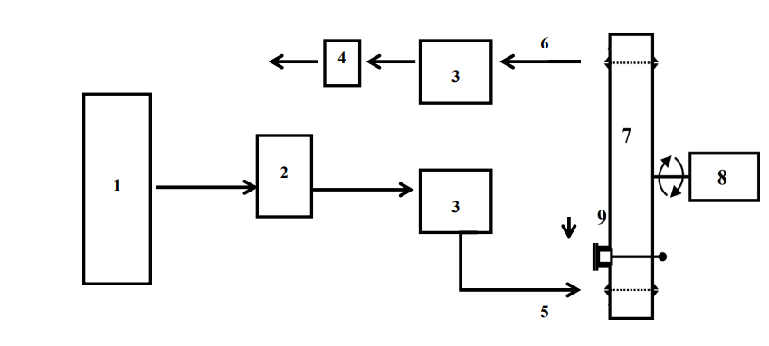

Fig. 1. Ozone treatment system for gaseous phase used for laboratory purposes (1-oxygen bottle, 2-ozone generator, 3-ozone analyzer, 4-surplus gas elimination unit, 5-inlet of ozone, 6-outlet of ozone, 7-reactor, 8-control system with jolting and rotating mechanism, 9-supply and disposal of plant material treated with ozone) (adapted from Brodowska et al., 2015).
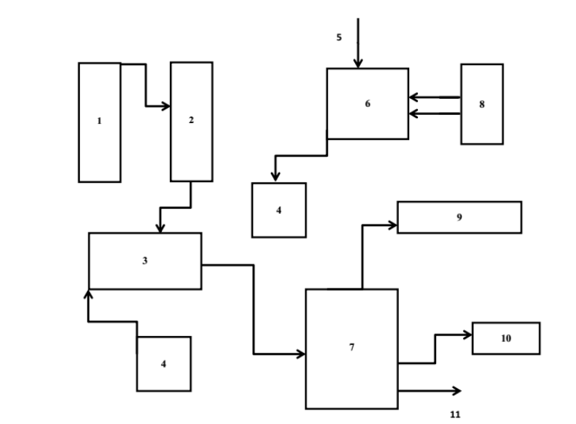
Fig. 2. Ozone treatment system for aqueous phase (1-oxygen cylinder, 2-ozone generator, 3- ozone dissolutor, 4-pump, 5-water, 6-water vessel, 7-dissolution vessel, 8-chiller, 9-ozone decomposition catalyst, 10-ozone monitor, 11-ozone-containing water) (Naito and Sawari, 2000)
Benefits of Ozone Treatment
The antibacterial effect of chlorine, a non-oxidative biocin, is more potent in terms of both concentration and duration.
• Compared to other procedures, disinfection requires less contact time.
• There is no residual problem as it is fully consumed and reduced.
• Non-toxic at low ppm and effective as a bactericidal agent at low ppm (less than 4 ppm).
• There is no need to store hazardous materials, in contrast to other sanitation methods.
• Lower operating costs, limited to the cost of refilling oxygen cylinders and possible problems with the power supply.
• Because no heat is produced during treatment and no heat is needed, the amount of energy required is lower (applicable to foods that are sensitive to heat).
• It reduces the price of shipping and storing cleaning supplies.
• Technology that is both financially feasible and environmentally friendly (Prabha et al., 2015).
Limitations of Ozone Treatment
• Ozonated air is dangerous and can cause asthma, sinus problems, and neck and throat pain when breathed.
• A regulated release on demand system needs to be developed due to the increased degree of ozone instability.
• Recontamination problems in clean process pipelines because ozone breaks down completely in a very short amount of time.
It is advisable to use caution while using ozone and discharge it into a treatment chamber because it can facilitate corrosion at high concentrations (greater than 4 ppm).
• Regular leak detection is required for indoor applications.
• Because generating equipment is unstable and unsuitable for storage, a larger initial investment is required.
• Ozone is generally applied as a surface treatment since it breaks down quickly and is easily oxidised when it comes into contact with organic materials (Prabha et al., 2015).
Utilisation of ozone to extend food shelf life and prevent the growth of microbes in the food industry
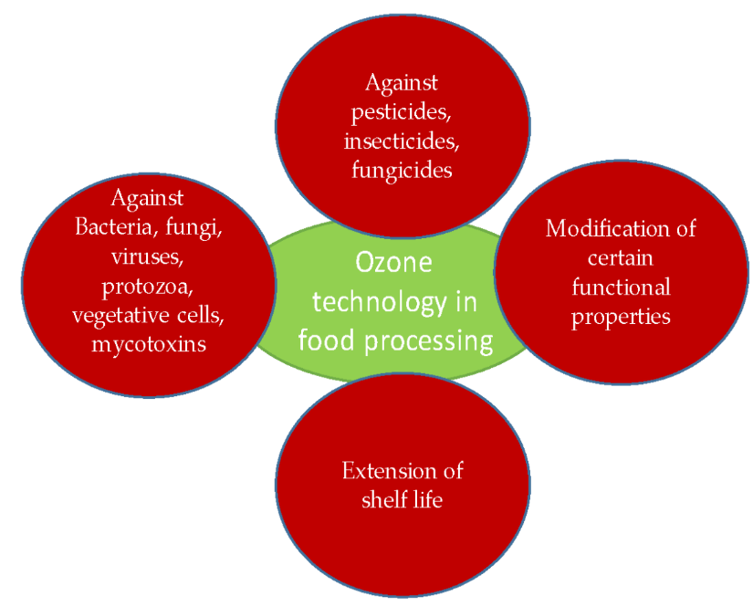

Figure 3: Ozone technology application in food processing (source: Chiozzi et al., 2022)

Ozone in Fluid Food Processing
Based on microbiological tests conducted so far, ozone has been utilized to achieve the necessary 5-log reductions in spoilage and potentially pathogenic microorganisms that are commonly found in fruit and vegetable juices. However, it's important to note that the application of ozone at disinfectant levels can sometimes impact the sensory qualities of food. Not all ozone treatments are the same, and in some cases, it may make food more susceptible to oxidative deterioration. When ozone is applied, unwanted organic and inorganic compounds, including iron, manganese, nitrite, cyanide, and hydrogen sulfide, can easily undergo oxidation (Rakness, 2005).
In one study by Dock (1999), ozone treatment had no discernible effect on the quality characteristics of apple cider. However, Bravo et al. (2007) reported that a significant portion of the polyphenols in green table olive solutions underwent rapid degradation after exposure to ozone (at a rate of 7g/h) for 24 hours. It took an additional 72 hours of ozone bubbling to reduce the amount of tyrosol remaining in the solution.
Ozone in Meat Processing
In a study conducted by Reagan et al. (1996), researchers investigated the most effective methods for cutting and washing cow carcasses to improve the microbiological quality of the meat. They employed cutting knives and used water, hydrogen peroxide (5%), and ozone (at concentrations ranging from 0.3 to 2.3 ppm) as intervention procedures. Ozone treatment led to a decrease in carcass surface contamination by 1.30 CFU/cm2, while hydrogen peroxide reduced aerobic plate counts by 1.14 CFU/cm2. In another study by Greer and Jones (1989), they assessed the effects of gaseous ozone treatment on meat quality, carcass shrinkage, and bacterial deterioration profiles in their examination of beef carcasses. Their findings indicated that exposing carcasses to an ozone atmosphere delayed the growth of psychrotrophic bacteria on the carcass surfaces.
Ozone has also been employed as a pre-treatment before cooking to explore potential synergistic effects on bacterial reduction. In a study by Novak and Yuan (2004a), they subjected treated meat to temperatures ranging from 45 to 75°C to investigate the impact of ozone treatment on strains of Clostridium perfringens, known for producing enterotoxins on the surface of beef. The researchers observed that after heating at temperatures between 45 and 75°C, along with aqueous ozone treatment, there was a reduction of 1-2 log CFU/g in C. perfringens. Although the same treatments also led to a slight decrease in spore counts, it was evident that the spores were considerably more resistant to heat and ozone treatments. Consequently, the study's findings suggested that reductions could be achieved at cooking temperatures where they typically would not occur by utilizing a combination of heat treatment followed by ozone treatment.
Ozone in Grain Processing
Eliminating insect, pest, and microbial infestations in stored grains after harvest is crucial due to the significant impact these infestations can have on grain yield, ranging from 3-10% in affluent countries to up to 50% in certain regions (Jian et al., 2013; Fleurat-Lessard, 2004; Magan and Aldred, 2007). Among the insects known to cause serious damage to stored grains are Tribolium, Sithophilus, and moths, which can also develop resistance to traditional insecticides. The use of ozone in fumigation presents an intriguing alternative to insecticides for controlling insect proliferation.
In a study by Kells et al. (2001), the effectiveness of ozone fumigation was investigated in a corn grain mass against adult insects such as the red flour beetle (Tribolium castaneum), maize weevil (Sithophilus zeamais), and Indian meal moth larvae (Plodia interpunctella). These insects were placed in cages containing maize kernels, slightly below the surface of the grain column. Following either a 50 ppm or 25 ppm ozone treatment for three or five days, the number of deceased insects in the columns was recorded. Exposure to 50 ppm ozone for three days resulted in a significant increase in insect mortality (ranging from 92-100% compared to 3-10%). Although the reduction in insect mortality varied depending on the insect species, it remained quite effective, with mortality rates between 77 and 99.9%. Mason et al. (2006) obtained similar results with insects positioned deeper in maize grain samples (0.6 m below the grain surface) and in the silos' plenum under similar conditions. Additionally, due to its ability to inactivate fungi, ozone may help reduce the formation of mycotoxins during grain storage.
Ozone in Fruits and Vegetables Processing
Ozone technology can be effectively utilized to extend the shelf life of fruits and vegetables after they have been harvested. In many studies, the primary objective of using ozone has been to eliminate or reduce the presence of Botrytis cinerea, commonly known as grey mould, which can affect susceptible fruits and vegetables like tomatoes, blackberries, strawberries, grapes, peaches, plums, carrots, and more (Barth et al., 1995; Hildebrand et al., 2008).
For instance, in a 1995 study conducted by Barth et al., blackberries were treated with ozone at concentrations of 0.1 and 0.3 ppm to prevent the development of fungus. After twelve days, only 20% of the berries showed significant mould deterioration caused by B. cinerea. Beyond inhibiting fungal growth, the study also evaluated anthocyanin content, color, and peroxidase (POD) activity. The concentration of anthocyanins remained stable over the 12-day ozone storage period, and there were no noticeable changes in the appearance or surface damage of the blackberries during ozone storage. The color of the berry surface, as indicated by hue angle values, remained at a high level after exposure to ozone at concentrations of 0.1 and 0.3 ppm and storage for 5 or 12 days, respectively. The addition of ozone contributed to a longer shelf life and higher quality of blackberries (Barth et al., 1995).
In a study conducted by Perez et al. (1999), ozone therapy was evaluated for its effects on strawberries with the same goal of addressing Botrytis cinerea. However, in contrast to the findings of Barth et al. (1995), ozone did not have an impact on B. cinerea in this case. Moreover, the vitamin C content of strawberries exposed to ozone decreased threefold after three days of storage. Perez et al. (1999) also observed that ozone had an adverse effect on the smell of strawberries, resulting in a 40% decrease in volatile ester content.
Conversely, Kute et al. (1995) reported different results when studying strawberries treated and stored with gaseous ozone at concentrations of 0.3 and 0.7 L/L. They found that there was no change in the ascorbic acid concentration in the ozone-treated strawberries. Additionally, the total soluble solid content increased and eventually surpassed that of untreated strawberries over the course of a week following the treatment (Kute et al., 1995).
Ozone in Beverage Processing
Ozone technology finds applications in the field of juice quality management as well. Typically, ozone is introduced into juice as a gas using stirred-tank reactors or bubble columns. Numerous microbiological studies have demonstrated that ozone treatment can effectively reduce the deterioration of fruit and vegetable juices and potentially hazardous microorganisms by up to 5 log numbers (Tiwari and Muthukumarappan, 2012). This makes ozone treatment a valuable tool for enhancing the safety and shelf life of juices.
Ozone in Dairy Processing
Ozonation technology is employed in the treatment of dairy products to enhance their quality and protect against microbial contamination. In 1985, Sander developed and patented a novel method for treating raw milk using small amounts of ozone. Traditional methods of treating raw milk, such as pasteurization, may have a negative impact on its nutritional value and flavor. Sander's approach (1985) addressed these issues and limited the decline in quality.
According to Rojek et al. (1995), the psychrotrophic count in skim milk was significantly reduced (by 99%) when it was treated with ozone at concentrations ranging from 5 to 35 mg/L for durations of 5 to 25 minutes. Additionally, ozone has been shown to effectively eliminate Listeria monocytogenes in both raw and pasteurized milk (Sheelamary and Muthukumar, 2011). This demonstrates the potential of ozone technology to enhance the safety and quality of dairy products.
Ozone in Spices Processing
Zhao and Cranston (1995) conducted a study to investigate the impact of ozone on the volatile components in spices, including both powdered and whole black pepper. Their findings were consistent with those of Perez et al. (1999), who observed a significant reduction in microbiological activity at higher ozone concentrations. Zhao and Cranston (1995) also noted that the form of the spices, whether they were whole or ground, influenced the aroma quality.
In their study, the microbial population was reduced by three to four log units for whole black pepper and three to six log units for ground black pepper when treated with ozone in the gaseous phase at a concentration of 6.7 mg/L for ten minutes, with a flow rate of six liters per minute. Interestingly, while whole black peppercorns were largely unaffected by ozone, crushed black pepper exposed to the gas did experience oxidation of many volatile components (Zhao and Cranston, 1995). This difference could be attributed to the fact that volatile compounds are more readily accessible in ground plant materials compared to unground plant materials, making them more susceptible to ozone-induced oxidation.
Conclusion
The food industry is continually striving to enhance consumer safety in food products, and the information presented in this assessment suggests that ozone treatment could be a valuable method for food preservation. While there have been occasional reports of adverse effects of ozone on various types of food, its use as a sterilizing agent, especially for stored food, remains uncontested. This assertion is strongly supported by the advantages of employing ozone in the food industry, including the preservation of product quality and extension of shelf life. Additionally, ozone treatment offers the added benefit of reducing emissions of unpleasant odors. However, it's important to recognize that even though ozone breaks down rapidly and leaves minimal residue, precautions must still be taken to prevent human exposure.
References
- Bablon G., Bellamy W.D., Bourbigot M.-M., Daniel F.B., Dore M., Erb F., Gordon G., Langlais B., Laplanche A., Legube B., Martin G., Masschelein W.J., Pacey G., Reckhow D.A., Ventresque C. (1991). Fundamental aspects. In: Langlais G., Reckhow D.A., Brink D.R., editors. Ozone in water treatment: Application and engineering. Chelsea, Mich., USA: Lewis Publishers, Inc. pp. 11-132.
- Barth M.M., Zhou C., Mercier J., Payne F.A. (1995). Ozone storage effects on anthocyanin content and fungal growth in blackberries. J Food Sci. 60(6): 1286–1288.
- Bravo, K. S., López, F. A., García, P. G., Quintana, M. D., & Fernández, A. G. (2007). Treatment of green table olive solutions with ozone. Effect on their polyphenol content and on Lactobacillus pentosus and Saccharomyces cerevisiae growth. International journal of food microbiology, 114(1), 60-68.
- Brodowska A.J., Śmigielski K., Nowak A., Brodowska K., Catthoor R., Czyżowska A. (2014). The impact of ozone treatment on changes in biologically active substances of cardamom seeds. J Food Sci. 79(9): C1649-1655
- Brooks, G. M. and Pierce, S. W. (1990), Ozone applications for commercial catfish processing. Paper presented at 15th Annual Tropical and Subtropical Fisheries Technological Conference of the Americas, December 2-5, Orlando, Florida. Available at
- Campos, C. A. et al. (2006), Evaluation of an ozone– slurry ice combined refrigeration system for the storage of farmed turbot (Psetta maxima). Food Chemistry, 97, 223–230.
- Chiozzi, V., Agriopoulou, S., & Varzakas, T. (2022). Advances, applications, and comparison of thermal (pasteurization, sterilization, and aseptic packaging) against non-thermal (ultrasounds, UV radiation, ozonation, high hydrostatic pressure) technologies in food processing. Applied Sciences, 12(4), 2202.
- De Souza, L.P., Lê Faroni, Rita D.’Antonino, F.F Heleno, P.R Cecon, T.D.C Gonçalves, G.J Da Silva, and L.H.F Prates. (2018). “Effects of Ozone Treatment on Post Harvest Carrot Quality.” LWT - Food Science and Technology doi: 10.1016/ j.lwt.2017.11.057.
- Dock L.L. (1999). Development of thermal and non-thermal preservation methods for producing microbially safe apple cider. PhD thesis, Purdue University, West Lafayette
- EPRI.(2000).“Ozone as an Antimicrobial Agent for the Treatment, Storage and Processing of Foods in Gas and Aqueous Phases.” Food Additive Petition filed with FDA.
- EPRI. (1997). Technical Report-108026, Vols. 1, 2, 3: Evaluation of the history and safety of ozone in processing food for human consumption. EPRI. Palo Alto, CA.. www.epri.com
- Fleurat-Lessard, F. (2017). Integrated management of the risks of stored grain spoilage by seedborne fungi and contamination by storage mould mycotoxins–An update. Journal of Stored Products Research, 71, 22-40.
- Gonçalves A.A. (2016). Ozone as a safe and environmentally friendly tool for the seafood industry. J Aquat Food Product Technol. 25(2): 210-229.
- Greer, G.G. and Jones, S.D.M. (1989). Effects of ozone on beef carcass shrinkage, muscle quality and bacterial spoilage, Can Inst Food Sci Technol J, 22: 156–60.
- Guzel-Seydim Z.B., Greene A.K., Seydim A.C. (2004). Use of ozone in the food industry. LWT - Food Sci Technol. 37: 453–460.
- Hildebrand P.D., Forney C.F., Song J., Fan L., McRae K.B. (2008). Effect of a continuous low ozone exposure (50 nL L−1 ) on decay and quality of stored carrots. Postharvest Biol Technol. 49(3): 397–402.
- Jian, F., Jayas, D. S., & White, N. D. (2013). Can ozone be a new control strategy for pests of stored grain?. Agricultural Research, 2, 1-8.
- Kells, S. A., Mason, L. J., Maier, D. E., & Woloshuk, C. P. (2001). Efficacy and fumigation characteristics of ozone in stored maize. Journal of stored products research, 37(4), 371-382.
- Kunicka - Styczyńska A., Śmigielski K. (2011). Bezpieczeństwo mikrobiologiczne surowców ziołowych. Przemysł spożywczy. 6: 50-53.
- Kute K.M., Zhou C., Barth M.M. (1995). The effect of ozone exposure on total ascorbic acid activity and soluble solids contents in strawberry tissue. Proc IFT Ann Meet. pp. 82.
- Magan, N., & Aldred, D. (2007). Post-harvest control strategies: Minimizing mycotoxins in the food chain. International journal of food microbiology, 119(1-2), 131-139.
- Manley, T. C., and S. J. Niegowski. (1967). “Ozone.” Encyclopedia of Chemical Technology 14:410–32.
- Mason, L. J., Woloshuk, C. P., Mendoza, F., Maier, D. E., & Kells, S. A. (2006). Ozone: A new control strategy for stored grain. In Proceedings of the 9th International Working Conference on Stored Product Protection (pp. 15-18).
- Miller, G. W. (1978). An assessment of ozone and chlorine dioxide technologies for treatment of municipal water supplies (Vol. 1). Environmental Protection Agency, Office of Research and Development, Municipal Environmental Research Laboratory.
- Mohammadi, H., S.M. Mazloomi, M.H. Eskandari, M. Aminlari, and M. Niakousari. (2017). “The Effect of Ozone on Aflatoxin M1, Oxidative Stability, Carotenoid Content and the Microbial Count of Milk.” Ozone: Science & Engineering 39: 447–53. doi: 10.1080/ 01919512.2017.1329647
- Naito S., Sawairi A. (2000). Ozone inactivation of lactic acid bacteria. Biocontrol Sci. 5(2): 107– 110.
- Novak, J. S., & Yuan, J. T. (2004). Increased inactivation of ozone-treated Clostridium perfringens vegetative cells and spores on fabricated beef surfaces using mild heat. Journal of food protection, 67(2), 342-346.
- Pascual, A., Llorca, I., & Canut, A. (2007). Use of ozone in food industries for reducing the environmental impact of cleaning and disinfection activities. Trends in food science & technology, 18, S29-S35.
- Peleg M. (1976). Review paper: The chemistry of ozone in the treatment of water. Water Res. 10: 361–365
- Perez A.G., Sanz C., Rios J.J., Olias R., Olias J.M. (1999). Effects of ozone treatment on postharvest strawberry quality. J Agri Food Chem. 47: 1652–1656.
- Perez A.G., Sanz C., Rios J.J., Olias R., Olias J.M. (1999). Effects of ozone treatment on postharvest strawberry quality. J Agri Food Chem. 47: 1652–1656
- Prabha, V. I. T. H. U., Barma, R. D., Singh, R. A. N. J. I. T., & Madan, A. (2015). Ozone technology in food processing: A review.
- Pryor W.A., Squadrito G.L., Friedman M. (1995). A new mechanism for the toxicity of ozone. Toxicol Lett. 82/83: 287-293
- Rakness K. L. (2005). Ozone in drinking water treatment: process design, operation, and optimization. First edition. Denver, CO, USA: American Water Works Association
- Reagan, J. O., Acuff, G. R., Buege, D. R., Buyck, M. J., Dickson, J. S., Kastner, C. L., ... & Sofos, J. N. (1996). Trimming and washing of beef carcasses as a method of improving the microbiological quality of meat. Journal of food protection, 59(7), 751-756.
- Rice, R. G. (1986). Application of ozone in water and waste water treatment. In: Rice, R.G., Browning, M.J. (Eds.), Analytical Aspects of Ozone Treatment of Water and WasteWater. Syracuse, The institute, New York, pp. 726.
- Rojek U., Hill A.R., Griffiths M. (1995). Preservation of milk by hyperbaric ozone processing. J Dairy Sci. 78(suppl. 1), 125.
- Sander M. (1985). Process for the gentle ozone treatment of liquids, such as fruit juices, milk, liquid milk products, wine, oils, liquid medicaments, blood and/or similar products. Patent No. DE 3325568A1
- Seafish (1997), Use of Ozone in the Fish Industry. Seafish Fish Technology Department, Sea Fish Industry Authority, St. Andrew’s Dock, East Yorkshire Available at
- Sheelamary M., Muthukumar M. (2011). Effectiveness of ozone in inactivating Listeria monocytogenes from milk samples. WJYR. 1: 40–44
- Stephan, R., D. Althaus, S. Kiefer, A. Lehner, C. Hatz, C. Schmutz, M. Jost, N. Gerber, A. Baumgartner, H. Hächler, et al. (2015). “Foodborne Transmission of Listeria Monocytogenes via Ready-To-Eat Salad: A Nationwide Outbreak in Switzerland, 2013–2014.” Food Control 57: 14–17. doi: 10.1016/j.foodcont.2015.03.034
- Strittmatter R.J., Yang B., Johnson D.A. (1996). Ozone application for cooling tower water. ASHRAE J. 38: 27–34.
- Tapp C., Rice R.G. (2012). Generation and control of ozone. In: O’Donnell C., Tiwari B.K., Cullen P.J., Rice R.G., editors. Ozone in food processing. First edition. Chichester: Blackwell Publishing Ltd. pp. 33-46
- Tiwari B.K., Muthukumarappan K., O’Donnell C.P., Cullen P.J. (2008). Kinetics of freshly squeezed orange juice quality changes during ozone processing. J Agric Food Chem. 56(15): 6416–6422.
- U.S. FDA. (1982). GRAS status of ozone. Federal Register 47(215):50209-50210.
- USDA FSIS. (2001). Letter from Robert C. Post (FSIS, Washington, DC) to Mark D. Dopp (American Meat Institute, Arlington, VA).
- Zhao J., Cranston P.M. (1995). Microbial decontamination of black pepper by ozone and the effect of the treatment on volatile oil constituents of the spice. J Sci Food Agri. 68: 11–18.

