Title: Plastination: An amazing educational technique for understanding medical anatomy.

Author: Dr. Amit Kumar Shreevastava
Assistant Professor
Department of Anatomy
All India Institute of Medical Sciences, Raebareli.
Uttar Pradesh, India.
PIN: 229405
Mobile No: 7706006006
Email: dr.amitaiims12@gmail.com
Introduction:
Plastination is a splendid scientific procedure utilizing curable polymers for the long-term shielding of cadavers and biological specimens. The plastinated specimens thus produced can be utilized for educational, research, public exhibitions, and instructional purposes. Dr. Gunther von Hagens developed the method in Heidelberg, Germany in 1977. This technique revolutionizes the concept of body preservation [1,2,3].
The basic principle of plastination-
During this procedure, water and lipids present inside the biological specimens are replaced with curable polymers. Plastination has been performed with several different polymers, the most common being: silicone (S10), polyester (P40), and epoxy (E12). The prepared plastinated specimens are dry, odorless, inert, durable, natural-looking, easy to carry, and non-toxic [1,2,3].
What are human plastinates and their importance?
The specimens obtained after the plastination of cadavers and their body parts are called human plastinates. It may play a vital role in generating resource materials for the enhancement of understanding of 3D anatomical configuration, cross-sectional relative view, forensic medicine, pathological anatomy, biology, and medical imaging. It is an important tool for comprehending both macroscopic and microscopic structures [1,2,3,4].
Disadvantages of the traditional formaldehyde fixation method:
- Formaldehyde is volatile.
- The storage tank area should be spacious & and equipped with exhaust fans.
- Difficulties in handling specimens.
- Long-term exposure to formalin fumes may cause cancer [5].
- Lack of student participation due to offensive odor, watering of eyes, and skin irritation [6].
Plastination consists of the following steps:
- Specimen Preparation (dissection and fixation): The cadaveric tissue is fixed and prevented from bacterial decomposition by formalin (10%) based chemical solutions pumped through major easily accessible arteries. It will require 3-4 hours for proper tissue fixation. After fixation, meticulous dissection will be followed for several days to achieve the desired anatomical structures [1,6-8].
- Dehydration & Defatting: The well-dissected fixed cadaver or body part is fully immersed in a tank containing acetone at (-25°C). At this low temperature, all the intra or extra-cellular water is replaced with acetone. During this step, at least three changes of the acetone are necessary. After that, the specimen is kept at room temperature for the removal of fat from the specimen. The total duration of this process is about 4-5 weeks [1,6-8].
- Forced impregnation: During this procedure, the specimen is dipped in a tank of liquid polymers, namely silicone, polyester, or epoxy resin. In this process, a vacuum is generated inside the chambers, which causes acetone to come outside the cells and allows the liquid polymer to go inside. This is a vital step taking around 2-5 weeks [1,6-8].
- Curing (hardening): The polymerized soft specimens are exposed to either gas, light, or heat to make them hard. Curing increases the lifespan of the plastinates. It requires several weeks [1,6-8].
Types of plastination:
- Whole body plastination: The entire body or viscera can be plastinated with silicon S10 polymer. In this process, the in-situ position of the viscera or entire body topography is maintained.
- Luminal plastination: In this process, hollow viscera like intestines, heart, urinary bladder, stomach, blood vessels, and kidneys are plastinated with silicone S10 polymer.
- Sheet plastination: This procedure is used for making thin or thick slices of the cadaver or viscera. It provides excellent plastinated cross-sectional specimens. The epoxy polymer (E12) is used for transparent body slices (2-3 mm), polyester (P40) for semi-transparent brain slices (3-6 mm), and silicone (S10) for opaque body or viscera slices (1cm). It is very useful for understanding the cross-sectional anatomy and interpretation of medical imaging [1-4,6].
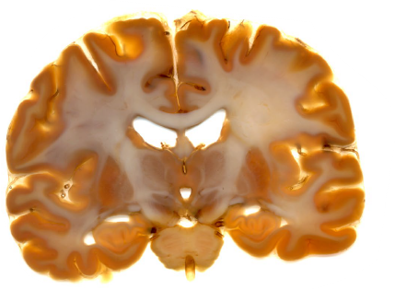
Figure 1: Coronal section of the human brain (sheet plastination). Polyester (P40) technique [3].
Advantages of plastinates:
- Lack of odor.
- Clean, inert, and non-toxic.
- Dry and hand-able items.
- More student participation.
- Provides excellent additional resource materials for medical teaching and research purposes.
- Long-lasting and minimal aftercare.
- Using real specimens is motivational.
- Excellent 3D and cross-sectional anatomical view.
- Public museum.
- Plastinates can be scanned, photographed, and digitalized [1,2,3,4].
Disadvantages of plastinates:
- Expensive and time-consuming.
- Trained technician needed.
- It lacks empathy.
- It can not provide meticulous hands-on skill activities.
Silicon cast preparation:
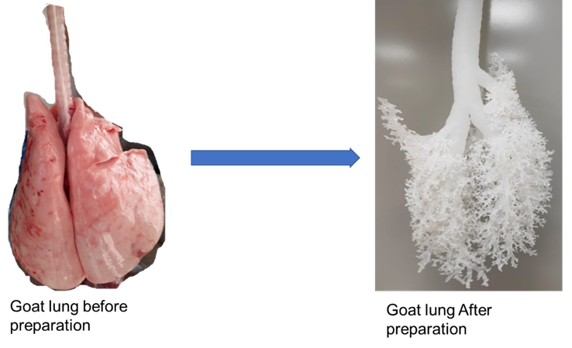
Figure 2: Preparation of silicon cast of tracheobronchial trees.
Conclusion:
- Plastinated specimens are the ‘Anatomical Art’.
- The formaline fixed specimens can be substituted with exquisite plastinates for academics, research, medico-legal cases, and public exhibitions.
- Plastination may not completely replace the old recommended dissection methodology used in the medical curriculum due to a lack of hands-on skill activities.
- With the use of the latest technology like artificial intelligence, the plastinates may further enhance the understanding of human anatomy.
- Considering the ethical issues plastinated cadavers must not be commercialized.

References:
- Von Hagens G, Tiedemann K, Kriz W. The current potential of plastination. Anat Embryol 1987;175(4):411-421. doi: 10.1007/BF00309677.
- Pashaei S. A brief review on the history, methods, and application of plastination. Int J Morphol 2010; 28(4):1075-1079.
- Sora MC, Latorre R, Baptista C, López-Albors O. Plastination-A scientific method for teaching and research. Anat Histol Embryol 2019;48(6):526-531. doi: 10.1111/ahe.12493.
- Riederer BM. Plastination and its importance in teaching anatomy. Critical points for long-term preservation of human tissue. J. Anat 2014; 224, 309-315. doi: 10.1111/joa.12056.
- NTP (National Toxicology Program). 2021. Report on Carcinogens, Fifteenth Edition. Research Triangle Park, NC: U.S. Department of Health and Human Services, Public Health Service. https://ntp.niehs.nih.gov/go/roc15 (EndNote XML). doi: https://doi.org/10.22427/NTP-OTHER-1003
- Raed Ogaili, Sameem S.M. Baker, and Hong-Jin Sui. International Journal of ChemTech Research 2018,11(09): 393-398. DOI= http://dx.doi.org/10.20902/IJCTR.2018.110945.
- https://bodyworlds.com/about-us/organisations/.
- DeJong K, Henry RW. Silicone Plastination of Biological Tissue: Cold-temperatureTechnique Biodur S10/Sl5 Technique and Products. J Int Soc Plastination 2007; 22:2–14.

