CLIMATE INDUCED URBANIZATION IMPACT ON URBAN FLOOD HAZARD USING GIS AND REMOTE SENSING

V. Sampath Kumar¹, S. Muthusamy² and P. Mohana³*

- Department of Civil Engineering, Sathyabama Institute of Science and Technology, Chennai – 119.
- Assistant Professor, Department of Geology, V.O.C College, Tuticorin
- Centre for Remote Sensing and Geoinformatics, Sathyabama Institute of Science and Technology, Chennai – 119.

ABSTRACT

Flood is one of the serve disaster affecting the people across the globe. It is one of the major natural hazard of Velachery which is occurs in every year. Flood in Velachery is characterized by their extremely large magnitude, extensive devastation and high frequency. The flood occurs in Velachery caused by Velachery Lake. The topographic condition, accelerated rate of deforestation, high intensity of rainfall, explosive growth of population, great amount of land use etc. are the dominant cause of flood in that area. Although it is an age old phenomena in the lake in the Velachery, the extent of damage caused by the flood has increased significantly in recent year. It cause huge destruction and irreparable loss to the local people. It adversely effects on human life and properties, transport and communication, etc. which lead to huge amount of economic loss in every year. This article is about the major economic losses of the state due to flood.
Floods are uncontrollable natural event causing loss of life and damage to public property. The flood water has to be managed so that it can be used for many purposes. The extent of inundation and the depth of flooding can be estimated using remote sensing and GIS (Geographic Information System) techniques. This study intends to focus on the aspect of field investigation along with GIS to reconstruct a Flood event so as to estimate the flood volume and extent. Field investigation shows that Velachery area of Chennai city in India is subjected to severe flooding. This study is an attempt in reconstructing the flood event of December 03, 2005 through field investigation in Velachery area. Field of study has been restricted to the Velachery area.
Keywords: Flood, Economy, Rainfall, Population.

INTRODUCTION
Urban flood is the important issue at present in Chennai metropolitan area. In this issue we were taken to study about the Velachery area flooded details and to assess the storm water drainage system. By using this system whenever the flood are raised, the local people can open the storm water drain in Velachery.

The people from this areas are never want to temporarily migrate for this issues. In future, the people are live in safe manner like, where the people are residents in non-flooded zone areas. To compare the results of existing and new systems.

Storm water drain is infrastructure used to drain excess rain and ground water from impervious surfaces such as paved streets, car parks, parking lots, footpaths, sidewalks, and roofs. Storm drains varies from small residential dry wells to large municipal systems.

Drains receive water from street gutters on most motorways, freeways and other busy roads, as well as towns in areas with heavy rainfall that leads to flooding, and coastal towns with regular storms. Even gutters from houses and buildings can connect to the storm drain. Many storm drainage systems are gravity sewers that drain untreated storm water into rivers or stream so it is unacceptable to pour hazardous substances into the drains.

Storm drains sometimes cannot manage the quantity of rain that falls in heavy rains or storms. Inundated drains can cause basement and street flooding. Many areas require detention tanks inside a property that temporarily hold runoff in heavy rains and restrict outlet flow to the public sewer. This reduces the risk of overwhelming the public sewer. Some storm drains mix storm water (rainwater) with sewage, either intentionally in the case of combined sewers or unintentionally.

Flood is an inevitable natural phenomenon occurring from time to time which Not only damages natural resources and environment, but also causes the loss of lives, economy and health. Flooding is observed when the discharge in the channels (natural/ artificial) is greater than the carrying capacity. Urbanization of watershed leads to decrease in infiltration or increase in runoff coefficient, increased peak flow, reduced time of concentration and hence for the same amount of rainfall, greater is the flooding. Nowadays the state of the art technology in the field of Geographic Information System (GIS) allows spatial analysis so as to generate the flood hazard modeling. With regard to flood studies, GIS is an important tool which enables data capture, input, manipulation, transformation, visualization, combination, query, analysis, modeling and output. Although several flood modeling techniques are available, this study focuses on first hand information from the flood affected people to analyze the flood situation. Thereby, the volume of flood water in the area is calculated from the high flood level obtained in the field along with the Digital Elevation Model created in GIS.

OBJECTIVES
    - Find out the location of man-made storm water drainage
    - To assess the Digital Elevation Model and other topographical features
    - To find out the location for new storm water path or where to improve the existing system
SCOPE
The scope of the project is, to make the flooded zone as non-flooded zone in Velachery
To plan adequate construction of storm water drainage and to avoid flood in residents, commercial, hospitals and institutional buildings.

METHODOLOGY

The methodology is based on a GIS-based index called Flood Intensity Index (Iw), which can be considered as a trade-off between morphometric indexes and physically based two-dimensional (2D) hydraulic models.

Some of the common techniques used for flood control are the installation of rock beams, rock rip-raps, sand bags, maintenance of normal slopes with vegetation or application of soil cements on steeper slopes and construction or expansion of drainage. Other methods include dykes, dams, retention basins or detention.

The proposed methodology uses the aforementioned Iw index for providing an insight of flood variables and processes, considering both simple (e.g. local failure of flood defences) and complex hazard scenarios (e.g. failure or overflowing from one or multiple river reaches). According to the chosen strategy, the methodology synthesizes the information regarding the flood susceptibility of an area into graphs and curves. By combining this information with appropriate damage functions, the flood vulnerability of the area, relating the different flood scenarios with the damage they are expected to originate, can then be computed effortlessly. Additionally, the result of these analyses can be used to characterize, compare and rank the susceptibility and vulnerability of different flood-prone areas within a region.

METHODOLOGY
Study Area

Digital Elevation Model

Slope Map

Land Cover Map

Rainfall Data

Overlay Analysis

Flood Map

Possible zones for Storm water Drainage

Flood Inundation

Fig 1: Flow Chart

DESCRIPTION OF STUDY AREA

Velachery is a fast-developing residential area in South West Chennai, a metropolitan city in Tamil Nadu, India. Velachery lies between latitude 12° 58' 20"and longitude 80°13' 35". It is well-connected by roads and Metro railway network, MRTS (Mass Rapid Transit System). Most of the study area is built up and there are only few open lands. Due to rise in water table, water gets stagnated in this open land.

The study area is a part of Velachery, Detailed Development Plan (DDP) in Chennai, India (Fig 1). The study area consists of different type of land-uses such as residential, commercial, hospitals and institutional use (Industrial use is not within the study area limit) and the built structure varies from single floor structures to nine floor structures with different floor-wise uses.
Velachery is a commercial and residential area in south Chennai, and is the largest commercial centre in south Chennai. It is surrounded by Guindy in the north, IIT Madras in the north-east, Taramani in the east, Perungudi in the south-east, Pallikaranai Wetland in the south, Madipakkam in the south and south-west, Adambakkam in the west and north-west.
Pallikaranai wetland is a freshwater marsh in the city of Chennai, India. It is situated adjacent to the Bay of Bengal, about 20 kilometres (12 miles) south of the city centre, and has a geographical area of 80 square kilometres (31 sq miles). Pallikaranai marshland is the only surviving wetland ecosystem of the city and is among the few and last remaining natural wetlands of South India. It is one of the 94 identified wetlands under National Wetland Conservation and Management Programme (NWCMP) operationalised by the Government of India in 1985–86 and one of the three in the state of Tamil Nadu, the other two being Point Calimere and Kazhuveli. It is also one of the prioritised wetlands of Tamil Nadu. The topography of the swamp is such that it always retains some storage, thus forming an aquatic ecosystem. A project on 'Inland Wetlands of India' commissioned by the Ministry of Environment and Forests, Government of India had prioritised Pallikaranai marsh as one of the most significant wetlands of the country. The marsh contains several rare or endangered and threatened species and acts as a forage and breeding ground for thousands of migratory birds from various places within and outside the country. The number of bird species sighted in the wetland is significantly higher than the number at Vedanthangal Bird Sanctuary.
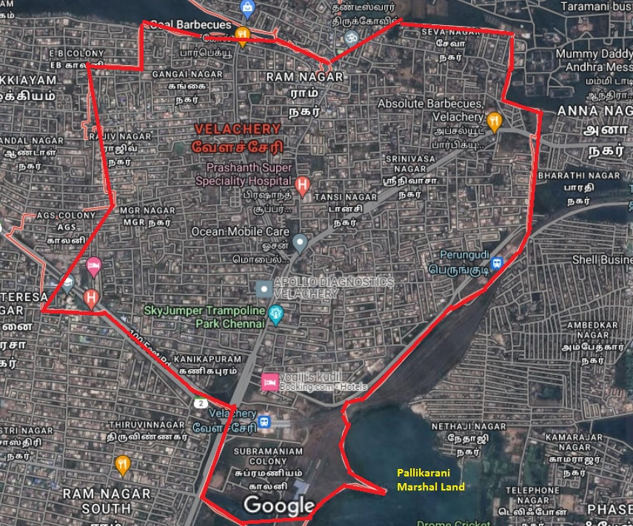

Fig 2: Velachery study area location map (Source: Google Map)

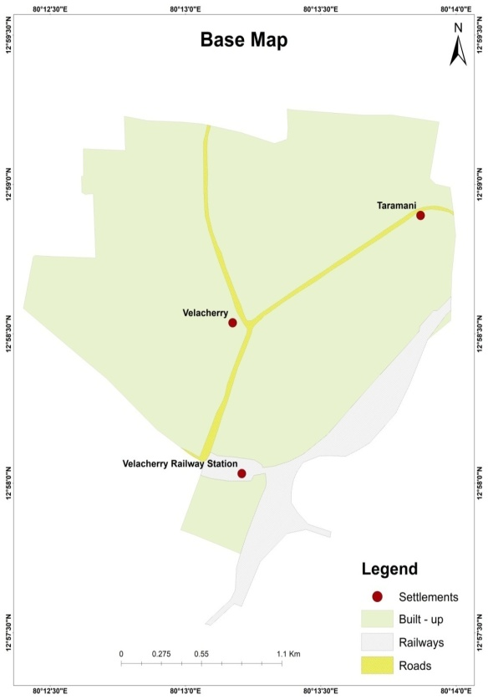

Fig.3: Velachery Base map (Study Area Location)
THEMATIC LAYERS

Digital Elevation Model (DEM)

A satellite imagery model is a three-dimensional visual effects illustration of elevation data used to depict terrain on a planet. DEMs are the the majority general basis for digitally generated relief maps and are frequently used in geographic information systems. It shows in fig (4)

It is a representation of the bare ground (bare earth) topographic surface of the Earth excluding trees, buildings, and any other surface objects. DEMs are created from a variety of sources. Shuttle Radar Topography Mission (SRTM) DEM’s used to be derived primarily from topographic maps.

DEMs are commonly built using data collected using remote sensing techniques, but they may also be built from land surveying. Mappers may prepare digital elevation models in a number of ways, but they frequently use remote sensing rather than direct survey data. By using satellite we can capture the study area and process into DEM. The below fig. shows the values in meters and satellite is covered the pixel about 30 meters.

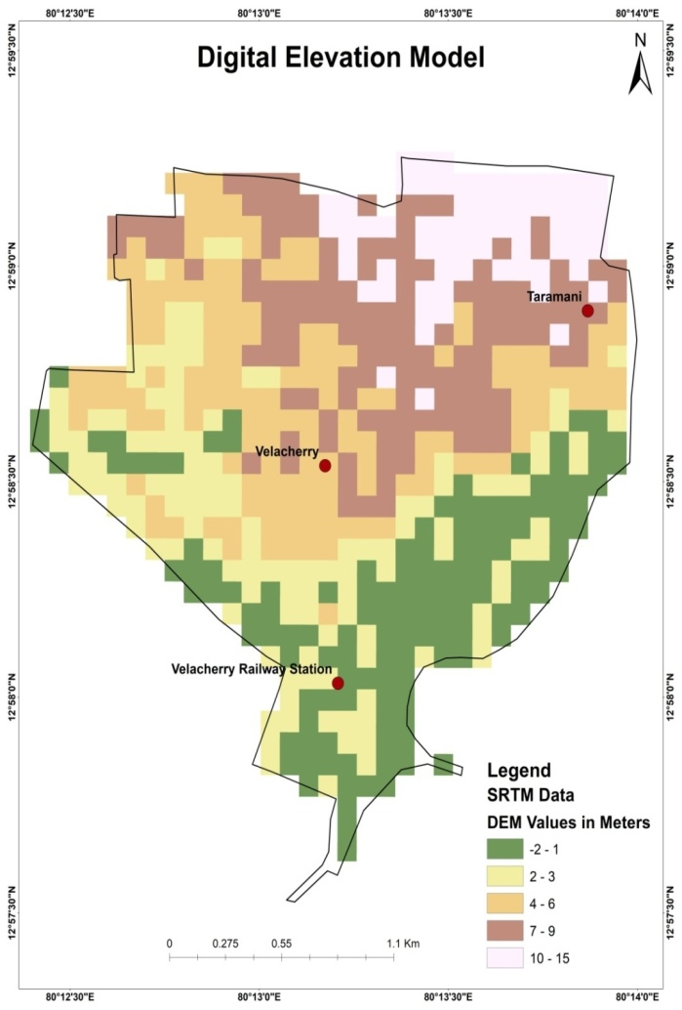
Fig 4: Velachery Digital Elevation Model

Geomorphology
Velachery mostly has areas of clay and hard rock. The Velachery lake was historically about 250 acres with the ancient Selliamman and Narasimhar temples on its Southern corner. South of Velachery, there were thousands of acres of marshland called Kazhuveli made of coarse elephant grass and swamps. The area was also called Kazhiveli as it allowed rain water runoff and catchment. It had six natural spring aquifers that enabled groundwater table to be recharged. The marshland also was a sanctuary for resident and migratory birds. Beginning in the last decades of 20th century, the marshland all but disappeared due to rapid development and encroachment. The remaining southern portions of the marshland make up the Pallikaranai wetland.

Slope
The rise and fall of the study region land surface is referred to as a slope. By using the ArcGIS software we can identify the land arrangements in the study area in which the flood will inundated.

Land use and Land cover
Water bodies, urban areas, barren land, and woodland make up the majority of the study region.
Rainfall
Rainfall refers to the amount of precipitation in the form of rain that falls to the earth's surface, whether on land or water. It happens when a cloud of air travels over a warm body of water or wet ground.

Slope Map (From ArcGIS Software)

It is a two-dimensional representation of the gradient of a surface. It shows how steep or gentle a slope is at any given point.

It can be used to identify potential hazards, plan construction projects, and more. Consideration of the slope of the land is important to reduce construction costs, minimize risks from natural hazards such as flooding and landslides, and to minimize the impacts of proposed development on natural resources such as soils, vegetation, and water systems.

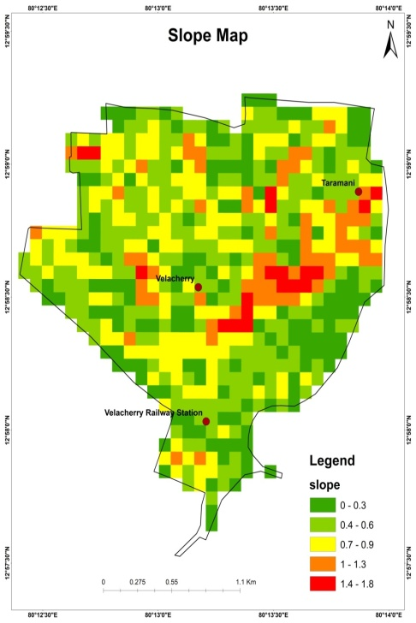
Fig 5: Velachery Slope Map (From ArcGIS Software)

Slope Map (From Satellite)

Slope maps are used to represent the land relief, but in contrast to topographic maps where the altimetry is represented numerically with contour lines or with color bands, the slope values correspond to the angle (in degrees) of the Earth's surface

They show quantitatively the maximum slope of the relief Slope is calculated in a GIS by comparing a certain point within a raster to that point's neighbors. Usually a point is compared with eight of its neighbors to derive its slope, but the exact method varies depending on the specific slope analysis desired.

The Slope tool identifies the steepness at each cell of a raster surface. The lower the slope value, the flatter the terrain; the higher the slope value, the steeper the terrain.

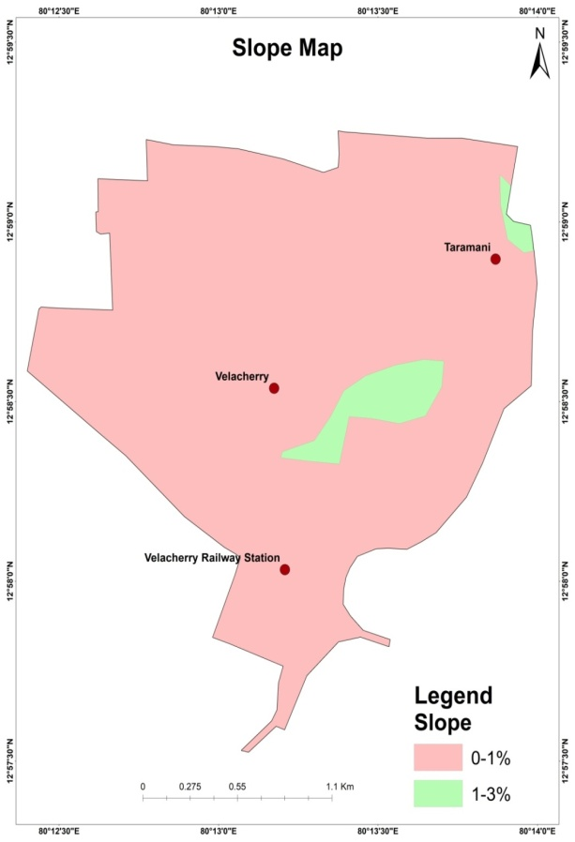

Fig 6: Velachery Slope Map (From Satellite)

Land Cover Map

Land cover maps are tools that provide vital information on the Earth's land use and cover patterns. They aide policy development, urban planning, forest and agricultural monitoring etc.
It is a process that quantifies current land resources into a series of thematic categories, such as forest, water, and paved surfaces. Land cover maps of an area provide information to help users to understand the current landscape. Annual information on national spatial databases will enable the monitoring of temporal dynamics of agricultural ecosystems, forest conversions, surface water bodies, etc. The systematic mapping of land cover patterns, including change detection most often follow two main approaches: field survey. Land use and land cover mapping is carried out to study the land utilization and future planning and management of land resource. Five land use classes have been identified in the study region such as, agricultural crop land, built-up (urban and rural), Water body, Forest area and wasteland. Land cover and land use mapping is one the most imperative and typical application of remote sensing. Land cover represents the physical condition of the earth surface features such as forest; grassland etc. Identification of land cover establishes the baseline from which monitoring activities (change detection) can be performed, and provides the ground cover information for baseline thematic maps. Land use refers to the purpose the land serves, for example, recreation, wildlife habitat, or agriculture.

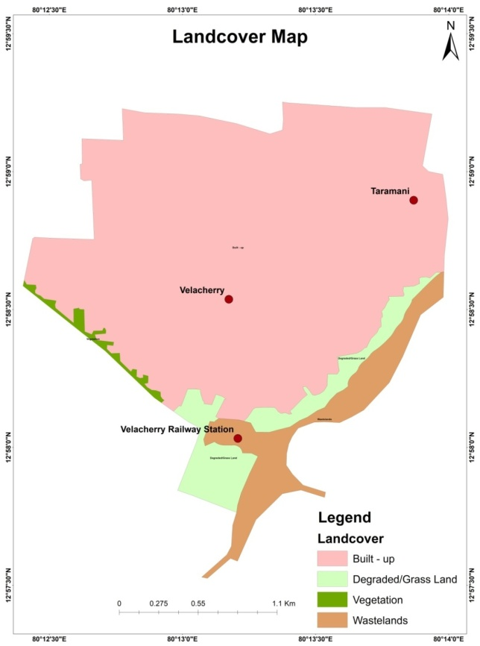

Fig 7: Velachery Land cover map

Settlements Map

Accurately mapping and naming settlements enables tracking and monitoring the progress of activities/interventions/ programmes, etc., Human settlement maps are useful in understanding growth patterns, population distribution, resource management, change detection, and a variety of other applications where information related to earth surface is required. A dataset that provides settlement points or polygons and their names to spatially locate, identify, and visualize settlement features. These map represents a place where the people live. A settlement may be as small as a single house in a remote area or as a large as a mega city (a city with over 10 million residents). They provide vital information about communities such as name, buildings distribution, and geographic extent.

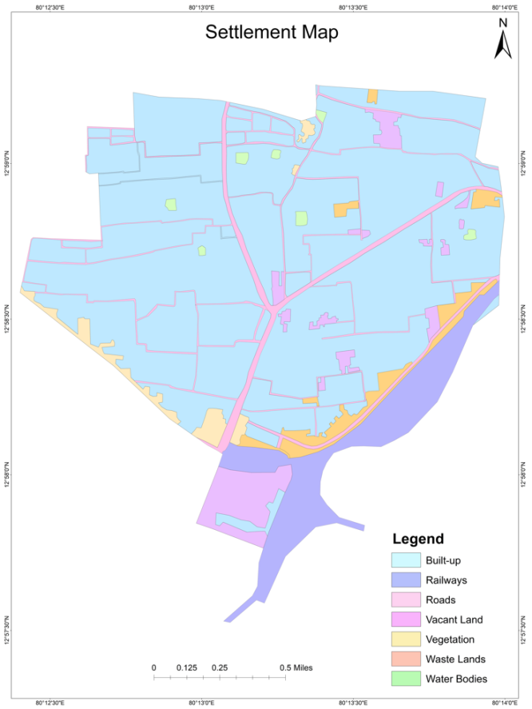
Fig 8: Velachery Settlement map

Rainfall Data

On North East Monsoon rainfall it has rained 635.42mm from 01.10.2021 to 29.11.2021. This is 80% more than 352.6mm (when it is compared to normal rainfall)

The annual rainfall in last 7 years:
Year | North East Monsoon rainfall in Tamil Nadu (mm) | North East Monsoon rainfall in Chennai (mm) | Annual rainfall in Tamil Nadu | Annual rainfall In Chennai
2015 | 518 | 1167 | 1057 | 1610
2016 | 100.6 | 95 | 472 | 789
2017 | 300.6 | 854 | 877 | 1310
2018 | 314.8 | 321 | 768 | 722
2019 | 348 | 417 | 800 | 1006
2020 | 303.8 | 811.5 | 814 | 1343
2021 | 613 | 1121 | 1300 | 1866

Based on survey taken, 2021 has more rained when it is compared from 2015 to 2021. Tamil Nadu and Chennai has more rained 1300mm and 1866mm on last year.

YEAR | SWMS |  |  |  | NEMS |  |  |  |  | WINTER |  |  |  |  | HOT WEATHER |  |  |  |  | ANNUAL RAINFALL
 | Normal | Actual | Deviation | % Variation |  | Normal | Actual | Deviation | % Variation |  | Normal | Actual | Deviation | % Variation |  | Normal | Actual | Deviation | % Variation |  | Normal | Actual | Deviation | % Variation
2003-2004 | 332 | 337 | 5 | 2 |  | 465 | 403 | -62 | -13 |  | 37 | 12 | -26 | -69 |  | 128 | 283 | 155 | 121 |  | 961.8 | 1035 | 7.6 | 8
2004-2005 | 332 | 361 | 29 | 9 |  | 465 | 472 | 8 | 2 |  | 37 | 14 | -23 | -62 |  | 128 | 232 | 103 | 80 |  | 961.8 | 1079 | 12.2 | 12
2005-2006 | 333 | 308 | -25 | -7 |  | 459 | 830 | 371 | 81 |  | 37 | 16 | -21 | -57 |  | 130 | 151 | 21 | 17 |  | 958.5 | 1306 | 36.1 | 36
2006-2007 | 316 | 251 | -65 | -21 |  | 431 | 498 | 66 | 15 |  | 35 | 11 | -24 | -69 |  | 129 | 100 | -29 | -22 |  | 911.6 | 860 | -5.7 | -6
2007-2008 | 316 | 342 | 26 | 8 |  | 431 | 515 | 84 | 20 |  | 35 | 47 | 11 | 32 |  | 129 | 261 | 132 | 102 |  | 911.6 | 1165 | 27.7 | 28
2008-2009 | 288 | 334 | 46 | 16 |  | 431 | 553 | 122 | 28 |  | 35.3 | 7.7 | -28 | -78 |  | 129 | 132 | 3 | 2 |  | 883.1 | 1026 | 142.5 | 16
2009-2010 | 316 | 317 | 1 | 0 |  | 431 | 483 | 52 | 12 |  | 35 | 12 | -23 | -66 |  | 129 | 127 | -2 | -2 |  | 912 | 938 | 26 | 2.9
2010-2011 | 319 | 384 | 64 | 20 |  | 430 | 605 | 175 | 41 |  | 31.3 | 36.3 | 5 | 16 |  | 128 | 140 | 12 | 10 |  | 908.6 | 1165 | 256.5 | 28.2
2011-2012 | 439.1 | 769.6 | 75.3 | 100.4 |  | 789.9 | 835.9 | 5.8 | 38.1 |  | 36.8 | 17 | -53.8 | -53.2 |  | 58.5 | 0.5 | -99.1 | -99.6 |  | 1324.3 | 1623 | 22.6 | 39.3
2012-2013 | 433.9 | 852.7 | 418.8 | 97 |  | 877.3 | 852 | -25.3 | -3 |  | 24.7 | 16.3 | -8.4 | -34 |  | 55.6 | 3.6 | -52 | -94 |  | 1391 | 1724.6 | 333.1 | 24
2013-2014 | 439.1 | 597.6 | 158.5 | 36.07 |  | 789.9 | 463.5 | -326.4 | -41.32 |  | 36.7 | 7.1 | -29.6 | -80.65 |  | 58.8 | 30.5 | -28.3 | -48.37 |  | 1324.5 | 1098.7 | -225.8 | -17.04
2014-2015 | 439.1 | 529.4 | 90.3 | 20.6 |  | 789.9 | 719.6 | -70.3 | -8.9 |  | 36.7 | 14 | -22.7 | -61.9 |  | 58.5 | 59.2 | 0.7 | 1.2 |  | 1324.2 | 1322.2 | -2 | -0.2
2015-2016 | 439.1 | 369.9 | -69.2 | -15.8 |  | 789.9 | 1608.6 | 818.7 | 103.6 |  | 36.7 | 0.5 | -36.2 | -98.6 |  | 58.5 | 198.1 | 139.6 | 278.6 |  | 1324.2 | 2177.1 | 792.9 | 64.4
2016-2017 | 739.1 | 459.9 | 12.9 |  |  | 789.9 | 342.1 | -56.7 |  |  | 36.7 | 4.5 | -81.7 |  |  | 58.5 | 1.8 | -96.9 |  |  | 1324.2 | 844.3 | -36.2

Abbreviations:

SWMS – South West Monsoon Season
NEMS – North East Monsoon Season

Flood Map

Flooding is the most common natural hazard and causes widespread loss of life, property, and livelihoods worldwide. The problem will only increase as climate change makes extreme weather more common and unpredictable and urbanisation in combination with poor land use planning means people settle in areas with high exposure to floods.

Flood mapping is crucial to flood risk management and risk reduction. Flood mapping helps minimise the loss and damage caused by floods. If you know what areas have high exposure to flood risk you can choose not to build important infrastructure, like hospitals, there. Flood maps also play an important role in risk communication, if people know they live in an area with flood risk they are more likely to seek information on how to protect themselves, and take alerts and warning seriously.

Flood maps are one tool that communities use to know which areas have the highest risk of flooding. FEMA maintains and updates data through flood maps and risk assessments. Flood maps show a community's risk of flooding. Specifically, flood maps show a community's flood zone, floodplain boundaries, and base flood elevation. Property owners, insurance agents, and lenders can use flood maps to determine flood insurance requirements and policy costs.
Flood risk mapping is the process of establishing the spatial extent of risk (combining information on probability and consequences). Risk mapping requires combining maps of hazards and vulnerabilities.
Flood maps or flood mapping exercises are vital for a range of activities carried out my public, private, and third-sector actors including: to establish and enforce zoning, land use and building standards, when planning and building infrastructure and transportation networks, for flood warning, evacuation and emergency management and planning.
Flood mapping exercises carried out with or by communities can provide useful knowledge and for example identify safe evacuation routes, suitable locations for emergency shelters, and community members who are particularly vulnerable to flooding. In the resources below you can find a range of useful mapping exercises for understanding and mitigating community flood risk.
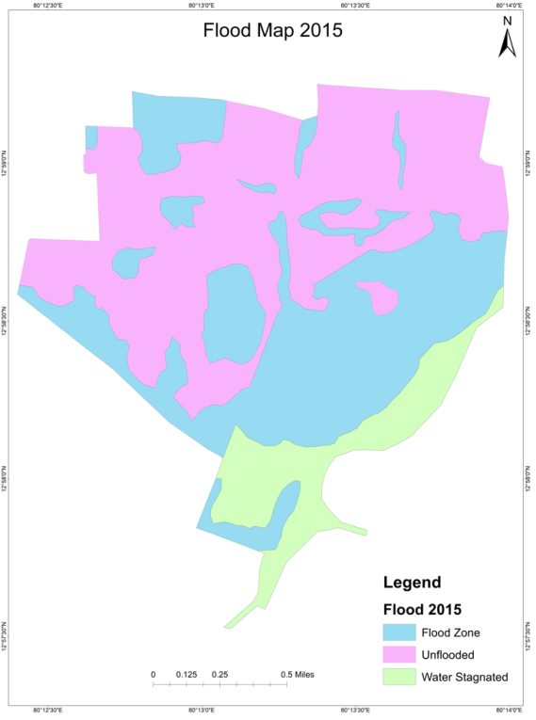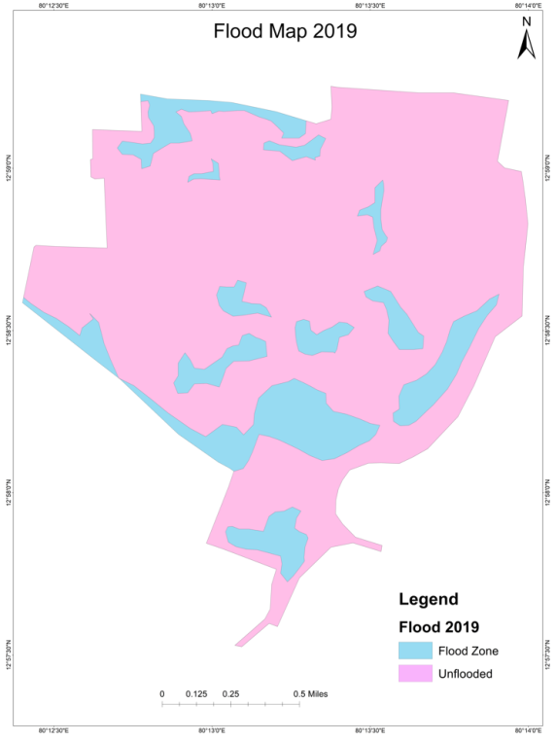
Figure. 10.1Velachery flood map in 2015 Figure 10.2: Velachery flood map in 2019
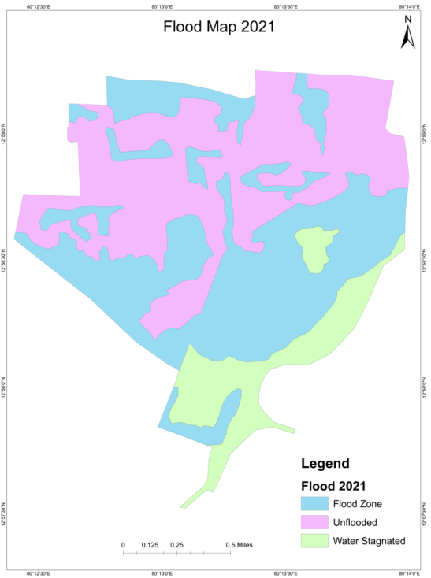
Figure 10.3: Velachery flood map in 2021
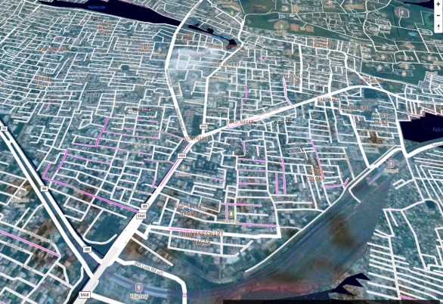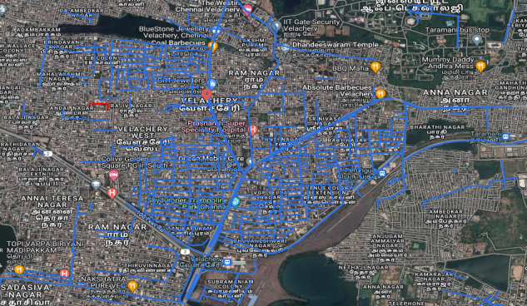
Figure 10.4: Velachery Vulnerable and Inundated areas Figure 10.5: Velachery Flood Map (Source: Chennai Flood Map Satellite View)
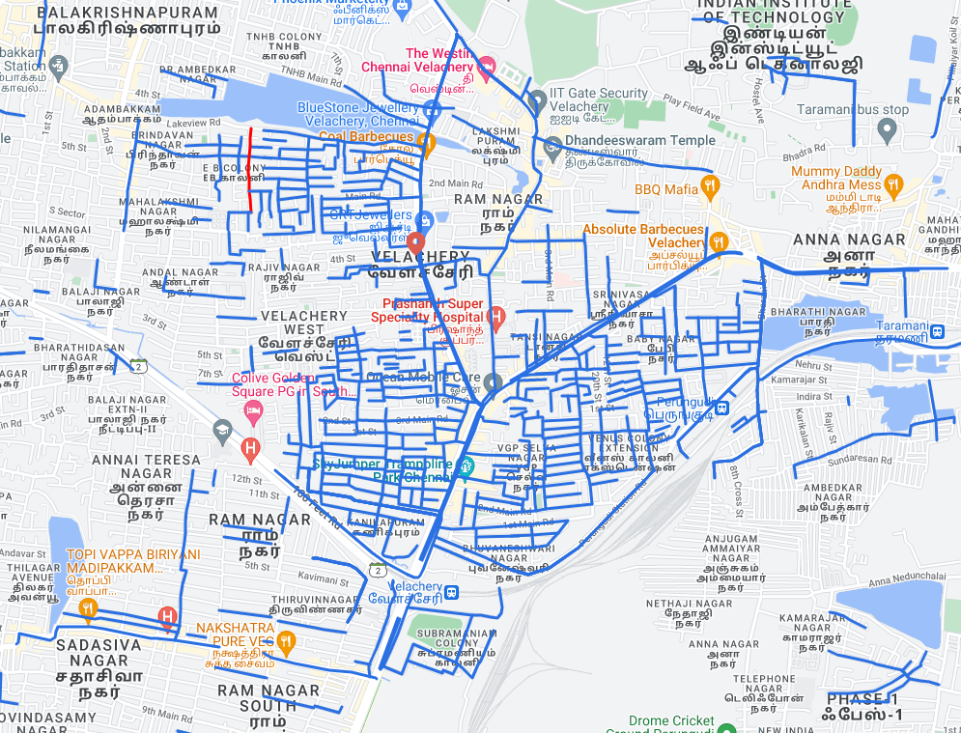
Figure 10.6: Velachery Flood Map (Source: Chennai Flood Map Terrain View)
SUMMARY AND CONCLUSION

The areas that are highly susceptible to floods are found out based on the flood extent and the volume calculation. In this study, the extreme flood events of November 12, 2021 are considered.
Conclusion
The flood prone area cannot be defined by considering the contour information only, high flood levels observed on ground also need to be included. The limitations of this study are the water levels are determined by the information gathered from residents, which may be exaggerated. If ALTM (Airborne Laser Terrain Mapping) data is used, a more accurate DEM can be generated for analysis. Places like Vijaya Nagar, Tansi Nagar and Baby Nagar are more susceptible to floods in Velachery area. There is only one exit point which connects the storm water drainage to Pallikaranai marsh. The entire channel is not sufficient to carry the flood water from Velachery. Thus field surveys help to throw light on the real life situations and conditions providing reliable information for management of disasters such as floods.

Integrating GIS and Flood Damage Analysis‟, NSW Annual
Floodplain Management Authorities Conference Papers, Wentworth, 8–11th May, 2001.
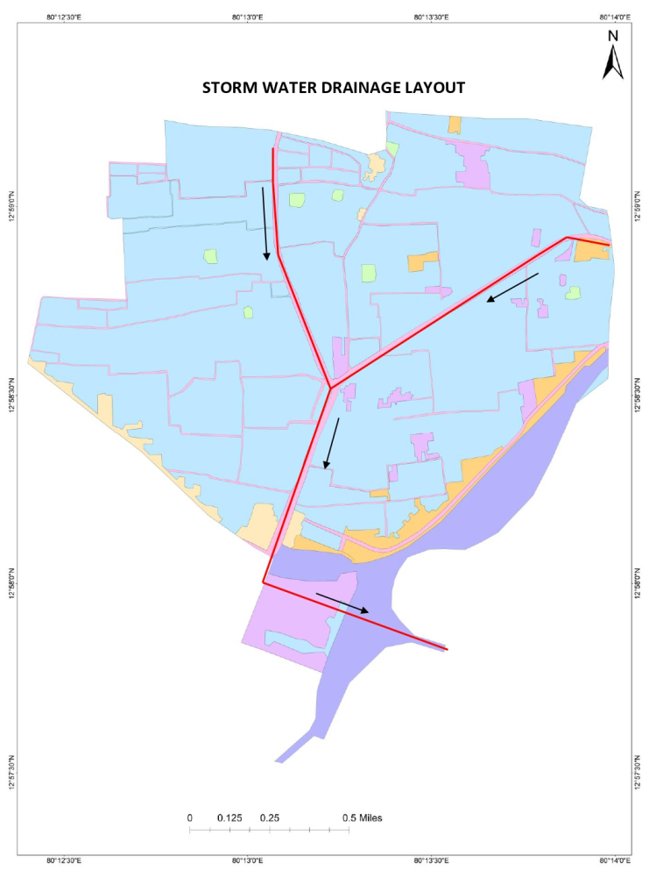
Figure 5.1: Velachery Storm Water Drainage Layout
REFERENCES
1. Md. Monirul Islam, Kiyokazu Ujjies, Tofael Ahamed in 7 January 2022 - Flash flood-induced vulnerability and need assessment of wetlands using GIS, remote sensing and economic models. Remote Sensing Applications: Society and Environment.

2.Jar R.S. Doorga, Leonard Mageri, Ravindra Boojhawon are an International Journal of Disaster Risk Reduction, 19 November, 2021done GIS-based muli-crirtera modelling of flood risk susceptibility in Port Louis, Mauritius: Towards resilent flood management.

3.Daouda Nsangou, Amidou Kpoume, Jules Remy Ndam Ngoupyou are African Scientists, 29 November done Urban flood susceptibility modeling using AHP and GIS approach: case of the Mfoundi watershed at Yaounde in the South-Cameroon plateau.

4.E.C. Chukwuma, C.C. Okonkwo, C.P. Nwachukwu Hliyon, 22 September 2021 a GIS based flood vulnerability modelling of Anambra State using an integrated IVFRN-DEMATEL-ANP model.

5.Hunegnaw Desalegn, Arega Mulu are African Scientists, 5 July 2021 published the Mapping flood inundation areas using GIS and HEC-RAS model at Fetam River, Upper Abay Basin, Ethipoia.

6.Sandeep Samantaray, Sambit Sawan Das, Deba Prakash Satapathy proceedings, 11 December 2021 are Evaluating the appilcations of metaheuristic approaches for flood simulatiuon using GIS. A case study of Baitarani river Basin, India.

7.Felix Ndidi Nkeki, Ehiaguina Innocent Bello, Ishola Ganiy Agbaje are an International Journal of Disaster Risk Reduction, 3 June 2022 published the Flood risk mapping and urban infrastructural susceptibility assessment using a GIS and analytic hierarchial raster fusion approach in the Ona River Basin Nigeria.

