Communication Aspects, Enhancement and Analyze the Risk of IoT in 5G Technology

Mrs. Sujeeta S. Shah.
Computer Science and Engineering
D. Y. Patil Agriculture and Technical University, Talsande
Kolhapur, Maharashtra, India
shahsujeeta4443@gmail.com

Mrs. Ashwini N. Sawant.
Computer Science and Engineering
D. Y. Patil Agriculture and Technical University, Talsande
Kolhapur, Maharashtra, India
ashwininileshsawant@gmail.com

Mr. Nileshkumar M. Sawant.
Engineering dept.
RCSM College of Agriculture,
Kolhapur, Maharashtra, India
sawant.nil@gmail.com

ABSTRACT

The term "Internet of Things" (IoT) refers to a network of physically connected appliances, cars, and other objects that are equipped with sensors, software, and connectivity capabilities to gather and exchange data online. These gadgets, which are frequently referred to as "smart" gadgets, may converse with humans and other gadgets to offer a variety of functions, automation, and data-driven insights. The fifth generation of cellular network technology, or 5G, promises considerable advancements over earlier versions like 4G. Faster data transfer rates, reduced latency (the amount of time it takes for data to move between devices), increased capacity to accommodate a high volume of connected devices, and improved reliability are all features of 5G networks. These developments turn 5G into a crucial technology enabler for a variety of fields. For linked devices and applications, the combination of IoT with 5G creates new opportunities and capabilities. IoT devices may transmit and receive data more quickly and in real-time 5G networks have high data transfer speeds, reduced latency, and greater network capacity. The deployment of more complex and demanding IoT applications in a variety of domains, such as smart cities, healthcare, industrial automation, transportation, and agriculture, is supported by this combination, which enables seamless connectivity, faster response times, improved scalability, and supports these features. In this paper, we discuss the aspects of communication, enhancement, and examine the risk of IoT in 5G technology. As IoT is more established and essential due to the rapid growth of 5G, We talk about the development and importance of IoT over 5G. Finally, we concentrate on the IoT component of modern 5G technology.

Keywords-4G/LTE,5G, Internet of Things, Ultra Reliable Low Latency, Grant-Free, Grant-based, Enhanced Mobile Broadband, Massive Machine Type Communications.

I. INTRODUCTION of IoT

The Internet of Things (IoT) describes physical objects embedded with sensors and actuators that communicate with computer systems through wired or wireless networks, enabling digital monitoring or even control of the physical world [1]. These "things" can be cars, buildings, smart home devices, etc.

A. An IoT system includes four main components:
Sensors - collect information about the environment and convert it into signals that can be sent over the Internet.
Connectivity – Sensors can be connected to the cloud in various ways, such as 5G.
Data processing – Once collected, the data must be processed, analyzed, and stored using IoT software.
User Interface - This component allows users to interact with devices. For example, people can be alerted, and connected physical objects can be monitored and controlled.

B. IoT architecture:
The basic IoT architecture consists of four layers.
Data Gathering- Input data from the user end is collected by the IoT application. Data Transmission: The data is transferred to the cloud or other storage servers through a network connection. This connection can be established using Wi-Fi, GPRS, Ethernet, etc.
Data Processing- The data stored in the server is processed to create the desired output for the user.
Application Layer- This layer is used for data storage and display.

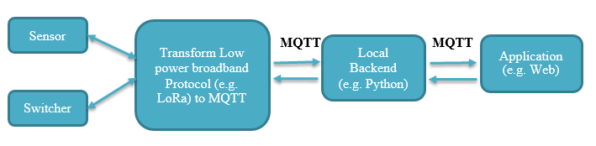
Fig.1. IoT Architecture
Information from several sensor nodes installed in the monitored area is transmitted to the central gateway. The communication protocols used to send data to the IoT gateway are mostly low-power broadband protocols such as LoRa. The IoT gateway has a built-in internet connection module. This data is forwarded to the server (using the Internet) via data protocols MQTT (Message Queuing Telemetry Transport protocol) / HTTP. This information from the cloud server is retrieved from the web/mobile applications associated with the IoT solution [2].

II. 5G Technology

5G refers to the use of fifth-generation (5G) wireless technology. 5G technology is the latest telecommunication network modeled after 4G networks. The fifth generation of cellular networking can provide several GB/s data speeds with low latency. The network will accommodate more users than the current generation and have exceptional dependability. The user experience will also be more constant [3]. The following figure shows 5g network features-
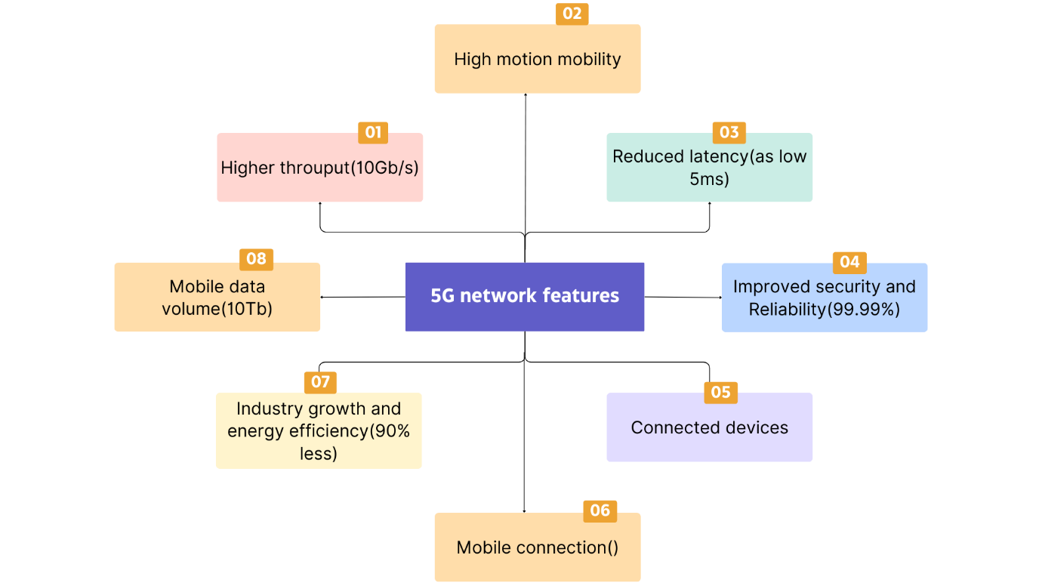
Fig.2. 5G network features

One of the most significant factors in this growth will be the quick adoption of 5G networks, which will have a significant impact on how people live, work, and play around the world [4].

III. Benefits of IoT over 5G

The improvements involved in 5G will greatly help in the real-time processing of huge volumes of data, which is practically not possible with any other technology. 5G enables higher data transfer rates and thus enables connected IoT devices to communicate and share data at higher speeds, 5G enables increased connection frequency which enables more devices to be connected and efficient IoT connection signaling. Other key benefits of 5G IoT include very low latency (down to 1 ms), improved reliability, high network capacity, better availability, and a more consistent user experience, as 5G creates more stable connections. A reliable and stable network enables the use of IoT devices in real-time applications. We can connect more devices to 5G without experiencing quality reduction due to its tremendous bandwidth and mobile data volume up to 10Tb.
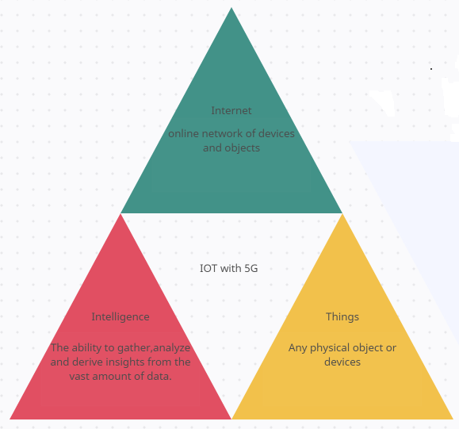
Fig.3. Diagrammatic representation of IoT with 5G

The general 5G mobile networks with an IOT architecture are what the 5G is dependent upon. Large networks, small static networks, and mobile networks are all covered by the most recent technologies. Additionally, it provides a silhouette of the 5G basic stations' & cloud's IOT architecture. They also incorporate small cell entrance points, IOT with 5G and device-to-device networking models. In contrast, the 5G and IOT paradigm is presented in three distinct parts [5].

IV. COMMUNICATION TECHNOLOGY

A speedier communication channel will be provided by 5G; we can anticipate rates of up to a few gigabits per second. Your gadgets may work together and complete tasks more quickly as a consequence. Additionally, it will offer a network with extremely low latency; early 5G deployment, according to Verizon, demonstrated a latency of 30 ms. that will make it easier to do delicate procedures like surgery using IoT devices. Finally, you may connect more devices to 5G without experiencing quality reduction due to its tremendous bandwidth [6].

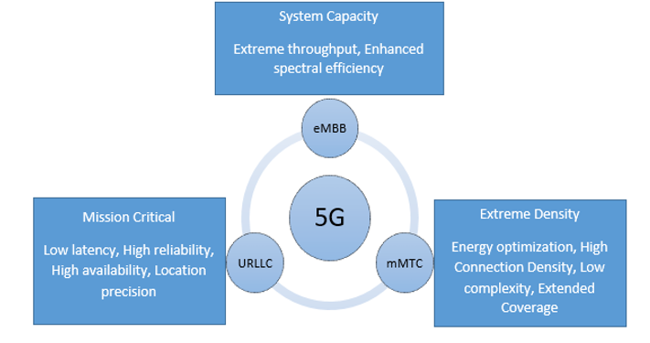

Fig.4. Features and Communication Strategies

5G has three facets-

A. Ultra-Reliable Low-Latency Communication (URLLC)
It is applicable in mission-critical use cases such as smart grids, intelligent transport systems, and remote surgery. The amount of time it takes for a signal to get from its source to its receiver and vice versa is known as latency. The ability to remotely control equipment in real-time is made feasible by 5G latency, which operates quicker than human visual processing. Among the many advantages that URLL capabilities will provide are robotic procedures. The Fifth Generation (5G) New Radio (NR) is a flexible communication system that can only be used to implement the novel solutions needed to address the increasingly common applications of Ultra-Reliable Low-Latency Communications (URLLC). Although several Grant-Free (GF) and Grant-based (GB) transmission schemes have been put out to satisfy URLLC requirements, there hasn't been much progress made on their design [7].
A. Grant Free (GF)-In 5G, grant-free random access is recommended as a key method for lowering latency since it allows access to channel resources without requiring assignment through a handshake process. Both of the suggested strategies yield sizable performance improvements in terms of resource effectiveness. The fundamental idea of GF transmission is to set up/allocate periodic dedicated resources for URLLC service. It works nicely with intermittent traffic. However, because URLLC traffic is intermittent, UE (User Equipment) can skip the GF resource if no data is to be transferred. If a GF resource is devoted to a UE for URLLC service and cannot be used by other UEs or services, it may be wasted. One proposed option for better resource utilization is to allow multiple UEs and services to share the GF resource. However, collisions between UEs may occur, reducing transmission reliability and increasing transmission delay. Diversity transmission is used to increase reliability. The combination of nonorthogonal multiple access (NOMA) and GF transmission, where NOMA techniques are employed on the transmitter side to enhance resource efficiency while sophisticated receivers are utilized on the receiver's side to avoid collisions [8].

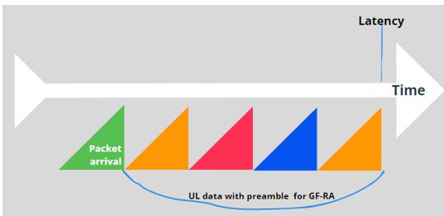

Fig. 5. Uplink transmissions for grant-free random access

B.Grant-Based (GB)-In the current 4G-LTE system, UEs use a grant-based method to provide reliable transmission in UL. To mitigate potential collisions, the grant-based approach includes a four-step handshake process between UEs and base stations (BSs). However, it comes with a long delay for the access grant response. Such a grant-based model is inapplicable for the low latency needs of URLLC's mission-critical applications. As a result, GF random access, which allows UEs to escape from handshake phases and gain quick access, is an appealing alternative for reducing UL access latency.

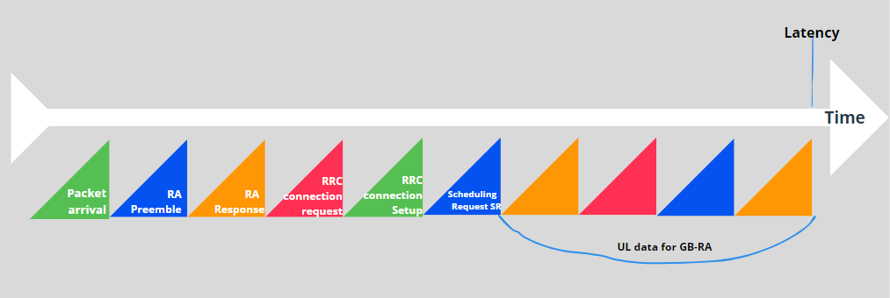

Fig. 6. Uplink transmissions for grant-based random access

The URLLC specifications can rarely be met by the Long Term Evolution (LTE) system in use today. Current LTE uses grant-based (GB) scheduling, which is based on scheduling and is specifically used in the uplink. When the User Equipment (UE) requests access to the network, the Base Station (BS) can reply by granting access via a four-step random access (RA) mechanism, as shown in the figure above. This is how standard GB scheduling works. Such scheduling-request-triggered transmission would not meet the URLLC latency criterion since it would start transmitting data at least 10 milliseconds after the scheduling request, which is not acceptable. Recently, grant-free (GF) access has been suggested and has been intensively debated in 3GPP Technical Specification Group Radio Access Network (TSG RAN) WG1 to deal with the URLLC need in the uplink transmission. Small packets can be transmitted by a UE via uplink GF access [9].

B. Enhanced Mobile Broadband (eMBB)

A significant word linked with 5G is enhanced mobile broadband. 4G LTE networks provide enhanced mobile broadband. It is one of three 3GPP-defined services or use cases for 5G NR application deployment. eMBB's goal is to provide faster bandwidth with lower latency for applications like augmented reality (AR), virtual reality (VR), and 4K media. 5 NR provides dependable and fast mobile broadband with upgraded mobile broadband service. By expanding the technology to link and redefine multiple industries and businesses, eMBB is transforming the wireless communication market. eMBB extension is also on the cutting edge of expanding coverage areas. With eMBB support, 5G networks can provide greater quality of service (QoS) internet access to the general people even under prohibitive or difficult settings [10].eMBB is not only transforming the face of smartphone connectivity, but it is also ushering in a new era of cloud connectivity, real-time video monitoring applications, and remote operations.

How is eMBB delivered over 5G?

5G must accomplish higher throughput, lower latency, larger capacity, better uniformity, and total mobility to live up to those promises and must do it at a cheaper cost to mobile carriers. The following are some of the 5G technologies that make eMBB possible:
A. Massive MIMO stands for Multiple Input, Multiple Output and describes approaches that use a lot of antennas to expand cellular coverage and capacity. While 5G is intended to offer huge MIMO, using up to 256 antenna components in the base station, there are restrictions on how many antennas can fit into a mobile device. As a result, spectrum ranges below 6 GHz are now ready for intelligent beam forming and beam-tracking.
B. Mobility focused on the device – Devices consume a lot of battery power processing and monitoring reference signals from all adjacent cells. The device is also used in 5G's device-centric mobility to transmit periodic reference signals that the access network can track. The network can initiate cell reselection or handover based on the strength of the signal returning from the device. Additionally, the 5G network will only send out the bare minimum of system information on a periodic basis rather than sending it out regardless of device existence.
C. Spectrum sharing: These are methods for expanding the 5G network and freeing up additional airwaves. Spectrum sharing has the potential to free up frequency bands that are only marginally utilized by operators, as I highlighted in my blog post regarding spectrum in 5G. Additionally, a sizable portion of the spectrum may be shared or unlicensed, particularly in the higher bands. All current spectrum types are supported by 5G NR, which also has the option to adopt sharing paradigms that are still under development.

C. Massive Machine Type Communications (mMTC)

Massive Machine-Type Communications (mMTC) is a new 5G service category that can handle exceptionally high online device connection density. Devices can communicate with one another using mMTC connections by sporadically exchanging small quantities of traffic. It is intended for the scalable and efficient networking of a large number of devices transmitting very small packets, which cannot be adequately accomplished in human-type cellular systems. As a result, one of the primary application areas for 5G will most likely be IoT and machine-to-machine (M2M) communication.5G networks are designed to allow each of the three service zones to operate independently while sharing the same physical infrastructure. Network slicing, also known as software-defined networking or SDN technology, is a method of dividing bandwidth among various different sectors in order to customize different service tasks. This means that each program can access the appropriate resource at the same time, with higher-priority applications taking precedence [11].mMTC provides low-bandwidth connectivity with extensive coverage, whereas URLLC gives excellent dependability but not as extensive coverage. Existing IoT technology uses low-power wide area networks (LPWAN), which may necessitate Ethernet from an IoT gateway. The sensors communicate via a network such as LoRaWAN or Sigfox, and the gateway transmits the data to a server via a 4G LTE network or a wired internet connection.

V. ENHANCEMENT OF 5G OVER IOT

5G, the fifth generation of cellular network technology, has the potential to significantly aid the Internet of Things (IoT) in various ways. IoT refers to the interconnection of everyday objects, devices, and machines via the Internet, enabling them to collect and exchange data without human intervention. Here's how 5G enhances IoT [12]:
A. Higher Data Speeds: 5G offers significantly faster data speeds compared to its predecessors. This means that IoT devices can send and receive data much more quickly, enabling real-time communication and faster response times. This is especially crucial for time-sensitive applications, such as autonomous vehicles or remote surgery, where low latency is vital.
B. Lower Latency: 5G's low latency capabilities reduce the time it takes for data to travel between IoT devices and the cloud. This instant communication is crucial for applications like industrial automation, where split-second decisions are necessary to ensure safety and efficiency.
C. Higher Device Density: 5G can support a higher number of connected devices per unit area than previous generations. This is essential for the growing number of IoT devices that will coexist in urban environments, industrial settings, and public spaces.
D. Energy Efficiency: 5G offers improved energy efficiency, which is vital for IoT devices that are often battery-powered or have limited power resources. With 5G, IoT devices can conserve energy while maintaining consistent and reliable connections.
E. Network Slicing: 5G introduces the concept of network slicing, which allows the network to be divided into virtual slices to cater to specific IoT requirements. This enables different IoT use cases to have dedicated network resources tailored to their needs, ensuring better performance and quality of service.
F. Enhanced Coverage: 5G expands network coverage, reaching remote and underserved areas. This broader coverage benefits various IoT applications, such as agricultural monitoring, environmental sensing, and smart infrastructure, where devices may be deployed in remote locations.
G. Massive Machine-Type Communications (mMTC): 5G introduces mMTC, which is designed to efficiently handle large-scale IoT deployments with a massive number of low-power devices. This feature enables the deployment of IoT networks with millions of devices, making it easier to create extensive IoT ecosystems.
H. Edge Computing: 5G facilitates edge computing, which allows data processing to occur closer to the IoT devices themselves rather than solely relying on centralized cloud servers. Edge computing reduces latency and network congestion, making it ideal for real-time IoT applications that require immediate data analysis and response.
I. Reliability and Security: 5G offers enhanced security features, which are crucial for safeguarding the massive influx of data generated by IoT devices. Improved security ensures the protection of sensitive information and helps prevent potential cyber threats and attacks.
Overall, 5G's high data speeds, low latency, increased device density, energy efficiency, and other features make it a powerful enabler for the expansion and advancement of the Internet of Things, transforming how we interact with technology and the world around us.

VI. 5G AND HOW IT AIDS IOT

The combination of IoT (Internet of Things) and 5G technology has the potential to significantly transform various industries and improve existing applications. 5G networks, with their high data speeds, low latency, and increased capacity, are an ideal platform for supporting the vast number of devices and data generated by IoT devices. Here are some key IoT applications in 5G [13]:
A. Smart Cities: 5G-enabled IoT can help cities manage urban services like smart street lighting, waste management, traffic control, and public safety more efficiently. Sensors and connected devices can collect real-time data to optimize city operations and improve residents' overall quality of life.
B. Industrial IoT: 5G makes it possible for numerous sensors and devices to be connected in industrial settings, enhancing automation, enabling predictive maintenance, and allowing for real-time monitoring of production processes. For industries, this can lead to more productivity, less downtime, and cost savings.
C. Healthcare: The low latency and dependability of 5G can help IoT devices in the industry. 5G connectivity can significantly enhance medical wearables, remote patient monitoring systems, and real-time data transmission for telemedicine applications.
D. Autonomous Vehicles: For safe navigation, self-driving cars need to instantly and reliably communicate data with their surroundings. For enabling real-time communication among autonomous vehicles, infrastructure, and pedestrians, 5G's low latency and great data throughput are essential.
E. Agriculture: IoT devices can be used in agriculture to track animals, crop health, weather patterns, and soil conditions. Farmers will be able to make data-driven decisions for better resource management and yield thanks to 5G connectivity, which can assure seamless data transmission.
F. Environmental Monitoring: IoT devices with 5G capabilities can be installed in remote areas to keep an eye on environmental factors including air quality, water quality, and wildlife habitats. Real-time transmission of this data enables earlier identification of environmental problems and more successful conservation measures.
G. Smart Grid Automation: 5G enables us to automate the smart power grid, one of the technologies with the quickest growth rates and one that is far more efficient than the conventional grid. The usage of IoT devices for telemetry and AMI enables consumers to receive dependable services. Smart grid technology makes integration simple and is a self-sufficient network system used to control, analyze, and monitor issues that ensure safe and high-quality electricity. It combines a smart electrical network with digital communication technology to create a modernized smart grid that includes live management of hybrid electric systems where faults may be identified/predicted and solutions can be offered immediately.
H. Remote monitoring: With the use of ultra HD video, remote video surveillance over a 5G network using IoT sensors can be used to keep an eye on facilities, manufacturing lines, and high-security zones. 5G sensors and the low latency, high-speed communications enable video analytics. As a result, when an entry, act of vandalism, or suspicious movement is discovered, IoT sensors send real-time notifications.
I. Intelligent traffic management: Intelligent Transportation is made possible by 5G. IoT sensors collect real-time data from the infrastructure and vehicles on the road and issue prompt notifications when traffic cabinets integrate these systems at certain municipal street crossings. Regular application of these technologies can result in cost savings, system dependability, traffic safety, and flow.
J. Manufacturing Applications: 5G and IoT can be used for process automation and predictive analytics for repairs via remote monitoring at production floors. This transforms workflows into instrumented, data-collection, digital processes while integrating operators, machines, and sensors to achieve the desired business goals. Some exemplary use cases of how IoT benefits from 5G and its low latency high speed and HD video streaming features are augmented reality repairs, collaborative robotics, precision mining, and smart manufacturing.
K. Applications In Medicine: Little latency Using IoT sensors to connect ambulances to hospitals, ultra-high definition video streaming can be used to monitor patients as they are being transported and set up facilities for prompt treatment. Smart wearables and sensors built into healthcare systems can aid in maintaining constant communication with the surgeon during operations and allow patients to receive treatment sooner than would be possible manually. The low latency capabilities of 5G and IoT devices also help robotic surgeries.

VII. EXAMINING THE RISK OF IOT IN 5G TECHNOLOGY

A. Security and privacy: IoT devices are frequently targets of cyber-attacks because they collect and transmit sensitive data online. This information may be used maliciously by hackers for things like financial fraud and identity theft [14]. As a result of the difficulty in managing and securing a large number of IoT devices, data breaches may become more common.
B. Interference and reliability: 5G networks employ higher frequency radio signals with a limited range and are more easily blocked by objects like trees and buildings. Weaker signals, slower speeds, and lost connections may result from this. Regulations and infrastructure needs are two additional issues that make the deployment of 5G networks challenging [15].
C. Compatibility and interoperability: Different IoT devices can come from different manufacturers and operate on distinct software platforms. They are affected because there may be issues with device compatibility and interoperability. As a result, data and devices may become fragmented and difficult to integrate [16].
D. Energy use and sustainability: IoT gadgets and 5G networks use a lot of energy to function, which can have negative effects on the environment and the economy. In addition to raising operating expenses for both enterprises and consumers, rising energy use has the potential to contribute to climate change.
E. Implications for ethics and society: The widespread usage of IoT and 5G technologies may give rise to issues for ethics and society, such as how these developments will affect jobs, personal privacy, and human autonomy.

VIII. STRATEGIES TO OVERCOME RISK

A. The danger of cyber-attacks can be reduced by putting in place robust cyber security measures such as encryption and authentication methods, updating software and firmware often, limiting access to sensitive data, and utilizing intrusion detection systems. Furthermore, creating privacy policies and following rules can assist safeguard user data and enhance information security.
B. Increasing the number of 5G towers and equipment, introducing network slicing, and utilizing cutting-edge antenna technology can all help to strengthen the signal and lessen interference. Reliability can also be increased by performing site surveys to identify potential barriers and by enhancing network performance using machine learning.
C. Building open platforms, employing standard communication protocols, and creating standards and protocols for IoT devices can all enhance compatibility and interoperability. The integration and management of devices can also be streamlined by using solutions for device management and monitoring.
D. Energy consumption can be decreased by creating energy-efficient IoT devices, adopting power-saving technologies, and utilizing renewable energy for 5G networks. Additionally, IoT device environmental impact can be decreased by encouraging responsible IoT device use and disposal.
E. Addressing ethical and social ramifications can be made easier by creating policies for moral and responsible use, making sure that everyone is held accountable, and encouraging public awareness and education. Investing in upskilling and retraining programs might also lessen the effect on employment.

IX. CONCLUSION

An entirely new era of connectivity will begin with the adoption of 5G networks and IoT devices. It marks a dramatic shift in the IoT ecosystem, assuring higher speeds, lower latency rates, increased reliability, a consistent user experience, and amazing efficiency. It will also help to improve, make it more convenient, and lower the cost of technology-related applications. As well as being able to serve a very wide range of devices and their diverse service requirements, 5G networks can also securely handle the vast volume of data that will be generated by IoT devices.

X. REFERENCES

[1] Kumar S., Tiwari, P. & Zymbler, M. (2019), “Internet of Things is a revolutionary approach for future technology enhancement: a review”, Journal of Big Data, https://doi.org/10.1186/s40537-019-0268-2
[2]Antar Shaddad Abdul-Qawy, Pramod P.J, E.Magesh, T.Srinivasulu. (2015) “The Internet of thing (IoT): An Overview”, Journal of Engineering Research & Applications, ISSN: 2248-9622, Vol. 5, Issue 12.
[3] Nikhil Kumar, Mr. Ajay Singh, Mr. Pushpeel Verma.(2022), “Impact of 5G on IoT Implemented Devices”, International Journal of Computer Science & Mobile Computing, pg.131-137, ISSN: 2320-088X, vol.11, Issue 3.
[4] Khushneet Kour, Kausar Ali. (2016),” A Review Paper on 5G Wireless Networks”, International Journal of Engineering Research & Technology, DOI: 10.17577/IJERTCONV4IS32025, ISSN (Online): 2278-0181.
[5] Mitrabinda Khuntia, Debabratu Singh and Sipra Sahoo.(2021), “Impact of Internet of Things (IoT) on 5G”, Springer Nature Singapore Ptc. Ltd., Intelligent and cloud Computing, Smart Innovations, System & Technologies 153, https://doi.org//0.1007/978-981-15-6202-0_14
[6] Zhengyu Zhu, Xingwang Li, Zheng Chu.(2022), “Three major operating Scenarios of 5G eMBB, mMTC, URLLC”, in Intelligent sensing and communication of Internet of Everything (pp.15-76).
[7] Daquan FENG, Lifeng LAI, JingJing LUO, Yi ZHONG, Canjian ZHENG and Kai YING.(2021), “Ultra-reliable and low latency communication: applications, opportunities & Challenges Springer Nature, vol.64-120301:1-120301:12, http://doi.org//10.100//S11432-020-2852-1
[8] Abreu R.B. (2019), “Uplink Grant free Access for R. Ultra-Reliable Low-Latency Communication in 5G: Radio Access and Resource Management Solutions”.
[9] Yan Liu, Yansha Deng. Arumugam Nallanathan, George K. Karagiannidis. (2020), “Analyzing Grant free Access for URLLC Services”, publication at https://www.researchgate.net/publication/339374251.
[10] Dakhaz Mustafa Abdullah Siddeeq.Y. Ameen. (2021), “Enhanced Mobile Broadband (EMBB): A Review, In Journal of Information Technology and Informatics (JITI)”, Vol.01, No.01, pp.13-19.
[11] Jiale Hu, Zongxiao Li, Peiran Li, Jianwei Liu. (2022), “A Lightweight and Secure Authentication Protocol for 5G mMTC”, IEEE 9th International Conference on Cyber Security and cloud computing DOI 10.1109/CS Cloud-Edge Com54986. 2022.00041.
[12] George Gkagkas, Dimitrios .J .Vergados, Angelos Michalas. (2021), “The advantage of the 5G network for enhancing the Internet of Things”, 6th South-East Europe Design Authentication, Computer Engineering, Computer Networks, and Social Media Conference DOI: 10.1109/SEEDA-CE CNSM53056.2021.9566239
[13] Mario Pons Estuardo Valenzuela, Brandon Rodriguez. (2023),” Utilization of 5G Technologies in IoT Application: Current Limitations by Interference and Network Optimization Difficulties-A Review”, Applications of Internet of Things Networks in 5G and Beyond. https://doi.org.3390/S23083876.
[14]Symmetry Electronics Team in Blogs (2019), “5G IoT security issues: A Guide to Next-Gen Wireless Networks Risks”.
[15]Sabrina Sicari, Alessandra Rizzardi, Alberto coen-Porisini. (2020), “5G in the Internet of Things era: An overview on security and privacy challenges”, in Computer Networks (Elsevier) volume 179.
[16] M.Umaselvi, E.Menaka, V.Chandrasekar, D. Saravanapriya (2022), “5G and IoT Networks Risk Management”, in book-secure communication for 5G and IoT Networks, pp.47-71, DOI: 10.10071978-3-030-79766-9-4.

