Exploring the Nexus of Linguistics, Literacy, and Language Disorders: Taking the Complexity apart

Authors:
- Dr. Vivek Kumar
Assistant Professor in Speech Language Pathology
Institute of Health Science, Chandaka
- Ms. Priyanka Mishra
Clinical Psychologist
Institute of Health Science, Chandaka

Dyslexia is a developmental aberration that is more appropriately referred to as a syndrome. It is characterised by a deficiency in verbal processing, and its symptoms are brought on by phonological issues. The most commonly accepted cognitive explanation for dyslexia is that it results from a phonological impairment, which has been recognised for many years to be the root cause of the condition. Dyslexia is a brain-based disorder with a genetic basis and is on the continuum of language problem. Because phonological processing is selectively reduced in dyslexic individuals while other linguistic abilities, such as vocabulary and grammatical proficiency, are normal, dyslexia is a developmental aberration. A crucial need of learning to read is for the child to establish a system of mappings between the phonemic sequences that make up spoken words (phonology) and the letter strings of words that are written (orthography). Connectionist models, which see reading as the transfer of activation patterns between sets of basic processing components in input and output systems composed of orthographic and phonological units, do a good job of capturing this process.
Despite their relative skills in semantic processing, their brains code phonology less efficiently than those of typically developing youngsters. At the level of conduct, this issue with phonological representation results in a number of common symptoms. These include issues with word retrieval and quick naming. They also include deficiencies in nonword repetition, poor phonological acquisition of new verbal information, and verbal short-term memory issues. A difficulty with the development of phonological awareness is a recurrent characteristic of dyslexia among children who are learning to read in opaque orthographies, such as English. Readers of transparent language, where the regular links between letters and sounds in written language provide constant input about how words are constructed, are considerably less likely to have this issue.
The fact that the phonological deficit definition for dyslexia makes sense in light of what is known about the typical development of reading is one of its key benefits. Even when the significant impacts of intelligence quotient (IQ) are controlled, it is known that phonological awareness assessed in preschool is an excellent predictor of eventual reading performance. Indeed, the development of the alphabetic principle, which enables kids to decode words they have never seen before, depends on the capacity to reflect on the structure of sounds of words at the phonemic level. But dyslexic youngsters frequently struggle to move beyond logographic reading to the alphabetic phase due to their phonological difficulties. Phonological deficiencies perspective of dyslexia offers a fair explanation for the variety of behavioural symptoms associated with the condition and is consistent with ideas of typical literacy development. There is some evidence that exposure to alphabetic literacy may have an impact on phonological processing more broadly, and it has been claimed that literacy experience is essential for the development of phonological awareness.
While the dyslexic children's pattern of underdeveloped decoding abilities was predicted, it is noteworthy to note that the healthy children also had impairments in their usage of the "phonological" route. These results imply that the difficulty in creating mappings between spelling and phonology may be an innate propensity in dyslexia.
It has been challenging to pinpoint any environmental condition or event that is a necessary and sufficient cause of SLI, despite the fact that several things have been suggested as potential causes. Despite the absence of parental verbal stimulation, neurological deficits brought on by prenatal issues, and variable hearing loss caused by middle ear illness, language development seems to be astonishingly strong. This is not to imply that these factors have no effect on development; rather, it is meant to emphasise that the effects of spoken deprivation, mild to moderate hearing loss, and focal brain damage are typically mild, do not specifically affect verbal skills, and do not result in a clinical picture resembling SLI. Although this gene-environment connection has not yet been experimentally shown, it is plausible that such environmental influences may become more significant if they affect a kid who is already genetically predisposed to a condition.
The diagnostic criteria for SLI and dyslexia both include that the kid must have good hearing and be free of significant disabilities that could impair learning. The study of SLI was mostly carried out by speech and language pathologists for many years, whereas the study of dyslexia was primarily carried out by educators and psychologists. Dyslexia was widely thought of as a visual perception problem in the 1960s. However, over the last thirty years, there has been a change in focus due to increased knowledge that the majority of dyslexic children have significant challenges categorising speech sounds and connecting them to orthography.
This understanding of the two illnesses has grown so widespread as the 21st century approaches that researchers frequently refer to children who have reading and/or speaking deficits using new words such language learning impairment. Poor phonological processing has received a lot of attention in the dyslexia community as a contributing factor to reading difficulties. Study of children with oral language disorders, however, shows that issues with meaning, grammar, and discourse will also impede a child's ability to learn to read; in some children (referred to as poor comprehenders), these issues may arise without any phonological impairment. Learning to read can be hampered by phonological and nonphonological language deficits in more severe forms of SLI.
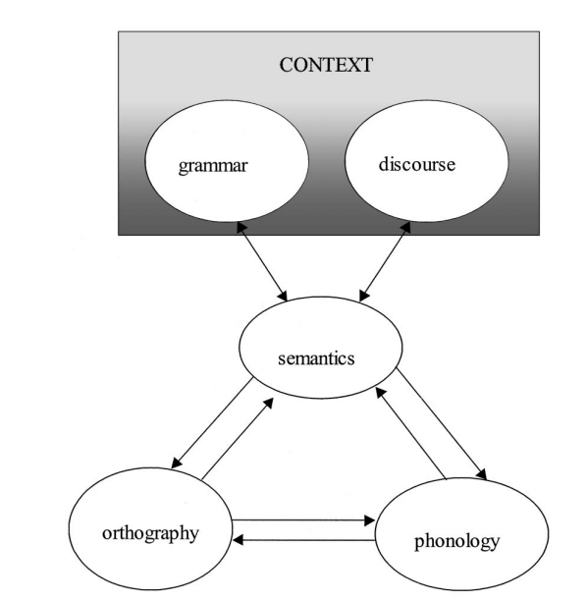
Figure 1: The triangle model extended. Adapted from “A Distributed, Developmental Model of Word Recognition and Naming,” by M. S. Seidenberg and J. L. McClelland, 1989, Psychological Review, 96, p. 526. Copyright 1989 by the American Psychological Association.
Those who contend that afflicted persons should be recognised on the strength of the underlying cognitive loss rather than observable behaviour on psychometric tests take a considerably more radical, but in our opinion preferable, approach to the identification of dyslexia. Since dyslexia has been linked to phonological impairments over the past three decades, this condition should be referred to as having a core phonological deficiency. The phonological deficit technique is frequently used in research on people who may have overcame reading challenges as children and can now read within normal ranges but still struggle on phonological processing tests.
Although the cognitive marker technique is more likely than the conventional psychometric approach to identify cohesive groups of children, it is insufficient to rely on a single component of impairment, such as phonological deficiency. We contend that it is critical to distinguish between children with more general spoken language deficits and those whose reading difficulties are primarily phonological in nature. Instead of using IQ as the standard against which reading is evaluated in the long run, effective cognitive marker examinations for the key components of language need to be created in order to contrast reading comprehension with listening comprehension.
In the field of reading disabilities, a distinction has been made between surface dyslexia, where the reading of regular words as well as nonwords is adequate but reading of irregularly spelt words is impaired, and developmental phonological dyslexia, in children who read words significantly better than nonwords. Children with SLI can have varying degrees of expressive and receptive language impairment, as well as additional linguistic challenges caused by nonorganic issues with speech sound production or pragmatic language issues.
If early oral language deficiencies in dyslexia are causally related to the literacy issues, then a high prevalence of literacy issues should be expected in kids who present with SLI. The topic of whether literacy issues are connected to certain facets of language difficulty is raised by the diagnostic group of SLI, which encompasses an extensive variety of challenges. First, issues with spoken language are at least as strongly associated with poor reading comprehension as are difficulties with decoding. Second, unless they are severe, chronic, or combined with other language challenges, overt issues with speech-sound production—which could be anticipated to represent a substantial danger for the development of letter-sound decoding skills—rarely result in literacy issues. The children were evaluated on phonological awareness, rapid naming, letter and word identification, word attack, reading comprehension, reading and spelling skills, showing that their experience with printed words was generally transferring to the processing of novel items in a typical manner.
Children who overcame linguistic difficulty fared better than those who continued to struggle.
However, functional imaging investigations can be very helpful in evaluating hypotheses about the causes of dyslexia or SLI as well as showing how the brain responds to interventions or improper localization of function. On fMRI, adults with dyslexia did not exhibit the typical differentiated brain response for rapid vs slow temporal shift in auditory nonverbal stimuli. It is difficult to determine how generalizable this conclusion is and whether it just pertained to weak readers who also had oral language problems.

References:
- Aram, D. M., & Nation, J. E. (1980). Preschool language disorders and subsequent language and academic difficulties. Journal of Communication Disorders, 13(2), 159-170. https://doi.org/10.1016/0021-9924(80)90033-7
- Boder, E. (2008). Developmental dyslexia: A diagnostic approach based on three atypical reading-spelling patterns. Developmental Medicine & Child Neurology, 15(5), 663-687. https://doi.org/10.1111/j.1469-8749.1973.tb05180.x
- De Jong, P. F., & Van der Leij, A. (1999). Specific contributions of phonological abilities to early reading acquisition: Results from a Dutch latent variable longitudinal study. Journal of Educational Psychology, 91(3), 450-476. https://doi.org/10.1037/0022-0663.91.3.450
- Eckert, M. A. (2003). Anatomical correlates of dyslexia: Frontal and cerebellar findings. Brain, 126(2), 482-494. https://doi.org/10.1093/brain/awg026
- Harm, M. W., & Seidenberg, M. S. (1999). Phonology, reading acquisition, and dyslexia: Insights from connectionist models. Psychological Review, 106(3), 491-528. https://doi.org/10.1037/0033-295x.106.3.491
- Snowling, M. J. (2001). From language to reading and dyslexia. Dyslexia, 7(1), 37-46. https://doi.org/10.1002/dys.185

