Transforming Education with AI: Embracing ChatGPT and Addressing Challenges for the Future
Abstract
This study explores the rapid progress of AI in the education sector, aiming to improve teaching and learning through new solutions that enhance quality, efficiency, and equity. The Generative Pre-trained Transformer (GPT) model, known as ChatGPT, offers various potential uses in higher education, including assisting with brainstorming and writing, facilitating professional communication, and providing personalized learning experiences. While AI can revolutionize education, there are challenges to address, such as ethical concerns, academic integrity, and the need for proper teacher training and support. By integrating AI responsibly, higher education can benefit from innovative progresses in teaching and learning. The author completes by emphasizing the significance of a complete change in the education system to adopt and incorporate AI tools efficiently.
Keyword: Learning, education, Artificial Intelligence, AI

Introduction

In Education, In recent years, Artificial Intelligence (AI) has made significant strides in creating innovative training and learning solutions to enhance the value, efficiency, and inclusivity of education. Its application in education holds the promise of benefiting learners, educators, and institutions alike.AI streamlines operations, by automating routine administrative tasks and all the while enables personalized learning too. This, in turn, allows educators to dedicate more time to higher-value activities like student mentoring and support.

The GPT or the Generative Pre-Trained Transformer is an AI program that is trained on extensive text data to produce human-like text. Through Natural Language Processing (NLP), it recognizes patterns in the dataset, enabling it to draw conclusions and make predictions with sufficient information. While ChatGPT excels in generating human-like text, it struggles to grasp the complexities and gradations of language spoken by human. Nonetheless, progressions in NLP and machine learning hold the potential to enhance the effectiveness of the human like conversations of ChatGPT. AI has shown remarkable capabilities across various sectors, with technologies like SciNote, Galacticia, and Writefull, but ChatGPT, in particular, has experienced exponential growth, boasting approximately 100Mn monthly active users as on January 2023. These AI chatbots have emerged as prominent players, occupying a space that was once dominated by the Educational Technology segment throughout COVID 19 pandemic. Although the Educational Technology industry witnessed huge surge throughout the pandemic, many players are now revising their tactics to configuration and content.

Furthermore, the novel GPT4 can study from imageries, expanding its potential use cases in Large Language Models (LLM), especially in healthcare, research and education domains, where graphic representations play a crucial role in facilitating understanding and knowledge enhancement.

Research indicates that chatbot technology has had a positive impact on student education and gratification. The results revealed that the majority of students gained insights into problem-solving and decision-making, while only a few focused on learning business through practical experience. Additionally, many students expressed a desire to apply their learning by taking reasonable risks and fostering creativity and innovation, while a smaller number sought networking opportunities as a means of application.

Concerning the use of chatbot technology in education, most students perceived it as supportive, but a few students felt it hindered the learning process because chatbots lack human-like responses. This finding aligns with the concerns raised by Sandu (2020) about potential inaccuracies in chatbot answers. Despite this, overall student satisfaction with chatbot technology was high, which is consistent with the findings of Tavichaiyuth and Rattagan (2021) regarding user satisfaction in assessing chatbot performance. Chaipram et al. (2020) also did a satisfaction survey, reporting that the chatbot effectively aided students, with a high level of satisfaction due to its ease of use.

GPT, as a student-facing tool, offers the potential for learners to enhance their deep learning, critical thinking, and writing skills.
Literature Review
ChatGPT undergoes training on an extensive dataset of 570 gigabytes, with a staggering 175 billion parameters, enabling it to perform tasks beyond its explicit training. Notably, ChatGPT stands as the largest language model ever trained and gains a competitive edge through additional Reinforcement Learning with Human Feedback (RLHF), surpassing earlier tools. Executed as a chatbot, ChatGPT is accessible through various platforms such as websites, smartphone apps, and messaging services (OpenAI, 2023). It delivers real-time responses based on the text input provided. While multiple users can be accommodated simultaneously, heavy traffic may affect system performance. Powered by the GPT-3 language model, ChatGPT serves as a potent chatbot, offering personalized and interactive assistance in conversational mode.AI possesses the potential to revolutionize learning and transform how students approach learning. This generative pre-trained tool can generate prompt-based text very quickly, enhancing motivation and participation among students. This caters especially to autodidactic learners, fostering autonomy by providing personalized support, convenience, adaptable learning, immediate feedback, self-assessment, and introspection. Drawing from Vygotsky's concepts of spontaneous and scientific thinking in human cognitive development, ChatGPT aids students in applying new concepts in various contextualized situations. Autodidactic learning, or self-directed learning, allows learners to gain knowledge independently without an instructor's supervision (Candy, 1991) (Garrison, 1987). This type of education relies on the student's independence and freedom to drive their learning process, often involving open educational resources (OER) and other open educational practices (Caswell et al., 2008). Autodidactic learning empowers learners to take control of their understanding and study at their pace, tailored to their specific needs and goals (Gureckis & Markant, 2012; Schweder & Raufelder, 2022). An essential feature of ChatGPT is its ability to accept and respond to ideas in natural language.
Opinions are divided on whether ChatGPT will pose a significant challenge to Google. While ChatGPT has the ability to generate responses that resemble human answers based on input, the algorithm is not without its limitations. Users of ChatGPT acknowledge its capacity to understand word relationships and provide statistically sensible responses. However, Google encompasses more than just a search engine; it encompasses email, maps, calendars, workspaces, storage, and numerous other services. While ChatGPT may enhance productivity in various domains, it lacks the extensive scope and comprehensiveness that Google offers. It could potentially pose a threat to Google's subsidiary, DeepMind. There have been discussions about DeepMind developing a chatbot called "Sparrow" that could serve as a reliable and informative dialogue agent. Ultimately, the decision of whether ChatGPT can serve as a viable alternative to Google depends on individual user preferences and requirements.
Addressing Bias and Fostering Critical Thinking –ChatGPT in Higher Education
Many educational institutions, across the globe, have implemented restrictions on the usage of ChatGPT in their campuses. Notices have been delivered, warning students and faculty about the importance of maintaining originality in their submissions, with strict consequences for non-compliance. Certain institutes even require students to redo their work if any discrepancies are found, and disciplinary actions are taken as necessary. Additionally, numerous academic journals have disallowed the use of this AI chatbot as an aid in research.
While tools like ChatGPT provide interactive answers for learners, there is concern that they may hinder critical thinking and rational decision-making. Instead, companies are seeking students who possess logical thinking skills, have a great understanding of ideas and a logical mind, as crucial attributes for success in the corporate world.

Being an artificial intelligence language model, ChatGPT itself doesn't have beliefs or intentions. It's a machine learning model that generates responses based on configurations it has learned from the data it was trained on. However, the issue of bias in AI models, including language models like ChatGPT, is a legitimate concern. During the training process, AI models like ChatGPT are exposed to a huge quantity of text data from the world wide web, which may contain biases present in the language, culture, and perspectives of the sources. The model learns to predict the likelihood of certain words or phrases based on this data. If the training data contains biased information, the model can inadvertently learn and reproduce those biases in its responses.

When information from various biased sources is included in the training data, the AI model can indeed weave together a "tapestry of biases." This can make it challenging to directly trace the biases back to specific sources, as the model learns patterns and associations from a mixture of data. Additionally, AI models like ChatGPT can amplify biases by generating responses that align with the dominant narratives present in the training data, even if those narratives are biased or unfair. Users should be aware of this and critically evaluate the responses generated by AI models, especially when dealing with sensitive or controversial topics.

Researchers and developers are actively working on ways to reduce biases in AI models, improve transparency, and provide clearer guidelines for model behavior. This includes efforts to create more diverse and balanced training datasets and developing techniques to mitigate biases during model training and generation. While AI has the potential to assist and augment human capabilities positively, it's crucial to be aware of its limitations and potential biases, and to use it responsibly in any context where results can have important effects on individuals or humanity.

Fig(i). AI in three contexts of education
Source:Author

The field of education technology is rapidly expanding, and within it, AI in Education offers a unique opportunity to showcase a wide range of applications at an extraordinary level. This advancement brings about enthusiasm and numerous innovations, revolutionizing the implementation of various applications and tools. A thorough examination of the existing literature on AI in Education reveals how instructors can effectively mitigate risks while exploring innovative teaching and learning practices using AI. According to (Smith&Baker,2019) educational contexts can be categorized into three main categories: student-facing, teacher-facing, and system-facing. Each of these categories holds immense potential to fundamentally transform educational practices. This framework has proven instrumental in providing valuable insights into the integration of artificial intelligence in education.
Therefore the author has tried to distinguish between these three contexts of education and analyzed the applicability of AI in those three categories
Moreover, there are majorly four key technologies which drives the use of AI in Education -
(a)Vision (b) Language (c) Analytics (d) Voice
Of these its perceived that analytics and language has the most potential impact on education industry. Though in its infancy, Voice and Vision are also sought after applications for Education.
Fig(ii): The Technologies that drive AI in Education
Source: HolonIQ, February 2023

Vanichvasin(2022) found out that the technological advancements of chatbot has impacted the student learning and learning satisfaction positively. Students could learn to solve problems and improve their decision making skills. This made them equip themselves for the corporate world and real life scenarios The creativity and innovation skills of the students also improved and they were able to take risks to bring about changes to the concepts they learned. Like as in two sides of the coin there were varying opinions were learners feel that AI may obstruct the critical thinking skills of students. Moreover there are instances where wrong answers were thrown by the chatbots, though it was very user friendly.

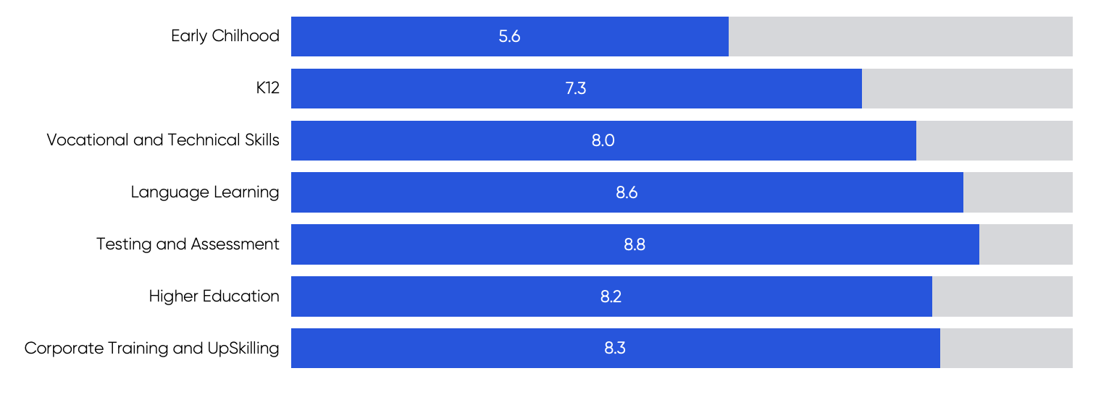
Fig(iii). Imapct of AI in learning
Source: HolonIQ, February 2023

Researchers have also found that in the education market, AI is expected to have most impact on Testing and Assessment, followed by Language Learning, Corporate Training/ Upskilling and Higher Education.
Impact on Teaching, Learning and Academic Integrity
As per the UNESCO report 2023, it is unsafe to use ChatGPT when you don’t have the expertise to verify that the output is accurate. The report continues to state that when you are willing to take the full ethical, legal and moral resposibility for the missed accuracies of the chatGPT output, then its advisable that we may use ChatGPT.Under the framework of the Beijing Consensus, UNESCO has produced a publication to promote the preparedness of education policymakers regarding artificial intelligence.
Thorp (2023) did a research critiquing the use of ChatGPT in education and highlighted the serious implications it can have in the academic and scientific community. While acknowledging the application's fun aspects, there are significant concerns regarding its impact on education. ChatGPT's academic writing capabilities are still in development, leading academics to reconsider their teaching approaches and assessments to avoid tasks easily solved by AI. On the other hand, Anu and Ansah (2023) explored the possible benefits of ChatGPT education. They identified benefits such as personalized learning, interactive engagement, and the potential for formative assessment, providing continuous feedback to support teaching and learning. However, ChatGPT also faces challenges related to generating misinformation, biases in data training, and privacy concerns.

Educators face a significant challenge in redefining how they assess learning due to the presence of AI tools like ChatGPT. There is a risk of academic dishonesty, as students may use ChatGPT to generate answers and engage in fraud during assignments or exams. Additionally, precision issues may arise since ChatGPT's knowledge is limited to events up until 2021, potentially leading to inaccuracies. Excessive reliance on AI tools like ChatGPT may also negatively impact students' problem-solving and decision-making skills, which are essential for success in the workforce. While AI can generate numerous ideas, true creativity and the ability to identify appropriate solutions require human thinking and foresight beyond the scope of existing data.AI tools, including ChatGPT, are inherently biased based on the data they are trained on, leading to potential ethical concerns. It is crucial to critically evaluate and set boundaries on the decisions made by AI tools to ensure fairness and justice in their applications. Ethics should be a core consideration when utilizing AI tools in education.

Despite lacking human interaction, ChatGPT is viewed as a ground-breaking content generation model. While some publishers have restricted its use in manuscript preparation, others consider its adoption inevitable due to its potential benefits. Academic integrity is probably the most discussed challenge ChatGPT will pose to education.

To promote responsible use of AI language models like ChatGPT, educational institutions can establish policies in their syllabus that encourage students to disclose their utilization of such models. College professors can design assignments with diverse assessment methods to minimize potential cheating through ChatGPT. These methods may include verbal presentations, group activities, and hands-on events, fostering interactive and engaging demonstrations of students' knowledge and skills. Additionally, plagiarism detection software can be employed to find any imitative or copied content in submitted papers. Applying these strategies can uphold academic honesty and discourage learners from trying to cheat using ChatGPT or comparable technologies.

Some research papers now list ChatGPT as a co-author, showcasing legitimate usage of the technology. However, without proper oversight from publishers, misinformation and inaccurate data may proliferate in research papers due to the information fed into the system. Ensuring rigorous review and validation processes by publishers can help mitigate these issues and uphold the quality of research publications.
Innovative Learning Advancements
In order to take advantage of this penetration of AI , organizations have started practices to enable early adoption of AI. HolonIQ has done a survey between 2019 and 2022 and Fig(iv) shows the differences in the thought process of organizations in adoption of AI, which is applicable for the education industry too.
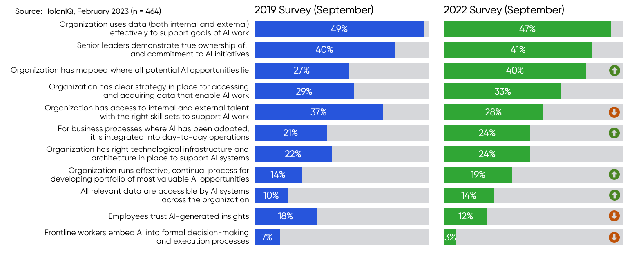
Fig(iv). Core AI processes in the various organizations
Source: HolonIQ, February 2023

The survey very clearly says that less employees trust AI insights, but organizations are using it for various opportunities and data access Beyond the mentioned applications, ChatGPT holds significant promise for higher education, ushering in transformative changes in process of education through the following avenues:
- Thinking and Writing Assistance: ChatGPT can comprehend project requirements, providing suggestions and alterations to improve writing clarity and consistency. This benefits non-native speakers and learners struggling with script, as it can produce ideas, offer comment on written work, and enhance total writing skills.
- Communicating Professionally: Creating official documents which are used in organizations, simulating realistic situations for teaching and rehearsal. This helps professionals improve their communication skills, while also receiving advice on tone and style to ensure effective professional communication.
- Customized Learning: ChatGPT's abilities enable the creation of personalized exercises, quizzes, and learning plans that align with each student's unique learning style and progress. This tailored approach ensures that students receive educational materials tailored to their individual needs, fostering personalized learning skills. Moreover, learners can develop resources precise to their learning preferences, streamlining their learning journey.
By harnessing the capabilities of ChatGPT, higher education can adopt innovative methods that improve learning outcomes and elevate various aspects of academic and professional life for students, educators, and professionals.
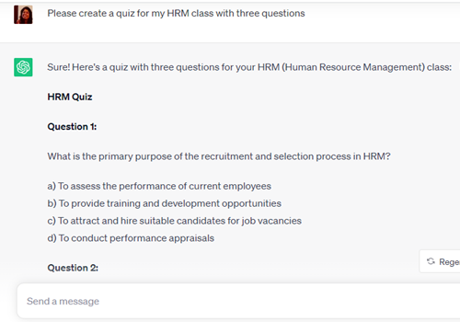
Fig(iv). ChatGPT creates a quiz for the class
Source: Self & ChatGPT

The integration of technology in education can be a challenging task for both students and teachers. Proper training and support for teachers are crucial to ensure that technology is effectively utilized in the classroom and enhances the learning experience for students.
Here are some important points to consider in addressing the challenge:
- Professional Development: Educational institutions should prioritize providing professional development opportunities for teachers to learn how to use technology effectively. This could include workshops, training sessions, online courses, or access to educational technology specialists who can guide them.
- Peer Learning and Collaboration: Encouraging teachers to share their experiences and knowledge about using technology in the classroom can create a collaborative learning environment. Peer support and mentorship can be highly beneficial for those who are less confident in adopting new technologies.
- User-Friendly Tools: Schools should aim to adopt user-friendly technology tools that are easy for both teachers and students to navigate. Intuitive interfaces and clear instructions can help reduce the learning curve for educators.
- Gradual Implementation: Instead of overwhelming teachers with a wide array of technologies all at once, schools can introduce new tools gradually. This allows teachers to get comfortable with each one before moving on to the next.
- Tailored Support: Different teachers will have varying levels of comfort and familiarity with technology. Providing personalized support based on their needs and preferences can be more effective in helping them embrace educational technology.

Incentives: Recognizing and rewarding teachers who effectively integrate technology in their teaching can motivate others to follow suit. Positive reinforcement can be a powerful tool to encourage tech adoption.

Open Communication Channels: Schools need to create open communication channels where teachers can voice their concerns, seek help, and share successes related to technology integration. This creates a culture of continuous improvement and support.

Student Involvement: Involving students in the learning process and seeking their feedback on the use of technology can help identify areas of improvement and make the learning experience more engaging for them.

Ongoing Support: The process of learning and adapting to technology is continuous. Schools should offer ongoing support and follow-up opportunities for teachers to further develop their skills and explore new technologies.

By addressing these aspects, educational institutions can empower teachers to use technology effectively, resulting in more engaging and enriching learning experiences for their students. Ultimately, the goal is to create a technology-enhanced learning environment that prepares students for the digital world they will face in the future.

Conclusion

The Age of Machine Learning and AI has propelled us forward, and the advent of these AI tools is inevitable and enduring. To harness the true potential of AI, it is crucial to embrace, integrate, and complement these tools with our educational practices; otherwise, we risk imparting obsolete and ineffective skills to our students. Enhancing the knowledge base and refining the bot's ability to understand and respond to context is essential.

It is recognized that ChatGPT, by incorporating information from diverse and possibly biased sources to generate responses, weaves a complex "tapestry of biases." This process makes it challenging to pinpoint the biases embedded within the used sources. As AI and Machine Learning reshape the landscape of education, a transformative, 360-degree shift is called for in the entire educational system. It is better to emphasize humans in the loop and align AI models to a shared vision for education. The educators need to be informed and involved which will strengthen the trust. Focusing on R&D and developing education specific guidelines and guardrails is important for the seamless functioning It is crucial to exercise caution and implement appropriate safeguards when utilizing ChatGPT in higher education to ensure ethical and responsible use. Though AI has a huge potential to transform the education landscape for both students and teachers it will never replace teachers, for sure.

References
Baidoo-Anu, D., & Owusu Ansah, L. (2023). Education in the era of generative artificial intelligence (AI): Understanding the potential benefits of ChatGPT in promoting teaching and learning. Available at SSRN 4337484.
Baker, T., & Smith, L. (2019). Educ-AI-tion rebooted? Exploring the future of artificial intelligence in schools and colleges. Nesta Foundation
Candy, P. (1991). Self-direction for lifelong learning. San Francisco: Jossey-Bass.
Firat, M. (2023). How Chat GPT Can Transform Autodidactic Experiences and Open Education?.
Garrison, D. R. (1987). Self-direction and distance learning: Facilitating self-directed learning beyond the institutional setting. International Journal of Lifelong Education, 6, 309 – 318 Caswell, T., Henson, S., Jensen, M., Wiley, D.: Open Content and Open Educational Resources: Enabling universal education. The International Review Of Research In Open and Distance , 9, 1, (2008) 1-11
Gureckis TM, Markant DB. Self-Directed Learning: A Cognitive and Computational Perspective. Perspect Psychol Sci. 2012 Sep;7(5):464-81.
Hosseini, M., Gao, C. A., Liebovitz, D. M., Carvalho, A. M., Ahmad, F. S., Luo, Y., ... & Kho, A. (2023). An exploratory survey about using ChatGPT in education, healthcare, and research. medRxiv, 2023-03.
Sandu, N., & Gide, E. (2019, September). Adoption of AI-Chatbots to enhance student learning experience in higher education in India. In 2019 18th International Conference on Information Technology Based Higher Education and Training (ITHET) (pp. 1-5). IEEE.
Schweder, S., & Raufelder, D. (2022). Adolescents' expectancy–value profiles in school context: The impact of self‐directed learning intervals. Journal of Adolescence, 94(4), 569-586.
Tavichaiyuth, N., & Rattagan, E. (2021). Developing chatbots in higher education: A case study of academic program chatbot in Thailand.
Thorp, H. H. (2023). ChatGPT is fun, but not an author. Science, 379(6630), 313-313.
Vanichvasin, P. (2022). Impact of Chatbots on Student Learning and Satisfaction in the Entrepreneurship Education Programme in Higher Education Context. International Education Studies, 15(6), 15-26.
Varghese, R.M.(2023),Is ChatGPT a Game changer for Higher Education in India?,University News,61(9)

