b 3D printing of PLA material for passive prosthetic finger for hand rehabilitation
Nitin Sahai^{1,2}, Pynwanjanai Marbaniang¹, Mariabiang Marwein, ¹ Browinson Ksoo¹ Damankhraw Nongrem¹, Shyamal Mandal¹
¹Department of Biomedical Engineering, North Eastern HillUniversity, Shillong, Meghalaya
Abstract
This case report explores the ease of utilizing patient-specific design in computer-aided software, open-source 3D printed design software. Participants were recruited and examined using subjective and objective analysis to guide the prosthetic designs. The measurements of the particular finger (i.e. index finger) were obtained and fed into computer software to develop computer-aided design drawings of the required prosthetics. This report uses CAD (Computer-Aided Design) software and additive technology to produce a low-cost mechanical finger prosthesis. The goal was to use Autodesk Tinkercad and Ultimaker Cura software which are freely available, to design and develop an index finger prosthesis from PLA (polylactic acid) material using a 3D printer. The prosthetic finger should be suitable and comfortable for the users depending on the size, weight and overall shape or model of the device and with the use of parametric modelling measures, which is a great help in producing specific and suitable prosthetics for the patient. To enable the lost gripping of the missing joints and to make it function well, the mechanical finger prosthesis will give a proper flexion and extension performance, the same as the movement of an excellent healthy finger. The designed and developed prosthetic finger has a simple construction consisting of components made on a 3D printer; a specifically attached cable system takes its movement and function into action. The model of the finger prosthetic was printed with an adequately designed socket to make it look like a healthy finger which will give a successful extension and flexion of finger movement using a cable system. After analysing, we found that the prosthetic functions as an anatomically healthy finger. Therefore, the current 3D printing technology significantly impacts producing prosthetics devices that are uniform scaling to fit the prostheses of different users.
Keywords: - CAD, Additive Manufacturing, 3D printing, Finger prosthesis,
- Introduction: -
3D printing is a significant technique in developing patient-specific three-dimensionally printed prosthetics and orthotic devices[1]–[5]. Prosthetic limbs or finger prosthetics used for human needs to overcome limb loss are used widely. Prosthetic demands, or finger prosthetics used for human needs to overcome the loss of limbs, are widely demanded. The global market for upper limb prosthetics application is projected to grow at a CAGR of 4.97% and will reach $1131.36 million by 2030, as confirmed by strategic market and research. Prosthetic upper limbs have the potential to provide individuals with a genuine limb sensation and enhanced capability to carry out daily activities. Regrettably, various prostheses have high costs and demand frequent and regular maintenance.
Consequently, the traditionally developed prosthesis poses a more significant financial burden and is largely inaccessible to most of the population, like people living in villages and developing nations. A viable solution could be the utilisation and adaption of 3D-printed upper limbs, offering affordability and adaptability. Nonetheless, the finger's suitability for these countries' environmental conditions and lifestyles is crucial. To assess the functionality of the 3D-printed finger, a comprehensive set of experiments and object tests were conducted.
It is widely believed that three-dimensional printing is part of an additive manufacturing method that can build objects directly from a computer model. It forms any solid shape from a digital model. 3D printing methods are a subcategory of additive manufacturing (AM) technology. A three-dimensional model was generated by developing the addition of successive layers by a layer of printable material, which forms the final object. 3D printers enhance product designers’ ability to print models, parts and components made from variable materials with variable mechanical and physical characteristics in a single developed object. The highly advanced 3D printing methods currently develop models which are very much similar in the appearance and functionality of the final product.
Moreover, three-dimensional printing is an advanced and different manufacturing methodology based on the latest technological innovations. It will develop variable parts additively joints in layers by layers at a millimetre of scale size. This differs from traditional product manufacturing techniques[6]–[9].

By utilising additive manufacturing technology, also known as 3D printing, it becomes possible to create cost-effective and high-performance prosthetic devices. This cutting-edge technology, 3D printing, fosters innovation by providing novel design possibilities and reducing the need for intricate mechanical assembly. The 3D printing method is a technology that decreases prohibitive money and lead times and reduces product delivery time. Product components can be precisely designed to eliminate the need for intricate assembly, incorporating complicated geometry and complex features without significant additional expenses. Additionally, three-dimensional printing is emerging as an environmentally friendly approach in manufacturing, using as much as 90% of standard materials and promoting sustainability over the product's lifespan by enabling lighter and more durable designs.

Three-dimensional printers are the latest generation of types of equipment that can make daily usable things. They are remarkable because they can produce different objects in different materials, all from the same device [10]–[12]. A 3D printer can make anything from alphabet letters to numerical digits, plastic toys, metal machine parts and more.
  - Computer Aided design

Computer-Aided Design (CAD) allows the designing of a variety of realistic models in different fields of work virtually[2]–[4], [13], [14]. Employing computer-based software, this technique harnesses digital tools to assist and streamline various stages of the design process. CAD allows engineers to build 3D computer models, design, and layout of products; it also allows the designing of 2D physical components, which after completion, can be simulated for functional results[15]. Computer-Aided Design (CAD) is an essential tool for biomedical engineering applications, enabling scientists, doctors, engineers, and researchers to think, design, model, and simulate various medical equipment/ devices, implants, and systems. CAD for biomedical engineering plays a significant role in developing and optimising medical products and technologies. Several examples show the application of CAD in biomedical engineering in some ways, like in the development of medical device design. CAD creates detailed and accurate 3D models of biomedical devices consisting of orthotics, implants, prosthetics, high-end surgical instruments, and patient-specific diagnostic equipment. Engineers can iteratively design and modify these models to meet specific requirements, functionality, and ergonomic considerations. Human implant and prosthesis design comprises CAD designs of patient-specific tissue or organ implants and prosthetics tailored to patients’ anatomies. By the utilisation of medical imaging data (CT, MRI scans), CAD software can create custom implants that fit perfectly into a patient's anatomy, improving the success of surgeries and reducing complications[16]–[19]. 3D models can also be developed from medical images like, Magnetic resonance imaging(MRI), Ultrasound, X-ray and computed tomography (CT), as described in Figure 1 and Figure 2.

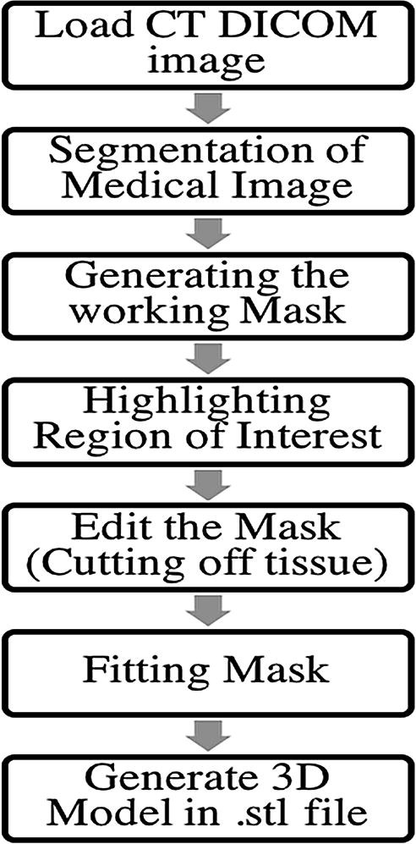
1. Figure stepwise method for generating cad model from medical images reproduced with permission form[13].

The sequential stepwise systematic procedure for developing and generating a computer-aided three-dimensional model for cartilage tissue is shown in Figure 2
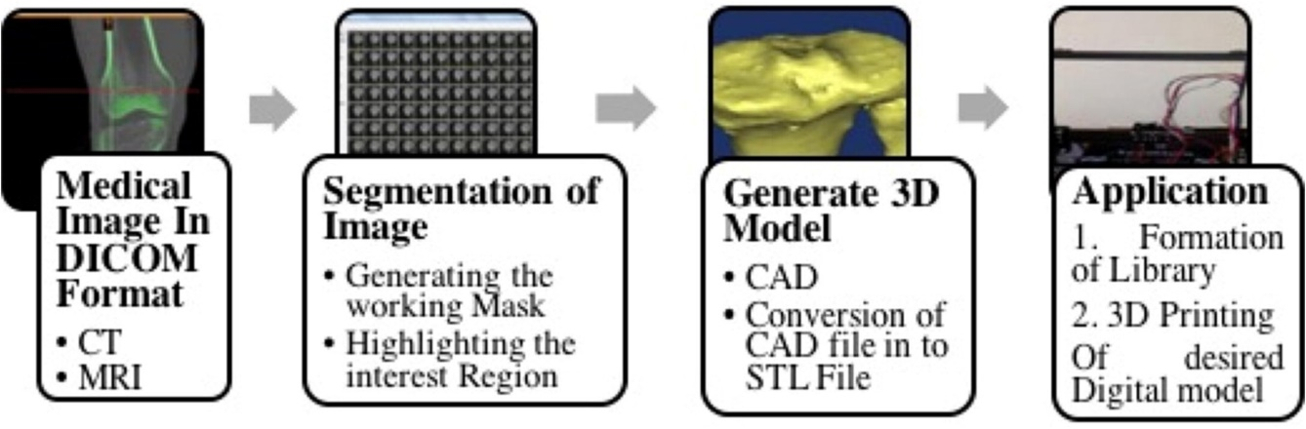
2. Figure development of cartilage model from the medical image reproduced with permission form[13]

CAD software/tools

Numerous tools for CAD development are available, catering to the needs of designers, technicians, and engineers alike. Specific CAD applications are tailored to address distinct use cases and industries, including fields like design and architecture. Diverse computer-aided software can be employed to support an array of industries and project types. A selection of commonly utilised CAD tools includes:
- AutoCAD ( developed by Autodesk)
- Corel CAD
- Iron CAD
- CADTalk
- SolidWorks
- Onshape
- Catia
- Libre CAD
- OpenS CAD

  - Finite Element Analysis (FEA) Integration: CAD models can be integrated with FEA software to analyse biomedical devices' structural integrity and mechanical behaviour under different loading conditions. This helps identify potential failure points, optimise designs, and ensure safety and reliability. Tissue and Organ Modeling: CAD can create 3D models of tissues, organs, and anatomical structures. These models are helpful in medical education, surgical planning, and simulation, providing insights into complex anatomy and pathology. Medical Prototyping: CAD allows engineers to create virtual prototypes of medical devices before physical production. This enables rapid prototyping using techniques like 3D printing, reducing development time and costs. Surgical Planning: CAD models, combined with medical imaging data, aid surgeons in planning complex surgeries. They can simulate procedures, evaluate different approaches, and assess potential risks before operating on the patient. Biomechanical Simulations: CAD models can affect the biomechanical behaviour of tissues, joints, and organs under various conditions, providing insights into physiological responses and aiding in developing bio-inspired devices. Customised Medical Instruments: CAD facilitates the design of specialised surgical instruments and tools tailored to specific procedures and patient needs. Regulatory Compliance: CAD documentation and models are crucial in meeting regulatory requirements for medical device approval, ensuring compliance with safety standards and guidelines. Overall, CAD is a fundamental tool that enhances biomedical engineering projects' efficiency, accuracy, and safety, leading to advancements in medical technology, patient care, and treatment outcomes[20]–[26].

Prosthesis
An artificial body part, known as a prosthesis, is designed to alter both the function and appearance of the absent body part. The choice of a prosthetic lower limb, hand, finger, or arm is primarily determined by factors such as the location and size of the remaining hand or finger, as well as your daily routine and functional requirements.
A prosthetic finger and hand will be advantageous in different methods and perform the following functions:
- Capable of reinstating and preserving the length of a partially amputated finger
- Allow the movement for the opposition between fingers and thumb and a finger.
- Enable a person with a hand amputation to stabilise and grasp objects using flexible fingers.

Roughly 90 percent of upper limb amputations involve partial hand loss, which can entail the loss of one or more digits. Previously, 3D-printed prostheses for limb loss were often simplistic, relying on the individual's existing thumb or fingers to manipulate objects against a stationary prosthetic base. Nevertheless, recent technological progress has created compact, durable components that contribute to continuous enhancements in the body- and electrically powered designs.

Types of prosthetics

Passive advanced prosthetics
Crafted to replicate the appearance and tactile qualities of a non-prosthetic hand or finger, passive silicone prosthetic devices present a natural look and feel. These devices are frequently coated with varying grades of high- or low-definition silicone that can be individually painted, resulting in an authentic aesthetic. While passive prosthetics boast remarkable lightness, they lack the capacity for genuine active movement and possess constrained grasping capabilities. Nevertheless, they can enhance the user's functionality by furnishing a stable surface. Because of these characteristics, passive prosthetics are predominantly chosen for their aesthetic or cosmetic merits rather than being favoured for high-performance functional applications.

Myoelectric Advanced Prosthetics

As previously stated, externally powered prostheses are technologically advanced, electronically operated, functional, and exceptionally responsive devices. Designed explicitly for partial-hand amputations, this prosthesis generally includes multiple full-length prosthetic fingers or a full-length prosthetic thumb, depending on the individual's needs. These devices are powered by a lightweight, rechargeable onboard Li-ion battery system, contributing to their advanced capabilities. Due to their lightweight nature and advanced technology, they are well-suited for tasks requiring light to moderate day-to-day performance.

Body-powered advanced partial hand prosthesis
According to the studies, body-powered prostheses for partial hand amputees can generally be categorised into three main groups.:
- Cable controlled.
- Driven by joints.
- Driven by the wrist.
The 3D-printed prostheses exhibit remarkable durability and boast a sophisticated, high-tech aesthetic. A notable advantage lies in their functional capabilities, where the exertion of force is precisely regulated through the user's wrist or the residual part of their hand. This intricate control mechanism bestows a strikingly natural feel to movement and operation, greatly enhancing the user's overall experience with the prosthetic device.

Hybrid Prosthetics

Examples of hybrid prosthetics, such as the Bebionic hand by Ottobock, integrate both body-powered and myoelectric control mechanisms. This amalgamation empowers users to operate the elbow and wrist with precision simultaneously. Hybrid prosthetics frequently merge the robust grip capabilities of myoelectric devices with the intuitive biofeedback of body-controlled devices, all without adding extra bulk. This synergy lessens the weight and intricacy of trans-humeral prosthetic systems and enables swift elbow manipulation to position the terminal device efficiently.

  - Finger Prosthesis

The prosthesis will be positioned as the hand's second digit; the index finger ranks among the most frequently employed digit, along with the thumb and middle finger. Its significance arises from many functional applications, including sensory touch and gripping tasks, rendering it an indispensable tool in daily activities. Furthermore, the index finger is vital in expressive gestures, making it a versatile and crucial element in human interaction and communication. Nonverbal hand gestures generally express this. As a result, the index finger may be called an example of a "pointer." The human finger consists of three phalanges that stretch from the second metacarpal of the side. The proximal phalanx lies at the finger’s base, forming a crucial connection with the intermediate phalanx through the knuckle joint. Positioned at the tip of the hand finger, the distal phalanx plays a pivotal role in supporting the delicate pulp of the fingertip. Additionally, specific muscles aid in the finger's movement: the palmar interosseus contributes to adduction, drawing the index finger inward, while the extensor facilitates extension, allowing for outward movements. The finger is shown in Figure 3.

Ensuring the finger's vitality, the normal palmar artery, branching from the palmar arch and linking the ulnar and radial arteries, efficiently supplies oxygenated blood, sustaining its overall health. The median nerve accomplishes innervation of the finger's skin, ensuring proper sensory perception and responsiveness in this intricate and versatile hand part.
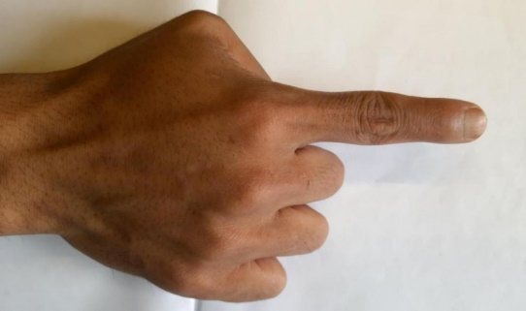
3. Figure index finger representation
Passive 3D-printed prosthetic devices are designed to emulate a non-prosthetic finger's natural look and texture. Emilio Soto et al. created a 3D-printed neural network hand. The 3D-printed tendon was developed for finger prosthesis, which cannot grow by conventional methods. Silicon finger prostheses use a new way for the development of suspension. The design incorporated a fabrication technique for the socket of the finger prosthesis, which involved reducing its size by Two millimetres from the primary measurement. Furthermore, a tunnel in the centre was intricately fashioned, with dimensions measuring 4 mm in depth and width, precisely matching the length of the pathway between the stump's ends. Additionally, a nail section was introduced in the design to allow the silicone material to extend over the stump, ensuring a commendable suspension and secure fit for the prosthesis.3D printed tendon-driven robotic finger was developed, which can restore normal function. The cost-effective index finger was 3D printed for carpenters using polyurethane. The patient-specific partial body-powered prosthetic finger was extended, commercially available in the market[27]–[31]. Contemporary prosthetics entail substantial manufacturing and assembly processes, especially for lower limbs, fingers, and hands. By leveraging additive manufacturing, specifically 3D printing, it becomes feasible to create 3D-printed prosthetic devices that are both economical and high-performing. This study focuses on a completely flexible finger produced through 3D printing, utilising a modified and cost-effective three-dimensional printer based on the Fused Deposition Modelling (FDM) technique. Before fabricating the finger, the bending characteristics of various well-established flexure hinges were modelled and experimentally verified to determine the most suitable design for a fully adaptable prosthetic finger... In this current research article, a 3D-printed mechanical prosthetic finger was developed. The prosthetic device is a low-cost, lightweight set without any electronic devices. The prosthetic figure was designed for long-lasting and smooth movement with a comfortable, harmless fitting socket and the wrist.

- Materials and methods

  - Polylactic Acid

The fused deposition modelling method was applied to produce the 3D-designed prosthetic figure. PLA (Polylactic Acid) is a versatile commercial biodegradable thermoplastic based on Lactic Acid used as material for 3D printing. A 3D printer made from 3D Dexter was used, as shown in Figure 4.
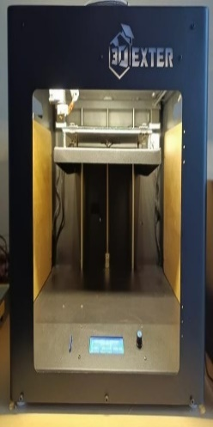
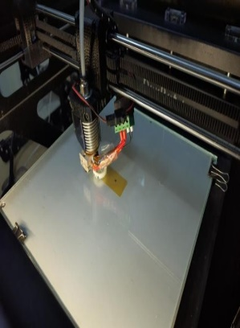
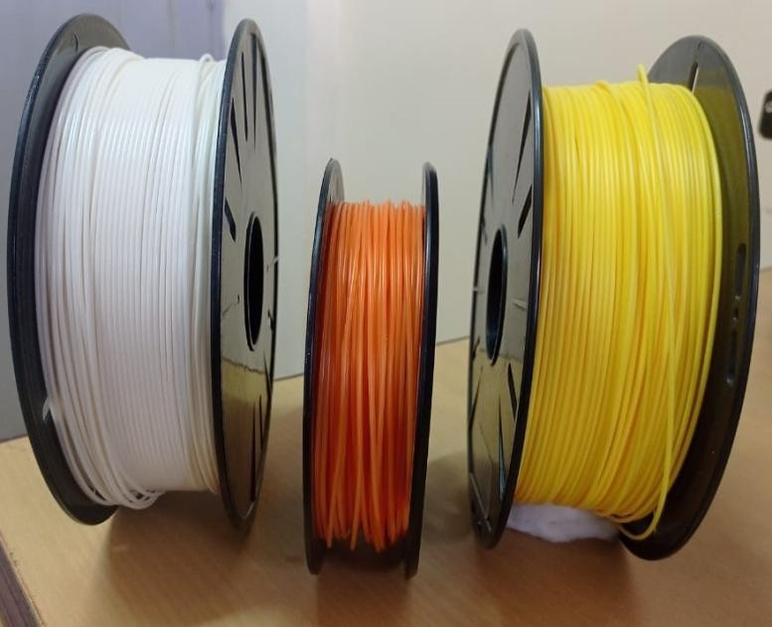

4. Figure 3D printer and PLA material

Polylactic acid's physical, morphological, and mechanical attributes fluctuate based on the polymer types, spanning from amorphous glassy polymers to semi or highly crystalline polymers.
The property of this acid makes it so desirable for use in the domain of 3D printing because it has a low melting point, and there are minimal dangers therefore connected to the use of this acid.
The general properties of PLA are summarized in Table (1) below.

1. Table Characteristics of PLA
Parameter of PLA | Values
The specific gravity of PLA | 1.27
Melting Density | 1.073 g/cm3
Glass Transition temperature (Tg) | 55℃
Melting Temperature (Tm) | 165℃
Density of material | 1.252 g/cm3
Young’s Modulus E | 3.5 GPA
Elongation at break | 6%
Tensile Strength σts | 36-55(MPa)
Ultimate Tensile Strength UTS | 35(MPa)
Strength-to-weight ratio | 40(kN•m/kg)
Shear modulus G | 2.4(GPa)
PLA Molecular weight (Mw) | 66,000 g/mol

The range of motion for different joints in the development of the CAD model was considered, as shown in Table 2.
- DIP stands for Distal Interphalangeal Joint,
- PIP stands for Proximal Interphalangeal,
- MCP stands for Metacarpophalangeal Joint, are shown in Table 2

Table2: Range of motion

Joint | Motion | Index
DIP | Flexion | 80
 | Extension | 11
PIP | Flexion | 110
 | Extension | 12
MCP | Flexion | 83
 | Extension | -22

  - Prosthetic finger parameters
The design for the prosthetic finger has been done from the open-source Tinker CAD, which is free to use to create and modify the model. The human hand’s second digit (2D), commonly known as the index finger, is positioned between the thumb and the middle finger. It is typically considered the most dexterous, practical, and sensitive finger after the thumb. To measure the index finger, digital callipers were employed, applying them to two specific locations: the basal crease at the bottom of each finger and directly at the fingertip. The index (= 2D) of both the left and right hands will be assessed. To initiate the design process, precise measurements were taken for both the intact left finger and the remaining right finger, which served as the basis for designing the prosthetic. These measurements were meticulously recorded to ensure an optimal fit for the prosthetic device. Subsequently, the Tinker cad software utilised these measurements as input to generate a comprehensive 3D representation of the various components, as depicted in the figure. Once the design views were finalised, the files were exported in STL format, which was input for the Ultimaker Cura software responsible for operating the 3D printer.

2.3 3D printing
The STL file containing the model of the index finger was exported to the Ultimaker Cura Software to prepare it for 3D printing. The measurements were used to ensure the model was adequately scaled and positioned on the build plate within the software. Careful attention was given to arranging the model's position and adjusting the print profiles or settings to ensure it was ready for 3D printing. Once all the settings were optimised correctly, the models were sliced and saved as a Gcode file, which was then sent to the 3D printer for printing and shown in Figure 5 the different CAD model.

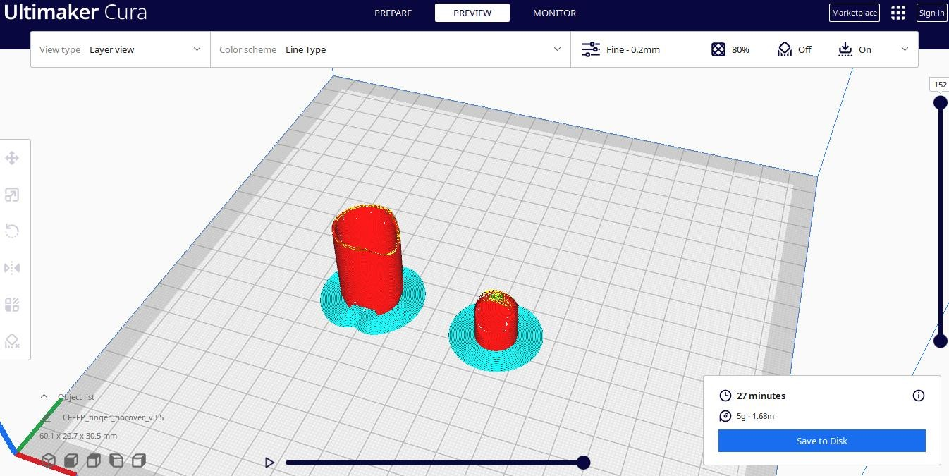
5. Figure 3D CAD Models
A
B
D
C

PLA, the ideal material for 3D printing, was inserted into the extruders of the 3D printer. The extruder, equipped with a stepper motor, controlled the amount of filament fed into the nozzle. The nozzle melted the filament, and the 3D printing process commenced.

  - Finite Element Method/Analysis

Finite Element Method/Analysis (FEM/FEA) is a numerical technique applied to analyse the behaviour of complex problems and structures by dividing them into more minor, more superficial elements. FEA is crucial in simulating and understanding the mechanical behaviour of various biological tissues, implants, medical devices, and other biomedical structures in biomedical applications. Here are some typical applications of FEA in the biomedical field: Biomechanics of Tissues: FEA can study the mechanical properties of biological tissues like bones, cartilage, ligaments, and tendons. By applying FEA to these tissues, researchers can gain insights into their stress, strain distribution, and deformation under different loads and predict failure or damage conditions. Implant and Prosthesis Design: FEA aids in optimising the design of implants and prosthetic devices. It helps evaluate the performance and safety of implants by analysing their stress distribution, stability, and potential for wear or fatigue over time. Orthopaedic Applications: FEA is widely used in orthopaedic biomechanics to study joint mechanics, spinal biomechanics, fracture healing, and the performance of orthopaedic implants such as hip replacements, knee replacements, and spinal implants. Dental Applications: FEA is utilised in dental research to understand the biomechanical behaviour of dental implants, bridges, and dentures, as well as to study the stress distribution in teeth under different loading conditions. Cardiovascular Simulations: FEA can simulate blood flow patterns in arteries, predict stress distribution in blood vessels, and assess the mechanical performance of stents and other cardiovascular devices. Soft Tissue Modeling: Besides studying rigid structures, FEA can also be extended to model soft tissues like heart muscles, brain tissues, and skin to study their behaviour and response under different mechanical forces. Biomechanical Testing Validation: FEA is often used to validate experimental testing results, providing a complementary method to verify and enhance empirical findings. It is important to note that FEA requires accurate material properties, boundary conditions, and meshing techniques to provide reliable results. Additionally, it should be used in conjunction with experimental data to validate and calibrate the models for accurate simulations.
In biomedical applications, FEA can significantly aid in improving medical devices, understanding biomechanical responses, and optimising treatment strategies, leading to advancements in healthcare and patient outcomes.
In later studies, Structural analysis of the prosthetics joint figure model was performed by ANSYS Workbench 2020 R1(ANSYS et al.).
Conventional parameters were employed to determine the mechanical properties of PLA for three-dimensional printing., such as Young’s Modulus of 2850 MPa, Poisson ratio of 0.25, and a pressure of 0.64 pascals was exerted on the boundaries while maintaining fixed constraints. The standard mesh was created with tetrahedral elements with regular intervals[32]–[34].
- Results

Once the 3D models have finished printing, the parts are detached from the printer's work platform and thoroughly cleaned shown in Figure 6. Subsequently, all supporting structures are carefully ground down and smoothed to facilitate the proper assembly of the prototype prosthesis. The finger phalanges are interconnected using pegs in the DIP, PIP, and MCP joints.
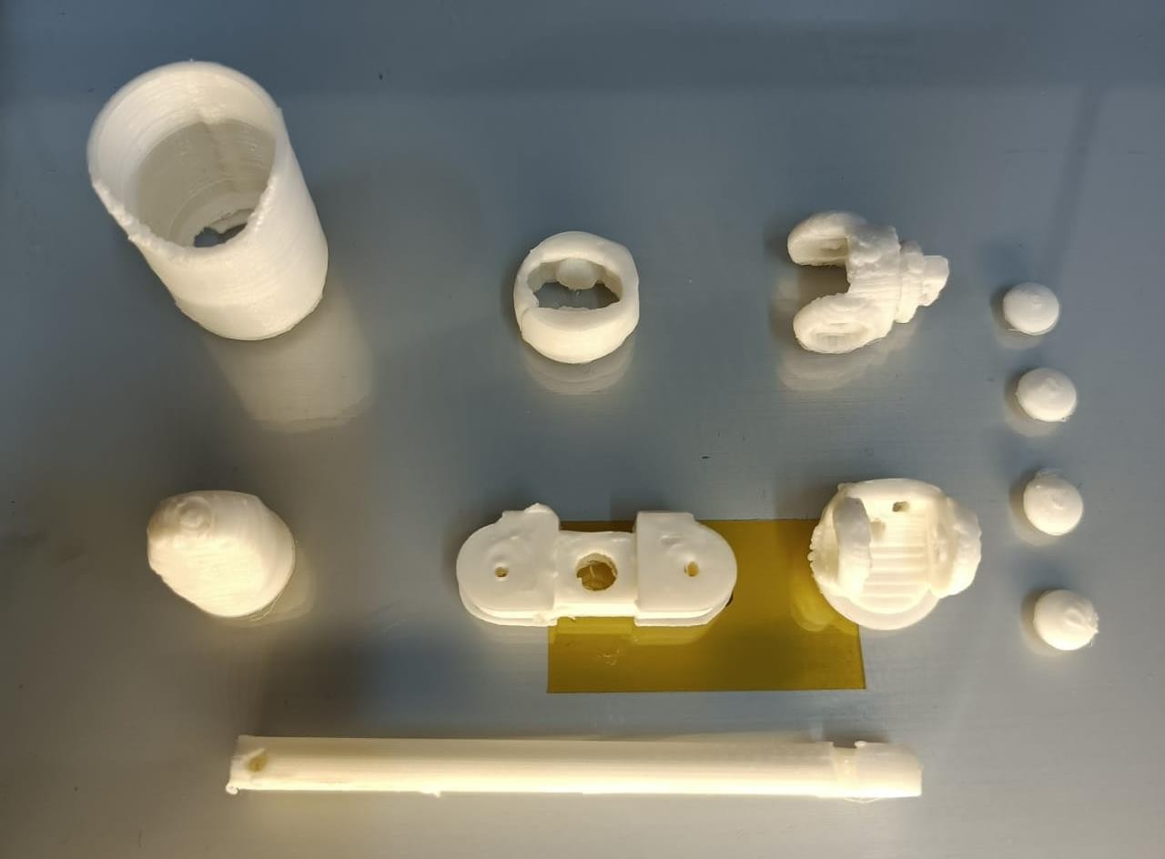
6. Figure Different components of Finger Prosthetic

The complete flexion performance of a finger prosthesis with a cable system enables finger prosthetic movement as the user wants to, and it can hold objects firmly as a healthy finger shown in Figure 7.

7. Figure The Complete model of a Finger prosthetic.

- Conclusion and prospects

This project used additive manufacturing to create a functional mechanical index finger prosthesis. The proposed design closely mimics the structure of a natural finger and features a straightforward and efficient movement mechanism. The prosthesis can be easily attached to the arm, and its size and construction resemble that of a healthy anatomical finger. Leveraging 3D printing, this technology enables the efficient and rapid production of personalised prosthesis components. By employing this approach, the aim is to enhance the aesthetic appeal and achieve improved functionality in the prosthesis. Finger prosthetics produced through 3D printing have become widely utilised today. From the early stages of CAD programming and 3D printing, these prosthetics have evolved from essential to advanced designs, with ongoing developments. Overstudy aims to create lightweight and cost-effective figure prosthetics, optimising them for superior outcomes compared to existing structures. This optimised design aims to alleviate the emotional distress caused by the absence of a figure due to birth, accidents, or amputation while restoring the lost fingers’ functionality and reducing pain associated with depression, grief, or PTSD.
This study yields a functional and durable prosthetic finger. There is potential for future model enhancement. Additionally, there is an opportunity to develop complementary components, such as cable-free prosthetics that enable wrist movement without hindrance.

References

