DESIGN AND FABRICATION OF RETROFIT E-BICYCLE
- Introduction
As the world population is increasing day by day, the demand for simple, reliable, environmentally friendly, safe, and affordable product in the manufacturing industry is increasing. One such product is E-Bicycle. Gasoline bicycles are not sustainable, and the fuel price increases with the environmental consideration. Traffic is a major issue we are facing in our daily life. E-Bicycles are used instead of conventional two wheelers for short trips, and they occupy less space hence it will be helpful in overcoming this issue. In this project, bicycle is retrofitted by advanced technologies and modified into E-Bicycle, wherein it can be operated in both pedaling and non-pedaling modes. The rider can control the motor output or speed through the throttle. It will be more affordable than the fuel-based bicycles as we use battery instead of fossil fuel. The BLDC controller is used to control the speed, acceleration, motor power, battery voltage and pedaling activities. It gets the input from the pedal assist sensor and gives the output accordingly. A hub motor which is very sleek in design and very light in weight is considered due to their low self-discharge rate, low maintenance and high energy density. Li-ion batteries are used to supply power to the drive train. Battery cooling system along with Battery management system is included. The cooling system helps in temperature management during high demand on battery. This combination can increase the life cycle of the battery and reducing the need of battery replacement. The current scenario is witnessing significant challenges in the form of global warming and the depletion of non-renewable resources. Individuals are actively seeking to transition towards environmentally sustainable energy sources. Undoubtedly, the most crucial innovation of the previous century was the development of the internal combustion engine, specifically the petrol and diesel variants. The transport sector has undergone significant transformation. The concept of speed has facilitated the conversion of units of time, such as days into hours, hours into minutes, and minutes into seconds. The driving factors behind this innovation are the enhancement of passenger comfort and the reduction of strain on human muscles. However, the swift process of modernization within the transportation industry consumes a substantial amount of gasoline. The over utilisation of petrol and diesel automobiles is associated with detrimental consequences such as heightened pollution levels and the exacerbation of global warming. In order to address these challenges, researchers have developed the notion of electric automobiles. One notable benefit of electric vehicles is their avoidance of conventional fuel sources, such as diesel and petrol, resulting in the absence of noxious emissions from exhaust systems. Electric bicycles, sometimes referred to as e-bikes, hold significant prominence within the realm of electric vehicles. These modes of transportation exhibit a high degree of user-friendliness when utilised for commuting purposes inside the confines of urban areas. E-bicycles are essentially conventional bicycles that have been equipped with an electric motor to enhance their speed. Globally, a diverse array of electric bicycles exists, encompassing models with modest motors that provide pedal assistance, reducing physical effort, as well as those equipped with more robust motors that have a striking resemblance to mopeds. Nevertheless, in the event of battery depletion or motor malfunction, the rider has the ability to pedal all-electric bicycles. The electric bicycle is an electromechanical device that provides assistance to the user by delivering electromagnetic momentum to a conventional bicycle, so alleviating the need for the user to generate the energy required to propel the bicycle.
At the moment, there are numerous advancements in technology and mobility, which can indirectly encourage individuals to develop innovative tools. In addition, the existence of several environmental issues has shifted human attention away from using fuel oil and toward conserving energy. Additionally, this has an effect on the availability of various environmentally friendly and energy-efficient modes of transportation. In order to address these challenges, researchers have developed the notion of electric automobiles. One of the primary benefits of electric vehicles is their avoidance of conventional fuel sources, such as diesel and petrol, resulting in the absence of emissions from exhaust fumes. Electric bicycles, sometimes referred to as e-bikes, hold significant prominence within the realm of electric vehicles. These modes of transportation exhibit a high degree of user-friendliness when utilised for commuting purposes inside the confines of urban areas. E-bicycles are essentially conventional bicycles that have been equipped with an electric motor to enhance their velocity. Across the globe, a diverse array of electric bicycles can be found, encompassing a spectrum of designs. These range from models equipped with modest motors that provide assistance for pedalling, so reducing physical effort, to those featuring more robust motors that bear a striking resemblance to mopeds. Nevertheless, in the event of battery depletion or motor malfunction, riders have the option to pedal all-electric bicycles manually. The electric bicycle is an electromechanical device that provides assistance to the user by delivering electromagnetic momentum to a conventional bicycle, thereby reducing the energy required from the user to propel the bicycle. Electric bicycles can be used to meet the requirements for comfortable and safe transportation. It is thought that its use in residential areas with a lot of people helps cut down on air pollution, which is getting worse and is mostly caused by car fumes. The invention of electric bicycles is now used for more than just sport. On the other hand, it has been made into a mode of transportation. Using an electric bicycle allows you to travel a greater distance, navigate hills with relative ease, and reach a destination like work. E-bicycles can overcome some common barriers to cycling for all demographics thanks to features on them. Electric bicycles are used in place of human-powered bicycles or conventional motorized vehicles for travel.
The traditional bicycle frame (with or without pedals) and a small electric motor make up the e-bicycles main design. Light rechargeable batteries (lead-acid, NiCd, NiMH, and Li-ion) power the motor. These motors have enough power to achieve maximum speeds of 24 to 32 km/h (about 20 mph). Direct-drive and geared motors are two of the many types of motors currently in use. Chain drive, belt drive, hub motors, or friction drive are the methods used to transmit power to the wheels. A solar charging station was included in one of the earliest electric bicycle models from 1980, and it was used to recharge the on-board batteries. The current method of traveling in a city needs to be reconsidered because of air pollution and growing traffic congestion. Moving away from internal combustion engines and towards electric and hybrid vehicles is one potential remedy. Electric bicycles can offer an alternative to traditional forms of transportation and encourage sustainable methods of getting around cities, with the bonus of encouraging physical exercise. The use of lithium-ion (Li-Ion) batteries is growing exponentially as EVs gain popularity because of their excellent charge/discharge performance, high energy and current density, and optimal power support. Due to their considerable significance in electric vehicles (EVs), lithium-ion (Li-Ion) batteries must be precisely monitored and controlled. Although Li-Ion batteries have numerous benefits, they also have significant drawbacks. To provide secure operation, expanded driving ranges, an ideal power management approach, increased battery life, and lower battery prices, a battery management system (BMS) is necessary. The purpose of a BMS is to track or estimate battery conditions, such as voltage, current, projections of remaining range, battery health, and power capability estimation. Notably, the fundamental metrics used to assess the entire BMS are state of charge (SOC), state of health (SOH), and state of function (SOF).
The battery pack has a big impact on how well an EV performs. To achieve maximum performance, safety, and dependability under diverse operating situations, the temperatures of the cells in a battery pack must be kept within its optimal operating temperature range. A battery pack's capacity, speed of fast charging, cycle life, cell balance, and charging and discharging power will all be impacted by poor thermal management. Consequently, a thermal management system is required to improve performance and lengthen the life of the battery pack. An electric bicycle is a bicycle with an electric motor which reduces the effort of pedalling. There are now a variety of electric bicycles available worldwide, ranging from lightweight models with only a small motor to more powerful models that are more functional and stylish. With advancement of modern drive technologies, a proper motor selection is also becoming much important in various electric traction applications. Brushless direct current motors (BLDC), a type of DC motor with an electronic commutator, are being utilized more and more frequently in place of conventional DC motors with a mechanical commutator. Reliable controller is required for the BLDC drive applications, by the proper control method only it can overcome the nonlinearities and good dynamic response can be obtained.
- Literature review
A sub-maximal incremental ramp test has been designed to examine pedalling characteristics and their relationship to the physiological parameters of participants. The data analysis allowed for the identification of factors that provided statistically significant differences between common performance factors, such as mechanical power and normalised power. Using the findings of this study, three novel controller strategies have been proposed, demonstrating how increased awareness of human conditions and capabilities can lead to a more accommodating symbiosis between human and machine, resulting in a new generation of e-bikes. [1]
In the paper, an accurate electrical equivalent circuit model of a rechargeable lithium-ion cell with thermal dependence is created, along with a method for identifying the model's SOC. A Coulomb integration and EKF technique for SOC estimation based on the state space equations of a second-order Thevenin equivalent circuit have been developed. The design processes of both techniques are described in detail. Simulation results demonstrate that EKF is substantially more accurate than the Coulomb counting method. The error rate of EKF simulation results is less than 1%. [2]
This paper redefines SOC as the battery's residual capacity relative to its current utmost capacity. This work proposes the computation and monitoring of three essential indices, namely state of charge (SOC), state of health (SOH), and state of function (SOF), for EV BMS (battery management system). To reduce the estimation error of the SOC, the SOC is re-defined by the current utmost capacity. The proposed SOC's measurement indicates that the utmost error is 0.334%. In addition, this paper proposes SOF based on SOC and SOH to disclose the system's driving force. [3]
In this paper, the prospects and challenges of electric vehicles (EVs) are examined, and the significance of thermal management in EVs is emphasised. Compared to conventional ICE vehicles, EVs are one of the environmentally benign and energy-efficient sustainable solutions for future transportation. Among the available thermal management systems, the liquid cooling system is more effective at extracting heat from the cell and creating an optimal environment for the battery's operation. The issues associated with electrically unbalanced cells can be mitigated, along with the cycle life of the cell and battery safety. [4]
Using ANN-based FOC and MRAS-based rotor position estimation, this paper compares IM, BLDC, and PMSM for electric vehicle traction applications. All detail behaviours are evaluated in terms of their benefits and drawbacks. The PMSM-based drive has demonstrated superior efficacy in comparison to others. [5-7]
- System description
Major components required for development of e-bicycle:
- Battery
- BLDC Motor
- Battery Management System
- Cooling system
- Controller
- Auxiliary components
3.1 Battery
For all-electric vehicles, energy storage systems, usually batteries, are necessary. Lithium-ion batteries are highly preferred since they have a high power-to-weight ratio, great energy efficiency, and low self-discharge and rechargeable. Lithium-ion battery parts may often be recycled. Compared to other batteries life cycle of this battery is more. The battery chosen for the project is 36V, 12.5 Ah Li-ion battery. Electric vehicles use large battery packs composed of numerous individual lithium-ion cells. These cells are typically arranged in series and parallel configurations to meet the voltage and capacity requirements of the vehicle.
Battery Pack Design:
- Battery selected is 36V,12.5Ah
- Each cell capacity=3.6V and 2500mAh
12.5Ah=12500mAh
- To calculate number of cells to be connected in parallel:
Total cell capacity/each cell current capacity=12500/2500=5
Therefore no. of cells to be connected in parallel are 5 (5P)
- To calculate no. of cells to be connected in series:
Total cell voltage/each cell voltage=36/3.6=10S
Therefore 10S, 5P connection.
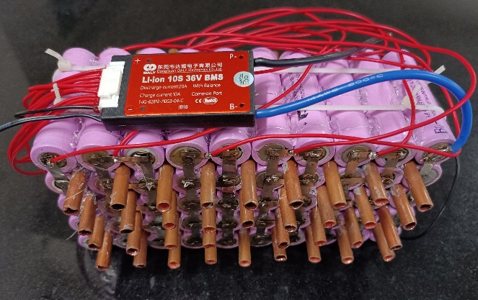
Fig 1 Battery
3.2 Motor
The Brushless DC (BLDC) motor was chosen for the electric bicycle. The BLDC motor, often known as the electronically commutated motor (ECM), is a type of motor. For its power supply, BLDC motors use a direct current (DC) electrical source. The source is given via an integrated inverter, which is also known as a switching power supply. The integrated inverter powers the motor by generating an alternating current (AC) electrical signal.
The BLDC motor was chosen because of its significant advantages over competing motor types. The Brushless Direct Current (BLDC) motor is famous for its lack of dependency on brushes and physical commutators. In compared to brushed motors, this results in less wear and breakage, necessitating replacement. Furthermore, when compared to other motor types, the Brushless Direct Current (BLDC) motor has higher dependability, lifetime, and efficiency. In comparison to brushed motors, BLDC motors produce less noise and electromagnetic interference. Furthermore, the BLDC motor's impressive efficiency and reliability, together with its lightweight construction and availability in a variety of sizes, make it an excellent choice for a wide range of applications, particularly electric bicycles. The BLDC motor's motor component is often a permanent magnet synchronous motor, although it can also be a switching reluctance motor or an induction motor. Although the term "stepper motor" is sometimes used to describe a Brushless DC (BLDC) motor, it is not an accurate description. BLDC motors are designed to operate in a mode in which the rotor repeatedly comes to a halt at a certain angular location or precise angle. The Brushless DC motor is fundamentally similar to the permanent magnet synchronous motor, also known as the AC motor. The stator winding layout in a brushless DC (BLDC) motor is similar to that of an alternating current (AC) motor with a poly-phase arrangement. The stator contains a variable number of permanent magnets, which can have a single pole or many poles. The distinction between BLDC and AC synchronous motors is found in their separate techniques of rotor position detection, which allows for the generation of signals for operating electronic switches. The Hall element is the most common position or pole sensor used in BLDC motors. When compared to other types of motors, the BLDC motor has several advantages. These benefits include:
• Improved speed-to-torque ratio
• Improving dynamic responsiveness.
The capacity of a system or process to achieve peak performance while minimising waste or inefficiencies is referred to as high efficiency.
The primary advantage is that the system has a lengthy operational life. This signifies that the system can run for an extended period of time without having any major problems or malfunctions. Another advantage is that the system operates quietly. This means that the system functions without making any discernible sound or noise, which might be useful in particular places or situations when noise reduction is needed. Finally, the system is capable of reaching great speeds. This means that the system is operational.
Furthermore, the use of BLDC motors has grown in popularity due to the potential for a higher torque-to-motor size ratio.
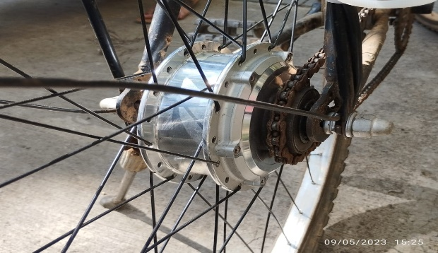
Fig 2 BLDC Motor
3.3 Battery Management System
The main function of BMS involves monitoring and protection of battery pack. A battery pack, which is an assembly of battery cells electrically organised in a row by column matrix configuration, is under the control of a battery management system (BMS), a piece of technology designed to deliver a targeted range of voltage and current for a period against anticipated load scenarios. Electrical protection, which means preventing the battery from being damaged by usage outside of its safe operating area, and thermal protection, which comprises passive and/or active temperature regulation to keep or bring the pack into its SOA (Safe Operating Area), are the two main areas of battery pack protection management.
Key features and functions of a typical battery management system:
- Cell Monitoring: The BMS monitors the individual cells within the battery pack. It measures parameters such as voltage, current, and temperature of each cell to assess their state of charge (SoC), state of health (SoH), and state of safety (SoS). This monitoring helps prevent cell overcharging, over-discharging, or operating outside safe temperature limits.
- Balancing: Battery cells within a pack can exhibit slight variations in their characteristics, leading to imbalances in charge/discharge rates and capacities. The BMS implements cell balancing techniques to redistribute the charge among cells, ensuring optimal performance and prolonging overall battery life. Balancing can be achieved through passive balancing (resistors), active balancing (switching circuits), or hybrid methods.
- SoC and SoH Estimation: The BMS utilizes the measured voltage, current, and temperature data to estimate the state of charge (SoC) and state of health (SoH) of the battery pack. SoC estimation determines the remaining available energy, allowing users to gauge the battery's capacity. SoH estimation evaluates the degradation of the battery over time, providing information on the battery's health and remaining lifespan.
- Temperature Management: The BMS monitors and controls the temperature of the battery pack to prevent overheating or operating outside safe temperature ranges. It can activate cooling or heating systems, such as fans or liquid cooling, to maintain optimal temperature conditions for safe and efficient battery operation.
- Overcurrent and Overvoltage Protection: The BMS includes protection mechanisms to prevent excessive current flow or voltage levels that could damage the battery cells or other connected components. It monitors the current flowing into and out of the battery pack and triggers protective actions, such as disconnecting the load or activating safety measures, to prevent overcurrent or overvoltage situations.
- Short Circuit Protection: The BMS incorporates safeguards against short circuits that can occur due to internal faults or external factors. It can rapidly disconnect the battery from the circuit to prevent excessive current flow and minimize potential damage.
- State-of-Charge Management: The BMS provides accurate information about the battery's state of charge, allowing users to monitor the remaining energy and plan their operations accordingly. This information helps prevent deep discharging or overcharging, which can harm the battery's lifespan and performance.
- Communication and Data Logging: Many BMS implementations include communication interfaces, such as CAN bus or Bluetooth, to facilitate communication between the BMS and external devices. This enables real-time monitoring, remote diagnostics, and firmware updates. Additionally, the BMS can log data related to battery performance, temperature, voltage, and current for later analysis and optimization.
- Safety and Fault Handling: The BMS incorporates safety measures to handle fault conditions, such as abnormal temperature, excessive voltage, or communication failures. It can trigger alarms, cut off power supply, or activate protective mechanisms to prevent hazards and ensure the safety of the battery pack and its surroundings.
The specific features and capabilities of a battery management system may vary depending on the application, battery chemistry, and system requirements. Advanced BMS designs may incorporate additional functions, such as predictive maintenance algorithms, deep learning for improved estimation accuracy, or adaptive control strategies to optimize battery performance based on usage patterns.
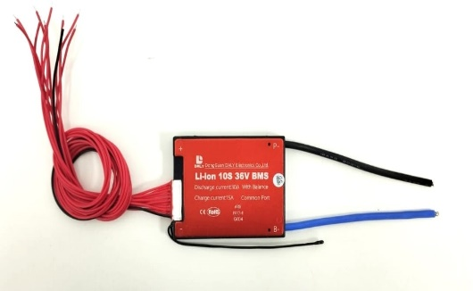
Fig 3 Battery Management System
3.4 Cooling System
It is generally recommended to store e-bicycle batteries at temperatures below 30 degrees Celsius. For optimal storage conditions, it is advised to keep the batteries in a temperature range between 10 and 20 degrees Celsius. Maintaining the battery within this temperature range for as long as possible is advisable in order to ensure its longevity and proper functioning. By following these guidelines, electronic device and appliance users can prevent overheating and ensure the longevity of their batteries.
To prevent overheating copper is used in electronic devices and appliances from a smartphone to a refrigerator. Since copper is a good material for dissipating heat. We have employed copper pipes with a diameter of 6mm can be incorporated between the vacant space of battery cells. These copper pipes are highly conductive and help to dissipate heat away from the batteries. To improve heat transfer efficiency, thermal paste can be applied to the copper pipes, and water can be circulated through them using a 12V DC pump motor. The water is cooled using a Peltier module, which transfers heat away from the water, reducing its temperature. A small circuit for speed control can be added to the pump motor, allowing for better regulation of the water flow rate and cooling performance. In addition, a temperature control module can be incorporated into the system to detect when the temperature exceeds 30 degrees Celsius. When the module detects a temperature above this threshold, it automatically activates the pump motor and Peltier module, allowing for automatic operation of the cooling system.
3.4.1 Cooling Components:
The components of a liquid cooling system for e-bike batteries would be similar to those used in other liquid cooling systems, albeit on a smaller scale. These components could include:
Cooling Plates: Specialized cooling plates or heat sinks are attached to the battery cells in the e-bike. These plates have channels or fins that make direct contact with the battery cells to absorb and transfer heat.
Coolant: A liquid coolant, such as a mixture of water and glycol or other specialized coolants, is used to absorb and carry away heat from the battery cells. The coolant is selected for its heat transfer capabilities and corrosion resistance.
Pump: A small pump is employed to circulate the coolant through the cooling plates. It creates flow and ensures efficient heat transfer from the battery cells.
Radiator: A compact radiator or heat exchanger is used to dissipate the heat absorbed by the coolant. The radiator may have fins to increase surface area for better heat dissipation. Airflow provided by the bike's movement or additional fans can assist in heat dissipation.
Tubing: Flexible tubing connects the cooling plates, pump, and radiator, forming a closed loop for the coolant to flow through.
Control System: A control system with temperature sensors and a control unit may be implemented to monitor the battery temperature and regulate the cooling system's operation accordingly. It can adjust the coolant flow rate or activate additional cooling mechanisms when needed.
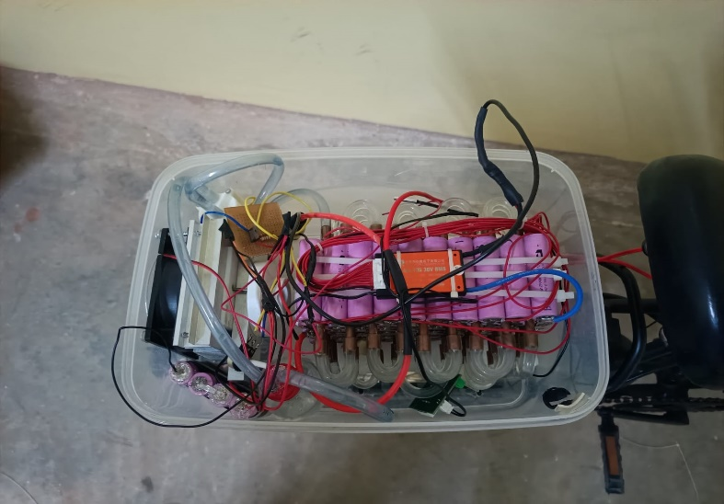
Fig 4 Liquid Cooling System
3.5 Peltier sensor:
A Peltier sensor, also known as a Peltier device or thermoelectric cooler, is a solid-state device that utilizes the Peltier effect to transfer heat. It consists of two dissimilar conductive materials, usually semiconductor materials, sandwiched together with a P-N junction between them. The Peltier effect is based on the principle that when an electric current flows through the junction of two dissimilar conductive materials, heat is either absorbed or released at the junction, depending on the direction of the current.
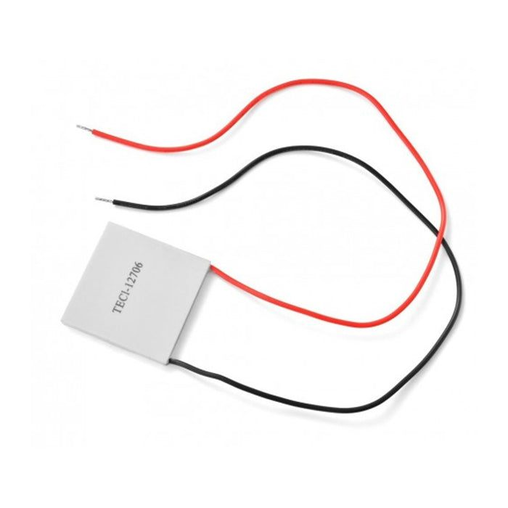
Fig 5 Peltier sensor
The primary function of a Peltier sensor is typically cooling. When an electric current is applied in the proper direction, heat is absorbed from one side of the device, while the other side becomes cooler.
3.6 W1209 Temperature Control Switch:
The W1209 is an incredibly low cost yet highly functional thermostat controller. With this module you can intelligently control power to most types of electrical device based on the temperature sensed by the included high accuracy NTC temperature sensor. Although this module has an embedded microcontroller no programming knowledge is required. 3 tactile switches allow for configuring various parameters including on & off trigger temperatures.
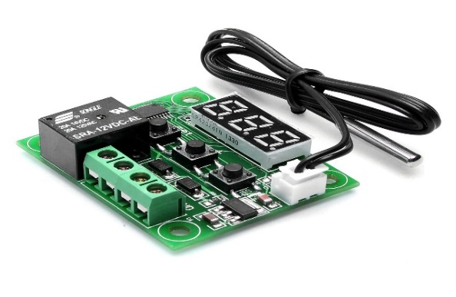
Fig 6 W1209 temperature control switch
3.7 Heat sink:
A heat sink is a passive heat exchanger that transfers the heat generated by the cells of a battery to a fluid medium, often air or a liquid coolant, where it is dissipated away from the battery cells, thereby allowing regulation of the cell temperature
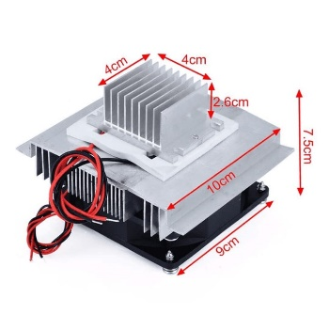
Fig 7 Heat sink
A heatsink in a liquid cooling system for batteries is a component designed to dissipate heat generated during the operation of the batteries. Liquid cooling systems are commonly used in high-performance applications where traditional air cooling may not be sufficient to handle the heat generated by the batteries. In a liquid cooling system for batteries, a heatsink is typically a metal structure, often made of aluminium or copper, that is in direct contact with the batteries or battery modules. The heatsink is designed to efficiently transfer heat from the batteries to the cooling liquid flowing through the system. The heat sink's primary function is to provide a large surface area for heat transfer. It often features fins or other extended surface structures to increase the effective area for heat dissipation. These fins increase the contact area between the heatsink and the cooling liquid, enhancing the heat transfer process.
3.8 Aluminium water block:
The water-cooling block is manufactured with high-quality aluminium alloy and is designed with a 40mm dimension. It has internal extrusions for optimum internal flow.
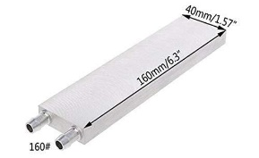
Fig 8 Aluminium water block
3.9 Pump motor:
In a liquid cooling system of batteries, a pump motor is a crucial component responsible for circulating the coolant through the system. It provides the necessary pressure to move the liquid coolant from the reservoir to the water block or heat exchanger, facilitating the transfer of heat away from the components being cooled.
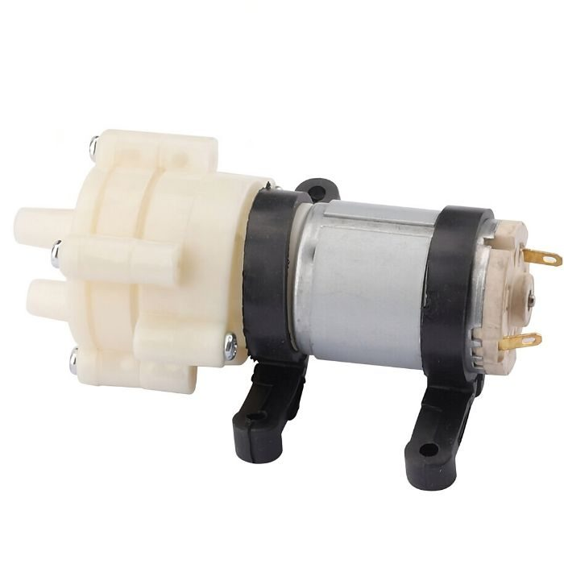
Fig 9 Pump motor
3.10 Controller
The motor controller is also known as the electric e-bike controller or electric speed controller. It is a circuit board in a sealed protective box with several connection wires sticking out. Controller houses inside a circuit board with sensors and firmware. This manages all input and output to control the critical functions of the e-bike. It takes the input from the user and draws power from the battery to allocate it to necessary functions such as turning LCD screen on, throttling, toggling the lights, and powering the motor for pedal assist levels.
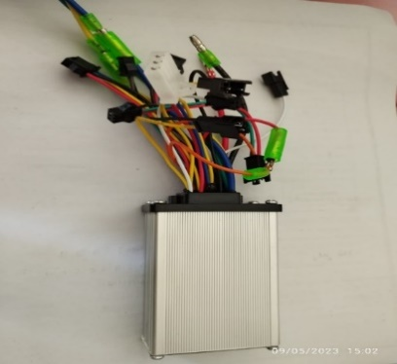
Fig 10 BLDC Controller
3.11 Auxiliary components
Auxiliary components include:
- Throttle
- Pedal assist sensor
- Brakes
- Headlight
- Horn
- Connecting wires
- Throttle: The simplest and most common method of allowing the rider to control how much power they receive from the motor is a throttle. Regardless of how hard they are pedalling; a throttle allows the rider complete control over how much power is coming from the electric motor at any given time.
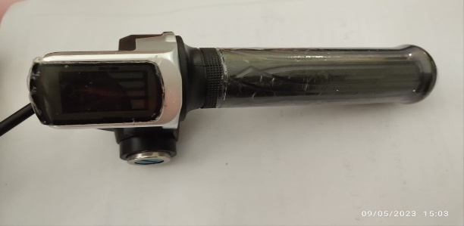
Fig 11 Throttle
- Pedal assist sensor: The pedal assist sensor detects whether the rider is pedalling or not, and the controller outputs the appropriate power based on the input from the pedal assist sensor. A pedal assist sensor, also known as a pedal sensor or PAS, is a device used in electric bicycles (e-bikes) to detect the rider's pedaling input and provide proportional assistance from the electric motor. The pedal assist sensor enables a more intuitive and efficient riding experience by automatically adjusting the level of electric assistance based on the rider's pedaling effort.
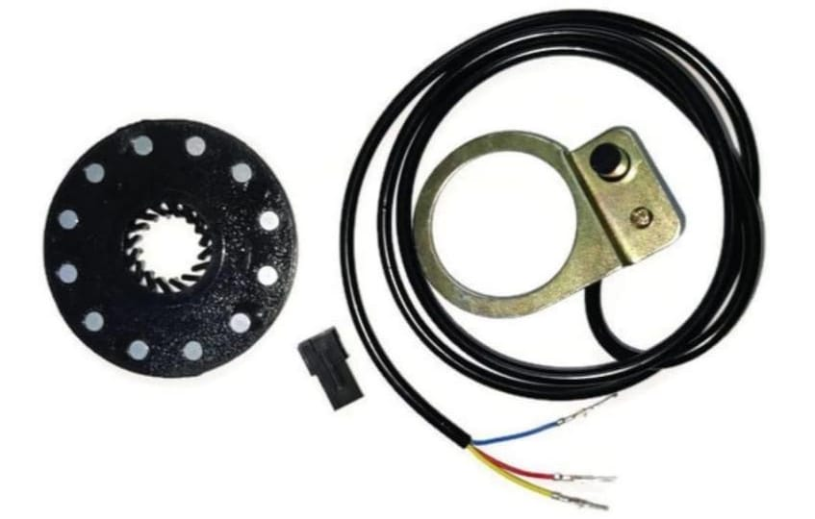
Fig 12 Pedal Assist Sensor
- Brake: Brakes in an e-bicycle play a critical role in ensuring rider safety by allowing them to slow down and stop the bike effectively. While the basic principles of braking in e-bicycles are similar to traditional bicycles, there may be some differences in the braking systems due to the additional weight and higher speeds associated with e-bikes

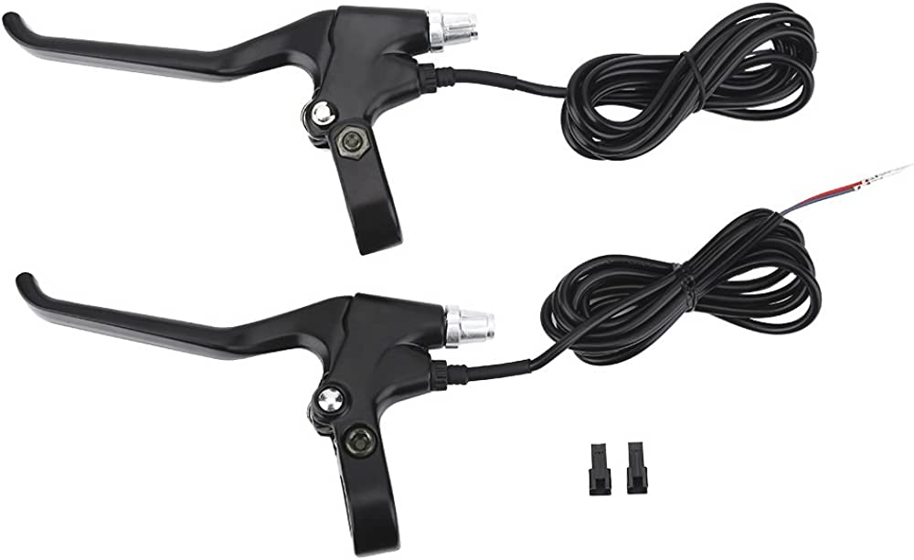
Fig 13 Brake
- Headlight: Headlights on e-bicycles are an important safety feature, especially for riding in low-light conditions or at night. They improve visibility for the rider and make the e-bike more noticeable to other road users.

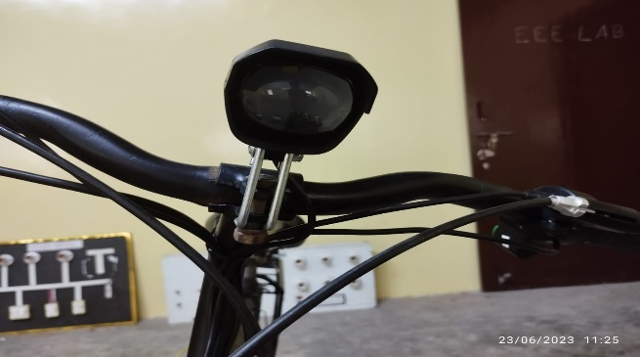
Fig 14 Headlight
- Horn: A horn in an e-bicycle serves as an audible warning device to alert pedestrians, other cyclists, and motorists of your presence, especially in situations where visual communication may be limited or ineffective
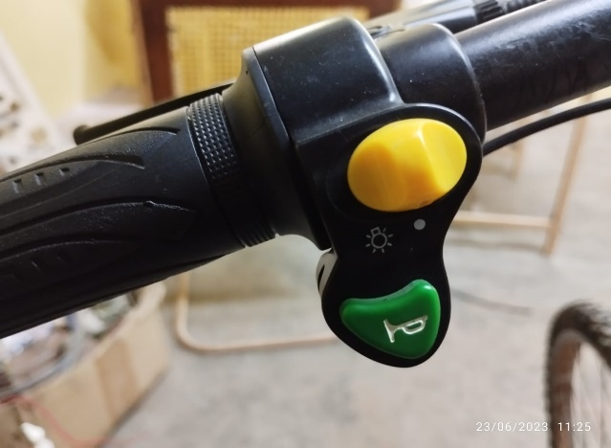
Fig 15 Horn
- Calculations
Motor Power Calculation:
Maximum weight of E bicycle = weight of e-bicycle+ weight of drive
=25+75=100kg
Maximum speed=30km/hr=30*(5/18)=8.33m/s
Ft(total force)= Fr + Fd + Fg
Where, Fr=Rolling force
Fd=Drag force
Fg=Gradient force
Fr=mg*Cr (Cr=Co-efficient of rolling resistance)
=100*9.81*0.004=3.924N
Fd=0.5*ρ*Cd*Af*V^2
Where, ρ= air resistance=1.1664
Cd=coefficient of air resistance=0.5
Af=fontal area= (height*width)-0.5
= (1.527*0.5)-0.5
= 0.26 m^2
V=Velocity=8.33m/s
- Fd=0.5*1.1644*0.5*0.26*((8.33)^2)
=5.249N
- Fg=m*g*sinθ=100*9.81*sin (2)
=34.23 N
- Ft=Fr+Fd+Fg= 3.924+5.249+34.23= 43.403 N
- Power Required =Total Force * Velocity
= 43.403 * 8.33
= 361.546W
So standard power selected for hub motor is 350 W.
So, motor selected is 350W 36 V.
Battery Requirement:
- To run the 350W 36 V motor for 1 hour
350w*1hr=350W hour
- When 80% efficiency is considered
350/0.8 = 437.5W hour
- Converting W hour into ampere hour
P= Voltage * current
W hour = voltage * ampere hour
Ampere hour = 437.5/36
= 12.152 Ah
So, battery selected is 36V 12.5 Ah.
Battery Pack Design:
- Battery selected is 36V,12.5Ah
- Each cell capacity=3.6V and 2500mAh
12.5Ah=12500mAh
- To calculate number of cells to be connected in parallel:
Total cell capacity/each cell current capacity=12500/2500=5
Therefore no. of cells to be connected in parallel are 5 (5P)
- To calculate no. of cells to be connected in series:
Total cell voltage/each cell voltage=36/3.6=10S
Therefore 10S, 5P connection.
- Working of E-Bicycle
The power to the controller is supplied from the 36V, 12.5AH Li-ion Battery, then the power is channelled to the motor depending on sensor and user inputs. Controller monitors the speed, acceleration, motor power, battery voltage and then it calculates the error and helps in obtaining the desired output. Additionally, it gathers data on how much assistance we receive from the pedals when riding the cycle.

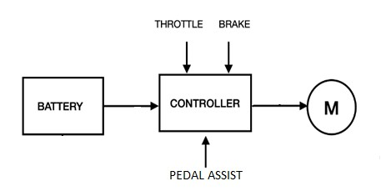
Fig 16 Block Diagram of the Bicycle
5.1 Liquid Cooling System in Batteries
A liquid cooling system in batteries refers to a mechanism that uses a liquid, typically a coolant or thermal management fluid, to regulate the temperature of batteries. This technology is commonly employed in high-performance or high-capacity battery systems, such as those found in electric vehicles (EVs) or large-scale energy storage applications. The purpose of a liquid cooling system in batteries is to maintain optimal operating temperatures for the battery cells. Batteries generate heat during charge and discharge cycles, and excessive heat can degrade their performance, shorten their lifespan, or even lead to safety issues. By utilizing a liquid cooling system, the heat produced by the batteries can be efficiently transferred away from the cells, ensuring that they remain within a suitable temperature range.
The liquid cooling system typically consists of a network of channels or tubes embedded within or around the battery cells. Coolant fluid flows through these channels, absorbing heat from the cells and carrying it away to be dissipated through a heat exchanger or radiator. The coolant fluid can be a dedicated coolant, such as a mixture of water and antifreeze, or specialized thermal management fluids designed to enhance heat transfer and withstand high temperatures. Liquid cooling systems offer several advantages over other cooling methods, such as air cooling. They provide more effective heat dissipation, enabling better thermal management and temperature control. This can result in improved battery performance, increased energy efficiency, and extended battery life. Liquid cooling can also help prevent temperature gradients within the battery pack, which can lead to cell imbalances and reduced overall capacity.
Overall, liquid cooling systems in batteries are a valuable technology for managing the thermal characteristics of high-performance battery systems, allowing for optimized performance, longevity, and safety. They are particularly prevalent in applications where battery heat dissipation is critical, such as electric vehicles or grid-scale energy storage systems.
5.1.1 Cooling Components:
The components of a liquid cooling system for e-bike batteries would be similar to those used in other liquid cooling systems, albeit on a smaller scale. These components could include:
- Cooling Plates: Specialized cooling plates or heat sinks are attached to the battery cells in the e-bike. These plates have channels or fins that make direct contact with the battery cells to absorb and transfer heat.
- Coolant: A liquid coolant, such as a mixture of water and glycol or other specialized coolants, is used to absorb and carry away heat from the battery cells. The coolant is selected for its heat transfer capabilities and corrosion resistance.
- Pump: A small pump is employed to circulate the coolant through the cooling plates. It creates flow and ensures efficient heat transfer from the battery cells.
- Radiator: A compact radiator or heat exchanger is used to dissipate the heat absorbed by the coolant. The radiator may have fins to increase surface area for better heat dissipation. Airflow provided by the bike's movement or additional fans can assist in heat dissipation.
- Tubing: Flexible tubing connects the cooling plates, pump, and radiator, forming a closed loop for the coolant to flow through.
- Control System: A control system with temperature sensors and a control unit may be implemented to monitor the battery temperature and regulate the cooling system's operation accordingly. It can adjust the coolant flow rate or activate additional cooling mechanisms when needed.
It's important to note that the implementation of a liquid cooling system for e-bike batteries may depend on factors such as the battery capacity, power output, and intended usage of the e-bike. In some cases, air cooling or passive cooling solutions may be sufficient for smaller e-bikes with lower power requirements. Manufacturers will determine the most appropriate cooling method based on their design considerations and performance goals. Proper design, installation, and maintenance of the liquid cooling system are essential for optimal cooling performance and battery longevity.
- Results and Discussions
The battery pack with the cooling system, controller and BMS was assembled in the cycle with the BLDC Hub motor. The e-bicycle designed with pedal assist achieved 40Km/h speed. The performance of EV’s is sensitive to the operating temperature of the cell in the battery pack. Lithium-ion batteries need to be operated within 25-40 degree celsius for maximum performance and battery life. Among the thermal management systems available, the liquid cooling system is more effective in extracting the heat generated in the cell and creating an optimum operating environment for the battery, hence the battery liquid cooling system is designed and Temperature management is achieved during fast charging and when demand on battery is high. With the full charged battery, the cycle run almost 30 Km/h on full throttle.
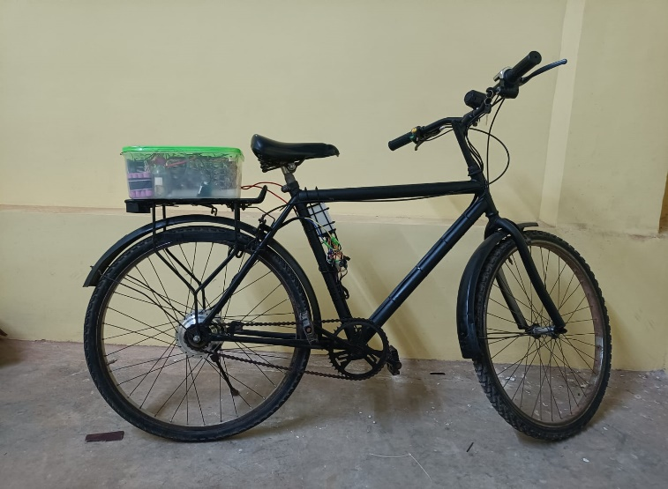
Fig 18 E-Bicycle
- Conclusion
In this work a detailed description of design and fabrication of retrofit e-bicycle has been presented, Battery cooling system has been successfully tested in the lab. Calculations for the specific motor and battery selection has been done. Battery pack is designed and tested according to the obtained calculations. The experimental data show an excellent performance of the developed e-bicycle with the 36V, 12.5 AH Li-ion battery 30 Km/hr speed is achieved, whereas with pedal assist 40 Km/h speed can be achieved. It can be concluded that the developed e-bicycle can be helpful to the people to reduce the daily expenses for travelling and to avoid the traffic which the face on the daily basis.
References
- L. Stilo, H. Lugo, D. S. Velandia, P. P. Conway and A. A. West, "Personalised Controller Strategies for Next Generation Intelligent Adaptive Electric Bicycles," in IEEE Transactions on Intelligent Transportation Systems, vol. 22, no. 12, pp. 7814-7825, Dec. 2021, doi: 10.1109/TITS.2020.3009400.
- M. Khalid, S. S. Sheikh, A. K. Janjua and H. A. Khalid, "Performance Validation of Electric Vehicle’s Battery Management System under state of charge estimation for lithium-ion Battery," 2018 International Conference on Computing, Electronic and Electrical Engineering (ICE)
- Zong-You Hou, Pang-Yen Lou and C. -C. Wang, "State of charge, state of health, and state of function monitoring for EV BMS," 2017 IEEE International Conference on Consumer Electronics (ICCE), Las Vegas, NV, USA, 2017, pp. 310-311, doi: 10.1109/ICCE.2017.7889332.
- L. H. Saw, A. A. O. Tay and L. W. Zhang, "Thermal management of lithium-ion battery pack with liquid cooling," 2015 31st Thermal Measurement, Modeling & Management Symposium (SEMI-THERM), San Jose, CA, USA, 2015, pp. 298-302, doi: 10.1109/SEMI-THERM.2015.7100176.
- S. S. Rauth and B. Samanta, "Comparative Analysis of IM/BLDC/PMSM Drives for Electric Vehicle Traction Applications Using ANN-Based FOC," 2020 IEEE 17th India Council International Conference (INDICON), New Delhi, India, 2020, pp. 1-8, doi: 10.1109/INDICON49873.2020.9342237.
- K. F. I. Faruque, N. NaWhin, M. F. Bhuiyan, M. R. Uddin, M. Hasan and K. M. Salim, "Design and Development of BLDC controller and its Implementation on E-Bicycle," 2018 International Conference on Recent Innovations in Electrical, Electronics & Communication Engineering (ICRIEECE), Bhubaneswar, India, 2018, pp. 1461-1465, doi: 10.1109/ICRIEECE44171.2018.9008597.
- S. S. Rauth and B. Samanta, "Comparative Analysis of IM/BLDC/PMSM Drives for Electric Vehicle Traction Applications Using ANN-Based FOC," 2020 IEEE 17th India Council International Conference (INDICON), New Delhi, India, 2020, pp. 1-8, doi: 10.1109/INDICON49873.2020.9342237.

