Intelligent street lighting and parking system for cities

Bhavan Kumar *, Dayalan J**, Dr. Venkatesha Raju***, Dr. Jagadish H Godihal****

Department of Civil Engineering, Presidency University

Abstract- Intelligent urban street lighting and parking systems play a key role in smart city strategies. Street lighting and other outdoor lighting equipment serve as the backbone of networks in which services are provided for the benefit of citizens, businesses and city governments. Smart lighting products help cities to monitor the environmental problems, enhance public and road safety, enhance connectivity as WiFi hotspots, and facilitate location-based services such as smart parking and smart navigation.

Index Terms- LDR (Light Dependent Resistor), PIR Sensor, Ultra sonic sensor.
- Introduction
The current manual system in which the street lights are turned on in the evening well before the sun sets and turn them switched off in the next morning only after bright light is received outside. Actually these street lights are to be turned ON only when there is complete darkness. Therefore some quantity of energy is getting wasted by adopting this manual system. Issues such as traffic congestion, restricted car parking facilities, safety of road etc. The major disadvantages of the current manual system of operation of street lights are:
- High Energy Consumption.
- More expenses.
- Manpower dependent.
Hence it is clearly evident that there is a need to change to smart street lighting system that minimizes waste of energy and helps to save energy.
Traditional parking methods and systems have always been cumbersome, tedious and time-intensive. This can cause severe traffic congestion problems and disorientation, affecting the driver’s attention and causing chaos in the city. This is a simple parking technique, but population growth and urbanization are making it obsolete and unsatisfactory. Therefore, there is a need to create intelligent parking systems that alleviate traditional parking problems.
- General-description

The current technology, the facility managers can able to remotely control the operation of street lights while recording track of consumption of electrical energy in the street lamps and also in the driving circuits. This current technology uses combination of cameras and sensors. Implement of this current technology in standard streetlights, these devices can detect the motion and enables dynamic lighting and dimming. Smart parking is a system that allows drivers to easily identify parking spots through their mobile phone application or through website without any physical effort or getting out of their vehicles for parking.
- PROPOSED SYSTEM
The intelligent irrigation system aims at:
- To develop a prototype with automated and intelligent systems to eliminate the manual operation of the street lighting and parking system.
- To provide a solution to conserve energy.
- EXPERIMENTAL SETUP

Working Principle:
- The basic architecture system of the smart street light system consists of PIR set of sensors, LDR, Arduino microcontroller. LDRs are basically light dependent devices and the resistance of LDRs decreases when exposed to light and increases when it gets dark. If a light dependent resistor is stored in the dark environment, its resistance will be more. Vehicles passing in front of the roadside lights are detected by a PIR sensor, and the roadside lights automatically turns on at night and off at other times.
- In The Smart Parking System, we are using a Ultrasonic sensor to find the distance, based on the distance we can know whether the Parking slot is empty or full. In the mobile phone application we can get the information

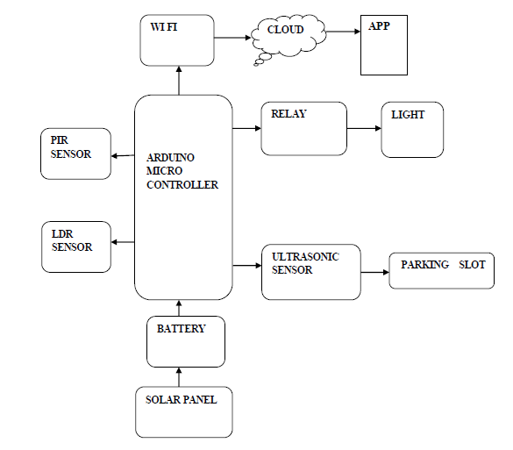
Figure 1: Block diagram

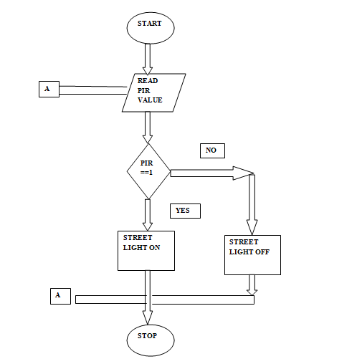
Figure 2: Power flow diagram

Operation method: The operation method includes an automatic street light system with sensors and wireless components that are used to implement this automatic system. The LDR (Light Dependent Resistor) are used to detect the environmental condition. LDR allows the system to distinguish between bright and dark environments. If the surrounding is dark, the system permits to turn on the street lights. The same intelligent street lights are switch off automatically by the system when the environment becomes bright. The LDR process is used to detect optical error detection and transmit to the control room using the ESP8266 WiFi module. Here, the street light brightness is controlled by a controller. When the PIR detects vehicle movement, the street light will turn on brightly or turn on normally. Otherwise, the street lamps will glow equally dimly. Ultrasonic sensor is used for distance measurement. If the parking slot is less than 10cm then it means the parking slot is full, if it is more than 10 cm then it is vacant/empty.

Coding for Smart Street Lighting System:

#define LAMP 8 //
#define PIR 9 //
void setup() {
pinMode(LAMP, OUTPUT);
pinMode(PIR,INPUT);
Serial.begin(9600);
}
void loop() {
int value_ldr = analogRead(A4);
int value_pir = digitalRead(PIR);
Serial.println(value_ldr);
Serial.println(value_pir);
if((300<value_ldr) && ( value_pir==HIGH) ){
digitalWrite(LAMP,1); // Turn ON the light
delay(6000);
}

We are connecting a digital pin 8 to the Relay. Pin 9 to PIR Sensor from the Arduino. Void Setup Void loop Continuous execution takes place. We are initializing a LDR value. LDR value will be read from Analog read of 4th pin of Arduino UNO. LDR is connected to the 4th pin of the Analog. We are initializing PIR value that is read from the digital PIR pin. After reading it will display the LDR value and PIR value. If both PIR value and LDR value is high then the lamp will be turned on. It means the Relay will turn on the streetlight or else it will turn off.
Coding for Smart Parking System:
#define BLYNK_PRINT Serial
#include <ESP8299WiFi.h>
#include <BlynkSimpleEsp8299.h>
#define echoPin D2
#define trigPin D3
// defines variables
long duration; // variable for the duration of sound wave travel
int distance; // variable for the distance measurement
// Auth Token is required in the Blynk App.
// Look for the Project Settings (nut icon).
char auth [] = "OdSLS9X9WqpRbnVVivvoBPOVvvAvrHmi";

// Your WiFi credentials.
// Set password to "" for open networks.
char ssid[] = “MI A5";
char pass[] = “12345678";
void setup()
{
// Debug console
Serial.begin(9600);
pinMode(trigPin, OUTPUT); // Sets the trigPin as an OUTPUT
pinMode(echoPin, INPUT); // Sets the echoPin as an INPUT
Blynk.begin (auth, ssid, pass);
}

void loop()
{
Blynk.run();
Digital Write(trigPin, LOW);
delayMicroseconds(2);
digital Write(trigPin, HIGH);
delay Microseconds(10);
digital Write(trigPin, LOW);
duration = pulseIn (echoPin, HIGH);
distance = duration * 0.034 / 2;
Blynk.virtualWrite(V0, distance);
if((distance>0) && (distance<10))
{
Blynk.virtualWrite(V1,"Parking slot is Full");
}
else{
Blynk.virtualWrite(V1,"Parking slot is Empty");
}

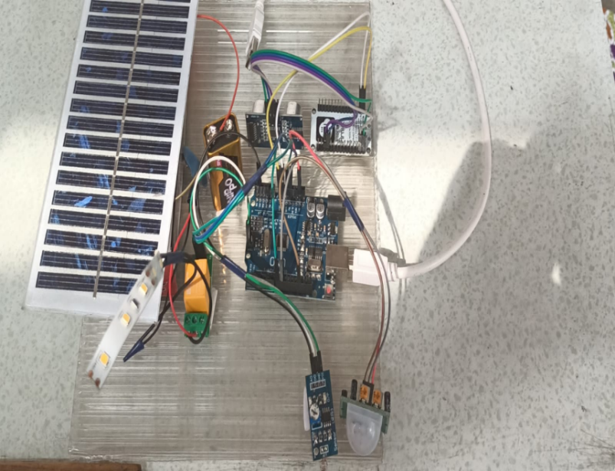

Plate 1: Experimental Setup

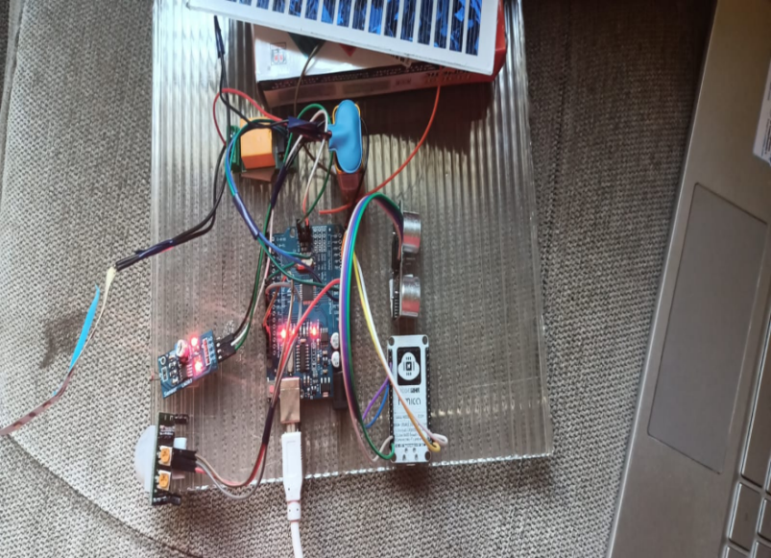

Plate 2: Smart Street Lighting turned off.

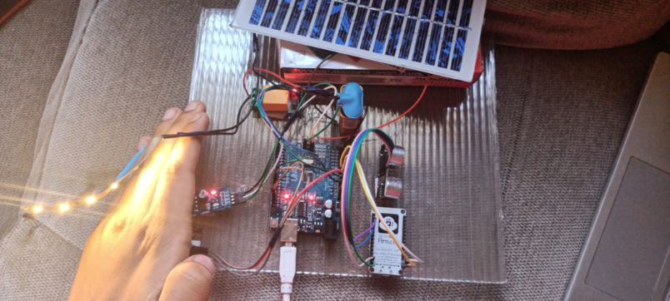

Plate 3: Smart Street Lighting turned on.

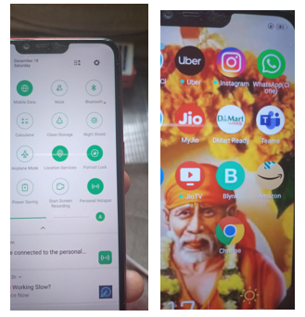

Plate4: Installation of personal hotspot and blynk application

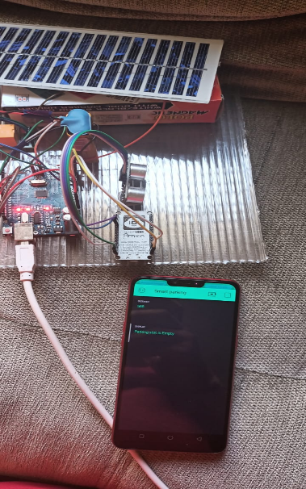

Plate5: Parking Slot is Empty

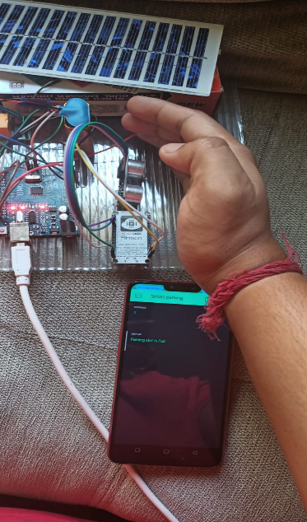

Plate 6: Parking Slot is Empty

- RESULTS AND DISCUSSIONS

The main aim of this innovative work is to reduce the side effects of popular street lighting systems and find solutions. to regain power. The first task in this project is to construct the statement. A prototype of this system was implemented and it's completely normal. And it simply proves to be smart effective. The current work meets all practical constraints. If this were achieved on a large system. Intelligent System shows a fully functioning prototype assembly of the “IoT-based Smart Smart Lighting System” towards a smart city”. This prototype system builds an LDR, current sensor, AT89S52 microcontroller, IR sensor, GSM module, relay and WiFi module. One can get the actual time data anytime and anywhere through the Internet. The system is equipped with obstacle type of prototype with on-road detection by IR sensors.
The sensor catches the obstacle and switch on the light. Hence this system of smart light is classified as the smart system. It automatically turns on when it senses an impact. LDR status is also can be checked.
- Conclusion
Smart and Intelligent street lighting, parking system for smart cities leads to several advantages:
- Reduced Cost of Maintenance
- Reduced light pollution.
- Wireless Communication.
- Energy Saving.
- downsizing.
- Smart and Intelligent parking

References
- “Archana. G, Aishwarya, Anitha, Intelligent street light system, The international journal of recent advances in engineering & technology”; vol-3, issue-4, 2015.
- “Akshaybalachandran, Parthasarathi, Surya and Shriram k., Vasudevan” “An innovation in the field of street lighting system with cost and energy efficiency”, Indian journal of science and technology, vol-8, Agust 2015
- “Deepanshu, Biju M Thomas, Nitin kumar” “Sensor based automatic street lighting system”, IJESR review volume-2, issue-2 april- 2015
- “Isah abdul azeez, watson”, “oshomah abdula ibraimah; alexander “Automatic street light control system”; International journal of emerging technology & advanced en-gineering, volume 5, Issue 3, march 2015
- “Kapse sagarsudhakar”; abhaleamol anil: kudakechetanashok; shirsath shravan bhaskar; “automatic street light control system” volume 3, “international journal of emerging technology and ad-vanced engineering” issue 5, may 2013

.

