DFT study of the interaction between Acetylsalicylic acid and N,N-Dimethylformamide
ªJyotshna Saikia*, ^{a,b}Th. Gomti Devi
ª Department of Physics
North Eastern Regional Institute of Science and Technology, Arunachal Pradesh-791109, India
^{b} Department of Physics
Manipur University, Canchipur-795003, Manipur, India
*Corresponding author: E-mail: jyotshnasaikianlp@gmail.com
Abstract
The complexation of Acetylsalicylic acid and N,N-Dimethylformamide is studied under Density Functional Theory (DFT) using B3LYP functional and 6-31G(d,p) basis set. The intermolecular hydrogen bonds are formed between the two monomers, validated by NBO study. The reactive regions of the complex are studied by means of MEP plot. The HOMO-LUMO gap of the complex bespeaks its bioactive nature.

Keywords – DFT, NBO, MEP, HOMO-LUMO

- Introduction
Acetylsalicylic acid, commonly known as Aspirin, is a nonsteroidal anti-inflammatory drug (NSAID) that exhibits a broad spectrum of pharmaceutical activities such as antipyretic, analgesic, and anti-inflammatory properties. The drug shows its preventive effect against several human cancers including breast cancer, gastric cancer, and colon cancer [1]. Cancer is one of the leading causes of death around the globe. Multiple lines of evidence show that reactive oxygen species (ROS) is one of the major contributors towards the growth, progression, and regeneration of cancer cells. A high concentration of ROS level promotes metastatic tumor progression [2-4]. N,N-Dimethylformamide (DMF), also known as Fumaric acid, is a simple aprotic polar molecule that significantly inhibited tumor metastasis by reducing reactive oxygen species (ROS) production in tumor-associated macrophages [5]. In the current article, we focus on the study of the Aspirin-DMF interaction using DFT to enlighten the reactivity of the new potent drug combination for future pharmaceutical applications.
- Computational Methods
The computational calculations are accomplished by B3LYP/6-31G(d,p) level under DFT [6]. GaussView 6.0 tool is used for the visualization of the geometries of the molecules. Structural optimization is carried out using Gaussian 09W software. MEP plot and HOMO-LUMO calculations are performed under the same computational level.
- Results and discussions
  - Molecular geometry
The optimized structure of Aspirin+DMF having SCF energy -897.25 Hartree is presented in Fig.1. In Aspirin+DMF, O2−H21∙∙∙O22 (1.64 Å) and C11=O3∙∙∙H33 (2.31 Å) hydrogen bonds are observed to be formed between the carboxyl group of Aspirin and the carbonyl group of DMF, which leads to the structural modulation of the monomers under complexation [7]. The O2−H21, O3=C11, C6−C11, O22=C26 bonds are significantly elongated by 0.03, 0.02, 0.01, 0.01, 0.01 Å, respectively, whereas, O2−C11, O1−C12 bonds are contracted by 0.02 and 0.01 Å, respectively than that of the individual states.
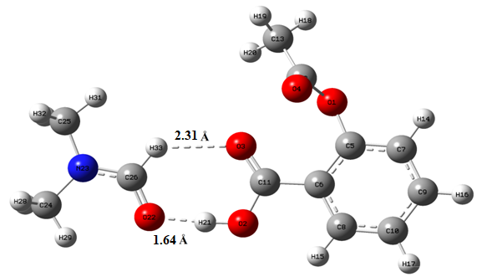

Fig.1. Optimized structure of Aspirin+DMF.
  - Natural Bond Orbital (NBO) analysis
The intermolecular hydrogen bond formation between Aspirin and DMF is confirmed by NBO study that demonstrates the electron density transfer from n₂(O22) $→$ σ*(O2−H21) and n₂(O3) $→$ σ*(C22−H33) orbital leading stabilization of the system with energy values of 15.93 kcal/mol and 0.45 kcal/mol, respectively. The highest stabilization of energy 114.46 kcal/mol is obtained due to the interaction between the donor orbital π*(C5−C6) and the acceptor orbital π*(O3−C11).
  - Molecular Electrostatic Potential (MEP) analysis
MEP surface of Aspirin+DMF generated using DFT is portrayed in Fig. 2. The existence of both electropositive and electronegative potential areas indicated by blue and red colour, respectively demonstrate the reactive nature of the complex [8]. The blue regions are found covering the hydrogen atoms attached with nitrogen atoms and red regions are noticed over the oxygen atoms.
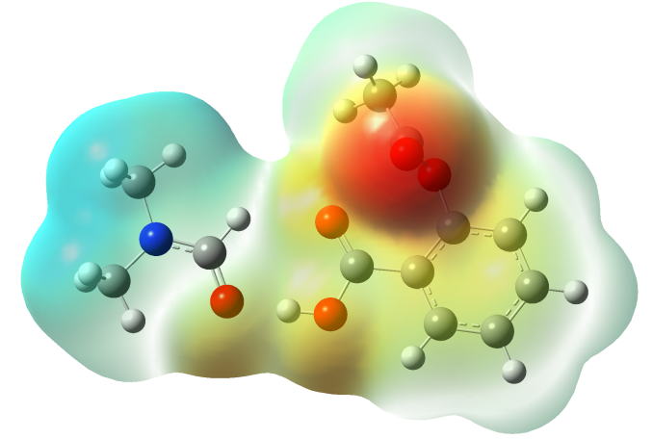
Fig.2. MEP surface of Aspirin+DMF.
  - Frontier molecular orbitals (FMOs) analysis
FMO energy gap is an important descriptor to predict the bioactivity of a complex. Highest occupied and lowest unoccupied molecular orbitals (HOMO and LUMO) collectively named as FMOs are used for the computation of several quantum chemical parameters that describe the stability as well as reactivity of the molecule. The HOMO and LUMO orbitals of Aspirin+DMF are shown in Fig. 3. E_{LUMO}−E_{HOMO} is found as 5.59 eV and the hardness is computed as 2.79 eV, which is comparable to the reported bioactive molecules [9, 10]. Table 1 shows the calculated quantum chemical parameters of Aspirin+DMF.
E_{LUMO} –E_{HOMO} =5.59 eV

E_{HOMO} = −6.59 eV
E_{LUMO} = −1.00 eV
Fig.3. FMOs of Aspirin+DMF.

Table 1 - Quantum chemical parameters of Aspirin+DMF.
Parameters | Carmustine + Melatonin
E_{LUMO} | – 1.00 (eV)
E_{HOMO} | – 6.59 (eV)
E_{LUMO}– E_{HOMO} | 5.59 (eV)
Hardness (η) =1/2(E_{LUMO}–E_{HOMO}) | 2.79 (eV)
Chemical potential (µ) =1/2(E_{HOMO}+E_{LUMO}) | 3.79 (eV)
IE = – E_{HOMO} | 6.59 (eV)
EA = – E_{LUMO} | 1.00 (eV)
Global electro-philicity index (ω)=μ²/2η | 2.57

- Conclusion
Geometrical optimization of Aspirin+DMF is done using DFT-B3LYP/6-31G(d,p) calculations that shows the presence of O2−H21∙∙∙O22 (1.64 Å) and C11=O3∙∙∙H33 (2.31 Å) hydrogen bonds in the complex, which is further confirmed by NBO analysis. The stabilization energy associated with O2−H21∙∙∙O22 bond is higher as compared to the C11=O3∙∙∙H33 bond indicating the more intense interaction. MEP plot shows the reactive areas in the complex. The FMO gap of the complex is calculated as 5.59 eV representing its bioactive nature.
Acknowledgement
The author (J. Saikia) is thankful to DST-INSPIRE, India, to provide financial assistance during the research work (grant number DST/INSPIRE Fellowship/2019/IF190217).
References
[1] | Liu J, Zheng F, Yang M, Wu X, Liu A. Effect of aspirin use on survival benefits of breast cancer patients: A meta-analysis. Medicine (Baltimore). 100(33) e26870 (2021).
[2] | Aggarwal V, Tuli HS, Varol A, Thakral F, Yerer MB, Sak K, Varol M, Jain A, Khan MA, Sethi G. Role of Reactive Oxygen Species in Cancer Progression: Molecular Mechanisms and Recent Advancements. Biomolecules. 9(11) 735 (2019).
[3] | Liou GY, Storz P. Reactive oxygen species in cancer. Free Radic Res. 44(5) 479-96 (2010).
[4] | Perillo, B., Di Donato, M., Pezone, A. et al. ROS in cancer therapy: the bright side of the moon. Exp Mol Med. 52, 192–203 (2020).
[5] | Li Y, Jia Y, Xu Y and Li K, DMF Activates NRF2 toInhibit the Pro-Invasion Ability of TAMs in Breast Cancer. Front. Oncol. 11 706448 (2021).
[6] | Saikia J, Borah B, Devi T.G., Study of interacting mechanism of amino acid and Alzheimer's drug using vibrational techniques and computational method, J. Mol. Struct. 1227 129664 (2021).
[7] | Saikia J, Devi T.G., Karlo T., Study of the molecular interaction between hormone and anti-cancer drug using DFT and vibrational spectroscopic methods, J. Mol. Struct. 1250 131889 (2022).
[8] | Borah M.M., Devi T.G., The vibrational spectroscopic studies and molecular property analysis of L-Phenylalanine using quantum chemical method, J. Mol. Struct. 1136 182–195 (2017).
[9] | Borah B., Devi T.G., Molecular property analysis of the interacting state of L-Threonine and Metformin: An experimental and computational approach, J. Mol. Struct. 1221 128819 (2020).
[10] | Saral A, Sudha P, Muthu S., Irfan A., Computational, spectroscopic and molecular docking investigation on a bioactive anti-cancer drug: 2-Methyl-8-nitro quinoline. J. Mol. Struct. 1247 131414 (2022).

