MRI-LINEAR ACCELERATOR (MR-LINAC)
Mr. Mayank pal singh¹, Mr. Raushan kumar², Ms. Mamta verma³, Mr. Neeraj kumar sah⁴ ,khush jain⁵
¹M.Sc.Research fellow, Department of radiology and imaging techniques, college of paramedical sciences, Teerthanker Mahaveer University, Moradabad, India.
²Assistant professor, Department of radiology and imaging techniques, college of paramedical sciences, Teerthanker Mahaveer University, Moradabad ,India.
³Assistant professor, Department of radiology and imaging techniques, college of paramedical sciences, Teerthanker Mahaveer University, Moradabad ,India.
⁴Assistant professor, Department of radiology and imaging techniques, college of paramedical sciences, Teerthanker Mahaveer University, Moradabad, India.
⁵M.Sc.Research fellow, Department of radiology and imaging techniques, college of paramedical sciences, Teerthanker Mahaveer University, Moradabad, India.

Introduction
Radiation therapy (RT) delivery & magnetic resonance imaging (MRI) imaging are now combined in hybrid systems. Four distinct photon MR-guided radiotherapy (MRgRT) systems with various magnetic field intensities, as well as beam orientations, have been developed. The MR Imaging Guided Linear Accelerator (MRI-LINAC) uses magnetic resonance imaging, combined together with radiotherapy to cure tumors throughout the human body, with specific advantages for soft-tissue tumors. The MRI-LINAC's radiation delivery system is completely integrated with the MRI.
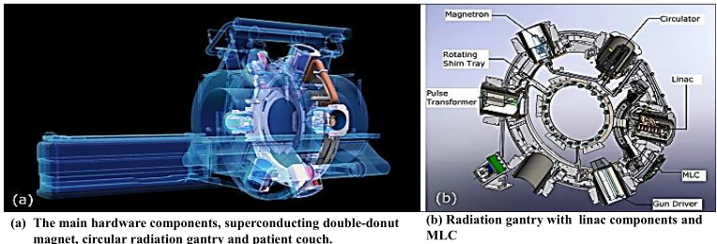
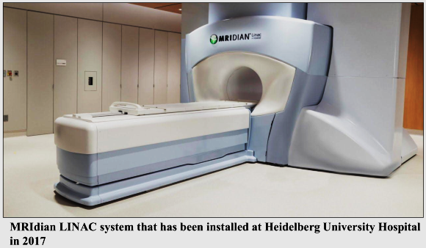
MRIdian linac system (system design)
The bore
Within the allowed bore limits, the system's bore is 70 cm wide. The therapeutic beam is sent with respect to the stationary field of magnets. thanks to placement of the spherical gantry arrangement carrying all linac elements at the space between the two magnet sections.
0.35T split superconducting magnet
A 0.35 T separated superconducting magnet has a 28 cm gap between its two magnet surfaces. Both parts are mechanically as well as thermally linked for stability purposes.
Linac and MLC
The linac operates in the S-band and generates a 600 cGy/min, 90 cm source-to-axis distance (SAD), 6 MV FFF (flattening filter free) photon beam. The treatment beam is shaped without the need of additional jaws using a two stack, twice-focus multi-leaf collimator (MLC), whose virtual focusing point is fifteen millimeters beyond the linac's focusing spot. MLC is made up of 138 tungsten alloy leaves overall, which are split between the two stacks. The physical leaf height of each stack is 5.5 cm, making the overall MLC leaf height 11 cm. There are no tongues or grooves on the sides of the leaves.
Gradient coil
Due to the gradient coil being divided and narrowing to a connecting fibreglass segment that is 5 mm wide at the magnet gap, the treatment beam is only exposed to a minimal quantity of attenuating material.With a gradient power of 18 mT m-1 and a slew rate of 200 T/m/s, the gradient system is visible.

Six spaces for protection (so-called buckets)
Since the linear accelerator wasn't able to work properly under the influence of a stationary magnetic field, six shielding compartments, also known as buckets, are positioned within the gantry as well as house the linac as well as linac components like the magnetron.
Magnetron
A microwave-powered electron tube that accelerates electrons. Preferred for linacs with lower electron energy, between 4 and 6 MeV.
Ferromagnetic cylinders
The interior of each compartment is well protected from the magnetic field by the presence of several concentric ferromagnetic cylinders.
Room lasers
A simulated isocenter exterior the passageway, which is typically 155 cm distant from the isocenter of the treatment, is projected by room lasers in the system.
Patient couch
All three dimensions allow for movement of the patient on the couch. The range of potential couch heights is twenty centimetres from the isocenter to the lowermost point, and the range of potential lateral movements is dependent on the actual couch height.
Surface receive coils & full-body RF transmit coils
Coils are received by the patient's surface in the patient's front and back. The transparent phased array receive coils, which have 2 x 5 channels (anterior as well as rear) for the head and neck with 2 x 6 channels for the lower body, are implanted in low-density foam.
Pulse sequence
A T2/T1-weighted contrast is produced by a balanced steady-state free precession (bSSFP) sequence known as the True Fast Imaging using Steady State Precession (TRUFI) sequence. For volumetric imaging, the person using it can choose between predetermined area of visions (FOVs) with slice thicknesses of 1.5 mm and 3 mm and an in-plane resolution of 1.5 mm x 1.5 mm. 2-dimensional cine MR images can be simultaneously acquired in a single sagittal direction at a rate of 4 shots per second or in 3 sagittal levels at a rate of two frames per second while the patient is receiving therapy. Additional pulse sequences can be employed for quality assurance (QA) and research modes.

FEATURE | MRIDIAN | UNITY
Construction | Split magnet design | one-magnet construction
Imaging | based on TRUFI sequence imaging | There are various imaging sequences available
Gating | Real time tracking and automatic gating | Real-time monitoring without gating automation
Treatment | A maximum gantry rotational speed of 0.5 rpm | Gantry rotation maximum speed of 6.0 rpm
Table-01Comparison of the platforms for MRIdian & Unity MRI-linac radiation system
Treatment planning and delivery
The MRIdian uses coplanar static IMRT fields and has a 650MU/min dosage rate for radiation delivery. With no collimator rotation, the gantry rotates at a speed of 0.5 rpm. The dose is quickly calculated using a Monte Carlo technique, with the option to account for a uniform magnetic field. The primary visuals for planning therapy can be obtained from MR simulation scans as well as computed tomography (CT) scans.

Existing MRI-linac systems
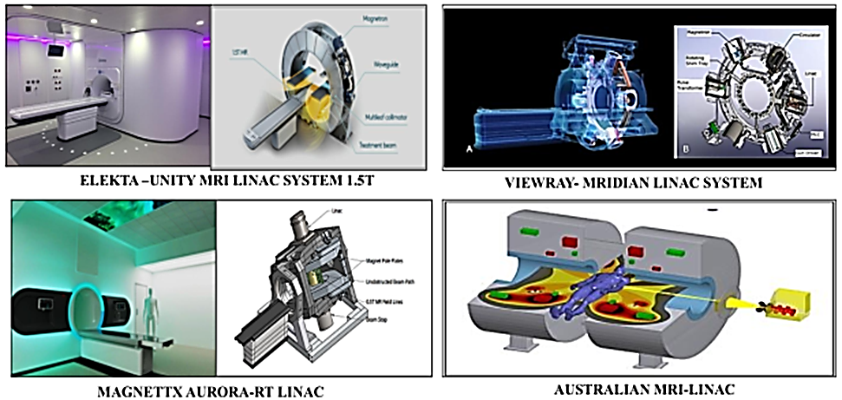

The MRI-linac Technology's benefits
- Imaging for therapy guidance
- Planning a customized course of treatment for inter-fractional management
- For intra-fractional therapy, gating & real-time imaging
The MRI-linac Technology's challenges
- Capital expenditures
- Treatment time as well as throughput
- The absence of non-coplanar beam delivery & associated deployment limitations
- MR imaging contraindications

Clinical applications
- Prostate cancer
- Lung cancer
- Liver malignancies
- Pancreatic cancer
- Breast cancer
- Central nervous system tumors

References
- Klüter S. Technical design and concept of a 0.35 T MR-Linac. Clinical and translational radiation oncology. 2019 Sep 1; 18:98-101.
- Keall PJ, Glide-Hurst CK, Cao M, Lee P, Murray B, Raaymakers BW, Tree A, van der Heide UA. ICRU REPORT 97: MRI-Guided Radiation Therapy Using MRI-Linear Accelerators. Journal of the ICRU. 2022 Dec; 22(1):1-00.

