Use of innovative Approaches in Horticulture: A Case Study of Sopore Baramulla Jammu and Kashmir
Dr Zubair Ahmad Bhat
Department of Sociology Government Degree College Hajin Jammu and Kashmir India
zubairbhatt2@gmail.com

- Abstract
- Kashmir Valley has got the potential to produce different varieties of fresh apple crop which contributes state gross domestic product and foreign exchange. Apple fruit is one of the important fresh fruits which alone account 44.10 per cent of area and 90 per cent of production in the union territory. Every year millions of apple boxes are being exported to various parts of country and to some neighbouring countries like Bangladesh from various parts of region. To pick, pack and carry the Apples, every year millions of trees were cut down for the manufacturing of wooden crates. With the introduction of cardboard and plastic crates the grower find some relief as it is cheaper and easy to carry from traditional wooden crates. The present paper will try to find out the benefits and usage of cardboard crates in place of traditional wooden crates for marketing of apple.
- Keywords: Horticulture, apple boxes, cardboard and plastic crates

- Introduction
- Every year millions of fresh fruit boxes are exported from Kashmir valley consisting of fresh apples, pears, apricot, plums and other fruits to various parts of country. Apple fruit is one of the important fresh fruit which alone accounts 44.10 per cent of area and 90 per cent of production in the union territory. After cultivation of apples, it should be made ready for marketing which should done in phased manner like picking of apples, grading of apple and packing of apples. Packing is an important process for marketing of any fresh fruit which is crucial stage for cultivators. Packing is a process of putting commodities in to convenient containers in order to prevent them for spoilage and waste from producers to final consumers. There is wide market for Kashmir apples and if it is not packed properly, run the risk of spoilage before reaching the final consumers. Traditionally orchardists were using only wooden apple boxes as roads were not laid up to orchards and suitable carriage system was not available to them. Boxes made of wood gives them assurance and durability to carry the apple from distant places. People in December or in early March will visit a nearby sawmill to sign a contract with owner and fix rates per box both small and large. The price range varies from 50 to 70 rupees per box depends upon the quantity and instalments from the grower. From first week of March the sawmill owners starts their work and from May the stock is ready to deliver. With the coming of cardboard boxes the grower has an option to replace the wooden box. Both wooden and cardboard boxes had their benefits and limitations. The cardboard boxes are very cheap, available with different sizes, material and price. Suppose a grower has second grade apple in large quantity he can use lower quality cardboard boxes generally ranging from 18 to 25 rupees. This facility is not available with wooden apple boxes, there a grower has to use 65 rupees box for the quality of apple which only gives him 100 rupees. Due to this transition from wooden crates to cardboard boxes sawmill owners at first suffered some loss but with the increasing trend of converting paddy fields into apple orchards both industries are flourishing keeping check on price hiking. Apple growers need boxes and crates at two stages, first when fruit is ripen on trees and at the time of packing. Growers with quantity of more than 500 boxes use both wooden and cardboard and plastic crates as well. Generally, they collect the fruit from trees in wooden crates as cardboard is not suitable at this stage because of its raw material. Once the collection is done, they store the fruit in a shed near their house and start packing in cardboard boxes because it is lighter, needs less straw, paper and easy to carry from one place to another. The emergence of cardboard boxes is one of the innovative strategies in the field of horticulture which not only helped the grower but has widened the employment opportunities in the valley. In the present study fruit growers from the Sopore town of Baramulla district were consulted regarding the use of cardboard as innovative strategy in their field. Some labourers (hamals) and truck owners were also consulted regarding the emergence of cardboard in apple industry.
- 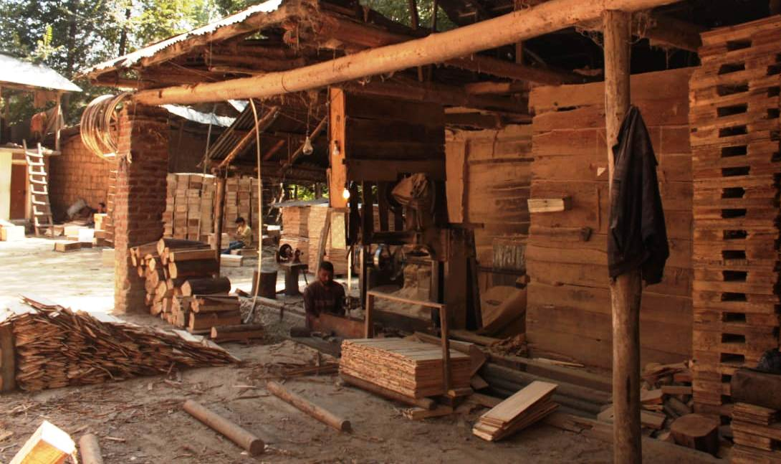
  - Fig 1.Traditional Kashmiri sawmill where wooden crates are being manufactured.
- It is seasonal and starts operating from early April to September employing large population as drivers, makers, and helpers inside the manufacturing unit. These are still functioning as an essential part of apple industry providing basic infrastructure as well as employment. With transition of follow land and other miscellaneous tracts into apple orchards sawmills are nourishing in this industrial and modern technological world. Though cardboard and other innovative tools have emerged from last ten years the age old industry has survived due to various factors.
- Objectives
- To study the benefits of cardboard boxes and their impact on the economy of apple growers
- To study the impact of cardboard boxes on labours and truck owners
- Methodology and data collection
- Baramulla is leading apple producing district in valley is taken as a study area. Primary data was collected with the help of unstructured direct interview from the growers, commission and forwarding agents. Various truck owners and drivers both local and outside Jammu and Kashmir and retail shopkeepers in Mandi were consulted. Mustafa Memorial fruit mandi, Asia’s second largest fruit markets were thousands of people are working as loaders of apple craters were also consulted by the researcher. The fruit merchants and commission agents who sell the farmers produce were also a part of the program during the investigation. The researcher visited the fruit Market (mandi) located in Sopore and asks several questions to all the stakeholders, growers, labourers, truck drivers and traders. An attempt was made to be unbiased regarding the selection of respondents. While visiting the mandi researcher consult growers, buyers, sellers and workers and get detailed information regarding the emerging trends in apple packing. Each and every respondent was given freedom to speak either in favour or against the cardboard crates.
- 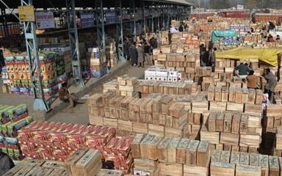
  - Figure2. Mustafa Memorial Fruit Mandi Sopore
- Views of Growers on the introduction of cardboard boxes
- Javid Ahmad Mir one of the youngest Apple entrepreneur from Sopore town revealed that every year he used to buy five to six thousand wooden boxes. He used to pack second grade and fallen apple (Giran) in these costly boxes, which hardly give him 100 to 120 rupees. Apart from higher cost wooden boxes need straw, paper, nails and are labour intensive. As there is a decline in rice production in valley, the price of straw went up dramatically. The price of used newspaper per 50 kg was 800 few years back and now the same costs 1500 to 1600 now a day. The price of our apple fluctuates, depends upon various factors apart from the fact that region is terror hit which adds our plights. But with the introduction of cardboard boxes I used to buy only 2000 wooden boxes rest the respondent revealed is using cardboard boxes. It gives him the choice to pack second grade apple in cheaper boxes and saves paper, straw and labour expenses.
- Another grower from Rafiabad block of Baramulla district namely Jalal Ud din lone revealed that with the introduction of cardboard boxes he didn’t bought wooden crates from last two years. He has maintained 200 wooden boxes which he carries in cart to his orchards for apple collection. After that he packed the produce in cardboard boxes and the process goes on again. The grower however is of the opinion that cardboard boxes are not strong enough to bear harsh weather conditions like rain and are not suitable for collection in far flung areas. But the introduction cardboard crates have ended the monopoly of wooden boxes and sawmill owners and helped the grower. In every village one can easily find two to five retailers of these cardboard crates. We can easily get the desired boxes as per the size of our apple revealed on of the grower from nearby shop. It is very easy to store as it takes little space as compared to wooden crates he added.
- 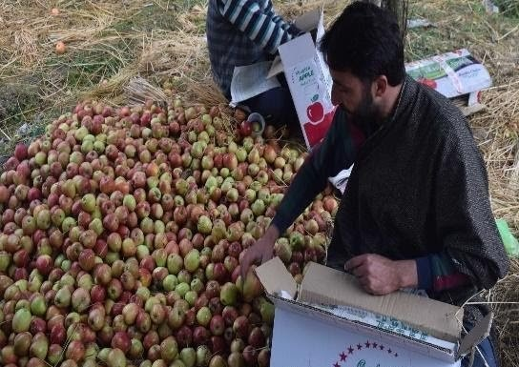
- Figure 3 A Kashmiri Professional Apple packer, packing in cardboard crates in a village Seer Jagir near Sopore known as Apple town
- Labours working in Fruit Mandi Sopore their views about cardboard boxes
- Thousands of labourers working in fruit mandi Sopore are directly dependent on horticulture sector for their livelihood. Hundreds of firms, commission agents, buyers and forwarding agents hire these labourers to load and unload the apple boxes. The workers get wages as per the number of boxes one load on truck or unloads from mini truck, cart or tractors. At present the labours who work with firms who sell the apple boxes on commission get 2 rupees per box whereas who work with buyers get 3 rupees per box while loading. The workers were of the opinion that with the coming of cardboard it becomes easier for them to load boxes on large trucks as these are not as heavy as wooden boxes. During peak season cardboard boxes take lesser time to open and close in the course of sale. We only need tape roles to close them once sale is over said one of the worker. Ghulam Nabi one of the senior workers said to load cardboard boxes one truck, we need two to three persons. For wooden boxes we had to add one or two more persons for the same quantity. The introduction of these boxes had helped us to earn more and takes less time to load.
- 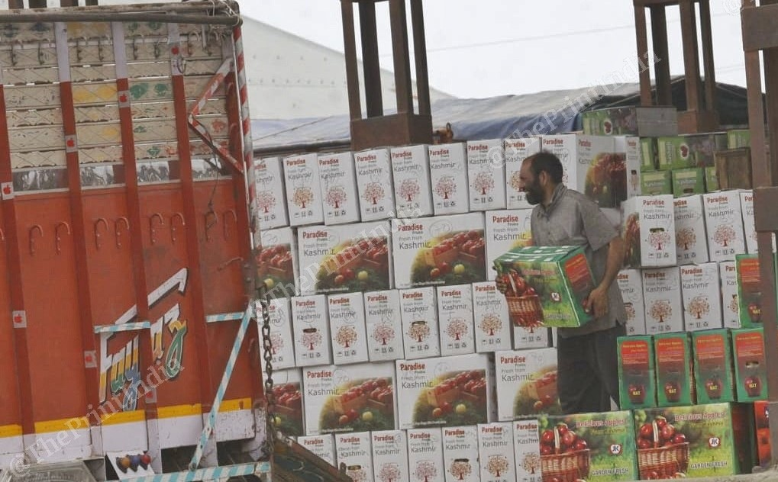
- Figure 4 Labourers (Hamals) loading cardboard crates in a truck in fruit mandi apple town Sopore
- Trading Firms, Commission Agents, Buyers, Truck owners and their views
- In Kashmir Apples are sold as per boxes unlike rest of the country where it is sold and bought as per weight. Suppose Delicious apple is sold 700 per box may weigh 15 to 18 kgs. If it is packed in wooden crates the buyer is reluctant to buy these crates. Because where forwarding the same to other markets there the weight of the wooden crates will be deducted. That’s why now days buyers prefer to buy cardboard crates for states like Punjab, UP, Haryana and Delhi said Manzoor Ahmad one of entrepreneur from Sopore. Most of the traders were of the opinion new trends and innovations should be included in apple production as it will boost grower’s economy. Abdul Rashid one of the commission agent revealed that with the introduction of cardboard crates and other related items the grower is not bound to take huge advances from traders. Most happy people were truck owners who feel joyous to load cardboard crates to their trucks. It is easier to load them and we didn’t need to pay extra money at toll plazas for overweight said one of the driver. Introduction of cardboard crates had revolutionized the horticulture sector as it saves time and money of grower and provides employment opportunities to unemployed youth. Besides being economical cardboard crates are eco-friendly and save millions of trees from cutting for the same purpose. For transportation purpose cardboard is durable and easy to carry making it profitable for both carrier and seller. Talking about the demand from last three years various firms revealed their records regarding cardboard crates distributed among their growers. However not all firms provide these crates to their parties as most of the growers bought from local dealers and retailers. Firms with maximum number of growers have more demand and they tie up with one of the manufacturing units mostly outside valley for supply. Growers get the demand fulfilled easily and they need not to pay in cash as the firm charges them at the end of season. All the firms however said that the demand and usage of cardboard crates is increasing every year.
- The shops near fruit mandi were also consulted by the researcher and most of them were of the opinion that demand of these crates is increasing per year. However the retailers were of the opinion that quality of the crates is increasing with time and price also rose up for the superior one. Iqbal Ahmad one of the trader revealed that he has to change the manufacturing brand per year as per quality of the crates. Iqbal who started his business in 2015 revealed that every year the sale of the crates has increased. He told that in year 2019, 35000 crates were sold by him which was highest by him so far. Other retailers also share the same about the sale of cardboard crates being the major product they sold. The table below will show the business of major retailers dealing in cardboard crates in fruit mandi apple town Sopore.
- Table 1. Showing statistics from retailers regarding sale of Cardboard crates since last four years, there was an increase in sale respectively.
- Name of retailer | - Year-2017 | - Year-2018 | - Year-2019 | - Year-2020
- Iqbal Traders | - 19000 | - 25000 | - 35000 | - 30000
- Wani Traders | - 20000 | - 30000 | - 36000 | - 42000
- Sopore Apple Pvt Ltd | - 22000 | - 28000 | - 25000 | - 36000
- Shah Traders | - 15000 | - 24000 | - 32000 | - 40000
- Kisan Traders | - 25000 | - 35000 | - 45000 | - 58000
- 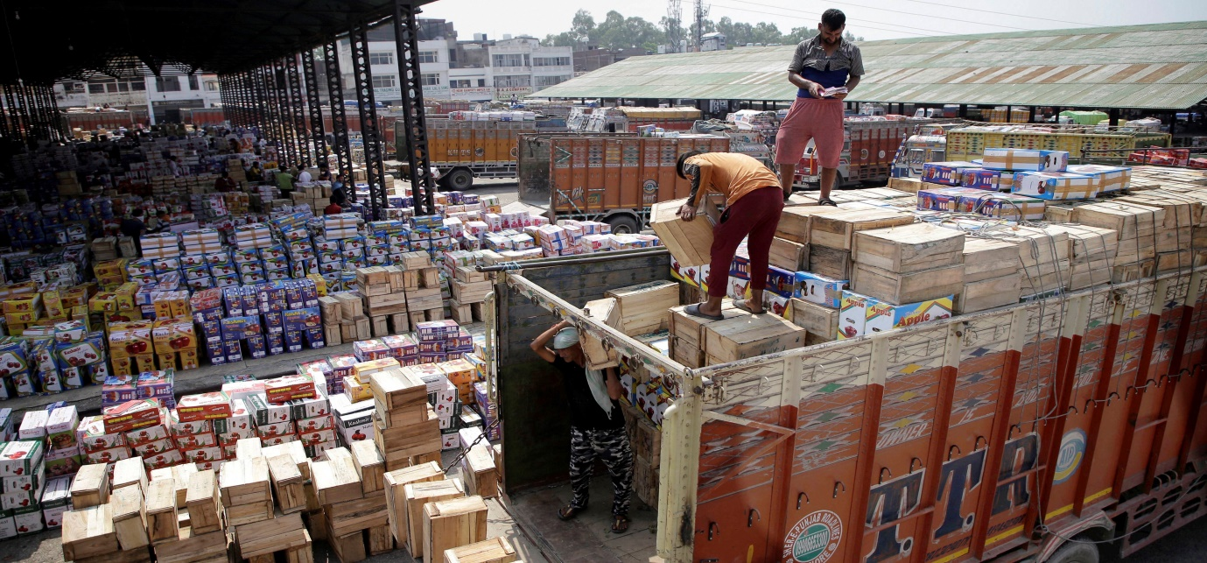
- Figure 5. Loading of Apple crates: Photo courtesy, Mustafa Memorial Fruit Mandi Sopore
- Conclusion
- In modern times we cannot ignore the technological advancements in each and every aspect of our social and economic life. India being the agriculturalist country has implemented new technologies and modern machinery to compete with other countries. Jammu and Kashmir has got the tropic and sub-tropical climate, which is suitable for the cultivation of different kinds of fresh and dry fruits. Kashmir being known for its fresh apples is the hub of commercial farming and is leading producer in the country. Traditionally people used tools and equipment’s which were manufactured on old patterns and were costly. After the fruit is ready to be collect grower needs boxes and crates which were traditionally manufactured at local sawmills. Made from the wood planks of poplar and willow trees the wooden crates were easily available but with the indiscriminate cutting of these trees and their use in plywood industry leads to increase in rates per crate. Various farmers gave up their traditional profession as it was difficult to meet the ends. But from the last five years Kashmiri orchardists are expanding their apple fields. Various technologies innovations are responsible for this transition, availability of various pesticide companies, new and innovative tools and implements. Introduction of cardboard and plastic crates is one of the innovative strategies to boost the income of farmer. At present farmers are using cardboard crates to replace the traditional wooden boxes which were very costly and labour intensive. Easy to carry, pack and load these crates have been modified every year by local and national companies. Their introduction gives the grower choice to pack large size apples in big and medium size in small, whereas to pack second grade and giran in lower quality crates. Over the years it has proven a worthy innovation in horticulture sector which is one of the main branches of economy in valley. Growers and other sections of population who are dependent on horticulture are of the opinion that sector needs to be made familiar with modern technological advancements.
- References
- Malik Ahmad Zahoor, 2014, Horticultural growth trajectory Evidence in J&K
- (A lesson for Apple industry in India) volume 3.
- Shah Ishfaq Ahmad, 2019, A study on the production and marketing cost of apple fruit in Kupwara District of Jammu and Kashmir
- Vajhat Khurshed & Mohammad Tarique,2019, Spatial analysis of horticulture efficiency and fruit production concentration in Kashmir Valley
- Bhat, J. (2010). Problem of apple marketing in Kashmir. Abhinav J. Res. Commerce & Mgmt., 1(6).
- Singh, C. and Kumar, P. (1987). Changes in prices and marketing margins of fruits in India. Indian J. Agric. Econ., 42 (3).
- Rather Naseer Ahmad et.al (2013) “An analytical study on production and export of fresh and dry fruits in Jammu and Kashmir”, In.Jou. of Scientific and Research Publications, vol. 3(2)
- Shapoo Javid Ahmad and Banerjee B.N. (2003) “Economics of apple trade in Anantnag district of Jammu and Kashmir”, A National Level Quarterly Journal on Agricultural Marketing, vol. XLVI (2)
- http://archive.indianexpress.com/news/jk-to-introduce-cardboard-packaging..
- https://www.greaterkashmir.com/news/opinion/box-manufacturingduo-cashin...
- http://www.kashmirlife.net

