Biological sources as an Ingenious Renewables
Dr. Preeti Kalia*
Department of Zoology
Goswami Ganesh Dutta Sanatan Dharma College, Sector: 32, Chandigarh, India.
*Email: preeti.kalia84@gmail.com

ABSTRACT

Due to continuous increase in the emission of green house gases, climate change, the need is to switch to some sustainable alternative sources which not only causes substantial reduction in global warming but also is cost effective and helps in conserving the fossil fuel reserves which are near to depletion. The biological resources which includes animal and plant not only plays significant role in maintaining biodiversity but also act as source of renewables. Biological sources contribute in generation of clean and green energy and the various options for generating the same have been discussed like animal bio-waste in the form of fish scales from fish markets act as a potent source of green energy, insects can be used to generate green energy. The use of the renewables should be encouraged for sustainable and secure future.

Keywords: Renewable energy, biofuels, biological sources, biomass.

- INTRODUCTION

The growing global population leads to urbanization which further leads to increase in the energy demand. There are usually two major sources of energy that are Non- Renewable sources and Renewable sources. Out of the non-renewables, Fossil fuels are considered as a primary energy sources but at the same time the immoderate use of these fossil fuels results in maximum pollution throughout the world which directly-indirectly hampers the climate, biodiversity of earth, human health ^{[1]} and this cannot be ignored (Fig. 1) . As per Environmental Protection Agency, U.S, 2021 the fossils fuels burning contributes 73% of the total green house gas emissions.

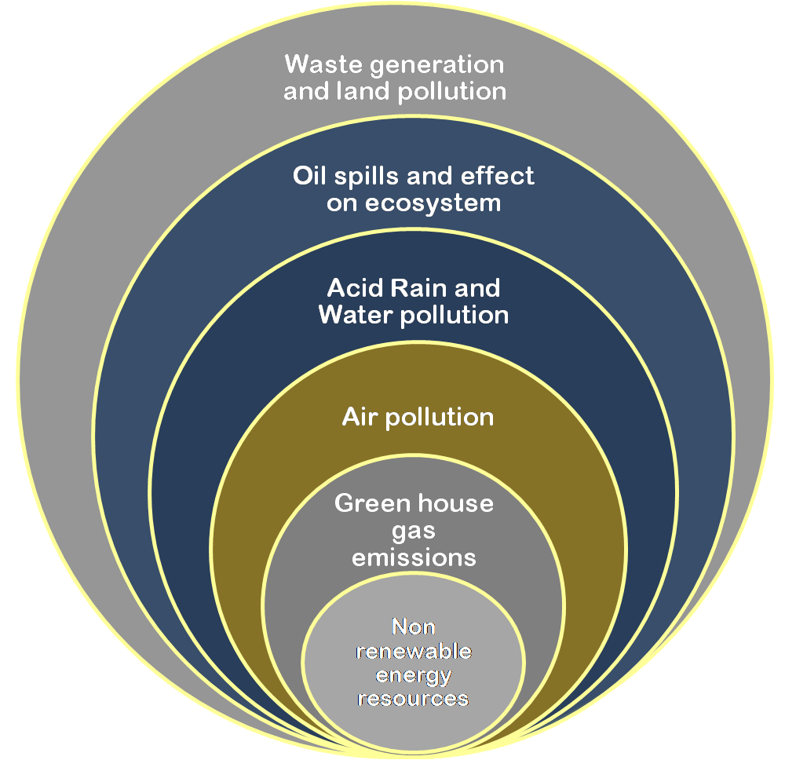

Fig. 1: Harmful effects of non renewable resources

So, the need of the hour is to mitigate this situation and look for some strategies for using renewable sources of energy in best possible ways and finding the sustainable alternative sources also. Even in the United Nations list of Sustainable Development Goals, 2030, the emphasis is on to providing clean energy as well as take quick action to combat the climate change. By adopting the 3 R' s policy i.e. Reduce, Reuse and Recycle we are definitely bringing down the burden on natural resources and creating sustainable societies but this is not so significantly lowered that the pressure on depleting non renewables, increasing pollution can be ease out.
Renewable energy as we all know is that energy from the natural resources which is replenished constantly like sunlight, wind, water, geothermal and bioenergy (Fig. 2). Bioenergy is mainly obtained from biomass to produce biofuels, electricity etc. The biomass is produced from organic matter (plants and animals). The sources of natural renewable energy are very limited so throughout the world the focus is on to find a suitable, easily available, clean and green sources. Both plants and animals contribute as renewable sources. The biomass from plants results in production of biofuels, bioplastics etc. These are easily produces, pollution free and are energy efficient but at the same time these green alternatives are sometimes not so cost effective. The advantages of these are more as compared to the disadvantages. The more the usage of renewables we encourage, more this helps in combating the green house gases emission and making the environment apt for survival.
The renewable energy eases our life by giving us electricity, transportation, heating, cooling etc. Renewable energy benefits us in many ways like:
- These energy resources will not run out soon.
- Enhances the life span as it reduces pollution.
- Environment friendly.
- Reduces burden on fossil fuels, coal etc.
- Reduces the import of fuels etc from other nations.
- Maintenance cost is very less as compared to the cost of non - renewables.
- Renewable technologies helps in creating more jobs and especially empowering people in developing nations.

But we know that everything comes with a cost, so few pitfalls about renewable resources are listed below:
- Initial cost is very high
- The efficiency of renewable technologies is less as compared to traditional methods of generating energy.
- Renewable resources like solar and wind are not available all the time, so this may be the unfavorable point and reduces the reliability on these technologies.
But the cons are very less and can be easily manageable as compared to the large number of pros.

Fig. 2: Various renewable energy sources

- VARIOUS ALTERNATIVES FOR GREEN ENERGY

The main emphasis here is to compile the various options by which the biological sources specifically animals help us to generate renewable energy. The few alternatives are summarized as under (Fig.3):

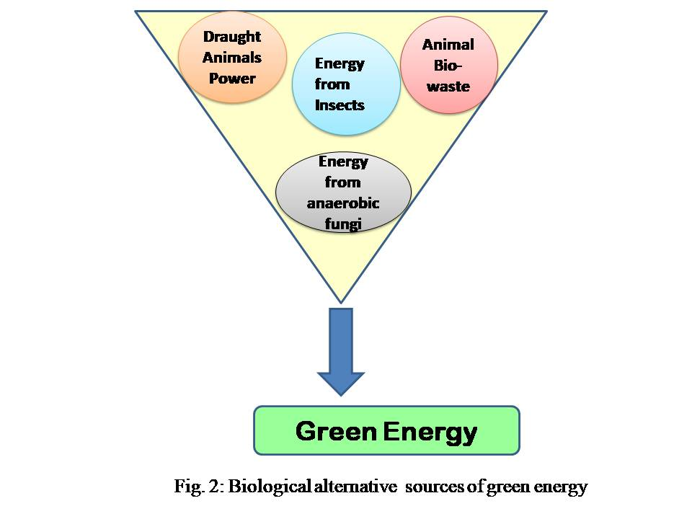
Fig. 3: Biological alternative sources of green energy

- Draught Animals:
Earlier draught animals were consider only for ploughing and harvesting purposes in the agriculture but due to mechanization in the agriculture the use of these animals was reduced. Even today in rural areas of many countries the power of draught animals has been used for various purposes like transportation, to pump water and so on. Findings from the researchers have proved that the draught animal power (DAP) can be used to generate electricity at a very low running cost^{[2]}. Scientists also studied that electric generation system powered by animals for home lighting etc^{[3]}.

- Animal Bio-waste:
Waste material from animals in the form of faecal matter, waste from the slaughterhouses, carcasses etc. constitute the animal bio-
waste. The continuous search for the alternative source of renewable energy motivate us to delve into every possible option.

Livestock waste:
Livestock waste is not only used as manure but it is used for the production of Biogas with the help of anaerobic digestion method as well as for the production of electricity^{[4]}. The production of biogas is the best practical way to basically recycle the waste. Research also showed the potential of biogas to produced green electricity^{[5]}.
Along with that another benefit of animal bio waste is the production of Bio-fuels which further helps in reducing the burden on fossil fuels. This can be achieved either by the use of some biological agents like anaerobic and photosynthetic microorganisms, algae etc or by the use of thermochemical treatment like gasification and pyrolysis for the production of liquid or gaseous fuels on the animals waste^{[6]}. The use of biofuels helps in reducing the green house gases and hence reducing the burden on the environment^{[7]}.

Farm animal bio waste:
Different animal bio-wastes like the chicken and feathers of birds from poultry slaughterhouse can also be used for the production of biofuels^{[8]}. Even the microorganisms present in intestines of animals can lead to the production of biofuel as in the case of Clostridium bacteria which is present in faecal matter of Zebra helps in production of butanol fuel^{[8]}.
The waste from the slaughterhouses has also been used for the production of biodegradable plastic. According to the latest UN Environment Program (UNEP), the carbon emission from the normal plastics is about 15% of the world’s carbon emissions. The benefit of this biodegradable plastic is that it does not causes the carbon dioxide emission when incinerated. It contains environment friendly compound i.e. polyhydroxyalkanoates (PHA). The novel plastic is used for packing of various medicines and pharmaceutical materials ^{[9]}.Various ongoing research projects are focusing to find some biocompatible alternatives. Researchers also confirmed that the ground up bone and animal meat could be used to form petroleum free plastic with strength as that of normal plastic.

Fish Scales:
Another animal source which is abundantly available in fish markets as waste, showing promising results in generating green energy is Fish scales. The waste fish scales and wool contains high amount of proteins which help in forming electrochemical cell that can be used to charge the batteries^{[10]}. Recent research showed the electricity generation potential of Rohu fish scales by Triboelectric nanogenerators. And the electricity produced with the help of fish in the above experiment lights upto 90 green LEDs^{[11]} which again is a remarkable achievement in the field of finding a great alternative energy source.
Moreover, the incredible use fish scales for making implantable medical devices to replace pacemakers (bio piazoelctric nanogenerators) has also been investigated. The formation of bioplastics from the fish scales for packaging has also reduces the environment pollution. Its main advantage is that it can decomposed very easily and has reduce burden on fossil fuels^{[12]}.

- Energy from Insects:
Honeybees not only give us honey and act as pollinator but various bee hive products are also the gift to humans by the generous bees. These valuable bee products have many nutritional as well as medicinal values. The latest research has unraveled that the swarm of honeybees can results in the production of electric charge of 100 to 1000 volts per meter which is higher than the thunderstorm^{[13]}.
Studies also explored the possibilities of using kinetic energy of bees in the bee hive to generate electricity^{[14]}. Recent research proved that fat stored in the body of insects (which feeds on waste mainly crop residues) can be utilized in the production of bio fuels like bio diesel, biofertilizers^{[15,16]}. Here, insect based biorefinery has been developed where the insects who are voracious feeders were selected and use their ability to produce biodiesel and proteins.

- Energy from anaerobic fungi:
In the gut of herbivores specifically ruminants, the anaerobic fungi is residing in the gut. The role of this fungi is to causes the breakdown of lignocellulose from the grass, plant polymers etc and convert it into sugars which are used for the normal activities of the animal. With the help of genetic engineering techniques and process engineering, the fungi is transferred from its natural habitat to artificial habitat and utilized for the production of biofuels like bioethanol^{[17, 18]}. So the conversion of agricultural waste into biofuel with the help fungi can result in remarkable decrease in environmental pollution.

- CONCLUSION

All the above discussed alternative sources are easily available in large quantities and are cost effective with causing minimum environmental damage. Producing the green energy or biofuels or bioplastic from insects, fungi or any other living organism is a formidable challenge. But, if we are able to harness the power of these alternative sources, we can reduce the pollution burden and can make the earth a sustainable planet. The emphasis should be on judicial use of both the non renewable and renewable resources as our future depends upon these resources.

REFERENCES

- Silva, A.V. S., Torquato, L. D. M. & Cruz, G. Potential application of fish scales as feedstock in thermochemical processes for the clean energy generation, Waste Management, Vol. 100, pp. 91-100, 2019.
- Paras, Singh, V.K. & Chaudhary, A. Generation of Electricity by Utilization of Power of Draught Animal. Indian Research Journal of Extension Education, Vol. 1, pp 150-153. 2012.
- Chandrakar, S. K., Soni, D. L., Yadav, D. K. & Sahu, L. K. Experimental Study on Animal Powered Mechanical Device for Home Lighting System. International Journal of Environmental Engineering and Management, Vol. 4, pp. 471-482, 2013.
- Abed, A. M., Lafta, H. A., Alayi, R., Tamim, H., Sharifpur, M., Khalilpoor, N. & Bagheri, B. Utilization of Animal Solid Waste for Electricity Generation in the Northwest of Iran 3E Analysis for One-Year Simulation. Hindawi International Journal of Chemical Engineering, 2022, pp. 1-8, 2022.
- Ardebili, S. M. S. Green electricity generation potential from biogas produced by anaerobic digestion of farm animal waste and agriculture residues in Iran, Renewable Energy, Vol.154, pp. 29-37, 2020.
- Cantrell, K. B., Ducey, T., Ro, K. S. & Hunt, P. G. Livestock waste-to-bioenergy generation opportunities, Bioresource Technology, Vol. 99, Issue. 17, pp. 7941-7953, 2008.
- Seglah, P.A., Wang, Y., Wang, H., Gao, C. & Bi, Y. Sustainable Biofuel Production from Animal Manure and Crop Residues in Ghana. Energies, Vol. 15, 5800, 2022.
- Shrivastava, S & Tomar, R. S. Biofuel Production by Animal Wastes- A Review International Journal of Research in Advent Technology, Vol. 7, Issue. 3, pp. 1104-1108, 2019.
- Biotechnological conversion of carbon containing wastes for eco-efficient production of high added value products. https://cordis.europa.eu/article/id/89651-animal-waste-transformed-into-plastics.
- Battampara, P., Ingale, D., Guna, V. et al. Green Energy from Discarded Wool and Fish Scales. Waste Biomass Valor, Vol. 12, pp. 6835–6845, 2021.
- Singh, H., Sheetal, A., Singh, M., Kaur, J., Sui, T., Loja, M. A. R., Uros Trdan, Sharma, M. Electrical energy generation using fish scale of Rohu fish by harvesting human motion mechanical energy for self powered battery-less devices, Sensors and Actuators A: Physical, Vol. 349, 114023, 2023.
- Arunagiri, C., Durai, S., Kumar, S. D. S., Angukumar, S. S. & Raj, V. P. Analysis of bio plastic wrappers derived from fish scales for wrapping candies. International Journal of Creative Research Thoughts, Vol. 9, Issue. 8, pp. 783-790, 2021.
- Hunting, E. R., O’Reilly, L. J., Harrison, R. G., Manser, K., England, S. J., Harris, B.H. & Robert, D. Observed electric charge of insect swarms and their contribution to atmospheric electricity. iScience, Vol. 25, Issue. 11, pp. 1-8, 2022.
- Abou-Shaara, H. F. (2019). Devices to generate clean and renewable energy from honey bee hives. Arthropods, Vol. 8, Issue. 3, pp. 97-101, 2019.
- Manzano-Agugliaro, F., Sanchez-Muros, M. J., Barroso, F. G., Martínez-Sánchez, A., Rojo, S. & Pérez-Bañón, C. (2012). Insects for biodiesel production, Renewable and Sustainable Energy Reviews, Vol. 16, Issue. 6, pp. 3744-3753, 2012.
- Wang, H., Rehman, K.u., Liu, X., Yang, Q., Zheng, L., Li, W., Cai, M., Li, Q., Zhang, J., Yu, Z. Insect biorefinery: a green approach for conversion of crop residues into biodiesel and protein. Biotechnol Biofuels, Vol. 10, 304, 2017.
- Saye, L.M.G., Navaratna, T. A., Chong, J. P. J., O'Malley, M. A., Theodorou, M. K. & Reilly, M. The Anaerobic Fungi: Challenges and Opportunities for Industrial Lignocellulosic Biofuel Production. Microorganisms, 9 (4):694. 2021 doi: 10.3390/microorganisms9040694. PMID: 33801700; PMCID: PMC8065543.
- Miteva- Staleva, J., Eneva, R. & Hubenov, V. Fungi and their potential for biofuels production (review). Bulgarian Journal of Agricultural Science,Vol. 28, Issue. 2, 265–270, 2022.

