**"PACK HOUSE: ENHANCING POSTHARVEST QUALITY AND MARKET READINESS OF FRESH PRODUCE"**

**Shourathunnisa Begum1, Sharanagouda Hiregoudar2 , Udaykumar Nidoni3and Pramood Katti4**

**1Ph.D Scholar, Department of Processing and Food Engineering, University of Agricultural Sciences, Raichur, Karnataka, India.**

**2Prof. and Head of the Department, Department of Processing and Food Engineering, University of Agricultural Sciences, Raichur, Karnataka, India.**

**3 Prof. and University Head, Department of Processing and Food Engineering, University of Agricultural Sciences, Raichur, Karnataka, India.**

**4Professor, Department of Agricultural Entomology, University of Agricultural Sciences, Raichur, Karnataka, India.**

**Corresponding email address:** [**shohrat357@gmail.com**](mailto:shohrat357@gmail.com)

**Abstract**

The pack house development as per the requirement for material handling, holding, pre-inspection, sorting, grading, washing, standard treatment, packaging, stacking, pre-cooling, cold storage, quarantine check etc., is to maintain the traceability, export of good quality produce, encouraging adoption of internationally acceptable standards and practices, up gradation of standards for product quality, hygiene, food safety and creation of a healthy, competitive environment among exporters. Pack house could be an efficient link between the grower and market it serves as a single platform for aggregating the products, cleaning and processing them under the supervision for market and export to get higher returns.

**Keywords: Pack house, Traceability, Export and food safety**

1. **Introduction:**

Fresh produce has an extremely limited shelf life after harvest, making it very perishable. After harvest, they undergo ongoing change that culminates in senescence since they are living tissues with a high water content. The disintegration and death of cells characterise the plant organ's final stage of development, known as senescence. To maintain the freshness of fresh food from the field to the consumer level, special measures must be made to mitigate the effects of these naturally occurring processes (Berk, 2013). The first stage of the postharvest system is harvesting, which has an impact on subsequent activities such crop packing, handling, transport, and preservation. Fresh horticultural items must be harvested and packaged quickly after reaching the ideal level of maturity due to their perishability. Keeping produce of a good caliber from the farm to the consumer is a crucial requirement for marketing (Oubahou *et al*., 2019).

Packing house operations are customized for each handled commodity and the intended market. Activities within the packing house are finely tuned to align with the specific requirements of the target market and the individual items being processed. Trimming, cleaning, removing excess moisture, curing, waxing, sorting and grading, ripening, degreening, packaging, and pre-cooling are a few examples of operations (Ajay, 2020).

Produce that has already been harvested is frequently taken to a shared facility for processing and storage prior to transportation to market. This facility is known by a variety of names, including packing shed, a pack house, and a packing house. In a physical building known as a "pack house," harvested product is gathered and readied for transportation and distribution to markets ([www.fao.com](http://www.fao.com))

1. **Users of packing-house facilities**
2. Growers
3. Processors
4. Traders, importers & exporters
5. Co-operatives and clusters
6. **Components of pack house**

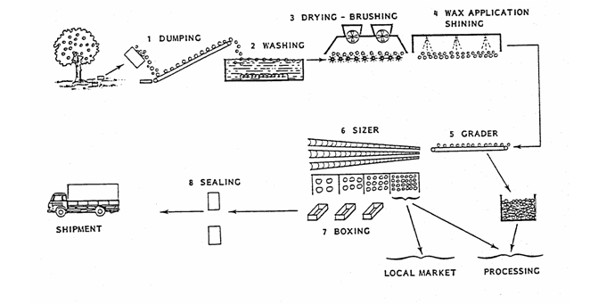

**Plate: 1. Components of pack house**

1. **Key packing house operations**
   1. **Receiving**

Produce must go through a thorough inspection at the packing house before acquiring a specific code designating the supplier, harvest or delivery date, and production site (including origin, lot/block number, and tree number). Potential damage, insect or rodent infestations, deterioration, extraneous items, and obvious chemical residues are all evaluated during this evaluation. The gross harvested weight may also be recorded at this time, depending on the type of crop. It is advised to use test kits that can be verified by precise techniques such gas chromatography, high performance liquid chromatography, or high performance gas chromatography wherever practical. These tests make sure that produce is thoroughly examined for any chemical residues (Boonyakiat and Janchamchoi 2007).

* 1. **Maturity assessment**

The maturity evaluation must be in line with the demands of the intended or target market. Fruits that float are disregarded since it is assumed that they are not fully ripe. The Soluble Solids Content (SSC) of various fruits reveals the sweetness and ripeness of certain fruits. A specified minimum SSC has been established for the following crops: pineapple - 12%, papaya - 13-15%, litchi - 16-17%, and watermelon - 10%. The ideal harvesting ripeness for "Solo" papaya fruits is indicated by a Total Soluble Solids (TSS) level of 12%. The terms SSC and TSS are frequently used synonymously (Hewett *et al.* 2009).

* 1. **Buffer storage**

The freshly received fruit is then placed in a cold storage room within pallet bins to serve as a buffer until it's required. The packing lines are designed for continuous operation. However, the supply of raw materials often arrives in irregular bursts at the packing house. In such cases, a storage buffer between supply and demand becomes essential (Berk, 2013). Many packing houses allocate two to three days' worth of buffer storage. This storage facility should be maintained at approximately 10°C to uphold the quality of the fruit.

Maintaining the fruit's stability post-harvest necessitates cold storage of the detached fruit at this stage. If the fruit underwent prior heating for degreening, it must be gradually cooled to approximately 10°C. In cases where degreening isn't necessary, it's advantageous to cool the fruit from its field temperature to around 10°C before packing. This cooling process reduces moisture loss by 50% and retards decay (Yehoshua and Cameron, 1989)

* 1. **Dumping**

One by one, pallet bins laden with fruit are transferred onto the dumper platform at the packaging line's inception using a forklift. The dumper operates hydraulically, elevating and tilting the bins past vertical positioning, gently releasing the fruit onto the receiving roller conveyor. Underneath the dumper, a mechanism designed to catch debris, encompassing leaves, twigs, sand, and other matter, collects the bulk of the waste, channeling it downward into a designated trash container. Any residual refuse and fruit that is notably split or spoiled necessitates manual removal from the receiving conveyor.

The dumper is often equipped with an attachment for releasing the now-empty bins, which are then returned to the orchard. To maintain a consistent flow of fruit along the line, it's crucial to regulate the rate of dumping. This can be accomplished either manually or through mechanical means by the dumper operator. It is advisable to thoroughly clean the empty bins using high-pressure water sprays and steam, followed by disinfection using chlorinated water. This preventive measure helps avert fruit contamination during the subsequent loading of fruit. (Yaptenco and Esguerra, 2012)

**Plate: 2. Different dumping methods**

* 1. **Soaking or Drenching**

To begin cleaning, immerse the affected area in chlorinated water , which serves as both a wetting agent and a disinfectant. Early sanitation is crucial, not only for washing of fruit but also, and most importantly, for preventing microbial growth and biofilm on the machinery. Fruit is delivered to a soak tank filled with water that is room temperature via the receiving conveyor. In order to maintain a free chlorine content of 100–200 ppm (less in lemons), chlorine is supplied. Higher concentrations used to be the norm, however since then, it has been determined that high chlorine concentrations result in the creation of long-lasting chlorinated organic substances that are thought to be carcinogenic. As a pressurized gas in bottles, pure chlorine is sold. Automatic chlorinators regulate the flow of chlorine to maintain the proper concentration. In small-scale systems, sodium or calcium hypochlorite is utilised in place of bottled chlorine. If the soaking water is not changed as needed and the free chlorine concentration is not maintained, the soaking stage could turn into a source of contamination rather than a cleansing procedure ([www.fao.com](http://www.fao.com)).

* 1. **Presorting**

Pre-sorting can occur either prior to or following the drenching process. Opting to soak and sanitize the fruit before engaging in pre-sorting yields the benefit of presenting workers with fruit sporting a cleaner surface, which in turn facilitates easier detection of defects. Once the fruit has undergone washing and chlorine treatment, it attains a sufficient level of cleanliness that permits manual sorting (Ait-oubahou *et al*., 2019) This sorting process involves the separation of subpar fruit and fruit destined for juice production from the main stream of fruit. The fruit is directed to a pre-sorting "table," which might take the form of a roller or a belt conveyor. Workers are responsible for manually removing the undesired fruit and the fruit intended for juicing, depositing them into distinct chutes. This action leaves the superior fruit on the conveyor for further processing. (Mahajan *et al*., 2010)

* 1. **Cleaning/washing**

Cleaning the surface of the produce removes latex, dirt, chemical residues, lowers the microbiological load, insects like mealybugs and aphids, and other foreign items. Consumers find clean produce appealing, and it may be sold with ease. Produce that adheres to soil during transport may sustain abrasion damage and become contaminated. Therefore, harvesters should take as much soil out of the produce as possible before transporting it to the packing plant. Physical harm must be kept to a minimum while cleaning (CAC 2003). To remove latex, filth, chemical stains, microbiological burden, insects like mealybug and aphids, and other foreign objects, the produce's surface can be thoroughly cleaned. Produce that is preserved in good condition appeals to consumers and is simple to sell. Produce can sustain abrasion damage and get contaminated during shipping when soil adheres to it. Therefore, harvesters should remove as much soil as they can before delivering the product to the packing factory. Washing is necessary because physical injury while cleaning must be kept to a minimal. On the other hand, crops like onions and garlic that will be preserved in large quantities don't require washing. However, the dried exterior scales must be removed because they are filthy. Fresh latex adhering to the peel needs to be removed from fruits that are prone to or suffer from latex staining by washing them as soon as possible after harvest. This will not only enhance beauty but also stop latex burns. (Raiden *et al.* 2003).

**Methods of cleaning include:**

**Washing*: -*** Cleaning: Since microbial contamination is primarily found on fruits' and vegetables' exteriors, thorough washing is essential to reduce the microbial load. The variety of cleaning methods used include...

1. **Dump washing / immersion dipping**
2. **Spray washing**
3. **Brush spraying** 
   1. **Drying**

After being treated in the soak tank, the fruit is lifted into a tunnel where any leftover water on the surface is drained away by a circulation of room-temperature air. Fruit is moved over a conveyor belt by rollers into a tunnel where it is dried by hot air (40–45°C). Instead, the fruit is "wiped" by rotating soft brushes or rollers (Fito *et al*., 2004).

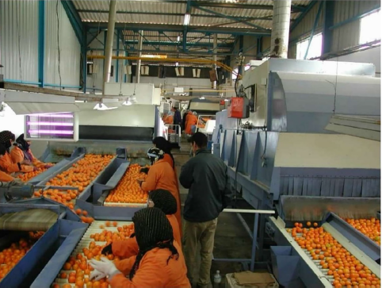

**Plate: 3. Drying**

* 1. **Waxing**

Due to the removal of the fruit's inherent wax layer during the washing phase, there arises a need to subsequently administer a fresh wax coating to the surface. The aims of wax application encompass:

■ To minimizing water loss

■ To create a gas exchange barrier

■ To restore the fruit's gleaming sheen

■ To provide assistance to preservationists

Several waxes, both natural and synthetic, have obtained statutory authorization for usage in food. Shellac, wood rosin, candelilla wax, carnauba wax, and beeswax are some examples of natural waxes (Abdelfattah *et al*., 2020). The *Copernicia cerifera* plant's leaves are used to make carnauba wax. Oxidized polyethylene, ester waxes made by esterifying saturated fatty alcohols with saturated fatty acids, and paraffin are among the non-vegetable and non-animal sources of wax. Typically, fungicides are included in the wax or wax emulsion. (www.fda.gov.in)

* 1. **Grading**

After waxing, the fruit can be graded manually or by computer. At this point, more fruit with a high processing grade may be sorted and sent to the plant, along with the fruit that was rejected during pre-sorting. Manual grading is more time-consuming and less precise than computerized grading.For better results and to lessen the amount of fruit that needs to be inspected by each employee, the fruit stream is divided into numerous conveyors. The quality standards are set in accordance with what consumers want.



**Plate: 4. Electronic sorter**

* 1. **Packaging**

Waxed fruit can be graded manually or using electronic graders. More fruit that is suitable for processing may now be sorted and transported bringing the fruit and going to the factory that was eliminated during presorting. Manual grading takes more time and is less precise. In order to get better outcomes, the fruit stream is separated into many conveyors, requiring fewer pieces of fruit to be each employee inspected. The quality standards are established in accordance with market demand. (www.fao.com).

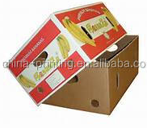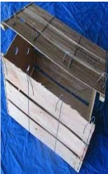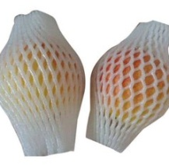

**Plate: 5. Telescopic boxes, Tray boxes, Wire-bound wooden crates and foam bags**

* 1. **Labeling**

Labelling is essential to promoting brand recognition and differentiating a product from similar ones on the market. Labels can be affixed as a sticker, a stamp with ink that is immediately transferred to the produce's surface, or a paper strap (particularly for vegetables). The appropriate government agency responsible for food safety must approve the use of ink for such purposes and ensure that it is moisture-resistant ([https://fssai.gov.in](https://fssai.gov.in/)).

**Shipping labels can contain some or all of the following information:**

* + Common name of the product.
  + Net weight, count and/or volume.
  + Brand name.
  + Name and address of packer or shipper.
  + Country or region of origin.
  + Size and grade.
  + Recommended storage temperature.
  + Special handling instructions.
  + Names of approved waxes.
  1. **Trimming**

Trimming is a broad word for the removal of plant portions that are undesirable, likely to be rejected by consumers, or that could hasten deterioration. Table 3 details specific cutting methods for several commodities. The dried flower remnants at the tips of the banana fingers are removed because they might contain organisms that induce rot, which could also serve as a source of inoculums in addition to making the bunch of bananas appear bad. Employees should put on clean gloves to remove dried floral remnants (Bautista and Esguerra, 2007).

**Table:1. Trimming operation in different crops**

|  |  |  |
| --- | --- | --- |
| **Commodity** | **Procedure** | **Description** |
| Banana | Dehanding | Separation of hands from the stalk |
| Carrot | Detopping | Trimming of tops and vegetative parts |
| Garlic | Detopping | Trimming of tops and vegetative parts |
| Onion (bulbs) | Onion (bulbs) | Trimming of tops and vegetative parts |
| Radish | detopping | Trimming of tops and vegetative parts |
| Roses | Dethorning | Removal of thorns from stems |
| Sweet corn, baby corn | Desilking | Removal of silk |
| Pineapple | Detopping | Removal of crown |

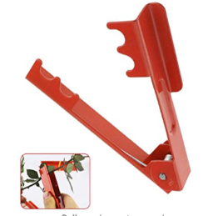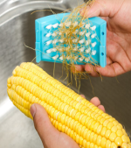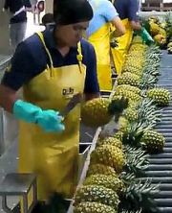

**Plate: 6. Special trimming operations**

* 1. **Palletizing**

The following illustrations show the arrangement of the most popular containers on a standard pallet (1000 x 1200 mm or 40 x 48 inches).

* 1. **There are five purposes of a packing house.**
* The packing-house system integrates factors including raw materials, utilities, technologies, equipment, and people that cooperate to prepare produce for the market. Therefore, each element has a big impact on the ultimate fresh produce quality.
* Control point where quality control can be used to ensure that consumers are supplied with producer of high quality.
* Adoption of practical measures to reduce or eradicate microbiological, chemical, and physical pollution (<https://www.moa.gov>) .

1. **Benefits of using a pack house facility**

**1. Quality Control:** A pack house facility provides a controlled environment that allows for meticulous quality control. Fruits and vegetables can be inspected, sorted, and graded according to specific standards, ensuring that only the highest quality produce reaches the market.

**2. Increased Shelf Life:** Pack house facilities often incorporate advanced techniques such as controlled atmosphere storage and temperature regulation. These methods can extend the shelf life of perishable goods, reducing spoilage and minimizing post-harvest losses.

**3. Hygiene and Sanitation:** Pack houses are designed to maintain high levels of cleanliness and hygiene. This reduces the risk of microbial contamination and ensures that the produce remains safe for consumption.

**4. Efficient Packaging:** Packaging is a critical factor in preserving the quality of produce during transportation and storage. Pack house facilities offer advanced packaging solutions that protect the items from physical damage, temperature fluctuations, and external contaminants, leading to improved market presentation.

**5. Market Access:** Utilizing a pack house facility can help farmers and producers meet the stringent requirements of export markets. Proper sorting, grading, and packaging not only enhance the appearance of the produce but also comply with international regulations, enabling access to a broader range of consumers and markets(Boonyakiat and Janchamchai, 2017).

**References**

Abdelfattah. A., Whitehead. S. R., Macarisin, D., Liu, J., Burchard, E., Freilich, S., Dardick, C., Droby, S. and Wisniewski, M., 2020, Effect of washing waxing and low temperature storage on the postharvest microbiome of apple. *Microorganisms*, 8(6): 944-955.

Ait-oubahou, A., Brecht, J. K. and Yahia, E. M., 2019, Packaging operations. In E.M. Yahia (Ed.), Postharvest technology of perishable horticultural commodities Cambridge: Woodhead Publishing , 311-351.

Ajay, W.T., 2020. Current advances in food processing and preservation. *Indian Association of Nuclear Chemists and Allied Scientists Bulletin*, 15(1): 1-5.

Bautista, O. K. and Esguerra, E.B. (eds.) 2007. Postharvest technology for Southeast Asian perishable crops. University of the Philippines Los Banos, Laguna and Department of Agriculture, Quezon City, Philippines. 447.

Berk, Z., 2013. Food Process Engineering and Technology, second ed. Elsevier, London.

Boonyakiat, D. and Janchamchai, K., 2007, The royal project packing-house quality assurance. *Acta Horticulture*, 741(7): 41-47.

Fito, P.J., Ortolá, M.D., Reyes, R., Fito, P. and Reyes, E. D., 2004, Control of citrus surface drying by image analysis of infrared thermography. *Journal of Food Engineering*, 61(5): 287–290.

Hewett, E., Rolle, R., Kanlayanarat, S. and Acedo, A. 2009, Maturity indices and harvesting. Horticultural chain management for countries of Asia and the Pacific region: a training package*, RAP Publication,* FAO-UN Regional Office for Asia and the Pacific.

[https://fssai.gov.in](https://fssai.gov.in/)

<https://www.fao.org/>

<https://www.moa.gov>.

Mahajan, B. V. C., Kaur, T., Gill, M. I. S., Dhaliwal, H. S., Ghuman, B. S. and Chahil, B. S. 2010, Studies on optimization of ripening techniques for banana*. Journal of Food Science and Technology*, 47(3): 315–319.

Raiden, R.M, Summer, S.S., Eifert, J.D. and Pierson, M.D. 2003,Efficacy of detergents in removing *salmonella* and *shigella* spp. from the surface of fresh produce. *Journal of Food Protection*,66(2): 2210-2215.

[www.fao.com](http://www.fao.com)

[www.fda.gov.in](http://www.fda.gov.in)

Yaptenco, K. and Esguerra, E., 2012, Good practice in the design, management and operation of a fresh produce packing-house. *RAP Publications*, Bangkok.

Yehoshua, S. B. and Cameron, A. C., 1989, Exchange determination of water vapour carbon dioxide oxygen ethylene and other gases of fruits and vegetables. *Gases in Plant abd Microbial Cells*, 30(7): 177-193.