Internet of Things and it’s Advanced Application Areas
Preethi B S¹  Professor, CSE Department  R R Institute of Technology, Bengaluru,  Karnataka, India, preethibssgowda@gmail.com | Shivakumar Swamy N²  Professor, CSE Department  City Engineering College, Bengaluru  Karnataka, India, skumar_singanallur@yahoo.com
Manjunath R³  Professor, CSE Department  R R Institute of Technology, Bengaluru,  Karnataka, India, drmanjunath.raj@gmail.com | Shivashankar⁴  Assistant Professor, CSE Department  Sapthagiri College of Engineering, Bengaluru,  Karnataka, India, chenduss123@gmail.com
ABSTRACT
The Internet of Things (IoTs) are the network of devices which allow them to communicate and exchange information with other smart devices over the Internet. The embedded sensors and related software make these IoT devices as smart. In this chapter, we are discovering some important applications of IoT and what its future looks like vehicular IoT, Healthcare IoT and Agricultural IoT are described in this chapter. The ever-increasing creation population motivations up the mandate for agricultural harvests. However, the migration of young people to world destabilizes the humanoid resource mandatory for agricultural progress. IoT and related it’s skills will be essential in automating farming developments and fulfilling food demand. IoT enabled strategy has made remote monitoring in healthcare area possible, releasing the potential to keep patients safe and healthy and permitting physicians to distribute superlative attention. IoT has also increased patient assignation and fulfillment as exchanges with doctor has become easier and more efficient. IoTs also have a major influence on reducing healthcare costs significantly and improving treatment outcomes. Agriculture IoT applications are the subject which cover the many applications of IoT skill in farming and agriculture. The use of sensors to collection of data, wireless networks and data analysis is already developing the farming and agricultural fields.

- INTRODUCTION TO VEHICULAR IOT

Vehicular IoT also refers to as 'Automotive IoT' or ‘connected vehicles system’. It is nothing but to embedding IoT technologies into automotive systems to create new applications and solutions which enable vehicles to provide a smarter, safer, more efficient, and more comfortable driving experience.
The use of connected vehicles is increasing rapidly across the globe. Consequently, the number of on-road accidents and mismanagement of traffic is also increasing. The increasing number of vehicles gives rise to the problem of parking. However, the evolution of IoT helps to form a connected vehicular environment to manage transportation systems efficiently. Vehicular IoT systems addressed the different aspects of the transportation ecosystem, including
- On-road to off-road traffic management
- Driver safety for heavy to small vehicles
- Security in public transportation.
- Vehicles are capable of communicating and sharing their information.
- A vehicle owner easily tracks his vehicular asset remotely.

- THE ARCHITECTURE OF A VEHICULAR IOT SYSTEM

The simple architecture of the vehicular IoT is divided into THREE sub layers are shown in figure 1.
- Device layer
- Fog layer
- Cloud layer

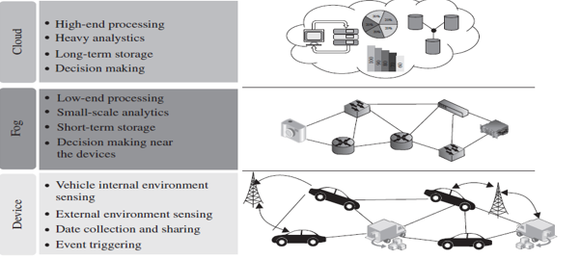
Figure 1: architecture of the vehicular IoT.

- Device layer
The device layer is the bottom-most layer, which consists of the basic infrastructure of the scenario of the connected vehicle. This layer includes the vehicles and road side units (RSU). These vehicles contain certain sensors which gather the internal information of the vehicles. On the other hand, the RSU works as a local centralized unit that manages the data from the vehicles.
- Fog layer
In vehicular IoT systems, fast decision making is pertinent to avoid accidents and traffic mismanagement. In such situations, fog computing plays a crucial role by providing decisions in real-time, much near to the devices. Consequently, the fog layer helps to minimize data transmission time in a vehicular IoT system.
- Cloud layer
Fog computing handles the data processing near the devices to take decisions instantaneously. However, for the processing of huge data, fog computing is not enough. Therefore, in such a situation, cloud computing is used. In a vehicular IoT system, cloud computing helps to handle processes that involve a huge amount of data. Further, for long-term storage, cloud computing is used as a scalable resource in vehicular IoT systems shown in figure 2 and 3.

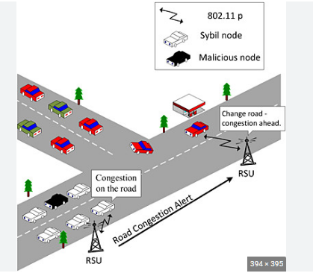
Figure 2: vehicular IoT system.

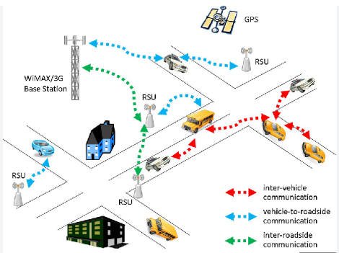
Figure 3: Scalable resource in vehicular IoT systems.

- COMPONENTS OF VEHICULAR IOT
The processes involved in a vehicular IoT have several components, along with many practical challenges. Modern cars come equipped with different types of sensors and electronic components. These sensors sense the internal environment of the car and transmit the sensed data to a processor. The on-road deployed sensors sense the external environment and transmit the sensed data to the centralized processor is presented in figure 4.

The main components are as follows:
- Sensors
- Satellite
- Wireless Connectivity
- Road side unit (RSU)
- Cloud and for Computing
- Analytic

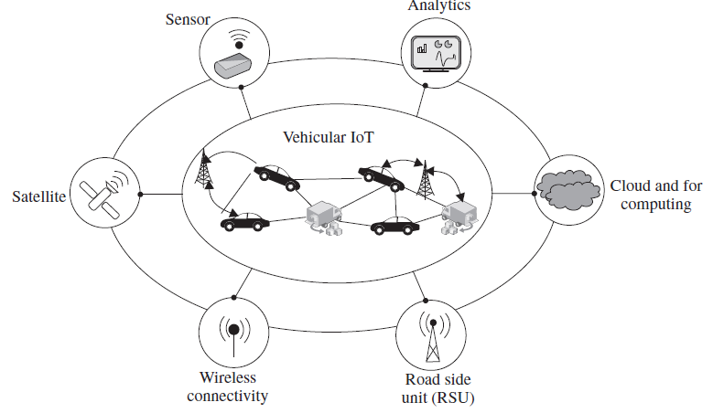
Figure 4: Components of vehicular IoT.

Sensors: In vehicular IoT, sensors monitor different environmental conditions and make the system more economical, efficient, and robust. Two types of sensors are used.

Internal sensors: The sensors are used within the vehicle to sense parameters that are directly associated with the vehicle. These internal sensors in a vehicle are connected to the processor board and actuator, to which they transmit the sensed data. Further, the sensed data are processed to take certain predefined actions. Examples of internal sensors are GPS, fuel gauge, ultrasonic sensors, proximity sensors, accelerometer, pressure sensors, and temperature sensors.
External sensors: It quantifies information like smart traffic systems and vacant parking lots outside the vehicle. The still images and videos from cameras are important inputs to generate decisions in a vehicular IoT system. Therefore, on-road cameras are widely used as external sensors to capture still images and videos. The captured images and videos are processed, either in the fog or in the cloud layer, to take certain pre-programmed actions. As an example, a camera sensor can capture the image of the license plate of an over speeding vehicle at a traffic signal.

Satellites: In vehicular IoT systems, automatic vehicle tracking and crash detection are among the important available features. Satellites help the system track vehicles and detect on-road crashes, detecting on-road congestions, and roadblocks.

Wireless connectivity: As vehicular IoT deals with connected vehicles, communication is an important enabling component. It carries the sensed data from multiple sensors to RS from RSUs to the cloud. In the vehicular IoT scenario, the high mobility of the vehicles necessitates the connectivity type to be wireless for practical and real-time data transmission. Different communication technologies, such as Wi-Fi, Bluetooth, and GSM, are common in vehicular IoT systems.

Road Side Unit (RSU): The RSU is a static entity that works collaboratively with internal and external sensors. The RSUs are equipped with sensors, communication units, and fog devices. To take decisions in real-time, the fog devices attached to the RSUs process the sensed data and take necessary action promptly. If a vehicular system involves heavy computation, the RSU transmits the sensed data to the cloud end. RSUs also work as intermediate communication agents between two vehicles.

Fog computing: It handles the lightweight processes geographically closer to the vehicles than the cloud. - It is used for faster decision-making in vehicular IoT systems. For example, find the traffic jam at closer locations with the help of sensed data. - Further, the congestion information can be shared by the RSU among another road vehicles, thereby suggesting that they avoid the congested road.

Cloud computing: It is used for heavyweight processes & handles a huge amount of data in Vehicular IoT systems. It provides more scalability of resources as compared to fog. The choice of the application of fog and cloud computing depends on the situation and applications in vehicular IoT systems. Determining regular on-road congestion, predictions are typically handled with the help of cloud computing. For the regular congestion prediction, the cloud end needs to process a huge amount of instantaneous data, as well as, historical data for that stretch of road spanning back a few months to years.

Analytics: In vehicular IoT, analytics is a crucial component. It is used to predict different dynamic and static conditions in the traffics. For example, strong data analytics is required to predict on-road traffic conditions that may occur at a location after an hour.

- Advantages of vehicular IoT
- Easy tracking: In a vehicular IoT system, the tracking of vehicles is straightforward; the system can collect information about the location and vehicle information.
- Fast decision-making: Most of the decisions in the connected vehicle environment are time critical. Fast and active decision-making is important for avoiding accidents. In the vehicular IoT environment, cloud and fog computing help to make fast decisions with the data received from the sensor-based devices.
- Connected vehicles: A vehicular IoT system provides an opportunity to remain connected and share information among different vehicles.
- Easy management: With the help of sensors, a communication unit, processing devices, and GPS, the management of the vehicle becomes easy. The connectivity among different components in a vehicular IoT enables systems to track every activity in and around the vehicle.
- Safety: Both the internal &external sensors placed at different locations provide safety to the vehicle, its occupants, as well as the people around it.
- Record: The record may be of any form, such as video footage, still images, and documentation. By taking advantage of cloud and fog computing architecture, vehicular IoT systems keep all the required records stored in their database.

Crime assistance in a smart IoT transportation system: This section provides a case study on smart safety in vehicular IoT infrastructure. The system highlights a fog framework for intelligent public safety in vehicular environments (fog-FISVER). The primary aim of this system is to Ensure Smart Transportation Safety (STS) in public bus services.

- HEALTHCARE IOT
The IoT made a huge impact on the medical field, especially wearable healthcare. These technologies have given rise to small, power-efficient, health monitoring and diagnostic systems. Currently, various IoT-enabled healthcare devices are in wide use around the globe for diagnosing human diseases, monitoring human health conditions, and caring /monitoring for elders, children, and even infants.
The IoT-based healthcare systems and services help to increase the quality of life for common human beings; in fact, it has a promising scope of revolutionizing healthcare in developing nations. IoT-based healthcare devices provide access and knowledge about human physiological conditions through handheld devices. In IoT-based healthcare services, the sensors are specifically designed to measure and quantify different physiological conditions of their users/patients.

- Architecture for healthcare IoT
The architecture into FOUR layers. The detailed description of these layers is shown in figure 5.
Layer 1: It contains different physiological sensors that are placed on the human body. These sensors collect the values of various physiological parameters. The physiological data are analysed to extract meaningful information.
Layer 2: It collects short-term storage and low-level processing data from layer 1. Layer 2 is equipped with local processing units (LPU). These units collect the sensed data from the physiological sensors attached to the body and process it based on the architecture’s requirements. Further, LPUs forward the processed data to Layer.

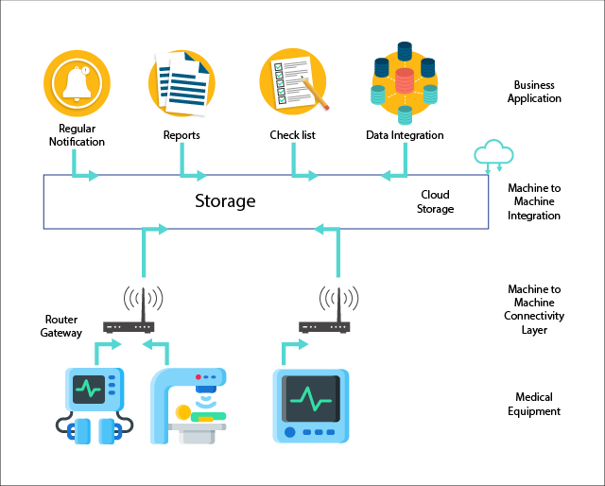
Figure 5: Architecture for healthcare IoT.

Layer 3: This layer consists of cloud architecture or high-end servers that perform application-specific high-level analytics. The data from multiple patients, which may be from the same or different locations, are accumulated in this layer. Postanalysis of data, some inferences or results are provided to the application in Layer 4.
Layer 4: The end-users directly interact with Layer 4 through receiver-side applications. The modes of accessibility of these services by an end user are typically through cell phones, computers, and tablets.

- Components of healthcare IoT
Sensors: Uses physiological sensors that collect the physiological parameters of the patient. Commonly used healthcare sensors.
Wireless Connectivity: Wireless connectivity is preferably used to communicate between the wearable sensors and the Local Processing Unit (LPU) with the help of Bluetooth and ZigBee. On the other hand, the communication between the LPU and the cloud or server takes place with Internet connectivity such as Wi-Fi and WLAN. The healthcare data are received by the end users with different devices such as laptops, desktops, and cell phones by use of 3G/4G/5G or Wi-Fi.
Privacy and Security: It is a major concern in healthcare IoT services. In a healthcare IoT architecture, several devices connect with the external world. If any of the devices are compromised, it may result in the theft of the health data of a patient, leading to serious security breaches and ensuing lawsuits. To increase the security of healthcare data, different healthcare service providers and organizations are implementing healthcare data encryption and protection schemes.
Analytics: It converts raw data into meaningful information. The doctors, nurses, and patients access healthcare information in a different customized format. Analytics is also used for diagnosing a disease from the raw physiological data available.
Cloud and Fog Computing: It plays a pivotal role in the storage of massive volumes of heterogeneous health data generated from the patient body. These data are used for checking the patient’s history, current health status, and future for diagnosing different diseases and the symptoms of the patient. To store health data in a healthcare IoT system, cloud storage space is used. Analytics of the stored data in cloud storage space is used for drawing various inferences. The major challenges in storage are security and delay in accessing the data.
Interface: The interface is the most important component for users in a healthcare IoT system. Among IoT applications, healthcare IoT is a very crucial and sensitive application. Thus, the user interface must be designed in such a way that it can depict all the required information clearly and, if necessary, reformat or represent it such that it is easy to understand. Moreover, an interface must also contain all the useful information related to the services.

- Advantages and risks of healthcare IoT
Real-time: A healthcare IoT system enables users, such as doctors, end users at the patient side, and staff in a healthcare unit, to receive real-time updates about the healthcare IoT components. It enables a doctor to observe a patient’s health condition in real-time even from a remote location and can suggest the type of care to be provided to the patient. On the other hand, users at the patient end can easily take different decisions, such as where to take a patient during critical situations. Moreover, the staff in a healthcare unit are better aware of the current situation of their unit, which includes the number of patients admitted, availability of the doctors and beds, total revenue of the unit, and other such information.
Low cost: Healthcare IoT systems facilitate users with different services at low cost. For example, an authorized user can easily find the availability of beds in a hospital with simple Internet connectivity and a web-browser-based portal. Moreover, multiple registered users can retrieve the same information simultaneously.
Easy management: Healthcare IoT is an infrastructure that brings all its end users under the same umbrella to provide healthcare services. However, healthcare IoT facilitates easy and robust management of all entities.
Automatic processing: Healthcare IoT enables end-to-end automatic processing in different units and also consolidates the information across the whole chain: from a patient’s registration to discharge.
Easy record-keeping: A healthcare IoT enables the user to keep these records in a safe environment and deliver them to the authorized user as per requirement. Moreover, these recorded data are accessible from any part of the globe.
Easy diagnosis: In a healthcare IoT system, the diagnosis of the disease becomes easier with the help of certain learning mechanisms along with the availability of prior datasets.

- Risk in healthcare IoT
The various risks associated with a healthcare IoT system.
Loss of connectivity: Intermittent connectivity may result in data loss, which may result in a life threatening situation for the patient. Proper and continuous connectivity is essential in a healthcare IoT system
Security: The healthcare system must keep the data confidential. This data should not be accessible to any unauthorized person. On the other hand, different persons and devices are associated with a healthcare IoT system. In such a system, the risk of data tampering and unauthorized access is quite high.
Error: In the healthcare system, errors in data may lead to misinterpretation of symptoms and lead to the wrong diagnosis of the patient. It is a challenging task to construct an error-free healthcare IoT architecture.

- AGRICULTURAL IOT
The development of an agricultural IoT has helped farmers enhance crop productivity and reduce the overhead of manual operations of the agricultural equipment in the fields.
The development of the IoT Agricultural loT systems perform.
- Crop Health Monitoring,
- Water Management,
- Crop Security,
- Farming Vehicle Tracking,
- Automatic Seeding, And
- Automatic Pesticide Spraying Over The Agricultural Fields.
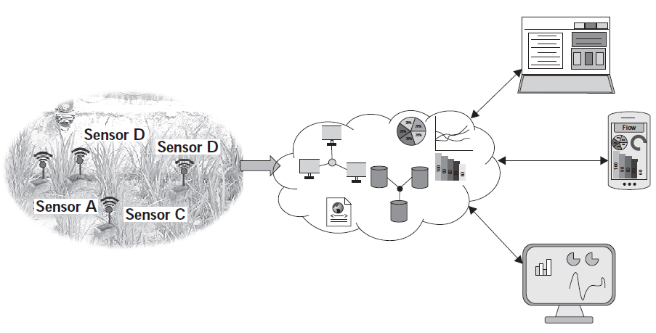
Figure 6. A basic architecture of an agricultural IoT.

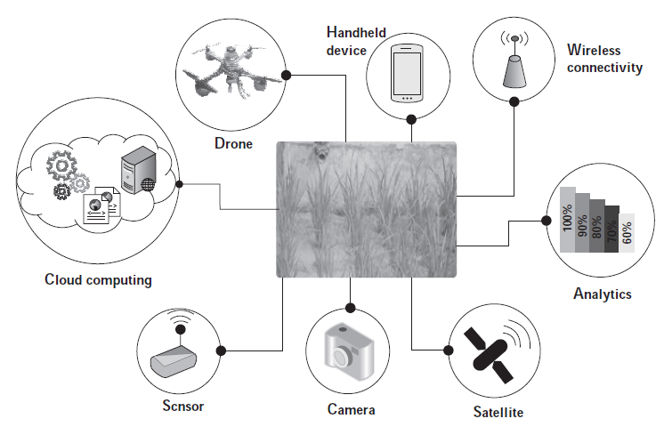
Figure 7: Components of agricultural IoT.

Different components such as analytics, drone, cloud computing, sensors, hand-held devices, and wireless connectivity enable agricultural IoT as depicted in the different components of an agricultural IoT are shown in figure 6 and 7 and are discussed as follows

Cloud computing: Sensors such as the camera, devices to measure soil moisture, soil humidity, and soil pH-level are used for serving different agricultural applications. These sensors produce a huge amount of agricultural data that need to be analyzed. Sometimes, based on the data analysis, action needs to be taken, such as switching on the water pump for irrigation. Further, the data from the deployed sensors are required to be stored on a long-term basis since it may be useful for serving future applications. Thus, for agricultural data analysis and storage, the cloud plays a crucial role.
Sensors: In previous chapters, we already explored different types of sensors and their respective requirements in IoT applications. We have seen that the sensors are the major backbone of any IoT application. Similarly, for agricultural IoT applications, the sensors are an indispensable component. A few of the common sensors used in agriculture are sensors for soil moisture, humidity, water level, and temperature.
Cameras: Imaging is one of the main components of agriculture. Therefore, multispectral, thermal, and RGB cameras are commonly used for scientific agricultural IoT. These cameras are used for estimating the nitrogen status, thermal stress, water stress, and crop damage due to inundation, as well as infestation. Video cameras are used for crop security.
Satellites: In modern precision agriculture, satellites are extensively used to extract information from field imagery. The satellite images are used in agricultural applications to monitor different aspects of the crops such as crop health monitoring and dry zone assessing over a large area.
Analytics: Analytics contribute to modern agriculture massively. Currently, with the help of analytics, farmers can take different agricultural decisions, such as estimating the required amount of fertilizer and water in an agricultural field and estimating the type of crops that need to be cultivated during the upcoming season. Moreover, analytics is not only responsible for making decisions locally; it is used to analyze data for the entire agricultural supply chain. Data analytics can also be used for estimating the crop demand in the market.
Wireless connectivity: One of the main components of agricultural IoT is wireless connectivity. Wireless connectivity enables the transmission of the agricultural sensor data from the field to the cloud/server. It also enables farmers to access various application services over handheld devices, which rely on wireless connectivity for communicating with the cloud/server.
Handheld devices: Over the last few years, e-agriculture has become very popular. One of the fundamental components of e-agriculture is a handheld device such as a smartphone. Farmers can access different agricultural information, such as soil and crop conditions of their fields and market tendency, over their smartphones. Additionally, farmers can also control different field equipment, such as pumps, from their phones
Drones: Currently, the use of drones has become very attractive in different applications such as surveillance, healthcare, product delivery, photography, and agriculture. Drone imaging is an alternative to satellite imaging in agriculture. In continuation to providing better resolution land mapping visuals, drones are used in agriculture for crop monitoring, pesticide spraying, and irrigation.

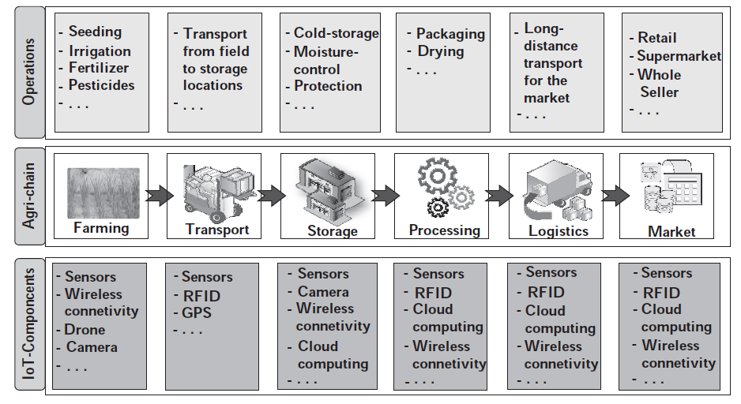
Figure 8: Use of IoT components in the agricultural chain
An agricultural food chain (agri-chain) represents the different stages that are involved in agricultural activity right from the agricultural fields to the consumers. a typical agricultural food chain with the different operations that are involved in it. Additionally, The figure 8 depicts the applications of different IoT components required for performing these agricultural operations. In the agri_chain, we consider farming as the first stage. In farming, various operations, such as seeding, irrigation, fertilizer spreading, and pesticide spraying, are involved.
For performing these operations, different IoT components are used. As an example, for monitoring the soil health, soil moisture and temperature sensors are used; drones are used for spraying pesticides; and through wireless connectivity, A report on on-field soil conditions is sent directly to a users’ handheld device or cloud. After farming, the next stage in the agri-chain is transport. Transport indicates the transfer of crops from the field to the local storage, and after that, to long-term storage locations. In transport, smart vehicles can automatically load and unload crops.

- SUMMARY
In agriculture Modern technological advancements and the rapid developments in IoT components have gradually increased agricultural productivity. Agricultural IoT enables the autonomous execution of different agricultural operations. The specific advantages of the agricultural IoT are as follows:
Seeding: IoT-based agricultural systems are capable of autonomous seeding and planting over the agricultural fields. These systems significantly reduce manual effort, error probability, and delays in seeding and planting.
Efficient fertilizer and pesticide distribution: Agricultural IoT has been used to develop solutions that are capable of applying and controlling the amount of fertilizers and pesticides efficiently. These solutions are based on the analysis of crop health.
Water management: The excess distribution of water in the agricultural fields may affect the growth of crops. On the other hand, the availability of global water resources is finite. The constraint of limited and often scarce usable water resources is an influential driving factor for the judicious and efficient distribution of agricultural water resources
Real-time and remote monitoring: Unlike traditional agriculture, in IoT-based farming, a stakeholder can remotely monitor different agricultural parameters, such as crop and soil conditions, plant health, and weather conditions. Moreover, using a smart handheld device (e.g. cell phone), a farmer can actuate on-field farming machinery such as a water pump, valves, and other pieces of machinery.
Easy yield estimation: Agricultural IoT solutions can be used to record and aggregate data, which may be spatially or temporally diverse, over long periods. These records can be used to come up with various estimates related to farming and farm management. The most prominent among these estimates is crop yield, which is done based on established crop models and historical trends.
Production overview: The detailed analysis of crop production, market rates, and market demand are essential factors for a farmer to estimate optimized crop yields and decide upon the essential steps for future cropping practices.

Reference:

- Akshi Kumar, Danda B. Rawat, Neeli Rashmi Prasad and Sumarga Kumar Sah Tyagi, “AI-Integrated Wireless Communications and Computing Trends for Next-Generation IoT”, Wireless Communications and Mobile Computing-Hindawi, 2023.
- Rajesh Kumar Kaushal, Rajat Bhardwaj, Naveen Kumar, Abeer A. Aljohani, Shashi Kant Gupta, Prabhdeep Singh and Nitin Purohit,
“Using Mobile Computing to Provide a Smart and Secure Internet of Things (IoT) Framework for Medical Applications”, Wireless Communications and Mobile Computing-Hindawi, Volume 2022 | Article ID 8741357 | https://doi.org/10.1155/2022/8741357, 2023.
- https://www.cogniteq.com/blog/top-5-applications-iot-agriculture.
- Rajesh Kumar Kaushal, Rajat Bhardwaj, Naveen Kumar, Abeer A. Aljohani , Shashi Kant Gupta, Prabhdeep Singh and Nitin Purohit, “Using Mobile Computing to Provide a Smart and Secure Internet of Things (IoT) Framework for Medical Applications”, Hindawi- Wireless Communications and Mobile Computing Volume 2022, Article ID 8741357, pp.13-22, https://doi.org/10.1155/2022/8741357, 2022.
- https://stl.tech/blog/what-are-the-applications-of-iot/
- Ebenezer Esenogho, Karim Djouani and Anish M. Kurien , “Integrating Artificial Intelligence Internet of Things and 5G for Next-Generation Smartgrid: A Survey of Trends Challenges and Prospect”, IEEE Access, DoI 10.1109/ACCESS.2022.3140595, Volume- 10, 2022.
- P. P. Raya and N. Kumar, ‘‘SDN/NFV architectures for edge-cloud oriented IoT: A systematic review,’’ Comput. Commun., vol. 169, pp. 129–153, Jan. 2021.
- Amir Masoud Rahmani, Suleyman Bayramov & Behnam Kiani Kalejahi, “Internet of Things Applications: Opportunities and Threats”, Wireless Personal Communications, Springer Publication, 122, pages451–476 (2022), 2022.
- https://www.manxtechgroup.com/internet-of-things-iot-applications-smart-agriculture/ .
- Sachin Kumar, Prayag Tiwari and Mikhail Zymbler, “Internet of Things is a revolutionary approach for future technology enhancement: a review”, Journal of Big Data, volume 6, Article number: 111 (2021), 2021.
- K. Shafique, B. A. Khawaja, F. Sabir, S. Qazi, and M. Mustaqim, ‘‘Internet of Things (IoT) for next-generation smart systems: A review of current challenges, future trends and prospects for emerging 5G-IoT scenarios,’’ IEEE Access, vol. 8, pp. 23022–23040, 2020.
- Z. Wang, Y. Liu, Z. Ma, X. Liu, and J. Ma, ‘‘LiPSG: Lightweight privacypreserving Q-learning-based energy management for the IoT-enabled smart grid,’’ IEEE Internet Things J., vol. 7, no. 5, pp. 3935–3947, Jan. 2020.

