**Cost-effective Well-suited Green Azadirachta Indica Reduced Ag-Tio2: A Potent Spherical Nano Scaffolds**

Dr. Aakash Singh1* Mr. Vikas Chaubey2 Dr. Anod Kumar Singh3 and Dr. P. K. Singh4

[aakashsingh.ucst@gmail.com](mailto:aakashsingh.ucst@gmail.com)1, [vikaschaubey0111@gmail.com2](mailto:vikaschaubey0111@gmail.com2),[anodsingh6789@gmai.com3](mailto:anodsingh6789@gmai.com3), [pksingh.lu@gmail.com](mailto:pksingh.lu@gmail.com)4

1,2IET, DSMNRU’ Lucknow, Uttar Pradesh India

3,4Department of Applied sciences and humanities, SMS, Lucknow, Uttar Pradesh, India.

***Abstract:***

The profitability of nanoparticles has been steadily increasing owing to their diverse use in catalysis, electronics, energy, & medicine. However, the conventional methods of preparing metallic nanoparticles often involve the use of harmful and combustible as reducing agents, chemicals. To address this concern and promote environmentally friendly production, a recent study presents an economically viable and environmentally conscious method for producing Ag-TiO2 nanoparticles is achieved through the sustainable synthesis process employing an extract from the Azadirachta Indica plant.

In this research work, Azadirachta Indica plant extract was utilized both as a reducing agent and a capping agent to facilitate the production of nanoparticles Ag-Tio2. High-purity isopropyl titanium and the synthesis of Silver-doped TiO2 nanoparticles was accomplished using an extract derived from the Azadirachta Indica plant. Within the span of an hour following the reaction's initiation, a noticeable change in the reaction mixture's color occurred, transitioning from a light brown hue to a green shade, signifying the rapid formation of Ag-TiO2 nanoparticles.

To verify the effective creation of Ag-TiO2 nanoparticles, the scientists utilized a range of methodologies. Characterization procedures encompassed FTIR (Fourier Transform Infrared Spectroscopy), UV-Vis (Ultraviolet-Visible Spectroscopy), XRD (X-ray Diffraction), EDX (Energy Dispersive X-ray Spectroscopy), and SEM (Scanning Electron Microscopy). FTIR analysis confirmed the creation of both Ag-TiO2 nanoparticles and the TiO2 phase was evident. UV-Vis spectroscopy provided further evidence of the successful synthesis of nanoparticles. XRD and SEM studies revealed that the nanoparticles exhibited a spherical morphology, with the size falling within the range suggested by electron microscopy data. Moreover, EDX analysis validated the presence of Ag ions successfully integrated into the Tio2 lattice, further supporting the successful formation of Ag-Tio2 nanoparticles. Overall, This research introduces a hopeful approach for environmentally friendly synthesis of Ag-TiO2 nanoparticles through the utilization of Azadirachta Indica plant extract, offering an eco-friendly alternative to traditional, toxic chemical-based approaches.

**Keywords-** Green synthesis, Ag-Tio2 Nps, *Azadirachta Indica*

**Introduction:**

Currently, nanobiotechnology is a crucial area of research focused on the fusion and design of nanoparticles, which possess unique characteristics such as small dimensions, large surface areas, specific chemical compositions, shapes, and sizes [1-2]. Over the past decade, the bio-synthesis of doped and monometallic nanoparticles has garnered noteworthy attention using plant-based methods due to their relieving, eco-friendly, and extensively photo-catalytic properties [3-6]. This approach also offers cost-effectiveness, allowing for increased bulk production of nanoparticles [7]. Eco-compatible biosynthesis of nanoparticles from plants has proven to be faster and results in more stable materials compared to other conventional methods [8-10].

The bioactive synthesis of nanoparticles from plants is considered a valuable and beneficial approach [11-13]. It offers several advantages, including safety, cleanliness, reliability, bio-eco-compatibility, speed, and the generation of ecological byproducts. This process ensures the production of nanoparticles without harmful residues or contaminants. The specific characteristics, composition, & the size of the nanoparticles is influenced by both the variety of plant extract utilized and the temperature employed during the oxide formation process.

The common name for Azadirachta Indica is Neem, and it belongs to the family Meliaceae. This plant species is found in countries such as India, Burma, Bangladesh, Thailand, Cambodia, Iran, Indonesia, Malaysia, Pakistan, Nepal, Sri Lanka, and Vietnam [14-16]. Neem has gained significant interest in the field of medicine Because of its diverse range of biological activities, which encompass antifungal, antibacterial, anticandidal, antiviral, and anticarcinogenic properties, the substance exhibits a wide array of effects. [17-22].

Throughout traditional practices, neem leaves have found application in the treatment of various health ailments, encompassing but not limited to eye disorders, leprosy, epistaxis, gastrointestinal discomfort, intestinal worms, diminished appetite, skin ulcers, cardiovascular disorders, diabetes, fever, gingivitis, and liver issues.

Furthermore, Neem is acknowledged for its cardioactive phytochemical attributes, encompassing an extensive array of cardenolide compounds that have been extracted from the Azadirachta Indica gigantea plant. Additionally, the plant houses a variety of biologically active constituents like triterpenoids, cardenolides, resins, flavonoids, proteolytic enzymes, tannins, sterols, and terpenes, which have the potential to contribute to metal reduction.

Titanium dioxide (TiO2) shows significant promise as a photocatalyst owing to its narrow band gap energy and robustness, rendering it appropriate for diverse uses like self-cleaning, eco-friendly decontamination, photocatalysis, and high quantum efficiency. The creation of TiO2 nanoparticles through the interaction of titanium with an extract from the Azadirachta Indica gigantea plant not only ensures biocompatibility but also aligns with environmental considerations.

In this investigation, a green synthesis approach was employed to create TiO2 nanoparticles, and their band gap characteristics exhibited variability in relation to the silver (Ag) content. The influence of Ag incorporation on the crystal structure of TiO2 nanoparticles was assessed through the utilization of SEM and spectroscopic methods. This study contributes to the ongoing exploration of nanoparticles and their doped variations, as well as their applications [22-26]. Notably, this research centers on assessing the effects of Ag-TiO2 nanoparticles, utilizing an aqueous extract from Azadirachta Indica.

In the course of the synthesis process, titanium isopropoxide was employed as the primary starting material, with Azadirachta Indica assuming roles as a reducing agent, stabilizer, and capping agent. The presence of capping agents within Azadirachta Indica significantly influenced the regulation of the dimensions and morphology of Ag-TiO2 nanoparticles, primarily achieved by augmenting surface energy and hindering agglomeration. As a consequence, innovative prospects emerged wherein the nanoparticles fulfilled dual roles as both reducers and surface stabilizers, ultimately yielding the development of Ag-TiO2 nanoparticles with a spherical configuration.

The optical attributes of the nanoparticles were assessed using UV-visible (UV-VIS) spectroscopy, while additional characterization was carried out employing X-ray diffraction (XRD), Fourier-transform infrared spectroscopy (FTIR), and Energy Dispersive X-ray Spectroscopy (EDX). Through these methodologies, significant revelations concerning the properties and structure of the produced Ag-TiO2 nanoparticles were garnered.

**Synthesis / Material and Methods:**

The synthesis of Ag-TiO2 nanoparticles involved utilizing high-quality chemicals for the process. Analytical-grade chemicals were used, and solvents along with double-distilled water were purified before use. The chemicals employed included titanium isopropoxide (sourced from Merck), silver nitrate (also from Merck), and concentrated hydrochloric acid (obtained from Hi-media).

The process consisted of the subsequent steps:

**I. Preparation of Azadirachta Indica gigantean plant extract-**

• Fresh foliage of Azadirachta Indica was gathered from the university campus.

• The accumulated leaves underwent a thorough washing process using fresh distilled water to eliminate particulate matter.

• Subsequently, the cleansed leaves were subjected to drying in an oven set at 60°C for a period of 2-3 hours.

• After achieving dryness, the leaves were pulverized into a fine powder.

• A quantity of 5 grams from the pulverized material was combined with 250 ml of deionized water within a 500 ml beaker.

• The mixture underwent boiling for a duration of 2-3 hours.

• The resulting solution was filtered and earmarked for the subsequent synthesis of Ag-TiO2 nanoparticles.

**II. Ag-TiO2 Nanoparticle Green Synthesis Procedure:**

• For the production of TiO2 nanoparticles, a blend was prepared by combining 50 ml of Azadirachta Indica plant extract solution, 5 grams of titanium isopropoxide, and 15 ml of 0.5 M silver nitrate solution in a 250 ml round bottom flask.

• The solution's pH was adjusted by introducing concentrated hydrochloric acid.

• The amalgamation of titanium isopropoxide and Azadirachta Indica plant extract was subjected to heating at 60°C for a span of 2 hours while maintaining stirring.

• Following the continuous agitation over 2 hours, the solution was left to settle overnight.

• The subsequent step involved subjecting the solution to centrifugation at 15000 rpm for 10 minutes to isolate the Ag-TiO2 nanoparticles.

• The separated nanoparticles underwent thorough washing cycles employing ethanol and water.

• Subsequently, the cleansed nanoparticles were subjected to drying in an 80°C hot air oven, followed by a calcination process at 600°C for 2 hours in a Muffle Furnace.

• Lastly, the particles were ground using a motor pistol to attain the desired particle size suitable for further characterizing purposes.

**Findings and Analysis-**

**1. UV-Visible Absorption Spectroscopy-**

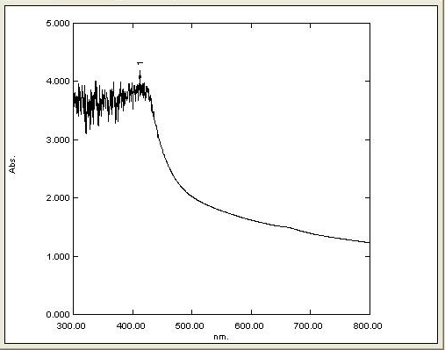

**Fig.1: UV-Visible Assessment**

The process of producing Ag-TiO2 nanoparticles by reducing aqueous metal ions with Azadirachta Indica plant extract was tracked using a dual-beam UV-visible spectrophotometer (Shimadzu Model Number: 1800). In the UV-Vis absorption spectra, an absorption peak emerged within the visible wavelength range, precisely at 390 nm, as depicted in Figure 1. This particular peak served as verification of the presence of Ti. Furthermore, an additional absorption peak became apparent at 430.0 nm, providing additional confirmation regarding the successful creation of TiO2 nanoparticles.

**2. FTIR Analysis:**



**Fig.2: FTIR Assessment**

The FTIR analysis substantiated the plant extract's multifaceted role in the Ag-doped TiO2 nanoparticle preparation, encompassing reduction, capping, and stabilization. The FTIR spectral examination spanned the 400 to 4000 cm-1 range, employing the KBr technique to capture spectra of the Azadirachta Indica plant leaf extract and the synthesized Ag-doped TiO2 nanoparticles.

Within the FTIR spectra, various distinct bands emerged. The band located around 705 cm-1 corresponded to the Ti-O stretching mode, serving as evidence for the presence of TiO2 in the nanoparticle composition. In the span of 3200 to 3600 cm-1, a notable band materialized, corresponding to the stretching vibration of the –OH bond, exhibiting a peak at 3452.27 cm-1. Another band at 1630 cm-1 was assigned to the first overtone of the fundamental stretching mode of –OH (see Fig. 2). These stretching vibrations were attributed to water molecules associating with the sample surface.

Furthermore, a discernible band at 1629.91 cm-1 was identified, linked to the Ag-O stretching vibration. This distinctive band was absent in the pure TiO2 scenario, underscoring the successful integration of Ag within the TiO2 nanoparticles. This substantiated the presence of Ag-doping within the TiO2 nanoparticles, a pivotal factor contributing to the nanoparticles' unique characteristics and prospective applications.

**3. X-ray Diffraction Examination (XRD):**

A meticulous X-ray diffraction (XRD) investigation was conducted to scrutinize the crystalline attributes of the resultant synthesized material. The outcomes divulged the generation of TiO2 nanoparticles existing as nanocrystals, with evident peaks emerging at 2θ = 33.21° and 58.97°, precisely corresponding to the (111) and (220) crystal planes, as depicted in Figure 3. The pattern observed in the XRD concurred with JCPDS card NO. 21-1272, lending affirmation to the nanoparticles' spherical morphology.

The X-ray diffraction findings showcased robust, intense, and sharply defined peaks, signifying the nanoparticles' high degree of crystallinity. The XRD profile exclusively displayed the presence of the TiO2 phase, devoid of any indications of impurity peaks.

The dimension of the crystalline form for both the pure and Ag-doped TiO2 nanocrystals was gauged employing Debye-Scherrer's equation:

D = Kλ/β cosθ

Wherein, D signifies the crystallite size of the TiO2 nanoparticles, λ denotes the wavelength of the X-ray source (0.1541 nm) utilized in XRD, β represents the full width at half maximum of the diffraction peak, and θ signifies the Bragg angle. The Scherrer's constant (K) is conventionally assigned a value within the range of 0.9 to 1.

This assessment furnished crucial insights into the crystalline arrangement and proportions of the synthesized TiO2 nanoparticles, contributing significantly to comprehending their attributes and plausible applications.

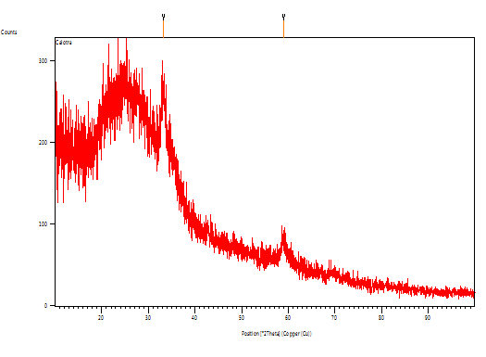

**Figure 3: X-ray Diffraction Investigation (XRD)**

**4. SEM and Energy Dispersive X-ray Analysis:**

Energy Dispersive X-Ray Analysis (EDX) is an X-ray technique employed to ascertain the elemental constitution of materials. Typically conducted as an adjunct to Electron Microscopy instruments, such as Scanning Electron Microscopy (SEM) or Transmission Electron Microscopy (TEM), this technique harnesses the microscopy apparatus's imaging prowess to pinpoint the specimen under scrutiny. The EDX process generates spectra displaying peaks corresponding to the constituent elements within the examined sample, thereby divulging insights into its authentic makeup.

Within the SEM imagery, the synthesized nanoparticles manifested dimensions within the nano scale, approximating sizes of around 22 nm, 15 nm, and 165 nm on the surface, adopting a spherical configuration. EDX analysis offers an avenue for corroborating the nanoparticles' elemental composition, thus corroborating their chemical attributes and potential utilizations.

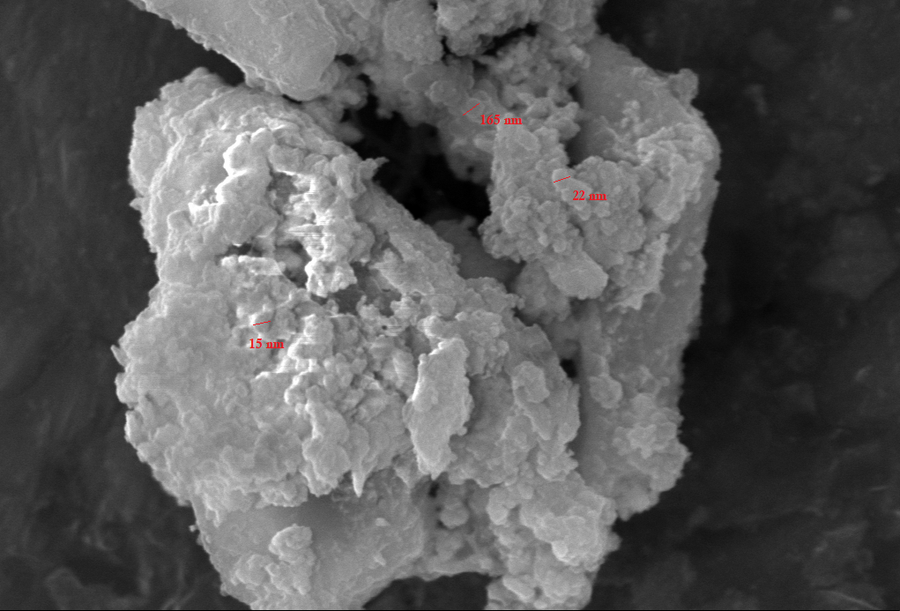 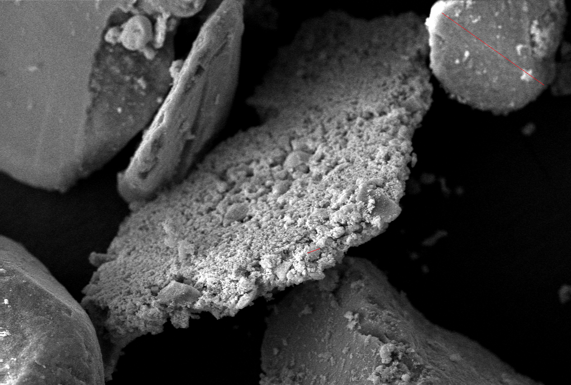

**Fig.4 Synthesized TiO2 nanoparticles**



**Figure 5: Scanning Electron Microscopy (SEM) and Elemental Analysis using Energy Dispersive X-ray (EDX)**

The information derived from Energy Dispersive X-Ray Analysis (EDX) encompasses spectra revealing peaks that correspond to the elemental constituents found within the examined sample. In this particular study, Figure 5 visually represents the outcomes of the EDX analysis, unequivocally validating the presence of metallic zinc oxide within the ZnO nanoparticles that were biofabricated.

The composition ascertained through the EDX analysis encompasses Titanium, Silver, Oxygen, Chlorine, Sulphur, and Carbon. The detection of trace amounts of carbon signifies the participation of plant-derived phytochemical groups in the reduction and encapsulation process of the synthesized TiO2 nanoparticles, as highlighted in Figure 4.

These EDX findings yield invaluable insights into the elemental makeup of the produced nanoparticles and suggest the occurrence of specific compounds derived from the plant that contribute to the reduction and stabilization of the TiO2 nanoparticles during the biosynthesis course.

**Concluding Remarks:**

To recapitulate, we have successfully devised an environmentally friendly and practical method for producing spherical Ag-doped Ti Nanoparticles employing the unique Azadirachta Indica plant. Notably, this marks the initial instance of utilizing this plant for the synthesis. The plant demonstrates a crucial role in acting as a capping agent for the surface of the Ag-TiO2 nanoparticles.

**Acknowledgments:**

The author extends gratitude to the MRC at MNIT Jaipur and IET DSMNRU in Lucknow for their support in conducting the spectral and experimental analyses. Additionally, our appreciation goes to the Department of Physics and the Research Laboratory at the School of Management Sciences in Lucknow, India.

**References**

1. D. S. Goodsell, Bionanomedicine in action: In Bionanotechnology: Lessons from nature.
   1. John Wiley & Sons, Inc., Hoboken, New Jersey, USA, **2004**.
2. R. P. Singh, V. K. Shukla, Raghvendra, S. Yadav, P. K. Sharma, P. K. Singh, A. C. Pandey, Biological approach of zinc oxide nanoparticles formation and its characterization, *Advanced Materials Letters,* vol. 2, no.4, pp.313-317, **2011**.
3. A. A. Moosa, A. M. Ridha, M. Al-kaser, Process Parameters for Green Synthesis of Silver Nanoparticles using Leaves Extract of Aloe Vera Plant, *Int. J. of Multidisciplinary and Current research,* vol. 3 pp.966–975, **2015**.
4. K. Elumalai, S. Velmurugan, S. Ravi, V. Kathiravan, G. A. Raj, Bio-approach: Plant mediated synthesis of ZnO nanoparticles and their catalytic reduction of methylene blue and antimicrobial activity, *Advanced Powder Technology*, vol. 26, pp. 1639- 1651, **2015**.
5. S. Ambika, M. Sundrarajan, Plant-extract mediated synthesis of ZnO nanoparticles using Pongamia pinnata and their activity against pathogenic bacteria, *Advanced Powder Technology,* vol 26, pp. 1–6, **2015**.
6. A. MA, E. CW, R. CL, Green chemistry and the health implications of nanoparticles, *Green Chem.* vol 8, pp. 417–432, **2006**.
7. S. S. Shankar, A. Rai, A. Ahmad, M. Sastry, Rapid synthesis of Au, Ag, and bimetallic Au core-Ag shell nanoparticles using neem (*Azadirachta indica*) leaf broth. *J. Colloid Interf. Sci.,* vol 275,no. 2, pp. 496-502, **2004.**
8. O. V. Kharissova, H.V. R. Dias, B. I. Kharisov, B.O. Pérez, V. M. J. Pérez, The greener synthesis of nanoparticles, *Trends in Biotechnology,* vol 31, pp. 240–248, **2013**.
9. A. Bankar, B. Joshi, A. R. Kumar, S. Zinjarde, Banana peel extract mediated novel route for the synthesis of silver nanoparticles, Colloids and Surfaces A: Physicochemical and Engineering Aspects. vol 368, pp. 58–63, **2010**.
10. H. P. Singh, S. Sharma, S. K. Sharma, R. K. Sharma, Biogenic synthesis of metal nanocatalysts using Mimosa pudica leaves for efficient reduction of aromatic nitrocompounds, *RSC* *Advances*, vol 4, pp. 37816, **2014**
11. A. T. Harris, R. Bali, On the formation and extent of uptake of silver nanoparticles by live plants. *J. Nanopart. Res.* vol 10,no. 4, pp. 691-695, **2008**.
12. K. N. Thakkar, S. S. Mhatre, R. Y. Parikh, Biological synthesis of metallic nanoparticles. *Nanomedicine: Nanotechnol. Biol. Med.*, vol 6, no 2, pp. 257-262, **2010**.
13. S. Iravani, Green synthesis of metal nanoparticles using plants. *Green Chem*, vol 10, pp. 2638-2650, **2011.**
14. P. C. Sharma, M. B. Yelne, T. J. Dennis, *Data base on medicinal plants used in ayurveda,* vol. 1, pp. 70-71 , **2008**.
15. N. Ahmad, S. Sharma, Green Synthesis of Silver Nanoparticles Using Extracts of Ananas comosus, *Green and Sustainable Chemistry,* vol. 2, pp.141-147, **2012**.
16. G. Alagumuthu, R. Kirubha, Green synthesis of silver nanoparticles using Cissus quadrangularis plant extract and their antibacterial activity, *University* *International Journal of Nanomaterials and Biostructures*, vol. 2, no. 3, pp. 30-33, **2012**.
17. K. B. Ishnava, J. B. Chauhan, A. A. Garg , A. Thakkar, Antibacterial and phytochemical studies on *Azadirachta Indica*  *gigantia* ( L .)R.Br. latex against selected cariogenic bacteria *Saudi J Biol Sci,* vol 19, no 1, pp. 87-91, **2012**
18. N. P. Manandhar, M. P. Manandhar, Folklore medicine of Chitwan District, Nepal. *Ethnobotany*, vol 2, pp. 33, **1990**.
19. J. S. Oliveira, L. V. osta-Lotufo, D. P. Bezerra, N. M. Alencar, J. D. Marinho-Filho, I. S. Figueiredo, In vivo growth inhibition of sarcoma 180 by latex proteins from *Azadirachta Indica*  procera. *Naunyn Schmiedebergs Arch Pharmacol* vol. 382, no 2, pp. 139-149, **2010**.
20. C. D. T. De Freitas, F. C. S. Nogueira, I. M. Vasconcelos, J. T. A. Oliveira, G. B. Dumont, M. V. Ramos, Osmotin purified from the latex of *Azadirachta Indica*  *procera*: biochemical characterization, biological activity and role in plant defense. *Plant Physiol Biochem,* vol 49 no. 7, pp. 738 -743, **2011**.
21. R. Sehgal, S. Arya, V. L. Kumar, Inhibitory effect of extracts of latex of Azadirachta Indica procera against *Candida* *Albicans*: a prilimary study. *Indian J Pharmacol* vol. 37 no.5, pp. 334-335, **2005**.
22. M. C. C. Silva, A. B. da Silva, F. M. Teixeira, P. C. P. D. Sousa, R. M. M. Rondon , J. E. R. H. Jú nior, Therapeutic and biological activities of *Azadirachta Indica*  *Procera* (AIt ). R. Br. *Asian Pac J Trop* *Med* vol 3, no.4, pp. 332-336, **2010**.
23. D. Bhardwaj, A. Singh, R. Singh, Eco-compatible sonochemical synthesis of 8-aryl-7,8-dihydro- [1,3]- dioxolo[4,5-g] quinolin-6(5H)-ones using green TiO2. *Heliyon*, vol. 5, no. 2, 1256-62, **2019**.
24. S. Munjal, A. Singh, Facile and Green Synthesis of Iron and Silver supported Iron Nanoparticles from Novel Plant Extract of Aegle marmelos: Anti-bacterial and Anti-fungal Activity, *Journal of Drug Delivery and Therapeutics,* vol 9, no(3-s), 334-341, **2019**.
25. S. Bhatt, A. Singh, S. Munjal and P. Kumar Poonia, Plant mediated bio synthesis of silver nanoparticles: Characterization and antimicrobial activity. Int. J. Chem. Stud.,vol 6, no 6, 2163-2167, **2018**.
26. S. Munjal, P. Srivastava, A. Singh, P. Jyani, P. S. Gour, Synthesis And Bio-Physical Characterization Of Mg Doped Zn Nanoparticles From Novel Plant , IJIRG, vol 9, no 3, 13-20, **2020**.