FUTURISTIC TRENDS IN MEDICAL SCIENCES- NEWER APPROACHES TO MANAGEMENT OF GROIN HERNIAS

AUTHORS
1.COL (DR) VIVEK UPADHYAY
MS GENERAL SURGERY
HOD MILITARY HOSPITAL, SECUNDERABAD
2.WG CDR (DR) HARSH PREET
MS , DNB GENERAL SURGERY
14 AIRFORCE HOSPITAL, HYDERABAD

INTRODUCTION
Hernia is a common problem of the modern world with its incidence more in developing countries. Inguinal hernia is the most common groin hernia repaired worldwide. Hernia has an incidence ranging from 5%-7%. The prevalence of hernia is far greater in developing countries like India amounting to a major health care burden. Of all groin hernias, around 75% are inguinal hernias^{[1,2]}. The repair of the groin hernia is therefore a commonly performed surgery worldwide.
Hernia is derived from the Latin word for rupture. A hernia is defined as an abnormal protrusion of an organ or tissue through a defect or ring in its surrounding walls. Although a hernia can occur at various sites of the body, these defects most commonly involve the abdominal wall, particularly the inguinal region. It follows that the surgeon must understand the boundaries of the ring, the content of the hernia, and at which surgico-anatomical layer this hernia occurs and the other implicated surgico-anatomical layers.
A hernia is reducible when its contents can be replaced within the surrounding musculature, and it is irreducible or incarcerated when it cannot be reduced. A strangulated hernia has compromised blood supply to its contents, which is a serious and potentially fatal complication.
INCIDENCE
The lifetime risk of inguinal hernia is 27% in men and 3% in women. Of inguinal hernia repairs, 90% are performed in men and 10% in women. Inguinal hernias are five times more common than femoral hernias. The most common subtype of groin hernia in men and women is the indirect inguinal hernia . In men, indirect hernias predominate over direct hernias at a ratio of 2 : 1.Although femoral hernias occur more frequently in women than in men, inguinal hernias remain the most common hernia in women. Femoral hernias are rare in men. Ten percent of women and 50% of men who have a femoral hernia have or will develop an inguinal hernia. Inguinal hernias occur more commonly on the right side. This is attributed to a delay in atrophy
of the processus vaginalis after the normal slower descent of the right testis to the scrotum during fetal development. The prevalence of hernias increases with age and also the likelihood of strangulation and need for hospitalization also increase with aging. Strangulation, the most common serious complication of a hernia, occurs in only 1% to 3% of groin hernias and is more common at the extremes of life. [.^{3,4,5]}
TYPES
Inguinal hernias are generally classified as indirect, direct, and femoral based on the site of herniation relative to surrounding structures. Indirect hernias protrude lateral to the inferior epigastric vessels, through the deep inguinal ring. Direct hernias protrude medial to the inferior epigastric vessels, within Hesselbach’s triangle.
The Nyhus classification categorizes hernia defects by location, size, and type:
Type I - Indirect hernia; internal abdominal ring normal; typically in infants, children, small adults
Type II Indirect hernia; internal ring enlarged without impingement on the floor of the inguinal canal; does not extend to the scrotum
Type IIIA Direct hernia; size is not taken into account
Type IIIB Indirect hernia that has enlarged enough to encroach upon the posterior inguinal wall; indirect sliding or scrotal hernias are usually placed in this category because they are commonly associated with extension to the direct space; also includes pantaloon hernias
Type IIIC Femoral hernia
Type IV Recurrent hernia; modifiers A–D are sometimes added, which correspond to indirect, direct, femoral, and mixed, respectively
RELEVANT SURGICAL ANATOMY
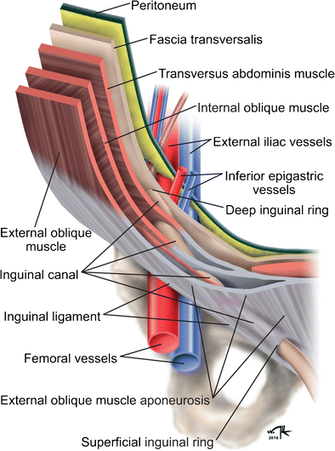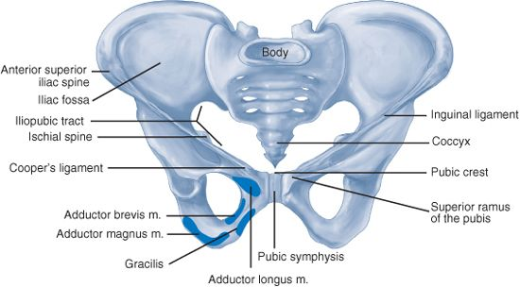
The inguinal canal is an approximately 4- to 6 cm-long cone shaped region situated in the anterior portion of the pelvic basin . The canal begins on the posterior abdominal wall, where the spermatic cord passes through the deep (internal) inguinal ring, a hiatus in the transversalis fascia. The canal concludes medially at the superficial (external) inguinal ring, the point at which the spermatic cord crosses a defect in the external oblique aponeurosis. The boundaries of the inguinal canal are comprised of the external oblique aponeurosis anteriorly, the internal oblique muscle laterally, the transversalis fascia and transversus abdominis muscle posteriorly, the internal oblique muscle superiorly, and the inguinal (Poupart’s) ligament inferiorly. The spermatic cord traverses the inguinal canal, and it contains three arteries, three veins, two nerves, the pampiniform venous plexus, and the vas deferens. It is enveloped in three layers of spermatic fascia. Additional important structures surrounding the inguinal canal include the iliopubic tract, the lacunar ligament, Cooper’s ligament, and the conjoined tendon. The vascular space is situated between the posterior and anterior laminae of the transversalis fascia, and it houses the inferior epigastric vessels. The inferior epigastric artery supplies the rectus abdominis. It is derived from the external iliac artery, and it anastomoses with the superior epigastric, a continuationof the internal thoracic artery. The epigastric veins course parallel to the arteries within the rectus sheath, posterior to the rectus muscles. Inspection of the internal inguinal ring will reveal the deep location of the inferior epigastric vessels. Nerves of interest in the inguinal region are the ilioinguinal, iliohypogastric, genitofemoral, and lateral femoral cutaneous nerves.
The preperitoneal anatomy seen in laparoscopic hernia repair led to characterization of important anatomic areas of interest, known as the triangle of doom, the triangle of pain, and the circle of death .
The triangle of doom is bordered medially by the vas deferens and laterally by the vessels of the spermatic cord. The contents of the space include the external iliac vessels, deep circumflex iliac vein, femoral nerve, and genital branch of the genitofemoral nerve. The triangle of pain is a region bordered by the iliopubic tract and gonadal vessels, and it encompasses the lateral femoral cutaneous, femoral branch of the genitofemoral, and femoral nerves. The circle of death is a vascular continuation formed by the common iliac, internal iliac, obturator, inferior epigastric, and external iliac vessels^{[6]}.

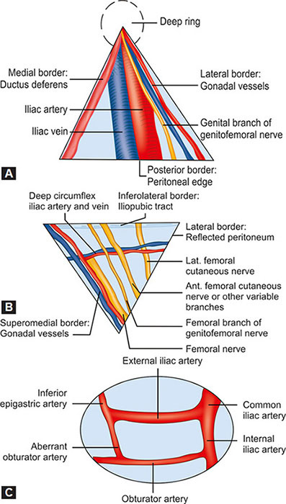
Triangle of Doom (A), Triangle of Pain(B) & Circle of Death(C)

APPROACH TO MANAGEMNT OF INGUINAL HERNIAS
Surgical repair is the definitive treatment of inguinal hernias; however, operation is not necessary in a subset of patients. Nonoperative management is an appropriate consideration in minimally symptomatic patients. A nonoperative strategy is safe for minimally symptomatic inguinal hernia patients, and it does not increase the risk of developing hernia complications and these include trusses and recumbent position^{[7,8]}.
HISTORICAL OR OPEN APPROACH
It is subdivided into techniques that employ prostheses to create a tension-free repair and those that reconstruct the inguinal floor using native tissue. Tissue repairs are indicated when the use of prosthetic material is contraindicated, (contamination or strangulation).
Exposure of the anterior inguinal region is common to the open approaches. An oblique or horizontal incision is performed over the groin followed by a small incision in the external oblique aponeurosis parallel to the direction of the muscle fibers. Then the flaps of the external oblique aponeurosis are elevated,the interior oblique fibers are dissected followed by dissection of the inferior flap to reveal the shelving edge of the inguinal ligament. The iliohypogastric and ilioinguinal nerves are identified and preserved.. The pubic tubercle is identified and the cord structures are atraumatically dissected off and the cord is elevated 2 cm over the pubic symphysis in an avascular plane. An indirect hernia sac will generally be found on the anterolateral surface of the spermatic cord. The floor of the inguinal canal is fully assessed for direct hernias. The floor of the inguinal canal is fully assessed for direct hernias. If a hernia is not visualized upon entry into the inguinal canal, the preperitoneal space should be explored for a femoral hernia. At this point, the inguinal canal is reconstructed, either with native tissue or with prostheses.
TISSUE BASED HERNIORRHAPHY
Tissue-based herniorrhaphy is a suitable alternative when prosthetic materials cannot be used safely. The Bassini repair was an historic advancement in operative technique. Its current use is limited, as modern techniques reduce recurrence. The original repair includes dissection of the spermatic cord, dissection of the hernia sac with high ligation, and extensive reconstruction of the floor of the inguinal canal .
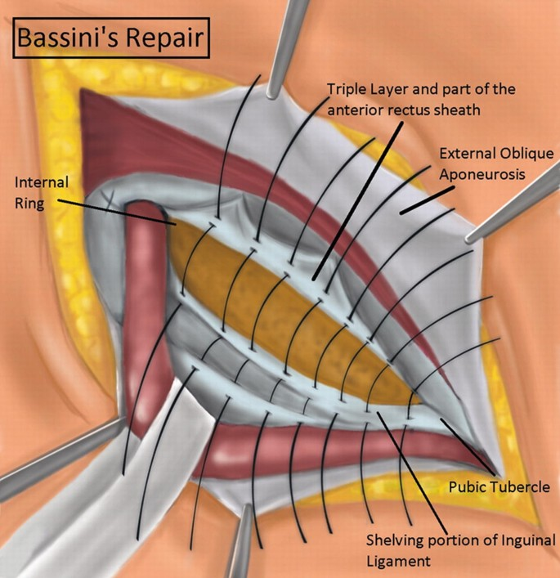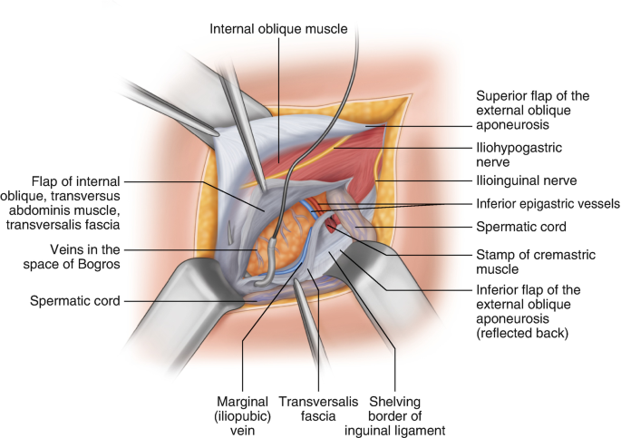
Bassini Repair Shouldice repair
The Shouldice repair recapitulates principles of the Bassini repair and its distribution of tension over several tissue layers results in lower recurrence rates. At the pubic tubercle, the iliopubic tract is sutured to the lateral edge of the rectus sheath using a synthetic, non absorbable, monofilament suture. This continuous suture progresses laterally, approximating the edge of the inferior transversalis flap to the posterior aspect of the superior flap. At the internal inguinal ring, the suture continues back in the medial direction, approximating the edge of the superior transversalis fascia flap to the shelving edge of the inguinal ligament. At the pubic tubercle, this suture is tied to the tail of the original stitch. The next suture begins at the internal inguinal ring, and it continues medially, apposing the aponeuroses of the internal oblique and transverses abdominis to the external oblique aponeurotic fibers. At the pubic tubercle, the suture doubles back through the same structures laterally toward the tightened internal ring.
In McVay repair A 2- to 4-cm relaxing incision is made in the anterior rectus sheath vertically from the pubic tubercle. This incision is essential to reduce tension on the repair; however, it may result in increased postoperative pain and higher risk of ventral abdominal herniation. Using either interrupted or continuous suture, the superior transversalis flap is then fastened to Cooper’s ligament, and the repair is continued laterally along Cooper’s ligament to occlude the femoral ring. Lateral to the femoral ring, a transition stitch is placed, affixing the transversalis fascia to the inguinal ligament. The transversalis is then sutured to the inguinal ligament laterally to the internal ring.

Mcvay repair

TRANSITION TO PROSTHETIC REPAIRS
Tension-free prosthetic mesh repairs signified a paradigm shift in the surgical concept of inguinal hernia. Mesh-based hernioplasty is the most commonly performed general surgical procedure
The Lichtenstein technique expands the domain of the inguinal canal by reinforcing the inguinal floor with a prosthetic mesh, thereby minimizing tension in the repair. The inguinal canal is dissected to expose the shelving edge of the inguinal ligament, the pubic tubercle, and sufficient area for mesh. The medial edge of the mesh is affixed to the anterior rectus sheath such that it overlaps the pubic tubercle by 1.5 to 2 cm. This refinement to the original Lichtenstein technique minimizes medial recurrence^{[9]}.
Plug and Patch Technique A modification of the Lichtenstein repair in which Prior to placing the prosthetic mesh patch over the inguinal floor, a three dimensional prosthetic plug is placed in the space previously occupied by the hernia sac. the plug is placed alongside the spermatic cord through the internal ring. Prosthetic plugs of various sizes are available, and one of appropriate size is fixed to the margins of the internal ring with interrupted sutures^{[10,11]}
Prolene Hernia System The Prolene Hernia System (PHS) repair provides reinforcement to the anterior and posterior aspects of the abdominal wall. With an indirect hernia, the sac is dissected from the spermatic cord, and the preperitoneal space is bluntly dissected through the internal ring. With a direct hernia, the transversalis fascia is opened at the defect, and the preperitoneal space is bluntly dissected to create space for the mesh. The advantage of the preperitoneal mesh position is that increased intra-abdominal pressure pushes the mesh into closer apposition to the abdominal wall.
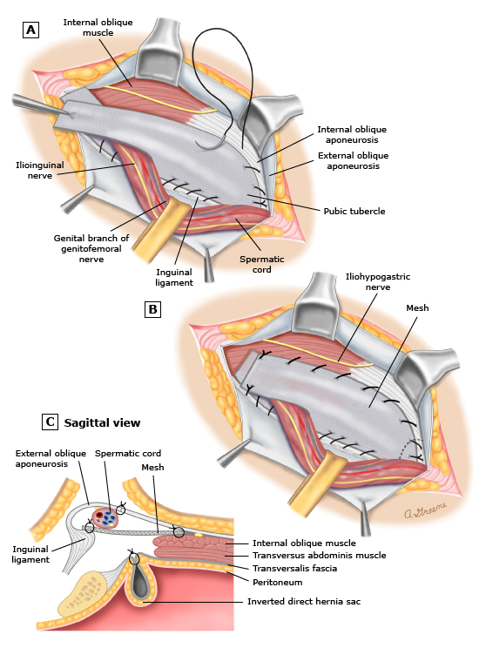
Lichtenstein technique
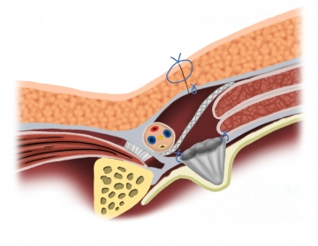

Plug and patch repair
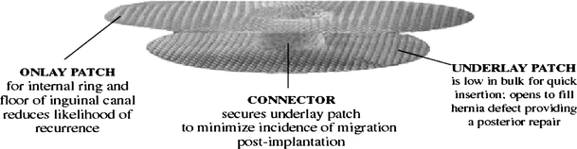
Prolene Hernia System
ADVENT OF LAPROSCOPIC TECHNIQUES
Laparoscopic inguinal hernia repairs reinforce the abdominal wall via a posterior approach. Principal laparoscopic methods include the transabdominal preperitoneal (TAPP) repair, the totally extraperitoneal (TEP) repair, and the less commonly performed intraperitoneal onlay mesh (IPOM) repair.
Most surgeons agree that the laparoscopic approach to bilateral or recurrent inguinal hernias is superior to the open approach^{[12]}. International Endohernia Society (IEHS) guidelines offer a Grade A recommendation that TEP and TAPP are preferred alternatives to Lichtenstein repair for recurrent hernias after open anterior repair.^{[13]}
Port placement in TAPP(A) & TEP(B)
The transabdominal approach(TAPP) confers the advantage of an intraperitoneal perspective, which is useful for bilateral hernias, large hernia defects, and scarring from previous lower abdominal surgery. For bilateral inguinal hernia repair, bilateral peritoneal incisions are advisable, leaving a midline bridge of tissue to avoid injuring a potential patent urachus. The inferior edge of incised peritoneum is retracted, and the preperitoneum is dissected to expose the spermatic cord. If a direct hernia is encountered, the sac is inverted and fixed to Cooper’s ligament to prevent development of hematoma or seroma. An indirect hernia sac will usually protrude anterior to the spermatic cord. In this case, the sac is grasped and elevated superiorly from the cord and the space below is developed bluntly to allow for mesh placement. The sac is dissected from its adhesions, and the cord is skeletonized. The mesh is rolled lengthwise and placed through the 12-mm trocar and unrolled in the preperitoneal space .The prosthesis can now be secured with staples, tacks or glue. The medial edge is stapled or tacked to the soft tissue around the contralateral pubic tubercle and the symphysis pubis. The medial , inferior border is secured just above Cooper ligament. Next the prosthesis is secured along the superior border to the posterior rectus sheath and transversalis fascia at least 2cm above the hernia defect. The last step is to cover the prosthesis by closing the peritoneum with sutures, tacks, staples or glue.
Incision of peritoneum Entering lateral inguinal space Hernial sac dissection
Pseudosac dissection in direct hernia Mesh is rolled and inserted Smoothed out mesh
Mesh is fixed to Cooper’s Ligament Securing the superior border of mesh Peritoneal closure
Totally Extraperitoneal Procedure(TEP).The advantage of the TEP repair is the access to the preperitoneal space without intraperitoneal infiltration. Consequently, this approach minimizes the risk of injury to intra-abdominal organs and port site herniation through an iatrogenic defect in the abdominal wall. As with TAPP, TEP is indicated for repair of bilateral inguinal hernias or for unilateral hernias when scarring makes the anterior approach challenging. A small horizontal incision is made inferior to the umbilicus. Subcutaneous tissue is dissected to the level of the anterior rectus sheath, which is then incised lateral to the linea alba. The rectus muscle is retracted superolaterally, and a dissecting balloon is advanced through the incision toward the pubic symphysis. Under direct visualization with a 30° laparoscope, the balloon is inflated slowly to bluntly dissect the preperitoneal space . The dissecting balloon is replaced with a 12-mm balloon trocar, and pneumopreperitoneum is achieved by insufflation to 15 mmHg. A 5-mm trocar is placed suprapubically in the midline, and another is placed inferior to the insufflation port . The patient is placed in the Trendelenburg position, and the operation proceeds in an identical fashion to TAPP.
The balloon is then inflated to create a working space
Preperitoneal space dissection-the balloon dissector is inserted into the preperitoneal space amd advanced to the pubic symphysis

The balloon deflated , removed and replaced with a Hasson or Balloon tip cannula. The preperitoneal working space is visualized with the laproscope and other ports are placed
Blunt graspers and gentle traction are used to reduce indirect sacs as they course with the cord structures through the internal inguinal ring

Intraperitoneal Onlay Mesh Procedure(IPOM) IPOM procedure permits the posterior approach without preperitoneal dissection. It is an attractive procedure in cases where the anterior approach is unfeasible, in recurrent hernias that are refractory to other approaches, or where extensive preperitoneal scarring would make TEP or TAPP challenging. The sac itself is not inverted from the preperitoneal space. Instead, mesh is placed directly over the defect and fixed in place with sutures or spiral tacks.

NOVELISTIC APPROACHES TO HERNIA REPAIR

Desarda technique The Desarda technique of inguinal hernia repair uses live muscle tissue adjacent to the hernia site to repair and reinforce the weakened area. There is no synthetic mesh material used in this operation. A strip of tissue is separated from the external oblique aponeurosis keeping its insertion and continuity with the muscle intact. This strip is sutured to the inguinal ligament below and the internal oblique muscle or aponeurosis above. This strip of natural tissue now covers the area of the hernia in the posterior wall of the inguinal canal. The advantages of this repair that it is performed with the patient's own tissue(natural tissue repair), avoidance of entry into the abdomen and potential injury to intestine or major blood vessels, Extraordinarily low risk of infection or major complications and it can be performed under local or regional anesthesia.^{[14,15]}
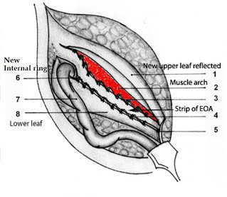
Desarda Technique
NOTES Natural orifice transluminal endoscopic surgery (NOTES) continues to be explored as a future option for general surgery. Proponents of this approach claim a potential benefit in cosmesis, decreased pain, early return to work, decreased port site complications, and specific advantages in the obese population. Most agree that NOTES operations for hernia repair increase the risk of a major complication, and these techniques should strongly be considered as experimental for now and performed under institutional research protocols^{[16]}

Robotic surgery The use of the da Vinci robot has expanded since its approval by the Food and Drug Administration in 2000^{[17]}. Initially applied for hysterectomy and prostatectomy, it has recently been used for an increasing number of general surgery procedures, including Nissen fundoplication, single site cholecystectomy, colectomy, and ventral or incisional hernia repair. The magnified, three-dimensional high-definition view, computer-aided elimination of tremor, and seven degrees of freedom at the distal ends of the instruments with superior maneuverability, have led to its increasing adoption^{[18]}. Many surgeons are currently utilizing the robot simply to facilitate their ability to suture the hernia defect closed, and thus place the mesh as an intraperitoneal onlay. The advantages include shorter hospital stay, less blood loss and less infection rates.^{[19]}
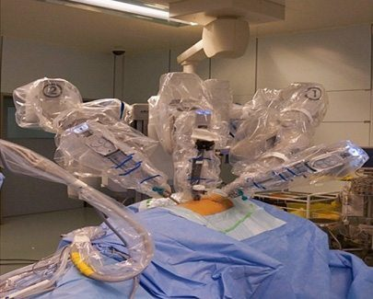
Da Vinci Robot
ADVANCEMENTS IN MESH
The mesh materials have been classified based on its biological response and handling characteristics. These includes non-absorbable and synthetic, non-absorbable and synthetic with a barrier, synthetic and partially absorbable, combined and biological materials.
Non-absorbable and synthetic materials
Polypropylene(PP) is a nonabsorbable polymer which are presented in both coated and uncoated forms and the main disadvantage is its heavy-weight ,therefore, abdomen is present with more foreign body and its resultant intense inflammatory response lead to side effects and complications includes formation of thick scar and contraction of the mesh, lead to hernia recurrence as the mesh “shrinks”. Recently light weight PP mesh has been introduced to overcome the complications of heavy-weight mesh^{[20,21]}.
Polyester This mesh is chosen for hernia repair mainly to improve conformability and tissue in-growth with the abdominal wall. Its biological response in terms of scar formation, side effects and complications are similar to PP. It has been reported to degrade over time, especially during infections, therefore claiming for hernia repair.^{[22]}
Expanded polytetrafluoroethylene (ePTFE) Its application is generally limited to surgical situations where visceral adhesion is of major concern. This mesh has smaller pores sizes and this property inhibits intestinal adhesion and it also does not facilitate tissue in-growth in the abdominal wall resulting eventually in encapsulation, thus weaker hernias repair^{[23]}.Advantages lie in the fact that it exhibits minimal inflammatory reaction and comparatively lower scar density.^{[24]}
Non-absorbable and synthetic materials with a barrier
Prosthesis with either an absorbable or a nonabsorbable barrier is used for preventing bowel adhesions when it placed intraperitoneally. Here the barrier minimize the biological response, provide the limited opportunity for initial adhesion to the material thereby reducing the activation of imflammatory cytokines and cells. The possible barriers are ePTFE, polyurethane, oxidised regenerated cellulose, omega-3 fatty acids, collagen, or beta glucan. Numerous experimental studies show the anti-adhesive properties of these compounds, both with physical (non-absorbable) or chemical (absorbable) barriers.^{[25,26]}

Synthetic and partially-absorbable meshes

The purpose of constructing partially absorbable mesh is mainly to reduce the density of the biomaterial and its subsequent inflammatory reaction while maintaining the intraoperative handling characteristics and long-term wound strength. Currently available meshes are developed with a fusion of non-absorbable (PP) and absorbable materials for eg polyglactin 910 , poliglecaprone 25 and Polyglycolide copolymer .Usage of this kind of mesh material has been known to cause less fibrosis and structural change.^{[27]}

Combined Meshes

Polyester and PTFE combined meshes, former allows the abdominal wall tissue in-growth whereas later prevent the occurrence of intestinal adhesion achieved through different pore size of the mesh.

Newer biological meshes

The primary importance for the construction of biological mesh is to overcome the problems of synthetic meshes and to provide mechanical support, tissue remodeling along the mesh scaffold in order to create highly organized collagen network thereby to establish new vascular access to the hernia site taking collagen rich tissues from human or animals, stripping of all cellular contents and stabilizing the resultant extracellular protein structure to act as a collagen scaffold for the in growth and deposition of fibroblast and collagen respectively .^{[28]} Because these materials induce angiogenesis for the remodeling of the tissue, potentially resist infection and they have a moderately good success rate for salvaging contaminated and infected fields, especially when placed with wide overlap.^{[29,30]} In general, they have lower tensile strength and subsequent higher rates of rupture than synthetic prostheses^{[31]}. They also have varying degrees of tensile strength and tissue biocompatibility between them. In general crosslinked graft materials are more durable and less prone to failure than non–cross-linked grafts^{[32]}.
SUMMARY
Inguinal hernia repair continues to advance, through a combination of newer, more innovative surgical techniques and improvements in technology, such as self-fixing sutureless systems that reduce postoperative pain and improve patient experience. Conventional methods have been widely successful in the past and progress in this field of surgery has largely involved ‘fine tuning’ a range of intraoperative and postoperative factors to maximise surgeon and patient satisfaction. Following the introduction of synthetic meshes, improvements continue to evolve in terms of design and materials. The use of minimally invasive surgery has been another source of progress although the comparative success of these techniques has been limited by its availability and cost-effectiveness. This has led to the concurrent use of both newer and more conventional methods. The common denominator for all these advances is an improvement in patient care manifested as a decrease in postoperative morbidity and more importantly a faster return to daily activities.
REFERENCES
- Fitzgibbons RJ, Richards AT, Quinn TH. Open hernia repair. In: Souba WS, Mitchell P, Fink MP, Jurkovich GJ, Kaiser LR, et al., editors. ACS Surgery: Principles and Practice. 6th ed. Philadelphia, USA: Decker Publishing Inc; 2002. pp. 828–849.
- Ruhl CE, Everhart JE. Risk factors for inguinal hernia among adults in the US population. Am J Epidemiol. 2007;165:1154–1161.
- Gould J. Laparoscopic versus open inguinal hernia repair. Surg Clin N Am. 2008;88:1073-1081.
- Abramson JH, Gofin J, Hopp C, et al. The epidemiology of inguinal hernia. A survey in western Jerusalem. J Epidemiol Community Health. 1978;32:59.
- Rutkow IM. Epidemiologic, economic, and sociologic aspects of hernia surgery in the United States in the 1990s. Surg Clin North Am. 1998;78:941.
- Spaw AT, Ennis BW, Spaw LP. Laparoscopic hernia repair: the anatomic basis. J Laparoendosc Surg. 1991;1:269.
- Fitzgibbons RJ Jr, Giobbie-Hurder A, Gibbs JO, et al. Watchful waiting vs repair of inguinal hernia in minimally symptomatic men: a randomized clinical trial. JAMA. 2006;295:285.
- Van den Heuvel, Dwars BJ, Klassen DR, et al. Is surgical repair of an asymptomatic groin hernia appropriate? A review. Hernia. 2011;15:251-259.
- Amid PK, Shulman AG, Lichtenstein IL. Critical scrutiny of the open "tension-free" hernioplasty. Am J Surg. 1993;165:369-371.
- Gilbert AI. Sutureless repair of inguinal hernia. Am J Surg. 1992;163:331.
- Millikan KW, Cummings B, Doolas A. The Millikan modified mesh-plug hernioplasty. Arch Surg. 2003;138:525.
- Voyles CR, Hamilton BJ, Johnson WD, et al. Meta-analysis of laparoscopic inguinal hernia trials favors open hernia repair with preperitoneal mesh prosthesis. Am J Surg. 2002;184:6.
- Bittner R, Arregui ME, Bisgaard T, et al. Guidelines for laparoscopic (TAPP) and endoscopic (TEP) treatment of inguinal hernia [International Endohernia Society (IEHS)].Surg Endosc. 2011;25:2773-2843.
- Szopinski J, Dabrowiecki S,Pierscinski S,Jackowski M,Jaworski M, Szuflet Z ..Desarda Versus Lichtenstein Technique for Primary Inguinal Hernia Treatment: 3-Year Results of a Randomized Clinical Trial. World J Surg. 2012; 36(5): 984–992.
- Philipp M, Leuchter M, Lorenz R, Grambow E, Schafmayer C , Wiessner R..Quality of Life after Desarda Technique for Inguinal Hernia Repair—A Comparative Retrospective Multicenter Study of 120 Patients . J Clin Med. 2023 Feb; 12(3): 1001.
- Vorst AL, Christodoulos K, Carbonel AM ,Franz MG .Evolution and advances in laparoscopic ventral and incisional hernia repair.. World J Gastrointest Surg. 2015 Nov 27; 7(11): 293–305.
- Finnerty BM, Afaneh C, Aronova A, Fahey TJ, Zarnegar R. General surgery training and robotics: Are residents improving their skills? Surg Endosc. 2015
- Allison N, Tieu K, Snyder B, Pigazzi A, Wilson E. Technical feasibility of robot-assisted ventral hernia repair. World J Surg. 2012;36:447–452
- Warren JA, Cobb WS, Ewing J, Carbonell AM. Prospective, observational, cohort study of robotic Rives-Stoppa retrorectus incisional hernia repair. 1st World Conference on Abdominal Wall Hernia Surgery; Paper presented at: Hernia Repair 2014, Americas Hernia Society. Las Vegas, NV, March 12-15; 2015. pp. Apr 25–29; Milan, Italy.
- Cobb WS, Kercher KW, Heniford BT. The argument for lightweight polypropylene mesh in hernia repair. Surg Innov. 2005; 12: 63–69.
- Robinson TN CJ, Schoen J, Walsh MD. Surgical Endoscopy. 2005; 19: 1556–1560.
- PB Matthews BD, Pollinger HS, Backus CL, Kercher KW, Sing RF. Heniford BT. J Surg Res. 2003; 114: 126–132
- Woloson SK, Greisler HP. Biochemistry, immunology, and tissue response to prosthetic material. In: Bendavid R, Abrahamson J, Arregui ME, Flament JB, Phillips EH, et al editors Abdominal wall hernias. Principles and management. New York: Springer-Verlag; 2001; 201–207.
- McGinty JJ, Hogle NJ, McCarthy HA, Fowler DL. Comparative study of adhesion formation and abdominal wall ingrowth after laparoscopic ventral hernia repair in a porcine model using multiple types of mesh. Surg Endosc. 2005; 19: 786–790.
- Bellon JM, Garcia-Honduvilla N, Serrano N, Rodriguez M, Pascual G, Bujan J. Composite prostheses for the repair of abdominal wall defects: effect of the structure of the adhesion barrier component. Hernia. 2005; 9: 338–343
- Bellón JM, Serrano M, Rodríguez M, García Honduvilla N, Pascual G, Buján J. Composite prostheses used to repair abdominal wall defects: physical or chemical adhesion barriers?. J Biomed Mater Res B Appl Biomater. 2005; 74: 718–724.
- Wolloscheck T, Gaumann A, Terzic A, Heintz A, Junginger T, Konerding MA. Inguinal hernia: measurement of the biomechanics of the lower abdominal wall and the inguinal canal. Hernia. 2004; 8(3): 233–241
- Baldwin HS. Early embryonic vascular development. Cardiovasc Res. 1996; 31: E34–E45.
- Deprest J, De Ridder D, Roovers JP, Werbrouck E, Coremans G, Claerhout F. Medium term outcome of laparoscopic sacrocolpopexy with xenografts compared to synthetic grafts. J Urol. 2009; 182: 2362–2368.
- Bachman S, Ramshaw B. Prosthetic Material in Ventral Hernia Repair: How Do I Choose?. Surg Clin N Am. 2008; 88: 101–112.
- Earle DB, Mark LA. Prosthetic material in inguinal hernia repair: how do I choose? Surg Clin North Am. 2008;88:179.
- Smart NJ, Bloor S. Durability of biologic implants for use in hernia repair: a review. Surg Innov. 2012;19:221-229.

